Ethernet and IEEE 802 Encapsulation
The term Ethernet generally refers to a standard published in 1982 by Digital Equipment Corp., Intel Corp., and Xerox Corp (the DIX - specification). It is the predominant form of local area network technology used with TCP/IP today. It uses an access method called CSMA/CD, which stands for Carrier Sense, Multiple Access with Collision Detection. It operates at 10/100/1000 Mbits/sec and uses 48-bit addresses.
A few years later the IEEE 802 Committee (Institute of Electrical and Electronics Engineers) published a sightly different set of standards.
- IEEE 802.3 covers an entire set of CSMA/CD networks,
- IEEE 802.4 covers token bus networks, and
- IEEE 802.5 covers token ring networks.
Common to all three of these is the IEEE 802.2 standard that defines the logical link control (LLC) common to many of the IEEE 802 networks.
Unfortunately the combination of IEEE 802.2 and IEEE 802.3 defines a different frame format from true Ethernet. In the TCP/IP world, the encapsulation of IP datagrams is defined in RFC 894 for Ethernets and in RFC 1042 for IEEE 802 networks.
The Host Requirements RFC requires that every Internet host connected to an Ethernet cable:
- Must be able to send and receive packets using RFC 894 (Ethernet) encapsulation.
- Should be able to receive RFC 1042 (IEEE 802) packets intermixed with RFC 894 packets.
- May be able to send packets using RFC 1042 encapsulation. If the host can send both types of packets, the type of packet sent must be configurable and the configuration option must default to RFC 894 packets.
RFC 894 encapsulation is most commonly used. Both forms of encapsulation are shown below:
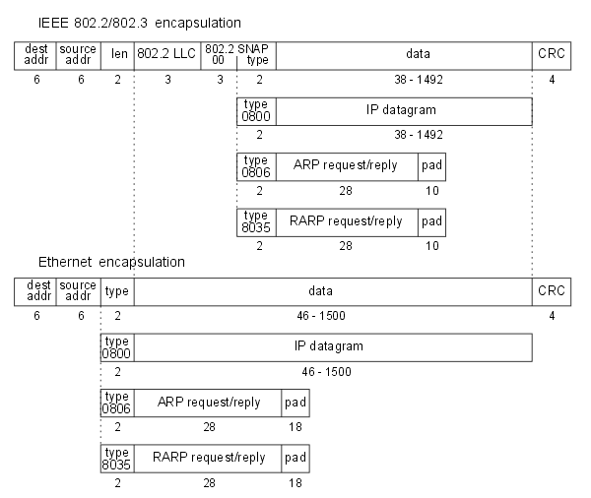
Both frame formats use 48-bit (6-byte) destination and source addresses. These are what we call MAC - addresses (MAC = Media Access Control). The ARPand RARP protocols map between the 32-bit IP addresses and the 48-bit hardware addresses.
The next 2 bytes are different in the two frame formats.
- The IEEE 802 length field says how many bytes follow, up to but not including the CRC at the end.
- The Ethernet type field identifies the type of data that follows.
In the context of this course following Ethernet type-values should be considered:
Type (in HEX) | higher layer protocol
0x0800 | IP datagram
0x0806 | ARP request/reply
0x8035 | RARP request/reply
Fortunately, none of the valid IEEE 802 length values is the same as the Ethernet type values, making the two frame formats distinguishable.
In the Ethernet frame the data immediately follows the type field, while in the 802 frame format 3 bytes of 802.2 LLC and 5 bytes of 802.2 SNAP follow.
The CRC field is a cyclic redundancy check (a checksum) that detects errors in the rest of the frame. (This is also called the FCS or Frame Check Sequence.)
There is a minimum size for 802.3 and Ethernet frames (64 bytes control + data). This minimum requires that the data portion be at least 38 bytes for 802.3 or 46 bytes for Ethernet. To handle this, padding bytes are inserted to assure that the frame is long enough. The data portion of Ethernet frames cannot be larger than 1500 bytes.

