# GUIDE TO PLANNED DEVELOPMENTS

Table of Contents

GUIDE TO PLANNED DEVELOPMENTS 1

1. Initial Contact 1

2. The Sketch Plan 1

Purpose: The purpose of the sketch plan is to assure completeness of the information required for formal application to the Planning and Zoning Commission as well as to gain an understanding of both the applicant’s desires as well as City’s policies as found in the City’s *Comprehensive Plan* and other ordinances and policies. A successful sketch plan review will help avoid delays after the formal application caused by incomplete information and the applicant will gain insight as to what may help future development on the site. This early contact will also provide staff an opportunity to inform the applicant what other development processes will have followed to achieve the desired development on the site. 1

3. Preliminary Development Plan 2

A. Application 2

B. The Development Plan (7 copies, including an 11"x17" blackline). The following items are required: 2

C. Written Text. 3

D. The following items must also be addressed and may be shown on the development plan or on separate graphics: 3

E. Neighborhood meeting: Both the City Council and the Planning and Zoning Commission strongly urge the applicant to contact and meeting with the property owners within 185 feet of the area to be rezoned and with other affected neighbors to discuss the proposal with them. If a meeting was held, please provide a written summary of the outcome. 5

4. Final Development Plan 5

Table of Figures

## 1. Initial Contact

The applicant is encouraged to discuss the proposed development with the Planning Department staff (address on page GUIDE TO PLANNED DEVELOPMENTS) to determine the feasibility of the project based on the policies of the *Cambridge Comprehensive Plan* and other City regulations and policies. Please contact staff to set up a meeting at the phone number listed on page 1. Initial Contact. Staff will outline the process involved and provide assistance to the developer to identify what basic information is required to submit a sketch plan.

## 2. The Sketch Plan

Purpose: The purpose of the sketch plan is to assure completeness of the information required for formal application to the Planning and Zoning Commission as well as to gain an understanding of both the applicant’s desires as well as City’s policies as found in the City’s *Comprehensive Plan* and other ordinances and policies. A successful sketch plan review will help avoid delays after the formal application caused by incomplete information and the applicant will gain insight as to what may help future development on the site. This early contact will also provide staff an opportunity to inform the applicant what other development processes will have followed to achieve the desired development on the site.

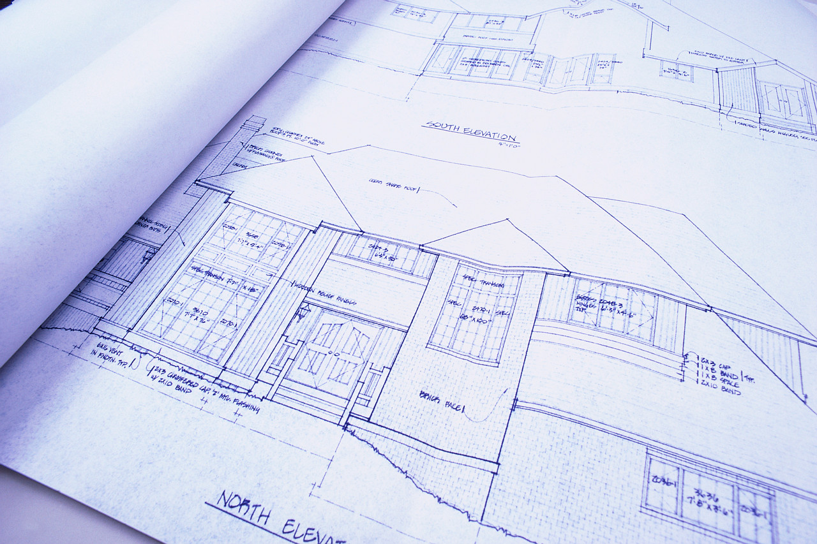

Figure 1: The Sketch Plan

A. The information to be provided by the applicant/developer is the same as that required for a Preliminary Development Plan (see belowabove), but may be in general, sketch form. A checklist titled “Planned Development Sketch Plan Checklist”, which contains information needed on this sketch, is available at Zoning and Subdivision Services. The sketch must be submitted to Zoning and Subdivision Services no later than seventeen (17) days prior to the application deadline.

B. The sketch plan review will be conducted by the Administrative Review Committee (ARC). The ARC is composed of the Directors of the Planning and Development, Public Works, and Building Development Services Departments along with any other city personnel as necessary. The ARC will review and comment on the concept of the sketch plan. The ARC review and subsequent approval to submit an application does not imply approval of the plan, nor does it imply approval of specific aspects of the plan; such as drainage detention, location of ingress/egress points, etc.. More detailed review by staff will occur after an application has been filed.

3. Preliminary Development Plan(the following items must all be submitted on or before the application deadline)

A. Application

1) The applicant’s name and address and his interest in the subject property.

2) The owner’s name and address, if different than the applicant’s, and the owner’s signed consent to the filing of the application.

3) The names and addresses of all professional consultants advising the applicant with respect to the proposed planned development.

4) The legal description of the subject property.

5) The processing fee.

6) A list of property owners within 185 feet of the planned development certified by a recognized abstractor, title company or attorney.

7) Two stamped (not metered), addressed, business-sized envelopes, without return address, for each name on the mailing list.

8) Legal advertising is required for all public hearings before the Planning and Zoning Commission and City Council. Advertising in the Cambridge News-Leader will be prepared and delivered by the Planning and Development Department. The newspaper will bill the applicant directly for all advertising costs. The cost will be based on the length of the legal description of the area proposed for the planned development.

B. The Development Plan (7 copies, including an 11"x17" blackline). The following items are required:

1) Legal description of the entire project area as shown on the application.

2) Tract location and dimensions.

3) Name and address of owners.

4) Existing zoning classification and land use.

5) Proposed floor area for commercial use.

6) Proposed residential density per gross acre.

7) Proposed residential density per net acre.

8) Amount of common or open space.

9) Location and dimension of proposed public or private streets and drives.

10) Topographical and natural features.

11) Water areas existing and proposed.

12) Flood prone areas.

13) Proposed treatment of project boundaries.

14) Existing zoning classification of adjacent properties.

15) Adjoining street systems.

16) Area public utility systems.

17) Area storm water drainage patterns.

18) Other pertinent information required regarding area.

19) Indicate parcel, tract or area within project boundary and proposed use.

20) The signature and seal of the architect, engineer or surveyor who prepared the development plan.

C. Written Text.

1) The overall concept and intent of the planned development.

2) Proposed uses.

3) Building type, bulk and height.

4) Prototype site layout.

5) Provisions for maintenance of common areas and open spaces.

6) Proposed restrictive covenants.

7) Proposed public dedications.

8) Phase development schedule.

D. The following items must also be addressed and may be shown on the development plan or on separate graphics:

1) Circulation Plan:

a) Location of surrounding and adjacent public streets.

b) Access location to development by private drive or public street.

c) Pedestrian circulation on perimeter and internal.

2) Improvements Plan:

a) Water supply source and proposed distribution

b) Sewage disposal plan.

c) Surface water runoff plan with hydraulic calculations and proposed treatment.

d) Other improvements to support the project.

3) Statistical Summary:

a) Acres in project area.

b) Allocation in acres of each land use proposed.

c) Gross and net residential densities.

d) Floor area for each proposed use.

e) Floor area ratios.

f) Open space ratios.

g) Drive and parking area ratios.

4) Sign Plan:

a) Size

b) Location on plan.

c) Type.

d) Design.

5) Parking Plan:

a) Number of parking spaces and circulation drives.

b) Location and design.

c) Perimeter treatment and interior landscaping of parking areas.

6) Landscaping and Perimeter Treatment Plan.

a) The design and arrangement of landscaping on all open space areas.

b) The design and arrangement of landscaping on all buffer and perimeter areas provided to mitigate the impact of the project on adjoining properties and/or to achieve an appropriate transition between land uses and density.

E. Neighborhood meeting: Both the City Council and the Planning and Zoning Commission strongly urge the applicant to contact and meeting with the property owners within 185 feet of the area to be rezoned and with other affected neighbors to discuss the proposal with them. If a meeting was held, please provide a written summary of the outcome.

## 4. Final Development Plan

The content, form and procedure will be prescribed by the ordinance which approves the planned development, if approved by Council. The Final Development Plan must refine, implement and illustrate how the project is in conformance with the approved preliminary development plan. Submission criteria will vary depending upon the form and procedures approved by City Council. No building permits or occupancy permits will be issued until the Final Development Plan is approved.

Zoning & Subdivision Office

Planning and Development Dept.

1st Floor, City Municipal Building

421 Lonnie Street

Cambridge, MN 55008

(763) 555-1234