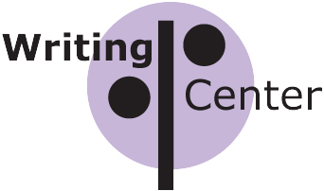
About the University of Pittsburgh

Writing Center

What is the Writing Center?
The Writing Center is an academic center supported by the Department of English and the School of Arts and Sciences for students to come to work on their writing. Students must be enrolled at the University of Pittsburgh in order to register for an appointment. Our staff, which includes faculty and undergraduate peer tutors, have been trained to help others with their writing.

When should I go to the Writing Center?
Suppose you’re writing a paper for one of your classes and you find yourself wondering:

• Will what I’ve written make sense to the audience I’ve chosen?

• Have I done what the assignment asks me to do?

• Are there parts that are unclear?

• Have I left something important unsaid or included too much?

• How do I give credit to the sources I’ve used?

• How can I make sure that there aren’t a lot of grammar mistakes?

• How can I revise my writing given the comments my instructor has made?

A consultant at the Writing Center can help you find the answers to these and other questions when you are writing.

Keep in mind that the consultant’s role is to provide support and guidance, not to correct your writing for you or tell you what to write. Ultimately, only you, the writer, can be responsible for your writing. The success of every appointment depends on the work you’re willing to put into your work.

What happens when I go to the Writing Center?
There are no grades, no homework, and no grammar drills at the Writing Center. Instead, you will be asked to identify why you’ve come to the Center, what sort of project you’re working on, and when it is due. Then you and the consultant will discuss your concerns as well as any added suggestions that the consultant might have.

But what if I don’t have anything written yet?
Come to the Writing Center with whatever you have: notes, scribbles, ideas, worries. You and your consultant can work from where you are to where you want to be.

How do I arrange to speak with a consultant?
You can make an appointment by visiting our online schedule at http://rich36.com/pitt/. Appointments are 25 minutes long, starting on the half-hour; students may make two appointments per week. Using multiple identities to book additional time is a violation of academic integrity.

You can also drop in during our operating hours, at either OSC or Hillman. If a consultant is available, you’ll be seen right away. You may not have more than one appointment per day, whether you book it in advance or drop in.

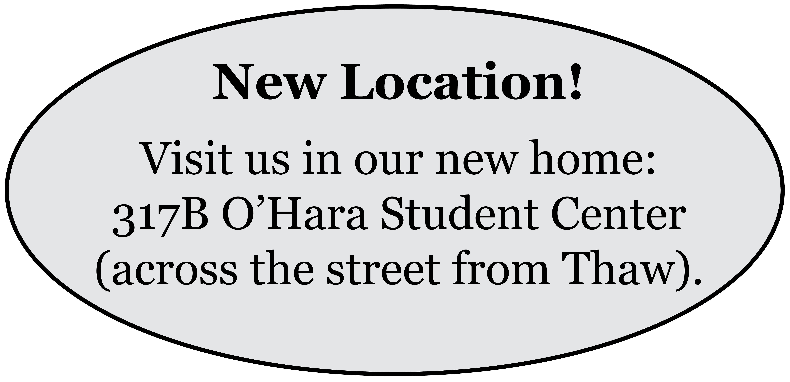

Writing Center (412) 624-6556

317B O’Hara Student Center

Monday, Tuesday, Thursday 9 to 7
Wednesday 11 to 8:30
Friday 9 to 3

Hillman Library, Ground Floor
Tuesday 1-6
Wednesday 1-6
Thursday 1-6

For information about the Writers’ Café, Workshop and Composition Tutorial, and the Peer Tutoring Program, visit our website:
www.composition.pitt.edu/writingcenter.

Geeta Kothari, Director
M-2 Thaw Hall (412) 624-5663 mano@pitt.edu

