***CS2310***

***Milestone 1***

***Mahbaneh Eshaghzadeh Torbati***

***Project title:*** A theoretical project to combine evolutionary computing algorithms such as genetic algorithms (GA) with Abstract Machines having multiple computation cycles.

***Milestone1:*** Reading Genetic Algorithm, Designing the Formalism for the Genetic Algorithm.

***Adapting the GA stages to the abstract Machine cycle:***

***Genetic algorithm:***

In GA, we iteratively run the following steps.

* **Selecting Feature:** In GA we should design a feature representation for the problem. Each feature vector will be an individual (Milestone2 when we have the data.)
* **Crossover:** In this step, we select a pair of individuals, called parents. Parents give birth to two children.
* **Mutation:** We can have mutation in each child. This Step can be run randomly. It means that We can change one feature of the feature vector for the individual.
* **Generation Selection:** By designing a Fitness function (Milestone2) we select a new generation from combination of both parents and children.

***Abstract Machine definition:***

The Abstract Machine Model is specified by: (P, S, P0, Cycle1, ..., Cyclen), where:

P is the non-empty problem set,

S is the non-empty solution set, which is a subset of Po,

P0 is the initial problem set, which is a subset of P,

Cycle1, ..., Cyclen are the computation cycles.

***Formalism for GA based on Abstract Machine model:***

Each iteration of the GA can be a cycle of an abstract Machine model. Thus, we can define the formalism as follows:

|  |  |
| --- | --- |
| **GA Steps** | **Abstract Machine Steps** |
| Selecting Feature | Designing P and the number of components |
| Crossover | Enumeration |
| Mutation (Optional) | Enumeration |
| Generation Selection | Concentration |

Table1. GA map to Abstract Machine.

P = Feature vector = (F1, F2, …., Fn)

We can have two different cycle in here based on having Mutation. It means that we can randomly have the cycle2. So we can call them:

Cycle1: Normal GA Cycle

Cycle1 [guard1,2]: P10 -enum< = P11 >conc= P12

That the enumeration in here is crossover.

Cycle2: Random GA Cycle

Cycle2 [guard2,1]: P20 -enum< = P21 >conc= P22

That the enumeration in here is Mutation.

***MileStone2:*** Design the system, Prepare the GA code, Prepare simulated data, Run Experiments.

***Design the system:***

Formerly I wanted to design the TDR system for predicting the person health status, Figure1. You can see the cycles and you can see the trend by following the arrows. But, when you asked Mohammad and I to work together, I changed the design in a way that we both can work on one project. If we still want to work on the TDR system and predict the personal health status of the patient, we can combine the Tian, Den, and Ren components to one component. For this aim, we can combine the features we have from these separate components and have one feature vector. The feature vector I designed for GA is based on this design. Then, Mohammad and I can apply our different abstract Machine models on the feature vector and compare our two evolutionary algorithms we are using. For this aim, as the next step, we should simulate our data.

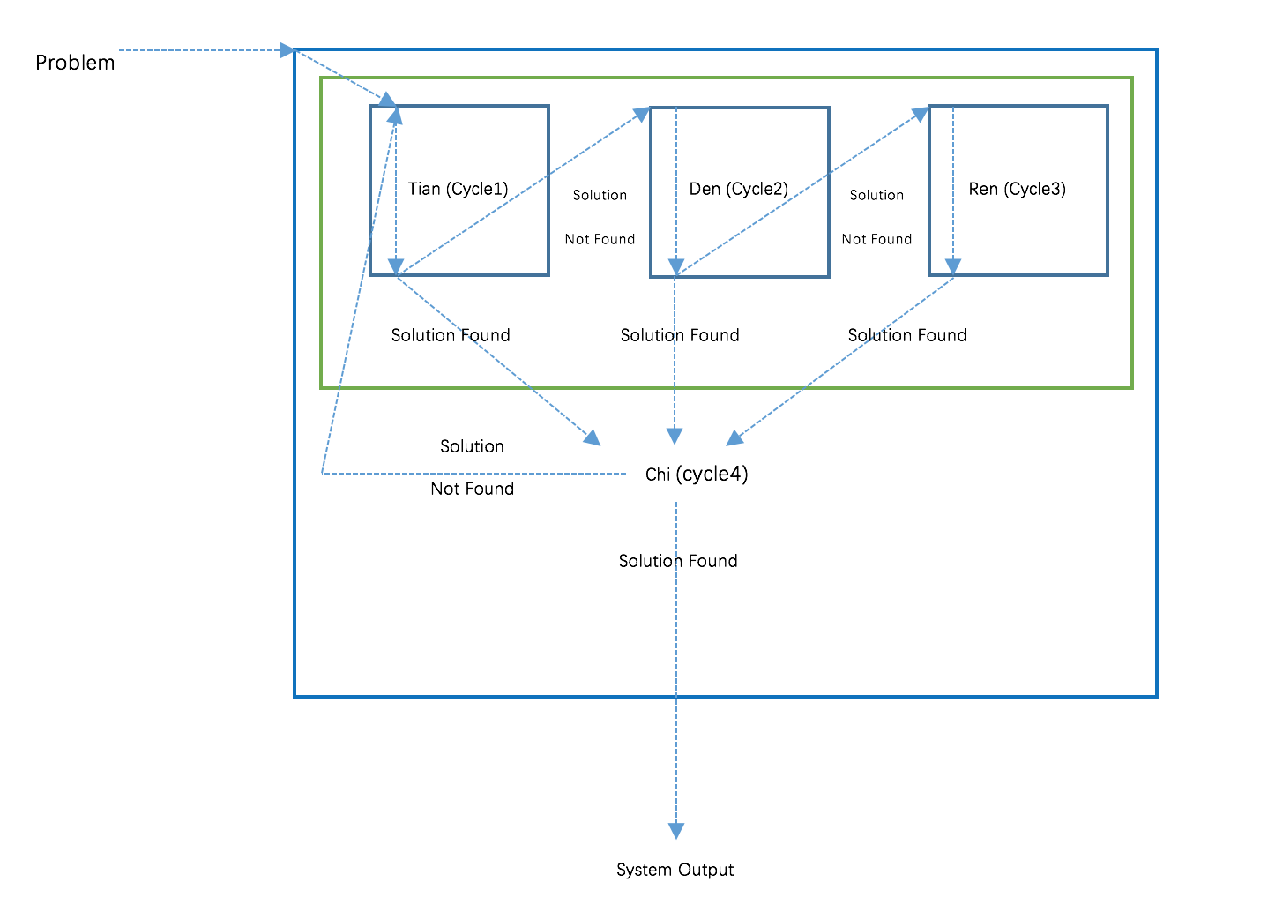

Figure 1. Abstract Machine model for TDR.