# CS 2310

# Nannan Wen

# Final Report:

Table of Contents

Final Report: 1

1 Introduction 2

2 Design 3

3 Steps of how the system works 3

Step 1: User login: 3

Step 2: Make a new Project: 4

Step 3: Select Project 5

Step 4: Add IC Card to Project 6

Step 5: Decompose Card 8

extra: 12

Appendix: 13

## Introduction

In recent years, more and more applications come into people’s life, which makes software engineer more popular than before, however the design and implementation can be quite a challenge. IC cards is a visual language which can represent syntactic patterns in the process of software development.

In this project, I’m doing the extended work of a previous student, the link can be find here: <http://intranet.cs.pitt.edu/~chang/icms4/login.php>.

The idea behind this project is that an activity can be decomposed and transformed. What I did is the decomposition part, decomposition is a process which decompose a complex activity into two or more simpler activities. An example of this is that to organize a picnic. Organizing a picnic is a complex activity, so it’s difficult for users to figure out how to do it without through thought. So this system help user to go through some process so the user will figure out how to finish simpler tasks in order to organize a picnic successfully. Hopefully, the system will help user to get the idea that a picnic consists of food, sport, date, location etc. A simple decomposition is shown below:

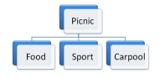

Figure 1

## Design

In this system, after the user log into the system, he/she will be asked whether the activity he wanted to decompose contains other activities or not, if it does, then the activity can be decomposed, the user will go through the user questionnaire to guide him/her through the process of decompose his/her activity, otherwise the user will be informed that based on what he/she provided the activity can’t be decomposed.

The data flow is shown as bellow:

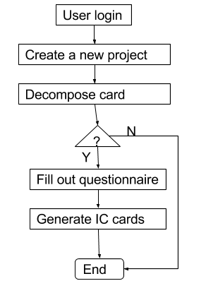

Figure 2: data flow for Decomposition

## Steps of how the system works

### Step 1: User login:

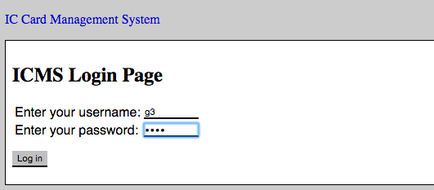

Figure 3: user login page

### Step 2: Make a new Project:

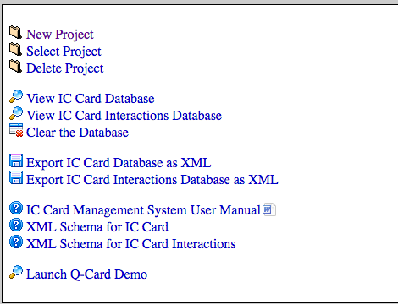

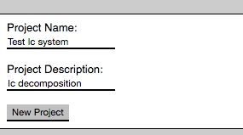

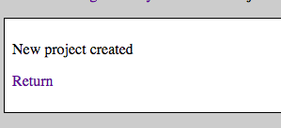

Figure 4-6: make a new project if there’s no project exist

### Step 3: Select Project

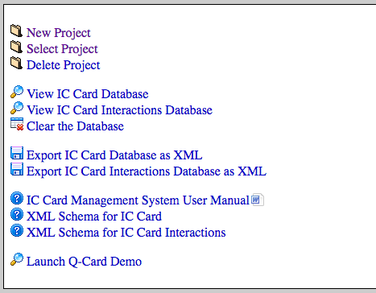

Select the project you created earlier:

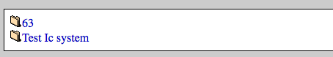

Figure 7-8: select the project you created

### Step 4: Add IC Card to Project

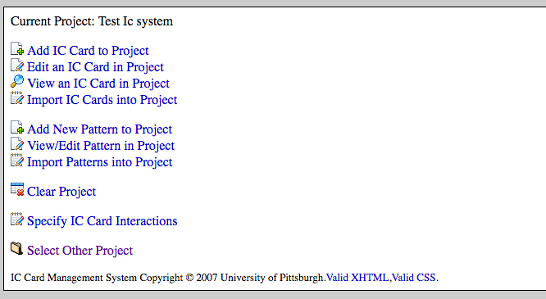

Figure 9: add IC card to your project

Create a new entry to your project

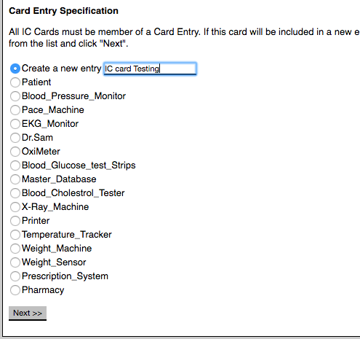

Figure 10: create a new entry to your project

### Step 5: Decompose Card

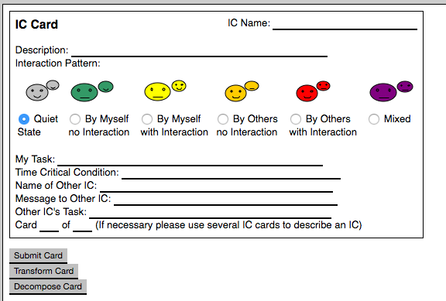

Figure 11: decompose card

Check whether the activity can be decomposed or not

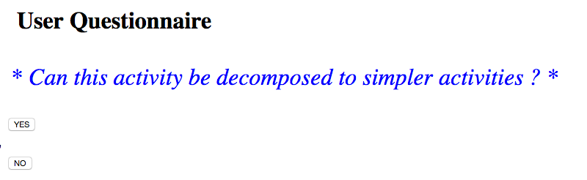

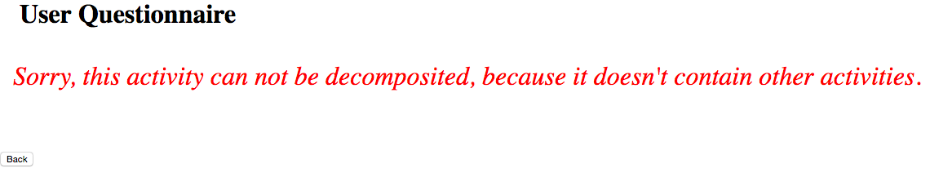

Back to IC card Page.



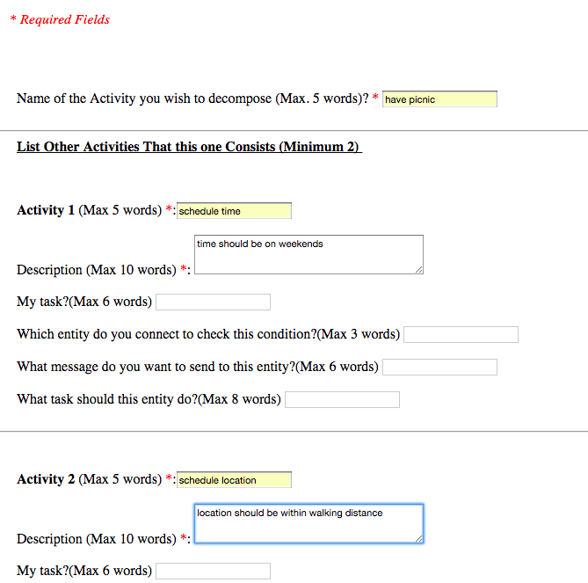

Activity description overview:

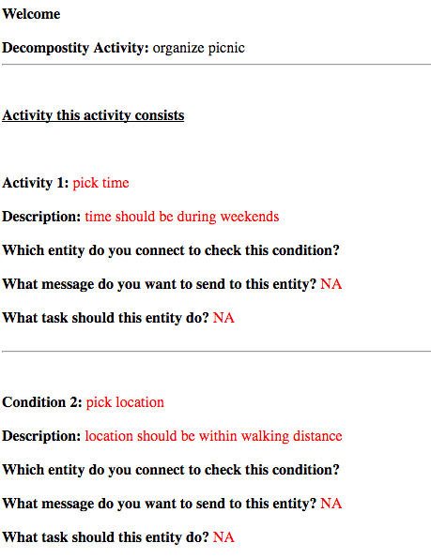



If the description is wrong, then click Back, otherwise click “IC RECOMMENDATION”

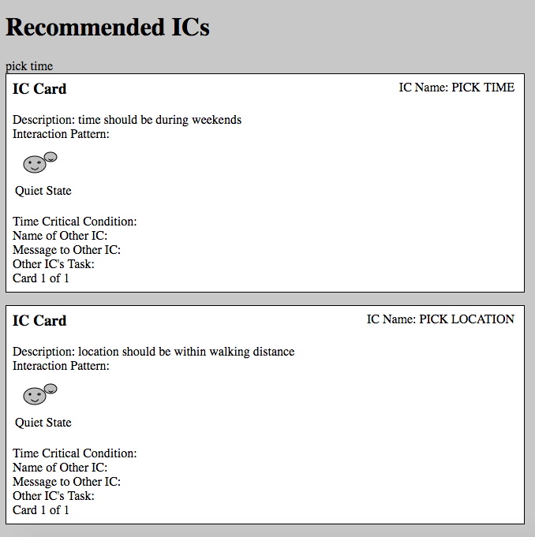

### extra:

###1. Keyword match:

I was trying to store the activities the user filled, and then use it to do evaluation. But it’s much more complicated than I expected, so I just finished the part with writing the key words into a file.

However, the system can do a simple keyword match now. Even though it didn’t prompt to ask user questions, but it does a keyword match, and then updated it in IC card. The picture is shown bellow:

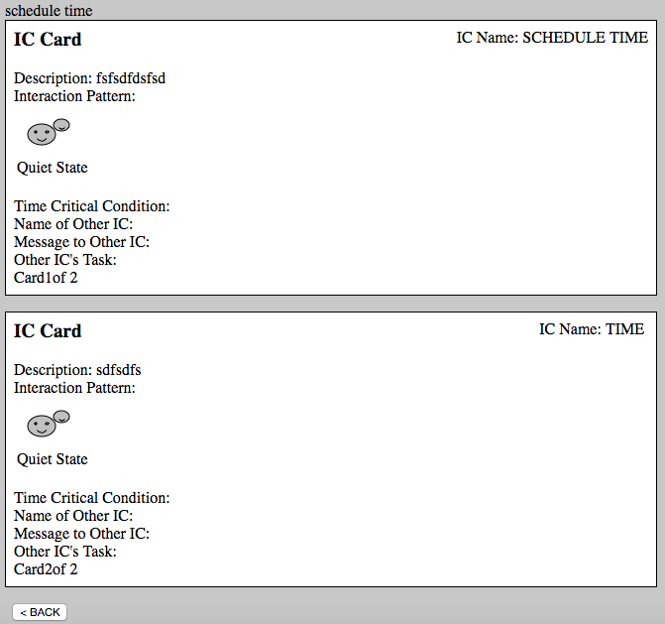

### Appendix:

<html>

<head>

<style>

.error {color: #FF0000;}

</style>

</head>

<body>

<div id="parent">

<h1>&nbsp&nbsp&nbspUser Questionnaire </h1>

<div id="popup" style="display: none">

<font color = GREEN>&nbsp &nbsp &nbsp

Suggestions:<br><br>

&nbsp &nbsp &nbsp 1)&nbsp Please be as brief and accurate as possible for best results.<br>

&nbsp &nbsp &nbsp 2)&nbsp If you are filling in a activity, it is MANDATORY to fill in its description for best results.<br>

&nbsp &nbsp &nbsp 3)&nbsp You can give a Minimum of 2 and a Maximum of 5 activities.<br>

</font>

</div>

</div>

<br><br>

<script>

var e = document.getElementById('parent');

e.onmouseover = function() {

document.getElementById('popup').style.display = 'block';

}

e.onmouseout = function() {

document.getElementById('popup').style.display = 'none';

}

</script>

<I>&nbsp&nbsp&nbsp <font color = RED> * Required Fields </font></I>

<br><br><br>

<!--<p><span class="error">* required field.</span></p> -->

<?php if (!empty($_POST["otherICname1"]))

{

echo $_POST["otherICmsg1"];

}

else

echo ""

?></font><br><br>

<?php

/*

$connection = openDBConnection();

if(!$connection){

echo("Connection failed!");

}

else{

$strInsertCardSQL = "INSERT INTO ICRELATION ("

."ACTIVITY_ID, "

."ACTIVITY_DESCRIBE, "

."ACTIVITY_NAME, "

."ACTIVITY_MYTASK, "

."ACTIVITY_OTHERICNAME, "

."ACTIVITY_OTHERICTASK, "

."ACTIVITY_OTHERICMSG) VALUES (";

#Set ACTIVITY_ID

$strInsertCardSQL .= "'" .1 "',";

#Set description

$strInsertCardSQL .= "'".$_SESSION["describe1"]."',";

#Set name

$strInsertCardSQL .= "'".$_SESSION["Activity1"]."',";

#Set mytask

$strInsertCardSQL .= "'".$_SESSION["mytask1"]."',";

#Set otherICname

$strInsertCardSQL .= "'".$_SESSION["otherICname1"]."',";

#Set otherICtask

$strInsertCardSQL .= "'".$_SESSION["otherICtask1"]."',";

#Set otherICmsg

$strInsertCardSQL .= "'".$_SESSION["otherICmsg1"]."') ";

if ( runDBInsertQuery($strInsertCardSQL, $connection) != 1 ) {

echo("connection failed");

}

# close DB

closeDBConnection($connection);

}

*/

?>

<form method="post" action="dec_form3.php">

&nbsp &nbsp &nbsp Name of the Activity you wish to decompose (Max. 5 words)?<font color = RED> *</font> <input type="text" name="decomposeActivity" required>

<br><br>

<hr>

<b>&nbsp &nbsp &nbsp <U>List Other Activities That this one Consists (Minimum 2) </U></b><br><br><br><br>

&nbsp &nbsp &nbsp <b>Activity 1</b> (Max 5 words)<font color = RED> *</font>:<input type="text" name="Activity1" required>

<br><br>

&nbsp &nbsp &nbsp Description (Max 10 words)<font color = RED> *</font>: <textarea name="describe1" rows="3" cols="40" required></textarea> <br><br>

&nbsp &nbsp &nbsp My task?(Max 6 words)<font color = RED> </font> <input type="text" name="mytask1" ><br><br>

&nbsp &nbsp &nbsp Which entity do you connect to check this condition?(Max 3 words)<font color = RED> </font> <input type="text" name="otherICname1" ><br><br>

&nbsp &nbsp &nbsp What message do you want to send to this entity?(Max 6 words)<font color = RED> </font> <input type="text" name="otherICmsg1" ><br><br>

&nbsp &nbsp &nbsp What task should this entity do?(Max 8 words)<font color = RED> </font> <input type="text" name="otherICtask1" ><br><br>

<hr>

<br><br>

&nbsp &nbsp &nbsp <b>Activity 2</b> (Max 5 words)<font color = RED> *</font>:<input type="text" name="Activity2" required><br><br>

&nbsp &nbsp &nbsp Description (Max 10 words)<font color = RED> *</font>: <textarea name="describe2" rows="3" cols="40" required></textarea> <br><br>

&nbsp &nbsp &nbsp My task?(Max 6 words) <input type="text" name="mytask2"><br><br>

&nbsp &nbsp &nbsp Which entity do you connect to check this condition?(Max 3 words)<font color = RED> </font> <input type="text" name="otherICname2" ><br><br>

&nbsp &nbsp &nbsp What message do you want to send to this entity? (Max 6 words)<font color = RED> </font> <input type="text" name="otherICmsg2" ><br><br>

&nbsp &nbsp &nbsp What task should this entity do? (Max 8 words)<font color = RED> </font><input type="text" name="otherICtask2" ><br><br>

<hr>

<br><br>

&nbsp &nbsp &nbsp <b>Activity 3</b> (Max 5 words):<input type="text" name="Activity3"><br><br>

&nbsp &nbsp &nbsp Description (Max 10 words): <textarea name="describe3" rows="3" cols="40"></textarea> <br><br>

&nbsp &nbsp &nbsp My task?(Max 6 words)<input type="text" name="mytask3" ><br><br>

&nbsp &nbsp &nbsp Which entity do you connect to check this condition?(Max 3 words) <input type="text" name="otherICname3"><br><br>

&nbsp &nbsp &nbsp What message do you want to send to this entity?(Max 6 words) <input type="text" name="otherICmsg3"><br><br>

&nbsp &nbsp &nbsp What task should this entity do?(Max 8 words) <input type="text" name="otherICtask3"><br><br>

<hr>

<br><br>

&nbsp &nbsp &nbsp <b>Activity 4</b> (Max 5 words):<input type="text" name="Activity4"><br><br>

&nbsp &nbsp &nbsp Description (Max 10 words): <textarea name="describe4" rows="3" cols="40"></textarea> <br><br>

&nbsp &nbsp &nbsp My task?(Max 6 words) <input type="text" name="mytask4" ><br><br>

&nbsp &nbsp &nbsp Which entity do you connect to check this condition?(Max 3 words) <input type="text" name="otherICname4"><br><br>

&nbsp &nbsp &nbsp What message do you want to send to this entity?(Max 6 words) <input type="text" name="otherICmsg4"><br><br>

&nbsp &nbsp &nbsp What task should this entity do?(Max 8 words) <input type="text" name="otherICtask4"><br><br>

<hr>

<br><br>

&nbsp &nbsp &nbsp <b>Activity 5</b> (Max 5 words):<input type="text" name="Activity5"><br><br>

&nbsp &nbsp &nbsp Description (Max 10 words): <textarea name="describe5" rows="3" cols="40"></textarea> <br><br>

&nbsp &nbsp &nbsp My task?(Max 6 words) <input type="text" name="mytask5" ><br><br>

&nbsp &nbsp &nbsp Which entity do you connect to check this condition?(Max 3 words) <input type="text" name="otherICname5"><br><br>

&nbsp &nbsp &nbsp What message do you want to send to this entity?(Max 6 words) <input type="text" name="otherICmsg5"><br><br>

&nbsp &nbsp &nbsp What task should this entity do?(Max 8 words) <input type="text" name="otherICtask5"><br><br>

<hr>

<br><br>

&nbsp&nbsp<input type="submit" name = "submit" value="NEXT >">

</form>

<form method="post" action="addcard.php">

&nbsp&nbsp<input type="submit" value="< BACK">

</form>

</body>

</html>

<html>

<body>

<h1>User Details </h1>

<br><hr><br>

<b>Welcome</b> <?php session_start(); ?><br><br>

<b>Decompostity Activity:</b> <?php echo $_POST["decomposeActivity"]; ?><br><hr><br><br>

<b><U>Activity this activity consists</U></b> <br><br><br><br>

<b>Activity 1:</b><font color = RED> <?php echo $_POST["Activity1"]; ?></font><br><br>

<b>Description: </b><font color = RED> <?php echo $_POST["describe1"]; ?></font><br><br>

<b>Which entity do you connect to check this condition?</b> <?php echo $_POST["otherICname1"]; ?><br><br><font color = RED>

<?php

$file = 'decompose.txt';

file_put_contents($file, " ");

file_put_contents($file, "1,");

file_put_contents($file, $_POST["Activity1"], FILE_APPEND);

file_put_contents($file, "\n", FILE_APPEND);

file_put_contents($file, "2,", FILE_APPEND);

file_put_contents($file, $_POST["Activity2"], FILE_APPEND);

file_put_contents($file, "\n", FILE_APPEND);

file_put_contents($file, "3,", FILE_APPEND);

file_put_contents($file, $_POST["Activity3"], FILE_APPEND);

file_put_contents($file, "\n", FILE_APPEND);

file_put_contents($file, "4,", FILE_APPEND);

file_put_contents($file, $_POST["Activity4"], FILE_APPEND);

file_put_contents($file, "\n", FILE_APPEND);

file_put_contents($file, "5,", FILE_APPEND);

file_put_contents($file, $_POST["Activity5"], FILE_APPEND);

$str1 = $_POST["Activity1"];

$arr1 = explode(" ", $str1);

$str2 = $_POST["Activity2"];

$arr2 = explode(" ", $str2);

$str3 = $_POST["Activity3"];

$arr3 = explode(" ", $str3);

$str4 = $_POST["Activity4"];

$arr4 = explode(" ", $str4);

$str5 = $_POST["Activity5"];

$arr5 = explode(" ", $str5);

$index1 = 1;

$index2 = 1;

$indexTotal = 1;

//compare all the values in the array

foreach($arr1 as $v1){

foreach($arr2 as $v2){

if($v1 == $v2){

$string = file_get_contents("decompose1.txt");

$string1 = explode("\n", $string);

if(in_array($v1, $string1)){

$index1 = 1;

$index2 = 2;

$indexTotal = 2;

$_SESSION["index1"] = 1;

$_SESSION["index2"] = 2;

$_SESSION["indexTotal"] = 2;

}

else{

$_SESSION["index1"] = $index1;

$_SESSION["index2"] = $index2;

$_SESSION["indexTotal"] = $indexTotal;

}

}//

}

}

foreach($arr1 as $v1){

foreach($arr3 as $v3){

if($v1 == $v3){

$string = file_get_contents("decompose1.txt");

$string1 = explode("\n", $string);

if(in_array($v1, $string1)){

$_SESSION["index1"] = 1;

$_SESSION["index3"] = 2;

$_SESSION["indexTotal"] = 2;

}

else{

$_SESSION["index1"] = 1;

$_SESSION["index3"] = 1;

$_SESSION["indexTotal"] = 1;

}

}//

}

}

foreach($arr1 as $v1){

foreach($arr4 as $v4){

if($v1 == $v4){

$string = file_get_contents("decompose1.txt");

$string1 = explode("\n", $string);

if(in_array($v1, $string1)){

$_SESSION["index1"] = 1;

$_SESSION["index4"] = 2;

$_SESSION["indexTotal"] = 2;

}

else{

$_SESSION["index1"] = 1;

$_SESSION["index4"] = 1;

$_SESSION["indexTotal"] = 1;

}

}//

}

}

foreach($arr1 as $v1){

foreach($arr5 as $v5){

if($v1 == $v5){

$string = file_get_contents("decompose1.txt");

$string1 = explode("\n", $string);

if(in_array($v1, $string1)){

$_SESSION["index1"] = 1;

$_SESSION["index5"] = 2;

$_SESSION["indexTotal"] = 2;

}

else{

$_SESSION["index1"] = 1;

$_SESSION["index5"] = 1;

$_SESSION["indexTotal"] = 1;

}

}//

}

}

foreach($arr2 as $v2){

foreach($arr3 as $v3){

if($v2 == $v3){

$string = file_get_contents("decompose1.txt");

$string1 = explode("\n", $string);

if(in_array($v2, $string1)){

$_SESSION["index1"] = 1;

$_SESSION["index2"] = 2;

$_SESSION["indexTotal"] = 2;

}

else{

$_SESSION["index1"] = 1;

$_SESSION["index2"] = 1;

$_SESSION["indexTotal"] = 1;

}

}//

}

}

foreach($arr2 as $v2){

foreach($arr4 as $v4){

if($v2 == $v4){

$string = file_get_contents("decompose1.txt");

$string1 = explode("\n", $string);

if(in_array($v2, $string1)){

$_SESSION["index1"] = 1;

$_SESSION["index2"] = 2;

$_SESSION["indexTotal"] = 2;

}

else{

$_SESSION["index1"] = 1;

$_SESSION["index2"] = 1;

$_SESSION["indexTotal"] = 1;

}

}//

}

}

foreach($arr2 as $v2){

foreach($arr5 as $v5){

if($v2 == $v5){

$string = file_get_contents("decompose1.txt");

$string1 = explode("\n", $string);

if(in_array($v2, $string1)){

$_SESSION["index1"] = 1;

$_SESSION["index2"] = 2;

$_SESSION["indexTotal"] = 2;

}

else{

$_SESSION["index1"] = 1;

$_SESSION["index2"] = 1;

$_SESSION["indexTotal"] = 1;

}

}//

}

}

?>

<?php

$_SESSION["decomposeActivity"] = $_POST["decomposeActivity"];

$_SESSION["Activity1"] = $_POST["Activity1"];

$_SESSION["describe1"] = $_POST["describe1"];

$_SESSION["mytask1"] = $_POST["mytask1"];

$_SESSION["otherICname1"] = $_POST["otherICname1"];

$_SESSION["otherICtask1"] = $_POST["otherICtask1"];

$_SESSION["otherICmsg1"] = $_POST["otherICmsg1"];

$_SESSION["Activity2"] = $_POST["Activity2"];

$_SESSION["describe2"] = $_POST["describe2"];

$_SESSION["mytask2"] = $_POST["mytask2"];

$_SESSION["otherICname2"] = $_POST["otherICname2"];

$_SESSION["otherICtask2"] = $_POST["otherICtask2"];

$_SESSION["otherICmsg2"] = $_POST["otherICmsg2"];

$_SESSION["Activity3"] = $_POST["Activity3"];

$_SESSION["describe3"] = $_POST["describe3"];

$_SESSION["mytask3"] = $_POST["mytask3"];

$_SESSION["otherICname3"] = $_POST["otherICname3"];

$_SESSION["otherICtask3"] = $_POST["otherICtask3"];

$_SESSION["otherICmsg3"] = $_POST["otherICmsg3"];

$_SESSION["Activity4"] = $_POST["Activity4"];

$_SESSION["describe4"] = $_POST["describe4"];

$_SESSION["mytask4"] = $_POST["mytask4"];

$_SESSION["otherICname4"] = $_POST["otherICname4"];

$_SESSION["otherICtask4"] = $_POST["otherICtask4"];

$_SESSION["otherICmsg4"] = $_POST["otherICmsg4"];

$_SESSION["Activity5"] = $_POST["Activity5"];

$_SESSION["describe5"] = $_POST["describe5"];

$_SESSION["mytask5"] = $_POST["mytask5"];

$_SESSION["otherICname5"] = $_POST["otherICname5"];

$_SESSION["otherICtask5"] = $_POST["otherICtask5"];

$_SESSION["otherICmsg5"] = $_POST["otherICmsg5"];

?></font>

<b>What message do you want to send to this entity?</b><font color = RED>

<?php if (!empty($_POST["otherICname1"]))

{

echo $_POST["otherICmsg1"];

}

else

echo "NA"

?></font><br><br>

<b>What task should this entity do?</b><font color = RED>

<?php if (!empty($_POST["otherICname1"]))

{

echo $_POST["otherICtask1"];

}

else

echo "NA"

?></font><br><br>

<hr>

<br><br>

<b>Condition 2: </b><font color = RED> <?php echo $_POST["Activity2"]; ?></font><br><br>

<b>Description: </b><font color = RED> <?php echo $_POST["describe2"]; ?></font><br><br>

<b>Which entity do you connect to check this condition? </b><font color = RED> <?php echo $_POST["otherICname2"]; ?></font><br><br>

<b>What message do you want to send to this entity?</b><font color = RED>

<?php if (!empty($_POST["otherICname2"]))

{

echo $_POST["otherICmsg2"];

}

else

echo "NA"

?></font><br><br>

<b>What task should this entity do?</b><font color = RED>

<?php if (!empty($_POST["otherICname2"]))

{

echo $_POST["otherICtask2"];

}

else

echo "NA"

?></font><br><br>

<hr>

<br><br>

<b>Condition 3:</b><font color = RED> <?php echo $_POST["Activity3"]; ?></font><br><br>

<b>Description:</b><font color = RED> <?php echo $_POST["describe3"]; ?></font><br><br>

<b>Which entity do you connect to check this condition? </b><font color = RED> <?php echo $_POST["otherICname3"]; ?></font><br><br>

<b>What message do you want to send to this entity?</b><font color = RED>

<?php if (!empty($_POST["otherICname3"]))

{

echo $_POST["otherICmsg3"];

}

else

echo "NA"

?></font><br><br>

<b>What task should this entity do?</b><font color = RED>

<?php if (!empty($_POST["otherICname3"]))

{

echo $_POST["otherICtask3"];

}

else

echo "NA"

?></font><br><br>

<hr>

<br><br>

<b>Condition 4:</b><font color = RED> <?php echo $_POST["Activity4"]; ?></font><br><br>

<b>Description:</b><font color = RED> <?php echo $_POST["describe4"]; ?></font><br><br>

<b>Which entity do you connect to check this condition?</b><font color = RED> <?php echo $_POST["otherICname4"]; ?></font><br><br>

<b>What message do you want to send to this entity?</b><font color = RED>

<?php if (!empty($_POST["otherICname4"]))

{

echo $_POST["otherICmsg4"];

}

else

echo "NA"

?></font><br><br>

<b>What task should this entity do?</b><font color = RED>

<?php if (!empty($_POST["otherICname4"]))

{

echo $_POST["otherICtask4"];

}

else

echo "NA"

?></font><br><br>

<hr>

<br><br>

<b>Condition 5:</b><font color = RED> <?php echo $_POST["Activity5"]; ?></font><br><br>

<b>Description:</b><font color = RED> <?php echo $_POST["describe5"]; ?></font><br><br>

<b>Which entity do you connect to check this condition?</b><font color = RED> <?php echo $_POST["otherICname5"]; ?></font><br><br>

<b>What message do you want to send to this entity?</b><font color = RED>

<?php if (!empty($_POST["otherICname5"]))

{

echo $_POST["otherICmsg5"];

}

else

echo "NA"

?></font><br><br>

<b>What task should this entity do?</b><font color = RED>

<?php if (!empty($_POST["otherICname5"]))

{

echo $_POST["otherICtask5"];

}

else

echo "NA"

?></font><br><br>

<hr>

<br><br>

<br><br>

<form method="post" action="dec_recommend.php">

&nbsp&nbsp<input type="submit" value="IC RECOMMENDATION >">

</form>

<form method="post" action="dec_form2.php">

&nbsp&nbsp<input type="submit" value="< BACK">

</form>

</body>

</html>

<?php

include_once('utils.inc');

include_once('db.inc');

?>

<!DOCTYPE html

PUBLIC "-//W3C//DTD XHTML 1.0 Transitional//EN"

"http://www.w3.org/TR/xhtml1/DTD/xhtml1-transitional.dtd">

<html xmlns="http://www.w3.org/1999/xhtml" xml:lang="en" lang="en">

<head>

<link rel="stylesheet" type="text/css" media="screen" href="icms.css" />

<style>

body{

background-color: rgb(200,200,200);

}

</style>

</head>

<body>

<h1> Recommended ICs</h1>

<?php

session_start();

echo $_SESSION["Activity1"];

if ((!empty($_SESSION["Activity1"]) && $_SESSION["Activity1"] != 'None' && $_SESSION["Activity1"] != 'NONE' ) && (!empty($_SESSION["describe1"]) && $_SESSION["describe1"] != 'None' && $_SESSION["describe1"] != 'NONE'))

{

//echo "JIUJI";

$cardString = '<div id="dataform" style="width: 40em">'

.'<p id="iclogo">IC Card</p><span id="icname">'

.'IC Name: '.strtoupper($_SESSION["Activity1"]).'<br /></span>'

.'Description: '.$_SESSION["describe1"].'<br />'

.'Interaction Pattern:<br />'."\n";

$cardString.= '<table class="noborder"><tr>';

$cardString.= '<td>';

//Determine the type of card

//Quiet State

if ((empty ($_SESSION["mytask1"]) || $_SESSION["mytask1"] == 'None') && (empty ($_SESSION["otherICname1"]) || $_SESSION["otherICname1"] == 'None')

&& (empty ($_SESSION["otherICtask1"]) || $_SESSION["otherICtask1"] == 'None') && (empty ($_SESSION["otherICmsg1"]) || $_SESSION["otherICmsg1"] == 'None') )

{

//Quiet State

$cardString.= '<img src="images/quietstate.png" alt="quiet state symbol" /><br />Quiet State';

}

else

{

$cardString .= '<img src="images/empty.png" alt="empty symbol" /><br />';

}

$cardString .= '</td>';

$cardString .= '<td>';

//By Myself No Interaction

if ( (!empty ($_SESSION["mytask1"]) && $_SESSION["mytask1"] != 'None')&&(empty ($_SESSION["otherICname1"]) || $_SESSION["otherICname1"] == 'None')

&& (empty ($_SESSION["otherICtask1"]) || $_SESSION["otherICtask1"] == 'None') && (empty ($_SESSION["otherICmsg1"]) || $_SESSION["otherICmsg1"] == 'None') )

{

$cardString .= '<img src="images/myselfnone.png" alt="quiet state symbol" /><br />By Myself no Interaction';

}

else

{

$cardString .= '<img src="images/empty.png" alt="empty symbol" /><br />';

}

$cardString .= '</td>';

$cardString .= '<td>';

//By Myself With Interaction

if ((!empty ($_SESSION["mytask1"]) && $_SESSION["mytask1"] != 'None') && (!empty($_SESSION["otherICname1"]) && $_SESSION["otherICname1"] != 'None')

&& (empty ($_SESSION["otherICtask1"]) || $_SESSION["otherICtask1"] == 'None') && (!empty($_SESSION["otherICmsg1"]) && $_SESSION["otherICmsg1"] != 'None') )

{

$cardString .= '<img src="images/myselfwith.png" alt="quiet state symbol" /><br />By Myself with Interaction';

}

else

{

$cardString .= '<img src="images/empty.png" alt="empty symbol" /><br />';

}

$cardString .= '</td>';

$cardString .= '<td>';

//By Others No Interaction

if ((empty ($_SESSION["mytask1"]) || $_SESSION["mytask1"] == 'None') && (!empty($_SESSION["otherICname1"]) && $_SESSION["otherICname1"] != 'None')

&& (!empty ($_SESSION["otherICtask1"]) && $_SESSION["otherICtask1"] != 'None') && (empty($_SESSION["otherICmsg1"]) || $_SESSION["otherICmsg1"] == 'None') )

{

$cardString .= '<img src="images/othersnone.png" alt="quiet state symbol" /><br />By Others no Interaction';

}

else

{

$cardString .= '<img src="images/empty.png" alt="empty symbol" /><br />';

}

$cardString .= '</td>';

$cardString .= '<td>';

//By Others With Interaction

if ((empty ($_SESSION["mytask1"]) || $_SESSION["mytask1"] == 'None') && (!empty ($_SESSION["otherICname1"]) && $_SESSION["otherICname1"] != 'None')

&& (!empty ($_SESSION["otherICtask1"]) && $_SESSION["otherICtask1"] != 'None') && (!empty ($_SESSION["otherICmsg1"]) && $_SESSION["otherICmsg1"] != 'None') )

{

$cardString .= '<img src="images/otherswith.png" alt="quiet state symbol" /><br />By Others with Interaction';

}

else

{

$cardString .= '<img src="images/empty.png" alt="empty symbol" /><br />';

}

$cardString .= '</td>';

$cardString .= '<td>';

//Mixed

if ((!empty ($_SESSION["mytask1"]) && $_SESSION["mytask1"] != 'None') && (!empty ($_SESSION["otherICname1"]) && $_SESSION["otherICname1"] != 'None')

&& (!empty ($_SESSION["otherICtask1"]) && $_SESSION["otherICtask1"] != 'None') && (!empty ($_SESSION["otherICmsg1"]) && $_SESSION["otherICmsg1"] != 'None') )

{

$cardString .= '<img src="images/mixedstate.png" alt="quiet state symbol" /><br />Mixed';

}

else

{

$cardString .= '<img src="images/empty.png" alt="empty symbol" /><br />';

}

$cardString .= '</td>';

//$cardString .= '<td></td>';

$cardString .= '</tr></table>';

$cardString .= '<br />Time Critical Condition: '

.'<br />'

.'Name of Other IC: '.$_SESSION["otherICname1"].'<br />'

.'Message to Other IC: '.$_SESSION["otherICmsg1"].'<br />'

.'Other IC\'s Task: '.$_SESSION["otherICtask1"].'<br />'

.'Card' .$_SESSION["index1"] .'of ' .$_SESSION["indexTotal"].' </div>';

echo $cardString;

}

else if ((empty($_SESSION["Activity1"]) || $_SESSION["Activity1"] == 'None' || $_SESSION["Activity1"] == 'NONE' ) && (!empty($_SESSION["describe1"]) && $_SESSION["describe1"] != 'None' && $_SESSION["describe1"] != 'NONE'))

{

echo "<br><br><br> <font color = RED> Condition 1 EMPTY or specified as 'None'!! </font><br><br><br>";

}

else if ((empty($_SESSION["describe1"]) || $_SESSION["describe1"] == 'None' || $_SESSION["describe1"] == 'NONE') && (!empty($_SESSION["Activity1"]) && $_SESSION["Activity1"] != 'None' && $_SESSION["Activity1"] != 'NONE'))

{

echo "<br><br><br> <font color = RED> Description 1 EMPTY or specified as 'None'!! </font><br><br><br>";

}

//IC Card 2

if ((!empty($_SESSION["Activity2"]) && $_SESSION["Activity2"] != 'None' && $_SESSION["Activity2"] != 'NONE' )&& (!empty($_SESSION["describe2"]) && $_SESSION["describe2"] != 'None' && $_SESSION["describe2"] != 'NONE'))

{

$cardString = '<div id="dataform" style="width: 40em">'

.'<p id="iclogo">IC Card</p><span id="icname">'

.'IC Name: '.strtoupper($_SESSION["Activity2"]).'<br /></span>'

.'Description: '.$_SESSION["describe2"].'<br />'

.'Interaction Pattern:<br />'."\n";

$cardString.= '<table class="noborder"><tr>';

$cardString.= '<td>';

//Determine the type of card

//Quiet State

if ((empty ($_SESSION["mytask2"]) || $_SESSION["mytask2"] == 'None') && (empty ($_SESSION["otherICname2"]) || $_SESSION["otherICname2"] == 'None')

&& (empty ($_SESSION["otherICtask2"]) || $_SESSION["otherICtask2"] == 'None') && (empty ($_SESSION["otherICmsg2"]) || $_SESSION["otherICmsg2"] == 'None') )

{

//Quiet State

$cardString.= '<img src="images/quietstate.png" alt="quiet state symbol" /><br />Quiet State';

}

else

{

$cardString .= '<img src="images/empty.png" alt="empty symbol" /><br />';

}

$cardString .= '</td>';

$cardString .= '<td>';

//By Myself No Interaction

if ( (!empty ($_SESSION["mytask2"]) && $_SESSION["mytask2"] != 'None')&&(empty ($_SESSION["otherICname2"]) || $_SESSION["otherICname2"] == 'None')

&& (empty ($_SESSION["otherICtask2"]) || $_SESSION["otherICtask2"] == 'None') && (empty ($_SESSION["otherICmsg2"]) || $_SESSION["otherICmsg2"] == 'None') )

{

$cardString .= '<img src="images/myselfnone.png" alt="quiet state symbol" /><br />By Myself no Interaction';

}

else

{

$cardString .= '<img src="images/empty.png" alt="empty symbol" /><br />';

}

$cardString .= '</td>';

$cardString .= '<td>';

//By Myself With Interaction

if ((!empty ($_SESSION["mytask2"]) && $_SESSION["mytask2"] != 'None') && (!empty($_SESSION["otherICname2"]) && $_SESSION["otherICname2"] != 'None')

&& (empty ($_SESSION["otherICtask2"]) || $_SESSION["otherICtask2"] == 'None') && (!empty($_SESSION["otherICmsg2"]) && $_SESSION["otherICmsg2"] != 'None') )

{

$cardString .= '<img src="images/myselfwith.png" alt="quiet state symbol" /><br />By Myself with Interaction';

}

else

{

$cardString .= '<img src="images/empty.png" alt="empty symbol" /><br />';

}

$cardString .= '</td>';

$cardString .= '<td>';

//By Others No Interaction

if ((empty ($_SESSION["mytask2"]) || $_SESSION["mytask2"] == 'None') && (!empty($_SESSION["otherICname2"]) && $_SESSION["otherICname2"] != 'None')

&& (!empty ($_SESSION["otherICtask2"]) && $_SESSION["otherICtask2"] != 'None') && (empty($_SESSION["otherICmsg2"]) || $_SESSION["otherICmsg2"] == 'None') )

{

$cardString .= '<img src="images/othersnone.png" alt="quiet state symbol" /><br />By Others no Interaction';

}

else

{

$cardString .= '<img src="images/empty.png" alt="empty symbol" /><br />';

}

$cardString .= '</td>';

$cardString .= '<td>';

//By Others With Interaction

if ((empty ($_SESSION["mytask2"]) || $_SESSION["mytask2"] == 'None') && (!empty ($_SESSION["otherICname2"]) && $_SESSION["otherICname2"] != 'None')

&& (!empty ($_SESSION["otherICtask2"]) && $_SESSION["otherICtask2"] != 'None') && (!empty ($_SESSION["otherICmsg2"]) && $_SESSION["otherICmsg2"] != 'None') )

{

$cardString .= '<img src="images/otherswith.png" alt="quiet state symbol" /><br />By Others with Interaction';

}

else

{

$cardString .= '<img src="images/empty.png" alt="empty symbol" /><br />';

}

$cardString .= '</td>';

$cardString .= '<td>';

//Mixed

if ((!empty ($_SESSION["mytask2"]) && $_SESSION["mytask2"] != 'None') && (!empty ($_SESSION["otherICname2"]) && $_SESSION["otherICname2"] != 'None')

&& (!empty ($_SESSION["otherICtask2"]) && $_SESSION["otherICtask2"] != 'None') && (!empty ($_SESSION["otherICmsg2"]) && $_SESSION["otherICmsg2"] != 'None') )

{

$cardString .= '<img src="images/mixedstate.png" alt="quiet state symbol" /><br />Mixed';

}

else

{

$cardString .= '<img src="images/empty.png" alt="empty symbol" /><br />';

}

$cardString .= '</td>';

//$cardString .= '<td></td>';

$cardString .= '</tr></table>';

$cardString .= '<br />Time Critical Condition: '

.'<br />'

.'Name of Other IC: '.$_SESSION["otherICname2"].'<br />'

.'Message to Other IC: '.$_SESSION["otherICmsg2"].'<br />'

.'Other IC\'s Task: '.$_SESSION["otherICtask2"].'<br />'

.'Card' .$_SESSION["index2"] .'of ' .$_SESSION["indexTotal"].' </div>';

echo $cardString;

}

else if ((empty($_SESSION["Activity2"]) || $_SESSION["Activity2"] == 'None' || $_SESSION["Activity2"] == 'NONE' ) && (!empty($_SESSION["describe2"]) && $_SESSION["describe2"] != 'None' && $_SESSION["describe2"] != 'NONE'))

{

echo "<br><br><br> <font color = RED> Condition 2 EMPTY or specified as 'None'!! </font><br><br><br>";

}

else if ((empty($_SESSION["describe2"]) || $_SESSION["describe2"] == 'None' || $_SESSION["describe2"] == 'NONE') && (!empty($_SESSION["Activity2"]) && $_SESSION["Activity2"] != 'None' && $_SESSION["Activity2"] != 'NONE'))

{

echo "<br><br><br> <font color = RED> Description 2 EMPTY or specified as 'None'!! </font><br><br><br>";

}

//Card 3

if ((!empty($_SESSION["Activity3"]) && $_SESSION["Activity3"] != 'None' && $_SESSION["Activity3"] != 'NONE' )&& (!empty($_SESSION["describe3"]) && $_SESSION["describe3"] != 'None' && $_SESSION["describe3"] != 'NONE'))

{

$cardString = '<div id="dataform" style="width: 40em">'

.'<p id="iclogo">IC Card</p><span id="icname">'

.'IC Name: '.strtoupper($_SESSION["Activity3"]).'<br /></span>'

.'Description: '.$_SESSION["describe3"].'<br />'

.'Interaction Pattern:<br />'."\n";

$cardString.= '<table class="noborder"><tr>';

$cardString.= '<td>';

//Determine the type of card

//Quiet State

if ((empty ($_SESSION["mytask3"]) || $_SESSION["mytask3"] == 'None') && (empty ($_SESSION["otherICname3"]) || $_SESSION["otherICname3"] == 'None')

&& (empty ($_SESSION["otherICtask3"]) || $_SESSION["otherICtask3"] == 'None') && (empty ($_SESSION["otherICmsg3"]) || $_SESSION["otherICmsg3"] == 'None') )

{

//Quiet State

$cardString.= '<img src="images/quietstate.png" alt="quiet state symbol" /><br />Quiet State';

}

else

{

$cardString .= '<img src="images/empty.png" alt="empty symbol" /><br />';

}

$cardString .= '</td>';

$cardString .= '<td>';

//By Myself No Interaction

if ( (!empty ($_SESSION["mytask3"]) && $_SESSION["mytask3"] != 'None')&&(empty ($_SESSION["otherICname3"]) || $_SESSION["otherICname3"] == 'None')

&& (empty ($_SESSION["otherICtask3"]) || $_SESSION["otherICtask3"] == 'None') && (empty ($_SESSION["otherICmsg3"]) || $_SESSION["otherICmsg3"] == 'None') )

{

$cardString .= '<img src="images/myselfnone.png" alt="quiet state symbol" /><br />By Myself no Interaction';

}

else

{

$cardString .= '<img src="images/empty.png" alt="empty symbol" /><br />';

}

$cardString .= '</td>';

$cardString .= '<td>';

//By Myself With Interaction

if ((!empty ($_SESSION["mytask3"]) && $_SESSION["mytask3"] != 'None') && (!empty($_SESSION["otherICname3"]) && $_SESSION["otherICname3"] != 'None')

&& (empty ($_SESSION["otherICtask3"]) || $_SESSION["otherICtask3"] == 'None') && (!empty($_SESSION["otherICmsg3"]) && $_SESSION["otherICmsg3"] != 'None') )

{

$cardString .= '<img src="images/myselfwith.png" alt="quiet state symbol" /><br />By Myself with Interaction';

}

else

{

$cardString .= '<img src="images/empty.png" alt="empty symbol" /><br />';

}

$cardString .= '</td>';

$cardString .= '<td>';

//By Others No Interaction

if ((empty ($_SESSION["mytask3"]) || $_SESSION["mytask3"] == 'None') && (!empty($_SESSION["otherICname3"]) && $_SESSION["otherICname3"] != 'None')

&& (!empty ($_SESSION["otherICtask3"]) && $_SESSION["otherICtask3"] != 'None') && (empty($_SESSION["otherICmsg3"]) || $_SESSION["otherICmsg3"] == 'None') )

{

$cardString .= '<img src="images/othersnone.png" alt="quiet state symbol" /><br />By Others no Interaction';

}

else

{

$cardString .= '<img src="images/empty.png" alt="empty symbol" /><br />';

}

$cardString .= '</td>';

$cardString .= '<td>';

//By Others With Interaction

if ((empty ($_SESSION["mytask3"]) || $_SESSION["mytask3"] == 'None') && (!empty ($_SESSION["otherICname3"]) && $_SESSION["otherICname3"] != 'None')

&& (!empty ($_SESSION["otherICtask3"]) && $_SESSION["otherICtask3"] != 'None') && (!empty ($_SESSION["otherICmsg3"]) && $_SESSION["otherICmsg3"] != 'None') )

{

$cardString .= '<img src="images/otherswith.png" alt="quiet state symbol" /><br />By Others with Interaction';

}

else

{

$cardString .= '<img src="images/empty.png" alt="empty symbol" /><br />';

}

$cardString .= '</td>';

$cardString .= '<td>';

//Mixed

if ((!empty ($_SESSION["mytask3"]) && $_SESSION["mytask3"] != 'None') && (!empty ($_SESSION["otherICname3"]) && $_SESSION["otherICname3"] != 'None')

&& (!empty ($_SESSION["otherICtask3"]) && $_SESSION["otherICtask3"] != 'None') && (!empty ($_SESSION["otherICmsg3"]) && $_SESSION["otherICmsg3"] != 'None') )

{

$cardString .= '<img src="images/mixedstate.png" alt="quiet state symbol" /><br />Mixed';

}

else

{

$cardString .= '<img src="images/empty.png" alt="empty symbol" /><br />';

}

$cardString .= '</td>';

//$cardString .= '<td></td>';

$cardString .= '</tr></table>';

$cardString .= '<br />Time Critical Condition: '

.'<br />'

.'Name of Other IC: '.$_SESSION["otherICname3"].'<br />'

.'Message to Other IC: '.$_SESSION["otherICmsg3"].'<br />'

.'Other IC\'s Task: '.$_SESSION["otherICtask3"].'<br />'

.'Card' .$_SESSION["index3"] .'of ' .$_SESSION["indexTotal"].' </div>';

echo $cardString;

}

else if ((empty($_SESSION["Activity3"]) || $_SESSION["Activity3"] == 'None' || $_SESSION["Activity3"] == 'NONE' ) && (!empty($_SESSION["describe3"]) && $_SESSION["describe3"] != 'None' && $_SESSION["describe3"] != 'NONE'))

{

echo "<br><br><br> <font color = RED> Condition 3 EMPTY or specified as 'None'!! </font><br><br><br>";

}

else if ((empty($_SESSION["describe3"]) || $_SESSION["describe3"] == 'None' || $_SESSION["describe3"] == 'NONE') && (!empty($_SESSION["Activity3"]) && $_SESSION["Activity3"] != 'None' && $_SESSION["Activity3"] != 'NONE'))

{

echo "<br><br><br> <font color = RED> Description 3 EMPTY or specified as 'None'!! </font><br><br><br>";

}

//Card 4

if ((!empty($_SESSION["Activity4"]) && $_SESSION["Activity4"] != 'None' && $_SESSION["Activity4"] != 'NONE' )&& (!empty($_SESSION["describe4"]) && $_SESSION["describe4"] != 'None' && $_SESSION["describe4"] != 'NONE'))

{

$cardString = '<div id="dataform" style="width: 40em">'

.'<p id="iclogo">IC Card</p><span id="icname">'

.'IC Name: '.strtoupper($_SESSION["Activity4"]).'<br /></span>'

.'Description: '.$_SESSION["describe4"].'<br />'

.'Interaction Pattern:<br />'."\n";

$cardString.= '<table class="noborder"><tr>';

$cardString.= '<td>';

//Determine the type of card

//Quiet State

if ((empty ($_SESSION["mytask4"]) || $_SESSION["mytask4"] == 'None') && (empty ($_SESSION["otherICname4"]) || $_SESSION["otherICname4"] == 'None')

&& (empty ($_SESSION["otherICtask4"]) || $_SESSION["otherICtask4"] == 'None') && (empty ($_SESSION["otherICmsg4"]) || $_SESSION["otherICmsg4"] == 'None') )

{

//Quiet State

$cardString.= '<img src="images/quietstate.png" alt="quiet state symbol" /><br />Quiet State';

}

else

{

$cardString .= '<img src="images/empty.png" alt="empty symbol" /><br />';

}

$cardString .= '</td>';

$cardString .= '<td>';

//By Myself No Interaction

if ( (!empty ($_SESSION["mytask4"]) && $_SESSION["mytask4"] != 'None')&&(empty ($_SESSION["otherICname4"]) || $_SESSION["otherICname4"] == 'None')

&& (empty ($_SESSION["otherICtask4"]) || $_SESSION["otherICtask4"] == 'None') && (empty ($_SESSION["otherICmsg4"]) || $_SESSION["otherICmsg4"] == 'None') )

{

$cardString .= '<img src="images/myselfnone.png" alt="quiet state symbol" /><br />By Myself no Interaction';

}

else

{

$cardString .= '<img src="images/empty.png" alt="empty symbol" /><br />';

}

$cardString .= '</td>';

$cardString .= '<td>';

//By Myself With Interaction

if ((!empty ($_SESSION["mytask4"]) && $_SESSION["mytask4"] != 'None') && (!empty($_SESSION["otherICname4"]) && $_SESSION["otherICname4"] != 'None')

&& (empty ($_SESSION["otherICtask4"]) || $_SESSION["otherICtask4"] == 'None') && (!empty($_SESSION["otherICmsg4"]) && $_SESSION["otherICmsg4"] != 'None') )

{

$cardString .= '<img src="images/myselfwith.png" alt="quiet state symbol" /><br />By Myself with Interaction';

}

else

{

$cardString .= '<img src="images/empty.png" alt="empty symbol" /><br />';

}

$cardString .= '</td>';

$cardString .= '<td>';

//By Others No Interaction

if ((empty ($_SESSION["mytask4"]) || $_SESSION["mytask4"] == 'None') && (!empty($_SESSION["otherICname4"]) && $_SESSION["otherICname4"] != 'None')

&& (!empty ($_SESSION["otherICtask4"]) && $_SESSION["otherICtask4"] != 'None') && (empty($_SESSION["otherICmsg4"]) || $_SESSION["otherICmsg4"] == 'None') )

{

$cardString .= '<img src="images/othersnone.png" alt="quiet state symbol" /><br />By Others no Interaction';

}

else

{

$cardString .= '<img src="images/empty.png" alt="empty symbol" /><br />';

}

$cardString .= '</td>';

$cardString .= '<td>';

//By Others With Interaction

if ((empty ($_SESSION["mytask4"]) || $_SESSION["mytask4"] == 'None') && (!empty ($_SESSION["otherICname4"]) && $_SESSION["otherICname4"] != 'None')

&& (!empty ($_SESSION["otherICtask4"]) && $_SESSION["otherICtask4"] != 'None') && (!empty ($_SESSION["otherICmsg4"]) && $_SESSION["otherICmsg4"] != 'None') )

{

$cardString .= '<img src="images/otherswith.png" alt="quiet state symbol" /><br />By Others with Interaction';

}

else

{

$cardString .= '<img src="images/empty.png" alt="empty symbol" /><br />';

}

$cardString .= '</td>';

$cardString .= '<td>';

//Mixed

if ((!empty ($_SESSION["mytask4"]) && $_SESSION["mytask4"] != 'None') && (!empty ($_SESSION["otherICname4"]) && $_SESSION["otherICname4"] != 'None')

&& (!empty ($_SESSION["otherICtask4"]) && $_SESSION["otherICtask4"] != 'None') && (!empty ($_SESSION["otherICmsg4"]) && $_SESSION["otherICmsg4"] != 'None') )

{

$cardString .= '<img src="images/mixedstate.png" alt="quiet state symbol" /><br />Mixed';

}

else

{

$cardString .= '<img src="images/empty.png" alt="empty symbol" /><br />';

}

$cardString .= '</td>';

//$cardString .= '<td></td>';

$cardString .= '</tr></table>';

$cardString .= '<br />Time Critical Condition: '

.'<br />'

.'Name of Other IC: '.$_SESSION["otherICname4"].'<br />'

.'Message to Other IC: '.$_SESSION["otherICmsg4"].'<br />'

.'Other IC\'s Task: '.$_SESSION["otherICtask4"].'<br />'

.'Card' .$_SESSION["index4"] .'of ' .$_SESSION["indexTotal"].' </div>';

echo $cardString;

}

else if ((empty($_SESSION["Activity4"]) || $_SESSION["Activity4"] == 'None' || $_SESSION["Activity4"] == 'NONE' ) && (!empty($_SESSION["describe4"]) && $_SESSION["describe4"] != 'None' && $_SESSION["describe4"] != 'NONE'))

{

echo "<br><br><br> <font color = RED> Condition 4 EMPTY or specified as 'None'!! </font><br><br><br>";

}

else if ((empty($_SESSION["describe4"]) || $_SESSION["describe4"] == 'None' || $_SESSION["describe4"] == 'NONE') && (!empty($_SESSION["Activity4"]) && $_SESSION["Activity4"] != 'None' && $_SESSION["Activity4"] != 'NONE'))

{

echo "<br><br><br> <font color = RED> Description 4 EMPTY or specified as 'None'!! </font><br><br><br>";

}

//Card 5

if ((!empty($_SESSION["Activity5"]) && $_SESSION["Activity5"] != 'None' && $_SESSION["Activity5"] != 'NONE' )&& (!empty($_SESSION["describe5"]) && $_SESSION["describe5"] != 'None' && $_SESSION["describe5"] != 'NONE'))

{

$cardString = '<div id="dataform" style="width: 40em">'

.'<p id="iclogo">IC Card</p><span id="icname">'

.'IC Name: '.strtoupper($_SESSION["Activity5"]).'<br /></span>'

.'Description: '.$_SESSION["describe5"].'<br />'

.'Interaction Pattern:<br />'."\n";

$cardString.= '<table class="noborder"><tr>';

$cardString.= '<td>';

//Determine the type of card

//Quiet State

if ((empty ($_SESSION["mytask5"]) || $_SESSION["mytask5"] == 'None') && (empty ($_SESSION["otherICname5"]) || $_SESSION["otherICname5"] == 'None')

&& (empty ($_SESSION["otherICtask5"]) || $_SESSION["otherICtask5"] == 'None') && (empty ($_SESSION["otherICmsg5"]) || $_SESSION["otherICmsg5"] == 'None') )

{

//Quiet State

$cardString.= '<img src="images/quietstate.png" alt="quiet state symbol" /><br />Quiet State';

}

else

{

$cardString .= '<img src="images/empty.png" alt="empty symbol" /><br />';

}

$cardString .= '</td>';

$cardString .= '<td>';

//By Myself No Interaction

if ( (!empty ($_SESSION["mytask5"]) && $_SESSION["mytask5"] != 'None')&&(empty ($_SESSION["otherICname5"]) || $_SESSION["otherICname5"] == 'None')

&& (empty ($_SESSION["otherICtask5"]) || $_SESSION["otherICtask5"] == 'None') && (empty ($_SESSION["otherICmsg5"]) || $_SESSION["otherICmsg5"] == 'None') )

{

$cardString .= '<img src="images/myselfnone.png" alt="quiet state symbol" /><br />By Myself no Interaction';

}

else

{

$cardString .= '<img src="images/empty.png" alt="empty symbol" /><br />';

}

$cardString .= '</td>';

$cardString .= '<td>';

//By Myself With Interaction

if ((!empty ($_SESSION["mytask5"]) && $_SESSION["mytask5"] != 'None') && (!empty($_SESSION["otherICname5"]) && $_SESSION["otherICname5"] != 'None')

&& (empty ($_SESSION["otherICtask5"]) || $_SESSION["otherICtask5"] == 'None') && (!empty($_SESSION["otherICmsg5"]) && $_SESSION["otherICmsg5"] != 'None') )

{

$cardString .= '<img src="images/myselfwith.png" alt="quiet state symbol" /><br />By Myself with Interaction';

}

else

{

$cardString .= '<img src="images/empty.png" alt="empty symbol" /><br />';

}

$cardString .= '</td>';

$cardString .= '<td>';

//By Others No Interaction

if ((empty ($_SESSION["mytask5"]) || $_SESSION["mytask5"] == 'None') && (!empty($_SESSION["otherICname5"]) && $_SESSION["otherICname5"] != 'None')

&& (!empty ($_SESSION["otherICtask5"]) && $_SESSION["otherICtask5"] != 'None') && (empty($_SESSION["otherICmsg5"]) || $_SESSION["otherICmsg5"] == 'None') )

{

$cardString .= '<img src="images/othersnone.png" alt="quiet state symbol" /><br />By Others no Interaction';

}

else

{

$cardString .= '<img src="images/empty.png" alt="empty symbol" /><br />';

}

$cardString .= '</td>';

$cardString .= '<td>';

//By Others With Interaction

if ((empty ($_SESSION["mytask5"]) || $_SESSION["mytask5"] == 'None') && (!empty ($_SESSION["otherICname5"]) && $_SESSION["otherICname5"] != 'None')

&& (!empty ($_SESSION["otherICtask5"]) && $_SESSION["otherICtask5"] != 'None') && (!empty ($_SESSION["otherICmsg5"]) && $_SESSION["otherICmsg5"] != 'None') )

{

$cardString .= '<img src="images/otherswith.png" alt="quiet state symbol" /><br />By Others with Interaction';

}

else

{

$cardString .= '<img src="images/empty.png" alt="empty symbol" /><br />';

}

$cardString .= '</td>';

$cardString .= '<td>';

//Mixed

if ((!empty ($_SESSION["mytask5"]) && $_SESSION["mytask5"] != 'None') && (!empty ($_SESSION["otherICname5"]) && $_SESSION["otherICname5"] != 'None')

&& (!empty ($_SESSION["otherICtask5"]) && $_SESSION["otherICtask5"] != 'None') && (!empty ($_SESSION["otherICmsg5"]) && $_SESSION["otherICmsg5"] != 'None') )

{

$cardString .= '<img src="images/mixedstate.png" alt="quiet state symbol" /><br />Mixed';

}

else

{

$cardString .= '<img src="images/empty.png" alt="empty symbol" /><br />';

}

$cardString .= '</td>';

//$cardString .= '<td></td>';

$cardString .= '</tr></table>';

$cardString .= '<br />Time Critical Condition: '

.'<br />'

.'Name of Other IC: '.$_SESSION["otherICname5"].'<br />'

.'Message to Other IC: '.$_SESSION["otherICmsg5"].'<br />'

.'Other IC\'s Task: '.$_SESSION["otherICtask5"].'<br />'

.'Card ' .$_SESSION["index5"] .' of ' .$_SESSION["indexTotal"].' </div>';

echo $cardString;

}

else if ((empty($_SESSION["Activity5"]) || $_SESSION["Activity5"] == 'None' || $_SESSION["Activity5"] == 'NONE' ) && (!empty($_SESSION["describe5"]) && $_SESSION["describe5"] != 'None' && $_SESSION["describe5"] != 'NONE'))

{

echo "<br><br><br> <font color = RED> Condition 5 EMPTY or specified as 'None'!! </font><br><br><br>";

}

else if ((empty($_SESSION["describe5"]) || $_SESSION["describe5"] == 'None' || $_SESSION["describe5"] == 'NONE') && (!empty($_SESSION["Activity5"]) && $_SESSION["Activity5"] != 'None' && $_SESSION["Activity5"] != 'NONE'))

{

echo "<br><br><br> <font color = RED> Description 5 EMPTY or specified as 'None'!! </font><br><br><br>";

}

?>

<form method="post" action="addcard.php">

&nbsp&nbsp<input type="submit" value="< BACK">

</form>

</body>

</html>

<!DOCTYPE html>

<html>

<head>

<style>

.error {color: #FF0000;}

</style>

</head>

<body>

<h1>&nbsp &nbsp &nbsp Welcome To ICMS Decomposition System </h1>

<br><br><br><br>

<?php

// define variables and set to empty values

/*

$nameErr = $email_addressErr = "";

$name =$email_address ="";

$goto1 = "<?php echo htmlspecialchars(\$_SERVER[\"PHP_SELF\"]);?>" ;

function test_input($data) {

$data = trim($data);

$data = stripslashes($data);

$data = htmlspecialchars($data);

return $data;

}

if ($_SERVER["REQUEST_METHOD"] == "POST")

{

if (empty($_POST["name"])) {

$nameErr = "Name is required";

} else {

$name = test_input($_POST["name"]);

$goto1 = "form2.php";

}

if (empty($_POST["email_address"])) {

$email_addressErr = "Email address is required";

} else {

$email_address = test_input($_POST["email_address"]);

$goto1 = "form2.php";

}

}

*/

?>

<!--<p><span class="error">* required field.</span></p>-->

<form method="post" action="test1.php">

&nbsp &nbsp &nbsp Name<font color = RED> *</font>: <input type="text" name="name" required>

<br><br><br>

&nbsp &nbsp &nbsp E-Mail<font color = RED> *</font>: <input type="text" name="email_address" required>

<br><br><br>

<!--&nbsp&nbsp&nbsp&nbsp<input type="submit" value="CONFIRM">

<br><br>-->

&nbsp&nbsp&nbsp&nbsp<input type="submit" value="NEXT">

</form>

</body>

</html>

<html>

<head>

<style>

.error {color: #FF0000;}

</style>

</head>

<body>

<h1 align = "center"> &nbsp &nbsp &nbsp <a href = "https://people.cs.pitt.edu/~chang/231/vl01/wwe0.htm">Welcome To ICMS Decomposition System </a></h1>

<h1>&nbsp&nbsp&nbspUser Questionnaire </h1>

<br>

<I>&nbsp&nbsp&nbsp <font color = BLUE size = 6> * Can this activity be decomposed to simpler activities ? * </font></I>

<br><br><br>

<!--<p><span class="error">* required field.</span></p> -->

<?php

/*

session_start();

$_SESSION['name'] = $_POST['name'];

$_SESSION['email_address'] = $_POST['email_address'];

*/

?>

<form method="post" action="dec_form2.php">

&nbsp&nbsp&nbsp<input type="submit" value="YES">

</form>'

<form method="post" action="dec_test2.php">

&nbsp&nbsp&nbsp<input type="submit" value="NO">

</form>

</body>

</html>

<html>

<head>

<style>

.error {color: #FF0000;}

</style>

</head>

<body>

<h1>&nbsp&nbsp&nbspUser Questionnaire </h1>

<br>

<I>&nbsp&nbsp&nbsp <font color = RED size = 6> Sorry, this activity can not be decomposited, because it doesn't contain other activities. </I>

<br><br><br>

<!--<p><span class="error">* required field.</span></p> -->

<form method="post" action="addcard.php">

<input type="submit" value="Back">

</form>'

</body>

</html>