CS2310 MSE Term Project Report
Zhenjiang Fan
TDR Android Version
Proposed functionality list & progress:
Feature | Progress in Percentage | Note
UI | 40%
User Login | 0%
User management | 0%
Bluetooth service - BLE | 100%
Bluetooth service - Traditional | 0%
Data transmission to the server | 100%
User Health Data Display | 0%
OpenBCI Sensor component | 0%

SIS PrjRemote Android Version
Proposed functionality list & progress:
Feature | Progress in Percentage | Note
UI | 80% | ###
Connection with the SIS server | 100% | ###
Load XML message configuration file | 0%
Message info entered by user | 80% | ###
Message display(both received and sent) | 0%

SIS Server Android Version
Proposed functionality list & progress:
Feature | Progress in Percentage | Note
UI | 80% | ###
Socket connection management  (long connection queue) | 90% | ###
Message parsing | 50% | ###
Message forwarding | 20%
Component registration | 30% | ###
Component management | 20% | ###

Implementation Detail of TDR Android Version
Introduction
The application enables users to collect their health data from sensors through Bluetooth, and then data can be uploaded to the TDR system. Users can also log into the system by using it.
All the finished UIs are implemented by using Android basic UI component Activity. Another Android basic component Service is used to collect data from sensors through Bluetooth.

Bluetooth Communication
Generally, there are two types of Bluetooth devices, one is so called traditional Bluetooth and the other is referred as Bluetooth Low Energy. To be able to exchange data between the application and anyone of these two types of Bluetooth devices, we have to use different APIs to communicate to them respectively. A better approach to effectively and clearly implement both communication channels is to use an common interface that is to be implemented by both communication components.

Remote Communication between the Application and Server

For the remote communication between the application and the TDR server, the best approach to implement this feature is to use Socket communication.
Given the fact that the total number of clients that the server maintains communication with is limited and the need to keep exchanging messages between the client application and the server, it is reasonable to keep the connection alive as long as the connection between them is established.

User Interface

All the user interfaces in the application are implemented by using the basic component Activity. To jump from one screen(Activity) to another, the state of the current Activity must be saved so that the current state can be restored when the user returns.

Background Service

Another Android basic component is used to connect to Bluetooth devices and exchange data between the application and Bluetooth devices. The service is automatically started when the application initializes.

Android Permission

To be able to access to the Internet, Android demands the Internet Permission be configured in the application configuration file.

The following figure some screenshots of the application:

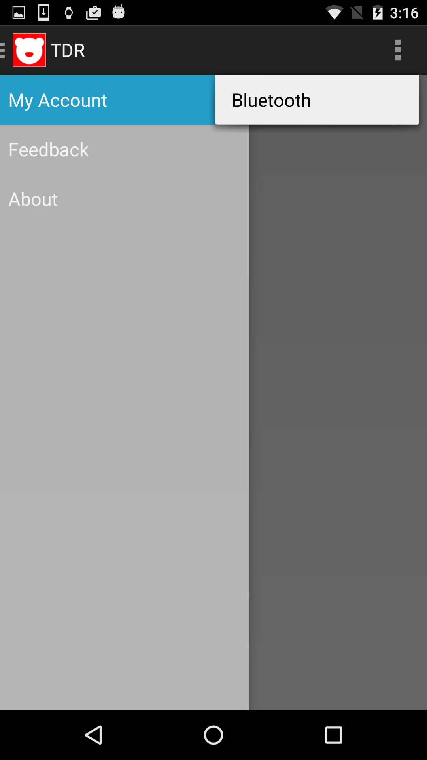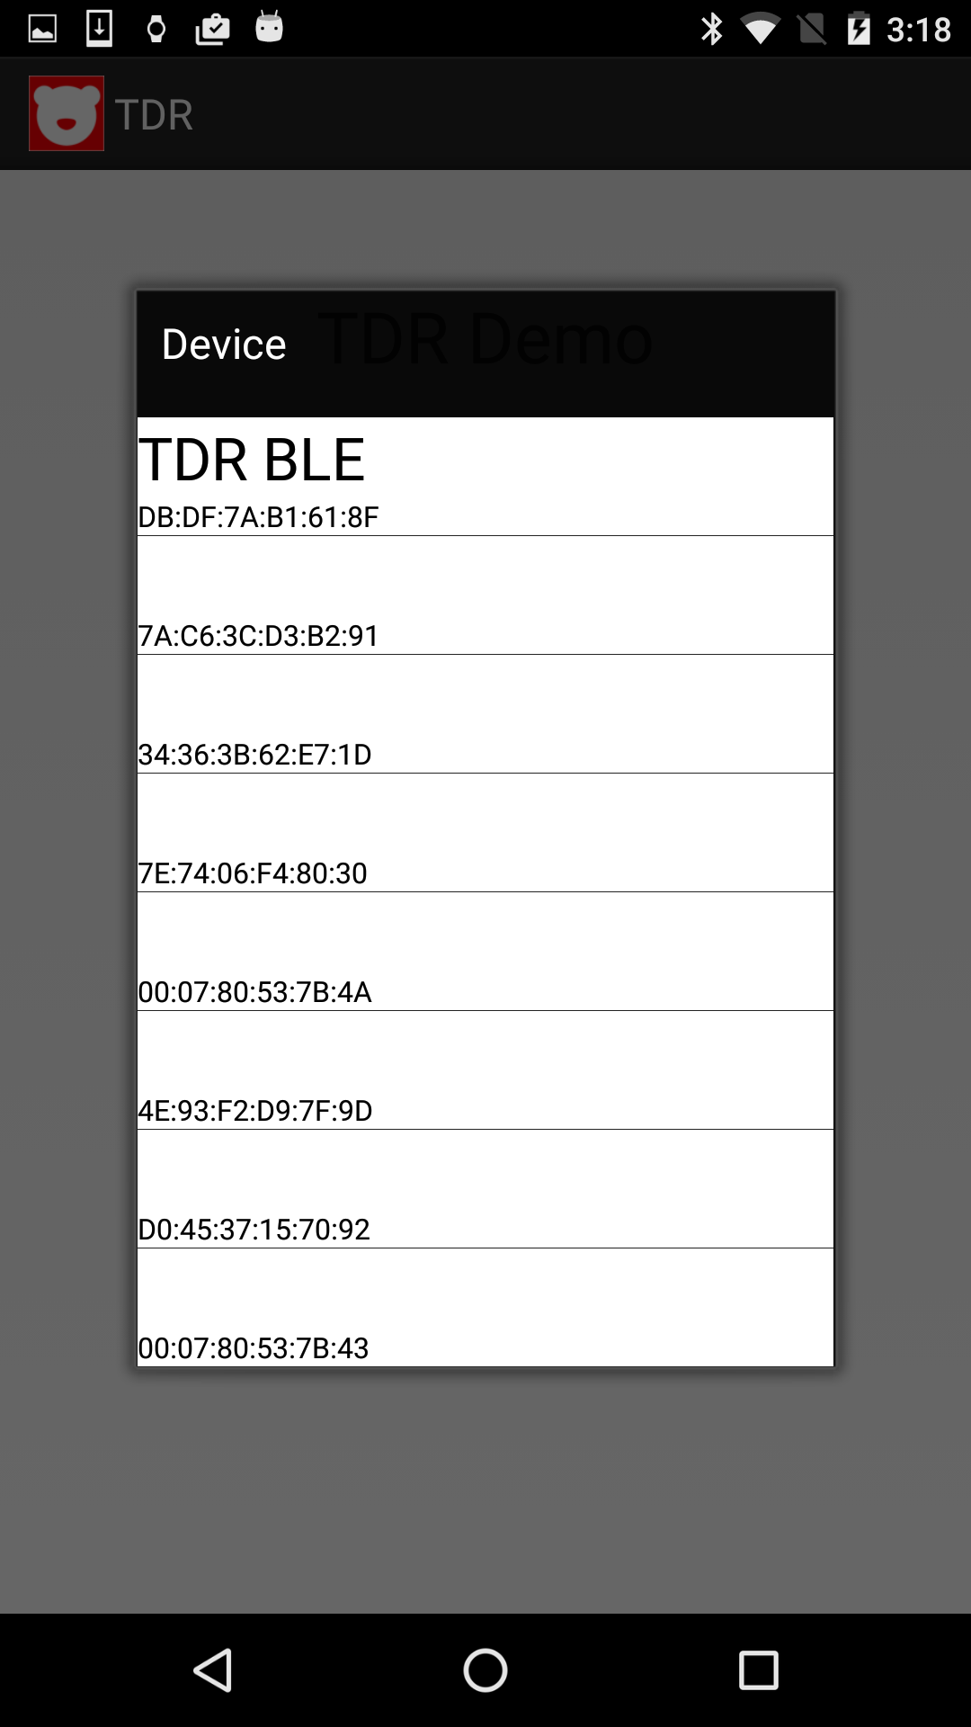

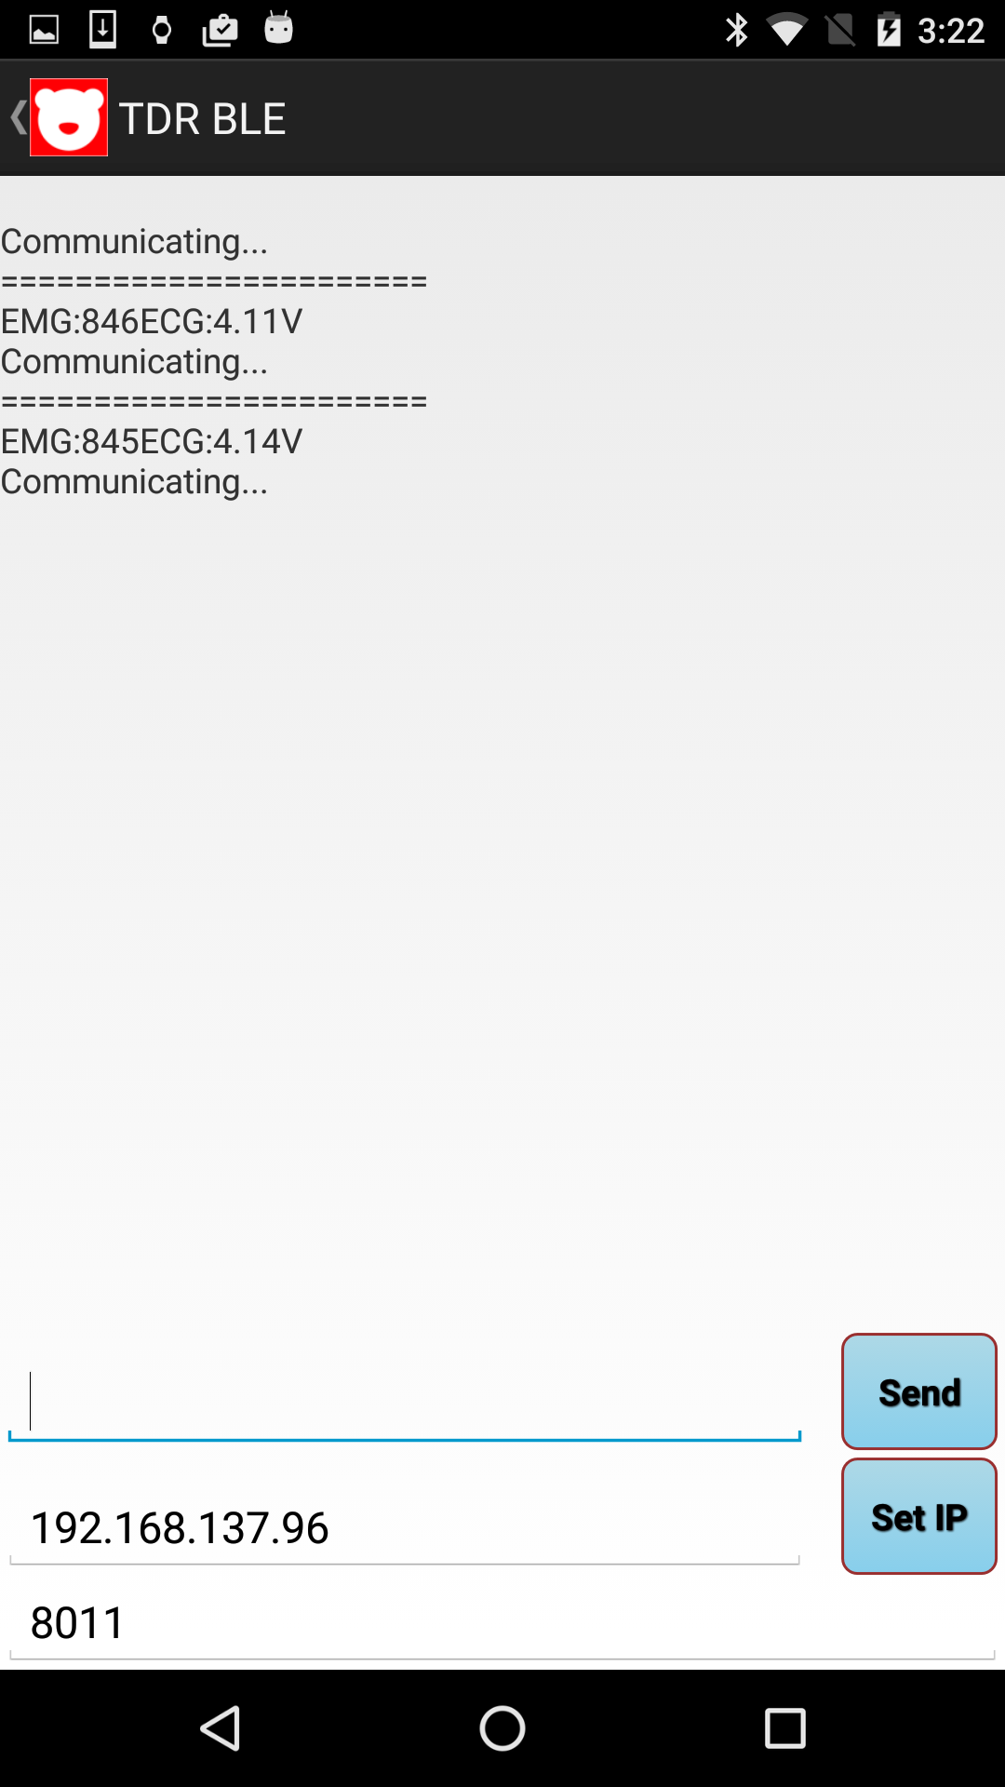

Implementation Detail of SIS PrjRemote Android Version
The application is designed as an Android version of the SIS RrjRemote. It enables users to test their SIS component definitions(either by XML component configuration files or enter by hand) or message definitions(either by XML component configuration files or enter by hand)when they don’t time to implement the component.
All the UIs are implement by using Android basic UI component Activity. The connection between the program and the SIS server is implemented by socket. The socket connection will be kept alive until either the program or the SIS server is down. Every socket connection runs in one unique thread. The application provides two options for users to test their component or message definitions, one option is that the user can define their components or messages in XML files and then load the configuration file into the application; the other option is that the user can enter the definition of their components or messages by hand.
After sending or receiving messages, the user can also view all the sent and received message.
Here are some screenshots of the application:

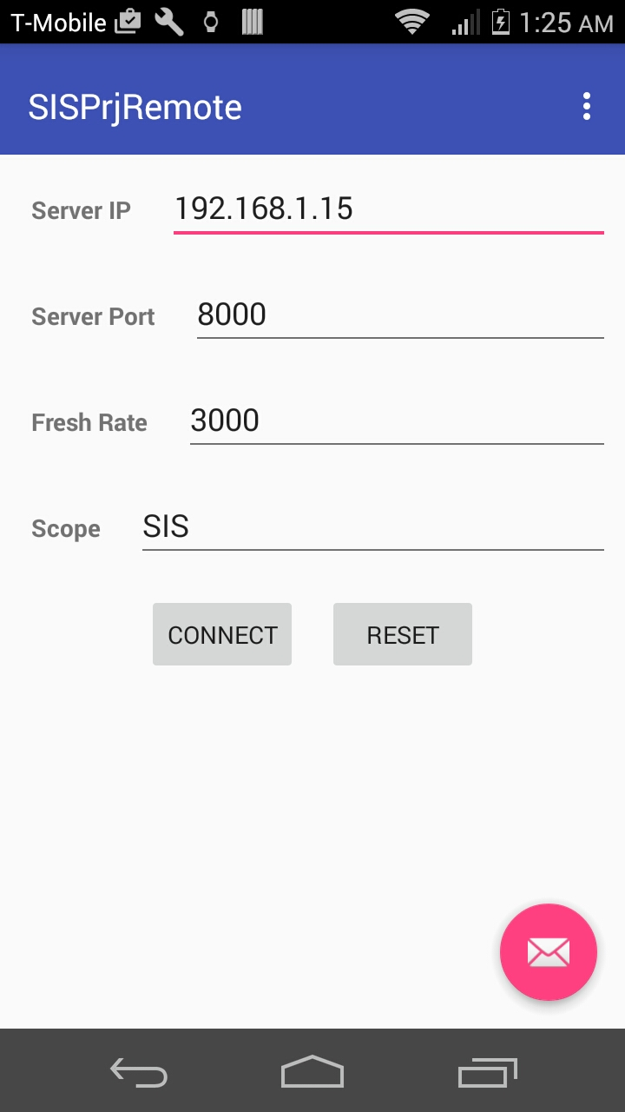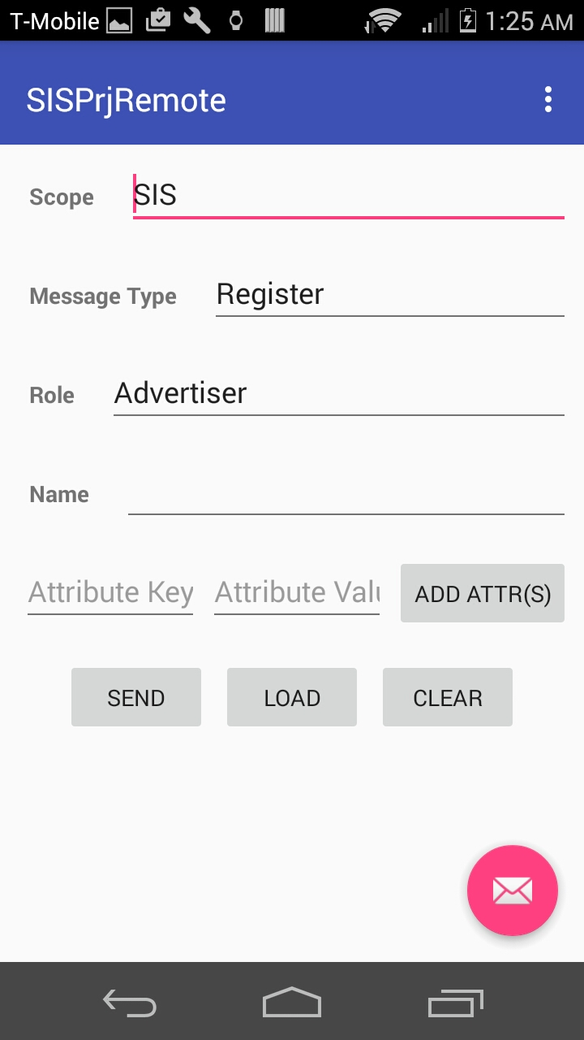
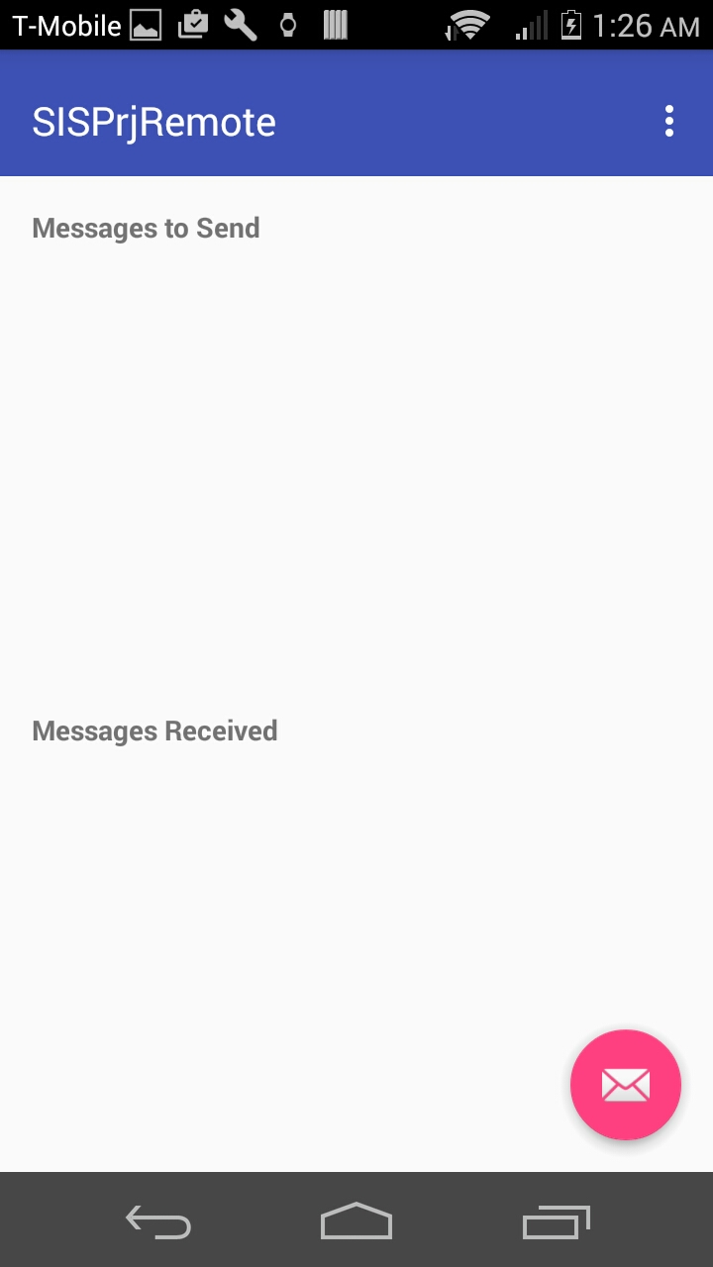

Implementation Detail of SIS Server Android Version

The application is designed as an Android version of the SIS Server. It receives all the messages that come from other SIS components. Every time it receives a connection request, it stores this socket connect into connection queue and keep it alive until the other side or itself is down. After receiving an message, then the massage will be parsed by the system protocols. If the incoming message is a component registration message then the server will save this component according to its component type. If the message is a reading message then the server will forward this message to other relative components that have been already registered. All the connected components will be displayed as a list socket items.
All the UIs are implement by using Android basic UI component Activity. The connection between the SIS component and the SIS server is implemented by socket. The socket connection will be kept alive until either the SIS component or the SIS server is down. Every socket connection runs in one unique thread. The application enables the user to view all the connected components.
Here are some screenshots of the application:

