December 8, 2016

Debarun das (PITT ID: DED59@pitt.edu)

Univeristy of pittsburgh

Department of Computer Science

CS 2310 Final project: ICMS Tranformation system

Project Report

**INDEX**

|  |  |
| --- | --- |
| Contents | Page No. |
| 1. Introduction | 2 |
| 2. Design | 3 |
| 3. Implementation | 3 |
| 4. Extra Deeds | 8 |
| 5. Conclusion & Future Work | 11 |
| 6. References | 11 |
| 7. Appendix | 11 |

**1. Introduction**

In this project, I have implemented an extension of the original ICMS system that was already there in *http://intranet.cs.pitt.edu/~chang/icms1/login.php*. I implemented the IC card Transformation feature. The IC card **transformation** allows a user to transform an organic activity to one or more inorganic activities. An **organic activity** is one that involves human interaction. An **inorganic activity** is one that does NOT involve human interaction [1]. In my implementation, the system prompts the user to enter the conditions under which the organic activity can be transformed to inorganic activities. For example, for the *organic activity* of *organizing a picnic*, the basic conditions are that *‘there should be no rain’* and *‘there should at least be more than 3 people’* (Figure 0). Also, after collecting some additional information, the user gets to see the recommended IC cards from the system. Based on the recommended IC cards, the user can go back and create his own IC cards. The following sections discuss about the Design (Section 2), Implementation (Section 3), Extra Deeds (Section 4), Conclusion and Future Work (Section 5), References (Section 6) and Appendix (Section 7).

NO RAIN

MORE THAN 3 PEOPLE NEEDED

ORGANIZING PICNIC

Figure 0. The organic activity of organizing a picnic is dependent on two conditions (“No Rain” and “More than 3 people needed”)

**2. Design**

The basic project design begins with the user logging in the system with a valid user ID and password. After logging in, the user has the option to add a new project and/or selecting a existing project. Then, the user gets an option to “Create a New IC Card”. On the “IC Card Adder” page, the user gets the options to “Transform/Decompose” an IC card. When the user chooses to *Transform* the IC Card, the user is taken to a page to fill in a User Questionnaire. After the user fills in the questionnaire, the user is asked some additional inferential questions. Based on the answers given by the user, recommended IC cards are shown to the user. The project Design is as shown in the diagram below (Figure 1).

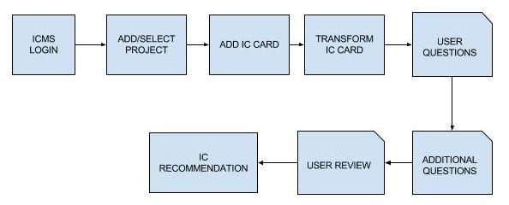

Figure 1. Detailed Design of the ICMS Transformation System

**3. Implementation**

I have used PHP to write most of the codes for the development of the ICMS transformation system. However, some portion of it does contain code in HTML, CSS and JavaScript. I installed PHP, an Apache server and a MySQL database using XAMPP v3.2.2. [2][3][4][5][6]

**STEPS:**

Initially the user logs in to the ICMS system using a valid user id and password (shown in Figure 2).

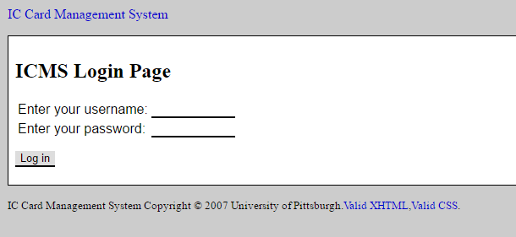

Figure 2. ICMS Login Page

Then, the user is given the option to add a new project or select an existing project (Figure 3).

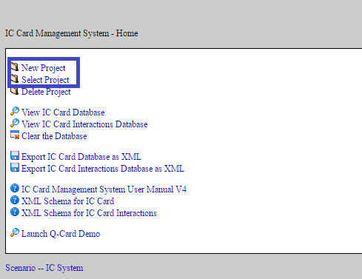

Figure 3. Page to Add/Select A New Project

After selecting a project, the user is given the option to create a new IC card (Figure 4).

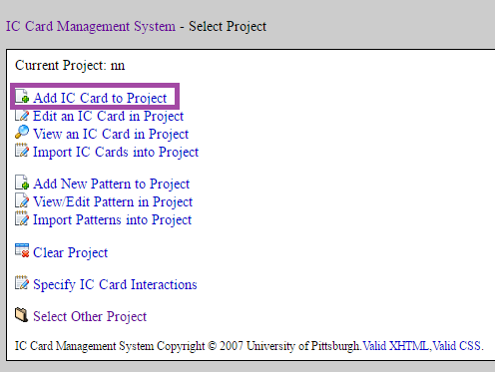

Figure 4. The page that gives the option to add a new IC card

Till this, all the implementations were already there in the ICMS system. Now, after selecting the option to add a new IC card, the user gets to choose a name for the IC card and the page shown in Figure 5 is displayed. In this page, I added the “Transform Card” button to transform to help the user transform an organic activity.

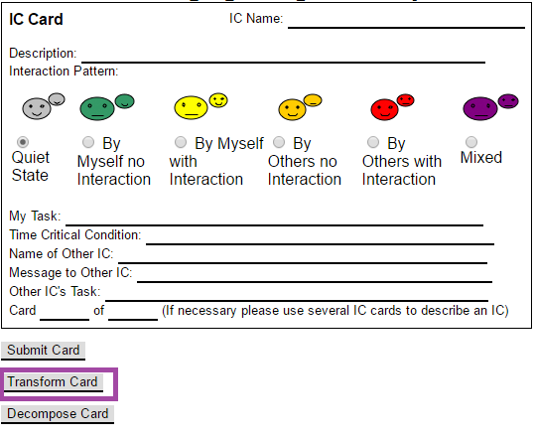

Figure 5. IC Card Adder page. The user selects “Transform Card” button for IC card transformation.

After clicking the “Transform Card” button, the user is taken to a new page where he/she has to fill in a User Questionnaire. This questionnaire collects information for providing recommendations to the user for transforming an organic activity into one or more inorganic activities. When the mouse is moved over the heading “User Questionnaire”, the suggestions for filling in the questions will be shown (shown in Green font in *Figure 6*). These suggestions are to be followed for best results.

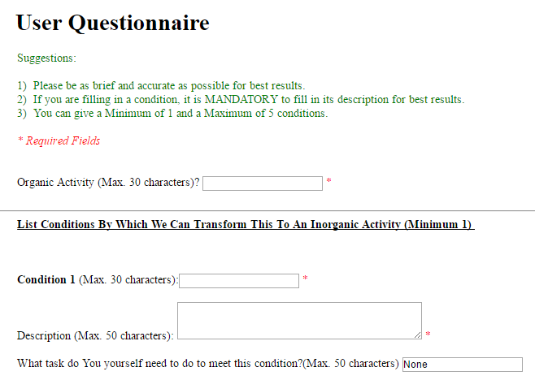

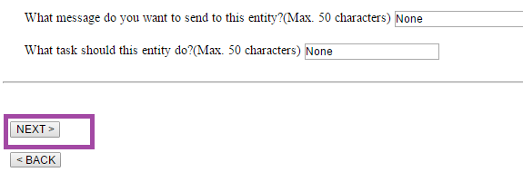

Figure 6. User Questionnaire Page

On Clicking the NEXT button in the user questionnaire page, it takes us to the next page where the user is asked additional questions. However, I will talk more about this in Section 4 (Extra Deeds). On clicking the NEXT button of the Additional questions page, the user is taken to the *User Details* page (as shown is Figure 7). The user can see all the information that he has entered and make any changes as per need by clicking the BACK button to go to the previous page. However, he can also choose to see the recommended IC cards by clicking the IC RECOMMENDATION button (as shown in Figure 7).

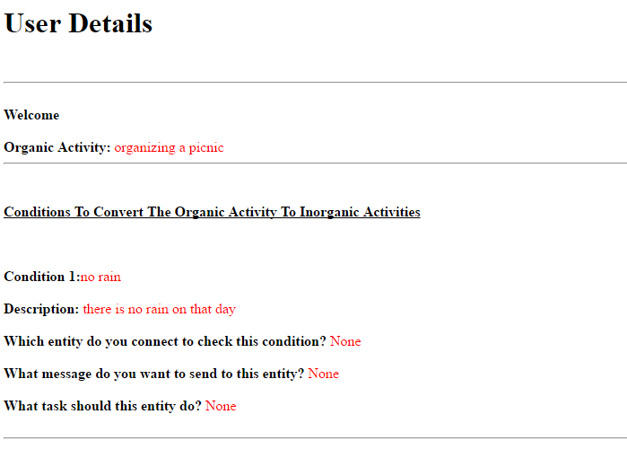



Figure 7. User Details page. Clicking the IC RECOMMENDATION page takes us to the next page, showing the recommended ICs.

Finally, the user gets to see the recommended ICs (as shown in Figure 8). On clicking the CREATE IC CARD button at the bottom (see Figure 8), the user is directed to the page to add a new IC card. On clicking the BACK button, the user is taken to the User Questionnaire page.

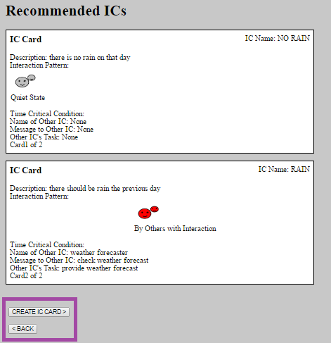

Figure 8. The page showing the recommended ICs to the user.

**4. ###Extra Deeds**

I have implemented the following extra deed.   
  
**4.1. ### Additional Questions Based On Keyword Matching**

This implementation of this included the following steps:

* Storing a list of keywords in a file named **“keywords_debarun.txt”.**
* Extracting the keywords in all the conditions that are being provided by the user. To determine if a word in the condition provided by the user is a keyword, I see if the word is present amongst the list of keywords in the file **“keywords_debarun.txt”.**
* The keywords of each condition is matched with every keyword of the other conditions given by the user.
* If there is a keyword match, then the user is asked the question if the two conditions are related or not. The user may choose to answer either “Y” or “N” (Figure 10).
* If the user chooses “Y”, then in the IC recommendation page, the user gets to see two related IC cards (Figure 11).

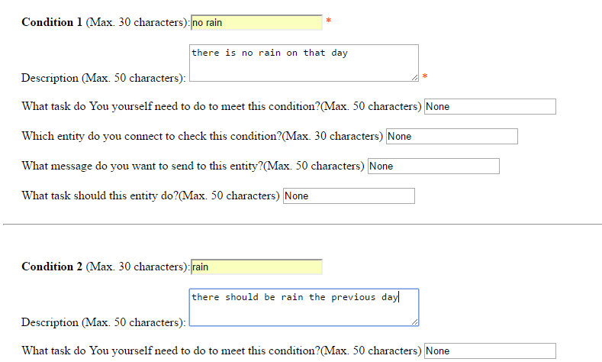

Figure 9. The user gives related conditions (“rain” and “no rain”).

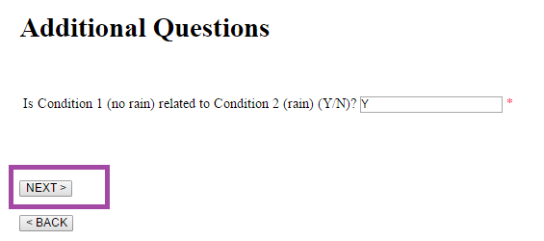

Figure 10. The user chooses ‘Y’ as the answer to whether Condition 1 and Condition 2 are related

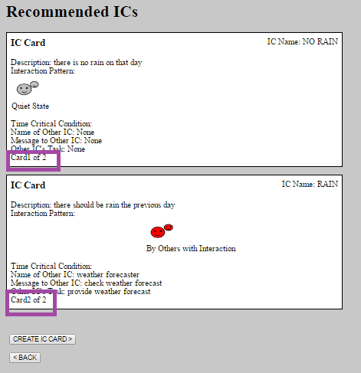

Figure 11. The two IC cards generated are related (‘Card 1 of 2’ and ‘Card 2 of 2’).

**5. Conclusion & Future Work**

This project was about extending the current ICMS system to include the feature for IC card transformation. The extra deed done by me makes deductions on whether two conditions (potential IC cards) are related or not based on keyword matching. However, this could be extended to include an **ontology based system**. In this way, the system will be able to make smarter inferences (like drawing relation between keywords “rain” and “weather”). Also, some implementations regarding deduction of patterns in a series of IC cards can be a possibility.

**6. References**

[1] <https://people.cs.pitt.edu/~chang/231/vl01/wwe0.htm>

[2] <http://www.w3schools.com/php/>

[3] <http://php.net/manual/>

[4] <http://www.html-form-guide.com/php-form/php-order-form.html>

[5] PHP files of the original ICMS system

[6] <http://php.net/manual/en/function.file-get-contents.php>

**7. APPENDIX**

**7.1. Code of *form2.php* (for User Questionnaire)**

<html>

<head>

<style>

.error {color: #FF0000;}

</style>

</head>

<body>

<h1 align = "center"> <a href = "https://people.cs.pitt.edu/~chang/231/vl01/wwe0.htm"> Welcome To ICMS Transformation System </a> </h1>

<br><br>

<div id="parent">

<h1>&nbsp&nbsp&nbspUser Questionnaire </h1>

<div id="popup" style="display: none">

<font color = GREEN>&nbsp &nbsp &nbsp

Suggestions:<br><br>

&nbsp &nbsp &nbsp 1)&nbsp Please be as brief and accurate as possible for best results.<br>

&nbsp &nbsp &nbsp 2)&nbsp If you are filling in a condition, it is MANDATORY to fill in its description for best results.<br>

&nbsp &nbsp &nbsp 3)&nbsp You can give a Minimum of 1 and a Maximum of 5 conditions.<br>

</font>

</div>

</div>

<br>

<script>

var e = document.getElementById('parent');

e.onmouseover = function() {

document.getElementById('popup').style.display = 'block';

}

e.onmouseout = function() {

document.getElementById('popup').style.display = 'none';

}

</script>

<!--<I>&nbsp&nbsp&nbsp <font color = RED> #Please be as brief and as accurate as possible for best results </font></I><br>-->

<I>&nbsp &nbsp &nbsp <font color = RED> * Required Fields </font></I>

<br><br><br>

<!--<p><span class="error">* required field.</span></p> -->

<?php

/*session_start();

$_SESSION['name'] = $_POST['name'];

$_SESSION['email_address'] = $_POST['email_address'];

*/

?>

<form method="post" action="addquestions.php">

&nbsp &nbsp &nbsp Organic Activity (Max. 30 characters)? <input type="text" name="organicActivity" required maxlength="30"> <font color = RED> * </font>

<br><br>

<hr>

<b>&nbsp &nbsp &nbsp <U>List Conditions By Which We Can Transform This To An Inorganic Activity (Minimum 1) </U></b><br><br><br><br>

&nbsp &nbsp &nbsp <b>Condition 1</b> (Max. 30 characters):<input type="text" name="Condition1" required maxlength="30"> <font color = RED> * </font><br><br>

&nbsp &nbsp &nbsp Description (Max. 50 characters): <textarea name="describe1" rows="3" cols="40" required maxlength="50"></textarea> <font color = RED> * </font> <br><br>

&nbsp &nbsp &nbsp What task do You yourself need to do to meet this condition?(Max. 50 characters) <input type="text" name="mytask1" maxlength="50" value = "None"><br><br>

&nbsp &nbsp &nbsp Which entity do you connect to check this condition?(Max. 30 characters) <input type="text" name="otherICname1" maxlength="30" value = "None"><br><br>

&nbsp &nbsp &nbsp What message do you want to send to this entity?(Max. 50 characters) <input type="text" name="otherICmsg1" maxlength="50" value = "None"><br><br>

&nbsp &nbsp &nbsp What task should this entity do?(Max. 50 characters) <input type="text" name="otherICtask1" maxlength="50" value = "None"><br><br>

<hr>

<br><br>

&nbsp &nbsp &nbsp <b>Condition 2</b> (Max. 30 characters):<input type="text" name="Condition2" maxlength="30"><br><br>

&nbsp &nbsp &nbsp Description (Max. 50 characters): <textarea name="describe2" rows="3" cols="40" maxlength="50"></textarea> <br><br>

&nbsp &nbsp &nbsp What task do You yourself need to do to meet this condition?(Max. 50 characters) <input type="text" name="mytask2" maxlength="50" value = "None"><br><br>

&nbsp &nbsp &nbsp Which entity do you connect to check this condition?(Max. 30 characters) <input type="text" name="otherICname2" maxlength="30" value = "None"><br><br>

&nbsp &nbsp &nbsp What message do you want to send to this entity? (Max. 50 characters) <input type="text" name="otherICmsg2" maxlength="50" value = "None"><br><br>

&nbsp &nbsp &nbsp What task should this entity do? (Max. 50 characters)<input type="text" name="otherICtask2" maxlength="50" value = "None"><br><br>

<hr>

<br><br>

&nbsp &nbsp &nbsp <b>Condition 3</b> (Max. 30 characters):<input type="text" name="Condition3" maxlength="30"><br><br>

&nbsp &nbsp &nbsp Description (Max. 50 characters): <textarea name="describe3" rows="3" cols="40" maxlength="50"></textarea> <br><br>

&nbsp &nbsp &nbsp What task do You yourself need to do to meet this condition?(Max 50 characters) <input type="text" name="mytask3" maxlength="50" value = "None"><br><br>

&nbsp &nbsp &nbsp Which entity do you connect to check this condition?(Max. 30 characters) <input type="text" name="otherICname3" maxlength="30" value = "None"><br><br>

&nbsp &nbsp &nbsp What message do you want to send to this entity?(Max. 50 characters) <input type="text" name="otherICmsg3" maxlength = "50" value = "None"><br><br>

&nbsp &nbsp &nbsp What task should this entity do?(Max. 50 characters) <input type="text" name="otherICtask3" maxlength = "50" value = "None"><br><br>

<hr>

<br><br>

&nbsp &nbsp &nbsp <b>Condition 4</b> (Max. 30 characters):<input type="text" name="Condition4" maxlength="30"><br><br>

&nbsp &nbsp &nbsp Description (Max. 50 characters): <textarea name="describe4" rows="3" cols="40" maxlength = "50"></textarea> <br><br>

&nbsp &nbsp &nbsp What task do You yourself need to do to meet this condition?(Max. 50 characters) <input type="text" name="mytask4" maxlength = "50" value = "None"><br><br>

&nbsp &nbsp &nbsp Which entity do you connect to check this condition?(Max. 30 characters) <input type="text" name="otherICname4" maxlength = "30" value = "None"><br><br>

&nbsp &nbsp &nbsp What message do you want to send to this entity?(Max. 50 characters) <input type="text" name="otherICmsg4" maxlength = "50" value = "None"><br><br>

&nbsp &nbsp &nbsp What task should this entity do?(Max. 50 characters) <input type="text" name="otherICtask4" maxlength = "50" value = "None"><br><br>

<hr>

<br><br>

&nbsp &nbsp &nbsp <b>Condition 5</b> (Max. 30 characters):<input type="text" name="Condition5" maxlength = "30"><br><br>

&nbsp &nbsp &nbsp Description (Max. 50 characters): <textarea name="describe5" rows="3" cols="40" maxlength = "50"></textarea> <br><br>

&nbsp &nbsp &nbsp What task do You yourself need to do to meet this condition?(Max. 50 characters) <input type="text" name="mytask5" maxlength = "50" value = "None"><br><br>

&nbsp &nbsp &nbsp Which entity do you connect to check this condition?(Max. 30 characters) <input type="text" name="otherICname5" maxlength = "30" value = "None"><br><br>

&nbsp &nbsp &nbsp What message do you want to send to this entity?(Max. 50 characters) <input type="text" name="otherICmsg5" maxlength = "50" value = "None"><br><br>

&nbsp &nbsp &nbsp What task should this entity do?(Max. 50 characters) <input type="text" name="otherICtask5" maxlength = "50" value = "None"><br><br>

<hr>

<br><br>

&nbsp&nbsp<input type="submit" name = "submit" value="NEXT >">

</form>

<form method="post" action="addcard.php">

&nbsp&nbsp<input type="submit" value="< BACK">

</form>

</body>

</html>

**7.2. Code of *addquestions.php* (for User Questionnaire)**

<!DOCTYPE html>

<html>

<head>

<style>

.error {color: #FF0000;}

</style>

</head>

<body>

<h1>&nbsp&nbsp&nbspAdditional Questions </h1>

<?php

// <= PHP 5

//$myfile = fopen("webdictionary.txt", "r")

$file = file_get_contents('./keywords_debarun.txt', true);

$pieces = explode(",", $file);

//echo "\n";

$size = count($pieces);

//echo $size;

for ($i = 0; $i < count($pieces); $i++)

{

//echo $pieces[$i], PHP_EOL;

}

session_start();

$_SESSION["IC1_cardSrc"] = '1';

$_SESSION["IC1_cardDest"] = '1';

$_SESSION["IC2_cardSrc"] = '1';

$_SESSION["IC2_cardDest"] = '1';

$_SESSION["IC3_cardSrc"] = '1';

$_SESSION["IC3_cardDest"] = '1';

$_SESSION["IC4_cardSrc"] = '1';

$_SESSION["IC4_cardDest"] = '1';

$_SESSION["IC5_cardSrc"] = '1';

$_SESSION["IC5_cardDest"] = '1';

$_SESSION["organicActivity"] = $_POST["organicActivity"];

$_SESSION["Condition1"] = $_POST["Condition1"];

$_SESSION["describe1"] = $_POST["describe1"];

$_SESSION["mytask1"] = $_POST["mytask1"];

$_SESSION["otherICname1"] = $_POST["otherICname1"];

$_SESSION["otherICtask1"] = $_POST["otherICtask1"];

$_SESSION["otherICmsg1"] = $_POST["otherICmsg1"];

$_SESSION["Condition2"] = $_POST["Condition2"];

$_SESSION["describe2"] = $_POST["describe2"];

$_SESSION["mytask2"] = $_POST["mytask2"];

$_SESSION["otherICname2"] = $_POST["otherICname2"];

$_SESSION["otherICtask2"] = $_POST["otherICtask2"];

$_SESSION["otherICmsg2"] = $_POST["otherICmsg2"];

$_SESSION["Condition3"] = $_POST["Condition3"];

$_SESSION["describe3"] = $_POST["describe3"];

$_SESSION["mytask3"] = $_POST["mytask3"];

$_SESSION["otherICname3"] = $_POST["otherICname3"];

$_SESSION["otherICtask3"] = $_POST["otherICtask3"];

$_SESSION["otherICmsg3"] = $_POST["otherICmsg3"];

$_SESSION["Condition4"] = $_POST["Condition4"];

$_SESSION["describe4"] = $_POST["describe4"];

$_SESSION["mytask4"] = $_POST["mytask4"];

$_SESSION["otherICname4"] = $_POST["otherICname4"];

$_SESSION["otherICtask4"] = $_POST["otherICtask4"];

$_SESSION["otherICmsg4"] = $_POST["otherICmsg4"];

$_SESSION["Condition5"] = $_POST["Condition5"];

$_SESSION["describe5"] = $_POST["describe5"];

$_SESSION["mytask5"] = $_POST["mytask5"];

$_SESSION["otherICname5"] = $_POST["otherICname5"];

$_SESSION["otherICtask5"] = $_POST["otherICtask5"];

$_SESSION["otherICmsg5"] = $_POST["otherICmsg5"];

// ==================================== Dealing With Condition 1 =================================

$Condition1 = $_POST["Condition1"];

//$Condition1 = "No rain on friend";

$Condition1_keys = array();

$split_Cond1 = explode(" ", $Condition1);

//Collect all the keywords

for ($i = 0; $i < count($split_Cond1); $i++)

{

if (in_array(strtolower($split_Cond1[$i]),$pieces))

{

//echo "Present";

//echo $split_Cond1[$i];

array_push ($Condition1_keys, strtolower($split_Cond1[$i]));

}

}

//print_r($Condition1_keys);

// ==================================== Dealing With Condition 2 =================================

$Condition2 = $_POST["Condition2"] ;

$Condition2_keys = array();

$split_Cond2 = explode(" ", $Condition2);

//Collect all the keywords

for ($i = 0; $i < count($split_Cond2); $i++)

{

if (in_array(strtolower($split_Cond2[$i]),$pieces))

{

//echo "Present";

//echo $split_Cond2[$i];

array_push ($Condition2_keys, strtolower($split_Cond2[$i]));

}

}

// ==================================== Dealing With Condition 3 =================================

$Condition3 = $_POST["Condition3"] ;

$Condition3_keys = array();

$split_Cond3 = explode(" ", $Condition3);

//Collect all the keywords

for ($i = 0; $i < count($split_Cond3); $i++)

{

if (in_array(strtolower($split_Cond3[$i]),$pieces))

{

//echo "Present";

//echo $split_Cond3[$i];

array_push ($Condition3_keys, strtolower($split_Cond3[$i]));

}

}

// ==================================== Dealing With Condition 4 =================================

$Condition4 = $_POST["Condition4"] ;

$Condition4_keys = array();

$split_Cond4 = explode(" ", $Condition4);

//Collect all the keywords

for ($i = 0; $i < count($split_Cond4); $i++)

{

if (in_array(strtolower($split_Cond4[$i]),$pieces))

{

//echo "Present";

//echo $split_Cond4[$i];

array_push ($Condition4_keys, strtolower($split_Cond4[$i]));

}

}

// ==================================== Dealing With Condition 5 =================================

$Condition5 = $_POST["Condition5"] ;

$Condition5_keys = array();

$split_Cond5 = explode(" ", $Condition5);

//Collect all the keywords

for ($i = 0; $i < count($split_Cond5); $i++)

{

if (in_array(strtolower($split_Cond5[$i]),$pieces))

{

//echo "Present";

//echo $split_Cond5[$i];

array_push ($Condition5_keys, strtolower($split_Cond5[$i]));

}

}

// ==================================== Keyword Matching between Condition1 and all other conditions

$combo_list = array();

$flag1 = 0;

$cardString = '<form method="post" action="form3.php"> ';

for ($i = 0; $i < count($Condition1_keys); $i++)

{

## 1 with 2

if ((in_array(strtolower($Condition1_keys[$i]),$Condition2_keys))&& $Condition1_keys[$i] != "")

{

$flag1 = 1;

array_push ($combo_list, 1, 2);

//echo "Matched key ",$Condition1_keys[$i], "Size:",count($Condition1_keys[$i]);

//$_SESSION["IC1_cardSrc"] = '1';

/*$_SESSION["IC1_cardDest"] = '2';

$_SESSION["IC2_cardSrc"] = '2';

$_SESSION["IC2_cardDest"] = '2';*/

$cardString.= '<br><br> &nbsp &nbsp &nbsp Is Condition 1 ('.$_POST["Condition1"].') related to Condition 2 ('.$_POST["Condition2"].') (Y/N)? <input type="text" name="Answer12" required maxlength="30"><font color = RED> * </font><br><br>';

//echo $_POST["Answer1"];

}

}

if ($flag1 == 0)

{

for ($i = 0; $i < count($Condition1_keys); $i++)

{

## 1 with 3

if ((in_array(strtolower($Condition1_keys[$i]),$Condition3_keys))&& $Condition1_keys[$i] != "")

{

$flag1 = 1;

array_push ($combo_list, 1, 3);

//$_SESSION["IC1_cardSrc"] = '1';

/*

$_SESSION["IC1_cardDest"] = '2';

$_SESSION["IC3_cardSrc"] = '2';

$_SESSION["IC3_cardDest"] = '2';

*/

$cardString.= '<br><br> &nbsp &nbsp &nbsp Is Condition 1 ('.$_POST["Condition1"].') related to Condition 3 ('.$_POST["Condition3"].') (Y/N)? <input type="text" name="Answer13" required maxlength="30"><font color = RED> * </font><br><br>';

}

}

}

if ($flag1 == 0)

{

for ($i = 0; $i < count($Condition1_keys); $i++)

{

## 1 with 4

if ((in_array(strtolower($Condition1_keys[$i]),$Condition4_keys))&& $Condition1_keys[$i] != "")

{

$flag1 = 1;

array_push ($combo_list, 1, 4);

//$_SESSION["IC1_cardSrc"] = '1';

/*

$_SESSION["IC1_cardDest"] = '2';

$_SESSION["IC4_cardSrc"] = '2';

$_SESSION["IC4_cardDest"] = '2';

*/

$cardString.= '<br><br> &nbsp &nbsp &nbsp Is Condition 1 ('.$_POST["Condition1"].') related to Condition 4 ('.$_POST["Condition4"].') (Y/N)? <input type="text" name="Answer14" required maxlength="30"><font color = RED> * </font><br><br>';

}

}

}

if ($flag1 == 0)

{

for ($i = 0; $i < count($Condition1_keys); $i++)

{

## 1 with 5

if ((in_array(strtolower($Condition1_keys[$i]),$Condition5_keys))&& $Condition1_keys[$i] != "")

{

$flag1 = 1;

array_push ($combo_list, 1, 5);

//$_SESSION["IC1_cardSrc"] = '1';

/*

$_SESSION["IC1_cardDest"] = '2';

$_SESSION["IC5_cardSrc"] = '2';

$_SESSION["IC5_cardDest"] = '2';

*/

$cardString.= '<br><br> &nbsp &nbsp &nbsp Is Condition 1 ('.$_POST["Condition1"].') related to Condition 5 ('.$_POST["Condition5"].') (Y/N)? <input type="text" name="Answer15" required maxlength="30"><font color = RED> * </font><br><br>';

}

}

}

// ==================================== Keyword Matching between Condition2 and all other conditions

if(! in_array(2, $combo_list))

{

if(! in_array(3, $combo_list))

{

for ($i = 0; $i < count($Condition2_keys); $i++)

{

//4

// 1 with 5

if ((in_array(strtolower($Condition2_keys[$i]),$Condition3_keys))&& $Condition2_keys[$i] != "")

{

//$flag1 = 1;

array_push ($combo_list, 2, 3);

//$_SESSION["IC1_cardSrc"] = '1';

/*$_SESSION["IC2_cardDest"] = '2';

$_SESSION["IC3_cardSrc"] = '2';

$_SESSION["IC3_cardDest"] = '2';

*/

$cardString.= '<br><br> &nbsp &nbsp &nbsp Is Condition 2 ('.$_POST["Condition2"].') related to Condition 3 ('.$_POST["Condition3"].') (Y/N)? <input type="text" name="Answer23" required maxlength="30"><font color = RED> * </font><br><br>';

}

}

}

}

if(! in_array(2, $combo_list))

{

if(! in_array(4, $combo_list))

{

for ($i = 0; $i < count($Condition2_keys); $i++)

{

//4

// 1 with 5

if ((in_array(strtolower($Condition2_keys[$i]),$Condition4_keys)) && $Condition2_keys[$i] != "")

{

//$flag1 = 1;

array_push ($combo_list, 2, 4);

$cardString.= '<br><br> &nbsp &nbsp &nbsp Is Condition 2 ('.$_POST["Condition2"].') related to Condition 4 ('.$_POST["Condition4"].') (Y/N)? <input type="text" name="Answer24" required maxlength="30"><font color = RED> * </font><br><br>';

}

}

}

}

if(! in_array(2, $combo_list))

{

if(! in_array(5, $combo_list))

{

for ($i = 0; $i < count($Condition2_keys); $i++)

{

//4

// 1 with 5

if ((in_array(strtolower($Condition2_keys[$i]),$Condition5_keys))&& $Condition2_keys[$i] != "")

{

//$flag1 = 1;

array_push ($combo_list, 2, 5);

$cardString.= '<br><br> &nbsp &nbsp &nbsp Is Condition 2 ('.$_POST["Condition2"].') related to Condition 5 ('.$_POST["Condition5"].') (Y/N)? <input type="text" name="Answer25" required maxlength="30"><font color = RED> * </font><br><br>';

}

}

}

}

// ==================================== Keyword Matching between Condition3 and all other conditions

if(! in_array(3, $combo_list))

{

if(! in_array(4, $combo_list))

{

for ($i = 0; $i < count($Condition3_keys); $i++)

{

//4

// 1 with 5

//echo "Matched key ",$Condition3_keys[$i], "Size:",count($Condition3_keys[$i]);

if ((in_array(strtolower($Condition3_keys[$i]),$Condition4_keys) ) && $Condition3_keys[$i] != "")

{

//$flag1 = 1;

array_push ($combo_list, 3, 4);

$cardString.= '<br><br> &nbsp &nbsp &nbsp Is Condition 3 ('.$_POST["Condition3"].') related to Condition 4 ('.$_POST["Condition4"].') (Y/N)? <input type="text" name="Answer34" required maxlength="30"><font color = RED> * </font><br><br>';

}

}

}

}

if(! in_array(3, $combo_list))

{

if(! in_array(5, $combo_list))

{

for ($i = 0; $i < count($Condition3_keys); $i++)

{

//4

// 1 with 5

if ((in_array(strtolower($Condition3_keys[$i]),$Condition5_keys))&& $Condition3_keys[$i] != "")

{

//$flag1 = 1;

array_push ($combo_list, 3, 5);

$cardString.= '<br><br> &nbsp &nbsp &nbsp Is Condition 3 ('.$_POST["Condition3"].') related to Condition 5 ('.$_POST["Condition5"].') (Y/N)? <input type="text" name="Answer35" required maxlength="30"><font color = RED> * </font><br><br>';

}

}

}

}

// ==================================== Keyword Matching between Condition4 and Condition5

if(! in_array(4, $combo_list))

{

if(! in_array(5, $combo_list))

{

for ($i = 0; $i < count($Condition4_keys); $i++)

{

//4

// 1 with 5

if ((in_array(strtolower($Condition4_keys[$i]),$Condition5_keys)) && $Condition4_keys[$i] != "")

{

//$flag1 = 1;

array_push ($combo_list, 4, 5);

$cardString.= '<br><br> &nbsp &nbsp &nbsp Is Condition 4 ('.$_POST["Condition4"].') related to Condition 5 ('.$_POST["Condition5"].') (Y/N)? <input type="text" name="Answer45" required maxlength="30"><font color = RED> * </font><br><br>';

}

}

}

}

$cardString.= '<br><br><br>&nbsp &nbsp &nbsp<input type="submit" name = "submit" value="NEXT >"></form>';

$cardString.= '<br><form method="post" action="form2.php">

&nbsp &nbsp &nbsp<input type="submit" value="< BACK">

</form>';

echo $cardString;

// > PHP 5

//$file = file_get_contents('./.txt', FILE_USE_INCLUDE_PATH);

//echo $file

?>

</body>

</html>

**7.3. Code of form3.php (User Details)**

<html>

<body>

<?php

session_start();

$_SESSION["Answer12"] = '';

$_SESSION["Answer13"] = '';

$_SESSION["Answer14"] = '';

$_SESSION["Answer15"] = '';

$_SESSION["Answer23"] = '';

$_SESSION["Answer24"] = '';

$_SESSION["Answer25"] = '';

$_SESSION["Answer34"] = '';

$_SESSION["Answer35"] = '';

$_SESSION["Answer45"] = '';

//echo "Answer 1,2", $_POST["Answer12"];

//echo "Combo Array: ", $combo_list;

if( isset($_POST["Answer12"]) )

{

$_SESSION["Answer12"] = $_POST["Answer12"];

}

if( isset($_POST["Answer13"]) )

{

$_SESSION["Answer13"] = $_POST["Answer13"];

}

if( isset($_POST["Answer14"]) )

{

$_SESSION["Answer14"] = $_POST["Answer14"];

}

if( isset($_POST["Answer15"]) )

{

$_SESSION["Answer15"] = $_POST["Answer15"];

}

if( isset($_POST["Answer23"]) )

{

$_SESSION["Answer23"] = $_POST["Answer23"];

}

if( isset($_POST["Answer24"]) )

{

$_SESSION["Answer24"] = $_POST["Answer24"];

}

if( isset($_POST["Answer25"]) )

{

$_SESSION["Answer25"] = $_POST["Answer25"];

}

if( isset($_POST["Answer34"]) )

{

$_SESSION["Answer34"] = $_POST["Answer34"];

}

if( isset($_POST["Answer35"]) )

{

$_SESSION["Answer35"] = $_POST["Answer35"];

}

if( isset($_POST["Answer45"]) )

{

$_SESSION["Answer45"] = $_POST["Answer45"];

}

?>

<h1>User Details </h1>

<br><hr><br>

<b>Welcome</b> <?php //session_start(); //echo $_SESSION['name']; ?><br><br>

<!--<b>Your email address is:</b> <?php //echo $_SESSION['email_address']; ?><br><hr><br><br><br> -->

<b>Organic Activity:</b> <font color = RED><?php echo $_SESSION["organicActivity"]; ?></font><br><hr><br><br>

<b><U>Conditions To Convert The Organic Activity To Inorganic Activities</U></b> <br><br><br><br>

<b>Condition 1:</b><font color = RED><?php echo $_SESSION["Condition1"]; ?> </font><br><br>

<b>Description: </b><font color = RED><?php echo $_SESSION["describe1"]; ?> </font><br><br>

<b>Which entity do you connect to check this condition?</b> <font color = RED> <?php echo $_SESSION["otherICname1"]; ?> </font> <br><br>

<b>What message do you want to send to this entity?</b>

<font color = RED>

<?php if (!empty($_SESSION["otherICname1"]))

{

echo $_SESSION["otherICmsg1"];

}

else

echo "NA"

?></font><br><br>

<b>What task should this entity do?</b>

<font color = RED>

<?php if (!empty($_SESSION["otherICname1"]))

{

echo $_SESSION["otherICtask1"];

}

else

echo "NA"

?>

</font>

<br><br>

<hr>

<br><br>

<b>Condition 2: </b><font color = RED> <?php echo $_SESSION["Condition2"]; ?> </font><br><br>

<b>Description: </b><font color = RED><?php echo $_SESSION["describe2"]; ?> </font><br><br>

<b>Which entity do you connect to check this condition? </b> <font color = RED> <?php echo $_SESSION["otherICname2"]; ?> </font> <br><br>

<b>What message do you want to send to this entity?</b>

<font color = RED>

<?php if (!empty($_SESSION["otherICname2"]))

{

echo $_SESSION["otherICmsg2"];

}

else

echo "NA"

?></font><br><br>

<b>What task should this entity do?</b>

<font color = RED>

<?php if (!empty($_SESSION["otherICname2"]))

{

echo $_SESSION["otherICtask2"];

}

else

echo "NA"

?> </font><br><br>

<hr>

<br><br>

<b>Condition 3:</b> <font color = RED><?php echo $_SESSION["Condition3"]; ?> </font> <br><br>

<b>Description:</b> <font color = RED><?php echo $_SESSION["describe3"]; ?> </font> <br><br>

<b>Which entity do you connect to check this condition? </b><font color = RED><?php echo $_SESSION["otherICname3"]; ?></font><br><br>

<b>What message do you want to send to this entity?</b>

<font color = RED>

<?php if (!empty($_SESSION["otherICname3"]))

{

echo $_SESSION["otherICmsg3"];

}

else

echo "NA"

?></font><br><br>

<b>What task should this entity do?</b>

<font color = RED>

<?php if (!empty($_SESSION["otherICname3"]))

{

echo $_SESSION["otherICtask3"];

}

else

echo "NA"

?> </font><br><br>

<hr>

<br><br>

<b>Condition 4:</b><font color = RED> <?php echo $_SESSION["Condition4"]; ?> </font><br><br>

<b>Description:</b> <font color = RED> <?php echo $_SESSION["describe4"]; ?> </font><br><br>

<b>Which entity do you connect to check this condition?</b> <font color = RED> <?php echo $_SESSION["otherICname4"]; ?> </font><br><br>

<b>What message do you want to send to this entity?</b>

<font color = RED>

<?php if (!empty($_SESSION["otherICname4"]))

{

echo $_SESSION["otherICmsg4"];

}

else

echo "NA"

?></font><br><br>

<b>What task should this entity do?</b>

<font color = RED>

<?php if (!empty($_SESSION["otherICname4"]))

{

echo $_SESSION["otherICtask4"];

}

else

echo "NA"

?></font><br><br>

<hr>

<br><br>

<b>Condition 5:</b> <font color = RED> <?php echo $_SESSION["Condition5"]; ?> </font><br><br>

<b>Description:</b> <font color = RED> <?php echo $_SESSION["describe5"]; ?> </font><br><br>

<b>Which entity do you connect to check this condition?</b> <font color = RED> <?php echo $_SESSION["otherICname5"]; ?> </font><br><br>

<b>What message do you want to send to this entity?</b>

<font color = RED>

<?php if (!empty($_SESSION["otherICname5"]))

{

echo $_SESSION["otherICmsg5"];

}

else

echo "NA"

?></font><br><br>

<b>What task should this entity do?</b>

<font color = RED>

<?php if (!empty($_SESSION["otherICname5"]))

{

echo $_SESSION["otherICtask5"];

}

else

echo "NA"

?></font><br><br>

<hr>

<br><br>

<br><br>

<form method="post" action="recommend.php">

&nbsp&nbsp<input type="submit" value="IC RECOMMENDATION >">

</form>

<form method="post" action="form2.php">

&nbsp&nbsp<input type="submit" value="< BACK">

</form>

</body>

</html>

**7.4. Code of *recommend.php* (for displaying IC card recommendations)**

<?php

include_once('utils.inc');

include_once('db.inc');

?>

<!DOCTYPE html

PUBLIC "-//W3C//DTD XHTML 1.0 Transitional//EN"

"http://www.w3.org/TR/xhtml1/DTD/xhtml1-transitional.dtd">

<html xmlns="http://www.w3.org/1999/xhtml" xml:lang="en" lang="en">

<head>

<link rel="stylesheet" type="text/css" media="screen" href="icms.css" />

<style>

body{

background-color: rgb(200,200,200);

}

</style>

</head>

<body>

<h1> Recommended ICs</h1>

<?php

session_start();

//echo $_SESSION["Condition1"];

$st = 'Answer 1,3'. $_SESSION['Answer13'] ;

//echo $st;

$combo_list = array();

if( isset($_SESSION["Answer12"]) )

{

if ($_SESSION["Answer12"] == 'Y' || $_SESSION["Answer12"] == 'y' || $_SESSION["Answer12"] == 'Yes' || $_SESSION["Answer12"] == 'yes')

{

array_push ($combo_list, 1, 2);

$_SESSION["IC1_cardDest"] = '2';

$_SESSION["IC2_cardSrc"] = '2';

$_SESSION["IC2_cardDest"] = '2';

//echo "I am here 12";

}

}

if( isset($_SESSION["Answer13"]) )

{

if ($_SESSION["Answer13"] == 'Y' || $_SESSION["Answer13"] == 'y' || $_SESSION["Answer13"] == 'Yes' || $_SESSION["Answer13"] == 'yes')

{

array_push ($combo_list, 1, 3);

$_SESSION["IC1_cardDest"] = '2';

$_SESSION["IC3_cardSrc"] = '2';

$_SESSION["IC3_cardDest"] = '2';

//echo "I am here 13";

}

}

if( isset($_SESSION["Answer14"]) )

{

if ($_SESSION["Answer14"] == 'Y' || $_SESSION["Answer14"] == 'y' || $_SESSION["Answer14"] == 'Yes' || $_SESSION["Answer14"] == 'yes')

{

array_push ($combo_list, 1, 4);

$_SESSION["IC1_cardDest"] = '2';

$_SESSION["IC4_cardSrc"] = '2';

$_SESSION["IC4_cardDest"] = '2';

//echo "I am here 14";

}

}

if( isset($_SESSION["Answer15"]) )

{

if ($_SESSION["Answer15"] == 'Y' || $_SESSION["Answer15"] == 'y' || $_SESSION["Answer15"] == 'Yes' || $_SESSION["Answer15"] == 'yes')

{

array_push ($combo_list, 1, 5);

$_SESSION["IC1_cardDest"] = '2';

$_SESSION["IC5_cardSrc"] = '2';

$_SESSION["IC5_cardDest"] = '2';

//echo "I am here 15";

}

}

// combination of 2

if( isset($_SESSION["Answer23"]) )

{

if ($_SESSION["Answer23"] == 'Y' || $_SESSION["Answer23"] == 'y' || $_SESSION["Answer23"] == 'Yes' || $_SESSION["Answer23"] == 'yes')

{

array_push ($combo_list, 2, 3);

$_SESSION["IC2_cardDest"] = '2';

$_SESSION["IC3_cardSrc"] = '2';

$_SESSION["IC3_cardDest"] = '2';

}

}

if( isset($_SESSION["Answer24"]) )

{

if ($_SESSION["Answer24"] == 'Y' || $_SESSION["Answer24"] == 'y' || $_SESSION["Answer24"] == 'Yes' || $_SESSION["Answer24"] == 'yes')

{

array_push ($combo_list, 2, 4);

$_SESSION["IC2_cardDest"] = '2';

$_SESSION["IC4_cardSrc"] = '2';

$_SESSION["IC4_cardDest"] = '2';

}

}

if( isset($_SESSION["Answer25"]) )

{

if ($_SESSION["Answer25"] == 'Y' || $_SESSION["Answer25"] == 'y' || $_SESSION["Answer25"] == 'Yes' || $_SESSION["Answer25"] == 'yes')

{

array_push ($combo_list, 2, 5);

$_SESSION["IC2_cardDest"] = '2';

$_SESSION["IC5_cardSrc"] = '2';

$_SESSION["IC5_cardDest"] = '2';

}

}

//Combination of 3

if( isset($_SESSION["Answer34"]) )

{

if ($_SESSION["Answer34"] == 'Y' || $_SESSION["Answer34"] == 'y' || $_SESSION["Answer34"] == 'Yes' || $_SESSION["Answer34"] == 'yes')

{

array_push ($combo_list, 3, 4);

$_SESSION["IC3_cardDest"] = '2';

$_SESSION["IC4_cardSrc"] = '2';

$_SESSION["IC4_cardDest"] = '2';

}

}

if( isset($_SESSION["Answer35"]) )

{

if ($_SESSION["Answer35"] == 'Y' || $_SESSION["Answer35"] == 'y' || $_SESSION["Answer35"] == 'Yes' || $_SESSION["Answer35"] == 'yes')

{

array_push ($combo_list, 3, 5);

$_SESSION["IC3_cardDest"] = '2';

$_SESSION["IC5_cardSrc"] = '2';

$_SESSION["IC5_cardDest"] = '2';

}

}

//Combination of 4 -----

if( isset($_SESSION["Answer45"]) )

{

if ($_SESSION["Answer45"] == 'Y' || $_SESSION["Answer45"] == 'y' || $_SESSION["Answer45"] == 'Yes' || $_SESSION["Answer45"] == 'yes')

{

array_push ($combo_list, 4, 5);

$_SESSION["IC4_cardDest"] = '2';

$_SESSION["IC5_cardSrc"] = '2';

$_SESSION["IC5_cardDest"] = '2';

}

}

/*for ($i = 0; $i < count($combo_list); $i++)

{

//echo "combo list: ", $combo_list[$i];

}

*/

$orig_combo = array(1,2,3,4,5);

for ($i = 0; $i < count($orig_combo); $i++)

{

if(!in_array($orig_combo[$i], $combo_list))

{

array_push ($combo_list, $orig_combo[$i]);

}

}

//echo "Combo List:";

//echo count($combo_list);

//print_r $combo_list;

//for ($i = 0; $i < count($combo_list); $i++)

//{

//echo "combo list later: ", $combo_list[$i];

//}

for ($i = 0; $i < count($combo_list); $i++)

{

$ic = $combo_list[$i];

if ($ic == 1)

{

if ((!empty($_SESSION["Condition1"]) && $_SESSION["Condition1"] != 'None' && $_SESSION["Condition1"] != 'NONE' ) && (!empty($_SESSION["describe1"]) && $_SESSION["describe1"] != 'None' && $_SESSION["describe1"] != 'NONE'))

{

$cardString = '<div id="dataform" style="width: 40em">'

.'<p id="iclogo">IC Card</p><span id="icname">'

.'IC Name: '.strtoupper($_SESSION["Condition1"]).'<br /></span>'

.'Description: '.$_SESSION["describe1"].'<br />'

.'Interaction Pattern:<br />'."\n";

$cardString.= '<table class="noborder"><tr>';

$cardString.= '<td>';

//Determine the type of card

//Quiet State

if ((empty ($_SESSION["mytask1"]) || $_SESSION["mytask1"] == 'None') && (empty ($_SESSION["otherICname1"]) || $_SESSION["otherICname1"] == 'None')

&& (empty ($_SESSION["otherICtask1"]) || $_SESSION["otherICtask1"] == 'None') && (empty ($_SESSION["otherICmsg1"]) || $_SESSION["otherICmsg1"] == 'None') )

{

//Quiet State

$cardString.= '<img src="images/quietstate.png" alt="quiet state symbol" /><br />Quiet State';

}

else

{

$cardString .= '<img src="images/empty.png" alt="empty symbol" /><br />';

}

$cardString .= '</td>';

$cardString .= '<td>';

//By Myself No Interaction

if ( (!empty ($_SESSION["mytask1"]) && $_SESSION["mytask1"] != 'None')&&(empty ($_SESSION["otherICname1"]) || $_SESSION["otherICname1"] == 'None')

&& (empty ($_SESSION["otherICtask1"]) || $_SESSION["otherICtask1"] == 'None') && (empty ($_SESSION["otherICmsg1"]) || $_SESSION["otherICmsg1"] == 'None') )

{

$cardString .= '<img src="images/myselfnone.png" alt="quiet state symbol" /><br />By Myself no Interaction';

}

else

{

$cardString .= '<img src="images/empty.png" alt="empty symbol" /><br />';

}

$cardString .= '</td>';

$cardString .= '<td>';

//By Myself With Interaction

if ((!empty ($_SESSION["mytask1"]) && $_SESSION["mytask1"] != 'None') && (!empty($_SESSION["otherICname1"]) && $_SESSION["otherICname1"] != 'None')

&& (empty ($_SESSION["otherICtask1"]) || $_SESSION["otherICtask1"] == 'None') && (!empty($_SESSION["otherICmsg1"]) && $_SESSION["otherICmsg1"] != 'None') )

{

$cardString .= '<img src="images/myselfwith.png" alt="quiet state symbol" /><br />By Myself with Interaction';

}

else

{

$cardString .= '<img src="images/empty.png" alt="empty symbol" /><br />';

}

$cardString .= '</td>';

$cardString .= '<td>';

//By Others No Interaction

if ((empty ($_SESSION["mytask1"]) || $_SESSION["mytask1"] == 'None') && (!empty($_SESSION["otherICname1"]) && $_SESSION["otherICname1"] != 'None')

&& (!empty ($_SESSION["otherICtask1"]) && $_SESSION["otherICtask1"] != 'None') && (empty($_SESSION["otherICmsg1"]) || $_SESSION["otherICmsg1"] == 'None') )

{

$cardString .= '<img src="images/othersnone.png" alt="quiet state symbol" /><br />By Others no Interaction';

}

else

{

$cardString .= '<img src="images/empty.png" alt="empty symbol" /><br />';

}

$cardString .= '</td>';

$cardString .= '<td>';

//By Others With Interaction

if ((empty ($_SESSION["mytask1"]) || $_SESSION["mytask1"] == 'None') && (!empty ($_SESSION["otherICname1"]) && $_SESSION["otherICname1"] != 'None')

&& (!empty ($_SESSION["otherICtask1"]) && $_SESSION["otherICtask1"] != 'None') && (!empty ($_SESSION["otherICmsg1"]) && $_SESSION["otherICmsg1"] != 'None') )

{

$cardString .= '<img src="images/otherswith.png" alt="quiet state symbol" /><br />By Others with Interaction';

}

else

{

$cardString .= '<img src="images/empty.png" alt="empty symbol" /><br />';

}

$cardString .= '</td>';

$cardString .= '<td>';

//Mixed

if ((!empty ($_SESSION["mytask1"]) && $_SESSION["mytask1"] != 'None') && (!empty ($_SESSION["otherICname1"]) && $_SESSION["otherICname1"] != 'None')

&& (!empty ($_SESSION["otherICtask1"]) && $_SESSION["otherICtask1"] != 'None') && (!empty ($_SESSION["otherICmsg1"]) && $_SESSION["otherICmsg1"] != 'None') )

{

$cardString .= '<img src="images/mixedstate.png" alt="quiet state symbol" /><br />Mixed';

}

else

{

$cardString .= '<img src="images/empty.png" alt="empty symbol" /><br />';

}

$cardString .= '</td>';

//$cardString .= '<td></td>';

$cardString .= '</tr></table>';

$cardString .= '<br />Time Critical Condition: '

.'<br />'

.'Name of Other IC: '.$_SESSION["otherICname1"].'<br />'

.'Message to Other IC: '.$_SESSION["otherICmsg1"].'<br />'

.'Other IC\'s Task: '.$_SESSION["otherICtask1"].'<br />'

.'Card'.$_SESSION["IC1_cardSrc"].' of '.$_SESSION["IC1_cardDest"].'</div>';

echo $cardString;

}

else if ((empty($_SESSION["Condition1"]) || $_SESSION["Condition1"] == 'None' || $_SESSION["Condition1"] == 'NONE' ) && (!empty($_SESSION["describe1"]) && $_SESSION["describe1"] != 'None' && $_SESSION["describe1"] != 'NONE'))

{

echo "<br><br><br> <font color = RED> Condition 1 EMPTY or specified as 'None'!! </font><br><br><br>";

}

else if ((empty($_SESSION["describe1"]) || $_SESSION["describe1"] == 'None' || $_SESSION["describe1"] == 'NONE') && (!empty($_SESSION["Condition1"]) && $_SESSION["Condition1"] != 'None' && $_SESSION["Condition1"] != 'NONE'))

{

echo "<br><br><br> <font color = RED> Description 1 EMPTY or specified as 'None'!! </font><br><br><br>";

}

}

//IC Card 2

if ($ic == 2)

{

if ((!empty($_SESSION["Condition2"]) && $_SESSION["Condition2"] != 'None' && $_SESSION["Condition2"] != 'NONE' )&& (!empty($_SESSION["describe2"]) && $_SESSION["describe2"] != 'None' && $_SESSION["describe2"] != 'NONE'))

{

$cardString = '<div id="dataform" style="width: 40em">'

.'<p id="iclogo">IC Card</p><span id="icname">'

.'IC Name: '.strtoupper($_SESSION["Condition2"]).'<br /></span>'

.'Description: '.$_SESSION["describe2"].'<br />'

.'Interaction Pattern:<br />'."\n";

$cardString.= '<table class="noborder"><tr>';

$cardString.= '<td>';

//Determine the type of card

//Quiet State

if ((empty ($_SESSION["mytask2"]) || $_SESSION["mytask2"] == 'None') && (empty ($_SESSION["otherICname2"]) || $_SESSION["otherICname2"] == 'None')

&& (empty ($_SESSION["otherICtask2"]) || $_SESSION["otherICtask2"] == 'None') && (empty ($_SESSION["otherICmsg2"]) || $_SESSION["otherICmsg2"] == 'None') )

{

//Quiet State

$cardString.= '<img src="images/quietstate.png" alt="quiet state symbol" /><br />Quiet State';

}

else

{

$cardString .= '<img src="images/empty.png" alt="empty symbol" /><br />';

}

$cardString .= '</td>';

$cardString .= '<td>';

//By Myself No Interaction

if ( (!empty ($_SESSION["mytask2"]) && $_SESSION["mytask2"] != 'None')&&(empty ($_SESSION["otherICname2"]) || $_SESSION["otherICname2"] == 'None')

&& (empty ($_SESSION["otherICtask2"]) || $_SESSION["otherICtask2"] == 'None') && (empty ($_SESSION["otherICmsg2"]) || $_SESSION["otherICmsg2"] == 'None') )

{

$cardString .= '<img src="images/myselfnone.png" alt="quiet state symbol" /><br />By Myself no Interaction';

}

else

{

$cardString .= '<img src="images/empty.png" alt="empty symbol" /><br />';

}

$cardString .= '</td>';

$cardString .= '<td>';

//By Myself With Interaction

if ((!empty ($_SESSION["mytask2"]) && $_SESSION["mytask2"] != 'None') && (!empty($_SESSION["otherICname2"]) && $_SESSION["otherICname2"] != 'None')

&& (empty ($_SESSION["otherICtask2"]) || $_SESSION["otherICtask2"] == 'None') && (!empty($_SESSION["otherICmsg2"]) && $_SESSION["otherICmsg2"] != 'None') )

{

$cardString .= '<img src="images/myselfwith.png" alt="quiet state symbol" /><br />By Myself with Interaction';

}

else

{

$cardString .= '<img src="images/empty.png" alt="empty symbol" /><br />';

}

$cardString .= '</td>';

$cardString .= '<td>';

//By Others No Interaction

if ((empty ($_SESSION["mytask2"]) || $_SESSION["mytask2"] == 'None') && (!empty($_SESSION["otherICname2"]) && $_SESSION["otherICname2"] != 'None')

&& (!empty ($_SESSION["otherICtask2"]) && $_SESSION["otherICtask2"] != 'None') && (empty($_SESSION["otherICmsg2"]) || $_SESSION["otherICmsg2"] == 'None') )

{

$cardString .= '<img src="images/othersnone.png" alt="quiet state symbol" /><br />By Others no Interaction';

}

else

{

$cardString .= '<img src="images/empty.png" alt="empty symbol" /><br />';

}

$cardString .= '</td>';

$cardString .= '<td>';

//By Others With Interaction

if ((empty ($_SESSION["mytask2"]) || $_SESSION["mytask2"] == 'None') && (!empty ($_SESSION["otherICname2"]) && $_SESSION["otherICname2"] != 'None')

&& (!empty ($_SESSION["otherICtask2"]) && $_SESSION["otherICtask2"] != 'None') && (!empty ($_SESSION["otherICmsg2"]) && $_SESSION["otherICmsg2"] != 'None') )

{

$cardString .= '<img src="images/otherswith.png" alt="quiet state symbol" /><br />By Others with Interaction';

}

else

{

$cardString .= '<img src="images/empty.png" alt="empty symbol" /><br />';

}

$cardString .= '</td>';

$cardString .= '<td>';

//Mixed

if ((!empty ($_SESSION["mytask2"]) && $_SESSION["mytask2"] != 'None') && (!empty ($_SESSION["otherICname2"]) && $_SESSION["otherICname2"] != 'None')

&& (!empty ($_SESSION["otherICtask2"]) && $_SESSION["otherICtask2"] != 'None') && (!empty ($_SESSION["otherICmsg2"]) && $_SESSION["otherICmsg2"] != 'None') )

{

$cardString .= '<img src="images/mixedstate.png" alt="quiet state symbol" /><br />Mixed';

}

else

{

$cardString .= '<img src="images/empty.png" alt="empty symbol" /><br />';

}

$cardString .= '</td>';

//$cardString .= '<td></td>';

$cardString .= '</tr></table>';

$cardString .= '<br />Time Critical Condition: '

.'<br />'

.'Name of Other IC: '.$_SESSION["otherICname2"].'<br />'

.'Message to Other IC: '.$_SESSION["otherICmsg2"].'<br />'

.'Other IC\'s Task: '.$_SESSION["otherICtask2"].'<br />'

.'Card'.$_SESSION["IC2_cardSrc"].' of '.$_SESSION["IC2_cardDest"].'</div>';

echo $cardString;

}

else if ((empty($_SESSION["Condition2"]) || $_SESSION["Condition2"] == 'None' || $_SESSION["Condition2"] == 'NONE' ) && (!empty($_SESSION["describe2"]) && $_SESSION["describe2"] != 'None' && $_SESSION["describe2"] != 'NONE'))

{

echo "<br><br><br> <font color = RED> Condition 2 EMPTY or specified as 'None'!! </font><br><br><br>";

}

else if ((empty($_SESSION["describe2"]) || $_SESSION["describe2"] == 'None' || $_SESSION["describe2"] == 'NONE') && (!empty($_SESSION["Condition2"]) && $_SESSION["Condition2"] != 'None' && $_SESSION["Condition2"] != 'NONE'))

{

echo "<br><br><br> <font color = RED> Description 2 EMPTY or specified as 'None'!! </font><br><br><br>";

}

}

//Card 3

if ($ic == 3)

{

if ((!empty($_SESSION["Condition3"]) && $_SESSION["Condition3"] != 'None' && $_SESSION["Condition3"] != 'NONE' )&& (!empty($_SESSION["describe3"]) && $_SESSION["describe3"] != 'None' && $_SESSION["describe3"] != 'NONE'))

{

$cardString = '<div id="dataform" style="width: 40em">'

.'<p id="iclogo">IC Card</p><span id="icname">'

.'IC Name: '.strtoupper($_SESSION["Condition3"]).'<br /></span>'

.'Description: '.$_SESSION["describe3"].'<br />'

.'Interaction Pattern:<br />'."\n";

$cardString.= '<table class="noborder"><tr>';

$cardString.= '<td>';

//Determine the type of card

//Quiet State

if ((empty ($_SESSION["mytask3"]) || $_SESSION["mytask3"] == 'None') && (empty ($_SESSION["otherICname3"]) || $_SESSION["otherICname3"] == 'None')

&& (empty ($_SESSION["otherICtask3"]) || $_SESSION["otherICtask3"] == 'None') && (empty ($_SESSION["otherICmsg3"]) || $_SESSION["otherICmsg3"] == 'None') )

{

//Quiet State

$cardString.= '<img src="images/quietstate.png" alt="quiet state symbol" /><br />Quiet State';

}

else

{

$cardString .= '<img src="images/empty.png" alt="empty symbol" /><br />';

}

$cardString .= '</td>';

$cardString .= '<td>';

//By Myself No Interaction

if ( (!empty ($_SESSION["mytask3"]) && $_SESSION["mytask3"] != 'None')&&(empty ($_SESSION["otherICname3"]) || $_SESSION["otherICname3"] == 'None')

&& (empty ($_SESSION["otherICtask3"]) || $_SESSION["otherICtask3"] == 'None') && (empty ($_SESSION["otherICmsg3"]) || $_SESSION["otherICmsg3"] == 'None') )

{

$cardString .= '<img src="images/myselfnone.png" alt="quiet state symbol" /><br />By Myself no Interaction';

}

else

{

$cardString .= '<img src="images/empty.png" alt="empty symbol" /><br />';

}

$cardString .= '</td>';

$cardString .= '<td>';

//By Myself With Interaction

if ((!empty ($_SESSION["mytask3"]) && $_SESSION["mytask3"] != 'None') && (!empty($_SESSION["otherICname3"]) && $_SESSION["otherICname3"] != 'None')

&& (empty ($_SESSION["otherICtask3"]) || $_SESSION["otherICtask3"] == 'None') && (!empty($_SESSION["otherICmsg3"]) && $_SESSION["otherICmsg3"] != 'None') )

{

$cardString .= '<img src="images/myselfwith.png" alt="quiet state symbol" /><br />By Myself with Interaction';

}

else

{

$cardString .= '<img src="images/empty.png" alt="empty symbol" /><br />';

}

$cardString .= '</td>';

$cardString .= '<td>';

//By Others No Interaction

if ((empty ($_SESSION["mytask3"]) || $_SESSION["mytask3"] == 'None') && (!empty($_SESSION["otherICname3"]) && $_SESSION["otherICname3"] != 'None')

&& (!empty ($_SESSION["otherICtask3"]) && $_SESSION["otherICtask3"] != 'None') && (empty($_SESSION["otherICmsg3"]) || $_SESSION["otherICmsg3"] == 'None') )

{

$cardString .= '<img src="images/othersnone.png" alt="quiet state symbol" /><br />By Others no Interaction';

}

else

{

$cardString .= '<img src="images/empty.png" alt="empty symbol" /><br />';

}

$cardString .= '</td>';

$cardString .= '<td>';

//By Others With Interaction

if ((empty ($_SESSION["mytask3"]) || $_SESSION["mytask3"] == 'None') && (!empty ($_SESSION["otherICname3"]) && $_SESSION["otherICname3"] != 'None')

&& (!empty ($_SESSION["otherICtask3"]) && $_SESSION["otherICtask3"] != 'None') && (!empty ($_SESSION["otherICmsg3"]) && $_SESSION["otherICmsg3"] != 'None') )

{

$cardString .= '<img src="images/otherswith.png" alt="quiet state symbol" /><br />By Others with Interaction';

}

else

{

$cardString .= '<img src="images/empty.png" alt="empty symbol" /><br />';

}

$cardString .= '</td>';

$cardString .= '<td>';

//Mixed

if ((!empty ($_SESSION["mytask3"]) && $_SESSION["mytask3"] != 'None') && (!empty ($_SESSION["otherICname3"]) && $_SESSION["otherICname3"] != 'None')

&& (!empty ($_SESSION["otherICtask3"]) && $_SESSION["otherICtask3"] != 'None') && (!empty ($_SESSION["otherICmsg3"]) && $_SESSION["otherICmsg3"] != 'None') )

{

$cardString .= '<img src="images/mixedstate.png" alt="quiet state symbol" /><br />Mixed';

}

else

{

$cardString .= '<img src="images/empty.png" alt="empty symbol" /><br />';

}

$cardString .= '</td>';

//$cardString .= '<td></td>';

$cardString .= '</tr></table>';

$cardString .= '<br />Time Critical Condition: '

.'<br />'

.'Name of Other IC: '.$_SESSION["otherICname3"].'<br />'

.'Message to Other IC: '.$_SESSION["otherICmsg3"].'<br />'

.'Other IC\'s Task: '.$_SESSION["otherICtask3"].'<br />'

.'Card'.$_SESSION["IC3_cardSrc"].' of '.$_SESSION["IC3_cardDest"].'</div>';

echo $cardString;

}

else if ((empty($_SESSION["Condition3"]) || $_SESSION["Condition3"] == 'None' || $_SESSION["Condition3"] == 'NONE' ) && (!empty($_SESSION["describe3"]) && $_SESSION["describe3"] != 'None' && $_SESSION["describe3"] != 'NONE'))

{

echo "<br><br><br> <font color = RED> Condition 3 EMPTY or specified as 'None'!! </font><br><br><br>";

}

else if ((empty($_SESSION["describe3"]) || $_SESSION["describe3"] == 'None' || $_SESSION["describe3"] == 'NONE') && (!empty($_SESSION["Condition3"]) && $_SESSION["Condition3"] != 'None' && $_SESSION["Condition3"] != 'NONE'))

{

echo "<br><br><br> <font color = RED> Description 3 EMPTY or specified as 'None'!! </font><br><br><br>";

}

}

//Card 4

if ($ic == 4)

{

if ((!empty($_SESSION["Condition4"]) && $_SESSION["Condition4"] != 'None' && $_SESSION["Condition4"] != 'NONE' )&& (!empty($_SESSION["describe4"]) && $_SESSION["describe4"] != 'None' && $_SESSION["describe4"] != 'NONE'))

{

$cardString = '<div id="dataform" style="width: 40em">'

.'<p id="iclogo">IC Card</p><span id="icname">'

.'IC Name: '.strtoupper($_SESSION["Condition4"]).'<br /></span>'

.'Description: '.$_SESSION["describe4"].'<br />'

.'Interaction Pattern:<br />'."\n";

$cardString.= '<table class="noborder"><tr>';

$cardString.= '<td>';

//Determine the type of card

//Quiet State

if ((empty ($_SESSION["mytask4"]) || $_SESSION["mytask4"] == 'None') && (empty ($_SESSION["otherICname4"]) || $_SESSION["otherICname4"] == 'None')

&& (empty ($_SESSION["otherICtask4"]) || $_SESSION["otherICtask4"] == 'None') && (empty ($_SESSION["otherICmsg4"]) || $_SESSION["otherICmsg4"] == 'None') )

{

//Quiet State

$cardString.= '<img src="images/quietstate.png" alt="quiet state symbol" /><br />Quiet State';

}

else

{

$cardString .= '<img src="images/empty.png" alt="empty symbol" /><br />';

}

$cardString .= '</td>';

$cardString .= '<td>';

//By Myself No Interaction

if ( (!empty ($_SESSION["mytask4"]) && $_SESSION["mytask4"] != 'None')&&(empty ($_SESSION["otherICname4"]) || $_SESSION["otherICname4"] == 'None')

&& (empty ($_SESSION["otherICtask4"]) || $_SESSION["otherICtask4"] == 'None') && (empty ($_SESSION["otherICmsg4"]) || $_SESSION["otherICmsg4"] == 'None') )

{

$cardString .= '<img src="images/myselfnone.png" alt="quiet state symbol" /><br />By Myself no Interaction';

}

else

{

$cardString .= '<img src="images/empty.png" alt="empty symbol" /><br />';

}

$cardString .= '</td>';

$cardString .= '<td>';

//By Myself With Interaction

if ((!empty ($_SESSION["mytask4"]) && $_SESSION["mytask4"] != 'None') && (!empty($_SESSION["otherICname4"]) && $_SESSION["otherICname4"] != 'None')

&& (empty ($_SESSION["otherICtask4"]) || $_SESSION["otherICtask4"] == 'None') && (!empty($_SESSION["otherICmsg4"]) && $_SESSION["otherICmsg4"] != 'None') )

{

$cardString .= '<img src="images/myselfwith.png" alt="quiet state symbol" /><br />By Myself with Interaction';

}

else

{

$cardString .= '<img src="images/empty.png" alt="empty symbol" /><br />';

}

$cardString .= '</td>';

$cardString .= '<td>';

//By Others No Interaction

if ((empty ($_SESSION["mytask4"]) || $_SESSION["mytask4"] == 'None') && (!empty($_SESSION["otherICname4"]) && $_SESSION["otherICname4"] != 'None')

&& (!empty ($_SESSION["otherICtask4"]) && $_SESSION["otherICtask4"] != 'None') && (empty($_SESSION["otherICmsg4"]) || $_SESSION["otherICmsg4"] == 'None') )

{

$cardString .= '<img src="images/othersnone.png" alt="quiet state symbol" /><br />By Others no Interaction';

}

else

{

$cardString .= '<img src="images/empty.png" alt="empty symbol" /><br />';

}

$cardString .= '</td>';

$cardString .= '<td>';

//By Others With Interaction

if ((empty ($_SESSION["mytask4"]) || $_SESSION["mytask4"] == 'None') && (!empty ($_SESSION["otherICname4"]) && $_SESSION["otherICname4"] != 'None')

&& (!empty ($_SESSION["otherICtask4"]) && $_SESSION["otherICtask4"] != 'None') && (!empty ($_SESSION["otherICmsg4"]) && $_SESSION["otherICmsg4"] != 'None') )

{

$cardString .= '<img src="images/otherswith.png" alt="quiet state symbol" /><br />By Others with Interaction';

}

else

{

$cardString .= '<img src="images/empty.png" alt="empty symbol" /><br />';

}

$cardString .= '</td>';

$cardString .= '<td>';

//Mixed

if ((!empty ($_SESSION["mytask4"]) && $_SESSION["mytask4"] != 'None') && (!empty ($_SESSION["otherICname4"]) && $_SESSION["otherICname4"] != 'None')

&& (!empty ($_SESSION["otherICtask4"]) && $_SESSION["otherICtask4"] != 'None') && (!empty ($_SESSION["otherICmsg4"]) && $_SESSION["otherICmsg4"] != 'None') )

{

$cardString .= '<img src="images/mixedstate.png" alt="quiet state symbol" /><br />Mixed';

}

else

{

$cardString .= '<img src="images/empty.png" alt="empty symbol" /><br />';

}

$cardString .= '</td>';

//$cardString .= '<td></td>';

$cardString .= '</tr></table>';

$cardString .= '<br />Time Critical Condition: '

.'<br />'

.'Name of Other IC: '.$_SESSION["otherICname4"].'<br />'

.'Message to Other IC: '.$_SESSION["otherICmsg4"].'<br />'

.'Other IC\'s Task: '.$_SESSION["otherICtask4"].'<br />'

.'Card'.$_SESSION["IC4_cardSrc"].' of '.$_SESSION["IC4_cardDest"].'</div>';

echo $cardString;

}

else if ((empty($_SESSION["Condition4"]) || $_SESSION["Condition4"] == 'None' || $_SESSION["Condition4"] == 'NONE' ) && (!empty($_SESSION["describe4"]) && $_SESSION["describe4"] != 'None' && $_SESSION["describe4"] != 'NONE'))

{

echo "<br><br><br> <font color = RED> Condition 4 EMPTY or specified as 'None'!! </font><br><br><br>";

}

else if ((empty($_SESSION["describe4"]) || $_SESSION["describe4"] == 'None' || $_SESSION["describe4"] == 'NONE') && (!empty($_SESSION["Condition4"]) && $_SESSION["Condition4"] != 'None' && $_SESSION["Condition4"] != 'NONE'))

{

echo "<br><br><br> <font color = RED> Description 4 EMPTY or specified as 'None'!! </font><br><br><br>";

}

}

if ($ic == 5)

{

//Card 5

if ((!empty($_SESSION["Condition5"]) && $_SESSION["Condition5"] != 'None' && $_SESSION["Condition5"] != 'NONE' )&& (!empty($_SESSION["describe5"]) && $_SESSION["describe5"] != 'None' && $_SESSION["describe5"] != 'NONE'))

{

$cardString = '<div id="dataform" style="width: 40em">'

.'<p id="iclogo">IC Card</p><span id="icname">'

.'IC Name: '.strtoupper($_SESSION["Condition5"]).'<br /></span>'

.'Description: '.$_SESSION["describe5"].'<br />'

.'Interaction Pattern:<br />'."\n";

$cardString.= '<table class="noborder"><tr>';

$cardString.= '<td>';

//Determine the type of card

//Quiet State

if ((empty ($_SESSION["mytask5"]) || $_SESSION["mytask5"] == 'None') && (empty ($_SESSION["otherICname5"]) || $_SESSION["otherICname5"] == 'None')

&& (empty ($_SESSION["otherICtask5"]) || $_SESSION["otherICtask5"] == 'None') && (empty ($_SESSION["otherICmsg5"]) || $_SESSION["otherICmsg5"] == 'None') )

{

//Quiet State

$cardString.= '<img src="images/quietstate.png" alt="quiet state symbol" /><br />Quiet State';

}

else

{

$cardString .= '<img src="images/empty.png" alt="empty symbol" /><br />';

}

$cardString .= '</td>';

$cardString .= '<td>';

//By Myself No Interaction

if ( (!empty ($_SESSION["mytask5"]) && $_SESSION["mytask5"] != 'None')&&(empty ($_SESSION["otherICname5"]) || $_SESSION["otherICname5"] == 'None')

&& (empty ($_SESSION["otherICtask5"]) || $_SESSION["otherICtask5"] == 'None') && (empty ($_SESSION["otherICmsg5"]) || $_SESSION["otherICmsg5"] == 'None') )

{

$cardString .= '<img src="images/myselfnone.png" alt="quiet state symbol" /><br />By Myself no Interaction';

}

else

{

$cardString .= '<img src="images/empty.png" alt="empty symbol" /><br />';

}

$cardString .= '</td>';

$cardString .= '<td>';

//By Myself With Interaction

if ((!empty ($_SESSION["mytask5"]) && $_SESSION["mytask5"] != 'None') && (!empty($_SESSION["otherICname5"]) && $_SESSION["otherICname5"] != 'None')

&& (empty ($_SESSION["otherICtask5"]) || $_SESSION["otherICtask5"] == 'None') && (!empty($_SESSION["otherICmsg5"]) && $_SESSION["otherICmsg5"] != 'None') )

{

$cardString .= '<img src="images/myselfwith.png" alt="quiet state symbol" /><br />By Myself with Interaction';

}

else

{

$cardString .= '<img src="images/empty.png" alt="empty symbol" /><br />';

}

$cardString .= '</td>';

$cardString .= '<td>';

//By Others No Interaction

if ((empty ($_SESSION["mytask5"]) || $_SESSION["mytask5"] == 'None') && (!empty($_SESSION["otherICname5"]) && $_SESSION["otherICname5"] != 'None')

&& (!empty ($_SESSION["otherICtask5"]) && $_SESSION["otherICtask5"] != 'None') && (empty($_SESSION["otherICmsg5"]) || $_SESSION["otherICmsg5"] == 'None') )

{

$cardString .= '<img src="images/othersnone.png" alt="quiet state symbol" /><br />By Others no Interaction';

}

else

{

$cardString .= '<img src="images/empty.png" alt="empty symbol" /><br />';

}

$cardString .= '</td>';

$cardString .= '<td>';

//By Others With Interaction

if ((empty ($_SESSION["mytask5"]) || $_SESSION["mytask5"] == 'None') && (!empty ($_SESSION["otherICname5"]) && $_SESSION["otherICname5"] != 'None')

&& (!empty ($_SESSION["otherICtask5"]) && $_SESSION["otherICtask5"] != 'None') && (!empty ($_SESSION["otherICmsg5"]) && $_SESSION["otherICmsg5"] != 'None') )

{

$cardString .= '<img src="images/otherswith.png" alt="quiet state symbol" /><br />By Others with Interaction';

}

else

{

$cardString .= '<img src="images/empty.png" alt="empty symbol" /><br />';

}

$cardString .= '</td>';

$cardString .= '<td>';

//Mixed

if ((!empty ($_SESSION["mytask5"]) && $_SESSION["mytask5"] != 'None') && (!empty ($_SESSION["otherICname5"]) && $_SESSION["otherICname5"] != 'None')

&& (!empty ($_SESSION["otherICtask5"]) && $_SESSION["otherICtask5"] != 'None') && (!empty ($_SESSION["otherICmsg5"]) && $_SESSION["otherICmsg5"] != 'None') )

{

$cardString .= '<img src="images/mixedstate.png" alt="quiet state symbol" /><br />Mixed';

}

else

{

$cardString .= '<img src="images/empty.png" alt="empty symbol" /><br />';

}

$cardString .= '</td>';

//$cardString .= '<td></td>';

$cardString .= '</tr></table>';

$cardString .= '<br />Time Critical Condition: '

.'<br />'

.'Name of Other IC: '.$_SESSION["otherICname5"].'<br />'

.'Message to Other IC: '.$_SESSION["otherICmsg5"].'<br />'

.'Other IC\'s Task: '.$_SESSION["otherICtask5"].'<br />'

.'Card'.$_SESSION["IC5_cardSrc"].' of '.$_SESSION["IC5_cardDest"].'</div>';;

echo $cardString;

}

else if ((empty($_SESSION["Condition5"]) || $_SESSION["Condition5"] == 'None' || $_SESSION["Condition5"] == 'NONE' ) && (!empty($_SESSION["describe5"]) && $_SESSION["describe5"] != 'None' && $_SESSION["describe5"] != 'NONE'))

{

echo "<br><br><br> <font color = RED> Condition 5 EMPTY or specified as 'None'!! </font><br><br><br>";

}

else if ((empty($_SESSION["describe5"]) || $_SESSION["describe5"] == 'None' || $_SESSION["describe5"] == 'NONE') && (!empty($_SESSION["Condition5"]) && $_SESSION["Condition5"] != 'None' && $_SESSION["Condition5"] != 'NONE'))

{

echo "<br><br><br> <font color = RED> Description 5 EMPTY or specified as 'None'!! </font><br><br><br>";

}

}

}

?>

<br> <br>

<form method="post" action="addcard.php">

&nbsp&nbsp<input type="submit" value="CREATE IC CARD >">

</form>

<br>

<form method="post" action="form2.php">

&nbsp&nbsp<input type="submit" value="< BACK">

</form>

</body>

</html>

**7.5. Section of Code in addcard.php (adding “Transform Card” and “Decompose Card” Buttons)**

echo '<form method="post" action="form2.php">

<input type="submit" value="Transform Card">

</form>';

echo '<form method="post" action="dec_test1.php">

<input type="submit" value="Decompose Card">

</form>';