Mile Stone 2

1. The Web Interface for connecting with the Users table is created which connects to the database and displays the user data. It can be accessed through:

<http://www.ksiresearch.org/chronobot/users.php>

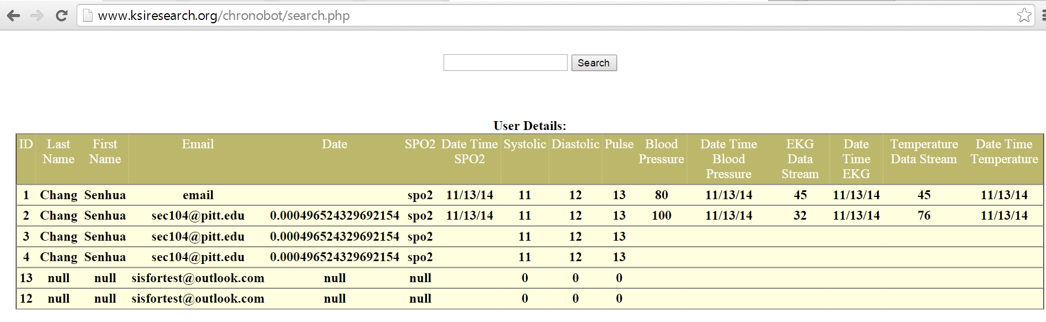

1. The Search functionality which allows the user to search through the values of any of the fields mentioned in the table is also completed.

The search box with value 11 returns the following results:

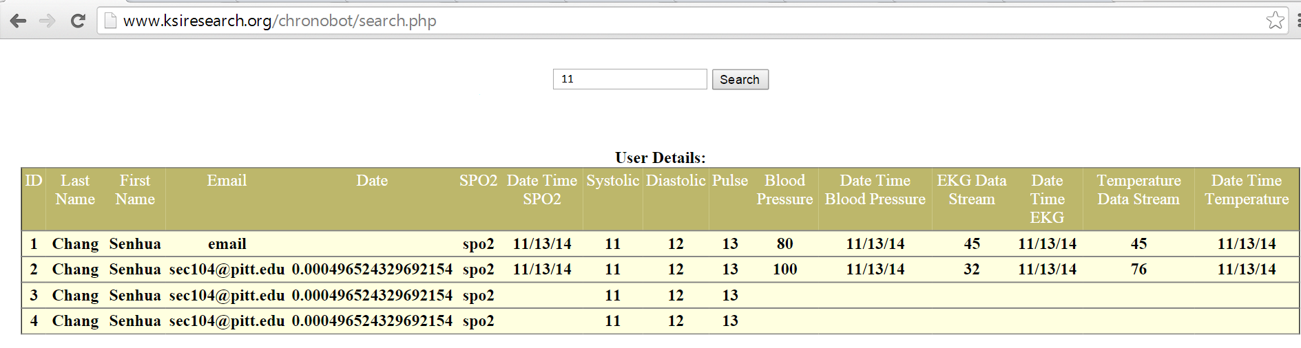

The search box with value 100 returns the following results.

