MS2 Report

Wei Guo

1. Run SISServer to start the SIS Environment.

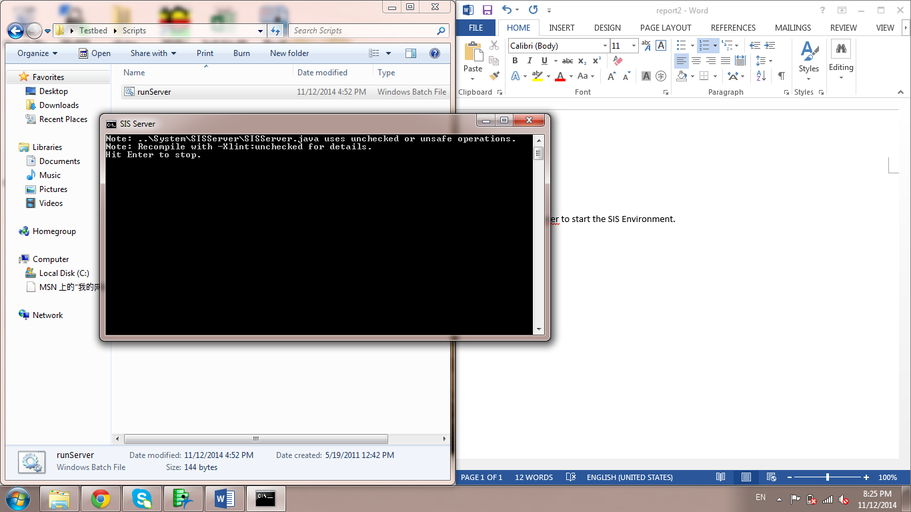

1. Run prjRemote.exe in order to send message to server later.

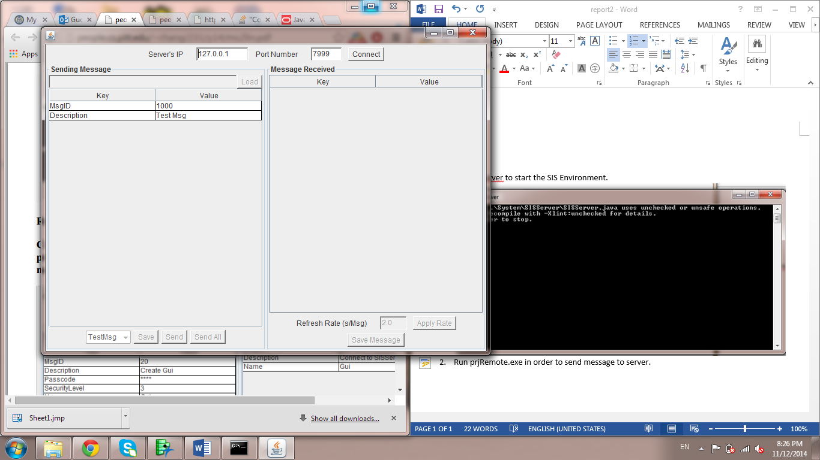

1. Click connect to connect to server, and then load initializing message to create components. And then click on “Send All”.

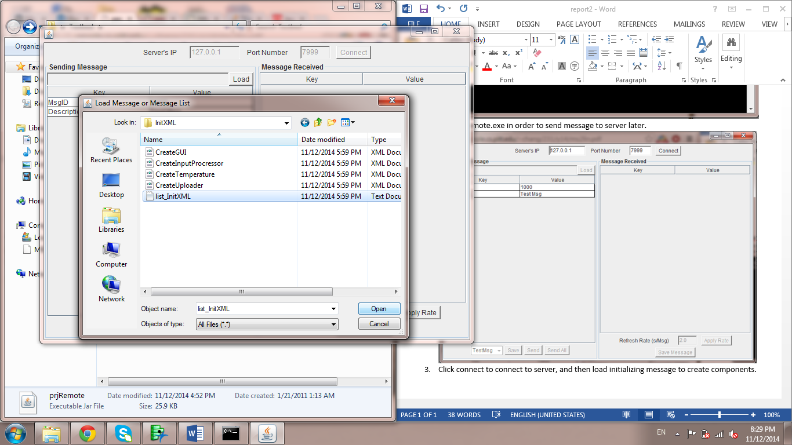

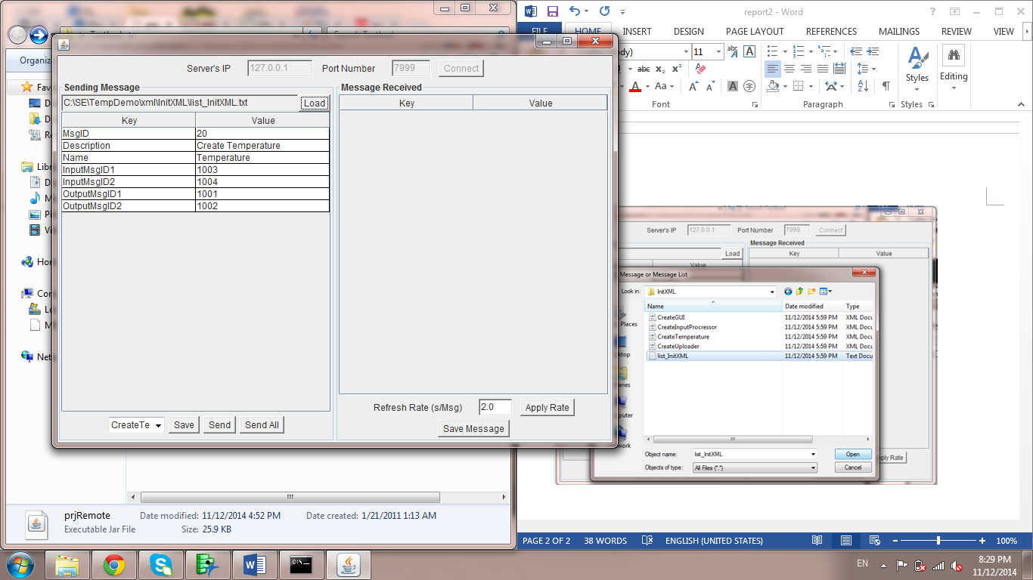

1. The components should be automatically created, but in this condition, I have to open them manually by clicking the runAllComps.exe

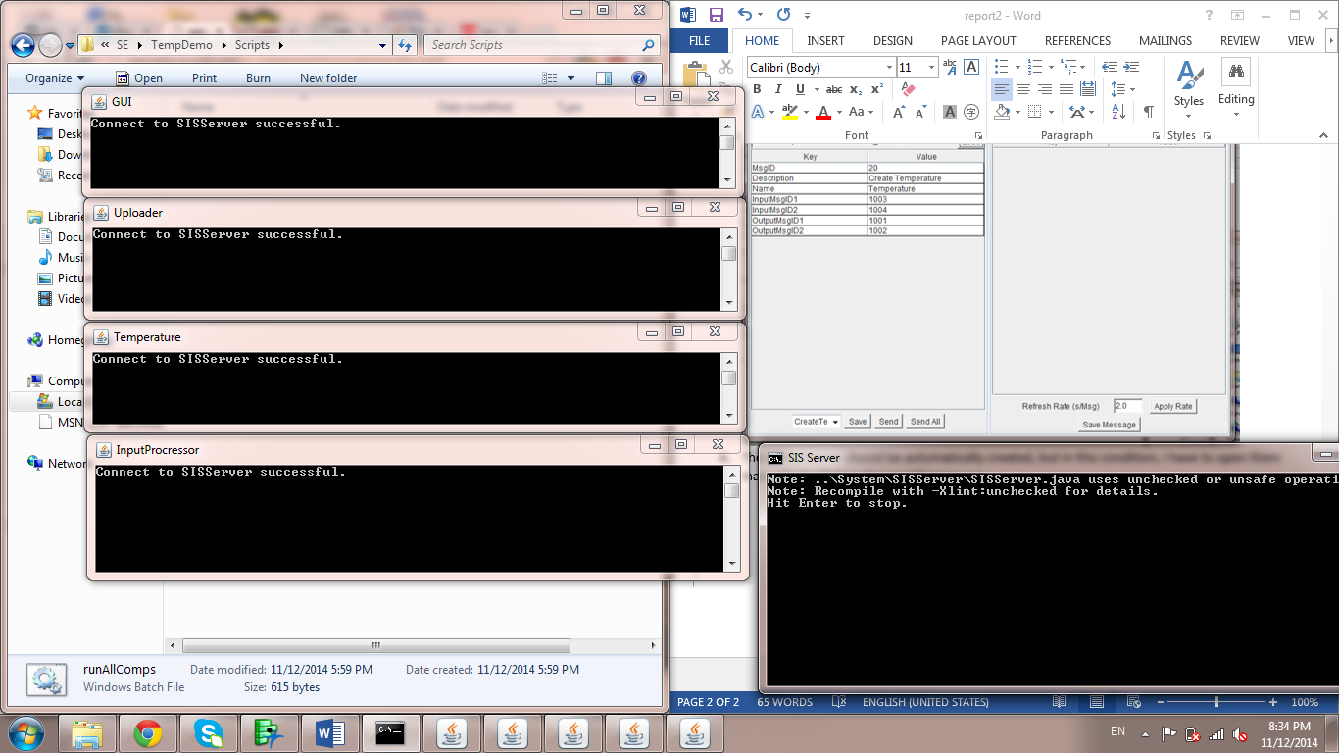

1. Use prjRemote to send message to components, and then use prjRemote to simulate the generation of the output message.

In this case, I would like to perform an example that GUI sends a message to Temperature (monitor), and then Temperature (monitor) send back the output message.

