CS2310 Multimedia Software Engineering
Final Project Report

Kinect Gesture Recognition Component
For SIS Healthcare System

Qiao Zhang
qz@cs.pitt.edu

Overview
In this project, I present the Kinect gesture recognition component for SIS healthcare system. The SIS healthcare system integrates several components, including a central server, several signal sensors and their corresponding processors. In this report, I will be discussing about the Kinect sensor and its processor, which processes the skeleton information Kinect generates and recognizes two pre-defined gestures. When a gesture is recognized, the processor sends the Uploader component a corresponding message.
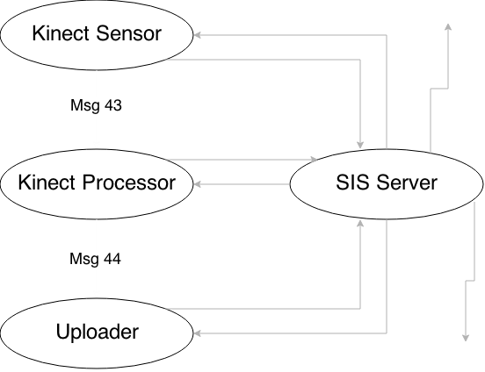
Figure 1. System Overview

System Workflow
First, the SIS server needs to be started as well as the initialization messages need to be sent. After that, we can launch the three main components of this project: Kinect sensor, Kinect processor, and Uploader.

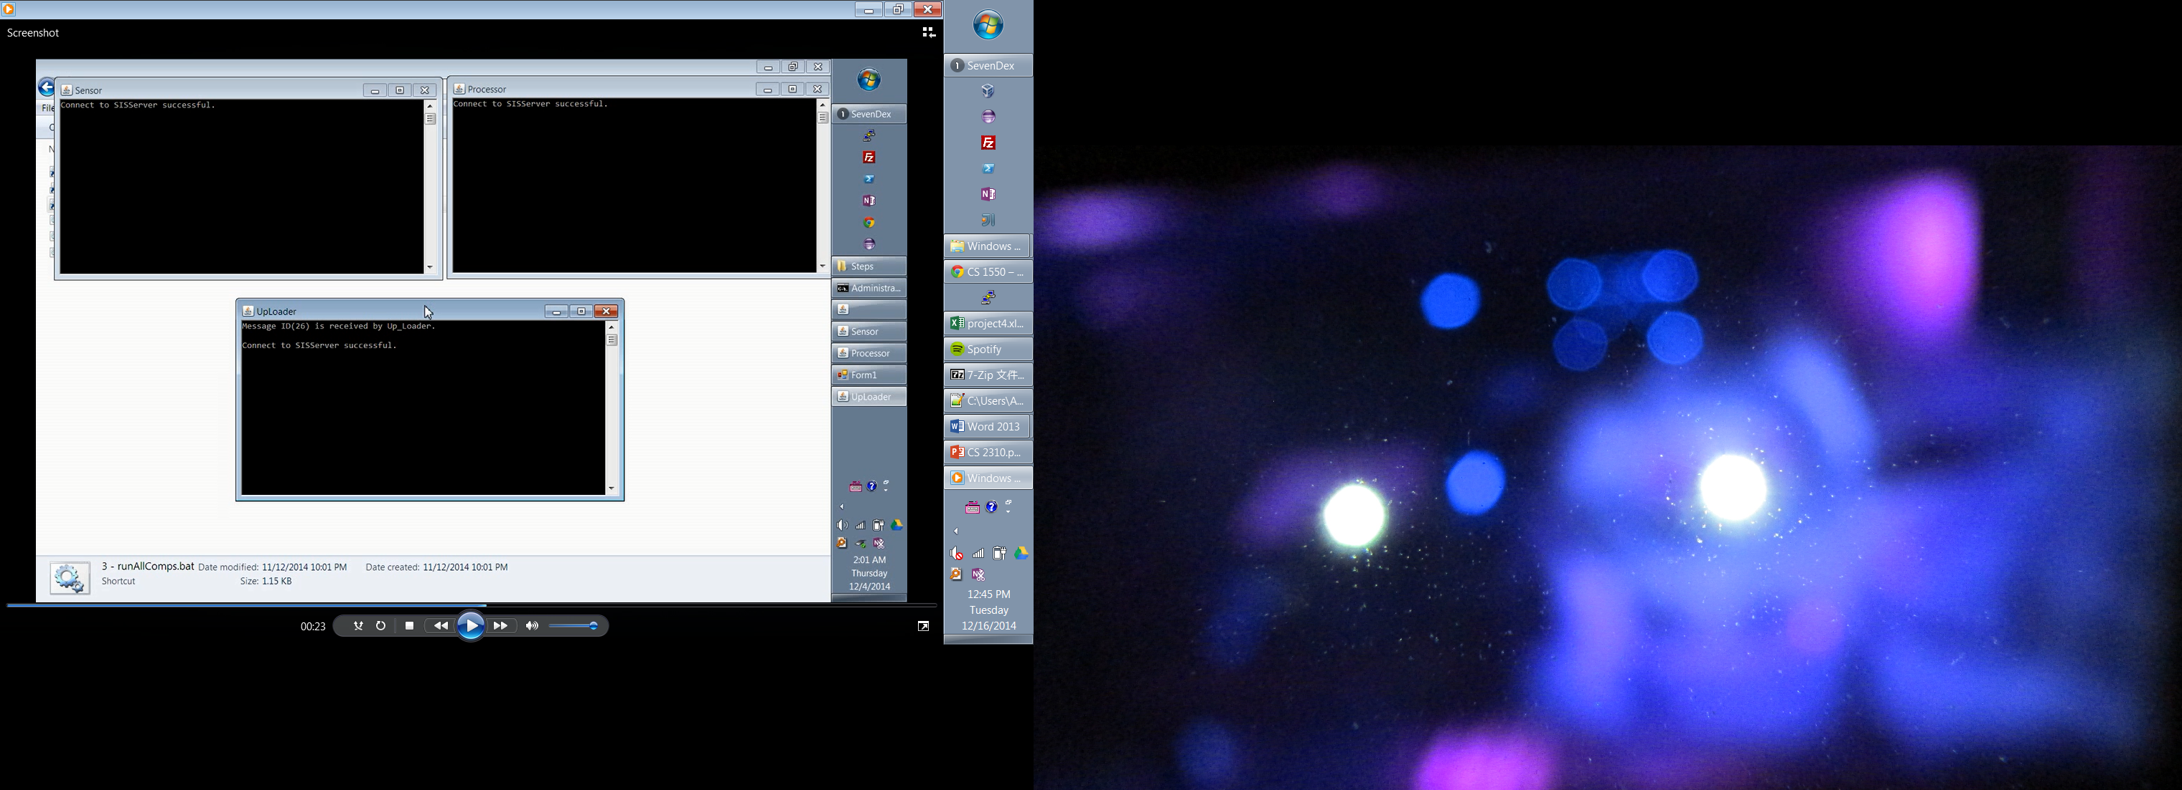
Figure 2. Main Components

At this point, the components are ready. The Kinect sensor does not generate input for the processor yet, because no user is detected. After a user goes into the view, the Kinect sensor generates the skeleton information and feeds the joint information (encoded in message 43) to the processor.

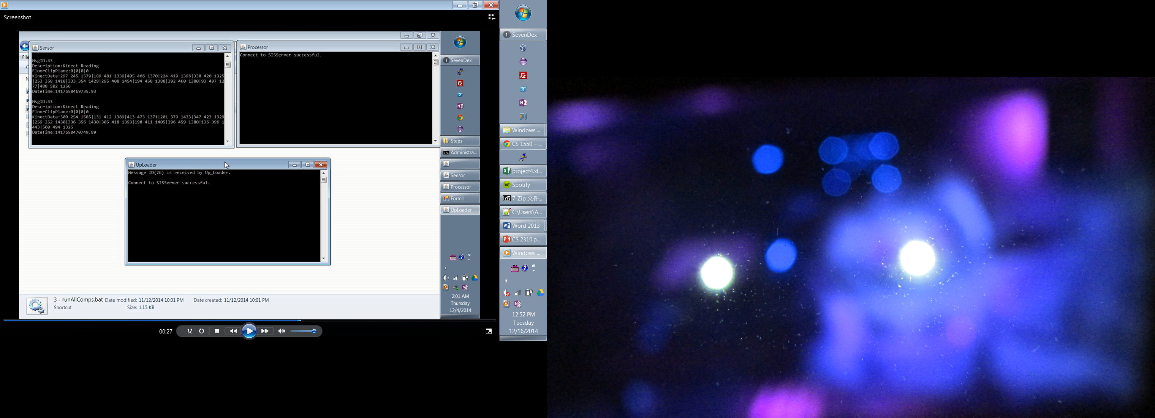
Figure 3. Kinect Sensor

The processor classifies the skeleton information and generates alert message 44 if a pre-defined gesture is recognized.
Since I am only supporting two simple gestures: left-hand reaching out for water delivery, right-hand reaching out for food delivery, the classification is simple: I use a threshold to determine if the shoulder, arm and wrist joints are in a straight line. If the three points are within a threshold, a gesture is recognized and an alert message is sent to Uploader. This method works well for static gesture recognition and does not require a training step. If a more complex gesture recognition system is needed, the component can always be changed to accommodate the needs by using a more sophisticated classification algorithm such as decision tree or Naïve Bayes classifier, which need data preprocessing to construct a classification model.

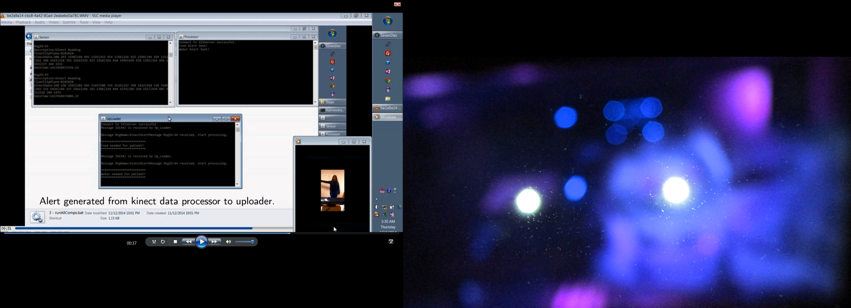
Figure 4. Gesture Recognized (1)
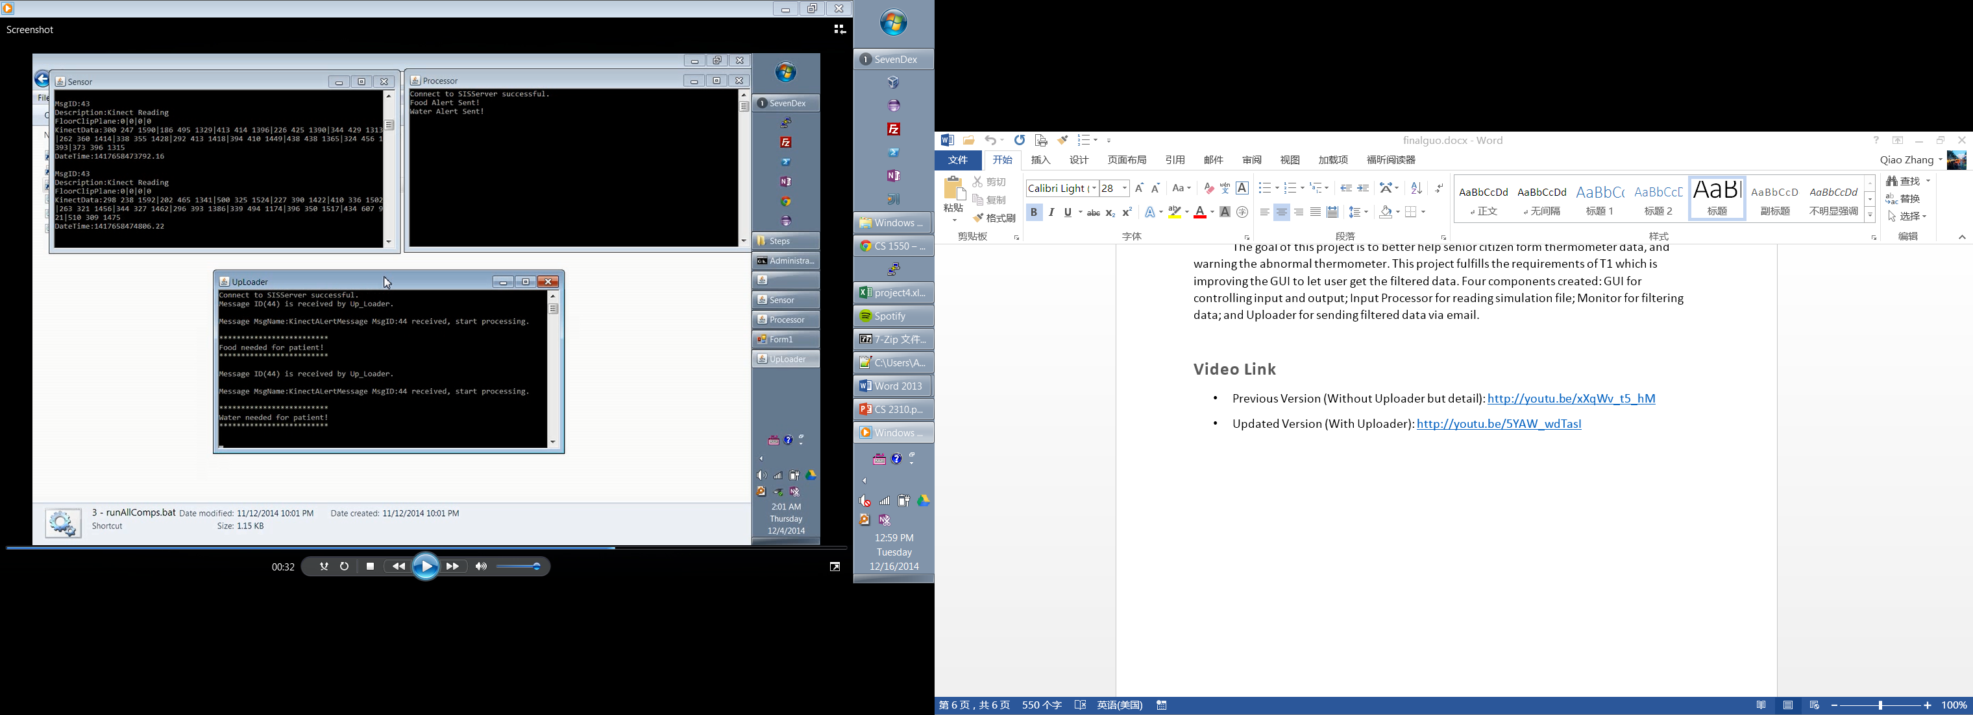
Figure 5. Gesture Recognized (2)

After sending the uploader the corresponding alert message, the uploader component will generate an email notifying the doctor/staff about the patient’s need.

Summary
This work extends the SIS personal healthcare system by adding a Kinect sensor component, and a Kinect input processor component. If a special condition is detected, the Kinect monitor sends a warning message 44 to SIS, which forwards it to the Uploader component. The Uploader component receives the warning message from the Kinect monitor and then sends an e-mail to the end-user. The Uploader component also stores the Kinect information in the online Patient Health database.

Appendix
Full demo: https://www.youtube.com/watch?v=P-dTL7qScGE
Screen-part only: https://www.youtube.com/watch?v=pS8ye8DLZxQ

