Web Interface for Health Care Database

Introduction:

The Health Care Database has been designed to store the patient’s data collected from the Kinect sensors at regular intervals of time. This data gives the accurate information of the patient’s health at a given point of time. In order to make this data available to the user or even to the Doctors, there was need of developing an interface to fetch this data from the database and display it on the webpage. Hence, a web interface has been developed in PHP to get this data. This interface, allows the user of the system to search for any of the patients details by using the given search box. Given a keyword to search, the results obtained would comprise all the entries in the database which match with the given keyword or its substring. By default, the search displays all the columns of the resulting rows. However, the user can filter out the columns needed by selecting the checkbox corresponding to those rows. The numerical fields Systolic, Diastolic & Pulse can be filtered based upon their values by using the “**Greater Than**” & “**Less Than**” radio buttons. Given a specific value of Systolic, Diastolic or Pulse to be searched, the results displayed would be with values either greater than or less than the specified vale depending upon the choice of radio button selected.

Database Definition:

The Users relation has been changed in order to incorporate all the aspects of the data sensed by the sensors regarding the patient’s health aspects. The User’s relation has been given below:

|  |  |  |
| --- | --- | --- |
| Sr. No. | Field Name | Data Type |
| 1. | Id | Integer |
| 2. | First Name | Varchar |
| 3. | Last Name | Varchar |
| 4. | Email | Varchar |
| 5. | Date | Varchar |
| 6. | SPO2DataStream | Varchar |
| 7. | Systolic | Integer |
| 8. | Diastolic | Integer |
| 9. | Pulse | Integer |
| 10. | BloodPressureDataStream | Varchar |
| 11. | DateTimeBP | Varchar |
| 12. | DateTimeSPO2 | Varchar |
| 13. | EKGDataStream | Varchar |
| 14. | DateTimeEKG | Varchar |
| 15. | TemperatureDataStream | Varchar |
| 16. | DateTimeTemperature | Varchar |

Working:

1. Details displayed on load of the Users.php page.

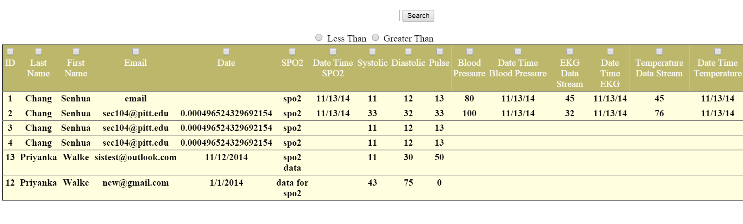

2. Searching a keyword “pitt” would result in all the rows that have “pitt” in any of its columns

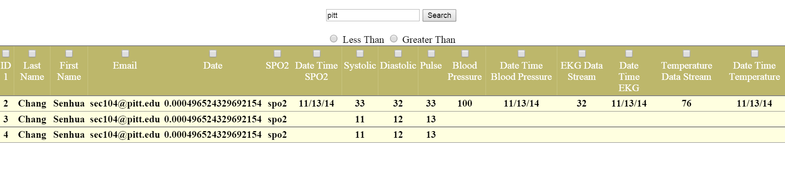

3. Searching a keyword “Senhua” with selected columns to be displayed.

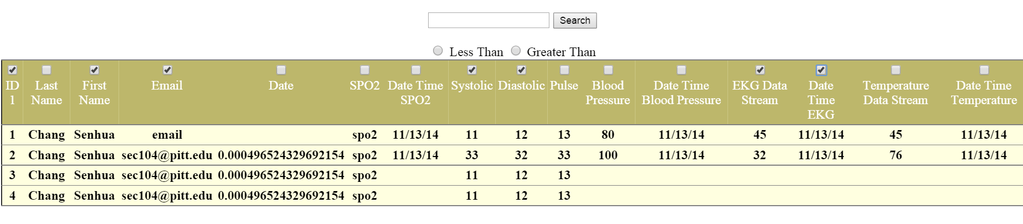

Search results are:

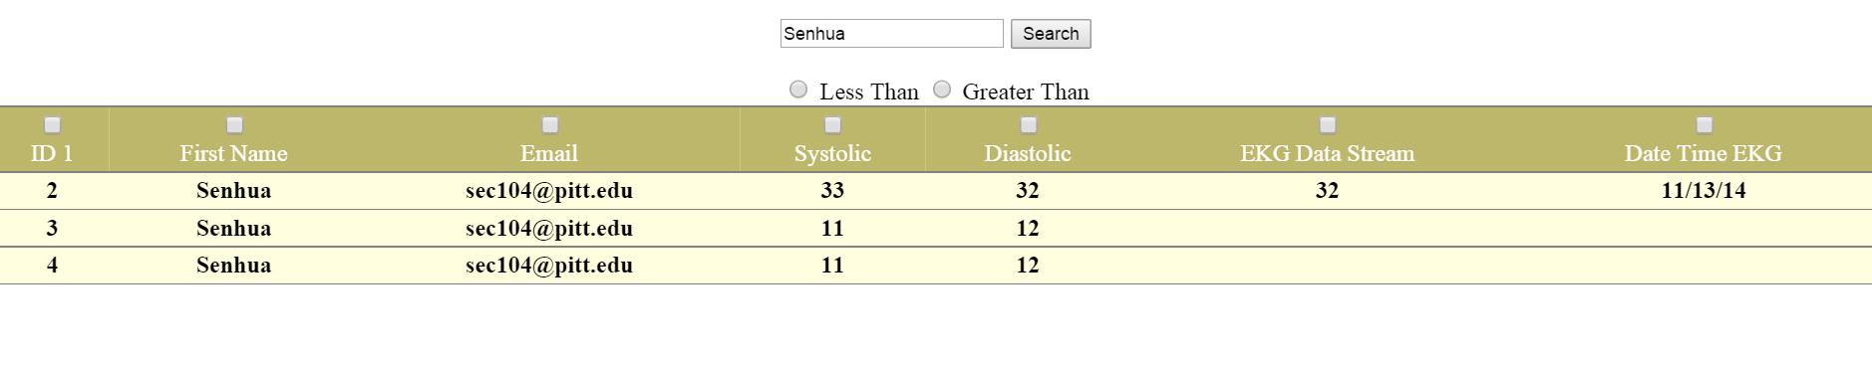

4. Searching for all the values greater than 43:

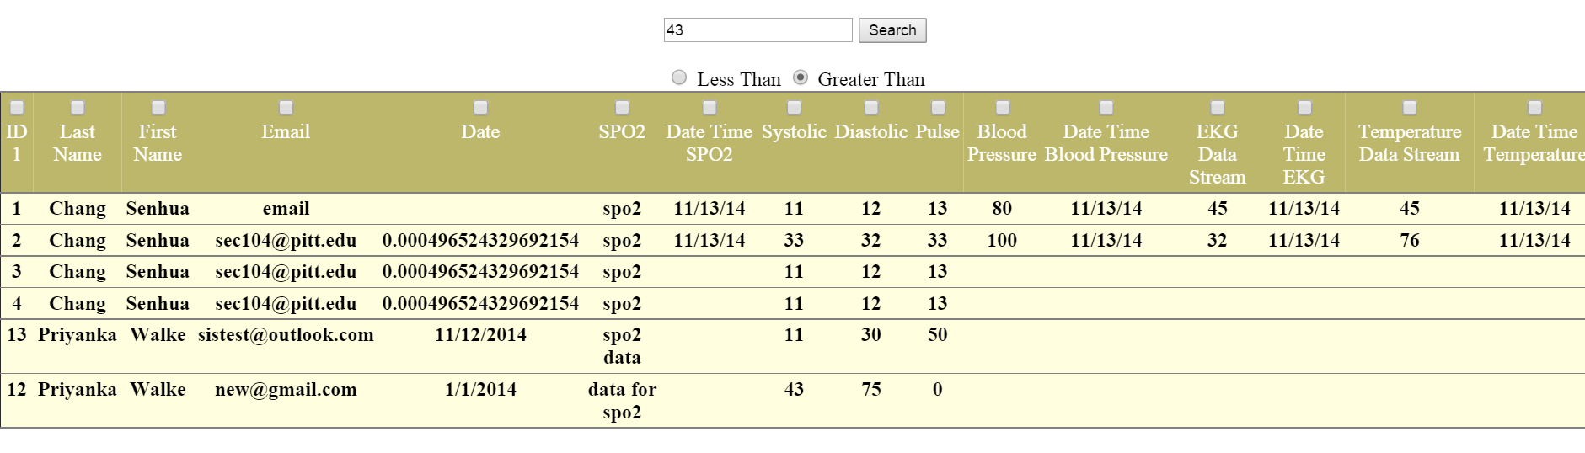

Search results are:

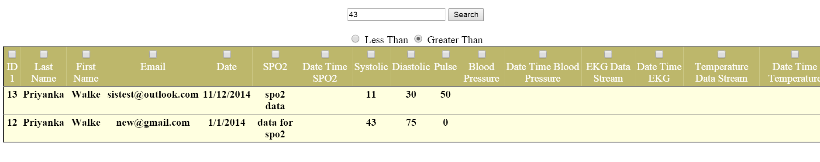

5. Searching for values less than “11” & displaying only specific columns

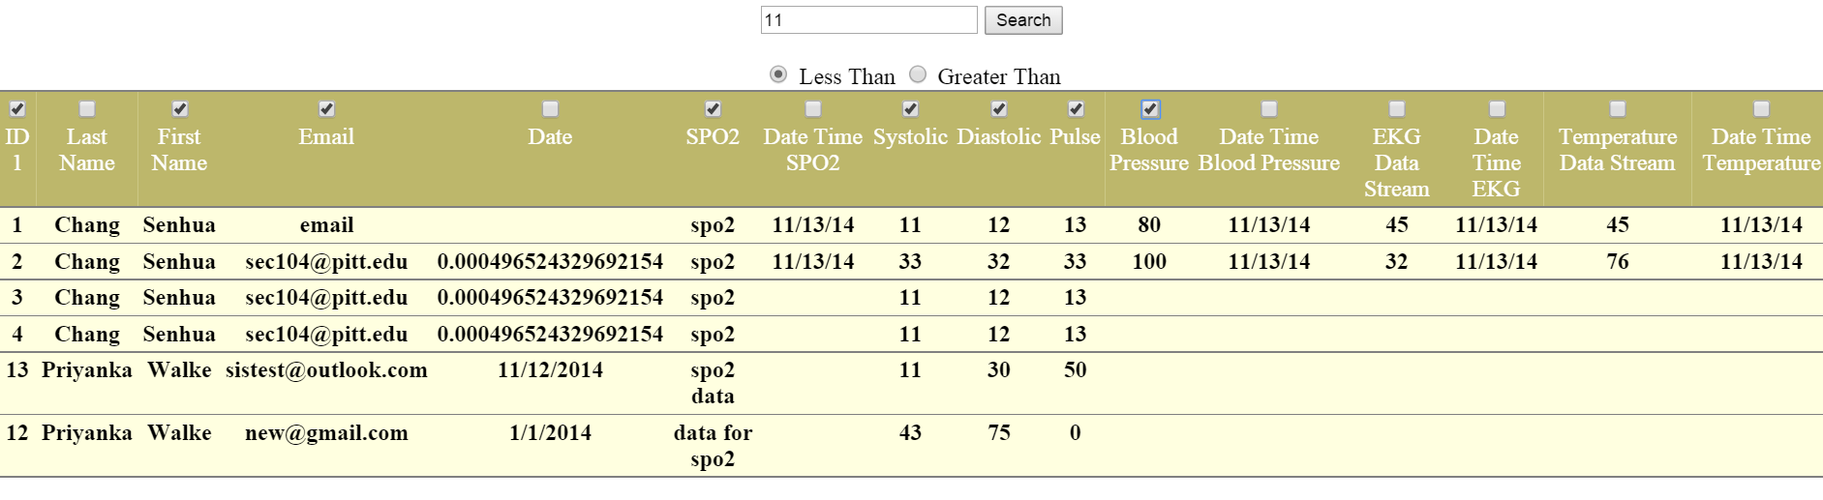

Search Results are:

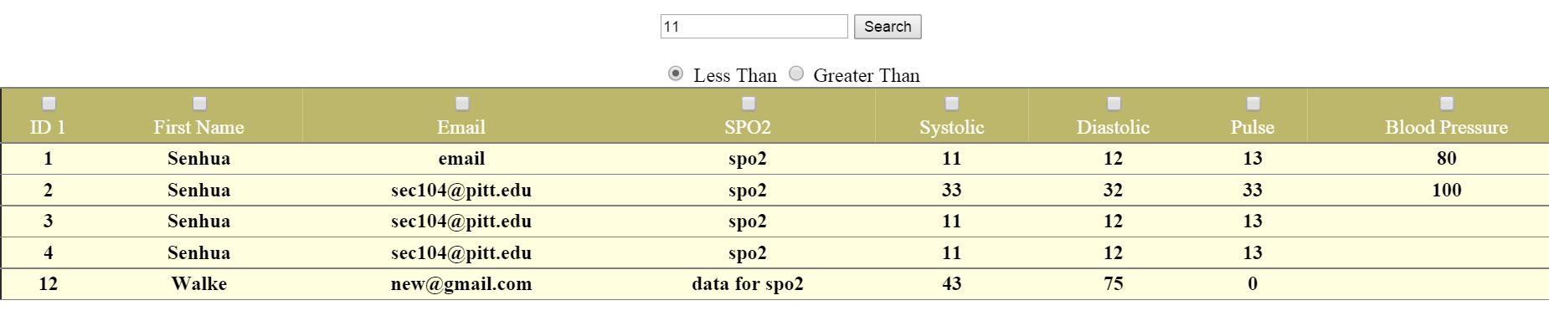

Future Work:

The vales for SPO2, EKG, Blood Pressure and Temperature are recorded against time. Also, these values would be in large numerous count per patient and hence need to be stored in files. A provision for displaying these values in graphical form can be made by plotting a graph against time for each of these columns. These graphs can be plotted by using javascript. There are some graph plotting API’s that can be used for plotting these graphs.