**CS 2310 Project Final Report**

**T1 Project**

Wei Guo

[weg21@pitt.edu](mailto:weg21@pitt.edu)

**Overview**

In this project, I develop a system called Temp1 to help senior citizen form thermometer data, and warning the abnormal thermometer.

This project improve the GUI so that it can specify various parameters for temp sensor, such as sampling rate, start/end time, high/low threshold, and reporting options and so on.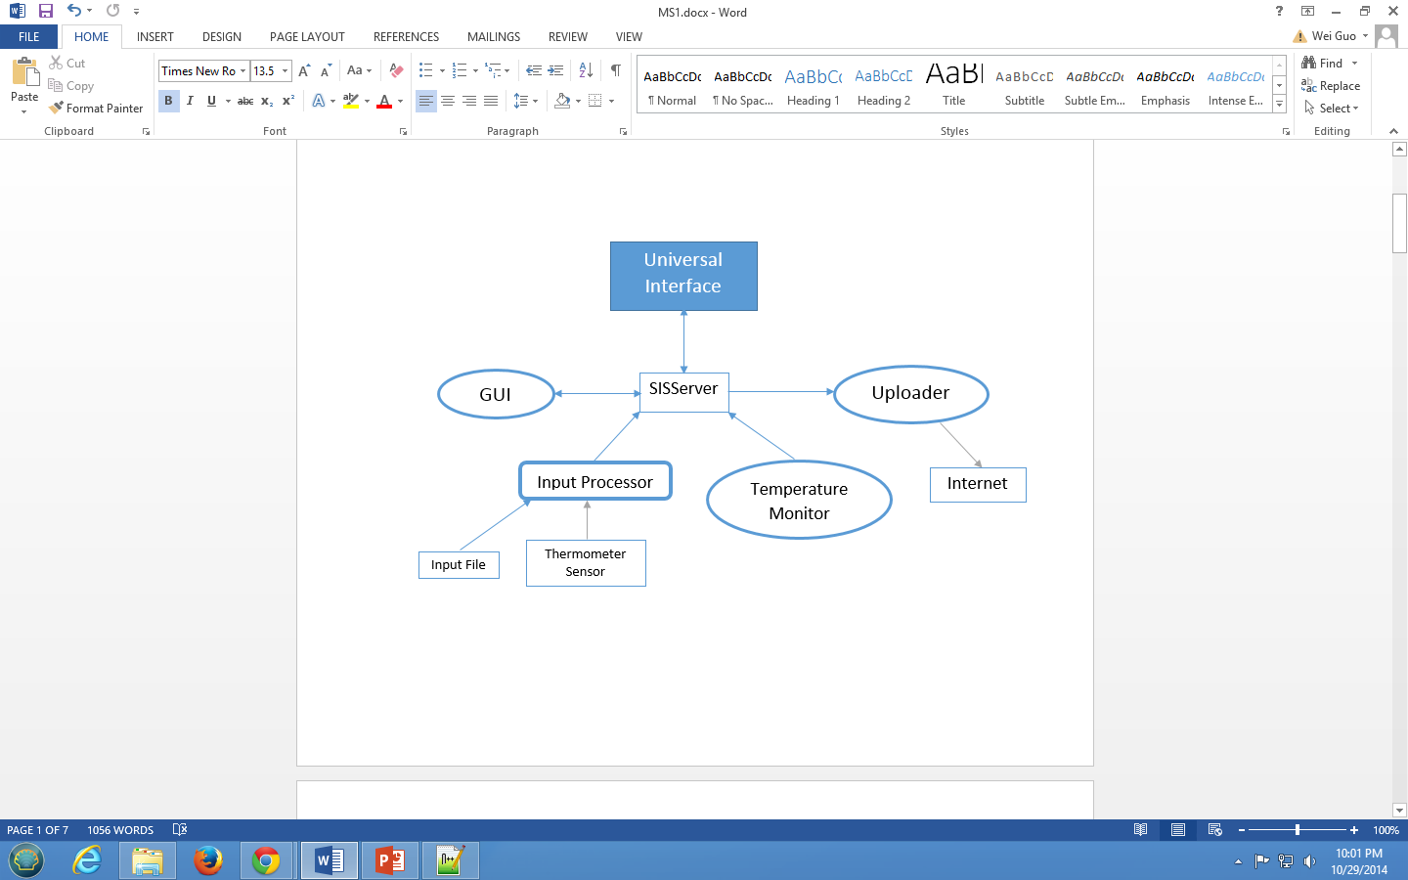

Temp1 consists with 4 major components: GUI, Input Processor, Temperature Monitor, and Uploader.

GUI is the user interface that allows user to get input data, filter data, view data, and upload data interactively.

The Input Processor collects the sensor data or reads a simulate file data then sends the related data to Monitor.

The Monitor is going to filtered data based on user’s selections on GUI and send the results to GUI and Uploader.

Uploader is going to send data to user’s input email address if user choose to send it.

**Framework and Messages**

The framework of four components are created by SISProjectCreator of Testbed.

Six types of messages are included in this project:

GUIToMonitor—MsgID 1001

GUIToUploader—MsgID 1002

GUIToInput—MsgID 1003

MonitorToGUI—MsgID 1004

MonitorToUploader—MsgID 1005

InputToMonitor—MsgID 1006

**How to use Temp1 System**

1. After starting SISServer and prjRemote, initialize and open four components. Note: the CreateUploader may not run successfully due to mail.jar wrong configuration. To solve this problem, first use command line: “set CLASSPATH=%CLASSPATH%; *address for uploader folder*\mail.jar;” then “javac CreateUploader.java”, and then “java CreateUploader” will make it run successfully.
2. Check “Temp” on GUI that will enable the button “View” and “Input”. Click “Input” button to perform the collecting data action. 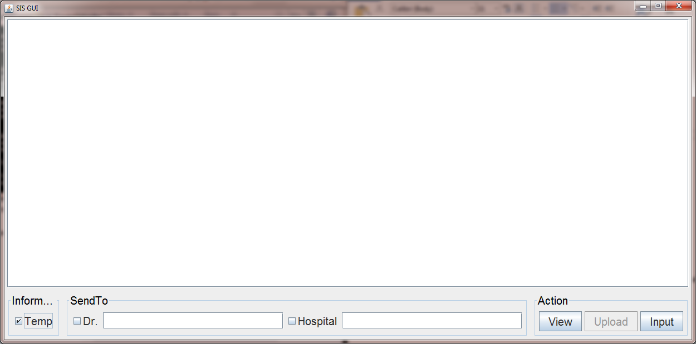 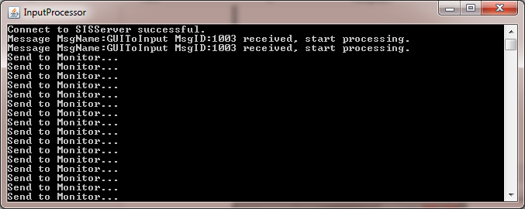
3. Check Doctor or Hospital checkbox. Type in the email address you want to send the data to. At last click the enabled “Upload” button to send to later generated data to email. 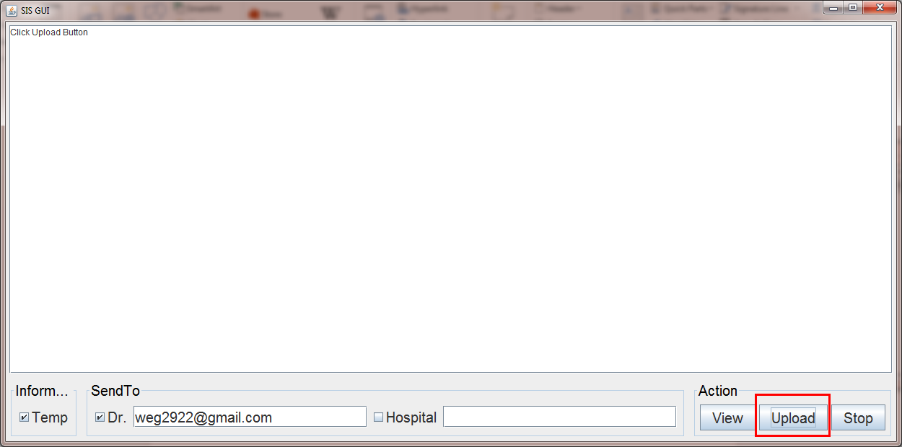
4. Click “View” button to generate a new window to filter the data from the sensor or simulation file. 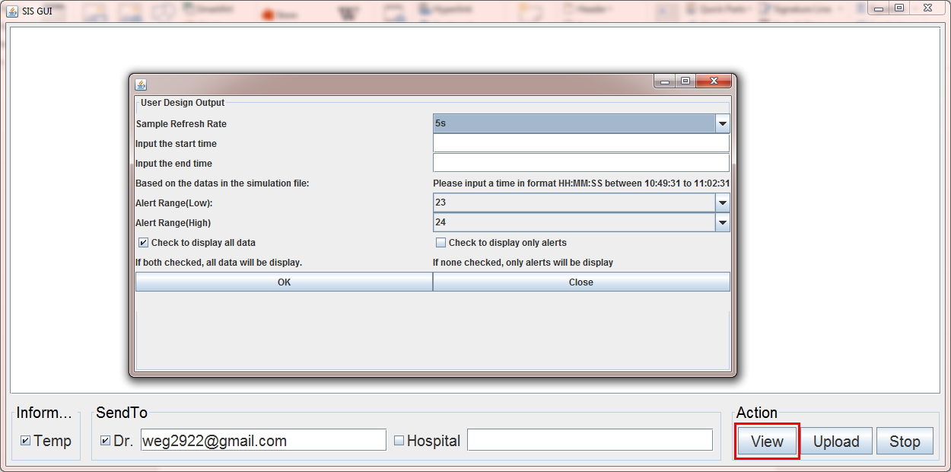
5. Input the data filtering condition and then click “OK” button to send data to Monitor. Note1: check both “Check to display all data” and “Check to display only alterts” will display all data; check none will display only alerts. Note2: the simulation file only includes data from time 10:50:00 to 11:02:00. Only a valid input will ensure displaying correct results. Note3: the “Sample Refresh Rate” has 5s, 10s, 30s, 1min, 2min, 5min, 10min choices. The time indicates the sample rate, and you have to wait the specific time to get data.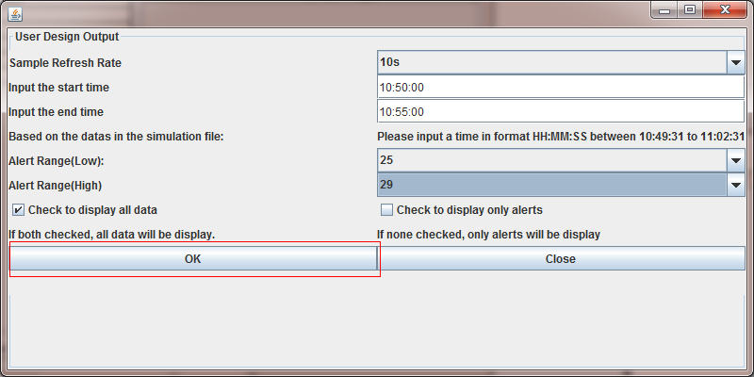
6. The results will be sent from Monitor to GUI and then be displayed on the GUI textarea. It will indicate whether this result is a alert or not. If the temperature is an alert, an alert message is also generated to notice the user.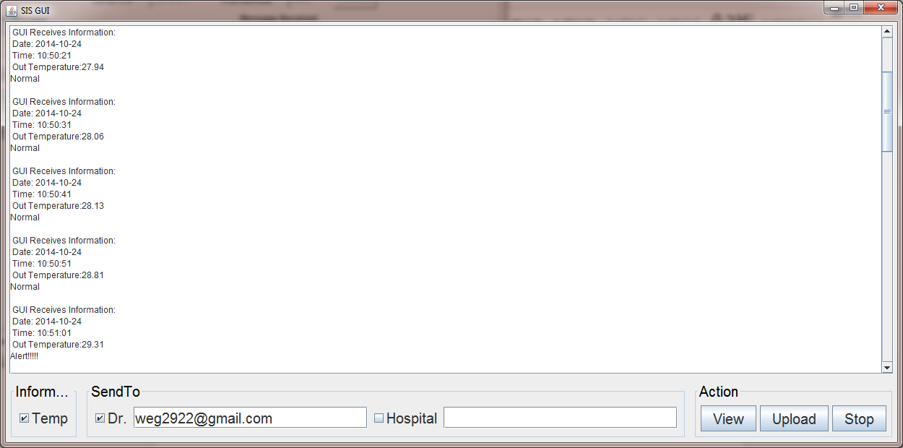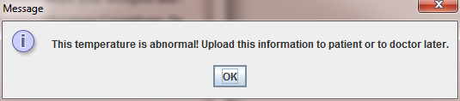
7. The emails each with one data is sent to the mailbox. 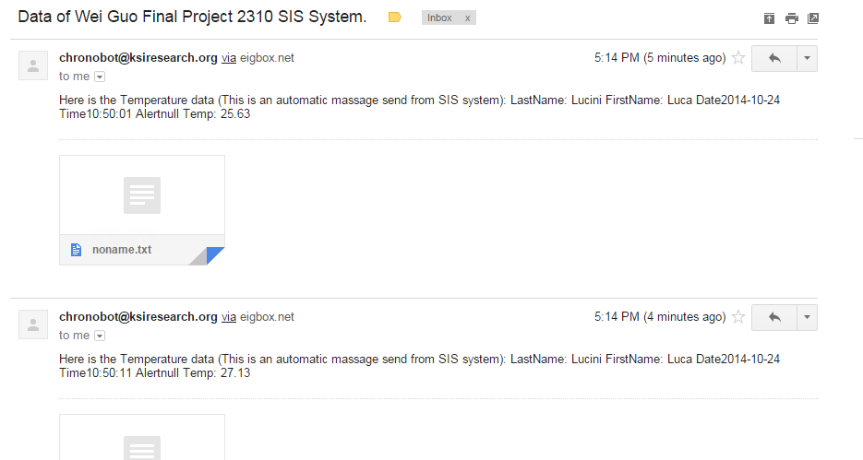

**Summary**

The goal of this project is to better help senior citizen form thermometer data, and warning the abnormal thermometer. This project fulfills the requirements of T1 which is improving the GUI to let user get the filtered data. Four components created: GUI for controlling input and output; Input Processor for reading simulation file; Monitor for filtering data; and Uploader for sending filtered data via email.

**Video Link**

* Previous Version (Without Uploader but detail): <http://youtu.be/xXqWv_t5_hM>
* Updated Version (With Uploader): <http://youtu.be/5YAW_wdTasI>