**VAMCIP**

**Project Final Report**

**CS 2310 “Multimedia Software Engineering”**

***Author:*** Daniel Petrov

***Instructor:*** Prof. S.K. Chang

***TA:*** Xiaoyu Ge

Pittsburgh, 2014

# Abstract

In this paper we discuss a new component for the SIS Healthcare system, which augments the functionality, provided by the system to the patients. The objective of the module is to process the information about the location of the patient, to track the patient on his/her way in near real-time and to act accordingly in case of emergency.

# Introduction

Dementia is a broad category of brain diseases. The number of patients, who suffer from dementia, is increasing in the United States of America for the last couple of years. Thus the mortal rate of fatalities, caused by dementia is increasing as well. The most common type of dementia is Alzheimer’s disease. Some of the other more popular types are vascular dementia, Dementia with Lewy, Frontotemporal labor degeneration, mixed dementia, Parkinson’s disease and Creutzfeldt-Jacob disease. The taxonomy is depicted on Figure 1.

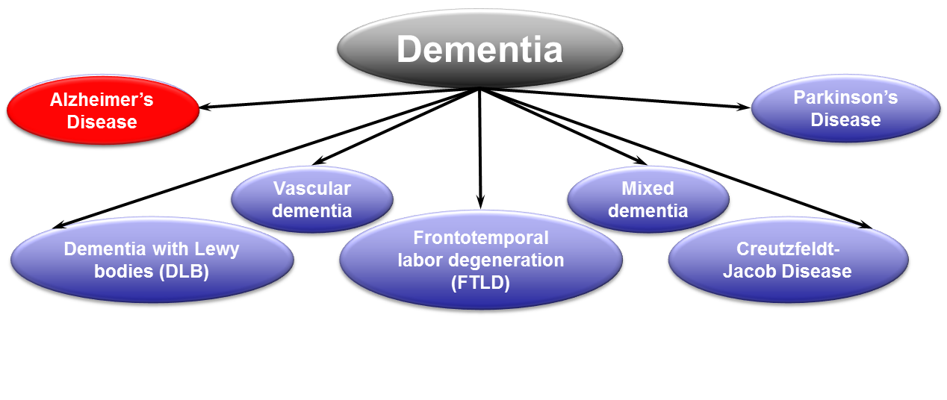

Figure 1 Types of Dementia

One in three seniors dies with Alzheimer’s or another dementia. The statistics shows that 15.4 caregivers provided an estimated of 17.5 billion hours of unpaid care, valued at more than 216 billion USD in 2012[1].

The work, done by the caregivers, might be of great benefit for those patients, who really need it. Still this approach has a number of concerns, which should be evaluated carefully, before opting for it. The first one is the fact that this method is very intrusive for the patient. The patient gets a caregiver, who is accompanying him/her wherever he/she goes to. This might be extremely bothering for the patients, who should share a lot of personal information with the caregiver. Other aspect of the problem is the mentality of the patients, suffering from any type dementia. The patients should give away part of their own independence. Last, but not least, the caregivers are quite expensive resource and thus their help should be used wisely.

How can Software engineering help in this case? Can we get an upper threshold value, which bounds us to a value, beyond which option for caregiving is to be provided by humans?

The second question is simple. The physicians measure what they call Clinical Dementia Rating (CDR), which changes between zero and three or more. The first stage is called CDR =0. There is no impairment for the patient at this stage. The next one is called Questionable Impairment; the value of CDR for it is -0.5. The third one is called Mild impairment and it is the last one, where the patient is capable of taking care of himself/herself. The value for it is 1. At this stage the patient gets geographically lost. For all CDR values beyond that point (2 and 3 – moderate and severe impairment), the patient should have a personal caregiver.

As now we know the extend, up to which the modern technologies are capable of replacing the human, we can answer the first question, introduced earlier. For all cases of CDR with value 1 or less, a machine can take over the responsibility of tracking the movements of the patient and his/her location. One example of such machine is VAMCIP.

# System Architecture

VAMCIP stands for Virtual Assistant for Mild Cognitive Impaired People. The frontend of VAMCIP component is part of the GUI component and it is one of the directions, discussed in the Future Work section. The backend of VAMCIP is implemented as an integral component of the SIS Healthcare system. It is developed in Java. It runs as a single-threaded server, which relies on TCP transport protocol for communication with the other components of the system. The component is depicted on Figure 2.

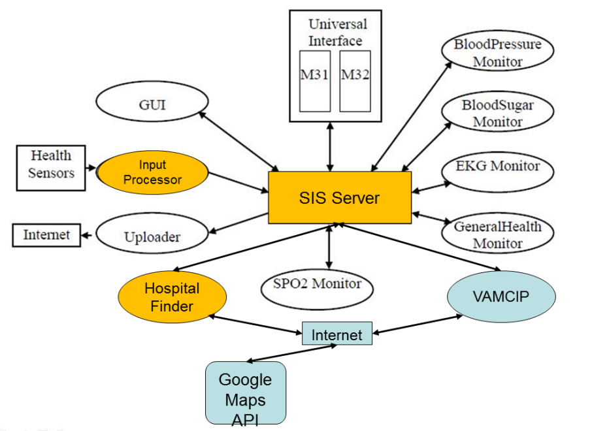

Figure 2 SIS Healthcare Components

VAMCIP is depicted in blue on the figure. It communicates directly with four other components of the system – GUI component, Input Processor component, Uploader and Hospital Finder component.

VAMCIP introduces four new messages to the system – GPS Reading, GUI Address Request, GPS Coordinates Request and GPS Coordinates Response. VAMCIP is using two different APIs of Google Inc. – Directions API, GmailAPI to provide the desired functionality. The developers of Google Inc. provided a Java wrapper library for those APIs to be used. VAMCIP is involved in three basic scenarios.

The first one is the supply of data about the current location of the patient. The Input Processor receives the raw data from a sensor, which typically is a smart phone, which has a GPS receiver and some capability of reporting the data, obtained from the receiver, back to the system – Wi-Fi connection, GPRS, WCDMA, LTE or a combination of them. The call-flow diagram is depicted on Figure 3.



Figure 3 Location Data Supply

The Health Sensor sends the raw information, marshaled in a Sensor Data Input message. The Input Processor module processes it and sends the information further to the VAMCIP module.

The next scenario covers the case, when a physician sends the destination of the patient VAMCIP and the modules starts tracking the patient. It is depicted on Figure 4.



Figure 4 Interaction with the GUI component

The third one involves the delivery of the last location of the patient, known by VAMCIP, to other modules of the system. The scenario is depicted on Figure 5.



Figure 5 Last known location propagation

Once VAMCIP receive a GUI Address Request message, which is followed by a positive acknowledgement, the module contacts the Google Maps, using Directions API in order to receive a route for the patient from his/her current location to the destination, received in the GUI Address Request message. The route contains a polyline, which is the smoothened polyline, which pins the route on the map. The module tracks the location of the patient for deviations from the received predefined route in the following way - upon every receiving of new location data information (i.e. GPS Reading message), the module determines if the point, representing the received coordinates is within no more than 0.2 miles distance from every rectangle, formed by two consecutive points of the polyline of the route.



Figure 6 Polyline, fence and new coordinates

In case the location is outside the boundaries, an Emergency is triggered. The VAMCIP module sends a short text message (SMS) to the patient, informing him/her to stay where he/she is and letting him/her know that the help is on the way. The emergency message is captured by the uploader module and a mail is sent to the physician.

# Application

The VAMCIP component was tested in the developers’ version test bed of the SIS Healthcare system. The GPS Reading messages as well as the GUI Address Request messages were emulated with the prjRemote application. The test bed was run on Dell Latitude E6410, 2.4 GHz Intel i5 CPU (2 cores + 2 threads), 8GB RAM, Windows 7 64-bit operating system and Java version 1.7. The results are shown in Appendix A.

# Future Work

There are several directions in which the system can be improved further. The first one is replacement of the address field in the GUI with address field provided by Google Inc. The address search field, provided by Google, will introduce additional flexibility to the physicians, who use it to enter the destination of the patient, as it will provide to them suggestions about the address they are trying to input.

Other direction, which should be explored, is related to power savings. Currently the GPS locator device is supposed to use mobile Internet connection or other data connection in order to send the current coordinates of the patient to the system. The data connections are power intensive and decrease the amount of time the device can be used between two consecutives charges of its battery. The option for reporting the GPS coordinates via short text messages (SMS) should be explored further. The power, required for a short message to be sent, is less than the power, required for a packet (or a number of packets) to be sent. Such approach will require the engineering of a gateway, which will receive the short messages and will convert them to messages, used by the SIS Healthcare system – i.e. for example “GPS Reading Message”.

Some sort of machine learning and artificial intelligence algorithms can be implemented in order to build knowledge for the usual behavior and the habits of the patients in terms of walks outside their homes. This will give an opportunity to the physicians to preapprove all trips to certain destinations, bounded in certain timeframes. For example, the physician should be able to preapprove all walks to the grocery store, located close to the home of the patient, which take place between 10:00AM and 12:00PM on Monday to Friday. The machine learning algorithms will build the knowledge that the patient goes to the grocery store before noon on business days. The system will inform the physician with a short message that the patient is going to the grocery and thus will save some time of the physician. Additionally the machine learning algorithms or any fuzzy logic can be used to know if the patients takes the same routes most of the time or he/she is inconsistent about them. The information can be used by the system to determine on per patient bases the deviation of the route, which should not be considered as an emergency. For the patients, who are sound in the routes they take, the allowed deviation, should be smaller, compared to that for the patients, who are take a different route every time.

The module can be extended further to provide details about the activities of the patient, which might be of interest for the physicians. Knowing the path of the patient, the system should be able to calculate the distance the patient walked the average speed, the denivelation and other attributes of the path, which might have influence on the physical condition of the patient.

# Conclusion

In this paper we discussed in details a new component of the SIS Healthcare system, which enriches the functionality provided by the system, adding some mobility and independence for the patient. Two video from the demonstrations of the component can be found on the following addresses: <http://youtu.be/iQz14fCR5Yo> and <http://youtu.be/Yv2laPBHQU8>. Appendix A contains the screenshots as pictures for this demo.

# Appendix A Scenario Demo

This appendix contains the screenshots for the following scenario, run in the test bed:

* **Step1:** The system gets initial reading from the GPS locator. The “home” of the patient is at Sennot Square, Pittsburgh, PA;
* **Step2:** The patient calls the physician and informs him for her plans to go to UPMC Shadyside Hospital. The physician inputs the name of the hospital and approves the walk for the patient;
* **Step3:** The several consecutive measurements show that the patient is on track and she is following the route, the system assigned to her.
* **Step4:** A new report from the GPS Locator shows that the patient is not following the route anymore. Such event triggers an emergency situation. The VAMCIP component sends an email to the physician, letting him know that the patient got lost. Additionally the component sends a short text message to the patients, asking him to stay where she is and informing her that the help is on the way.
* **Step5:**

The screenshots are following. The active window, which should be paid attention to is framed by a green frame:

A GPS Reading message is sent to VAMCIP. IT contains the coordinates of the location of the home of the patient – longitude: -79.956131, latitude: 40.441797:

A GUI Address Request message is triggered. The destination is “UPMC Shadyside, Pittsburgh, PA”. VAMCIP used its knowledge about the location of the patient and calculated the path between the home of the patient and the hospital. The second screenshot is omitted:

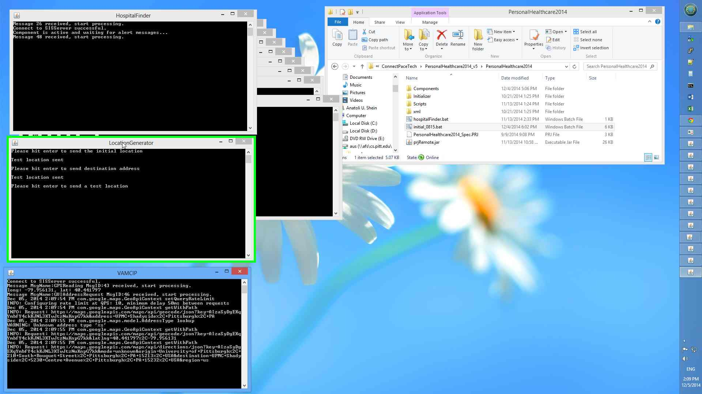

The GPS locator reported new current location for the patient:

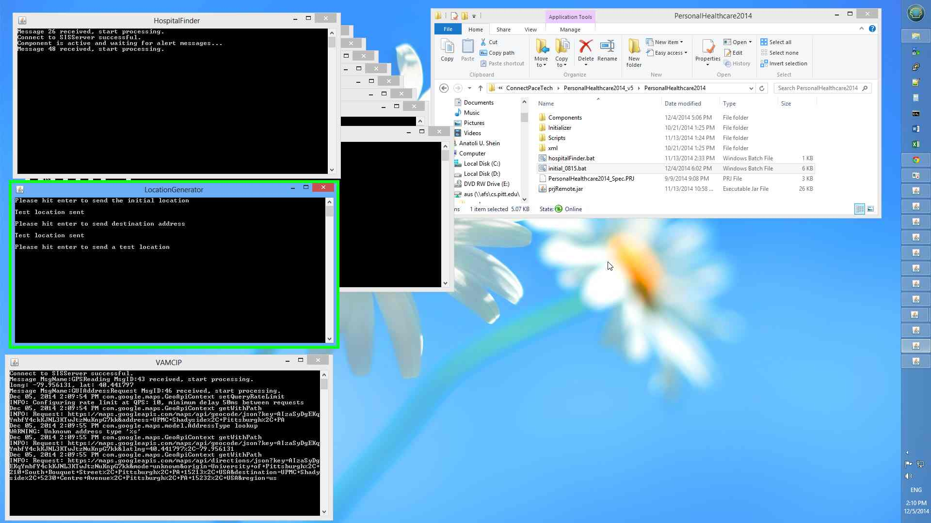

VAMCIP checked it and concluded that the patient is still on track:

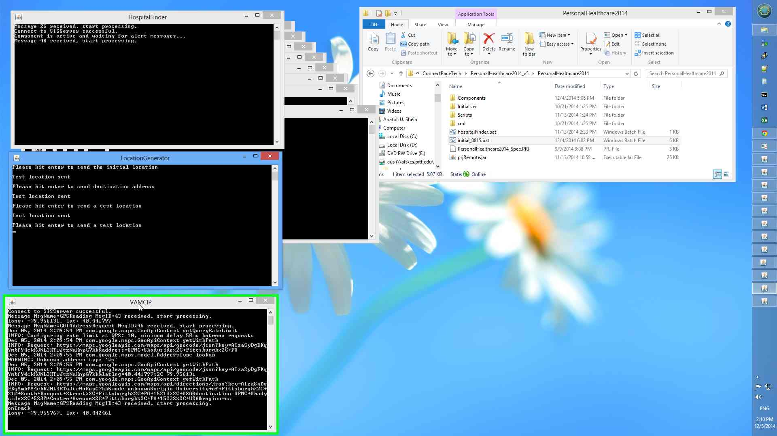

The same two events occurred one more time:

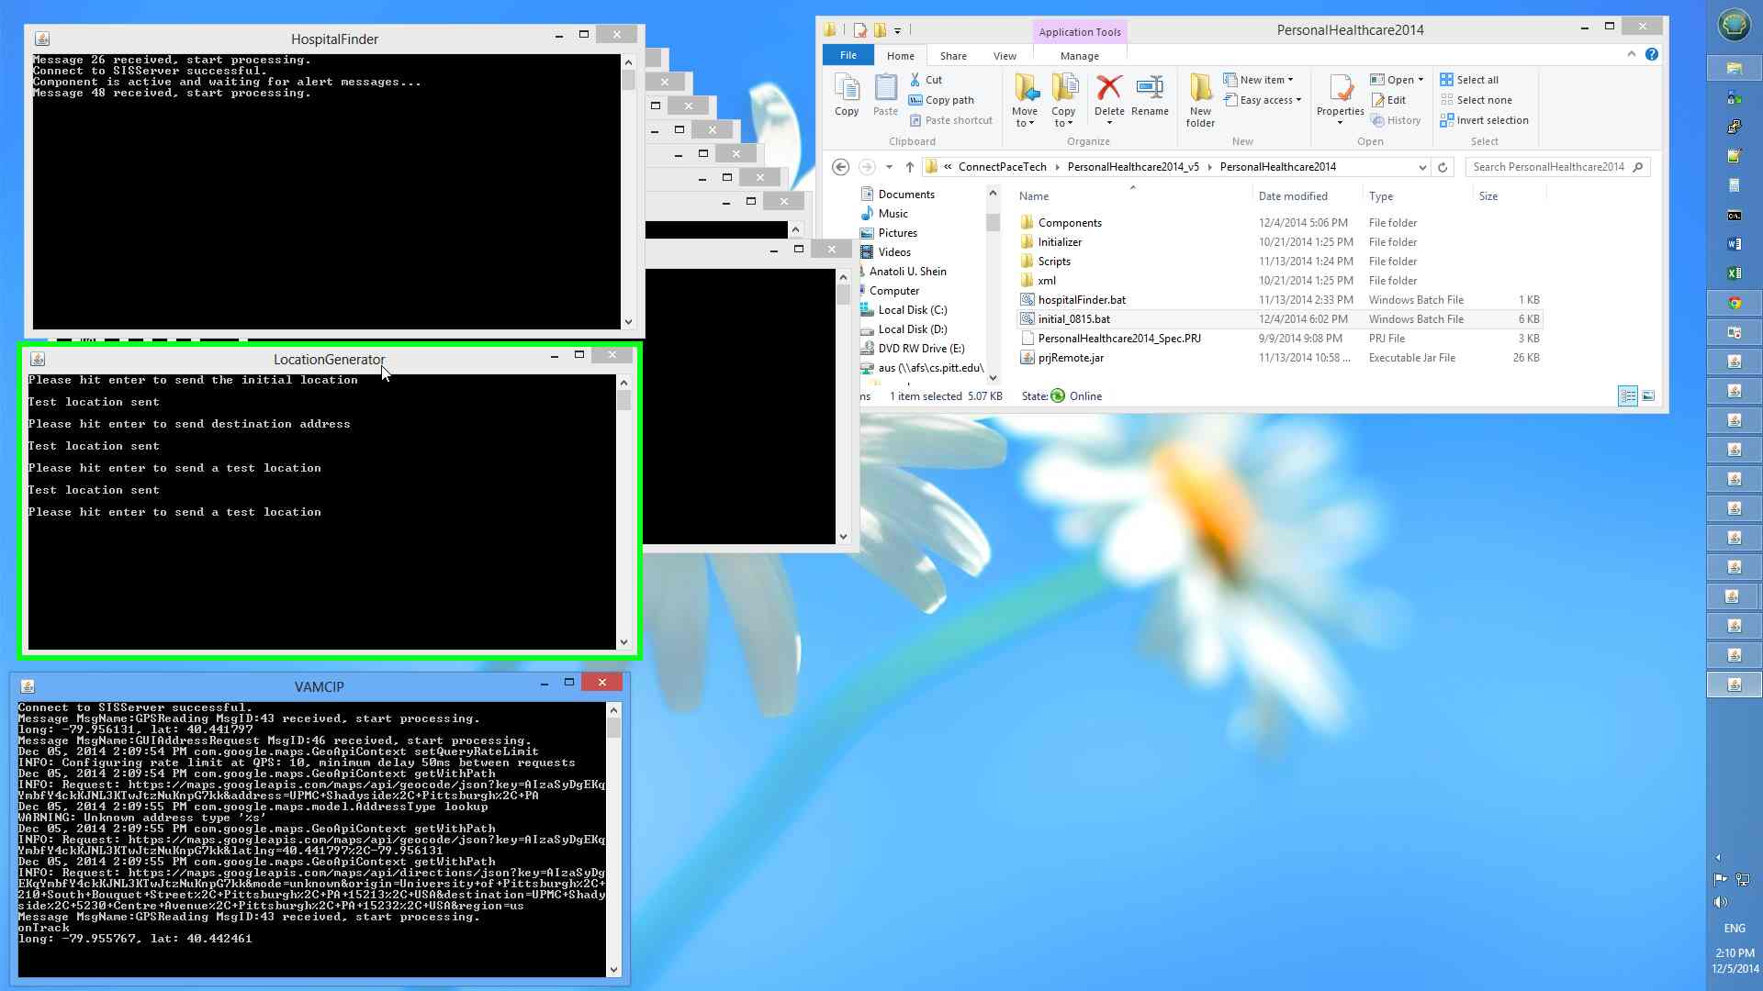

And the result:

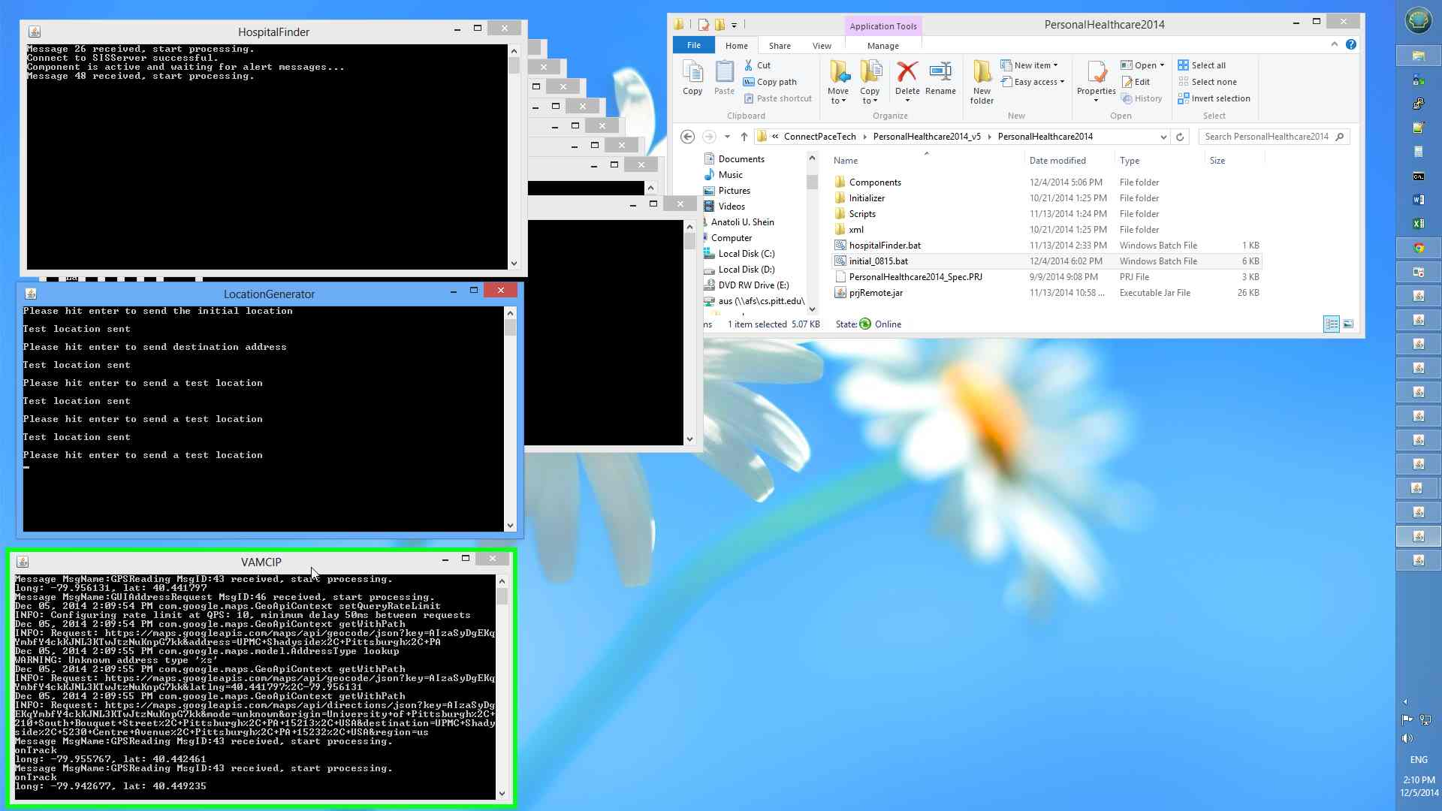

The next report about the location of the patient confirmed that the patient is more than 0.2 miles away from her route. VAMCIP triggered a General Alert message, which was kept by the HospitalFinder component:

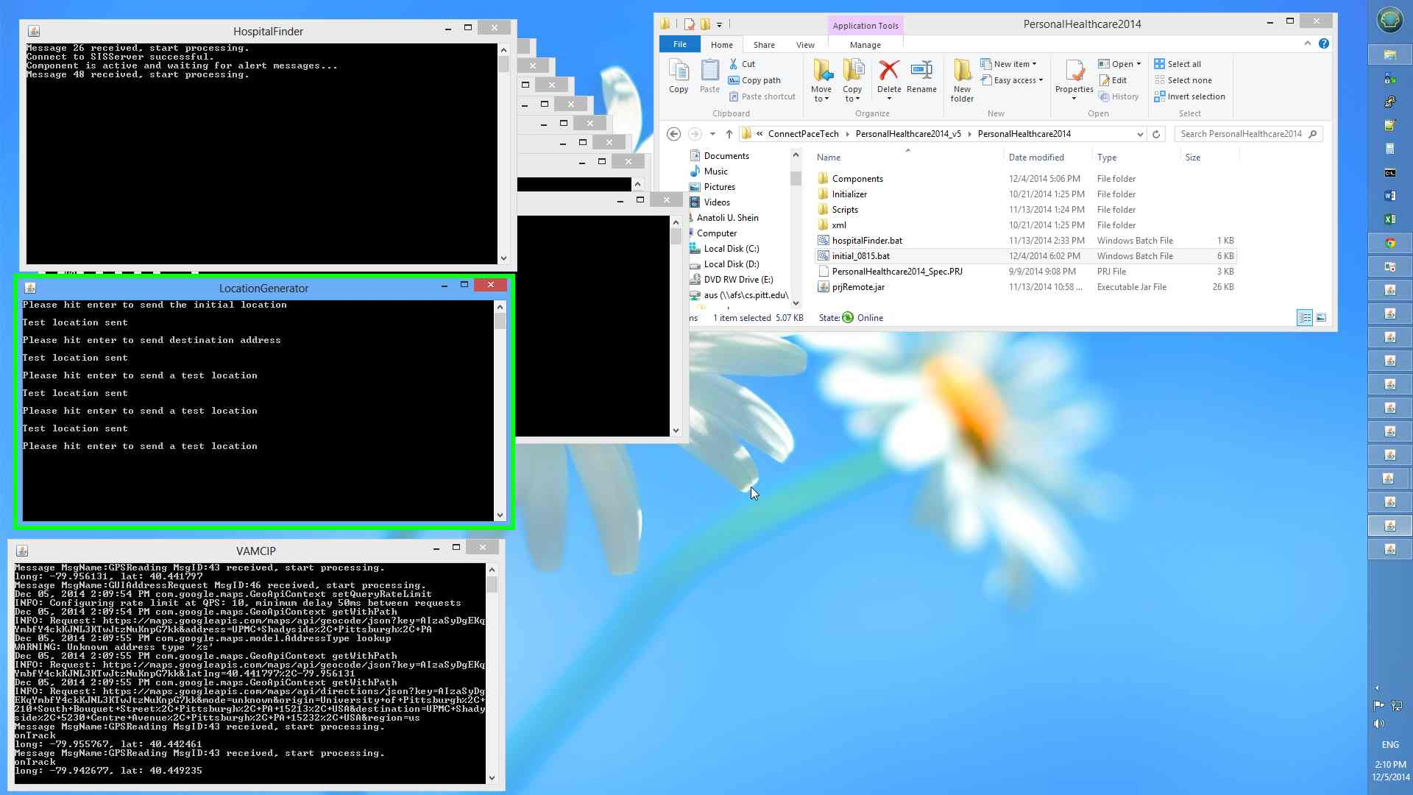

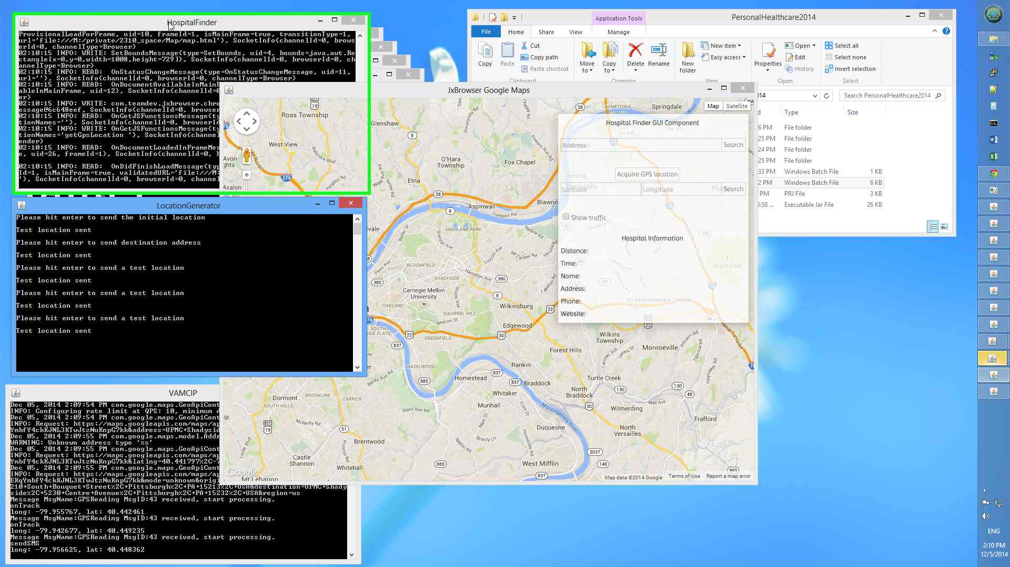

The HospitalFinder component opened a GoogleMaps window:

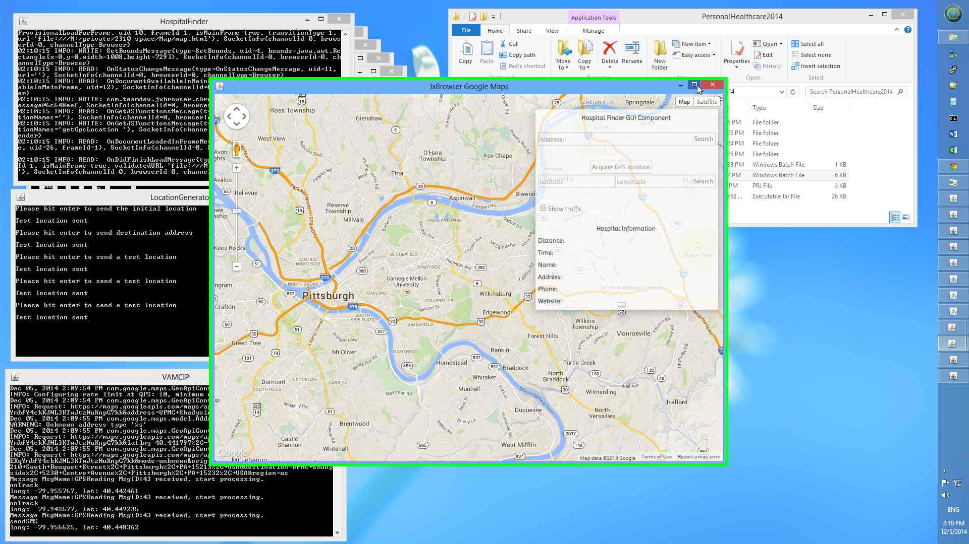

An operator requested the coordinates of the patient from VAMCIP (using Coordinates Request message). They were supplied back in a Coordinates Response message and the location of the patient was plotted on GoogleMaps:

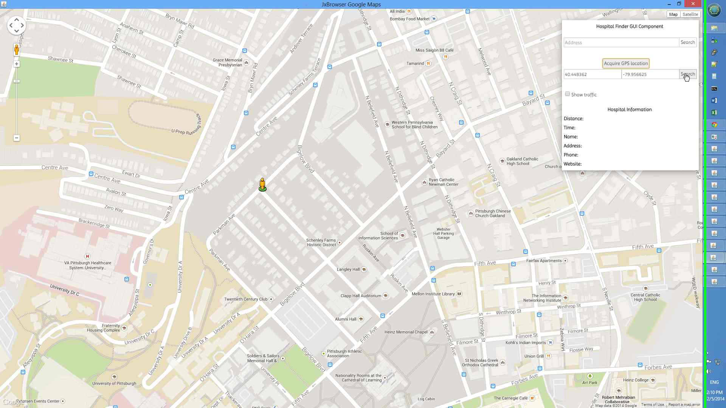

The patient got a short text message:

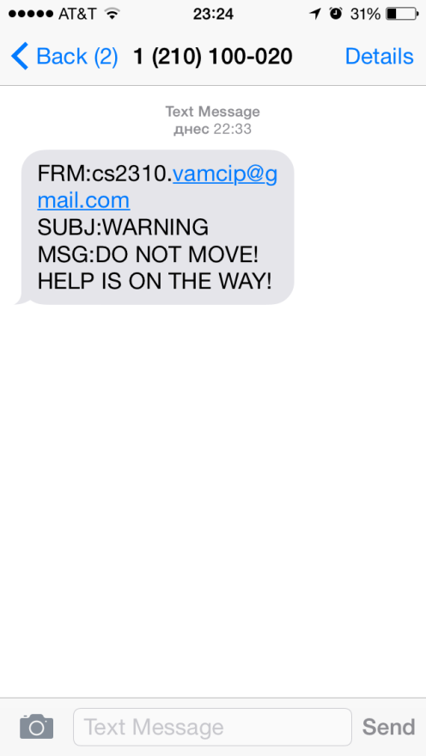

The rest of the functionality is provided exclusively by the HospitalFinder component.

It found the three hospitals, closest to the patient:

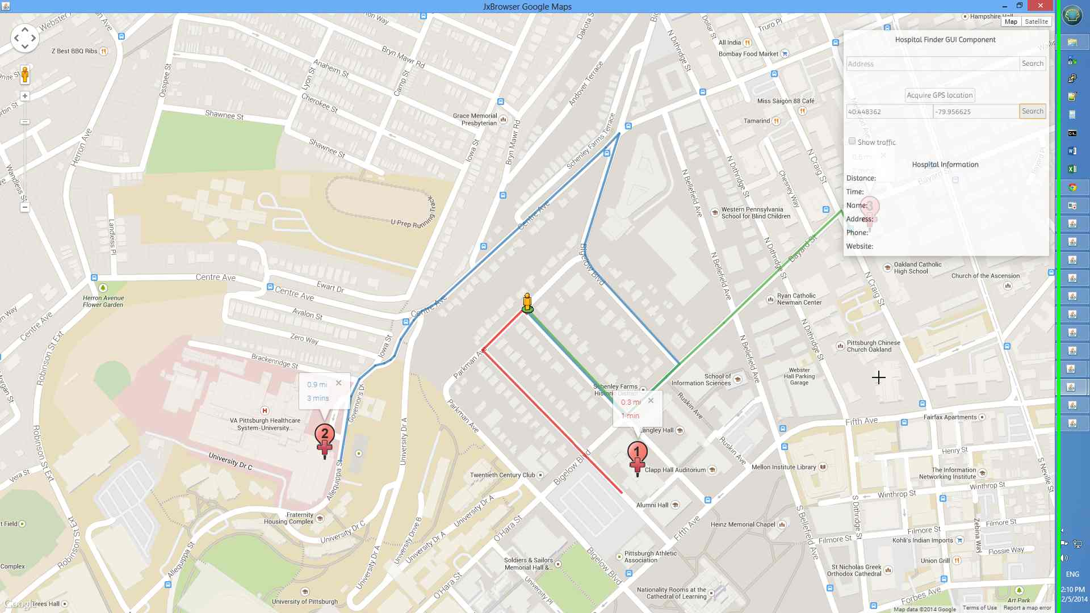

And upon additional request, the component provided details about the hospitals – contacts, address, etc.:

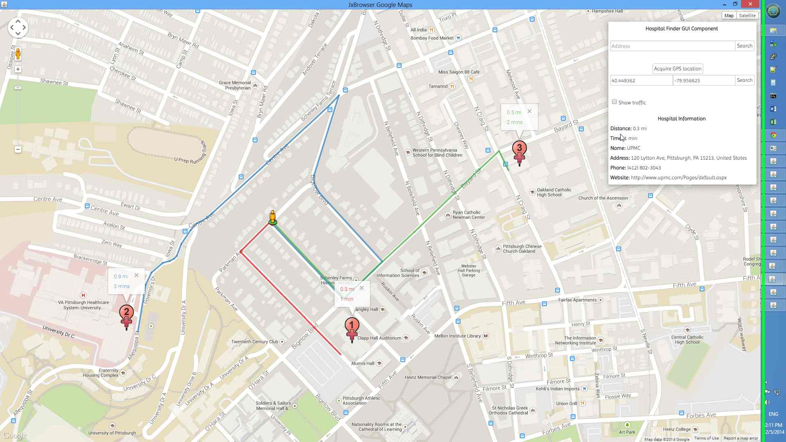

1. Source: 2013 Alzheimer’s Disease Facts and Figures (www.alz.org/downloads/facts_figures_2013.pdf)