***CS 2310 Final Project Report***

***Coordination Monitoring among Temperature Component, EKG Component and Blood Pressure Component***

***Senhua Chang Sec104***

**Part 1. System Overview**

The health Care SIS can help a senior citizen who may not be computer-literate. What my project mainly contains a Temperature Monitor which can prevent a senior citizen suffer freezing or hot temperature, cooperating with a EKG Monitor which is monitoring the patient’s heart beat pattern real time, and a Blood Pressure Monitor which is monitoring the patient’s blood pressure’ s condition. Those three Components can work together very well and send messages to each other to informs patient’s condition and determine whether need to send an Alert message.

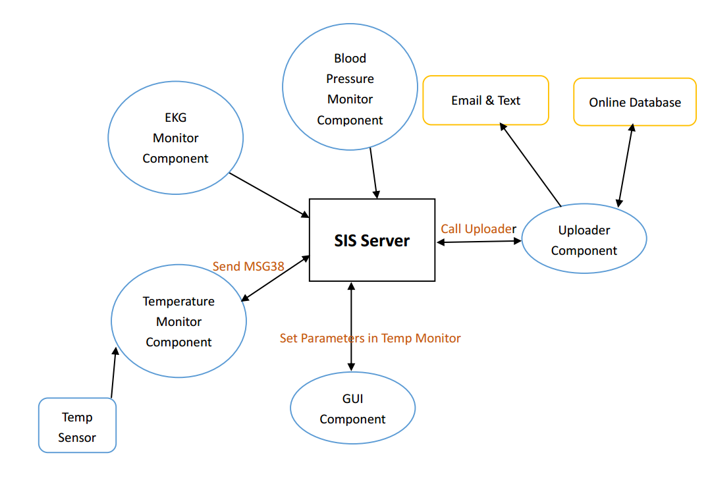

Figure 1. System diagram

**Part 2. System working procedure**

This part is mainly show you how to set up and launch how the components and how components work with each other to inform each other how the patient’s health conditions and how to decide alert message should be sent or not.

***Step 1.*** *Launch the basic components, including GUI and uploader.*

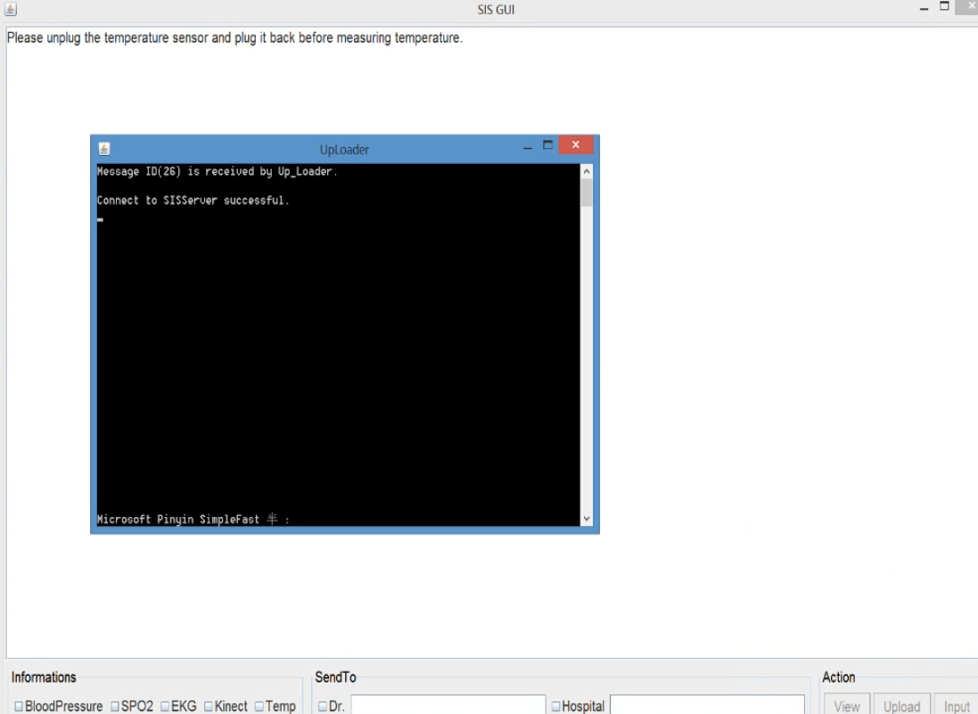

***Step 2.*** *Click Temp checkbox to launch the temperature component setting.*

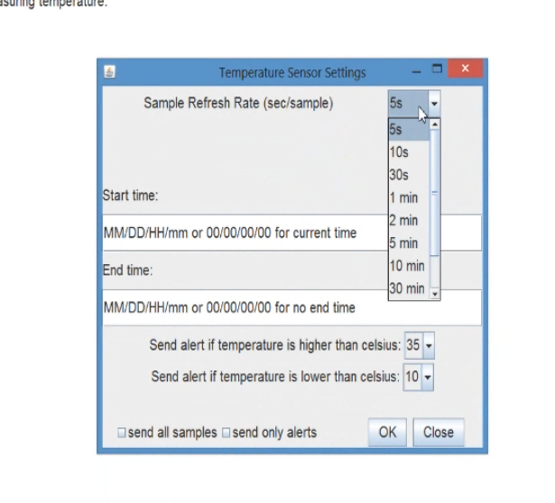

***Step 3****. Setting the Temperature variables such as start monitor time, End time, refresh time, high temperature threshold and low temperature threshold, and then click Ok button to launch the Temperature Component. Then click view button in GUI to active the Temperature component to start monitoring.*

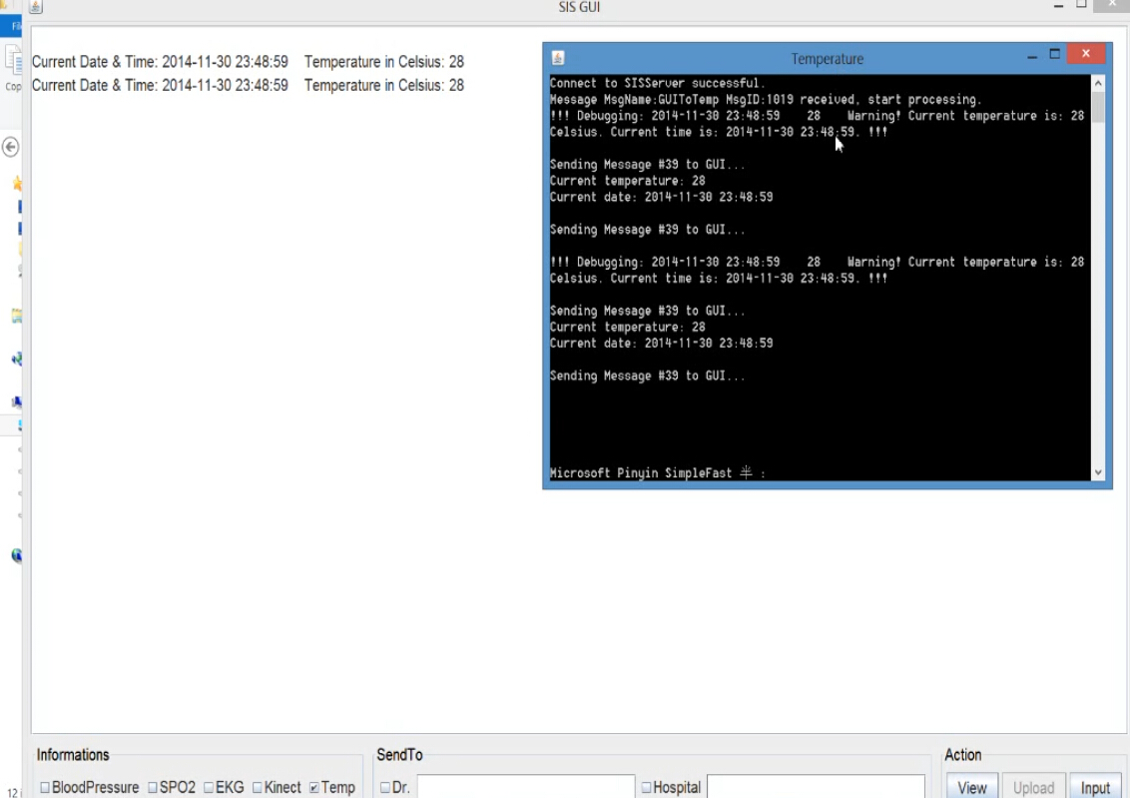

***Step 4.*** *Launch the EKG monitoring component and blood Pressure Component and active those to start monitoring the patient’s heart beat pattern and blood pressure.*

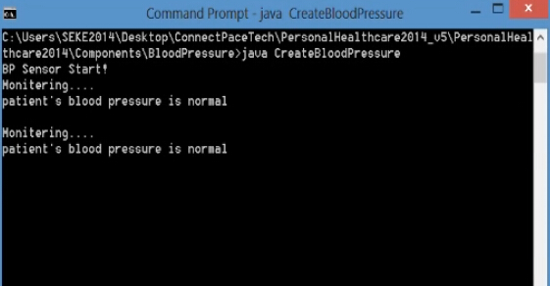

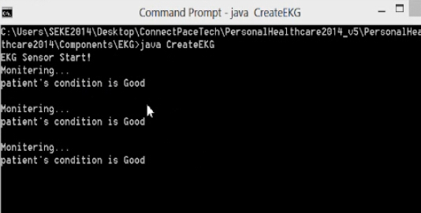

***Step 5.*** *Three components are now working individually, monitoring patient’s condition and temperature in real time, when the EKG component detect some bad heart beat pattern, it will send message 99 to Temperature component to inform temperature component that the patient’s heart beat pattern is bad right now, and ask temperature component to check the temperature change during the last one hour to decide whether an complex alert message 38 should be sent to doctor or patient’s children. At the same time, when Blood pressure component detect a high or low blood pressure, it will send message 98 to Temperature component to inform that patient’s blood pressure is a little high and low and ask temperature component to check the temperature change during the last one hour to decide whether a complex alert message 38 should be send to doctor.*

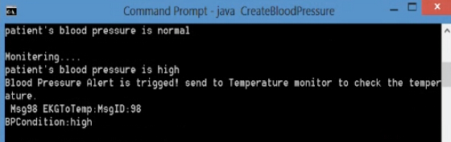

High blood pressure is detected, and Message 98 is sending to temperature component.

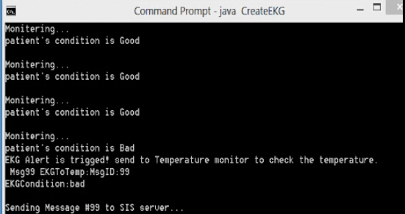

Bad Heart beat pattern is detected, and message 99 is sending to temperature component.

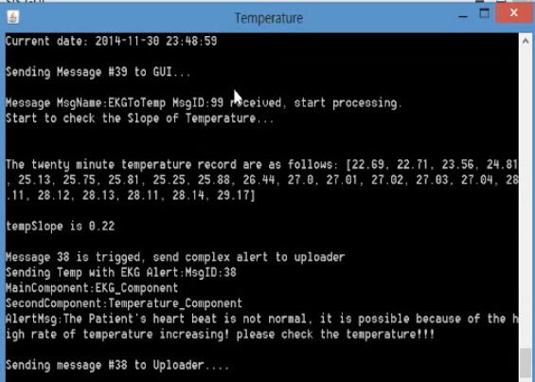

Message 99 received and temperature component start calculating the temp slope which represent the temperature changing during the last an hour, and if the temp slope higher or lower a threshold, it means the temperature changing during last one hour is not normal, a complex alert message 38 will be send to uploader. And uploader will send Email to doctor.

***Step 6.*** *Temperature component can do his own job well, which is that monitoring temperature, when the temperature is higher or lower the setting threshold, an alert message 40 will be sent to uploader and an email will send to doctor.*

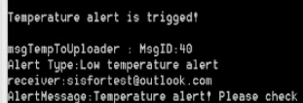

Low temperature alert

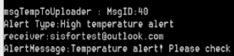

High temperature alert

***Step 7.*** *Check the Uploader and check the email box to figure out whether the whole system working good.*

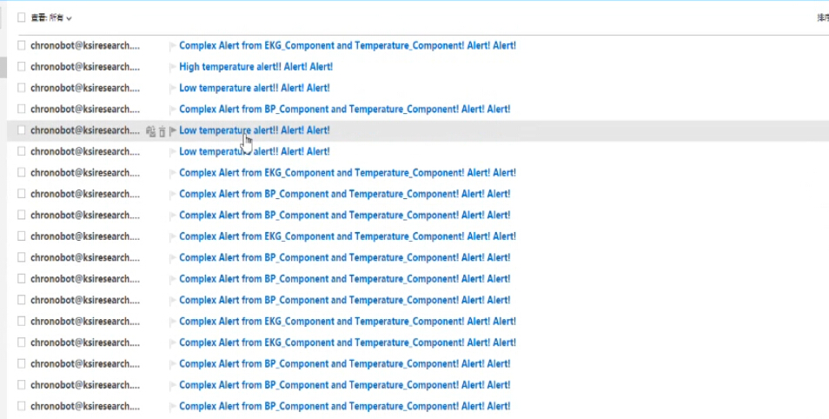

You can see, there are many kind of alert emails, including the low temperature and high temperature alert; complex alert from EKG component and Temperature Component; complex alert from Blood Pressure component and temperature component.

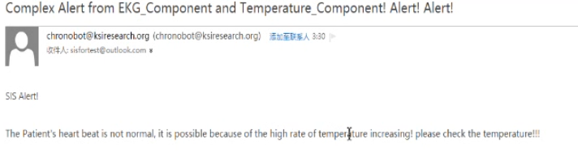

You can see the email content contains the alert message, and the system inference, in this email, is that the heart beat is not normal, may be because of the high rate of temperature increasing. The system seems to have intelligence!

***Part 3. Summary and future work***

In my course project, the system has already show a little intelligence to determine what is the cause of patient’s bad health condition and determine whether a complex alert need to be sent. However, in this project, the data read by EKG component and Blood Pressure component are all simulative data. In the future, I want to implement the real EKG monitoring component and Blood Pressure monitoring component, and at the same time, optimize the alert determination algorithm.

Video Link: <http://youtu.be/uwOzWuCaca0>