Exercise 4.a

Entity Relationship diagrams for all the entities:

SensorType

SensorId

PatientId

Sensor

Gets row for specified gestureId

Maps Sensor Type & Voice message or gesture

InformationId

Name

SensedValue

Information

Detects voice or gestures

SensedValue

Contact

Address

DiseaseInfo

Name

Patient

Application of multimedia functional dependency on the above entities:

1. Functional dependency 1:

R:{ SensedValue, GestureId, VoiceMessage, Gesture}

Mfd: SensedValue g1(t1)-> { GestureId, VoiceMessage, Gesture } g2(t2)

SensedValue can be characterized by independent values like audio & video. These can be incorporated in the database as follows:

R can be replaced by R1: {SensedValue, audio, video} & R2: {audio, video, GestureId, VoiceMessage, Gesture}

On which mfd1 & mfd2 hold respectively.

Mfd1: SensedValue g1(t1)-> { audio, video } g3(t3)

Mfd2: {audio, video} g3(t3)->{ GestureId, VoiceMessage, Gesture } g2(t2)

1. Functional dependency 2:

R: {Gesture, SensorType, VoiceMessage}

Mfd: Gesture g1(t1) -> { SensorType, VoiceMessage} g2(t2)

Gesture can be characterized by independent values hand, mouth, nose, neck & eyes.

These can be incorporated in the database as follows:

R can be replaced by R1 & R2.

R1: {Gesture, hand, mouth, nose, neck, eyes}

R2: {hand, mouth, nose, neck, eyes, SensorType, VoiceMessage}

Mfd1 & mfd2 hold on R1 & R2 respectively.

Mfd1: Gesture g1(t1) -> {hand, mouth, nose, neck, eyes} g3(t3)

Mfd2: {hand, mouth, nose, neck, eyes} g3(t3) -> {SensorType, VoiceMessage} g2(t2)

1. Functional Dependency 3:

R: {InformationId, Name, InformationDoc, GestureImages, AudioRecords, TextDocs}

Mfd: InformationDoc g1(t1) -> { InformationId, Name, GestureImages, AudioRecords,

TextDocs} g2(t2)

InformationDoc can be further characterized by independent values symptoms, effects, prevention, pros, cons.

R can be replaced by R1 & R2.

R1: {InformationDoc, symptoms, effects, prevention, pros, cons}

R2: {InformationId, Name, symptoms, effects, prevention, pros, cons, GestureImages, AudioRecords, TextDocs}

R1 & R2 have mfd1 & mfd2 on them respectively.

Mfd1: InformationDoc g1(t1) -> {symptoms, effects, prevention, pros, cons} g3(t3)

Mfd2: {symptoms, effects, prevention, pros, cons} g3(t3) -> { InformationId, Name, GestureImages, AudioRecords, TextDocs}

1. Functional dependency 4:

R: {InformationId, Name, InformationDoc, GestureImages, AudioRecords, TextDocs}

Mfd: TextDocs g1(t1) -> { InformationId, Name, InformationDoc, GestureImages, AudioRecords} g2(t2)

TextDocs can be further characterized by independent values word document, excel document, pdf.

R can be replaced by R1 & R2.

R1: {TextDocs, word document, excel document, pdf}

R2: {InformationId, Name, InformationDoc, GestureImages, AudioRecords, word document, excel document, pdf}

R1 & R2 have mfd1 & mfd2 on them respectively.

Mfd1: TextDocs g1(t1) -> {word document, excel document, pdf} g3(t3)

Mfd2: {word document, excel document, pdf} g3(t3) -> {InformationId, Name, InformationDoc, GestureImages, AudioRecords, word document, excel document, pdf}

IC Cards for the above system:

User performs some hand gestures or says something which is captured by the sensors

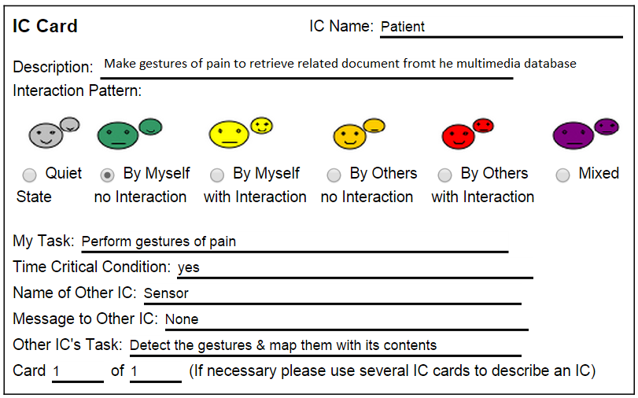

The Sensors detect the gestures or voice and retrieve the required info from the sensedValues table.

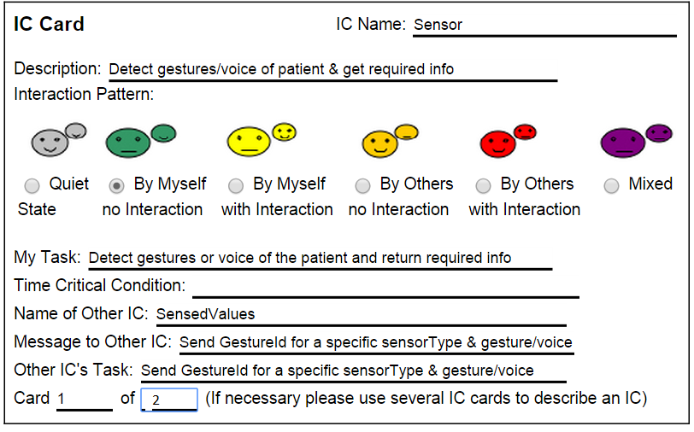

The sensedValues table then returns a specific GestureId for the observed gestured or heard voice.

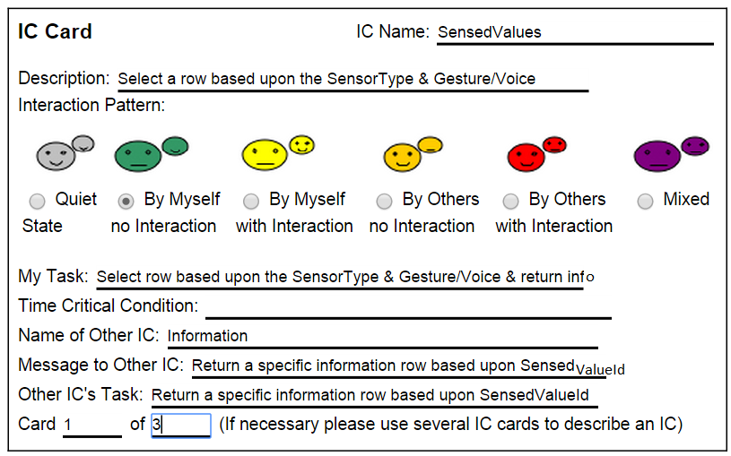

The gestureId from SensedValues table is used to retrieve a specific row of information tfrom the information table which is then returned to the user.

