**CS2310 Exercise 4**

Anh Phan Nguyen

[apn15@pitt.edu](mailto:apn15@pitt.edu)

**1. Application requirements**

A multimedia database that store a predefined list of voice responses. Here the assumption is that the senior citizen is not familiar with convention input method using keyboard, thus interaction via gesture/voice response is used as an alternative method. Each time patient issues a gesture, a voice response that corresponds to the gesture is played back at the patient computer, provide a list of options for the patients.

This is similar to the voice responses when we call to a number and receive the automatic voice response, which also provide a list of options and corresponding key pad enter. The detail description of the application is as following:

A senior patient want to remotely retrieve his current health information such as temperature, blood pressure, blood sugar, Pulse Oximeter Oxygen Saturation.

* Step1: patient issue a gesture0 to wake the voice interface. The gesture is send to the server. The server transmit the default voice response to the client computer to played back.
* Step2: patient issue gesture1 to ask for his current health status information. Gesture1 is sent to server.
* Step 3: Server identify gesture1, send back voice response confirm the previous action of patient.
* Step 4: Server retrieves health information of patient, send back to client.

The application has three components:

Voice_response_server

Database server

User is patient.

Voice_response_server passes gestures to database server and relays the responses from database server back to user.

Database server stores voice responses and user data.

**2. Multimedia database design**

The database has two relations:

R1: (**gestureFeature**, voiceResponse)

R2: (**PatientID, time**, PatientName, temperature, bloodPressure, bloodSugar, SPO2)

In R1, guestureFeature is the key field uniquely identify each record. Thus there is one multimedia functional dependency in R1 as following: gestureFeatureg1(t1) 🡪 voiceResponseg2(t2)

In R2, patientID and time uniquely identify a record. The second multimedia functional dependency in R2 is: {patientID, time}g3(t3) 🡪 {temperature, bloodPressure, bloodSugar, SPO2}g4(t4)

There are two queries sent to database server.

**Gesture queries:** when a patient issues a gesture, voice_response_server extracts the feature data from the gesture, and sends this feature data to database server in the form of a gesture query. Database server receives gesture query, compare the feature data of the gesture with records stored on R1 to identify gesture, then returns the voice response.

**Patient Info queries:** when a patient issues health-info-request gesture, the gesture data is sent to voice_response_server along with patientID. The extracted feature data along with patientID is then relayed to database server in the form of a Patient-Info query. This gesture is identified by matching with templates on R1, if matched, database server return information of patient based on patientID.

**3. IC cards**

1. Patient IC cards

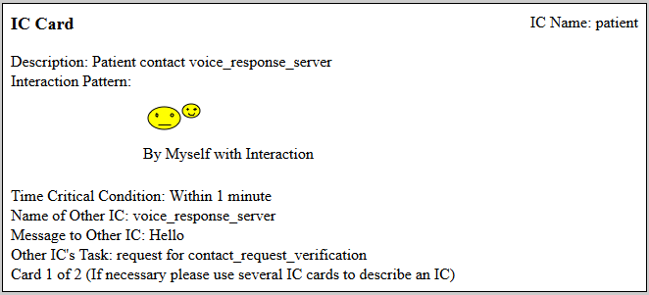

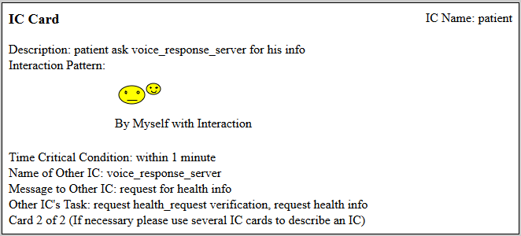

2. voice_response_server IC cards

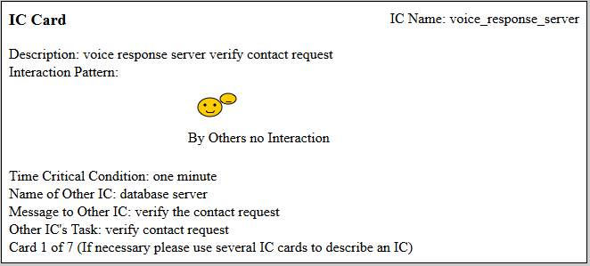

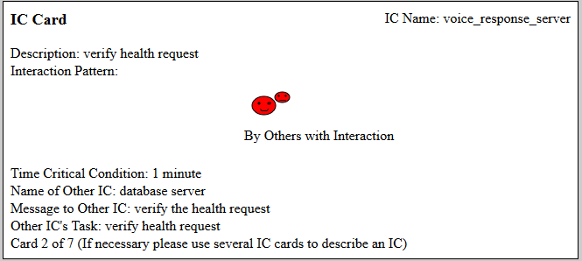

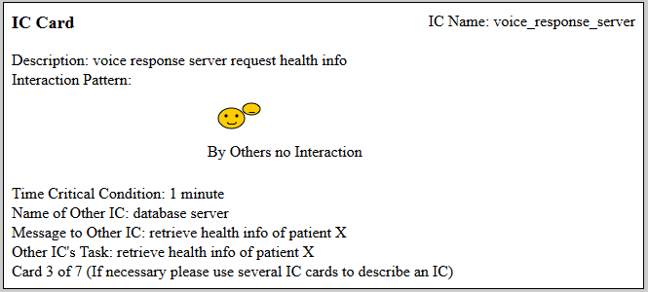

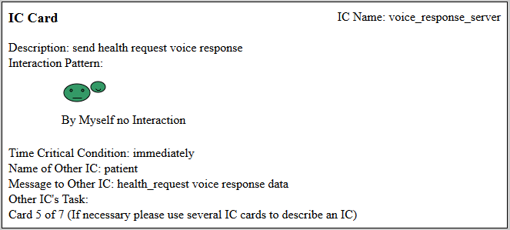

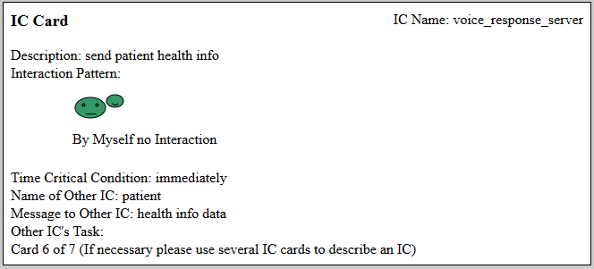

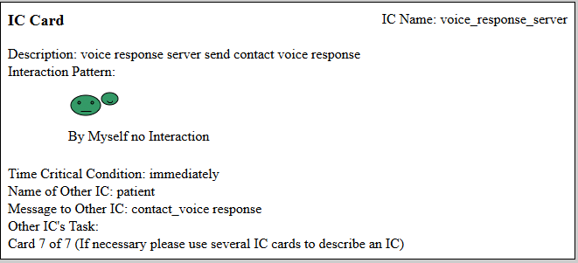

3. Database server IC cards

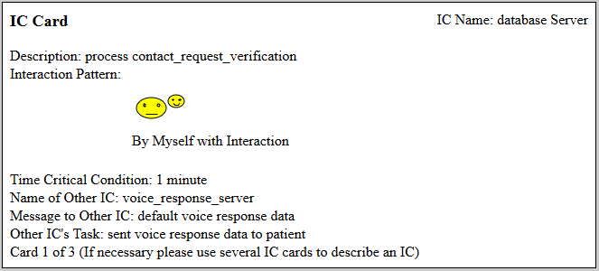

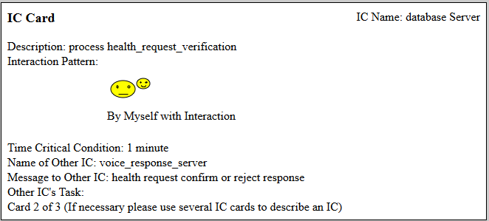

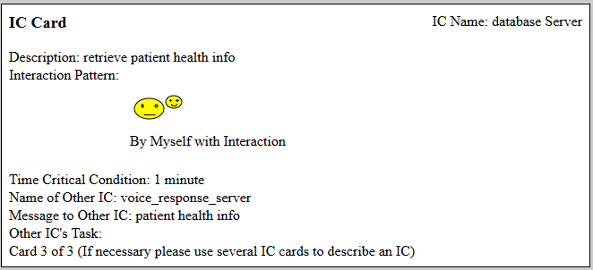

**4. Identify the patterns**

**Pattern 1:** in Request Classification Scheme, when an end system sends a request with data (gesture), there is a need to classify the data to identify the request. Then one way to solve this problem is to separate the server into two part, the Request Processing Server and the Database Server. The Request Processing Server interacts with end system while the Database Server stores the data related to the request for match making decision.

Context: a system comprises of one end system and one server. End system interact with server by sending request.

Problem: Each request issued by patient contains data that need to be analyzed and classified by matching with a list of data stored in database.

Solution: Divide the server into two parts, one is the request processing server that receives requests from end system, analyzes the request and send the processed data to database for verification. Database server receives request, classifies the requests based on the list of templates data which have been stored beforehand.

**Pattern 2:** There are at least two ways for a user to interact with a system. One way uses elaborated technique but convenient, the other uses simple technique but requires some skills from users. Which techniques to be used is depend on the requirements.

Context: a user interact with a system.

Problem: need to propose a suitable interaction method between user and system.

Solution: depend on the practice, a method that needs more elaboration, requires more processing power and storage maybe be used if the user is lacking of basic computer skills. Or simple method interaction maybe used but user need training.