For each senior citizen, this application offers them some instructions when occurring emergency situation.

In **database**, we have 4 tables:

* photoInstruction
  + pi_id which is the index
  + function which is the function of each instruction
  + photos which is the instruction photo
  + tableType in this table, the tableType is 1, which means photo
* audioInstruction
  + ai_id which is the index
  + function which is the function of each instruction
  + audios which is the instruction audio
  + tableType in this table, the tableType is 2, which means audio
* textInstruction
  + ti_id which is the index
  + function which is the function of each instruction
  + content which is the instruction text
  + tableType in this table, the tableType is 3, which means text
* gestureCorrespondence
  + gc_id which is the index
  + GestureTypePhoto which is sample gesture photo. User can imitate them. Each gesture photo corresponding a specific function in a specific type.
  + instructionType which is either 1,2, or 3. 1—photo; 2—audio; 3—text.
  + functionType which is the specific function.

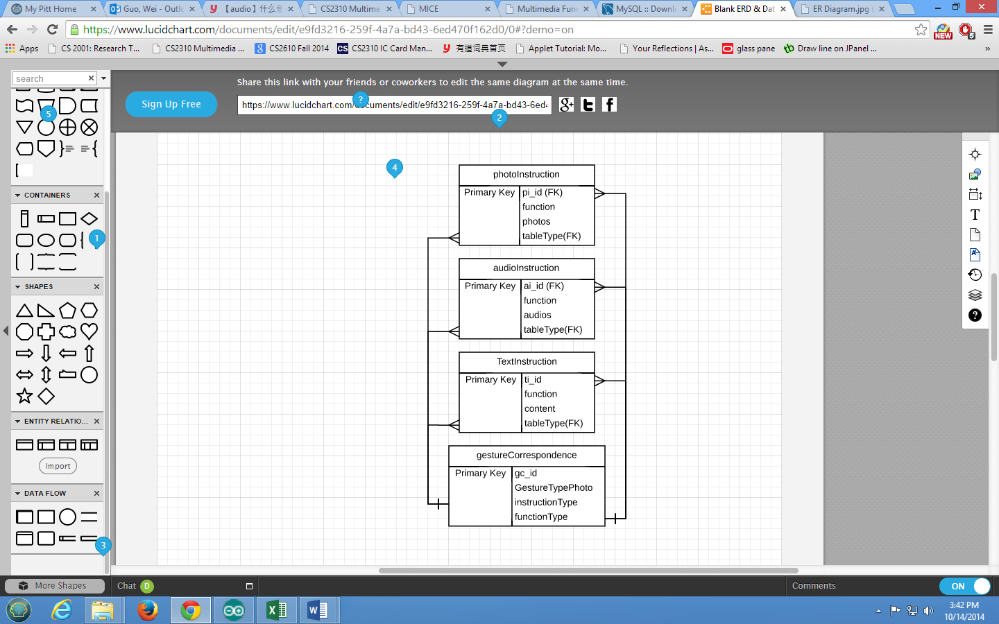

**Multi-media dependency:**

{gc_id, GestureTypePhoto, instructionType, functionType}gesture(t1) -> {pi_id, function, photos, tableType}photo(t2)

{gc_id, GestureTypePhoto, instructionType, functionType}gesture(t1) -> {ai_id, function, audios, tableType}audio(t2)

{gc_id, GestureTypePhoto, instructionType, functionType}gesture(t1) -> {ti_id, function, content, tableType}text(t2)

For any two tuples u1 and u2 such that u1[gestureCorrespondence] is considered similar within the threshold t1 to u2[gestureCorrespondence]

**IC cards:**

