Eric Gratta

S. K. Chang

CS 2310

Exercise 1, due 9/11/2014

**Part (a) – IC Cards**

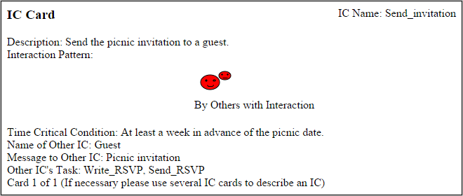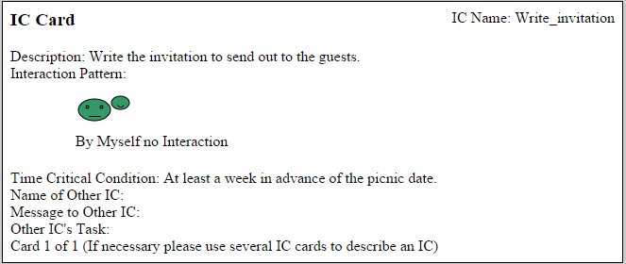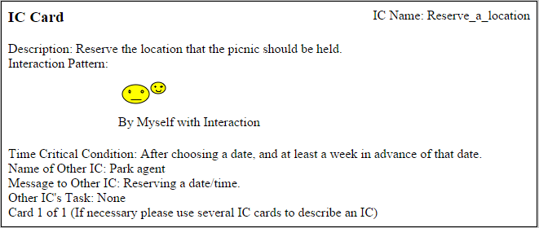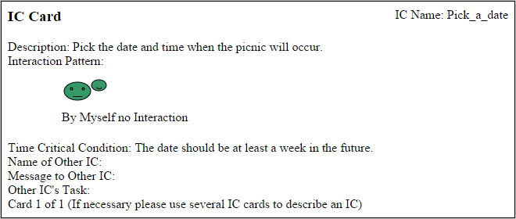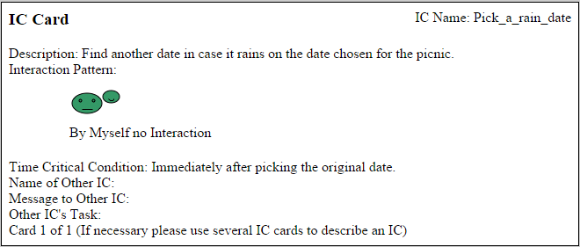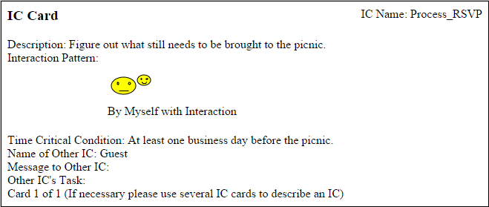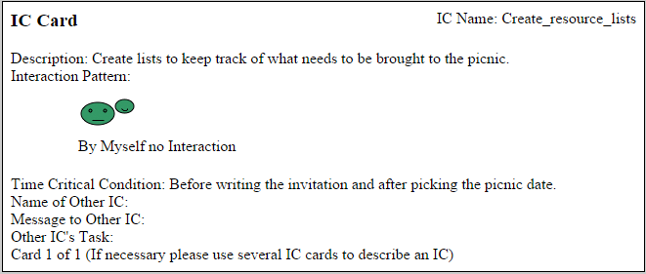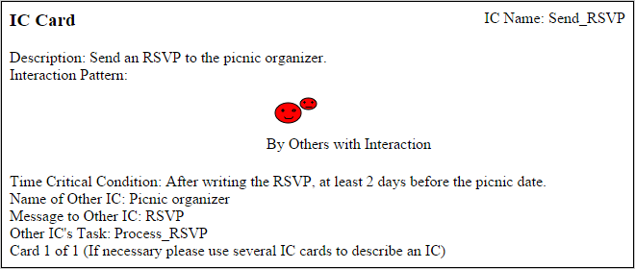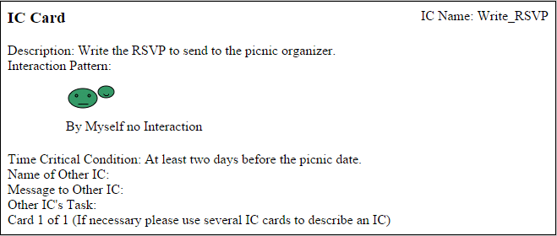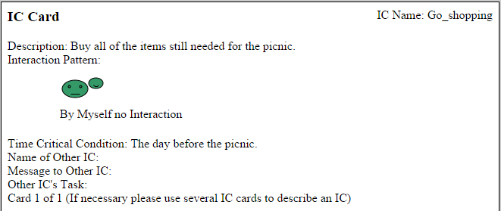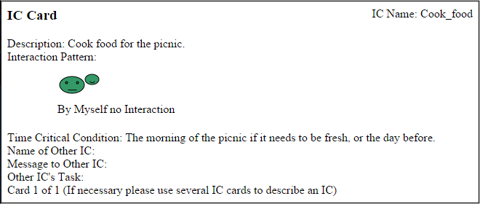

**Part (b) – Patterns**

Using the definition given in class describing patterns as a *context*, *problem*, and *solution*, there are two primary patterns that can be observed in organizing a picnic. The two contexts are the roles of the picnic organizer and that of the guest.

In the context of the picnic organizer, the problem is that they need a large number of resources to prepare for the picnic, and their solution is to synchronize the help of their guests to bring those resources. The picnic organizer needs to perform a lot of (what I will call) high-level tasks, such as compiling and keeping track of information and polling the guests of the picnic for information about what they are bringing.

In the context of the guest of a picnic, the problem is that they need to provide resources for the picnic that they said they would bring in their RSVP, and the solution is just the busy worked in getting those resources. This includes food, sports equipment, and general picnic equipment (tables, chairs, blankets, tents, etc.). These direct involvements with resources can be viewed as low-level tasks.

With the two patterns in combination, the high-level organizer never interacts with resources directly but hands off tasks to all of the guests by sending messages down to them. The guests respond and then do the busy work of cooking and shopping and preparing. The organizer reviews the RSVPs and synchronizes all of the information to make sure that the picnic as a whole will be completely prepared.

Only communicating about who is attending and who is bringing what resources necessitates interaction. The picnic organizer works independently on compiling lists of information. The guests work independently preparing resources.