CS2310 Term Project Milestone1

Junxiang Wu

**Title**: Design a “Fast Access” tool based on Gesture Recognition

**Description** emerging senor technology provides us new way to interact with computer.

In this project, I will demonstrate a human-machine interaction scheme using gestures with the help of “leap motion” senor. Specifically, I will design and implement a tool allow user to fast access some common functions, such as open a web-browser, with dedicated gestures. It also involves dynamic patterns such as rolling a page by moving figures.

**Progress**

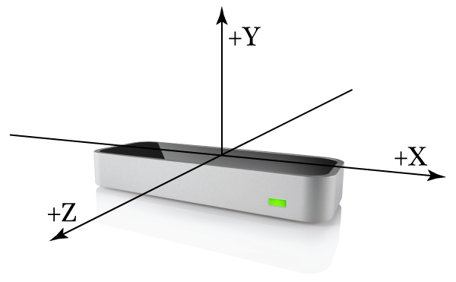

1. Studied Leap motion developer documentation, understand its retrieved data format.
2. Setup Leap motion develop environment under NetBeans IDE
3. Running sample application and get data samples
4. Play with sample data and primitive hand gestures, including swipe, circle, screen tap and key tap.
5. Try to use combinations of primitive gestures to accomplish an action, for example using circle to open a notepad.

**Next Step**

1. study swipe gesture to capture more detailed movement and converted it into an action
2. Create a scenario that using gesture to open, operate and exit an application.