**Milestone 2**

**Super Component of Blood Sugar Monitor**

----Ping Lang (pil8@pitt.edu)

**Project Description:** To complete a super component for blood sugar monitor. Monitoring patients’ blood sugar, based on different peoples’ different data patterns, to generate a customized alert & alert messages with high accuracy.

**Milestone 2 deliverables:**

* Diabetes patients & Normal people blood glucose level ranges

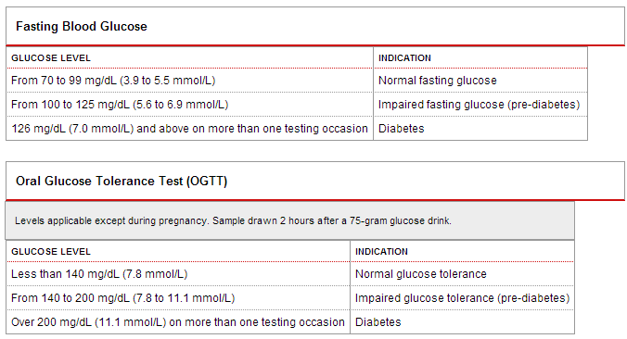

* Gestational Diabetes screening (will do it if everything goes well)

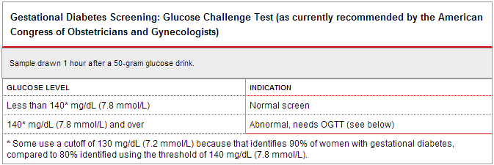

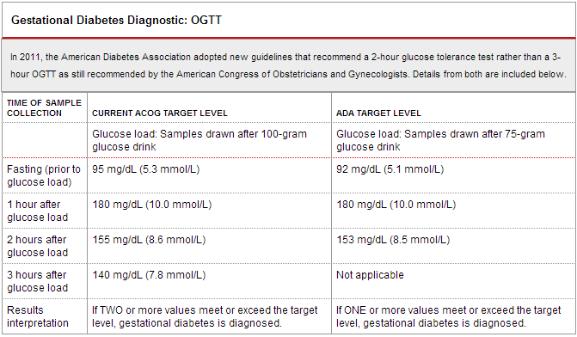

* Super Components Design

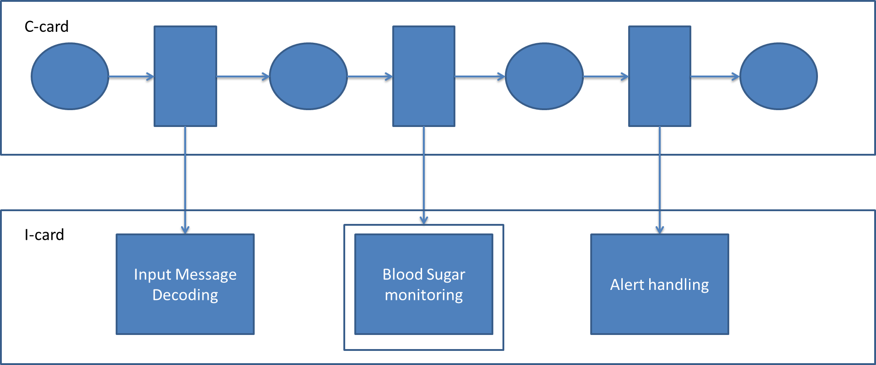

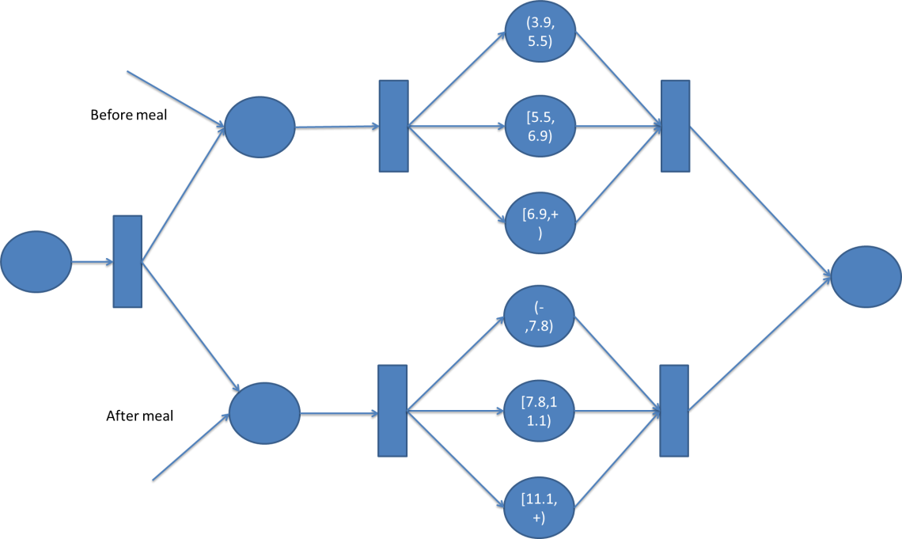

* Demo

Input:

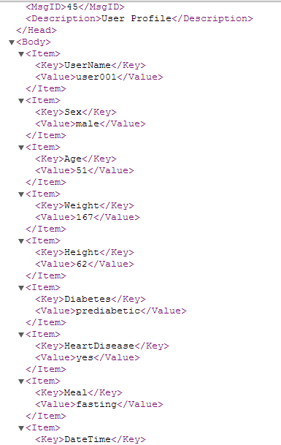 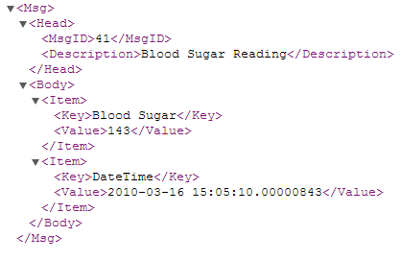

Output:

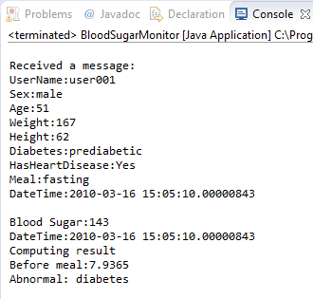

As we can see from the demo result, when getting input messages. It first test whether it is before meal or after. After that, based on the input blood sugar, which is 143mg/dl in this case, it is calculated to mmol/L (Because it is more common used around the world) and determine if there’s an emergency or not.

**References:**

The global diabetes community: <http://www.diabetes.co.uk/index.html>

<http://www.news-medical.net/health/Blood-Sugar-Normal-Values.aspx>

<http://labtestsonline.org/understanding/analytes/glucose/tab/test>

SBDR- SOCIETY FOR BIOMEDICAL DIABETES RESEARCH:

<http://www.soc-bdr.org/rds/authors/unit_tables_conversions_and_genetic_dictionaries/e5184/index_en.html>