CS2310 Term Project Milestone 1 Zhong Zhuang

## Title :

Restaurant inventory control system

## Motivation:

Restaurant inventory control can be very complicated and inefficient, especially for Chinese restaurant. Normally there are more than 200 different items in the inventory including meats, vegetables, source, spice, dry product, cooking tools, packaging etc. They all come from different suppliers, and their price changes constantly. This project intends to develop an inventory control system based on slow intelligence system. The preliminary goal is to generate a list for all items with cheapest pricing dynamically. The ultimate goal is to automate every aspect of inventory control.

## System diagram

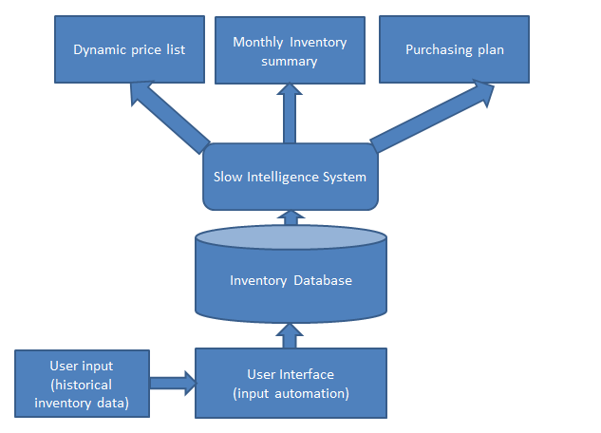

## Programing tools

* Java as the main programing tool
* JDBC and SQL as the database part
* Java GUI as the interface

## MS2 plan

Finish the database and slow intelligence engine

## Minimum accomplishment

Finish the dynamic pricing list part.