CS2310 Term Project Milestone1
Wen Gao

Title
Publication Integration System

Motivation & Requirement Analysis
Multimedia services need to be supported by content, metadata and an appropriate management system to efficiently manage huge amount of content items and metadata productions. Usually some conference administrators need to support the organization and delivery of multiple conferences, which has a lot of redundant information among all these conferences. Based on this situation, a solution of providing metadata extraction and creating a unified back database is proposed in this project.

Architecture
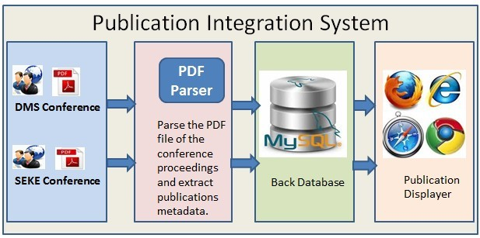

Functional Modules
- PDF parser and metadata extraction
- Metadata storage
- Publication displayer
- Metadata exportation

Programming Tools
- MySQL will be used as the back database.
- Java programming language and a java library pdfbox will be used for the PDF parser function.
- HTML, PHP and Javascript will be used for the web displayer and metadata exportation.

Accomplishment by MS2
The Prototype which includes: MySQL Database design and implementation; Architecture Design; UI design and implementation.

Accomplishment by Project Demo
Design and implementation of all the functional modules we talked above.

Minimal Accomplishment
Metadata collection module including database implementation and PDF parser tool need to be finished during this semester in case of extraordinary conditions such as time limitation.

