Project Report of CS2310: IC Builder and XML Wrapper
Lin Li, lil53@pitt.edu
2008-4-24

Project Report of CS2310: IC Builder and XML Wrapper 1
Steps to use the IC Builder in modern OS: 1
Under Windows XP and Vista 1
Under Linux/Unix 2
IC Builder Tutorial 2
XML Wrapper Problem Specification 3
Parser 5
Hash-Array Tree Structure 5
Exporting XML 5
XML Wrapper User Guide 6

The accomplishment of the project includes two parts: first, use the IC Builder in newer Windows versions, including Windows XP and Vista; second, implement the wrapper for the generated .in file to be used as .xml file. The first mission enables modeling the Index Cells for the IC compiler and IC Builder in modern Windows OS, and the second mission enables the built Index Cell specification to be used in newer IC developing system.
IC Builder is the front end of the IC developing system. Within the graphic interface, user could define multiple Index Cell types in one project, with each Index Cell type as a .gra file. The .gra file defines the internal states and the transitions of the Index Cell type, which is to be used in IC compiler.

Steps to use the IC Builder in modern OS:

Under Windows XP and Vista
Right Click the icon of ICTAPP.EXE, click “Properties” in the prompted menu;
In the “ICTAPP.EXE Properties” dialog, choose the “Compatibility” tab;
In the “Compatibility mode” section, check the box before “Run this program in compatible mode for:”, and chose the Windows 98/ Windows Me, and click OK.
The IC Builder could run smoothly under Window XP and Vista. In IC Builder, the project could be set, and individual .gra file could be included in the project. All the .gra files can be saved and exported to the corresponding .in file. The .in files and the .dat file is fed to the IC Compiler and IC manager.

Under Linux/Unix
Install the “wine” package to provide the API equivalent with that of the Windows in Linux
Run “winecfg” to configure the API simulation conforms to the Windows 98 version.
Run “<wine install path>/wine ICTAPP.EXE” to launch the IC Builder.
The IC Builder under the Linux could be used to save .gra file. However, it could not be used to export the .in file, due to the virtual path in the wine simulator. Thus, under Linux, we could not use IC Builder to export the .in file.

IC Builder Tutorial
Here an example of how to use IC Builder to build Index Cell types.
The three Index Cells we are modeling are the Deficiency, Proficiency and Self-adjustment Index Cell in the Exercise two.
- Setup the project files: click “Simulation” in the menu bar, and click “Project”. In the prompted “Project Files” dialog box, type the file name that will be included in the project and click “add” button to add the .gra file into the project. Also, “Remove” button could be used to remove the existing .gra file from the project. This step will generate the proj.ini file describing the .gra files like:
[Files]
File_List= pro.gra def.gra selfadjust.gra
- Define the Deficiency Index Cell: create the states 0, 1, 2, 3 by clicking the “create a new state” button; create the transitions by first clicking the “connect two states” and click the source state and drag to the target states; define the input message, output message, and actions for each transition. The input message and the .gra file are shown in Figure 1.
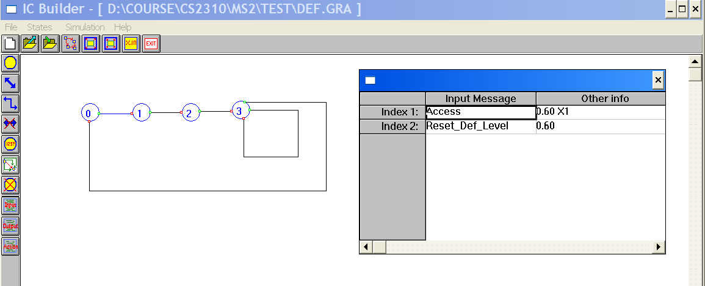
Figure 1: Example of def.gra and its input message definition
- Export the .gra file to the .in file: after saving the existing file, click the “create xx.in output file” button, and the .in file with the same file name of the .gra file will be exported in the current directory. For example, the def.gra file will be exported to def.in file.
- Define the Proficiency Index Cell and Self-adjustment Index Cell in the similar way, and export them into the .in file, as shown in Figure 2.
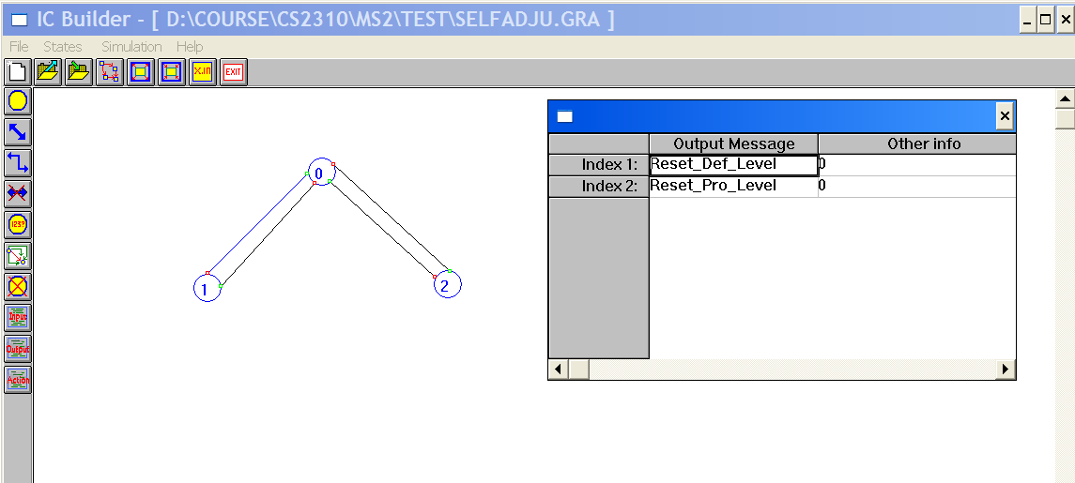
Figure 2: Example of selfadju.gra and its output message definition

XML Wrapper Problem Specification
The XML wrapper of .in file converts the .in file into the .xml file to be accessed by modern software developing environment. The XML file contains the information of all the objects in the .in file.
The .in file formalizes all the transitions of one Index Cell, the format is defined as:
<digit>// number notation of current state
<digit>// number notation of next state
<digit>// number of input message(s)
Message.1 // Input message 1 definition
....
Message.n // Input message n definition
<digit>// 1: predicate; 0: no predicate
<digit>// number of output ic(s) to which the output message is sent to
<digit>// number of output message(s)
Message.1 // Output message 1 definition
....
Message.n // Output message n definition
<digit>// number of action(s)
<digit>, para // number notation of actions and their parameters
....
<digit>, para // number notation of actions and their parameters

All the objects in the XML file is organized in the tree structure, as shown in Figure 3. The root node of the XML file is the icSystem, with the child node of multiple Index Cells. Each .in file describe one Index Cells. In each Index Cell, there are several states and transitions. All the transitions are defined in the .in file, and the states information could be extracted from the source and target state of each transition. Each transition composes several messages and actions. Each message composes several targetICs, parameters and predicate. All the objects in the tree have there own attributes.
Figure 3: Tree Structure of all the objects in XML
To convert the .in file to the .xml file, a parser is needed to parse all the necessary information in the .in file, and process them in a tree structure and export this tree structure to the .xml file. Thus, the parser and XML exporting are the two major parts in the wrapper.

Parser
The parser is used to parse all the necessary transition information in the .in file. The JavaCC (Java Compiler Compiler) is used to define the semantic and syntactic constraints. The constraints are defined in the xxx.jjt file. “jjtree” is used to convert the constraints to the parse tree generator xx.jj. Then, xx.jj will be compiled by “javacc”, and the resulting *.java file will be compiler by “javac” to generate the parser. While parsing the transition data, the source state, target state, input messages and the output messages could be parsed and correctly output to the Hash-Array Tree structure.

Hash-Array Tree Structure
In XML::Simple module of Perl, Hash-Array Tree is used to describe the tree structure in the XML. The parent nodes are the reference to the hash. The heterogeneous child nodes are the key-value pair in the hash. The homogenous child nodes, such as several states of one Index Cell, are modeled as the array. One example is shown as follow:
‘transition’ => [
{
‘id’ => ‘trans1’,
‘source’ => ‘state1’,
‘target’ => ‘state2’,
‘type’ => ‘internal’,
‘message’=> [
{
‘id’ => ‘msg2’,
‘type’ => ‘ic:OutputMessage’,
…
}
{
‘id’ => ‘msg2’,
‘type’ => ‘ic:OutputMessage’,
…
}
]
…
}

Exporting XML
XML::Simple module is used in Perl to export the tree structure to the XML file. Suppose the reference to the hash containing the tree structure is icsystem, the XML file could be exported in Perl by:
$xml = new XML::Simple (NoAttr => 1, RootName => icSystem);
$icSystem = $xml->XMLout(\@icsystem);
print XMLOUTFILE $icSystem;

XML Wrapper User Guide
- Use Parser to parse the data in the .in file and redirect it to the treestructure file
  - Define constraints in parser.jjt file
  - <jjtree installation path>/jjtree parser.jjt
  - <javacc installation path>/javacc parser.jj
  - javac *.java
  - java parser xxxxx.in > treestructure
- Export the tree structure file to the .xml file:
./in2xml.pl treestructure

