TAOEdit
User Guide

Multimedia
Software Engineering

Kingsley Adeoye
April 24, 2008
Table of Contents

Introduction 3

Install and Set up TAOEdit 4

How to run TAOEdit 7

How to create a TAO 8

How to open a TAO 9

How to edit TAO properties 10

How to create a TAOML 11
Introduction

This manual describes the TAOEdit program and how it is used. Tele-Action Objects is a multimedia object with an associated hypergraph structure and corresponding knowledge base structure. The diagram below shows these two components.
Modern multimedia applications require effective presentation and efficient transfer of various media objects. Tele-action objects offer developers the power to create multimedia applications by using simple media objects types and associated links to describe the behavior and hierarchy of the application. The TAOEdit tool allows users to develop complex hypergraph structures for TAOs with the use of a graphical interface integrating a user-friendly drawing application with a TAOML generator. TAOML is an extension of HTML used by web server applications to translate and create actual HTML web pages. TAOEdit provides the user with the ability to easily create these structures and also assign each sub-TAO specific pre-defined Active Index Cells which pass messages and execute desired commands for the application.
How to install and set up TAOEdit
To install and set up TAOEdit, please follow these simple instructions:
- Unzip the file in a directory which has no spaces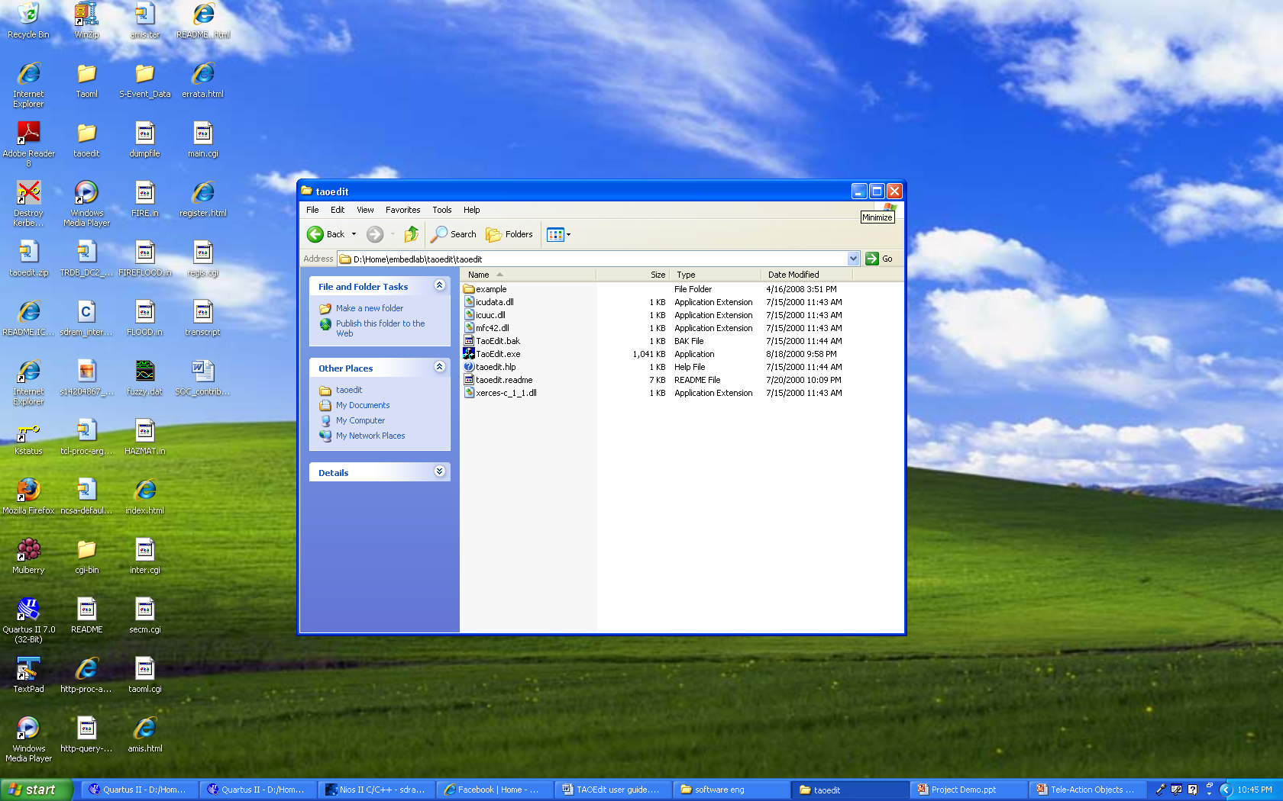
- Select the "Run" command from the Start Menu and type "sysedit" and hit enter.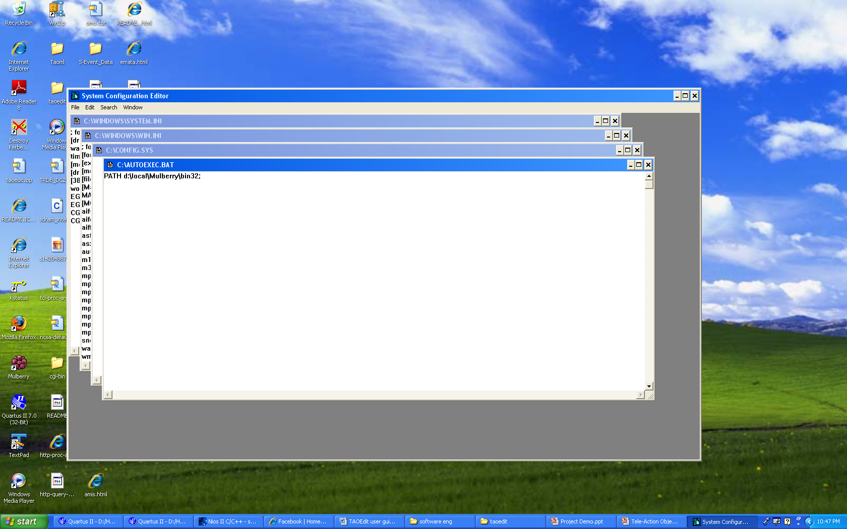
- In the autoexec.bat file, enter the path for your TAOEdit.exe file and save.
- Download the binary release for the Xerces-c_1_1_0 distributions from the archives section of the Apache website for Windows
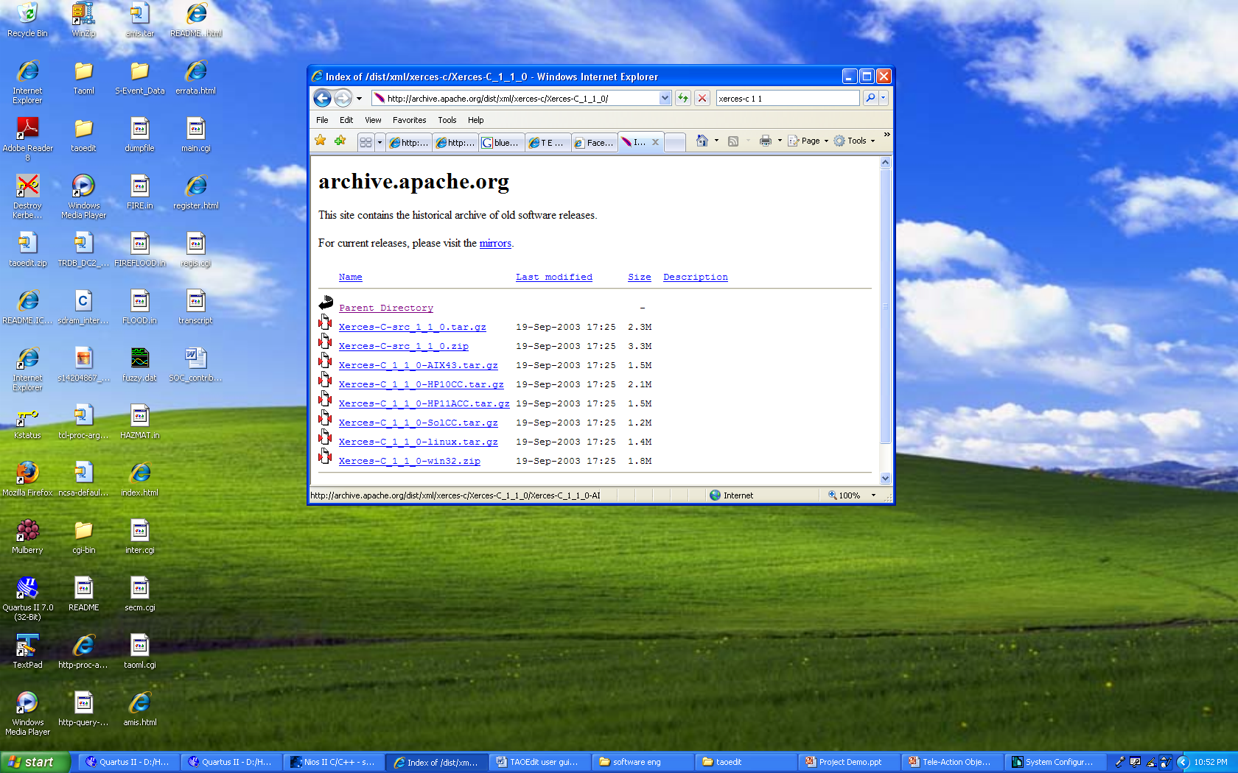
- Download and unzip this tool in your directory for the TAOEdit tool
- Use the "sysedit" command again to enter the path for the Xerces-c tool in this format SET PATH=<full_path_to_xerces-c_1_1_0>\bin;%PATH%
- Restart your computer so the changes to the autoexec.bat can be made.
- Return to your directory and create a dummy folder and move the xerces-c_1_1.dll and mfc42.dll library files into it

How to Run TAOEdit
To run the TAOEdit application, simply double-click on the TaoEdit.exe file and the TAOEdit window will pop-up. The dialog box contains the button New to create a new document, the button Open to open an existing document. A button with the label Preview is available, but it is not yet active as a Preview of the document. If you push that button it will act as the New button for now.

How to create a TAO
If you did not already select "New" from the dialog box and are operating in the Editor, go on File and choose the selection "New". You can have only one "New" document open at a time, therefore you need to close the previous document if you want to open a new one.
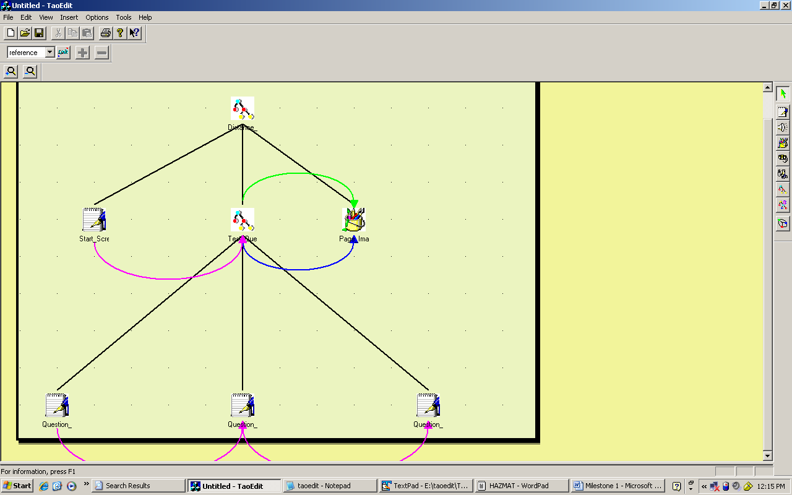
The diagram above shows you the outline of the TAOEdit application. A description of the layout is provided below
- The light yellow region describes where the TAO is to be created.
- To the right of the window, media type objects appear as buttons, allowing you to click and paste any media type icon you require. Once the node appears on the pane it is given a standard name. Make sure to rename each node to avoid conflicting names between them.
- Directly beneath above the yellow drawing pane are zoom in and zoom out buttons which allow you enlarge or compress your view of the pane
- Above the zoom buttons are buttons for the associated links for the hypergraph structure. Any link can be selected using the drop-down menu and connected between two media nodes. Only certain types of links are allowed between nodes. The tool employs error dialog boxes to prevent you from creating illegal links, but sometimes it also does it in error. Select a link type before using the link button. Dialog boxes will appear if an error is made along with a suggestion to correct the error.

How to open a TAO
If you did not already select "Open" from the dialog box and are operating in the Editor, go on File and choose the selection "Open". Remember, you can have only one document open at a time, therefore you need to close the previous document if you want to open a new one. You can select any file with a .tao extension.
How to edit TAO properties
To edit each of the properties for the sub-TAOs, you can simply double-click on a TAO icon or right-click and select properties. A dialog box will appear allowing you to change any aspect of the object.
Here are a few of the Tao properties you can adjust:
- Specify Index Cell types, messages and cgi functions for each TAO
- Import pre-created text, image or other media files for each TAO
- Include spatial and temporal references to other TAO objects with appropriate links
How to create a Taoml file
Creating Taoml and Tpl files are the essential contributions of this tool. Taoml files are used by web servers to basically provide a hierarchy of the multimedia web application. To create a Taoml file, you can simply right-click on a sub-TAO and select "Create Taoml" option. A dialog displaying the properties of the TAO in Taoml format will pop-up and will ask if you would like to "Create" or "Exit". After selecting "Create", you can type a name for the taoml. It is advised that you name the file the same name specified in the taoml text document. After saving the taoml file, you will find the taoml file along with a tpl file which is the template for the html interpreter. This file will allow you to customize your own HTML page for the taoml objects to appear in.
