MICE Project

August 4, 2008

University of Pittsburgh

Kirsten McCane

Table of Contents

1.0 Summary 3
2.0 IC Manager Attempted Solutions 4
2.1 Attempted Solutions 4
3.0 MICE For Dummies 7
3.1 MICE Development Directions 7
3.2 Using CGI Files and TAOs 10

- Summary
The ultimate goal of the MICE project was to take a previously developed multimedia IC system and to make it operational under the current UNIX environment. This involved creating a project using the IC builder, compiling this project using the IC Compiler, and executing the program using the IC manager. Directions and source files were provided which documented steps to do this under older conditions. However, errors were encountered at each level. At the levels of IC Builder and IC Compiler, I was able to pin point these errors and correct them with the assistance of Matthew McGettigan. These corrections will be discussed later in the report. However, at the level of the IC manager, the project was not able to execute without error. The error encountered was an internal server error during the execution of the project source code on the university Oracle servers. Through my efforts in this project and discussion with technical staff of the university, I feel this error due to compatibility issues between the Oracle server and the CGI binaries created or errors in the code. Efforts were made to correct this through use of different machine compilers, manual debugging of the source code, and the use of a new university server. None of these techniques produced a fully functional project.
In this report, the details of the efforts I made to correct the internal server error confronted will first be discussed. This will be followed by a discussion of the steps and corrections made at the IC Builder and IC Compiler levels that would allow an individual to come to the same point in the project I have reached.
- IC Manager Attempted Solutions
This section will describe the solutions attempted to correct the error encountered when trying to run the IC manager. First, the different compilers and options used and explored will be discussed. Second, my individual efforts to locate errors within the code are explored. Lastly, a look at an effort to use a new CS server is shown.
  - Attempted Solutions
The compiler was the suggested source of error for integrating the IC manager to the current UNIX environment. This suggestion comes from both professor Chang and the CS department technical staff. The reason behind this is that the run time libraries used on the compiling machine much be as close to those used by the server as possible. The CS department has server machines available to compile on. Using most CS machines, the following error was displayed when simply attempting to invoke inter.cgi.
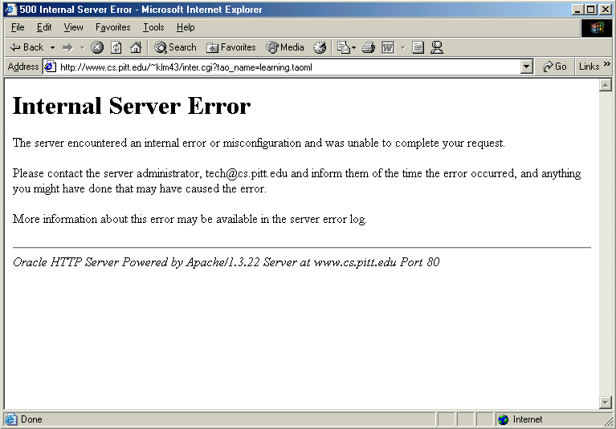
Figure 1: Server Error thrown running inter.cgi

Working with the CS technical department it was found that the nitrogen machine was most closely related to Oracle server. By compiling on this machine, the inter.cgi would successfully run and the test taoml page I setup would come up. This page was set up to invoke main.cgi. It looked as follows:
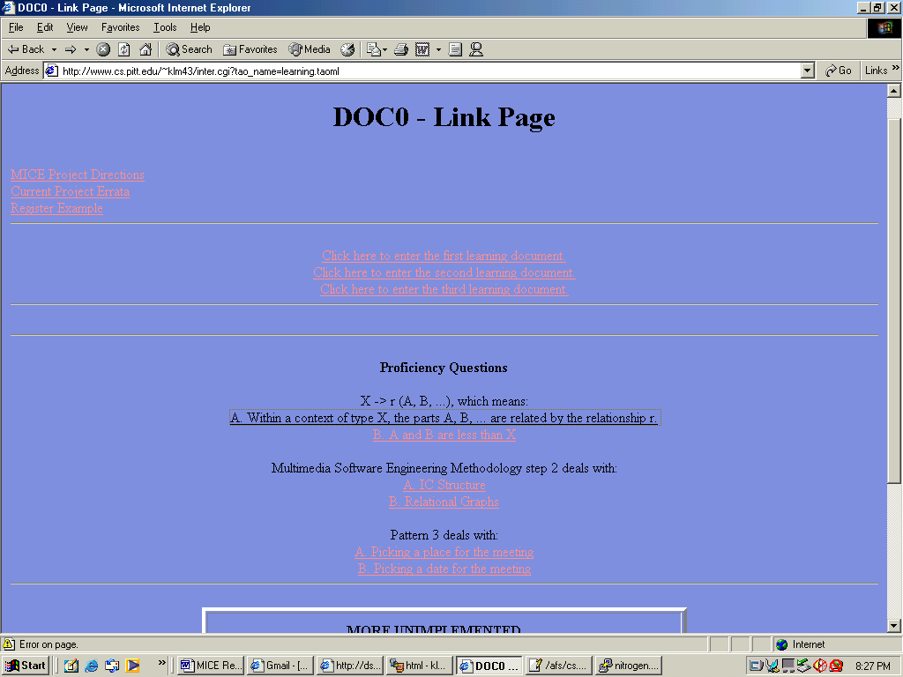
Figure 2:Link Page
The first time I ran this page the code would execute and print out debugging statements such as:

Lack of Content

At this point it is clear that the source code of main.cgi was running on the server and the input to the manager was not correct. Using examples of past taoml pages and icm projects I formed input that the source file main.c would accept. Main.c is the source file that forms the msg to be used by the ic_manager.c. Unfortunately, when ic_manager.c would attempt to process this msg the same error shown in Figure 1 would be displayed.
The internal server error gives no indication of what caused the server error. Therefore, my goal was to try and pin point the where in the source code this error get triggered. My only method for doing this was to prematurely exit the program using exit(0);. If I placed this before the error was triggered, a blank screen would be displayed. If I placed this after the error was triggered, the internal server error would be displayed. Using this tool, I found the line that causes the program to trigger an internal server error to be:
while ((active_ic != NULL) && (!accept)) {
If the program is exited before this conditional statement, the error will not be triggered. Looking at this line, I could not determine why this line would cause an error. The two variables active_ic and accept are defined and have values assigned to them. Therefore, I hit a wall at this point in my solution.
Given the advice of professor Chang, I also looked into the compiler options available. Using man make, a list of the compiler options are presented. Of these options, several were explored. However, none seemed to relate to the problem of compatibility on had more to do with providing information on the make. For example, -d provides debug information for the make. Using this I received details on the compile. This information did not reveal any information that struck me as a possible source of the error.
On the advice of the cs technical staff , a new cs server was also attempted. This server is new-www.cs.pitt.edu. Using this server however caused an internal server error to be set off when executing inter.cgi. The new server would give a error that looks as follows:
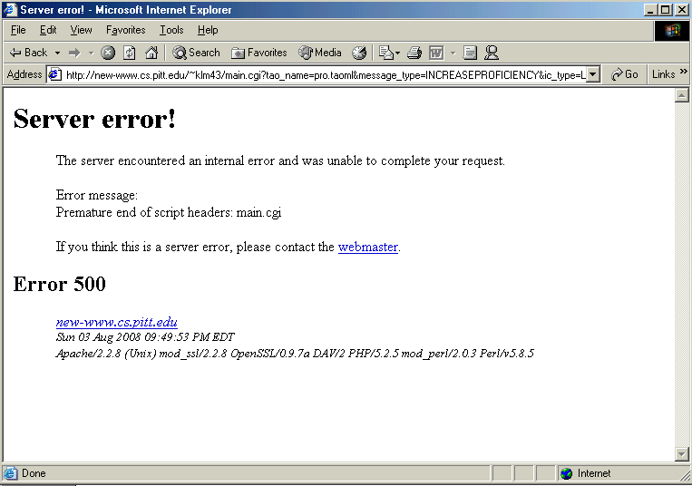
Figure 3: Error on New CS server
Therefore, this didn’t seem like it would quickly lead me to a solution and would actually set my progression back. Most recently, other collaborations with the cs tech department have been attempted. The dependencies of the Oracle server libraries were statically compiled into the binaries. This would effectively duplicate the dependencies. Running these binaries still produced error however.

- MICE For Dummies

This section will take the reader through every step necessary in creating his or her own multimedia IC system. So what is a multimedia IC system and how does it work? First, the concept of an IC must be introduced. An IC card is simply and active object that interacts with the system based upon different interaction patterns. Using ICs, one can setup information passing, timing, and control. Allowing these ICs to interact with each other will result in a dynamic multimedia system. The final goal of the MICE is to create a system that users will access through web pages. The basic steps for creation of the system come in a few discrete steps. First, your IC system must be designed. The easiest means to do this is through creating IC cards, which provide a structure for describing ICs and their relationships to other ICs and objects. Some of the ICs will be active while others will be passive. The difference is that active objects react. Given an active ICs state it will react differently and provide different output. The system as a whole can be thought of as a state machine. In fact, a popular way of describing the system is through Petri nets, which describe the state machine and its timing mathematically. The means by which you integrate these ideas into the MICE is through the IC builder. This allows you to graphically input your active system. The builder takes this system and produces a code description for it. The second step is to use the IC compiler, which uses these files to create a set of source files. These source file are then used create .cgi files. The .cgi files are the means by which html pages interact with your active IC system. They are what is known as the IC manager. Lastly, to create these html pages that invoke the .cgi files, another tool called a tao editor should be used. The use of this editor will not be covered in this document However, the files it produces, .taoml files, will be discussed in relation to how they work with the .cgi files and .tpl files. The last stage, creating the .tpl files is simply creating an html structure for each of the .taoml pages you create.
  - MICE Development Directions
The following is the MICE Developers Guide that can be found on the web at http://www.cs.pitt.edu/~chang/231/ictools/README.IC.html. Under each of the first five steps, I discuss issues that came up involving that step and how we went about resolving them.

Seven steps to build a MICE application in the IC_Work/ directory:

- Download the IC_Builder to your PC, unzip and install it under Windows. Use IC_Builder to draw each index cell and create the .in file for each ic. Use capital letters for the *.in files such as XIC.in, DIC.in, etc. The IC_Builder will also create the ic.dat file. (You can also create *.in and ic.dat manually without using IC_Builder)

When running the IC Builder on the Vista operating system, no problems were encountered. However, when running on XP, it is necessary to run the program under Windows98 compatibility mode. This can be done by right clicking on the program, selecting properties, selecting the compatibility tab, checking the box that says “Run this program in compatibility mode for:”, and selecting Windows98/ME from the drop down menu.

- Provide one action file for each action defined in the ic's. An action file contains the corresponding C function for each action and should be copied to the IC_Work/source/ directory.

No issues came up from this step.

- Copy *.in files to IC_Work/ directory and ic.dat file to IC_Work/source/ directory. Copy all files from IC_Compiler, IC_Manager and IC_Taoml to IC_Work/source/ directory. If necessary, modify the ic.dat file. Use IC_Compiler icc to generate the source files. See the README.ICC.html file in IC_Compiler directory for details. There are six files generated by IC_Compiler icc: actions.c ic_func2.c ic_func3.c app.h fuzzy.h db_def.h

The IC_Compiler, IC_Manager, and IC_Taoml directories can be found at /afs/cs.pitt.edu/usr0/jung/public/html. If when attempting to run the icc command you get an error:

icc: icc: cannot execute binary file

Simply recompile icc.c. This should take care of this error.
There is a good chance that when running the compiler on the ic.dat files that you get the following error:

=== gen_code: Unknown header
===
To resolve this error, you must determine which header in the ic.dat file isn’t being recognized. After doing this, simply deleting and rewriting the label within the ic.dat file should take care of it. When running the icc command, you will get a lot of warnings. You can just ignore these as they do not cause any problems and the files are all created.

- Use command "make -f makefile.maincgi" to make main.cgi which is the cgi program that your application will need. Therefore, you may call it main.cgi. The IC_Manager becomes part of main.cgi so any message to an ic will be sent to this main.cgi. See README.ICM.html file in IC_Manager directory for details.

First, Makefile.maincgi needed to be edited. The instructions for creating lex.yy.c and y.tab.c were commented out and those lines needed to be uncommented. Next, the file cgienv.c needed to be changed. First, the line that said:

extern char *sys_errlist[];

needed to be changed to

extern const char *const sys_errlist[];

Also, the line

printf("%s: %s\n", str, sys_errlist[errno]);

needed to be commented out.

Finally, in the file interpretor.c, the line

FILE *fpout = {stdout};

needed to be changed to

FILE *fpout = {NULL};

It is important to run this command on the Nitrogen machine if using the CS department Linux machines because creating the cgi files on any other machine may cause them to not run properly. This is due to the Nitrogen machine having the closest versioning compared to the web server (Oracle) used for the CS department. If the versioning of these two servers change, cs technical support should be contacted to determine the best compatibility.

- Use command "make -f makefile.intercgi" to make inter.cgi which is the cgi program to access a taoml page. main.cgi and inter.cgi should be copied to application directory IC_Work/ so that the home page can use inter.cgi to access a taoml page such as tao_1.taoml. The link has the following form:<a href="inter.cgi?tao_name=tao_1.taoml" &gt.

Remember to create inter.cgi on Nitrogen as well if using the CS department Linux machines.

(6) Design the home page index.html for the application and put it in directory IC_Work/. This home page should have a cgi link to a taoml page such as tao_1.taoml. tao_1.taoml and its associated template page tao_1.tpl should be in the sub-directory IC_Work/TAOML/. Indeed, all taoml pages and tpl pages should be in the sub-directory IC_Work/TAOML/. To create the taoml pages, you will use an extended html syntax to specify the TAOs and how they are structured and activate ic using the cgi program which is main.cgi. If you want to refer to your own cgi programs, they can be mentioned in the tpl pages. To sum up, there are three type of pages:
# html page index.html uses cgi program inter.cgi to link to tao_1.taoml
# taoml page tao_1.taoml uses cgi program main.cgi to activate an ic tao_1
# tpl page tao_1.tpl uses customized cgi program to do special tasks

(7) Now you are ready to run your application. Use a browser to enter application's home page IC_Work/index.html.

  - Using CGI Files and TAOs
The two cgi files that were created were inter.cgi and main.cgi. Inter.cgi is used to connect your homepage to your .taoml pages. The page can contain anything but when someone desires to enter the system a link, button, etc should reference the taoml as follows:
<a href="inter.cgi?tao_name=XXXX.taoml"> LABEL</a>
This should link you to the taoml pages you created. An example of a taoml page is as follows:
<TAO>
<TAO_NAME> "learning.taoml" </TAO_NAME>
<TAO_TYPE> text </TAO_TYPE>
<TAO_TEMPLATE> "learning.tpl" </TAO_TEMPLATE>
<TAO_LINKS>
name = "Proficiency" , type = structural, obj = "pro.taoml"
</TAO_LINKS>
<TAO_LINKS>
name = "Deficiency" , type = structural, obj = "def.taoml"
</TAO_LINKS>

</TAO>
In this situation the tao type is text based which means the html page will be supported a textual display. There other types you should specify if the content contain images, sound, etc. The tao links show how other taoml pages can be referenced. Within the .tpl these will be connected through a <TAO_rel> </TAO_rel> heading. A complete listing of options and formatting issues for the .taoml page are listed below:

1. Attributes of a Tele-Action Object TAO:

In order to use TAO_HTML to define a TAO, the data structure of a TAO is extended.
A TAO has the following attributes: tao_name, tao_type, p_part, links, ics
and sensibility.

** 'tao_name' is the name of the TAO, which is a unique identifier of each TAO.

** 'tao_type' is the media type of TAO, such as image, text, audio, motion graphs,
video or mixed.

** 'p_part' is the physical part of TAO. To implement it in the context of
TAO_HTML, 'p_part' here can be denoted by a template which indicates how a HTML
page looks like. Templates are some independent HTML document to define the
fundamental display element and location arrangement. For example, if the TAO is
of image type, the template will just contain a HTML statement to intrigue an
image. If the TAO is of mixed type, the template will define some common parts
and leave some space to insert the elements that is specific to this TAO.

** 'links' is the link to another TAO. A link has attributes 'link_type',
'link_obj'. 'link_type' is either relational (spatial or temporal) or structural
(COMPOSED OF). in the context of TAO_HTML, a spatial link describes visible
relationship between sub_objects inside one mixed object. For example, a mixed
tao1 contains an image TAO2 and a text TAO3, then TAO1 has spatial link with
both TAO2 and TAO3. A temporal link usually refers to an invisible object which
is not a display element, but its activation time is influenced by the other.
A structural link relates one TAO with another dynamically via user input or
external input. For example, the user clicks a button in TAO1 will invoke another
page TAO2, then there's a structural link from TAO1 to TAO2.

** 'ics' is the associated index cell. The flag is "old" if the ic already exists,
or "new" if the ic is to be created. The ic type, message type, ic_id list,
message content, and name of cgi can either be specified, or input by the user
(indicated by a question mark in the input string).

** 'sensibility' indicates whether this object is location-sensitive, time-
sensitive, content-sensitive or none-sensitive. Then the same object can have
different appearance or different functionality according to the sensibility. For
example, if TAO1 is content-sensitive, it is red when being contained in TAO2
while it is green when being activated by TAO3 via a button. The detailed meaning
of sensibility should be defined by user according to the requirement of applications.

2. Formal definition of TAO_HTML:

TAO_HTML ::= <TAO> TAO_BODY </TAO>
TAO_BODY ::= NAME_PART TYPE_PART P_PART LINK_PART IC_PART SENSI_PART
NAME_PART ::= <TAO_NAME> "name" </TAO_NAME>
TYPE_PART ::= <TAO_TYPE> TYPE_SET </TAO_TYPE>
TYPE_SET ::= [image, text, audio, motion_graph, video, mixed]
P_PART ::= <TAO_TEMPLATE> "template_name" </TAO_TEMPLATE>
LINK_PART ::= empty | <TAO_LINKS> LINK_BODY </TAO_LINKS> LINK_PART
LINK_BODY ::= name="link_name", type = LINK_TYPE, obj = "link_obj"
LINK_TYPE ::= [spatial, temporal, structural]
IC_PART ::= empty | <TAO_IC> flag = FLAG, ic_type = "input_string",
ic_id_list = "input_string", message_type = "input_string",
content= "input_string", cgi="input_string" </TAO_IC>
FLAG ::= [old, new]
SENSI_PART ::= empty | <TAO_SENSI> SENSITIVITY </TAO_SENSI>
SENSITIVITY ::= [location, content, time]

3. Formal definition of TAO_HTML tag in template:

In the template of a TAO, in addition to the normal HTML tags and definitions,
there are two special TAO tags. One is for link relation with other TAOs.
It is defined as:

<TAO_rel> "link_name" </TAO_rel>

The other is for the position where the IC form is located. It is defined as:

<TAO_IC_INPUT>

