Processing Continuous Queries on Sensor-based Multimedia Data Streams by Multimedia Dependency Analysis and Ontological Filtering

Shi-Kuo Chang¹, Francesco Colace², Lei Zhao³ and Yao Sun¹

¹Department of Computer Science
University of Pittsburgh
Pittsburgh, PA 15260 USA
{chang, yaosun}@cs.pitt.edu

²Department of Information and Electrical Engineering
University of Salerno
Fisciano, SA 80040 Italy
fcolace@unisa.it

³School of Computer Science and Technology
Soochow University
Suzhou, 215006 China
zhaol@suda.edu.cn

Abstract: We present a mathematical model of multimedia data streams and a framework for multimedia functional dependency analysis. The dual objectives are to effectively design multimedia data streams schema and to efficiently process continuous queries on sensor-based multimedia data streams. To further improve query processing, we introduce the concept of ontological filtering. A software tool to add multimedia functional dependencies to an ontology is developed. Based upon multimedia functional dependency analysis and ontological filtering, query processing algorithms, illustrative examples and experimental results for sensor-based multimedia data streams continuous querying are presented to demonstrate the practical applications of our approach.

Keywords: Sensor-based multimedia systems, multimedia functional dependencies, ontological filtering, continuous queries.

(Submitted Nov 11, 2010, revised June 15, 2011, accepted November 5, 2011)

1. Introduction

Multimedia data streams or MMDSs have many critical and important applications ranging from network monitoring applications and military applications to environmental monitoring applications. Multimedia data streams become even more important with the advances of the technology of sensor networks consisting of tiny sensing devices that can be spread over a large area to collect time-critical information. As sensor networks become prevalent, multimedia data streams will also become massive and data volume can be unbounded. It is thus critical to provide a framework for multimedia data streams modeling and performance estimation, based upon which we can provide performance guarantees such as minimum output rate per query, maximum supported queries per site, maximum supported data streams per site and so on.

The data stream management concept was first introduced in [1], and later comprehensive stream management systems were proposed such as STREAM [2], Borealis [3] and Aurora [4]. Several commercial data stream management systems or DSMSs are now available [5], [6]. Data stream management systems are expected to be able to handle massive updates of data collected from sensor networks. In the push-model for data stream management, data updates can arrive with high frequency, while a certain set of queries (called continuous queries or CQs) reside in the data stream server to process incoming data [7]. Users will first register their continuous queries, and data will be pushed into the data stream server to process these queries as they arrive. This model is in contrast to the traditional pull-model for database management.

On the other hand multimedia databases have been used in many applications for over two decades now. The Internet boom has accelerated this trend, introducing many new applications related to query processing for content based retrieval. In [8] a normalization framework for multimedia databases was provided as a generalization of the traditional relational database model. Data dependency theory was also extended to include dependencies involving different types of multimedia data. Recently a new research area is emerging called human computation [9], which utilizes the ultimate powerful computational units all humans possesses; i.e., the human brain. Starting with CAPTCHA, researchers proposed multimedia games that are applications utilizing multimedia data streams, multimedia databases and human computational power in solving difficult problems [9]. To tackle such problems the multimedia dependency theory must be extended to include dependencies among multimedia data streams.

As a motivating example for multimedia data stream management, a security system usually has multiple video cameras to monitor a building or a store. A multimedia data stream management system that receives the stream of video frames can process the input streams against its multimedia database. A number of continuous queries can be pre-specified to augment the tasks of the security guards and help them do their job better. Such CQs may include: 1) tell me whenever you see an object similar to any weapon; 2) tell me whenever you see a WANTED person; and so on. As another example, in health monitoring systems the patient’s heart rate, body temperature and other vital indicators are continuously being monitored, and a CQ can be pre-specified to report whenever these values go beyond the normal values. As a third example, for some diseases X-Ray images must be inspected to show progress or to identify anomalies. Again, appropriate continuous queries can be pre-specified. When this multimedia data stream of X-ray images are fed to a multimedia data stream management system, monitoring reports are generated whenever the query conditions are met.

In this paper we first present a mathematical model of multimedia data streams and a framework for multimedia functional dependency analysis. The dual objectives are to effectively design multimedia data streams schema and to efficiently process continuous queries on sensor-based multimedia data streams. To further improve query processing, we then introduce the concept of ontological filtering. A software tool to add multimedia functional dependencies to an ontology is developed. Based upon multimedia functional dependency analysis and ontological filters, query processing algorithms, illustrative examples and experimental results for sensor-based multimedia data streams continuous querying are presented to demonstrate the practical applications of our approach.

The paper is organized as follows. A review of related research is given in Section 2. Our approach is presented in Section 3. Section 4 provides the mathematical model of multimedia data streams. Dependency theory is extended to multimedia dependency theory in Section 5. The concept of ontological filtering is explained in Section 6. Algorithms for multimedia data streams continuous querying are presented in Section 7, and illustrative examples are given in Section 8 to demonstrate the applications of our approach. Experimental results are presented in Section 9, and a discussion on further extensions of the formal model, the extended dependency theory and ontological filtering is given in Section 10.

2. Related Works

There is a massive amount of research on both data streams and multimedia databases. The literature of data streams is focused on performance fine tuning; minimizing response time according to quality-of-service or QoS metric, or improving freshness according to quality-of-data or QoD metric [10]. Scaling with burst arrivals of data and peak loads has also gained some attention (known as the problem of load shedding) [11]. More recently techniques for mining data streams are also proposed [12]. There are indeed many issues and interesting applications over data streams such as the representation of infinite stream of data, continuous queries over data streams, performance tuning and so on. On the other hand many approaches in content-based retrieval and algorithms have also been proposed in the multimedia database literature. However our focus is on the use of multimedia database semantics to improve query processing. Since the literature is vast, rather than giving a superficial review on many papers, we will provide a focused review by discussing in detail three representative papers on data streams, which address some interesting and basic issues on continuous query, and then discuss recent advances in research on ontology to motivate our approach. It is hoped that this focused review will enable the reader to gain more insight into the complexities of the research issues.

2.1. Continuous Query for Data Streams

Sensor networks and monitoring applications provide increasingly fine-grained data, which can be encoded as data streams. Such data is huge and largely transient - so much of it will exist only as streams rather than be permanently recorded in raw form. Moreover, multimedia applications nowadays proliferated in many fields and gave birth to multimedia databases. We are interested in modeling multimedia data streams and constructing continuous queries over multimedia data streams. So we did a systematic investigation about data stream and continuous query.

The problem of scheduling multiple heterogeneous CQs in a DSMS with the goal of optimizing QoS for end users and applications is considered in [13]. To quantify QoS the authors first used the traditional metric of response time, which is defined over multiple CQs, including CQs that contain joins of multiple data streams. The authors also considered slowdown as another QoS metric, since they believe it to be a more fair metric for heterogeneous workloads, and, as such, more suitable for a wide range of monitoring applications. New scheduling policies that optimize the average-case performance of a DSMS for response time and for slowdown are developed. Additionally, hybrid policies are proposed to maintain a fine balance between the average-case performance and the worst-case performance, thus avoiding starvation. Furthermore, this paper extends the proposed policies to exploit operator sharing in optimized multi-query plans and to handle multi-stream queries. It also argues an adaptive scheduling mechanism that allows the proposed policies to react quickly to changes in data distribution. And finally, it evaluates the proposed policies and their implementation experimentally, which shows that the scheduling policies in this paper consistently outperform previously proposed policies.

The continuous query language or CQL and the execution engine for general-purpose continuous queries over data streams and stored relations are presented in [14]. CQL is implemented in the STREAM prototype data stream management system at Stanford University, including the “Linear Road” benchmark used as examples throughout this paper. This paper initially defines a precise abstract semantics for continuous queries. This abstract semantics is based on two data types – streams and relations – and three classes of operators over these types: operators that produce a relation from a stream (stream-to-relation), operators that produce a relation from other relations (relation-to-relation), and operators that produce a stream from a relation (relation-to-stream). The three classes of operators are “black-box” components of this abstract semantics, which means the abstract semantics does not depend on the actual behavior of the operators in these classes, but only on their input and output types. For each user, a dedicated server is started on a machine and a client is started on the user’s machine. Through the graphical user interface, users may register streams and continuous queries and view the streamed (or stored) results. Users may also inspect and alter query plans and perform visual system monitoring through “introspection”: query components can be specified to write statistics (such as throughput, selectivity, etc.) onto a special system stream. Graphical system monitors can obtain their plotted values by registering standard CQL queries on the special system stream.

A SQL-based standard for streaming databases is presented in [15]. This paper discusses some deep model differences that exist between Oracle CQL and StreamSQL. Then it proposes a new unification model that uncovers these differences. The key insight of this model is that evaluation of results in both systems is triggered by the arrival of a batch of tuples. In the Oracle model the batch is defined by values of the timestamp. In the StreamBase model, batches are always of the size of one tuple. By controlling the batching of tuples and the ordering between these batches, the proposed model can simulate both models plus many alternatives that neither model can capture. Moreover, this paper also presents the syntax and semantics of a new operator called SPREAD, a powerful stream-to-stream operator, and illustrates it using examples.

On the one hand, with the voluminous data streams arriving from data communications or sensor networks, many interesting applications in this area will emerge. So how to schedule continuous queries and optimize the performance becomes vital to these applications. The first paper investigated these issues and got many outstanding results. The work in this article gives the inspiration to their future works and many other related researches in this area. However it is necessary to develop policies that are able to balance the trade-off between different QoS metrics as well as QoD metrics.

On the other hand, many full-blown data stream management systems are proposed in recent years. It brings a lot of differences among these existed prototypes and products. So many researchers are devoting themselves to solve the problems on some unified or standard data stream model and the corresponding continuous query language. The other two papers are the representative works in this area. These works have the added benefits that they increase the expressive power of both languages and give the user an easy-to-use interface to work on data stream. However there are still many remaining problems that could be investigated on the road to a complete standard.

To summarize, there are many key issues in the management of data streams, and the three papers presented in this focused review address only a handful of the topics in this area. These articles did investigate the data stream model, syntax and semantics of continuous query language, execution engine for continuous queries over data streams, scheduling multiple CQs in DSMS, and optimizing QoS for end users and applications. In addition, multimedia databases have been used for over two decades. Though data stream model and multimedia database are both well-studied concepts, it is rarely reported that they have been integrated for the purpose of modeling multimedia data streams to the best of our knowledge. We anticipate that the growth in the use of smart sensors, microprocessors, networks, and the World Wide Web will fuel an explosion of demand for multimedia data stream management systems in the coming decade, and more research is needed to support the design of such systems.

2.2. Ontology

The definition of ontology is still a challenging task [16]. The term ‘ontology’ has its origin in the Greek word ‘ontos’, which means ‘being’. So in this sense ontology could be defined as a branch of philosophy dealing with the order and structure of reality. In the 1970s ontology came to be of interest in the computer science field. In particular the artificial intelligence community started to use the concept in order to create a domain of knowledge and establish formal relationships among the items of knowledge in that domain for performing some processes of automated reasoning, especially as a means for establishing explicit formal vocabulary to be shared among applications.

The term ‘ontology’ was first used in the computer science field by Gruber who used the term to refer to an explicit specification of a conceptualization [17]. The use of this term is rapidly growing due to the significant role it plays in information systems, semantic web and knowledge-based systems, where the term ‘ontology’ refers to “the representation of meaning of terms in vocabularies and the relationships between those terms” [18]. Also this kind of definition is still satisfactory for each field where ontology can be applied and so perhaps a good practical definition would be this: “an ontology is a method of representing items of knowledge (ideas, facts, things) in a way that defines the relationships and classification of concepts within a specified domain of knowledge” [16]. Following this point of view, ontologies are “content theories”, since their principal contribution lies in identifying specific classes of objects and the relations that exist in some knowledge domains [19]. Generally speaking an ontology consists of the following five components [20]:

- Classes: represent concepts which can represent abstract concepts or specific concepts. Classes in the ontology are usually organized into taxonomies where the inheritance mechanisms can be applied.
- Relations: represent a type of association between concepts of the domain. In the case of binary relations, typical in the lightweight ontology realm, the first argument is known as the domain of the relation and the second is the range.
- Functions: are a special case of relation in which the n^{th} element of the relation is unique for the n-1 preceding elements.
- Formal Axioms: represent knowledge that cannot be formally defined by the other components
- Instances: represent element or individuals in an ontology.

Ontologies can be classified into lightweight and heavyweight ontologies [20]. Lightweight ontologies include concepts, concept taxonomies, simple relationships between concepts (such as specialization is_a) and properties that describes concepts. Heavyweight ontologies add axioms and constraints to lightweight ontologies. Axioms and constraints clarify the intended meaning of the terms gathered in the ontology. Heavyweight and lightweight ontologies can be modelled by the use of different knowledge modelling techniques and they can be implemented in various kinds of languages which are usually divided in two groups: classical and ontology markup language [21]. The ontology markup languages, mainly used in the context of semantic web and of which the most important is OWL [18], have their own syntax, their own expressiveness, different knowledge representation paradigms and their own reasoning capabilities provided by different inference engines [21]. It is important to underline how database community as well as the object oriented design community build models using concept, relations and properties but they usually impose less semantic constraints. Ontologies are typically not static entities and so in recent years ontology evolution processes have drawn considerable attention of the researchers. The ontology evolution can be considered as the “timely adaptation of an ontology to the arisen changes and the consistent management of these changes” [22]. This definition suggests that a successful evolution can only be achieved by having both “adaptation” and “change management”.

Another core aspect of ontology evolution is how to guarantee the consistency of the ontology and the dependent applications [22][23]. In this sense many papers are introducing approaches and methodologies for the ontology evolution management and its change requirement description. In particular frameworks for the management of atomic and complex changes have been introduced [24]. A particular aspect of ontology application is in the analysis and comparison of particular ontologies that could be used to derive information beyond operational data. In this case ontologies could be for management support. This is a very interesting application field but some critical problems remain to be solved. In fact usually the lightweight ontology furnishes a very simple and generic representation of a context and so is not able to well manage a system or supporting users in the interactions with it. In particular if it represents the services and components of a system probably its computational and functional optimization could be not reached. However a heavyweight ontology could be very difficult to define and includes some aspects that are not all the time useful and the risk of wasting system’s resources to maintain a heavyweight ontology is quite high.

With the aim to avoid the above described problems, in this paper a lightweight plus ontology is proposed, which can be defined as O = {C, A, R_{H}, R} where C is the concept set, A is the concepts’ attributes set, R_{H} expresses the concept hierarchy relations type and R is the set of non-hierarchical relations. By the introduction of the non-hierarchical relations, a lightweight plus ontology is more complex and semantically richer than the lightweight ontology, but is not as complex as a heavyweight ontology because there are no axioms to consider. The lightweight plus ontology will be the starting point for the definition of an ontological filtering methodology that will support and improve the multimedia data stream management system.

3. Our Approach

Figure 3-1: Computation-Oriented Multimedia Data Stream Model.

In our approach, we want to provide a computation-oriented model of multimedia data streams. In addition the dependency theory is generalized for multimedia databases and multimedia data streams, and a normalization framework is proposed so that schema design and query processing can be carried out with respect to this framework. In our previous paper [25], the computation-oriented model is formalized and results on performance estimation are obtained. For completeness the formal definitions from [25] will be summarized in Section 4. Moreover multimedia data stream functional dependencies (Section 5) and ontological filtering (Section 6) will be utilized in continuous query processing. In this section we present our approach from the viewpoint of software architecture.

The computation-oriented multimedia data stream model or COMMDSM is illustrated in Figure 3-1. The data streams such as the video stream consist of time sequences of tuples (or frames when dealing with video data). They are either captured and stored, or processed on the fly as the tuples (or frames) arrive. The multimedia continuous queries or m-CQ’s are query trees whose nodes are operators on multimedia data. Therefore the COMMDSM describes how the multimedia data streams are to be processed with respect to the m-CO’s in order to compute the query results.

The multimedia data stream management system or MMDSMS is depicted in Figure 3-2, which illustrates the basic building blocks of a MMDSMS.
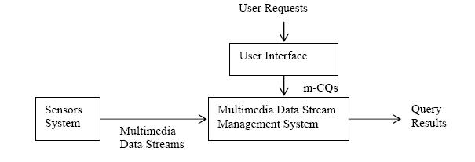
Figure 3-2: The basic building blocks of MMDSMS.

As shown in Figure 2, a user submits a request that is transformed by the user interface into a m-CQ, which is stored and repetitively executed by MMDSMS to produce the final results. For the basic MMDSMS, query processing is optimized using the techniques described in Section 4 and reference [25].

The adoption of an ontological filter could significantly improve the system’s performance. For example, in traffic control an ontological filter can be used to transform the m-CQ into a more efficient m-CQ’ (see sections 5 and 6). A further improvement is for the ontological filter to suggest what sensor(s) are to be used and what sensor(s) to be turned off. In other words, the ontological filter will extract from the m-CQs the system configuration information to be sent to the sensors system. The MMDSMS enhanced by the ontological filter is shown in Figure 3-3.

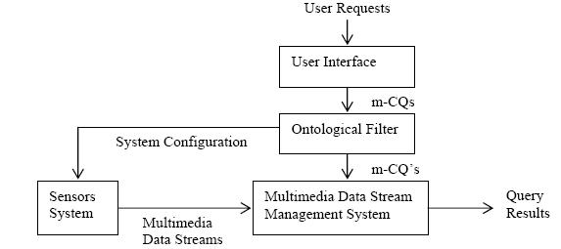

Figure 3-3: The MMDSMS enhanced by the ontological filter.

Figure 3-3 illustrates our proposed approach. For the enhanced MMDSMS, query processing will take into consideration the effects of the ontological filter (see Sections 7 and 8). If the ontological filter is removed, the basic system still works albeit in a less efficient way. The ontological filter makes use of the lightweight-plus ontology, which aims to improve the semantic value of the lightweight ontology and its effectiveness in the context depicted by user through the merging of three different ontologies:

- The Objects’ Ontology: this ontology describes the users’ requests in terms of objects that are involved in. In this ontology there are not very complex relations among the classes: only the “is a” relation is enough. Usually this ontology is a subset of the lightweight ontology and represents what the user imagines needs for the resolution of his request.
- The Application Ontology: this ontology describes the aims of the user in terms of system’s components (i.e. sensors) of the architecture and actions that can satisfy the users’ request. This ontology expresses complex relations among the classes and their attributes in order to define architecture’s components that are really involved in the task resolution
- The Scenario’s Ontology: this ontology describes the scenario where the system works in a very general way.

The combination of these three ontologies leads to the lightweight-plus ontology which represents the way to achieve the multimedia streams desired by the user. In other words starting from the lightweight ontology the proposed approach can create a lightweight-plus ontology removing classes that are not useful according to the user request, and adding new classes equivalent to other ones that are in the ontology but semantically richer (Figure 3-4).

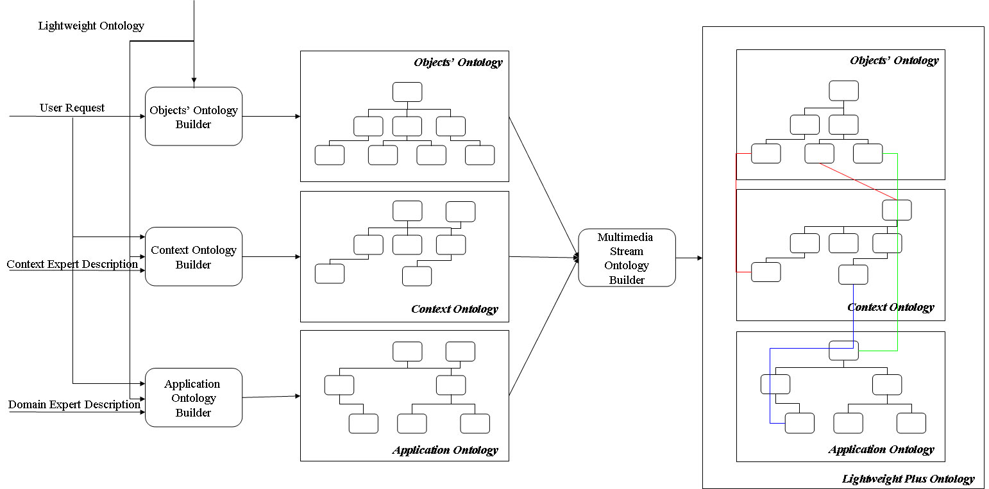
Figure 3-4: The lightweight-plus ontology’s building process.

The schema previously depicted is the core of the ontological filter. In order to better express the previous approach a more detailed architectural description of the ontological filter is furnished in Figure 3-5.

The starting point is the introduction by an expert of the scenario using a very simple lightweight ontology: O_{LS}={C_{LS},A_{LS}, R_{HLS}}. This ontology has the aim to describe only the main components involved in the scenario. This ontology has to be merged with the O_{S}={C_{S},A_{S},R_{HS},R_{S}} developed by an expert. The O_{S} ontology describes in a very detailed way the main functionalities of the system and the relations among its components. The result of this merging is the ontology O_{MS}={C_{MS}, A_{MS}, R_{HMS},R_{MS}}. It can be considered as a Medium-Weight ontology because it contains very detailed relation (hierarchical and non- hierarchical) among the nodes. This ontology explains in a very general way the working principles of the system and potentially can solve, in a non-optimized way, each kind of user’s request. The next stage is the simplification of the O_{MS} according to the user‘s requests. In particular the user expresses his needs and the components involved in. The user requests ontology builder furnishes as output O_{LU} ={C_{LU},A_{LU}, R_{HLU}}. The Request Ontology Builder simplifies the O_{MS} by the use of the O_{LU} and produces as output the O_{L+} ={C_{L+},A_{L+}, R_{HL+} , R_{L+}}. This is the lightweight plus ontology which better adapts the system to the user’s requests.

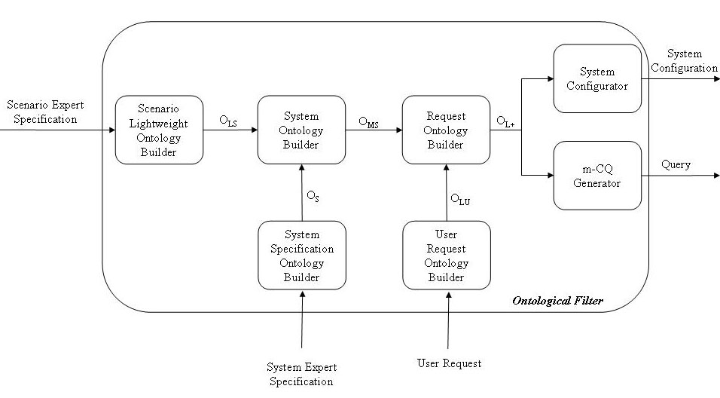
Figure 3-5: The Ontological Filter: Architecture Specification.

4. A Computation-Oriented Multimedia Data Streams Model

For completeness the formal definitions and some examples from [25] are included in this section.
  - Primary Data Type: Primary Data Type is an indivisible data structures. Let denote the entire set of data types and let denote one type of them.
There are four types of primary data type defined in MMDS. They are: int, float, timestamp and micon. The anterior three of them are commonly used in traditional data models and micon is a different one. Int and float are two basic calculable data types. They can be calculated under basic arithmetical operators. Timestamp is an extended calculable type. Usually it is called datetime type. Some operators were defined to calculate the difference between two values of datetime type and others are used to convert the format of them in common used data models. Many DBMS of relational data model are critical samples. They all use these three types.
Micon is not commonly used in traditional data models. But in MMDS, it is a basic type. The definition of micon is given in Definition 2.
  - Micon: A Micon is a multimedia icon that could be: text (ticon), still image (icon), audio (earcon), video (vicon).
  - Data Stream: A Data Stream is a constructed data type. It is a huge sequence of tuples according to a certain schema that keeps arriving to a Data Stream Management System. Each tuple has a unique identifier for verification and a timestamp for ordering. Each tuple is composed of properties and each property should be in one of the primary data type defined in Definition 1.
  - Multimedia Data Streams: A Multimedia data stream (MMDS) is a data stream that contains at least one Micon as one of its attributes, according to a certain schema.
  - Operator: Operators are some indivisible query operators in database management systems. Let denote the entire set of operators and let denote one operator of them.
SQL statements are the most widely used query language in traditional relational DBMSs. SQL statements can be represented by some primary operators. They are: π, σ, × and ∞. So that SQL statements can be written as algebra expressions. Followings are brief definitions of the four primary operators.
Projection(π): The projection operator is a unary operator that is parameterized by a list L of positive integers, and is denoted . When applied to a k-ary relation R, we require the elements of L to be in the range 1, ..., k, with no duplicates. The result of applying to R is the set of tuples formed by restricting the tuples in R to the attributes in L. For example, for a 5-ary relation R,
.
Selection(σ): The selection operator is a unary operator that is parameterized by a simple predicate θ, and is denoted . .When applied to a k-ary relation R, The result of applying to R is the set of tuples in R that satisfy the predicate θ. For example, for a 5-ary relation R,
.
where we use the notational convention of prefixing attribute indices with the # character to distinguish them from literals.
Natural Join(∞): In the named algebra, it is often convenient to use a join predicate that equates like-named attributes of its operands and discards one attribute from each pair of like-named attributes. This operator is called the natural join and denoted by . Thus the absence of a predicate below the symbol does not denote a vacuously satisfied predicate as one may expect; rather, it denotes a predicate that equates the like-named attributes of the operands. For example, with relation schemes R(a, b, c, d, e) and S(d, e, f),
Conversion operator(ψ): Conversion operator is used to process multimedia information. It can convert information from one form to another. For example, with relation schemes R(a, b, c, d, e), and a is in type of icon, which means values of a in tuples of R are a set of images, then
if there is a car in the images. It is a powerful operator in multimedia information processing systems.
Fusion operator(+): Fusion operator is used to merge several streams with the same structure into one for higher output rate.
For example, there are two streams of S₁ and S₂,
or .
Fusion operators can be nested if there are more than two streams wanted to be fused. For example,
.
So the general form of + operator should be,
.
  - Continuous Query: A Continuous Query (CQ) is a constructed operator. It is a query registered by a user at the MMDSMS that is to be executed -- theoretically -- forever. If the CQ includes one or more multimedia operators; conversion or fusion operators -- as defined before -- then the CQ is called a multimedia CQ, or m-CQ for short.
  - Cost of Operator: Cost of operator means the total time in terms of processor time to process a single tuple through an operator while the processor is exclusive. Let denote the cost of .
  - Cost of CQ: Cost of continuous query means the total time to process a single tuple through an m-CQ. Let denote the cost of .
  - Output Rate of operator: Output rate of operator means the speed of producing output tuples of an operator while the processor is exclusive. Let denote the output rate of . Apparently,
or .
  - Output Rate of CQ: Output rate of CQ means the speed of producing output tuples of m-CQ. Let denote the output rate of .
Figure 4-1 is the framework of our processing model. The parts with real line frame are input. The parts with dashed frame are midterm steps. The gray parts are the expected results.
Figure 4-1: Processing Model.

In Phase 1, m-CQ’s are the results. In Phase 2, some computational results are what we need. We can come up with some conclusions and suggestions by the computational results.
Given an m-CQ, it is required to compute a bound of performance, such as cost and output rate. We formalize an m-CQ to a weighted DAG for the convenience of computation.
Fig. 4-2(a) shows an example of m-CQ. Each rectangle represents an operator and each arrow represents a data stream. to are source data streams and other arrows are processed data streams of operators. Actually, there is no difference between these two kinds of data streams in character technically. A processed data stream of one operator can also act as a source data stream of another operator. The number marked on each arrow is the rate of the data stream.
Figure 4-2(b) shows a corresponding weighted DAG. Each vertex with a centered number represents an operator. We add the following kinds of vertices to the DAG. Vertices with tag mean start points and the vertex with tag means terminal. A DAG may have more than one start point for an m-CQ may have more than one source data stream. A DAG has only one terminal for an m-CQ has only one output data stream.
Figure 4-2 Performance Estimating Model.

To calculate the cost of an m-CQ, firstly, we should present the definition of computation chain which comes from its corresponding weighted DAG.
  - Computation Chain: Given a weighted DAG, corresponding to a certain m-CQ, a computation chain means a path from one vertex, except for any input source, to another vertex, except for the terminal, denoted
,.
Suppose, an m-CQ has operators and is a computation chain, the cost of this chain can be figured out by
.
Since
,
therefore
.
Suppose, has different computation chain, the cost of is the maximum cost of all computation chains, denoted as
.
The corresponding computation chain is called critical computation chain. An m-CQ may have more than one critical computation chain.
For example, the cost of the m-CQ in Figure 4-2(a) equals the cost of computation chain . So we can get
.
To calculate the output rate of an m-CQ, firstly, we should present the definition of performance chain which also comes from its corresponding weighted DAG.
  - Performance Chain: Given a weighted DAG, corresponding to a certain m-CQ, a performance chain means a path from any start point to the terminal, denoted
,.
Two kinds of vertices can be treated as start point.
- An input source, if there is no fusion (merging) operation in the chain.
- The last fusion operation, which is the nearest vertex to the terminal in the chain.
Suppose, an m-CQ has operators and is a performance chain, the output rate of this chain can be figured out by
.
Suppose, has different performance chains, the output rate of is the minimum output rate of all performance chains, denoted as
.
The corresponding performance chain is called critical performance chain. An m-CQ may have more than one critical performance chain.
For example, the output rate of the m-CQ in Figure 4-2(b) equals the output rate of performance chain . So we can get
.

5. Extended Dependency Theory

In this section we extend the multimedia dependency definitions from [8] to generalize to the multimedia streams case. We will first present an example for traffic control to motivate the need for multimedia dependencies. Suppose the continuous query is: “Identify the vehicle(s) moving above the specified speed limit in the parking lot for a particular time period.”

To process this query we need to know a vehicle has a license number, which can be determined by processing the image of the vehicle’s license plate. Such knowledge is contained in the Type-MS Functional dependency, which says the same vehicle has similar license plate images, i.e.: License- Number → License-Plate-Image.

As to be illustrated by the examples in Section 7, with the knowledge on the Type-MS functional dependencies, the query can be systematically translated into an expression in SigmaQL [26] involving a number of operators such as selection, fusion, transformation and so on. This query expression can then be improved for efficient execution.

As in [8], in order to evaluate the similarity between multimedia objects of two tuples, we need to use tuple-distance functions. The tuple-distance function summarizes the different distance functions applied to the elements of the two tuples under comparison. So, basically, a distance function is applied on corresponding attributes of the two tuples, then a function that takes these distances as input, will produce the final distance between the two tuples is called the tuple-distance function. What about tuples timestamps? Clearly, the notion of sliding windows on data streams can be utilized as follows for distance functions: if the two tuples belong to the same window then they might be considered for similarity, otherwise they may not. This way, we bound the calculations needed. And since the window specifications are set by the user, this way of utilizing the windows for calculating tuples distances does reflects user best interest. We are ready now to give the following definitions.

Definition 13. MS-Similarity: Let be a tuple distance function on a relation R, and t be a maximum distance threshold, and x and y be two tuples in R, we then say that x is type MS-similar (Multimedia Stream Similar) to y with respect to , denoted if x and y belongs to the same window, and

Definition 14. (type-MS functional dependency): Let R be a relation with attribute set U, and X, Y ⊆ U. X_{g1(t’)} → Y_{g2(t’’)} is a type-MS functional dependency (MSFD) relation iff for any two tuples t1 and t2 in R, if t₁[X] ≅_{g1(t’)} t1[X], then t1[Y] ≅_{g2(t’’)} t2[Y], where t’ and t’’ are similarity thresholds, and t_{i}[X] is the projection of the tuple t_{i} over the set of attributes X, and similarly is t_{i}[Y].

In other words there is a type-MS functional dependency (MSFD) between the set of attributes X (under MS-Similarity g1(t’)) and the set of attributes Y (under MS-Similarity g2(t’’)) if and only if, any two tuples that are MS-similar under g1(t’) imply that these very two tuples are also MS-Similar under g2(t’’). The set of attributes Y are said to be type-MS functionally dependent on attributes X.

Using these definitions, the set of inference rules presented in [8] still holds for multimedia data streams case. And similarly the type-M Multi-valued dependency (MMD) can be generalized to the type-MS Multi-Valued dependency (MSMD) and also the type-M join dependency (MJD) can be generalized to the type-MS Join dependency (MSJD). The set of multimedia functional dependencies, denoted by S_{mfd}, can be utilized to normalize the schema in database design [8]. As to be shown in the next section, S_{mfd} can also be used in the specification of non-hierarchical relations for an ontology to design the ontological filter, and a software tool was implemented to add multimedia functional dependencies to an ontology.

6. Ontological Filtering

In this section the ontological filtering approach will be introduced and explained in details. The main idea of this approach is the introduction of a methodology for the improvement of the system’s performance by the adoption of the ontology as a filter. In fact, in our vision the system will activate its modules according to the analysis’ results of the ontology which represents the real working scenario. In particular a system is generally designed in order to accomplish at the best each kind of request, but in a static way: in other words for each kind of request it works the same way, using also not useful components. An expert or an automatic system has to select the information acquired by the system. By the use of ontology a dynamic configuration of the system can be proposed. In particular starting from the ontological general description of the working scenario and the user request, an ontology representing the user desired working scenario, which the system will adopt as reference, can be developed. In order to accomplish this task a lightweight plus ontology formalism will be introduced. In fact the working scenario could be depicted or by the use of a lightweight ontology that is very simple and not capable of representing in depth the scenario, or by the use of a very complex ontology that is not easy to manage and does not guarantee the optimization of the system’s performance. In this paper a lightweight plus ontology approach is introduced. A lightweight plus ontology is an ontology capable of furnishing the system the information for accomplishing the tasks requested by user, but it does not involve all the properties, axioms and classes of a heavyweight ontology. First of all, with the aim to better explain the proposed approach, some definitions have to be introduced.

Definition 15. Ontology: an ontology is defined as O = {C, A, R_{H}, R, Ax} where

- C is the concept set. $c∈C$expresses one concept and in each ontology there is ever a root concept marked as “Thing”. In particular for each $c∈C$ there exist a descendant nodes set (C_{DN}) containing all its under layer concepts and an ancestry nodes set (C_{AN}) containing all upper layer concepts
- A is the concept attributes set. For $c∈C$its attributes set is expressed as A_{C} = {a₁, …, a_{n}} where n expresses the number of attributes related to c
- R_{H} is the set of hierarchy relations type. R_{H} = R_{HD}R_{HU}. R_{HD} means the set of hierarchical predefined relation (is_a, same_as, disjoint_with, equivalent) while R_{HU} means the set of user defined hierarchical relation types. The formalism (c_{i},c_{j}, r) with $r∈R_{H}$ means that between c_{i} and c_{j} there is the r relation. The set RelR_{H}(c_{i},c_{j}) contains the relation r between c_{i} and c_{j}
- R is the set of non-hierarchical relations. The formalism (c_{i},c_{j}, r) with $r∈R$ means that between c_{i} and c_{j} there is the r relation. The set Rel(c_{i},c_{j}) contains the relation r between c_{i} and c_{j}
- Ax is the set of axioms that are in the ontology

Definition 16. Ontology Equality Operator (OEO): the ontology equality operator is a function $\text{OEO}:O→O$. It is so defined: given the ontologies O₁={C₁,A₁, R_{H1},R₁} O₂=OEO(O₁) the obtained ontology is defined as O₂={C₁,A₁, R_{H1},R₁}

Definition 17. Ontology Change Operator (OCO): an ontology change operator is a function $\text{OCO}:O→O$ that modifies the structure and the relations of ontology. In particular three different kinds of changes can be considered: Atomic_Change, Entity_Change and Composite_Change.

Definition 18. Atomic Change Ontology (ACO): the atomic changes are further classified into additive changes (Addition) and removal changes (Removal), which represent the minimal operations that can be performed in ontology.

Definition 19. Add Operator (ADD): the ADD operation add a concept c as the sub concept of d: ADD(c,d).

Definition 20. Add Relationship Operator (ADDRel): the ADDRel operation add a relation, hierarchical or not, r between two nodes c and f of an ontology: ADDRel(c, d, r).

Definition 21. AddAttribute Operator (ADDAtt): the ADDAtt attribute a to a concept c: ADDAtt(c,a).

Definition 22. Del Operator (DEL): the DEL operation delete a concept c in the ontology: DEL(c). This operation erase also all the relationships of c with the other nodes of the ontology and all its sub-concepts and their relationships with the other node of the ontology.

Definition 23. Entity Change Operator (ECO): the entity change operator introduces changes in the properties of classes.

Definition 24. Composite Change Ontology (CCO): The composite change includes a set of ACO e ECO changes.

Definition 25. Ontology Merging Function (OMF): the ontology merging function is a function $\text{OMF}:\text{OxO}→O$and it is so defined: given the ontologies O₁={C₁,A₁,R_{H1},R₁} and O₂={C₂,A₂,R_{H2},R₂} the merged ontology is defined as O₃={C₃,A₃,R_{H3},R₃} where:

- $C_{3}=C_{1}∪C_{2}$. In particular the building merged ontology process will be the following:
  - 1. O₃ = O₁
  - 2. $∀c_{i}∈C_{2}$ with C_{AN}(c_{i}) ={Thing} and $∉C_{1}$ then in O₃ execute the atomic operation add(c_{i},Thing) and $∀a_{j}∈A_{{C_{j}}_{{}^{2}}}$ addAttr(c_{i,} a_{j})
  - 3. $∀c_{i}∈C_{2}$ with C_{AN}(c_{i}) ={Thing} and $∈C_{1}$ then in O₃ $∀a_{j}∈A_{c_{i}2}$ and $∀a_{j}∉A_{{c_{i}}_{1}}$ execute the atomic operation addAttr(c_{i,} a_{j})
  - 4. $∀c_{i}∈C_{2}$ with C_{AN}(c_{i}){Thing} and $∉C_{1}$ then in O₃ execute the atomic operation add(c_{i}, c_{j}) $∀$c_{j}$∈$C_{AN}(c_{i}) and $∀a_{j}∈A_{{C_{j}}_{{}^{2}}}$ addAttr(c_{i,} a_{j})
  - 5. $∀c_{i}∈C_{2}$ with C_{AN}(c_{i}){Thing} and $∈C_{1}$ then in O₃ $∀a_{j}∈A_{{C_{j}}_{{}^{2}}}$ and $∉A_{{C_{j}}_{{}^{1}}}$ addAttr(c_{i,} a_{j})
  - 6. $∀c_{i},c_{j}∈C_{2}$ and $∈C_{3}$ execute in O₃ Addrel(c_{i}, c_{j}, r_{ij})

Definition 26. Ontology Simplification Function (OSF): the ontology simplification function is a function $\text{osf}:\text{OxO}→O$. It is so defined: given the ontologies O₁={C₁,A₁,R_{H1},R₁} and O₂={C₂,A₂,R_{H2},R₂} the simplified ontology is defined as O₃={C₃,A₃,R_{H3},R₃} where:

  - O₃ = OMF(O₁, O₂)
  - $∀c_{i}∈C_{3}$with C_{DN}(c_{i}) is empty and if$∀c_{j}∈C_{3}$ Rel(c_{i}, c_{j}) is empty del(c_{i})

In order to evaluate the complexity of an ontology various approaches have been developed. In this paper we consider the framework developed in [27]. In particular the following parameters will be adopted:

- NOC: Number of Classes
- NOL: Number of Leaf Classes
- NONHR: Number of “non-hierarchical” relations
- NOF: Number of Fanouts
- AF-C: Average Fanout per Class
- MaxDIT: Maximum Depth of Inheritance Tree
- ADIT-LN: Average Depth of Inheritance Tree of All Leaf Nodes

Now the ontological filtering approach can be introduced by the use of an example: the design of a multimedia data stream management system. This kind of system is composed by many modules capable of managing various sub-tasks in order to accomplish a full task such as video-surveillance. In this case the multimedia data stream management system must control the traffic in a street answering to multimedia queries related to this topic. First of all the lightweight ontology for the proposed situation and which can support the MMDSMS is illustrated by Figure 6-1.

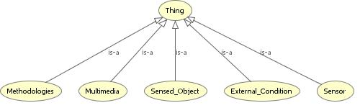

Figure 6-1: The lightweight ontology for the traffic control scenario: general view.

This lightweight ontology is very simple and represents only the very general representation of the problem stating what classes are needed in order to solve the problem. So it contains only the very general statement of the problem and represents the point of view of a user that is not very confident on the technical aspects involved in the problem. This lightweight ontology, according to the previous introduced ontology formalism, can be so defined: O_{SCL}={C_{SCL},A_{SCL}, R_{HSCL}}. The R set can be not considered because there are only hierarchical relations in the ontology. On the other hand a real expert on the technical issues of the problem can complicate the ontology adding new nodes. In particular at the end of the representation there are in the ontology the following nodes:

External_Condition
Weather
Rainy
Misty
Sunny
Cloudy
Snowy
Season
Winter
Spring
Summer
Fall
Day_Period
Daylight
Evening
Identified_Object
Identified_Vehicle
Identified_Motorcycle
Identified_Bicycle
Identified_Car
Identified_Truck
Sensed_Object
Vehicle
Motorcycle
Bicycle
Car
Truck
Multimedia
Image
CCD_Image
Video_Camera_Image
Video
Infrared_Video
Normal_Video
Sensor
Multimedia_Sensor
CCD_Camera
Infrared_Camera
Video_Camera
Laser_Radar
Methodologies
Plate_Detector
Speed_Detector
Vehicle_Detector
Heat_Signature_Detector

This proposed ontology is depicted in Figure 6-2. In this case the lightweight ontology, developed by an expert, represents a sort of taxonomy of the scenario and a general approach to the resolution of various users’ queries. In other words it could be considered as a mix between an UML’s use case and deployment diagrams. In this way the lightweight ontology could be considered as a sort of detailed recipe that describes the “ingredients” that have to be used in order to solve each task. This lightweight ontology, according to the previously introduced ontology formalism, can be defined as: O_{SCL1}={C_{SCL1},A_{SCL1},R_{HSCL}}. This lightweight ontology cannot describe the system’s dynamic behaviour because of its simplicity. In order to improve it, more relations, in particular non-hierarchical relations, are needed. First the medium-weight ontology definition is furnished:

Definition 27. Medium-weight Ontology: the medium-weight ontology is defined by the introduction of classes, attributes, hierarchical and non-hierarchical relations: O_{M}={C_{M},A_{M}, R_{HM,}R_{M}}.

So in the previous lightweight ontology the following non-hierarchical relations could be introduced in order to obtain the medium-weight ontology:

- Relation: is_furnished – Domain: Multimedia – Range: Multimedia_Sensor – Inverse of: furnish
- Relation: furnish – Domain: Multimedia_Sensor – Range: Multimedia – Inverse of: is_furnished
- Relation: is_identified_mfd – Domain: Sensed_Object – Range: Multimedia – Inverse of: identify_mfd
- Relation: identify_mfd – Domain: Multimedia – Range: Sensed_Object – Inverse of: is_identfied_mfd
- Relation: is_used – Domain: Multimedia – Range: Methodologies – Inverse of: use
- Relation: use – Domain: Methodologies – Range: Multimedia – Inverse of: is_used
- Relation: send_data – Domain: Sensor – Range: Methodologies
- Relation: is_used_on_day_period – Domain: Sensor – Range: External_Condition
- Relation: is_used_on_season – Domain: Sensor – Range: External_Condition
- Relation: is_used_on_weather – Domain: Sensor – Range: External_Condition
- Relation: is_prerequisite – Domain: Methodologies – Range: Methodologies

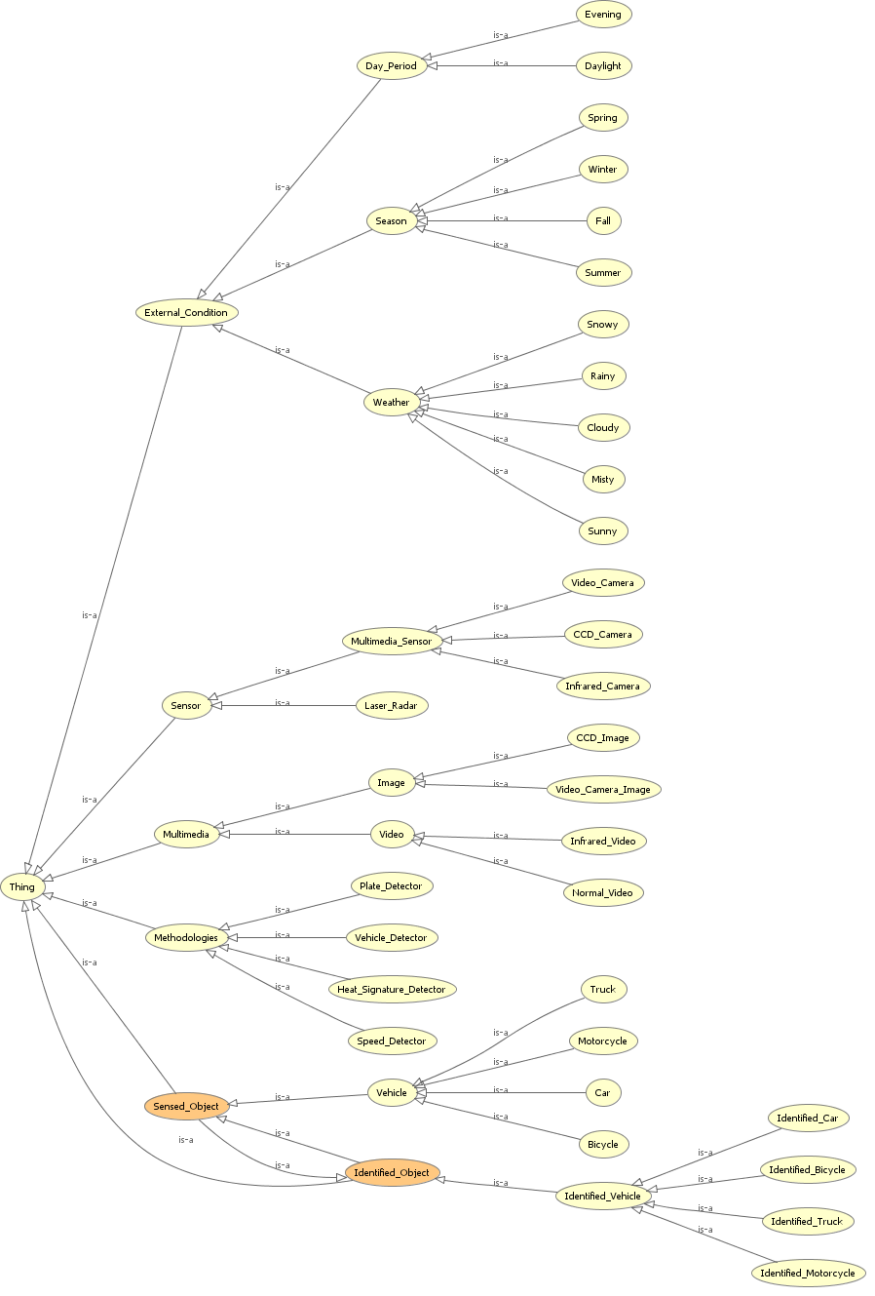
Figure 6-2: The lightweight ontology for the traffic control scenario: detailed view.
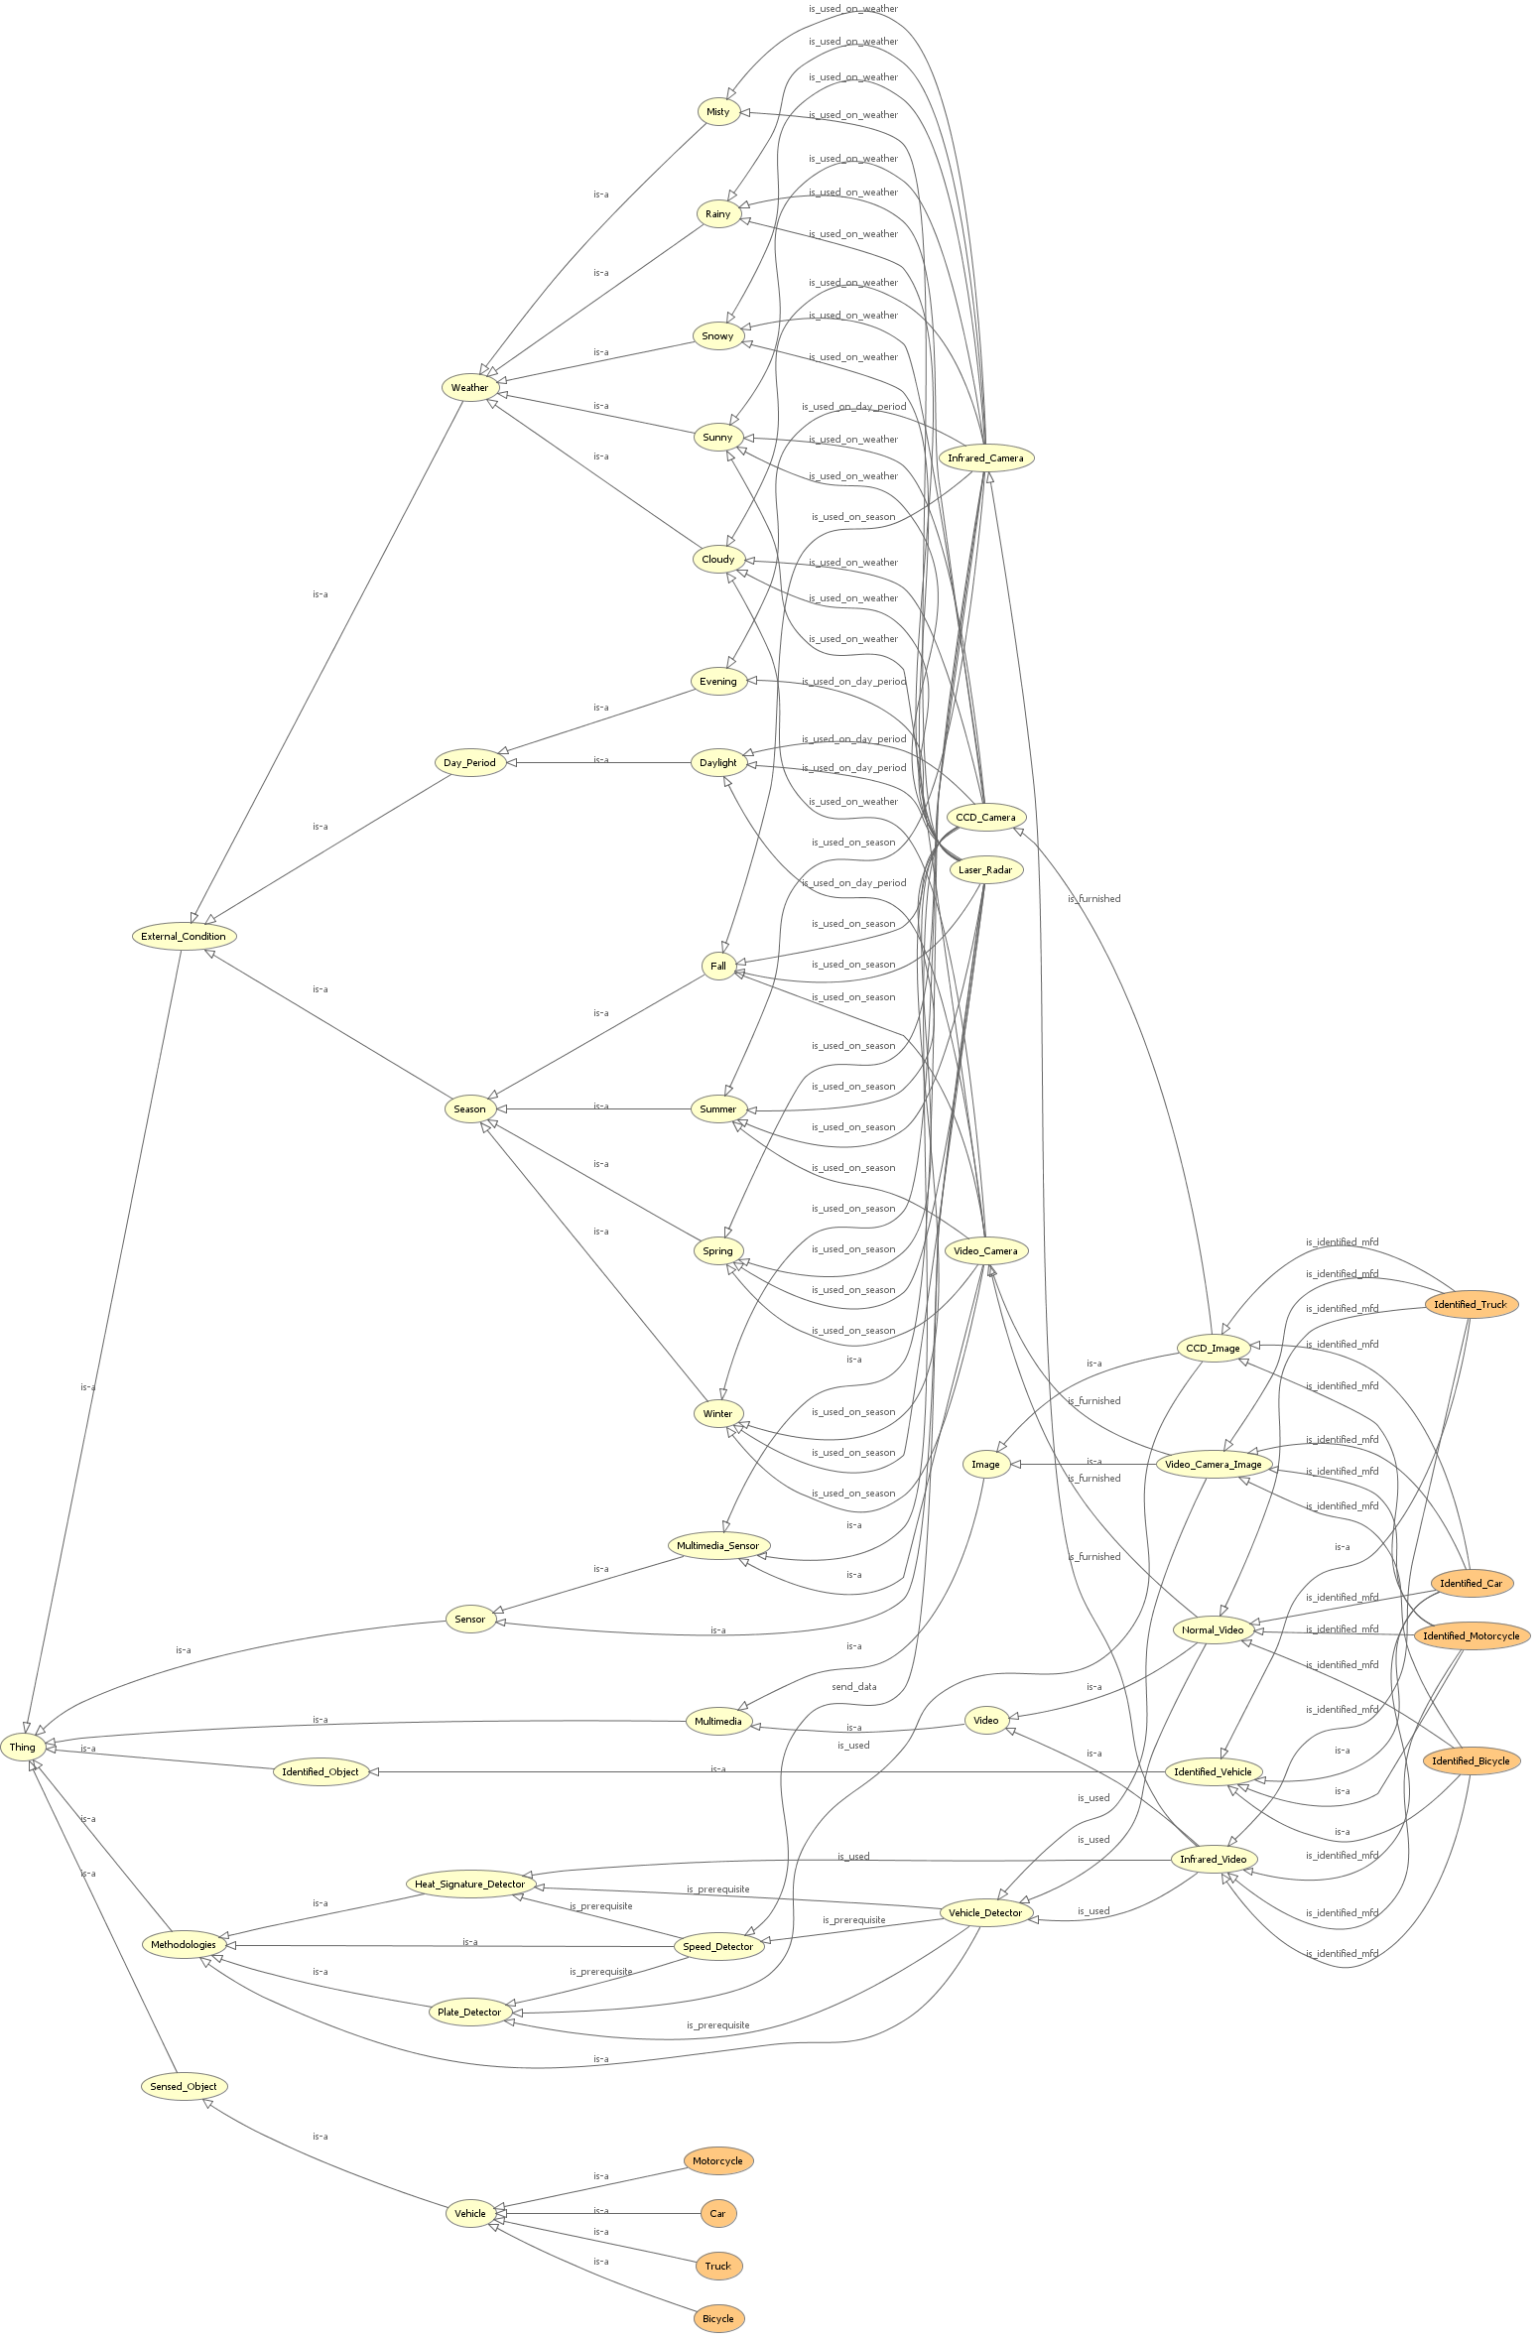

Figure 6-3: The medium-weight ontology for the traffic control scenario: detailed view.

These relations can be applied to the various nodes of the proposed ontology to obtain a medium-weight ontology depicted in Figure 6-3 and represented by O_{SCM}={C_{SCM},A_{SCM}, R_{HSCM}, R_{SCM}}. The relations “is_identified_mfd “and “identify_mfd” are from the set of multimedia functional dependencies S_{mfd} defined in Section 5. In other words, multimedia functional dependencies relevant to the continuous queries can be incorporated as non-hierarchical relations in a Medium-Weight ontology. A software tool was implemented to recognize and add multimedia dependency relations S_{mfd} to an ontology specified in OWL. For example a lightweight ontology shown in Figure 6-2 can thus be transformed into a medium-weight ontology shown in Figure 6-3.

However also this kind of representation is general purpose oriented and does not optimize the workflow of the system and, in general, could be inefficient because it follows a generic way for task solving involving each component of the system. In fact if for example the system previously described has to accomplish the following user’s query: “identify each car that travels in the street on a sunny summer day” it will identify each kind of vehicle using all its sensors and in any external conditions. In this way it wastes time and resources: in fact why the Heat_Signature_Detector has to be used if the day’s period is in the daytime or the Speed_Detector sensor if the user’s aim is only the identification of a car? Also the infrared camera is not useful in this scenario. So a good approach can be a simplification of the ontology by the use of information contained in the user query. In particular the user expresses his personal idea of the problem in the query. So by the analysis of the user query “identify each car that travels in the street on a sunny summer day” the following very simple ontology could be inferred:

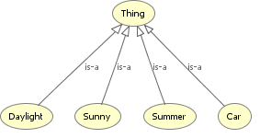
Figure 6-4: The lightweight ontology inferred by user request.

This ontology can be defined as the user ontology: in other words is how the user wonders the problem. This ontology could be defined as O_{U}={C_{U},A_{U}, R_{HU}}. In order to determine the reference ontology first of all the definition of lightweight plus ontology has to be introduced.

Definition 28. Lightweight Plus Ontology: the lightweight plus ontology O_{L+}={C_{L+},A_{L+}, R_{HL+,}R_{L+}} is an ontology obtained by the simplification of medium-weight ontology O_{M}={C_{M},A_{M}, R_{HM,}R_{M}}. In particular each component of O_{L+} is a subset or is equal to the homologous in O_{M} .

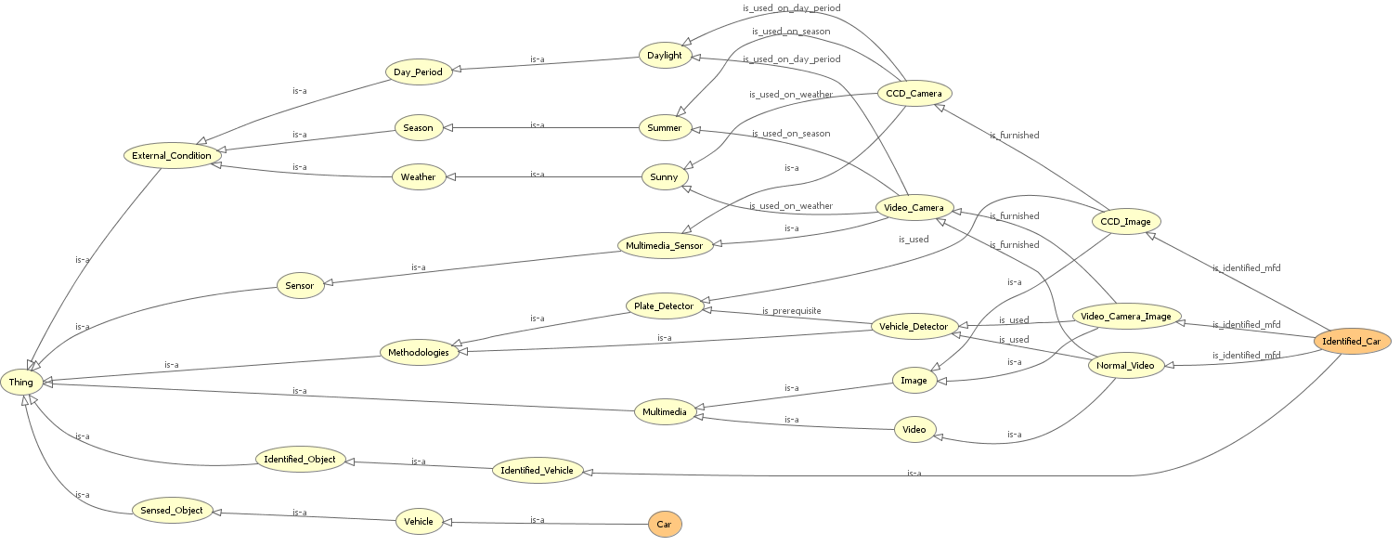

Figure 6-5: The lightweight plus ontology obtained from simplifying the medium-weight ontology.

According to the previous definition we can say that the Ontology Simplification Operator (OSO) in order to simplify the O_{M} by the use of O_{U} obtaining O_{L+} ={C_{L+},A_{L+}, R_{HL+},R_{L+}} depicted as in Figure 6-5.

This new ontology solves the user’s request and improves the use of the system’s resources. In fact this new ontology improves the use of the system selecting only the components that are actually needed for achieving the user request. In order to show the modularity of the proposed approach another example will be introduced: The query is: “identify those cars that reach a speed above 100 mph in the evening with misty condition during the winter period”. Also in this case the starting point is the formalization of the user request by the use of the ontology formalism. The ontology O_{U2}={C_{U2},A_{U2},R_{HU2}} is depicted in Figure 6-6.

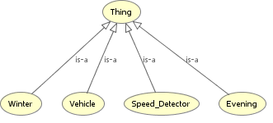
Figure 6-6: The Lightweight Ontology obtained simplifying the Medium-weight Ontology.

Adopting the previous approach and the operator OSF(O_{M},O_{U2}) we obtain the O_{L2+} ={C_{L2+},A_{L2+}, R_{HL2+},R_{L2+}} depicted in Figure 6-7.

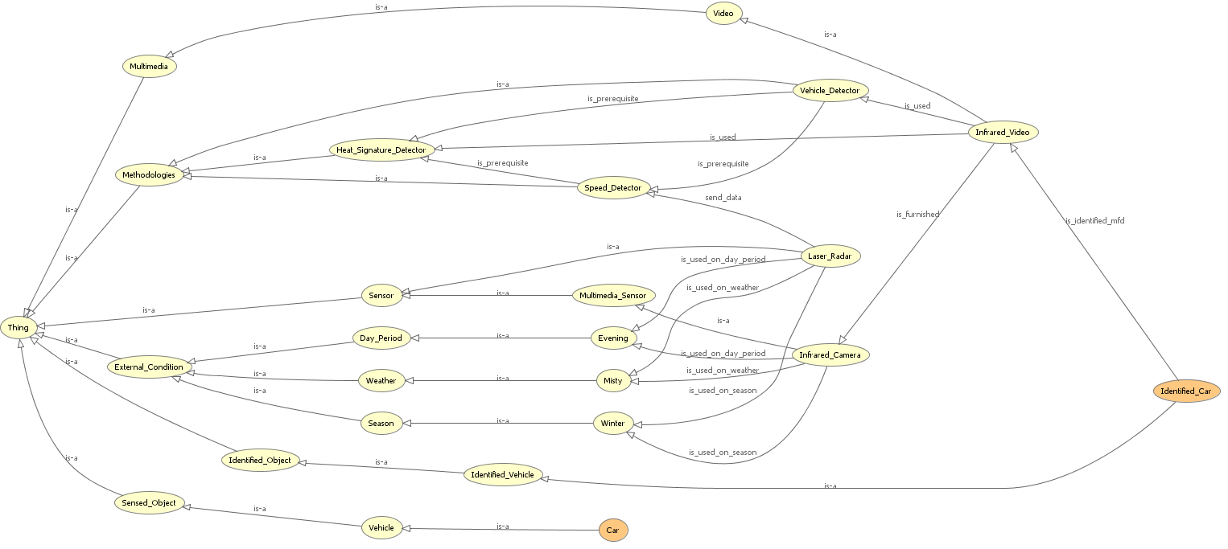

Figure 6-7: Lightweight plus ontology obtained from simplifying the medium-weight ontology for the second query.

In this case the parameters for the new ontology are simpler than those for the medium-weight ontology if it also supports the user’s requests. The system works in an efficient way to save resources. As illustrated by Table 6-1, the evaluation parameters for the new ontology also are simpler than those for the medium-weight ontology.

 | NOC | NOL | NONHR | NOF | AF-C | MaxDIT | ADIT-LN
Lightweight | 46 | 31 | 0 | 111 | 2.41 | 6 | 3.0
Medium-weight | 46 | 10 | 11 | 964 | 20,957 | 6 | 4
Lightweight Plus #1 | 27 | 4 | 11 | 134 | 4,963 | 6 | 3,5
Lightweight Plus #2 | 29 | 4 | 11 | 188 | 6,483 | 6 | 3,25
Table 6-1. Comparison of evaluation parameters of lightweight, medium-weight and lightweight plus ontologies.

The starting point of this approach is the idea that it is reasonable to think that between the lightweight and the heavy-weight ontology there are a series of ontologies that can be defined as lightweight-plus ontologies.

Some user requests can be supported by the use of one of these lightweight plus ontologies. Although the use of heavy-weight ontology guarantees the full execution of the task, it does not assure the optimal configuration of the system. Each of this ontology enriches its semantic level by the introduction of new classes, relations, functions, formal axioms and instances. These enrichments allow a better configuration of the system and the satisfaction of user requests.

7. Algorithms for Multimedia Data Streams Continuous Query Processing

In this section we describe a basic set of functions and algorithms to manipulate and handle multimedia data streams. First we define the standard multimedia data stream. To do so, we focus our discussion below on video and image streams, while generalizing the algorithms to other multimedia data streams, such as audio and hyper text, is trivial.
The standard multimedia data stream, irrespective of the source, will have the following attributes:

- Header- denoting start of frame
- Timestamp
- SourceID
- A set of other attributes, and
- EOF – denoting the end of frame

Note that the 3rd attribute listed above defines the source, as many sources (hardware) can map the tuples to the same multimedia data stream. Each source produces frames with a certain rate (frame per second) and different format. A video source will have a series of picture frames while a still camera source will have just one picture frame. Thus, the basic algorithm will be the same whether it is dealing with the picture frames or video frames. The second important attribute of the standard multimedia data stream shown above is the timestamp. Each frame will have a unique time stamp for that particular video source. There won’t be a similar timestamp on two frames that belong to the same source but the timestamp can be same for two frames that belong to different sources. Note that this is different from the regular data streams. Thus, the unique tuple identifier here is the compound key: Timestamp and SourceID. This is important when we use the multimedia querying techniques such as the transformational and fusion operators.

To process multimedia data streams, there should be algorithms to sort/group incoming multimedia data, algorithms for feature extraction, and algorithms for content-based retrieval. The general characteristics of these algorithms were discussed in [25]. In what follows we concentrate on algorithms for querying techniques, and algorithms for applying ontological filters to improve m-CQ processing.

7.1. Algorithm for the querying techniques

The retrieval will begin with the querying technique. The transformational and fusion operators can be applied for this purpose. A transformational operator is applied to any multi-dimensional source of objects in a specified set of intervals along a dimension. The generalized form of a transformational operator is for locating an object in a time period t1 to t2 from a source is:
ψ_{type}(object name)= (
ψ_{type} (object name) ψ_{xyz} (*)
σ (T) _{T>t1 and T<t2}
ψ_{media_sources}(source name) media_sources)

If we replace the source with some other media source such as the video camera, laser radar, etc we can query that source in order to find the required object. The corresponding algorithm for the transformational operator is:

- locate the media source in the query
- check the time-slot
- get the groups of images for that particular time slot from the media source
- apply the feature extraction algorithm
- compare the object with the existing objects in the database
- check the query for additional parameters like color
- compare it with the objects
- output the result of the query

Sometimes we may need to compare the results of two or more transformational operators. In such a case, we will apply the algorithm to each of the operators independently and then compare the results. We may use the existing SQL operators for this case as shown below:

- UNION: This can be used to combine two transformational queries coming from different sources in order to add their results. The syntax can be of the form:
ψ _{motion} (moving)
σ (T) (time)
ψ _{media_sources}(video)media_sources
UNION
ψ _{type} (vehicle)
σ (T) (time)
ψ _{media_sources}(laser_radar)media_sources

- INTERSECT: Similar to UNION but will take the intersection of the results of the two queries as follows:
ψ _{motion} (moving)
σ (T) (time)
ψ _{media_sources}(video)media_sources
INTERSECT
ψ _{type} (vehicle)
σ (T) (time)
ψ _{media_sources}(laser_radar)media_sources

This query will find the type of the vehicle from the list of moving vehicles

- EXCEPT: This query will find the ‘type’ of stationary vehicle, if any:
ψ _{type} (vehicle)
σ (T) (time)
ψ _{media_sources}(laser_radar)media_sources
EXCEPT
ψ _{motion} (moving)
σ (T) (time)
ψ _{media_sources}(video)media_sources

The fusion operator will perform sensor data fusion from heterogeneous data sources to generate fused objects. Fusion of data from a single sensor in different time periods is also allowed. It will combine the results of the transformational operators. The fusion parameter can have arguments and can be applied with respect to type, position and direction.

Once we have the data from various sources, we can use the existing fusion operator to combine the results of the two or more sources obtained through the transformational operators as follows:

φ_{type,position, direction}
(ψ_{motion}(moving) ψ_{type}(Object)
σ_{xy}(*)
σ (T)T mod 10 = 0 and T>t1 and T <t2
ψ_{media_sources} (source 1)media_sources
.
.
.
ψ_{type}(Object) ψ_{xyz}(*)
σ (T) _{T>t1 and T<t2}
ψ_{media_sources}(source n) media_sources)

The generalized algorithm combining the transformational and fusion operators is thus:

- Locate the transformational operators in the query
- Apply the transformational algorithm to each of the transformational operator independently
- Check the parameters of the fusion operator
- Apply the fusion operator with respect to the parameter specified to the results of the transformational operators
- Output the result

7.2. Algorithm for applying ontological filter to improve m-CQ processing and obtain the system architecture configuration

As we have stated in the previous section, by applying an ontological filter between the user query and the system (MMDSMS), we can produce an improved selection of the sensors and an improved execution sequence of the atomic operations that constitute the query according to certain external conditions and specific queries. That is to say, the meaning of the query is not changed. What is changed here is the form of the query, and how the system reacts to the query, i.e. how the system would adjust the operations that will constitute the query. In other words by the analysis of the lightweight ontology can be obtained the actual system architecture and the simplified version of the m-CQ. In this paragraph the algorithm for the transformation of the information which is in the lightweight plus ontology in m-CQ will be described. In order to better introduce the algorithm some definition has to be introduced.

Definition 29. Function for the identification of ending nodes in a branch according to a hierarchical relation IFH: the function $\text{IFH}:\text{CxH}→C$ is so defined: given a concept c_{i} and a hierarchical relationship h_{j} belonging to an ontology O the function IFH(c_{i}, h_{j}) gives as result the set of concepts {c_{k}} that respect the following conditions: $∀c_{z}∈O$and $∉C_{\text{AN}}(c_{k})$there is no relationship h_{j} between c_{k}, c_{z} with C_{DN}(c_{k}) empty and C_{AN}(c_{j}) contains c_{i} with c_{j} = {c_{k}, C_{AN}(C_{AN}(c_{k})), …} with C_{AN}(c_{j}) different from root

Definition 30. Function for the identification of nodes in a branch according to a non-hierarchical relation IFNH: the function $\text{IFNH}:\text{CxR}→C$ is so defined: given a concept c_{i} and a non-hierarchical relationship r_{j} belonging to an ontology O the function IFNH(c_{i}, r_{j}) gives as result the set of concepts {c_{k}} that respect the following conditions: there is between the nodes c_{i} and c_{k} the relationship r_{j}

Definition 31. Function for the ordering of nodes according to a non-hierarchical relation OFNH: the function $\text{OFNH}:C^{N}\text{xR}→C^{N}$ is so defined: given a set {c_{i}} and a non-hierarchical relationship r_{j}, which states an ordered sort and related to each {c_{i}}, belonging to an ontology O the function OFNH(c_{i}, r_{j}) gives as result the set of concepts {c_{k}} ordered according to the relationship r_{j}.

So the algorithm for the mapping of the lightweight plus ontology in the system architecture configuration and in the m-CQ can be described.

- First step - identification of the sensors: the first step of the proposed algorithm is the identification inside the lightweight plus ontology of the nodes representing the sensors that have to work in the system. At this aim the IOH operator is applied in the following way: IOH(“sensor”, “is_a”). In this way a set of concepts {c_{s}}, representing the sensors that are in the system architecture, is obtained. In other words starting from the “Sensor” node the algorithm traces down through the “is_a” relation to get all the sensors that are useful in the system for the specific query processing. So in this way all the not useful sensors can be removed as for example the sensors that either will not produce valid results in the given external conditions or are not useful in m-CQ processing even they are producing valid outputs. For example, if the current time is at night, then the CCD cameras should be turned off.
- Second step - identification of the methodologies: the second step is to identify methodologies that have to be used on the data collected by sensors. So for each node c_{s} representing a sensor, identified in the previous step, the set of {c_{m}} methodologies is obtained in the following way:
  - Step 2.1: if IFNH(c_{i}, r_{j}), with r_{j} = “send_data”, gives nodes {c_{h}} then these nodes are methodologies and belong to the set {c_{m}}. For each c_{m} belonging to the methodologies’ set a label indicating the related working sensor is furnished.
  - Step 2.2: if IFNH(c_{i}, r_{j}), with r_{j} = “is_furnished”, gives nodes {c_{ms}} then these nodes are multimedia stream and for each node c_{t} belonging to {c_{ms}} the function INFH(c_{t}, r_{p}) with r_{p} = “is_used” is applied. So the nodes {c_{h}} given by the use of INFH represent methodologies and belong to the set {c_{m}}. For each c_{m} belonging to the methodologies’ set a label indicating the related sensor and multimedia stream is furnished.
  - Step 2.3: merge the {c_{m}} obtained in the Step 1 and Step 2 and apply OFNH(c_{m}, r_{i}) where r_{i} is equal to “is_prerequisite” in order sort it. So the obtained concepts represent the methodologies that have to be activating in the system in order to answer the user’s query.

After this first two steps an ontology O_{SA}={C_{SA},A_{SA},R_{HSA,}R_{SA}}, with C_{SA}={c_{s}, c_{m}} and A_{SA}, R_{HSA,}R_{SA} the relative attributes or relations, that represents the components belonging to the system architecture is obtained. In other words an ontology representing the actual configuration of the system for the resolution of the user’s query is obtained. This ontology can be easily converted in the signals for the control of the sensors and the activation of methodologies. After this phase the process of mapping of the lightweight ontology in m-CQ can start according to the following steps:

- The third step is the definition of what kind of multimedia streams are involved in the system: These concepts can be retrieved applying the function IFNH: if IFNH(c_{i}, r_{j}), with r_{j} = “is_furnished”, gives nodes {c_{k}} then these nodes are multimedia stream and have to be inserted in the {c_{ms}} concepts
- The fourth step is the definition of what kind of sensed object has to be identified: The first step is the identification inside the lightweight plus ontology of the nodes representing the objects that have to be identified. At this aim the IOH operator is so applied: IOH(“identified_object”, “is_a”) obtaining a set of concepts {c_{s}}. In this way all the concepts {c_{io}} representing objects that have to be identified by the system architecture are selected. At this point for each c_{i} belonging to {c_{io}} the function IFNH(c_{i}, “is_identified_mfd”) is applied in order to obtain the set {c_{ms}} of multimedia streams’ concepts that allow the identification of the object. The multimedia streams identified are associated to the identified_objects’ concepts. At this point for each {c_{l}} belonging to the set {c_{ms}} the function IFNH(c_{l}, “is_used”) is applied obtaining the set {c_{m}} of methodologies needed for the identification of the identified_object. Also in this case the needed methodologies’ concepts are associated to “identified_object” concepts.

At this point by the use of the proposed algorithm the ontology O_{FA}={C_{FA},A_{FA},R_{FHA,}R_{FA}}, with C_{SA}={c_{s}, c_{m}, c_{ms}} and A_{FA}, R_{FHA,}R_{FA} the relative attributes or relations, that represents the components and the multimedia streams belonging to the system architecture is obtained. The next step is the effective mapping of the obtained ontology in the m-CQ graphical formalism. Also in this case a mapping algorithm is proposed.

- As first step the sensors nodes {c_{s}} obtained in the previous described algorithm will be the first level of the graph representing the m-CQ
- The second step is the distribution of the methodologies and atomic operators. In particular the methodologies are distributed according the order obtained by the use of OFNH function. The first ones will be connected directly to their reference sensors while the other will be connected in the other stages of the m-CQ graph.
- The third step is the introduction of the atomic operators. In particular each concept representing methodologies has as attributes the operators that have to be applied on their output. So analyzing the attributes the operators can be easily introduced in the graph representing the m-CQ. If the operator needs arguments them can be found both by the use of the “identified_object” nodes related to the methodologies’ nodes obtained during the execution of the step fourth of the previous algorithm both analyzing the attributes of the methodologies concepts that are also in the “identified_object” nodes.

After this last step the m-CQ query is obtained.

8. An Example of Continuous Query Processing and Performance Estimation

In this section we present an example showing how ontological filtering can be applied to improve the execution of user queries and thus enhance the system performance. We will use the following query mentioned in Section 6 as the example: “identify each car that travels in the street on a sunny summer day”. The system in Figure 3-3 serves as the reference MMDSMS system. First we give the SigmaQL representation of the query in both the unimproved and the improved cases, which can then be transformed into a DAG representation.

Query: Identify each car that travels in the street on a sunny summer day.

Solution without any query improvement:
{ ψ_{media_sources}(*) media_sources
ψ_{type}(vehicle)
ψ_{type}(car) }
INTERSECT
{ψ_{media_sources} (*)media_sources
σ_{platenumber} (*) }
INTERSECT
{ ψ_{media_sources} (*)media_sources
σ_{speed}(*) }
INTERSECT
{ ψ_{media_sources} (*)media_sources
σ_{heatsignature}(*)}

Solution with query improvement:
{ψ_{media_sources}(Video) media_sources
ψ_{type}(vehicle)
ψ_{type}(car)}
INTERSECT
ψ_{media_sources} (CCD)media_sources
σ_{platenumber} (*)

Then we give the DAG representation of the system behavior without the ontological filter. Figure 8-1 is the DAG representation for unimproved query processing. The system takes every sensor to consideration and executes all operations simultaneously, no matter whether the source sensors or operations would produce interesting results. The numbers on the edges are output rates of the sources or operations exclusively possessing one processor, which will be used later for performance estimation.

With the DAG representation of the unimproved query processing, we can apply the algorithms described in Section 7.2 to produce improved query processing.

Query Improvement

Starting from the lightweight plus ontological representation of the system (Figure 6-5) and applying the algorithm proposed in 7.2 the following statements are obtained:

- The set of sensors {c_{s}} has been identified. In details the sensors that have to be activated are: {CCD_Camera, Video_Camera}. In this way the infrared camera is not activated because does not give useful information in this scenario.
- The methodologies {c_{m}} are identified and ordered. In details the methodologies that have to be activated are: {Vehicle_Detector, Plate_Detector}. The other one methodologies are not activated because do not give useful information in this scenario. The methodologies have been associated to the sensors. In particular Vehicle_Detector to Video_Camera and Plate_Detector to CCD_Camera.
- The set of multimedia_streams {c_{ms}} are identified and associated to the methodologies. In details the multimedia_streams that have to be used are: {Normal_Video, Video_Camera_Image, CCD_Image}. These stream have been associated to the methodologies: in particular Normal_Video and Video_Camera_Image are associated to the Vehicle_Detector and the CCD_Image is associated to the plate detector.
- The set of identified_object {c_{io}} is identified. Keeping in mind that these classes are equivalent to the relative sensed_object also these ones have been identified. In particular for this case the identified_object is only one: {car}.
- The atomic operators are identified in the attributes of methodologies and inserted in the m-CQ graph. The arguments of these operators are obtained by the analysis of the identified_object’s concepts and relative multimedia streams.
- The m-CQ graph obtained is in Figure 8-2.

Through the above four-step improvement algorithms, we can give the DAG representations of the improved system behavior with ontological filter. Figure 8-2 is the DAG representation for improved query processing. The system activates sensors selectively and executes operations in an organized manner. The numbers on the edges are output rates of the sources or operations exclusively possessing one processor, which will be used later for performance estimation.

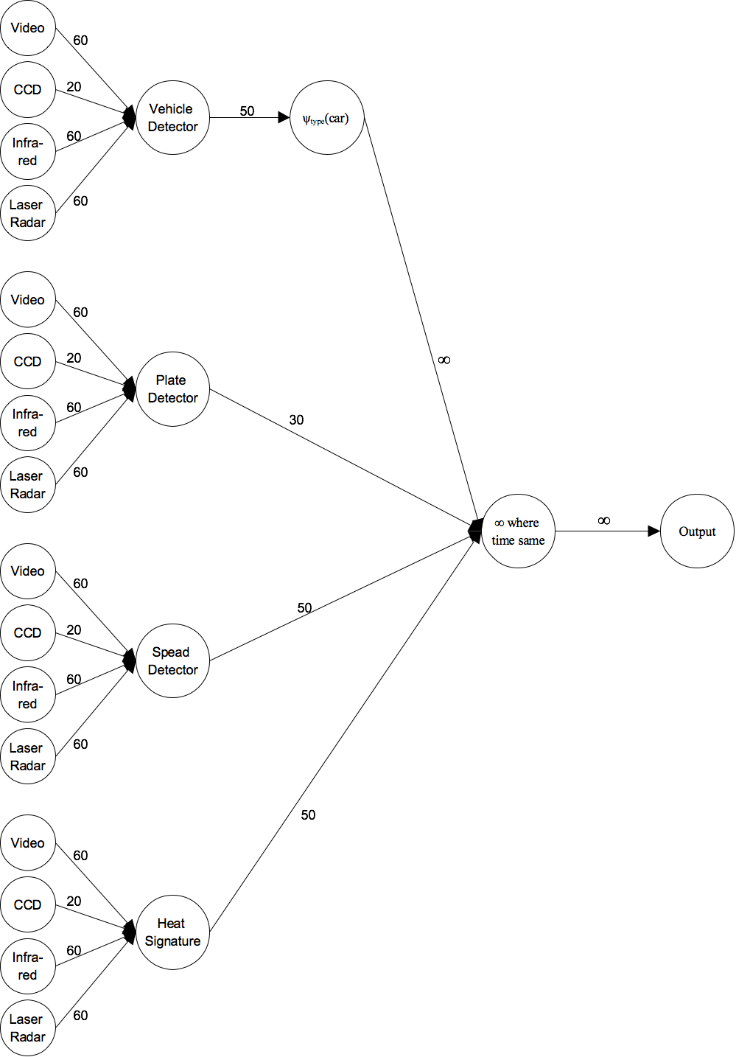
Figure 8-1: DAG for unimproved query processing.

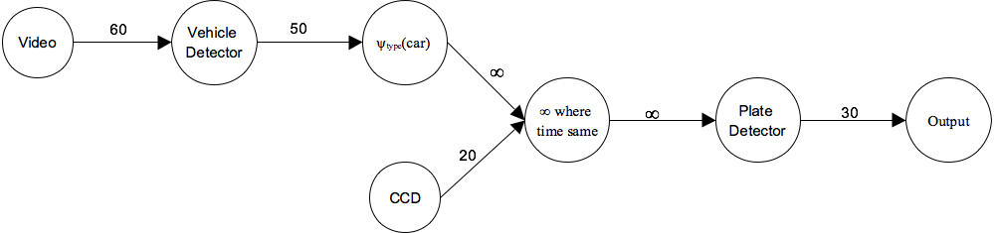
Figure 8-2: DAG for improved query processing.

Since the estimation model described in Section 4 did not consider the execution order of the atomic operators, it could not appropriately estimate the performance where query processing has certain ordering or priorities. So here we would like to estimate the performance in an extended method. In the following estimation, we consider the overload of atomic operations such as “selection”, “join” as negligible in comparison to the operations like “vehicle detector”, “plate detector”. Therefore these operations’ output rates are denoted as ∞. We will estimate the system’s performance mainly as output rate of interesting results (results containing what the users are interested in).

Performance Estimation
Assumption: we may assume that on the street only half of the detected vehicles are cars (what the users are interested in).

Performance Estimation for Un-improved Query Processing:
We may assume that all the operations are executed simultaneously in unimproved case. There are four operations consuming the majority of the processing power: they are “vehicle detector”, “plate detector”, “speed detector” and “heat signature”. So their output rates are all reduced to ¼ of their original output rates, 12.5, 7.5, 12.5, 12.5 respectively. Since they are taking all the incoming sources as inputs, the “interesting” output rates (for example, “plate detector” output useful results only when it is processing on the incoming stream from “CCD camera”) are 3.75, 0.75, 0, 0 respectively. So finally, the “interesting” output rate of the whole system is
Min{3.75/2, 0.75} = 0.75
since by assumption only half of the vehicles are cars.

Performance Estimation for Improved Query Processing:
Here there are only two operators consuming the majority of the processing power, “vehicle detector” and “plate detector”. Since “plate detector” is executed only after “vehicle detector” has already identified a vehicle type as car, so we may assume 2/3 of the processing power is used on “vehicle detector”, and the rest 1/3 is used on “plate detector”. So the output rates of “vehicle detector” and “plate detector” are 33.3 and 6.67, respectively. So are the “interesting” output rates because this time the algorithms are used on proper incoming streams. Finally, the “interesting” output rate of the whole system is
Min{33.3/2, 6.67} = 6.67
In this case, the “interesting” output rate of the system has improved a lot.

9. Experimental Results

As discussed in the previous sections, through applying the ontological filtering, the improvements to the m-CQ processing can be considered as consisting of two parts: one in reconfiguring the sensor system, and the other in reorganizing the atomic operations within a query graph.

In regard to reconfiguring the sensor system, the impact to the query graph is that some unnecessary incoming source nodes can be removed. And in regard to reorganizing the atomic operations, the impact to the query graph will be in the following three parts. First, nodes representing unnecessary operations will be removed. Second, nodes representing operations and nodes representing sensors (source streams) will be properly matched. Third, the execution of the nodes representing operations will be prioritized.

Through the above observation, an experiment was designed to simulate the improvement process, and a Query Improver was implemented. Generally speaking, the Query Improver reads in a query graph and also a customizable Knowledge Base for query improvement and evaluation. Both the query graph and the Knowledge Base are in text format. After calculation, the Query Improver will draw query graphs for both the original query graph and the improved query graph, and also produce the estimated output rate for each query graph.

The experiment was performed by applying this Query Improver on 100 continuous queries according to the previously described traffic control scenario. These queries are run under different external conditions to test our approach in different situations. Experimental results, which are described in the appendix of an extended version of this paper available from the authors, indicate that our approach is generally applicable, as the queries after improvement have better processing rates and under most circumstances enhance the performance by about four times.

10. Discussion

In this paper we presented a computation-oriented model to model sensor-based multimedia data streams as a potential tool for many useful applications such as security and health-care systems. Based on the proposed model, we provided performance estimates such as the output rate, maximum number of supported streams, and the maximum number of possible queries. We also generalized the multimedia dependency theory to include those involved in multimedia data streams and provided ontological filters along with suitable algorithms of how to efficiently process queries on sensor-based multimedia data streams, along with illustrative examples and experimental results. This approach provides a new research dimension in the database and the multimedia communities.

Compared to other models, our model is a computation-oriented model. This is the first major difference. With the computation-oriented model we can obtain performance estimates to deal with QOS and QOD issues, which cannot be easily accomplished in some other models. Since the focus of this paper is the model for sensor-based multimedia data stream, many important features of SigmalQL [26] such as the cluster operator are not discussed in the present paper. In fact, the query language SigmaQL is as expressive as CQL. All reasonable query languages should be equally expressive, just like all reasonable programming languages should be equally expressive. Therefore the issue is not whether one query language is more expressive than another. The issue is whether a query language can lend itself easily to performance estimates and therefore performance improvements. The second major difference is that we have further extended the multimedia dependency theory to include the ontological dimension. This has allowed the ontological filtering to improve the performance of sensor-based multimedia stream query processing. The third major difference is that we have developed a suitable ontology, the lightweight-plus ontology, which is expressive and yet amenable to transformations in order to be incorporated into efficient query processing algorithms.

We plan to further explore the evolution of the lightweight plus ontology, which could be the key to realize slow intelligence systems for sensor-based multimedia stream processing, which will slowly evolve to adapt to the current user interests through a process of enumeration, propagation, adaptation, elimination and concentration [28].

Acknowledgements: Thanks are due to Huichao Xue for implementing the software tool to add multimedia functional dependencies to a lightweight ontology to create a medium-weight ontology.

References:

[1] Jianjun Chen, David J. DeWitt, Feng Tian, and Yuan Wang. Niagaracq: a scalable continuous query system for internet databases. In SIGMOD ’00: Proceedings of the 2000 ACMSIGMOD international conference on Management of data, pages 379–390.ACM, 2000.

[2] Arvind Arasu, Brian Babcock, Shivnath Babu, Mayur Datar, Keith Ito, Itaru Nishizawa, Justin Rosenstein, and Jennifer Widom. Stream: The Stanford stream data manager (demonstration description). In SIGMOD ’03: Proceedings of the 2003 ACM SIGMOD international conference on Management of data, New York, NY, USA, 2003.

[3] D. J. Abadi, Y. Ahmad, M. Balazinska, U. C etintemel, M. Cherniack, J.-H. Hwang, W. Lindner, A. Maskey, A. Rasin, E. Ryvkina,N. Tatbul, Y.Xing, and S. B. Zdonik. The design of the borealis stream processing engine. In CIDR, pages 277–289, 2005.

[4] Daniel J. Abadi, Don Carney, Ugur C¸ etintemel, Mitch Cherniack, Christian Convey, Sangdon Lee, Michael Stonebraker, Nesime Tatbul, and Stan Zdonik. Aurora: a new model and architecture for data stream management. The VLDB Journal, 12(2):120–139, 2003.

[5] http://www.coral8.com/, 2004.

[6] http://www.streambase.com, 2006.

[7] S.K. Chang, Gennaro Costagliola, Erland Jungert and Karin Camara. Intelligent Querying Techniques for Sensor Data Fusion. Chapter from the book Intelligent Techniques for Warehousing and Mining Data Streams, (Alfredo Cuzzocrea, ed.), IGI Global, 2009.

[8] S.K. Chang, V. Deufemia, and G. Polese. A Normalization Framework for Multimedia Databases. IEEE Transactions on Knowledge and Data Engineering, v. 19, issue 12, Dec 2007.

[9] http://www.cs.cmu.edu/~biglou/research.html, 2008.

[10] Mohamed A. Sharaf, Panos K. Chrysanthis, Alexandros Labrinidis, and Kirk Pruhs. Algorithms and Metrics for Processing Multiple Heterogeneous Continuous Queries. ACM Transactions in Database Systems (TODS), March 2008.

[11] N. Tatbul and S. Zdonik. Window-aware load shedding for aggregation queries over data streams. In Proc. of VLDB Conference, 2006.

[12] M. Gaber, A. Zaslavsky, and S. Krishnaswamy. Mining data streams: a review. SIGMOD Record, 34(2), 2005.

[13] Sharaf, M. A., Chrysanthis, P. K., Labrinidis, A., and Pruhs, K. Algorithms and metrics for processing multiple heterogeneous continuous queries. ACM Trans. Database Syst. 33, 1, 1-44, March 2008.

[14] Arasu, A., Babu, S., and Widom, J. The CQL continuous query language: semantic foundations and query execution. The VLDB Journal 15, 2, 121-142, June 2006.

[15] Jain, N., Mishra, S., Srinivasan, A., Gehrke, J., Widom, J., Balakrishnan, H., Çetintemel, U., Cherniack, M., Tibbetts, R., and Zdonik, S. Towards a streaming SQL standard. Proc. VLDB Endow. 1, 2, 1379-1390, August 2008.

[16] Jepsen, T., Just What Is an Ontology, Anyway?, IT Professional, vol. 11, no. 5, pp. 22-27, Sep./Oct. 2009.

[17] Gruber, T.R, Translation approach to portable ontology specification, Knowledge Acquisition, vol. 5, pp. 199-220, 1993.

[18] “OWL Web Ontology Overview”, W3C Recommendation, 10 february 2004, http://www.w3.org/TR/2004/REC-owl-features-20040210/

[19] Maedche A., Staab S., Ontology Learning for the Semantic Web, IEEE Intelligent Systems, vol. 16 no. 2, Mar/Apr 2001, Page(s): 72-79.

[20] Corcho, O., A Layered Declarative Approach to Ontology Translation with Knowledge Preservation, Volume 116 Frontiers in Artificial Intelligence and Applications, 2005.

[21] Corcho, O., Gómez-Pérez, A., A Layered Model for Building Ontology Translation Systems, International Journal on Semantic Web and Information Systems, 1(2): 22-48, 2005.

[22] Haase, P., Stojanovic, L., Consistent evolution of OWL Ontologies, ESWC, Lecture Notes in Computer Science, vol. 3532, Springer, pp. 182-197.

[23] Yinglin Wang, Xijuan Liu, Rongwei Ye, "Ontology Evolution Issues in Adaptable Information Management Systems," E-Business Engineering, IEEE International Conference on, pp. 753-758, 2008.

[24] Zhang, L., Xia, S., Zhou, Y., Xia, Z., User Defined Ontology Change and its Optimization, Control and Decision Conference, 2008. CCDC 2008. Chinese, pp. 3586-3590, 2008.

[25] S. K. Chang, Lei Zhao, Shenoda Guirguis, Rohit Kulkarni, "A Computation-Oriented Multimedia Data Streams Model for Content-Based Information Retrieval", Journal of Multimedia Tools and Applications, Volume 46, Issue 2 (2010), pp. 399-423.

[26] S. K. Chang, Gennaro Costagliola, Erland Jungert and Francesco Orciuoli, "Querying Distributed Multimedia Databases and Data Sources for Sensor Data Fusion", IEEE Trans. on Multimedia, Vol. 6, No. 5, 687-702, October 2004.

[27] Orme, A.M., Haining, Y., Etzkorn, L.H., Indicating Ontology Data Quality, Stability and Completeness Throughout Ontology Evolution, Journal of Software Maintenance and Evolution: Research and Practice, vol. 19, pp. 49-75, 2007.

[28] Shi-Kuo Chang, “A General Framework for Slow Intelligence Systems”, International Journal of Software Engineering and Knowledge Engineering, Volume 20, Number 1, February 2010, pp. 1-15.

