Instructions for setup of VirtualClassroom Development Environment:

1. Install Eclipse 3.0.1
2. Install MyEclipse 3.8 GA
2a. Install Tomcat 5.0.28 and configure your $TOMCAT_HOME/common/endorsed library with the files
in jmenke/home/endorsed.zip

3. Checkout VirtualClassroom project from CVS

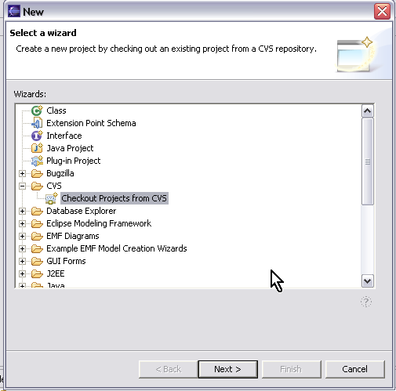

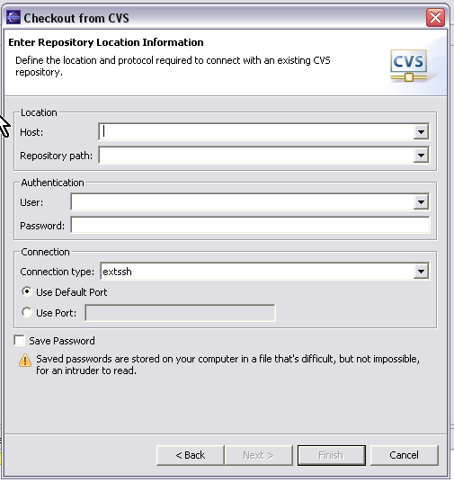

Fill in above with:

Host: 130.49.222.93
Repository Path: /var/lib/cvsroot
User: s(x) ie s1
Password: your password
Connection Type: extssh
Use Default Port
Check Save Password

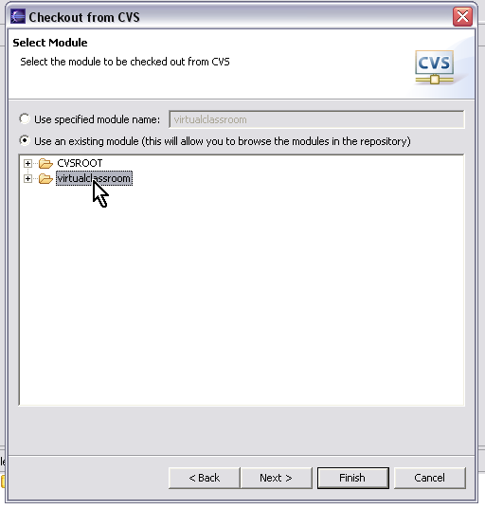

Select the virtual classroom repository

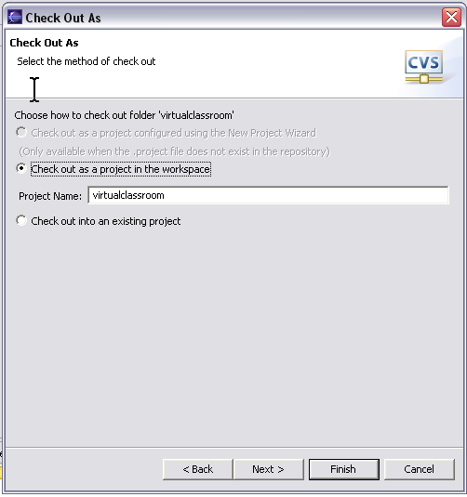

Select checkout project into workspace

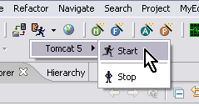

Assuming everything works OK and you have installed tomcat to c:\Tomcat 5.0

Start Tomcat

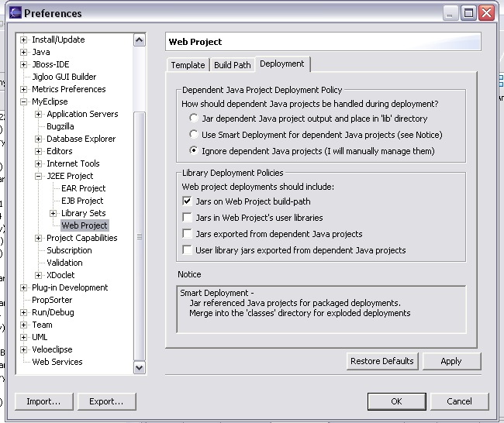

I'm not sure if this will come through with the project setting in CVS but check to see that these options are selected in your preferences

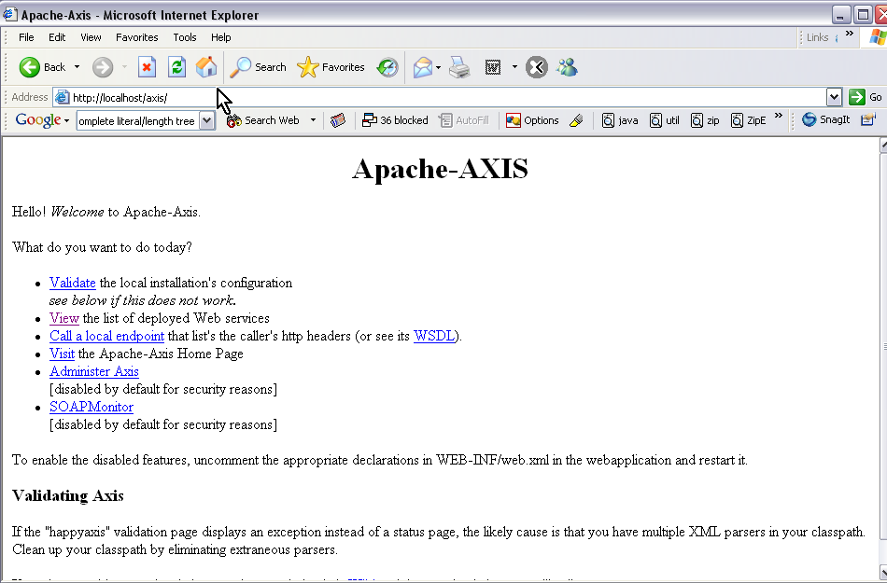

Deploy the project using the Deploy Icon and then browse to the above URL. (Note i have Tomcat installed at port 80 so i don't need port number on the URL)

Run the Sample Client

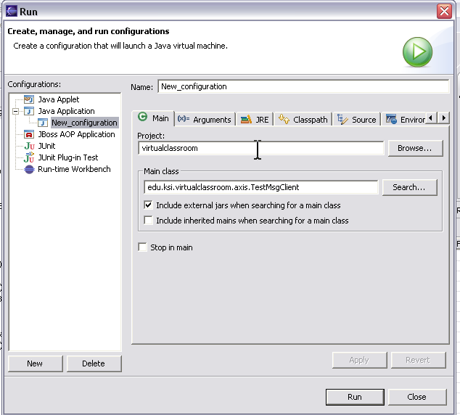

You should see:

