User Profiling in the Chronobot/Virtual Classroom System

Xin Li and Shi-Kuo Chang
Department of Computer Science,
University of Pittsburgh, USA,
{flying, chang}@cs.pitt.edu

Abstract

The Chronobot/Virtual Classroom (CVC) system is a novel time knowledge exchange platform where any pair of users can exchange their time and knowledge. User profile that contains user attributes, preferences, and learning patterns serves as a primary basis to identify exchange partners and determine exchange rates. In this paper, we described a methodology to assess user profile from user activities. The association between user preference and user behaviors (e.g. online reading, chatting and time/knowledge exchanging) is identified by several feedback indicators extracted from browsing history, chatting session and exchange transaction. A linear learning model is constructed to fuse multiple feedback indicators to infer user preference. The methods utilizing user profile to identify the exchange partners and determine the exchange rate are also described in detail.

Introduction
Comparing with the traditional face-to-face style teaching and learning, e-Learning is indeed a revolutionary way to provide education in life long term. Nowadays more and more people have benefited from various e-Learning programs. However, present-day e-Learning systems are still too rigid and do not lend themselves to the peer-to-peer learning in which any users can exchange their knowledge with any others. Chronobot/Virtual Classroom (CVC) [3] is a novel time knowledge exchange platform where any pair of users can exchange their time and knowledge. The chronobot is a time manage tool for storing and borrowing time. Using chronobot one can borrow time from some one and return time to the same person or someone else. The virtual classroom is a versatile communication tool that combines the functions of web browser, chatting room, white board, and multimedia display. The CVC system is an integration of chronobot and virtual classroom that allows users freely switch between these two applications and get maximum benefits from both.

For example, illustrated in figure 1, George, Bill, and Suzie are all students who are doing a group project together in a graphics design course in which they use the CVC system to collaborate with each other. The whole project is divided into several tasks, each of which is mainly assigned to one person. George meets a problem in his task and can not solve it by himself. So he interacts with Bill and Suzie in the virtual classroom, and eventually they help him out. However, in order to keep workload even among teammates, George has to put in efforts either in the past or in the future to help Bill and Suzie. The chronobot serves as a platform for them to do such time and knowledge exchanges which could have significant value for many applications. Many more interesting scenarios can be found in [3].

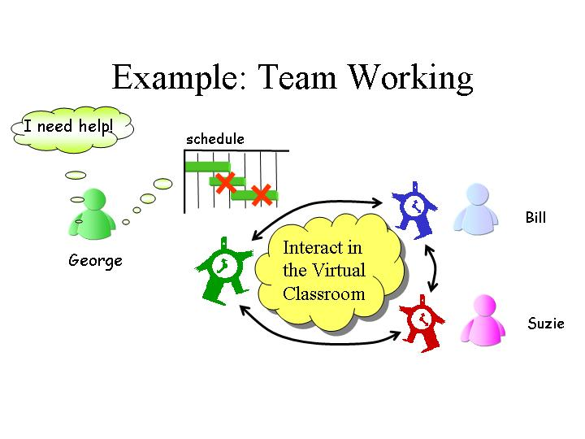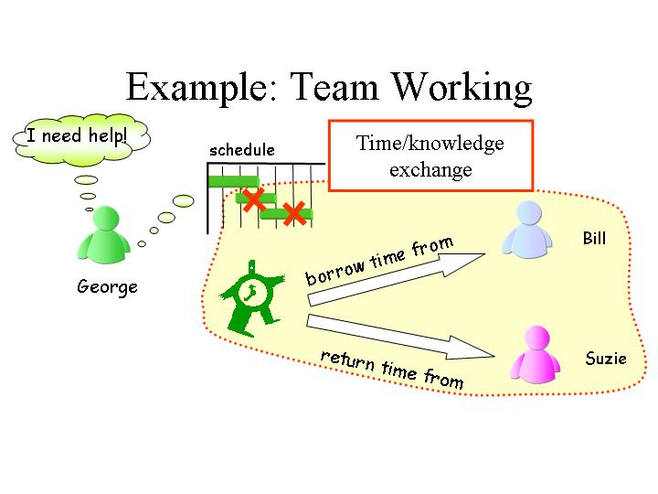
(a) (b)
Figure 1. Application of the CVC system: (a) Communication in Virtual Classroom; (b) Time and knowledge exchange in Chronobot

Generally speaking, a transaction of the time/knowledge exchange in the CVC system includes the following steps:
- Identify a slice of time or knowledge for exchange;
- Search for exchange partner or partners;
- Perform time or knowledge exchange through bidding and negotiation;
- Manage the exchange slice of time or knowledge;
- Provide feedback on the results.
In these processes, user profile that contains user attributes, preferences and learning patterns plays a vital role because:
- User preference is the fundamental information to identify time or knowledge for exchange and exchange partners.
- User profile is the primary basis to determine time/knowledge exchange rate.

In this paper, we describe an approach to implicitly assess user profile in the CVC system based upon user activities such as web browsing, chatting and time/knowledge exchanging. We believe this work has significant value not only because the user profiling is important in our system but also it is the key process of many other applications. For example, the recommendation systems [1, 4, 6, 8] mainly depend on user profiles in terms of similarity and differences to provide particular suggestions. The personalized web search engine [9] can construct user profiles from browsing history and consequently provide personalized results to match the information needs of individuals. Comparing with these applications, an effective user profiling is much more feasible in our system because of the following two reasons:
- Time/knowledge exchange (i.e. peer-to-peer learning) is a much more continuous process than the activities (e.g. online news reading and web searching) in many other applications.
- Multiple data sources can be employed to assess user profile in our system. For example, in addition to browsing history, chatting session and knowledge/time exchange transaction can also serve as important input sources for the profiling process.

User preference is key information in user profile. As far as we studied, the majority of user profiling approaches mainly depends on the user feedbacks to retrieve user preference. The feedback can be assessed explicitly by rating, or implicitly by the user behaviors such as print and save. In this paper, we are not advocating either of these two approaches because both of them have significant advantage and disadvantages [9]. Instead we propose a methodology which can combine multiple feedback measures to get more complete and accurate assessment. User preference can be inferred on the basis of data from three sources, i.e. browsing history, chatting session, and knowledge/time exchange transaction. A linear learning model is constructed to fuse all the related data for the inference of user preference. Five feedback indicators – reading time, scroll number and print/save from browsing history, relational index from chatting session, and the exchange index from knowledge/time exchange transaction serve as input variables of the model. Demonstrated by the experiments in the prototype system, the proposed model can infer user preference much more accurately than any single of these indicators. The applications of user profile – to identify the exchange partners and determine the exchange rate are also described in detail. A preliminary report about this work has been published in [7].

The rest of this paper is organized as follows: two basic concepts user profile and ontology knowledge base in our system are described in section 2 and 3 respectively. Section 4 discusses the measures to identify the association between user activities and preferences, where five implicit feedback indicators are defined. The learning model to fuse these indicators for a final assessment of user preference is described in Section 5. The application of user profile is described in Section 6. In Section 7, our prototype system and experiments in it are described. The related research is discussed in Section 8, followed by a brief conclusion in Section 9.

User Profile
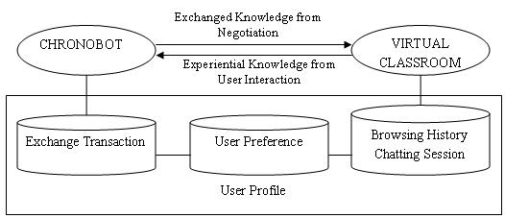
Figure 2 User Profile in the CVC System
The user profile is the physical realization of the user model, which is an abstraction of the user preferences and characteristics. Shown in figure 2, in the CVC system a user profile upf is organized as a 6-tuple:
upf = < id, user-attributes, browsing-history, chatting-session, exchange-transaction, preference>
- id is a unique identification number.
- user-attributes is a vector A(u) = (a₁(u), a₂(u), …., a_{n}(u)) = (x₁, x₂, …., x_{n}), where a_{i}(u) = x_{i} is the i^{th} attribute for the user u – it could be user’s name, expertise level, schedule and so on.
- browsing-history is a set of the pages which user has visited. For the purpose of user profiling, the corresponding behaviors are recorded for each page, e.g. reading time, number of scrolls and print/save.
- chatting-session is a set of conversations which user participated in the virtual classroom. All the contents are recorded in natural language.
- exchange-transaction is a set of time/knowledge exchange transactions which user performed in the chronobot.
- preference is a vector P(u) = (p₁(u), p₂(u), …., p_{n}(u)) = (y₁, y₂, …., y_{n}), where p_{i}(u) = y_{i} is the preference of user on the i^{th} topic. The topics are defined by the ontology knowledge base (which will be discussed in the next section).

When a user first registers the CVC system, the user is asked to enter information such as personal data, areas of expertise, levels on these areas and so on. The user profile manager provides a HTML front-end using which new users can register themselves with the system. During the registration, the user profile manager collects important information from the users such as the user id, name, address, credit card details, areas of experience, levels, skill set, the hourly rate, e-mail address and so on. The rationale behind having the credit card information is that if the user defaults in time/knowledge exchange transactions, then his/her credit card is billed depending upon the number of hours defaulted.

User preference is the most valuable information in user profile. However, it is usually hard to be assessed directly, because in many cases it is difficult to request users to express their interests explicitly -- it is simply too much work for them. Furthermore, users may change their preferences upon time, and hence they can not be assessed statically. For this reason, in our approach user preference is not directly input by users, but implicitly inferred from user behaviors.

Resource Organization
The learning resources in the CVC system are all web-based multimedia materials, which are organized by the ontology knowledge base (OKB). All the topics and their relations are described in the OKB. For example, a small part of the OKB in our system is shown in Figure 3.
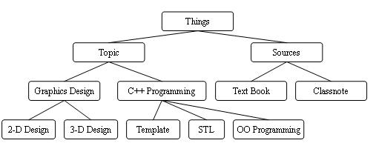
Figure 3: A small part of OKB tree

Based upon the OKB, a learning resource lr in the CVC system is defined as a tuple:
lr = <url, topic, keywords>
where
- url is the universal resource locator which is an identification string of lr.
- topic is a concept in the OKB which is the subject of lr.
- keywords is the set of key words of lr. They are closely related to the content of lr, but usually not in the OKB.
In practice, in order to build an efficient connection between the resources and user profile, two kinds of mapping are employed in our system:
- One-to-many mapping from topics to URLs.
- One-to-many mapping from topics to keywords.

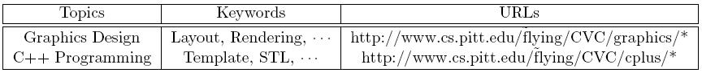
Figure 4. An example of topics to URLs and keywords mappings

Figure 4 shows examples of these two kinds of mapping. The star “*” represents any combination of characters in URLs. The rationale behind these mappings is that they can greatly facilitate the aggregation of feedback indicators on topics.

Feedback Extraction
There are three user feedback sources in our system: browsing history, chatting session, and time/knowledge exchange transaction. In this section, we discuss the method to extract user preference from these three sources respectively. Five distinct feedback indicators are defined. In fact, we can design these indicators to be as complex as is necessary for the intended application. However for practicality it is important to keep them simple and manageable.

  - Browsing History
There is no doubt that browsing history conveys significant information for inferring user preference. However, it is hard to determine interests of users just based on the pages they visited, because it always happen that users open a page they don’t like or just by mistake. Aiming at the more accurate assessment, three feedback indicators are defined based upon browsing history:
- Reading Time
Usually if users spend longer time on reading about a topic, it means that they have more interest on it. For this reason, we record reading time of the user u as a vector RT(u) = (<lr₁, rt₁>, <lr₂, rt₂>, …, <lr_{n},rt_{n}>), lr_{i} is the learning resource user u has visited, rt_{i} is the corresponding reading time.
- Number of Scrolls
Definitely the scroll either by mouse or PageDown/PageUp key on a page is a signal of interest. For this reason, we record the number of scrolls for user u as vector SC(u) = (<lr₁, sc₁>, <lr₂, sc₂>, …, <lr_{n}, sc_{n}>), lr_{i} is the learning resource user u has visited, sc_{i} is the corresponding number of scrolls.
- Print/Save
In most cases, printing or saving a page is a strong signal of interest. For this reason, we record the set PS(u) = (<lr₁, ps₁>, <lr₂, ps₂>, …, <lr_{n}, ps_{n}>), lr_{i} is the resource which user u has visited, ps_{i} is 1 if it has been printed/saved, 0 otherwise.

  - Chatting Session
The experiences accumulated in the virtual classroom are among the most valuable assets for preference inference. In practice the experiences are the stored transcripts of the virtual classroom sessions. These transcripts are represented as XML documents. In fact we consider everything that is exchanged or recorded in the chronobot/virtual classroom system as some form of XML document.

The Relational Index RI is built to support easy access of the accumulated learning experiences. The session transcripts (XML documents) are stored in an experience-base. The Relational Index is then constructed. It relates learning experiences to user preferences in the user profile. For example, if x₁, ..., x_{n} are keywords specified in the topic keywords mapping discussed in section 3, the Relational Index can be used to find u_{j}, the user most closely related to the specified topics.

We can also use the Relational Index RI to relate users to keywords and/or users to users. In other words, RI is used to form an association in the information exchange process among users.

The RI is updated each time a new session transcript is created. The transcript is analyzed with respect to a set of pre-specified keywords x₁, ..., x_{n} in the topic keywords mapping. If a dialog of user u_{j} in the transcript involves a keyword x_{k}, we can store a new record [x_{k}; u_{j}; p] in RI where the frequency p is set to 1, or update p if such a record already exists. Similarly if a dialog between two users u_{j} and u_{j} in the transcript involves a keyword x_{k}, we can store a new record [x_{k}; u_{j}; u_{j}; p] in RI where the frequency p is set to 1, or update p if such a record already exists.

For example the transcript is as follows:

George: Do you think we need to add 3D graphics to the presentation?

Suzie: No, I don’t think so. But the layout can be improved.

George: That is good, because I still cannot find a person to do 3D graphics.

The pre-specified keywords set is:
{layout, graphics, 3D graphics}

The Relational Index, after the processing of the above transcript, contains the following records as well as other previously entered records:

[3D graphics; George; 2]
[3D graphics; George; Suzie; 1]
[layout; Suzie; 1]
[layout; George; Suzie; 1]

  - Exchange Transaction
The transactions of time/knowledge exchange can also be a significant indicator of user preference. In our system, the exchange of time/knowledge is implemented as a bidding process: a person who needs help from others can start a bid, providing the task description, the required knowledge, and the amount of time needed. Anyone else can place a bid to offer his/her time. A successful exchange/bid transaction includes at least the following information: bid starter, bid winner, task description, keywords, and time amount. All these information is stored in XML file in practice.

The Exchange Index EI is built to easy access of the accumulated exchange history. Similar as Relational Index, the EI is used to relate user to keywords and/or user to users. It is updated every time a new transaction is created. The task description is analyzed with the respect to a set of pre-specified keywords x₁, ..., x_{n} in the topic keywords mapping. If a transaction of user u_{j} is related to a keyword x_{k}, we can store a new record [x_{k}; u_{j}; t] in EI where time t is set to the time amount of the transaction, or update t by adding the amount if such a record already exists. The time amount is positive if user u_{j} borrows the time to others, otherwise it is negative. Similarly if a transaction between two users u_{j} and u_{j} involves a keyword x_{k}, we can store a new record [x_{k}; u_{j}; u_{j}; t] in EI which means user u_{j} has borrowed t amount of time from u_{j}.

For example, George starts a bid as follows:

Bid Task: Help to improve the layout in a 3D graphics design;
Time Amount: 8 hours;

The pre-specified keyword set is the same with example in section 4.2.

Through a biding process, Bill can offer 5 hours, and the rest 3 hours help can be done by Suzie. The Exchange Index, after processing these transactions, contains the following records as well as other previously entered records:

[3D graphics; George; -8]
[3D graphics; Bill; 5]
[3D graphics; Suzie; 3]
[3D graphics; George; Bill; 5]
[3D graphics; George; Suzie; 3]

[layout; George; -8]
[layout; George; 5]
……

The Exchange Index may contain records relating multiple (more than two) users or multiple (more than one) keywords as well as the Relational Index.

Preference Assessment
As discussed in section 2, the preference of user u can be expressed as a vector P(u) = (p₁(u), p₂(u), …., p_{n}(u)) = (y₁, y₂, …., y_{n}), where p_{i}(u) = y_{i} is the preference of user u on the i^{th} topic. The topics are described in the OKB. Give a user u and a topic t, the preference of u on t can be inferred by the feedback indicators which are described in section 4. Using the mappings from topics to URLs and keywords, the five feedback indicators can be easily collected for each topic. Single topic could have multiple learning resources, and hence it could have many feedback indicators. For this reason, the following five variables are defined for any pair of u and t by aggregation and normalization:
- rt – the average reading time per 1000 words;
- sc – the average number of scroll per 1000 words;
- ps – the average number of print/save per view.
- ri – the average relational index per 1000 words in chatting sessions.
- ei – the average exchange index per 100 hours in time knowledge exchanges.

A linear model, which can predict user preference based on feedback variables, is constructed using linear regression. In this model, the five variables mentioned above serve as the input variables, the output variable -- user preference up can be assessed by a linear combination of the input variables:
$\text{up}=α_{1}⋅\text{rt}+α_{2}⋅\text{sc}+α_{3}⋅\text{ps}+α_{4}⋅\text{ri}+α_{5}⋅\text{ei}+β+e$ (1)
in which:
- $α_{i}(i=1,2,\text{.}\text{.}\text{.},5)$ and $β$ are coefficient variables, which can be assessed through linear regression on training data.
- $e$ is the residual with the mean zero for all the training data.
For more information about linear prediction and regression, please refer to [5].

Application of User Profile
In our system the major applications of user profile are to identify appropriate partners and determine the exchange rate in time knowledge exchange transactions.

  - Identification of Exchange Partners
The requirements for exchange partners are described in the exchange task. However, frequently there are so many candidates who are qualified. It is very important to choose a proper one who is most likely willing to perform the exchange. Assuming that users sharing more interests on the topics have more chances to do the time knowledge exchange, a similarity function S is defined on users. Given an exchange task t, users u and v are characterized by task related preferences (x1, ..., xn), and (y1, ..., yn) from their profiles. Denote the corresponding average preferences are $ϖ_{1},ϖ_{2},\text{.}\text{.}\text{.},ϖ_{n}$, the similarity function S on u and v is defined using Pearson correlation coefficient:
$S(\text{v,u})=\frac{\sum_{i=1}^{n}{(x_{i}−ϖ_{i})×(y_{i}}−ϖ_{i})}{\sqrt{\sum_{i=1}^{n}{(x_{i}−ϖ_{i})^{2}×\sum_{i=1}^{n}{(y_{i}−ϖ_{i})^{2}}}}}$ (2)

A list of exchange candidates can be sorted using the similarity function S. The one with the highest similarity is always the first candidate to be approached for the exchange.

  - Determination of Exchange Rates
User profile provides the fundamental information to determine the exchange rates between two users. Give an exchange task t, users u and v are characterized by task related attributes (x₁, ..., x_{n}), and (y₁, ..., y_{n}) from their profiles. The attributes could be the preferences, expertise levels and so on. For the two corresponding attributes x_{i} and y_{i}, the information distance measure is denoted by d_{i} (x_{i}, y_{i}), where d_{i} is between 0 and 1 (a metric).

The exchange rate between users u and v, is denoted as follows:

$\text{Exchange}(u,v)=e^{1/\sum{}C_{\text{ji}}×d(x_{\text{ji}},y_{\text{ji}})}$ (3)

where the summation is over all the terms C_{ji} * d(x_{ji}, y_{ji}), and C_{ji} is a scaling constant.

We now illustrate the concept by presenting an example. Let us assume that George and Bill are both media artists and the two agents' primary skill matches. Therefore C₁ d₁ (x₁, y₁) = 0. If the primary skill does not match, C₁ d₁ (x₁, y₁) becomes a big number. For instance, C₁ is 10,000 and d₁ is between 0 and 1, in this case close to 1. Then C₁ d₁ (x₁, y₁) is close to 100,000 and the exchange rate is close to 1. No need to continue.

The two agent's familiarity with subject area also is comparable, so c₂ d₂ (x₂, y₂) = 0. If the familiarly does not match, then C₂ d₂ (x₂, y₂) becomes a big number. For instance, C₂ is 1,000 and d₂ is between 0 and 1, in this case close to 1. Then C₂ d₂ (x₂, y₂) is close to 1,000 and the exchange rate is close to 1. No need to continue either.
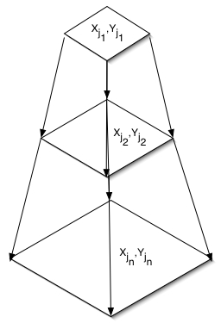
Figure 5. Determination of exchange rate.

Finally, the two agents differ in secondary skill. Therefore C₃ d₃ (x₃, y₃) is small and we have an exchange rate that reflects the difference in the two agents' secondary skill. Notice the index function takes care of the re-arrangement of the relative importance of the n attributes. The constants Cj are also important. They take care of the relative scaling of the various attributes. Figure 10 illustrates the determination of the exchange rate as a dynamic process of comparing different attributes to identify the ones that really matter. Once such attributes are identified, the users can negotiate to determine the exchange rate.

Prototype System and Experiments
A prototype CVC system has been implemented and used in real applications. Verified by the experiments in the prototype system, the proposed model can infer user preference much more accurately than any single of these indicators.

  - Prototype System
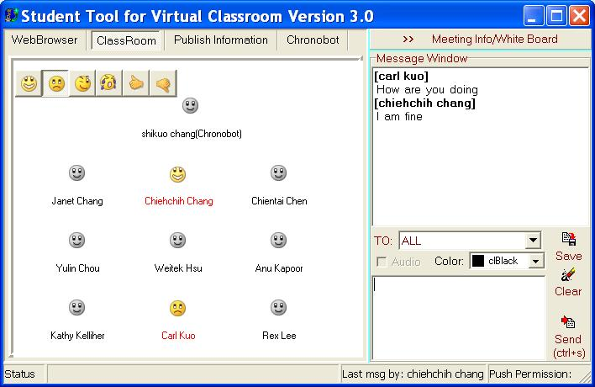
Figure 6. An example of virtual classroom

The prototype of virtual classroom system is illustrated in figure 6. Basically it is a universal communication tool. The users (students and/or instructors) represented by emotive icons can join a virtual classroom to exchange information including text messages, web pages, sketches, and audio/video clips. The system will automatically record user activities (e.g. browsing and chatting) and related information (e.g. reading time, scroll, etc.).
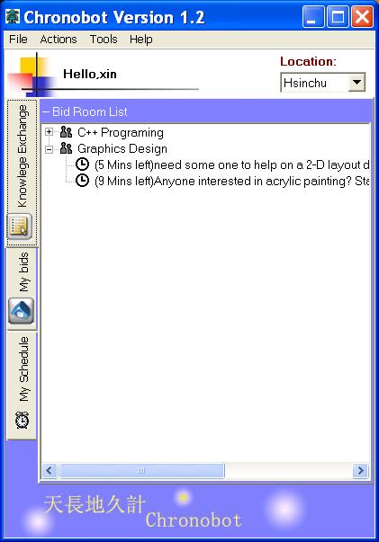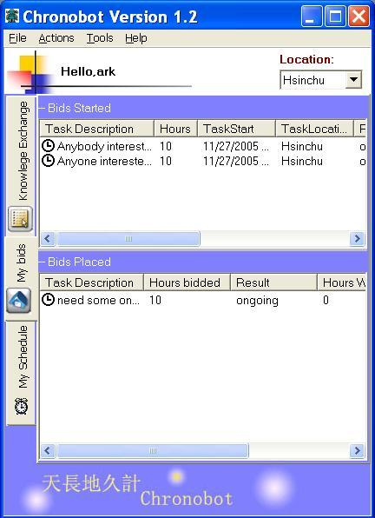
(a) (b)
Figure 7. An example of chronobot, (a): bidding room for time knowledge exchange;
(b): transaction records.

The prototype of chronobot is illustrated in figure 7. Basically, it is a tool to exchange time and knowledge though bidding processes. Users can start new bids in different bidding rooms (figure 7(a)). A simple example of such bids is “I need some one help me on 2-D layout design for 5 hours”. Users can respond these requests by placing their own bids. For example, a user can respond by “I can contribute 2 hours on it”. The details about these transactions are recorded in user profiles (figure 7(b)).

7.2 Experiments and Result Analysis
The prototype systems are used by the students from several classes in University of Pittsburgh. The following experiment has been done to obtain the training data for our linear learning model:
- Step 1: Encourage students to use the prototype system as much as they can
- Step 2: Select a set of students who used the systems for more than a reasonable time (i.e. 72 hours). Asked them to seriously indicate their interests from 0 (least) to 5 (most) on every topic in which they have involved.
- Step 3: Input the preference indicated by the students with the corresponding feedback variables into the linear model (1), assess the coefficient variables using linear regressions.
- Step 4: Separate the testing and training data sets, verify the linear model by the cross validation.

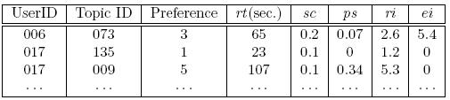
Figure 8. Examples of experimental results
The data of the experiment are illustrated in figure 8. For each pair of user and topic, there are five feedback variables (described in section 5) and preference. Input by these variables, the learning model in (1) can be constructed using least-squares linear regression [5].
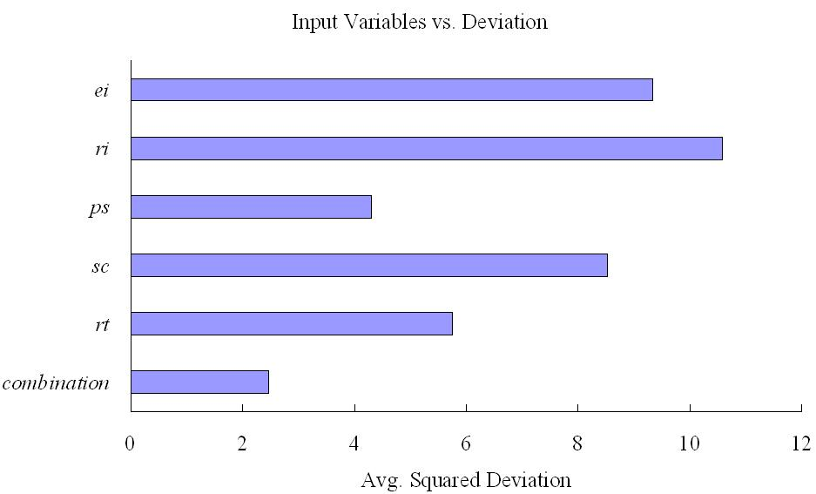
Figure 9. Input variables vs. Deviation

Using the cross validation, the model can be evaluated by the average squared deviation between the preference inferred by the linear model and the one which users indicated. Illustrated in figure 9, the combination of multiple feedbacks is compared with single feedback: the bar labeled with “combination” represents the result input by all five feedback indicators, while other bars are the results with only one indicator as the input variable i.e. rt, sc, ps, ri, and ei respectively. Shown in figure 9, the combination of the indicators can assess much more accurate preference than any single indicators.

Related Research and Discussion
Because the time and knowledge exchange is indeed a new concept, we can hardly find similar approaches with the CVC system up to the time of this paper. However, there are numerous user profiling approaches in other application areas. As the related research, recommendation system is one of the most important applications, where user profiling is the key process collecting user feedback for items in a given domain and assessing user preference in terms of similarities and differences to determine what to recommend. Depending on underline technique, recommendation systems can be divided into collaborative filtering-based [6] content-based [4] and hybrid [1, 8] approaches. Classified by means to acquire feedback, they can be categorized as explicit rating [1, 6, 8], implicit rating [6] and no rating needed [4] systems.

In fact, user's feedbacks are so important that only very few content-based recommendation systems require neither explicit rating nor implicit rating. For example, Surflen [4] is a recommendation system using data mining techniques to assess the association rules on web pages through user’s browsing history without the feedbacks. However, it is hard to find exact interests of users just based on the browsing history, since it always happens that users open a page they don’t like or just by mistake. This problem becomes even more severe in the situation that the system is sparsely used.

GroupLens system [6], which filters Usenet news, is a collaborative filtering system using n-nearest neighbor-based algorithm. In this algorithm, user profile is assessed based on a subset of appropriate n users similar to this user. The early version of GroupLens gathers user's feedback only by explicit rate. However, observing the extra costs of the explicit rating, in the latest version it also uses reading time as an implicit indicator.

Fab system [1] is also using the collaborative filtering model, meanwhile introducing the content analysis by a “topic” filtering. Web pages are initially ranked by the topic filter and then sent to user's personal filters. Users are required to give an explicit rate, and this feedback is used to modify both the personal filter and the original topic filter.

Compared with the approaches above, our approach can be classified as a hybrid approach. We assess the similarity of users in the exact same way as the collaborative filter-based systems (shown in equation (2)). Meanwhile, the mappings from topics to keywords and URLs based on the OKB serve as simple and effective content-based filters. Particularly, our approach proposes a novel way to infer the user preference: multiple implicit feedback indicators are employed at the same time, and the final assessment are retrieved using a linear learning model. As a result, more accurate preference can be assessed without introducing any extra costs for users.

Conclusions
The CVC system is a novel time knowledge exchange platform that supports peer-to-peer learning. In this paper, we describe an approach to assess and utilize user profile including user attributes, preference, expertise levels and so on in the CVC system. User preference – the most important information in user profile, are inferred from multiple data sources i.e. browsing history, chatting session, and time knowledge exchange transaction. The methods utilizing user profile to identify the exchange partners and determine the exchange rate are also described in detail.

Acknowledgements
This research is supported in part by the Industry Technology Research Institute (ITRI) and the Institute for Information Industry (III) of Taiwan. We would like to thank Chieh-Chih Chang and Jui-Hsin Huang for the valuable discussion and comments.

References
[1] M. Balabanovi and Y. Shoham. Fab: content-based, collaborative recommendation. Communication of the ACM, 40(3):66–72, 1997.
[2] M. Blochl, H. Rumershofer, and W. Wob. Individualized e-Learning systems enabled by a semantically determined adaptation of learning fragments. In Proceeding of the 14th international workshop on Database and Expert Systems Applications, pp. 640–645, 2003.
[3] S. K. Chang. A chronobot for time and knowledge exchange. In Proceeding of the 17th International Conference on Software Engineering and Knowledge Engineering, pp. 3–10, Taipei, Taiwan, Jul. 2005.
[4] X. Fu, J. Budzik, and K. J. Hammond. Mining navigation history for recommendation. In Proceeding of the 5th international conference on Intelligent user interfaces, pp. 106–112, 2000.
[5] T. Hastie, R. Tibshirani, and J. Friedman. The elements of statistical learning: data mining, inference, and prediction, Springer, New York, 2001.
[6] J. A. Konstan, B. N. Miller, D. Maltz, J. L. Herlocker, L. R. Gordon, and J. Riedl. Grouplens: applying collaborative filtering to usenet news. Communication of the ACM, 40(3):77–87, 1997.
[7] X. Li and S. K. Chang. A Personalized E-Learning System Based on User Profile Constructed Using Information Fusion, In Proceeding of the 11th International Conference on Distributed Multimedia Systems. pp. 109-114, Banff, Canada, Sep. 2005.
[8] S. E. Middleton, N. R. Shadbolt, and D. C. D. Roure. Ontological user profiling in recommender systems. ACM Trans. Inf. Syst., 22(1):54–88, 2004.
[9] K. Sugiyama, K. Hatano, and M. Yoshikawa. Adaptive web search based on user profile constructed without any effort from users. In Proceedings of the 13th international conference on World Wide Web, pages 675–684, 2004.

