IC Card Management System
User Manual

Table of Contents
IC Card Adder 1
IC Card Editor 2
IC Card Viewer 3
IC Card Interaction Tool 4
Clear the Database 4
IC Card XML Database 5
IC Card Interactions XML Database 5

IC Card Adder
The IC Card Adder is used to add IC Cards to the IC Card XML Database. To access this tool, click the “Add IC Card to Database” link on the management system’s main menu. Figure 1 shows the user interface for this tool. This tool allows users to enter all data specific to an IC card into this form and then submit it to be added to the database. If the user fails to fill out any of the IC card’s fields, the card will not be added to the database until all information is provided. The user will be notified of any missing data.
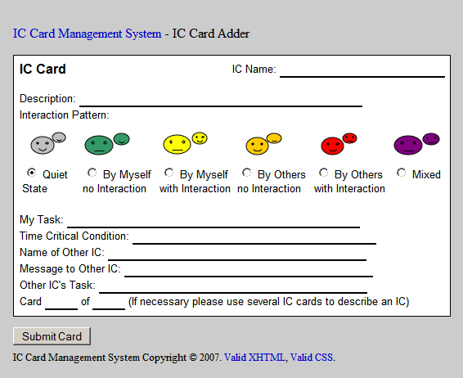
Figure 1

If the user indicates that a card is part of a group (i.e. Card “x” of “y,” where y > 1), he/she will be presented with an interface similar to Figure 2 for specifying the group to which the card belongs. The user is presented with a list of all groups that currently exist in the XML database. If the current card is a member of a pre-existing group, the user may select that group from the list. Otherwise, the user should choose the “Create a New Group” option to form a new group and add the current IC card to that group. After group selection is complete, press the “Submit Group” button.
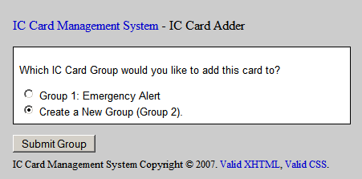
Figure 2

After all information has been entered for the IC card and, if necessary, the card’s group is specified, the current IC card XML database will be updated with the new IC card. This database is then available by selecting the “Current IC Card XML Database” link on the management system’s main menu.

IC Card Editor
The IC Card Editor is used to edit IC Cards currently in the IC Card XML Database. To access this tool, click the “Edit an IC Card in the Database” link on the management system’s main menu. The user will first be asked to select a card to edit. Figure 3 shows the interface for selecting a card to edit. After selecting an IC card to edit, press the “Edit Card” button. Next, the user will be presented with an interface nearly identical to Figure 1 displaying all the information currently stored in the selected IC card. All information on the card is editable. Once all desired changes have been made to the IC card’s contents, press the “Submit Card” button under the form. This will cause the IC card XML database to be updated to reflect all changes. The database is then available by selecting the “Current IC Card XML Database” link on the management system’s main menu.
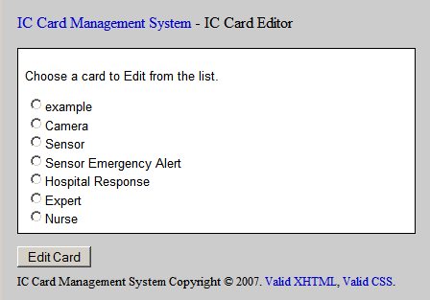
Figure 3

IC Card Viewer
The IC Card Viewer is used to view IC Cards currently in the IC Card XML Database. To access this tool, click the “View an IC Card in the Database” link on the management system’s main menu. The user will first be asked to select a card to view using an interface nearly identical to Figure 3. After selecting an IC card to view, press the “View Card” button. Next, the user will be presented with the selected IC card for viewing similar to Figure 4.
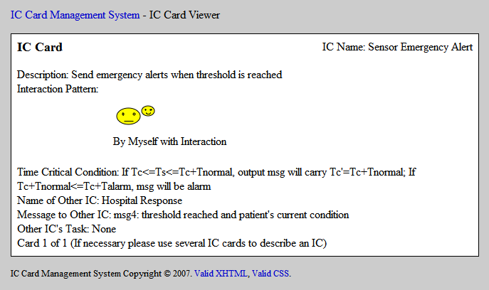
Figure 4

IC Card Interaction Tool
The IC Card Interaction Tool is used to specify the interactions of IC Cards currently in the IC Card XML Database. To access this tool, click the “Specify IC Card Interactions” link on the management system’s main menu. Figure 5 shows the user interface for this tool. All of the IC cards currently in the IC Card XML Database will be listed. This tool allows users to specify parent patterns for each IC Card in the database by selecting a parent pattern from the dropdown list next to each IC card’s name. Users may also (optionally) specify URLs for a scenario and/or IC system for each IC Card in the database by entering the corresponding URL(s) in the blanks to the right of the corresponding IC card name. Finally, users may specify URLs for a scenario and IC system for the entire IC card list. These global URLs may be entered in the blanks at the bottom of the form. As indicated in the text above the blanks, if the user does not specify URLs, default URLs will be used.
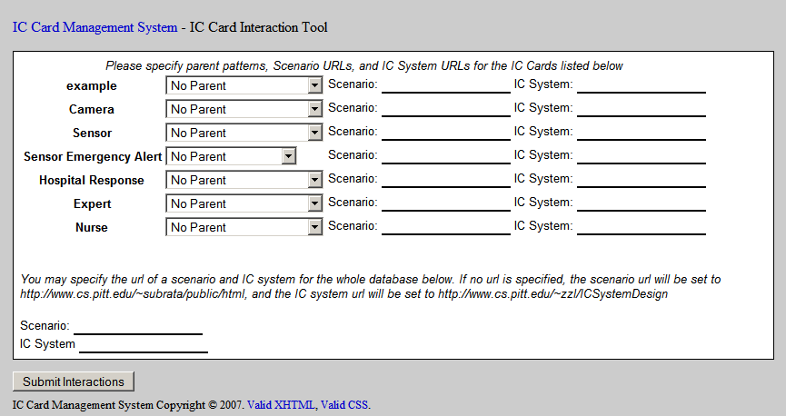
Figure 5
After all desired information has been entered into the form; press the “Submit Interactions” button under the form to generate an XML database from the specified information. This database is then available by selecting the “Current IC Card Interactions XML Database” link on the management system’s main menu.

Clear the Database
The Clear the Database option is used to clear the current IC Card XML Database. To access this option, click the “Clear the Database” link on the management system’s main menu.

IC Card XML Database
The IC Card XML Database is an XML file containing the IC card information entered since the last time the “Clear the Database” option was chosen. To view this database, click the “Current IC Card XML Database” link on the management system’s main menu. Note: if you view this database using a browser that supports XSLT, the XML will be rendered in a viewable, stylized fashion.

IC Card Interactions XML Database
The IC Card Interactions XML Database is an XML file containing the IC card interaction information specified the last time the IC Card Interaction Tool was used. To view this database, click the “Current IC Card Interactions XML Database” link on the management system’s main menu. Note: if you view this database using a browser that supports XSLT, the XML will be rendered in a viewable, stylized fashion.

(Prepared by Perry Robert Rajnovic and Mark D Zalar, April 23, 2007)

