CS 2310 Project— Just-in-Time Medical Application

Matching between IC Card and IC System in MKEE
Zhoulan Zhang (zzl@cs.pitt.edu)
- IC Card
  - IC Card and IC Card Editor Structure
The IC Card Editor enables efficient editing of IC cards (Figure 1). It is also a good tool to organize and manage IC cards. As shown in Figure 2, under the IC Card Editor environment, an icCardList maintains a list of icCardEntry, each with a unique id, along with a group id indicating which group it belongs to.

For each icCard, it includes the following attributes:
- icName— IC name.
- icDescription— Description for the IC
- icIntPattern— Interaction Pattern, can be one of the six patterns (grey, green, yellow, orange, red, and purple)
- icMyTask— Task of current IC
- icTimeCriticalCondition— Time Critical Condition
- icOtherName— Name of Other IC which current IC will communicate with
- icOtherMessage— Message sent to Other IC
- icOtherTask— Other IC’s Task
- icNumberCurrent— i, the ith IC card (if use n IC cards to describe current IC)
- icNumberTotal— n, the total number of IC cards to describe current IC

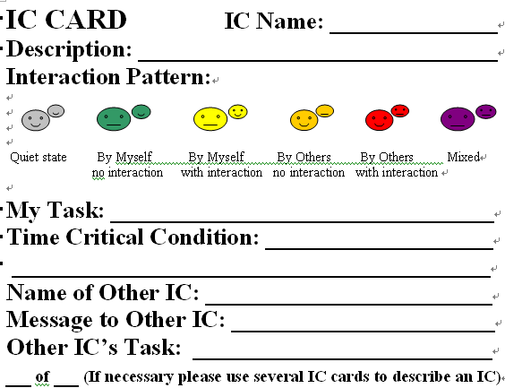
Figure1. IC Card
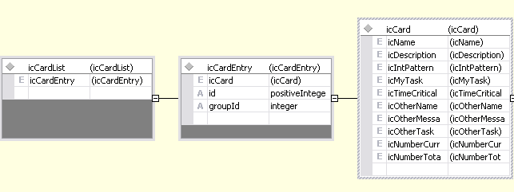
Figure2. IC Card Structure

  - IC Card XML schema
The following is an example of IC Card XML schema used by IC Card Editor. All attributes mentioned above are set to certain values.

<icCard>
<icName content="Patient Emergenc Alert" />
<icDescription content="Patient alerts network/database of emergency" />
<icIntPattern content="myselfwith" />
<icMyTask content="Alert network/database of emergency" />
<icTimeCriticalCondition content="Tc+Talarm > Ts > Tc+Tnormal: Talarm=2*smallest system granularity, Tnormal=smallest system granularity" />
<icOtherName content="Network/Database" />
<icOtherMessage content="Emergency Alert" />
<icOtherTask content="None" />
<icNumberCurrent content="1" />
<icNumberTotal content="1" />
</icCard>

- IC System Structure
  - IC System in MKEE
In MKEE (Multimedia Knowledge Eclipse Environment), the Index Cell is a little different from the IC depicted by IC Card. It can give more details than IC Card does (Figure 3 is an example of Index Cell and its specifications). The details for attributes are explained below:
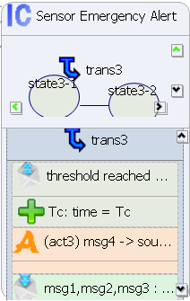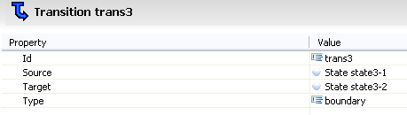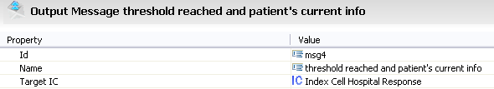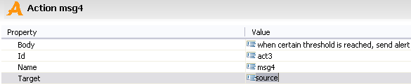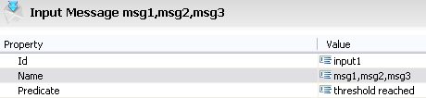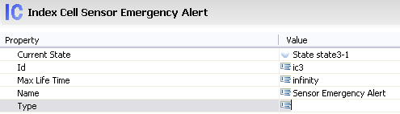
Figure3. Index Cell in MKEE

Each Index Cell has such properties:
- Current State
- Id
- Max Life time (cell life time, if you want a cell to be always active, set it to “inf”)
- Name
- Type

An Index Cell may have different states. To transform from one state to another state inside of an index cell, a transition will be used. The transition properties include:
- Id
- Source: initial state
- Target: final state
- Type ( can be “Boundary” or “Internal”)

A transition can include input message, output message, and actions.

The Input message has such properties:
- Id
- Name
- Predicate (it’s the condition that establishes the state change)

Output message properties include:
- Id
- Name
- Target IC

Both input message and output message can carry parameters. A parameter should state:
- Name
- Data Type
- Data Value

Besides input message and output message, a transition involves action. The action properties are:
- Id
- Name ( the name of output message name)
- Body ( action associated to the transition)
- Target ( it could be either “external” or “source”)
    - external: the action doesn’t directly work on multimedia system, but it shows itself through computations
    - source: the action works on multimedia system without any computation

  - IC System XML Schema
In MEKK, there is an XML file corresponding to each IC diagram. The following is an example of the XML schema used by MKEE IC diagram:

<?xml version="1.0" encoding="UTF-8"?>
<ic:icSystem xmlns:xsi="http://www.w3.org/2001/XMLSchema-instance" xmlns:ic="http://www.mke.org/ic/">
<indexCell currentState="//@icSystem/@indexCell.0/@state.0" id="ic1" maxLifeTime="infinity" name="Camera">
<state name="state1-1"/>
<state name="state1-2"/>
<transition id="trans1" source="//@icSystem/@indexCell.0/@state.0" target="//@icSystem/@indexCell.0/@state.1">
<message xsi:type="ic:OutputMessage" id="msg1" name="patient's image">
<targetIC>ic3</targetIC>
<parameter dataType="time" dataValue="Tc" name="Tc"/>
</message>
<action body="collect image info periodically" id="act1" name="msg1" target="source"/>
</transition>
</indexCell>
……
</ic:icSystem>

- Matching between IC Card and MKEE IC System
Although there are some differences between IC Card and IC System designed using the MKEE tool, there are many similarities. Especially both of them can be represented by XML, which is human-legible and facilitates the sharing of data across different information systems.

Matching can be summarized as the following (also shown in Figure 4)
Entries in IC Card Editor | Attributes in IC System by MKEE
icCardEntry.id | id
icCard.icName | name
icCard.icTimeCriticalCondition | time parameter in messages
icCard.icOtherName | the target Index Cell of output message
icCard.icOtherMessage | message sent to other Index Cell (target IC)
icCard.icMyTask/icCard.icOtherTask | action in transition (internal/external)

- icCardEntry.id = id;
Every icCardEntry has a unique id, since in IC System each Index Cell should also has a unique identification (id), these two can be simply regarded as the same.

- icCard.icName = name;
To make it compatible, the IC name used in IC card is the same as in IC System.

- icCard.icTimeCriticalCondition = time parameter in messages
In an IC Card, users can add timing constraints, indicating the time during which a task should be done. In IC System, similar timing constraints can be imposed, however, through the parameter in messages. As mentioned earlier, both an input and output message can carry parameters, time is one type of the parameters and can meet the just-in-time requirement.

- icCard.icOtherName = the target Index Cell of output message
In an IC card, if a message will be sent to other ICs, the entry “icOtherName” should be the name of the IC which the current IC wants to communicate with. In IC System, it is just the target index cell of output message.

- icCard.icOtherMessage = message sent to other Index Cell (target index cell)
Note that there are two message types in IC System: input message and output message. Since the message mentioned here is sent to another Index Cell, it is of the output message type.

- icCard.icMyTask/icCard.icOtherTask = action in transition (internal/boundary)
  - icMyTask → internal
If the current IC needs to do some task all by itself, the target of action in transition is internal, meaning the transition just associates with its own states, having nothing to do with other ICs.
  - icOtherTask → boundary
If the current IC needs other IC to accomplish some task, then the target of action in transition is of boundary type.
  - icCard.icIntPattern is also associated with action in transition.
For example, for a purple IC card, both internal and external actions will be shown in the Index Cell in IC System.

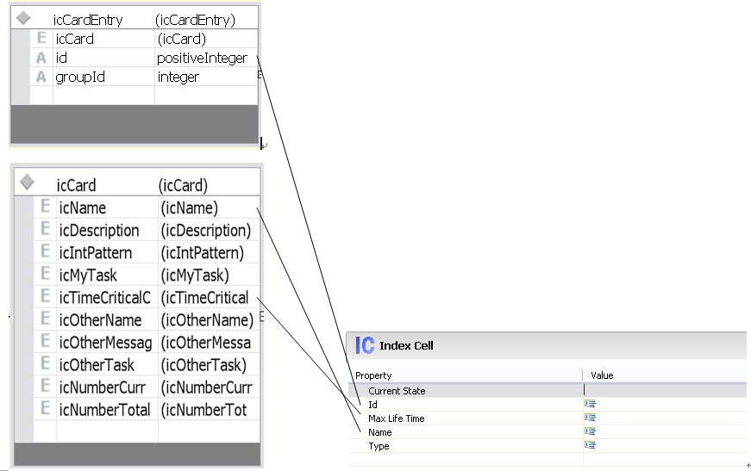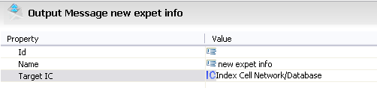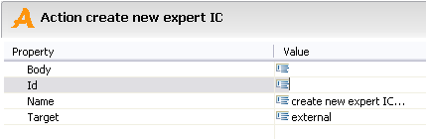
Figure4. Matching between IC Card and IC System in MKEE

- Conclusions
The XML matching between IC Card (in IC Card Editor) and IC System (in MKEE) suggests that these two tools are compatible.

Appendix
IC System Design for Non-Able Patient & the XML Presentation

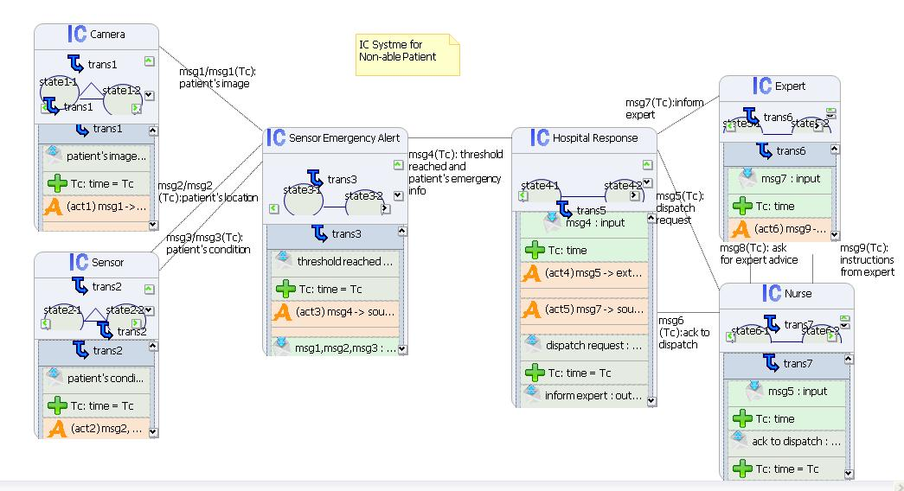

<?xml version="1.0" encoding="UTF-8"?>
<ic:icSystem xmlns:xsi="http://www.w3.org/2001/XMLSchema-instance" xmlns:ic="http://www.mke.org/ic/">
<indexCell currentState="//@icSystem/@indexCell.0/@state.0" id="ic1" maxLifeTime="infinity" name="Camera">
<state name="state1-1"/>
<state name="state1-2"/>
<transition id="trans1" source="//@icSystem/@indexCell.0/@state.0" target="//@icSystem/@indexCell.0/@state.1">
<message xsi:type="ic:OutputMessage" id="msg1" name="patient's image">
<targetIC>ic3</targetIC>
<parameter dataType="time" dataValue="Tc" name="Tc"/>
</message>
<action body="collect image info periodically" id="act1" name="msg1" target="source"/>
</transition>
</indexCell>
<indexCell name="Sensor">
<state name="state2-1"/>
<state name="state2-2"/>
<transition id="trans2" source="//@icSystem/@indexCell.1/@state.0" target="//@icSystem/@indexCell.1/@state.1">
<message xsi:type="ic:OutputMessage" id="msg2" name="patient's condition">
<targetIC>ic3</targetIC>
<parameter dataType="time" dataValue="Tc" name="Tc"/>
</message>
<action body="collect info about locatioin and condition periodically" id="act2" name="msg2, msg3" target="source"/>
</transition>
</indexCell>
<indexCell currentState="//@icSystem/@indexCell.2/@state.0" id="ic3" maxLifeTime="infinity" name="Sensor Emergency Alert" type="">
<state name="state3-1"/>
<state name="state3-2"/>
<transition id="trans3" source="//@icSystem/@indexCell.2/@state.0" target="//@icSystem/@indexCell.2/@state.1">
<message xsi:type="ic:OutputMessage" id="msg4" name="threshold reached and patient's current info">
<targetIC>ic4</targetIC>
<parameter dataType="time" dataValue="Tc" name="Tc"/>
</message>
<message xsi:type="ic:InputMessage" id="input1" name="msg1,msg2,msg3">
<predicate>threshold reached</predicate>
</message>
<action body="when certain threshold is reached, send alert" id="act3" name="msg4" target="source"/>
</transition>
</indexCell>
<indexCell currentState="//@icSystem/@indexCell.3/@state.0" id="ic4" maxLifeTime="infinity" name="Hospital Response">
<state name="state4-1"/>
<state name="state4-2"/>
<transition id="trans5" source="//@icSystem/@indexCell.3/@state.0" target="//@icSystem/@indexCell.3/@state.1">
<message xsi:type="ic:InputMessage" id="input2" name="msg4">
<predicate>alert msg received</predicate>
<parameter dataType="time" dataValue="Tc" name="Tc"/>
</message>
<message xsi:type="ic:OutputMessage" id="msg5" name="dispatch request">
<targetIC>ic6</targetIC>
<parameter dataType="time" dataValue="Tc" name="Tc"/>
</message>
<message xsi:type="ic:OutputMessage" id="msg7" name="inform expert">
<targetIC>ic5</targetIC>
<parameter dataType="time" dataValue="Tc" name="Tc"/>
</message>
<action body="dispatch nurse" id="act4" name="msg5" target="external"/>
<action body="inform expert" id="act5" name="msg7" target="source"/>
</transition>
</indexCell>
<indexCell currentState="//@icSystem/@indexCell.4/@state.0" id="ic5" maxLifeTime="infinity" name="Expert">
<state name="state5-1"/>
<state name="state5-2"/>
<transition id="trans6" source="//@icSystem/@indexCell.4/@state.0" target="//@icSystem/@indexCell.4/@state.1">
<message xsi:type="ic:InputMessage" id="input3" name="msg7">
<predicate>patient's alert and current condition received</predicate>
<parameter dataType="time" dataValue="Tc" name="Tc"/>
</message>
<message xsi:type="ic:OutputMessage" id="msg9" name="instructions from expert">
<targetIC>ic6</targetIC>
<parameter dataType="time" dataValue="Tc" name="Tc"/>
</message>
<action body="give instructions to nurse" id="act6" name="msg9" target="external"/>
</transition>
</indexCell>
<indexCell currentState="//@icSystem/@indexCell.5/@state.0" id="ic6" maxLifeTime="infinity" name="Nurse" type="">
<state name="state6-1"/>
<state name="state6-2"/>
<transition id="trans7" source="//@icSystem/@indexCell.5/@state.0" target="//@icSystem/@indexCell.5/@state.1">
<message xsi:type="ic:InputMessage" id="input4" name="msg5">
<predicate>dispatch request received</predicate>
<parameter dataType="time" dataValue="Tc" name="Tc"/>
</message>
<message xsi:type="ic:OutputMessage" id="msg6" name="ack to dispatch">
<targetIC>ic4</targetIC>
<parameter dataType="time" dataValue="Tc" name="Tc"/>
</message>
<action body="ack to dispatch request" id="act7" name="msg6" target="external"/>
<action body="ask for expert advice" id="act8" name="msg8" target="source"/>
</transition>
</indexCell>
</ic:icSystem>

