Final Project Report
Software Specifications for EKG Monitor
and Knowledge Base Components
Group 8: Brad Vukich and AJ Vento

Dr. Chang, CS 1631:
Component-Based Software Engineering

4/20/2010

- Overview
As the standard way to track the health of one’s heart, an EKG monitor is an invaluable tool and is an essential component of any personal health care device. For this project, we will attempt to recreate the functional and operational aspects of an EKG monitor and, using a coordinating knowledge base, notify the user of any and all heart risks they may have through the device’s GUI. The software component will comply will all communication specifications made by the SISServer program in order to do this. It will also entail new, custom messages in order to send and receive data with its knowledge base.

- Initial Tasks
  - Research and Design Specifications and Knowledge Base
The EKG knowledge base must act like a database of variable ranges of heart rates, each corresponding to a specific set of comprehensive user profile data, including the user’s sex, age, and body mass index calculated from height and weight. The acceptable ranges for men and women of various athletic levels form which the knowledge base originated can be seen in Figure 1 under “Knowledge Base Diagrams” of the appendix.
  - Create UML Diagrams
The UML Diagrams of the component display a high level, yet detailed view of the component and how the inner classes communicate with each other and with what data. The diagrams also provide guidance as the coding phase begins, leading to faster development.
  - Setup SISServer Environment
A thorough understanding of the main server component in any system is necessary when building any subordinate component. For this project, we must study the server’s connection protocols and message handling in order to create a compatible component.
  - Develop Monitor Algorithms to Handle EKG Data
Since EKG data is sent from the Input Monitor in such a raw form, complex algorithms must be devised to extract meaningful data, including the user’s heart rate, rhythm, and other vital signs.
  - Build/Maintain Knowledge Base API
Even though the EKG monitor will be able to generate various heart status variables, it will be unable to determine if they are healthy or not without a knowledge base. This separate component will be constructed from the research of (part a) and dictates whether or not the monitor sends an alert to the user.
  - Component Testing
Although listed last here, testing is an ongoing task that must be repeated through all stages in coding to ensure quality at each step in the overall development.
- Resources
  - Hardware
    - Personal HealthCare System Unit – the unit that will house and run the final version of the Server and all components, providing real user inputs to the system with sphygmomanometer, EKG leads, and other input devices.
  - Software
    - ArgoUML Diagram Software – complex software used for creating UML diagrams
    - Protégé OWL Diagram Software – program for build an ontological knowledge base
    - Java Coding Language – the class language of choice to build entire project
  - People
    - Brad Vukich
      - EKG Monitor Co-developer
      - Knowledge Base Designer and Builder
      - Message and Communications Lead
    - AJ Vento
      - EKG Monitor Co-developer
      - Specification Designer
      - Raw Data Analysis Lead
- Functions
  - main
Location | g8ekg.java and g8kb.java
Arguments | String[] args:  holds user inputs of program, namely the IP address of the Server
Returns | (Void)
Description | Simply checks for a valid IP address inputs and creates the component object in both programs.

  - processMsg
Location | g8ekg.java and g8kb.java
Arguments | KeyValueList kvInput:  stores the parsed XML values of the received message
Returns | (Void)
Description | Examines recived message data and responds by sending back an output KeyValueList in both components.

  - SendToServer
Location | g8ekg.java and g8kb.java
Arguments | KeyValueList kvInput:  stores the parsed XML values of the message about to be sent
Returns | (Void)
Description | Deals with the message encoding and server connection to successfully deliver the output message in both components.

  - ProcessData
Location | g8ekg.java
Arguments | String lead1, String lead2, String lead3:  EKG readings of each lead places in a single string to be analyzed
Returns | int[] results:  contains the discovered heart rate, rhythm, and QT length of the user
Description | Creates detailed heartbeat statistics from the lead data, including the number of pulses, the length of each pulse, etc., by analyzing the data with complex algorithm  Resulting Statistics:  - Heart Rate – number of beats per minute  - Rhythm – steadiness of heat beats  - QT length – time span from peak of heart pulse to the end

  - Diagnose
Location | g8kb.java
Arguments | String statType:  specifies what kind of values is to be examined, either "HeartRate", “Rhythm”, or “QTLength”;  int stat:  the actual health stat to be evaluated
Returns | String result:  holds a value describing how the user’s EKG data compares to acceptable health standards for the particular stat type.
Description | Uses numerous if statements to pinpoint a user’s acceptable range of health values for each health stat based on their profile data, including height, weight, sex, and age.  Possible Diagnoses:  - Bradyarrhythmia – abnormally low heart rate  - Tachyarrhythmia – abnormally high heart rate  - Tachycardia – heart rate over 100 BPM, very dangerous  - Arrhythmia – uneven heart rhythm  - SQTS – short QT syndrome, QT length of under 300 ms  - LQTS – long QT syndrome, QT length of over 460 ms

- Design Constraints / Exceptions
Because of a shorter read interval provided in the Personal Healthcare then we had expected (0.01 of a second), the EKG monitor may not be able to successfully detect heart rates higher than 150 beats per minute. At this high rate, periods of rest between beats become insignificant, throwing off regular expression of the data parser in the monitor software. Users should be aware that an extremely low registered heart rate (possibly 1 – 10 BMP) could mean that that they actually have a heart rate over the limit of monitor.
- Message Scenario
- GUI interacts with the user and sends Msg 45 (user profile) containing UserName, Age, Sex, Weight, Height and medical conditions, to Uploader and all Monitors, including EKG.
- HealthSensors sends Msg 30 (sensor data input) to InputProcessor, which parses the data and extracts vital signals.
- InputProcessor sends Msg 35 (raw voltage readings) to EKG Monitor, which analyzes the raw data to determine heart statistics, including heart rate, rhythm, and QL length.
- EKG Monitor sends Msg 182 (send heart data) containing the statistics and the user profile to the knowledge base. The knowledge base compiles acceptable ranges for the statistics based on the profile and compares the actual inputs to the ranges.
- Knowledge Base reports back to EKG Monitor with Msg 183 (receive heart results), describing how the user’s heart compares to standards
- EKG Monitor sends Msg 36 (EKG alert) to Uploader and GUI, which display and upload any abnormal heart readings, as well as a possible diagnosis and suggestions for the ailment.

- Informational Sources
  - David Eisenberg, University of Alabama School of Medicine. The Clinical Reference Guide (The "Yellow Book"). http://www.uab.edu/emig/yellow_book/the_yellow_book.htm
  - National Heart, Lung, and Blood Institute: Diseases and Conditions Index. Electrocardiogram. http://www.nhlbi.nih.gov/health/dci/Diseases/ekg/ekg_what.html
  - Nuffield Health. Get Healthy; Get Rewarded. http://www.nuffieldhealth.com/individuals/Rewards-offer-Terms--Conditions/
  - TheHealthFinder Limited. Resting Heart Rate. http://www.netfit.co.uk/fitness/test/resting-heart-rate.htm

- Revision History

Version 3.0: 4/17/10
- EKG monitor lead data parser is calibrated to read higher heart rates
- Diagnosis and Suggestion fields are added to EKG alerts

Version 2.5: 4/13/10 (Integration Day)
- Component programs are renamed “g8ekg.java” and “g8kb.java” to fit standard naming format
- Component names in messages for server matching are changed to “g8ekg” and “g8kb” to maintain naming consistency
- Monitor and knowledge base components accommodate user profile data of Msg45
- Knowledge base compares heart statistics to more personalized rages based on user profile data

Version 2.0: 4/6/10
- Programs are renamed “g8monitor.java” and “g8knowledgebase” to distinguish from other EKG development group
- EKGMonitor.java utilizes complex data analysis algorithm to obtain specific heart statistics, hard-coding is removed
- EKGKnowledgebase.java contains genuine ontology to map a user’s heart status to an acceptable range, hard-coding is removed

Version 1.5: 4/2/10
- EKGKnowledgebase.java is created as a separate component
- XML messages 180 and 184 are removed due to overlap of SISServer standard messages
- Messages 181, 182, and 183 are processed in appropriate programs

Version 1.0: 3/30/10 (Milestone 2)
- EKGMonitor.java connects to Server properly using Msg23 upon creation
- Two possible alerts types are sent to GUI: "EKG OK" and "EKG Alert"
- EKG data analysis is hard-coded as standard values for heart rate and rhythm
- Knowledge base comparisons are simplified to a single threshold for an acceptable heart rate.
- XML messages 180, 181, 182, 183 and 184 are reserved to create the knowledge base, acknowledge the creation, send processed EKG data, send back health results, and destroy the knowledge base

Appendix
- UML Diagrams

  - Use Case Diagram:
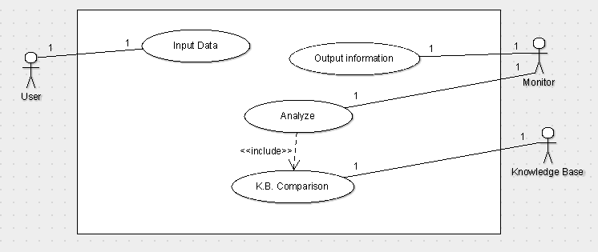

  - Class Diagram:
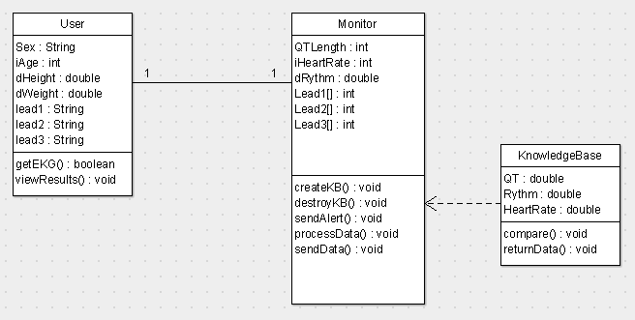

  - State Diagram:
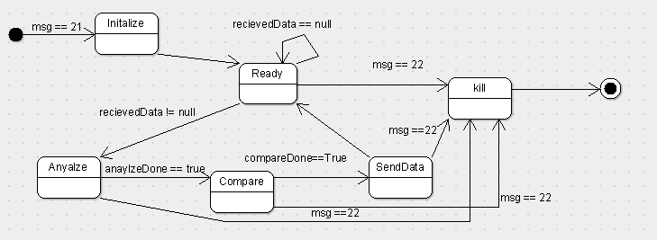

  - Collaboration Diagram:
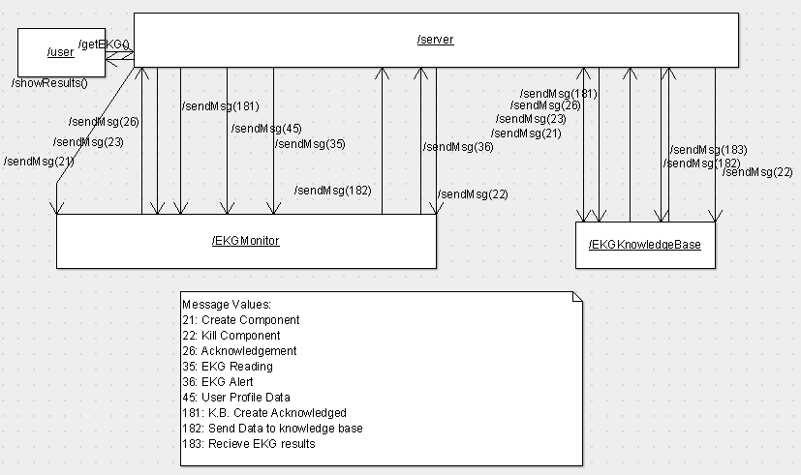
- Knowledge Base Diagrams

  - Knowledge Base Inspiration (from Reference 6.4)
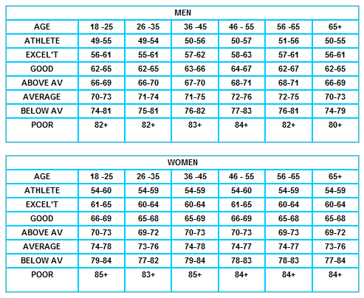
  - Existing Knowledge Base Ontology
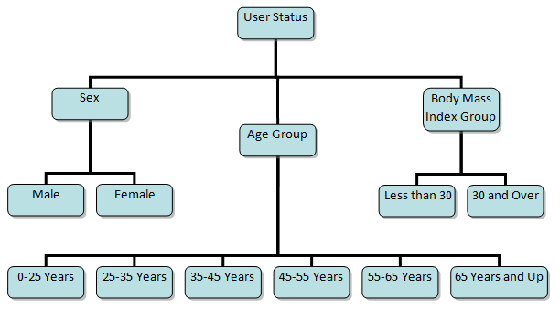
- XML Messages

  - Group 8 EKG Monitor Creation (Custom Msg21)

(Group 8 EKG Monitor Creation continued)

  - Group 8 Knowledge Base Creation (Custom Msg21)

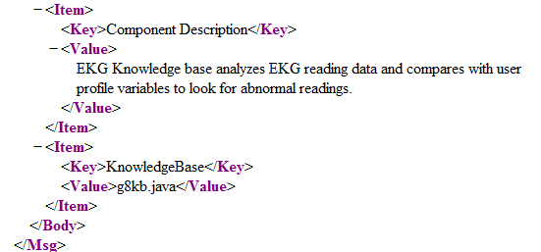
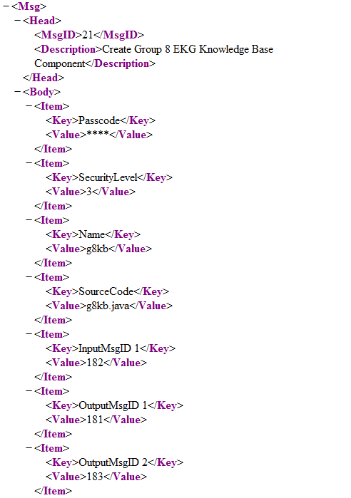

  - Knowledge Base Creation Acknowledgement (Msg 181)

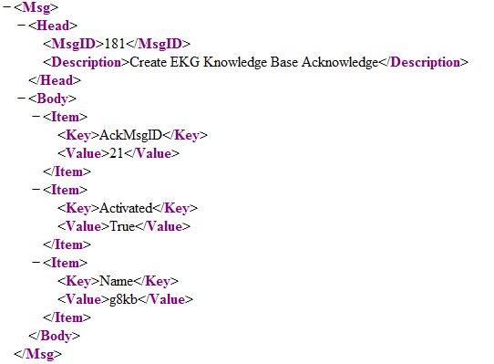
  - Send EKG Data (Msg 182)

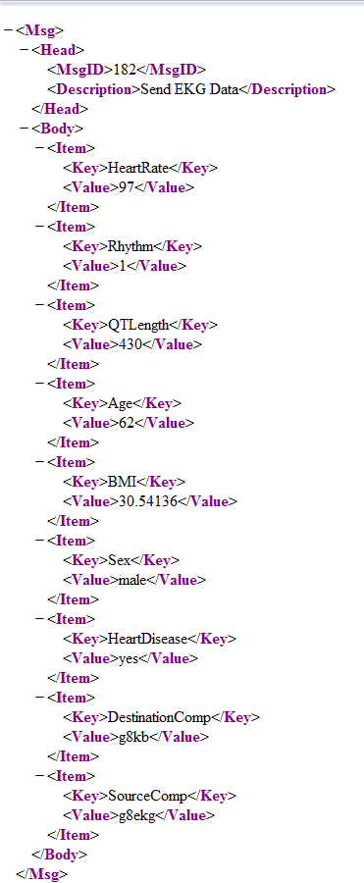
  - Receive EKG Results (Msg183)
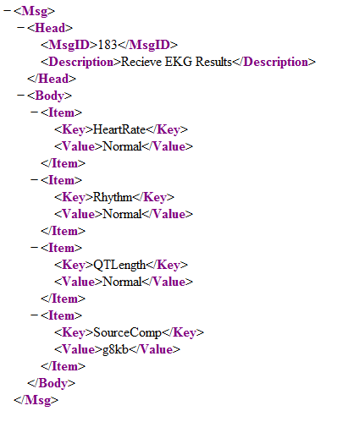
- Working Screenshots

4.1 Normal EKG Results: Msg183 from Knowledge Base (Normal, No Msg35 Alert Needed)

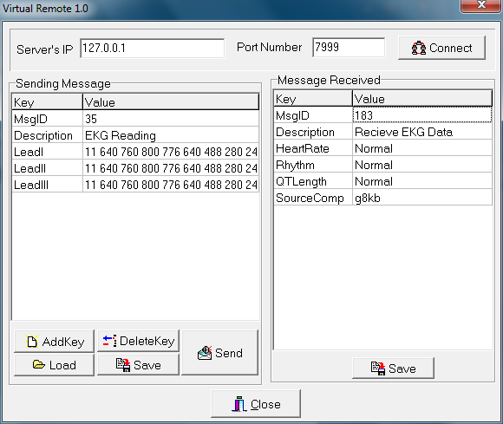

4.2 Abnormal EKG Results: Msg36 Alert from EKG Monitor with High Heart Rate

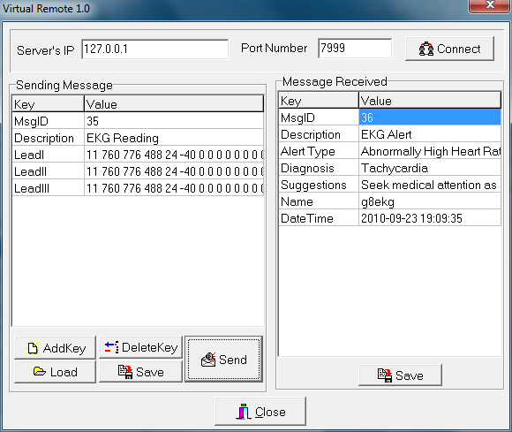
- Source Code

5.1 EKG Monitor (g8ekg.java):

/* EKG Component Code for CS 1631
* Group 8:
* Brad Vukich
* AJ Vento
* Version 3.0 - For Final Demo
* 3/30/10
*/

import java.io.*;
import java.net.*;
import java.util.*;
import java.text.*;
import java.util.regex.*;

public class g8ekg
{
private static final int PORT = 7999;
private Socket socket;

private boolean kbExists = false;
private boolean profileExists = false;
private final int maxZeros = 9;

// EKG lead data
private String lead1;
private String lead2;
private String lead3;

// user profile data
private double bmi;
private String age;
private String sex;
private String heartDisease;

public static void main(String[] args)
{
// if not enough arguments, print error and exit
if (args.length < 1)
{
System.out.println("Error - Insufficient arguments: Please provide IP address of SISServer");
System.exit(0);
}
try
{
g8ekg ekg = new g8ekg(args[0]);
}
catch(Exception e)
{
System.out.println("Error - Exception in EKGComponent creation: " + e.getMessage());
}
}

public g8ekg(String IPAddress) throws Exception
{
// create socket from IP address and port and instanciate message reading objects
socket = new Socket(IPAddress, PORT);
MsgEncoder mEncoder = new MsgEncoder();
final MsgDecoder mDecoder = new MsgDecoder(socket.getInputStream());

Thread t = new Thread (new Runnable()
{
public void run()
{
KeyValueList kvInput;
try
{
// send a request to the server for connection
KeyValueList kvOutput = new KeyValueList();
kvOutput.addPair("MsgID", "23");
kvOutput.addPair("Description", "Connect to Server");
kvOutput.addPair("Passcode", "****");
kvOutput.addPair("SecurityLevel", "3");
kvOutput.addPair("Name", "g8ekg");
System.out.println("=========Send msg23=========");
SendToServer(kvOutput);
while(true)
{
// recieve a message, parse it, and print it out depeinding on the MsgID
kvInput = mDecoder.getMsg();
if(kvInput != null)
{
System.out.println("============== Message Recieved! =================");
processMsg(kvInput);
}
}
}
catch(Exception e)
{
System.out.println("Error - Exception in Thread Run: " + e.getClass() + ", " + e.getMessage());
}
}
}); // end Thread

// mark thread as a Daemon to keep from inhibiting program shutdown
t.setDaemon(false);
t.start();
}

synchronized public void processMsg(KeyValueList kvInput) throws Exception
{
ArrayList<Socket> sendlist;
ArrayList<String> inmsgs, outmsgs;
int MsgID = Integer.parseInt(kvInput.getValue("MsgID"));
KeyValueList kvOutput;

switch(MsgID)
{
case 26: // *** SISServer Acknowledgement ***
System.out.println("Recieved Msg26");
break;

case 35: // *** EKG Reading ***
System.out.println("Recieved Msg35");
// aquire raw EKG data
lead1 = kvInput.getValue("LeadI");
lead2 = kvInput.getValue("LeadII");
lead3 = kvInput.getValue("LeadIII");

// only send to KB if it exists and we have user profile data
if(kbExists == true)
{
if(profileExists == true)
{
// process raw data to find rate, rhythm, etc
int[] heartData = ProcessData(lead1, lead2, lead3);
int rate = heartData[0];
int rhythm = heartData[1];
int qtLength = heartData[2];

// send the processed data to the EKG knowledge base
kvOutput = new KeyValueList();
kvOutput.addPair("MsgID", "182");
kvOutput.addPair("Description", "Send EKG Data");
kvOutput.addPair("HeartRate", "" + rate);
kvOutput.addPair("Rhythm", "" + rhythm);
kvOutput.addPair("QTLength", "" + qtLength);
kvOutput.addPair("BMI", "" + bmi);
kvOutput.addPair("Age", age);
kvOutput.addPair("Sex", sex);
kvOutput.addPair("HeartDisease", heartDisease);
kvOutput.addPair("DestinationComp", "g8kb");
kvOutput.addPair("SourceComp", "g8ekg");
SendToServer(kvOutput);
}
else
{
System.out.println("Error - Cannot process data, user profile has not been obtained");
}
}
else
{
System.out.println("Error - Cannot process data, EKG Knowledge Base does not exist");
}
break;

case 45: // *** User Profile ***
System.out.println("Recieved Msg45");
// mark that the profile data has been recieved
profileExists = true;

// parse desired data from profile and store in object
age = kvInput.getValue("Age");
sex = kvInput.getValue("Sex");
heartDisease = kvInput.getValue("HeartDisease");

// calculate bmi using height and weight
double weight = Double.parseDouble(kvInput.getValue("Weight"));
double height = Double.parseDouble(kvInput.getValue("Height"));
bmi = (weight*703)/(height*height);
break;

case 181: // *** Create EKG Knowledge Base Acknowledgement ***
System.out.println("Recieved Msg181");
// if the knowledge base was created, set the exist variable to true
if(kvInput.getValue("Activated").equals("True"))
{
kbExists = true;
}
else
{
kbExists = false;
System.out.println("Error - EKG Knowledge Base does not exist");
}
break;

case 183: // *** Recieve EKG Data ***
System.out.println("Recieved Msg183");
// examine the results from the knowledge base
String rateResult = kvInput.getValue("HeartRate");
String rhythmResult = kvInput.getValue("Rhythm");
String qtResult = kvInput.getValue("QTLength");

// use flag to mark whether an alert must be issued and store appropriate responses
boolean alert = false;
String alertType = "EKG Alert";
String diagnosis = "None";
String suggestion = "None";

/* check each heart reading for abnormalities in a prioritized order,
heart rate being most significant and QT length being least significant
*/
// ----- Heart Rate -----
if(!rateResult.equals("Normal"))
{
alert = true;
if(rateResult.equals("Low"))
{
alertType = "Abnormally Low Heart Rate";
diagnosis = "Possible Bradyarrhythmia";
suggestion = "Consult you doctor.";
}
else if(rateResult.equals("High"))
{
alertType = "Abnormally High Heart Rate";
diagnosis = "Possible Tachyarrhythmia";
suggestion = "Consult you doctor.";
}
else if(rateResult.equals("Very High"))
{
alertType = "Abnormally High Heart Rate";
diagnosis = "Tachycardia";
suggestion = "Seek medical attention as soon as possible.";
}
else if(rateResult.equals("Extremely High"))
{
alertType = "Abnormally High Heart Rate";
diagnosis = "Fibrillation";
suggestion = "Seek medical attention immediately.";
}
}
// ----- Heart Rhythm -----
else if(!rhythmResult.equals("Normal"))
{
alert = true;
alertType = "Abnormal Heart Rhythm";
diagnosis = "Possible Arrhythmia";
suggestion = "Seek medical attention as soon as possible.";
}
// ----- QT Length -----
else if(!qtResult.equals("Normal"))
{
alert = true;
if(rateResult.equals("Short"))
{
alertType = "Abnormally Short QT Length";
diagnosis = "Short QT Syndrome";
suggestion = "Consult you doctor.";
}
else if(rateResult.equals("Long"))
{
alertType = "Abnormally Long QT Length";
diagnosis = "Long QT Syndrome";
suggestion = "Consult you doctor.";
}
}

// if an alert was asserted, send message 36
if(alert)
{
kvOutput = new KeyValueList();
kvOutput.addPair("MsgID", "36");
kvOutput.addPair("Description", "EKG Alert");
kvOutput.addPair("Alert Type", alertType);
kvOutput.addPair("Diagnosis", diagnosis);
kvOutput.addPair("Suggestions", suggestion);
kvOutput.addPair("Name", "g8ekg");
Date date = new Date();
DateFormat dateformat = new SimpleDateFormat("yyyy-mm-dd HH:mm:ss");
kvOutput.addPair("DateTime", dateformat.format(date));
SendToServer(kvOutput);
}
break;

default:
System.out.println("Unsupported Message: MsgID " + MsgID);
break;
}
}

//wll send messages to the server
public void SendToServer(KeyValueList kvInput)
{
try
{
MsgEncoder mEncoder = new MsgEncoder();
if(socket != null)
{
mEncoder.sendMsg(kvInput, socket.getOutputStream());
System.out.println("Socket = " + socket.toString());
System.out.println("Stream = " + socket.getOutputStream().toString());
System.out.println("=========MSG SENT SUCCESS=========");
}
else
{
System.out.println("Error - Socket is null");
}
}
catch(Exception e)
{
System.out.println("Error - Exception while sending message to server: " + e.getClass() + ", " + e.getMessage());
}
}

/* ProcesData:
* analyzes peaks and falls of lead readings to produce heart rate, rhythm, and other statstics
to send to Knowledge Base
*/
public int[] ProcessData(String lead1, String lead2, String lead3)
{
System.out.println("Processing EKG Data");

// set the interval of lead readings to 10 milliseconds
double readInterval = .010;
Pattern p = Pattern.compile("(0 ){"+maxZeros+",}");

String[] l1toks;
String[] l2toks;
String[] l3toks;

ArrayList<PulseWave> LEADI = new ArrayList<PulseWave>();
ArrayList<PulseWave> LEADII = new ArrayList<PulseWave>();
ArrayList<PulseWave> LEADIII = new ArrayList<PulseWave>();

l1toks = p.split(lead1);
l2toks = p.split(lead2);
l3toks = p.split(lead3);

// //this is debug material----------------
// System.out.println(l1toks.length);
// System.out.println(l2toks.length);
// System.out.println(l3toks.length);
//--------------------------------------

//for LEADI
for(int i = 1; i < (l1toks.length-1); i++)
{
PulseWave temp = new PulseWave(l1toks[i]);
LEADI.add(temp);

// System.out.println("==========DEBUG==============================================");
// System.out.println(l1toks[i]);
// System.out.println("P: "+LEADI.get(i-1).getP().toString());
// System.out.println("Q: "+LEADI.get(i-1).getQ().toString());
// System.out.println("QT: "+LEADI.get(i-1).getQT().toString());
// System.out.println("R: "+LEADI.get(i-1).getR().toString());
// System.out.println("S: "+LEADI.get(i-1).getS().toString());
// System.out.println("T: "+LEADI.get(i-1).getT().toString());
// System.out.println("Total: "+LEADI.get(i-1).getTotal() .toString());
// System.out.println("==============================DEBUG==========================\n\n\n");
}

//for LEADII
for(int j = 1; j < (l2toks.length - 1); j++)
{
PulseWave temp = new PulseWave(l2toks[j]);
LEADII.add(temp);

// System.out.println("==========DEBUG==============================================");
// System.out.println(l1toks[j]);
// System.out.println("P: "+LEADII.get(j-1).getP().toString());
// System.out.println("Q: "+LEADII.get(j-1).getQ().toString());
// System.out.println("QT: "+LEADII.get(j-1).getQT().toString());
// System.out.println("R: "+LEADII.get(j-1).getR().toString());
// System.out.println("S: "+LEADII.get(j-1).getS().toString());
// System.out.println("T: "+LEADII.get(j-1).getT().toString());
// System.out.println("Total: "+LEADII.get(j-1).getTotal() .toString());
// System.out.println("==============================DEBUG==========================\n\n\n");
}

//for LEADIII
for(int i = 1; i < (l3toks.length - 1); i++)
{
PulseWave temp = new PulseWave(l3toks[i]);
LEADIII.add(temp);

// System.out.println("==========DEBUG3==============================================");
// System.out.println(l3toks[i]);
// System.out.println("P: "+LEADIII.get(i-1).getP().toString());
// System.out.println("Q: "+LEADIII.get(i-1).getQ().toString());
// System.out.println("QT: "+LEADIII.get(i-1).getQT().toString());
// System.out.println("R: "+LEADIII.get(i-1).getR().toString());
// System.out.println("S: "+LEADIII.get(i-1).getS().toString());
// System.out.println("T: "+LEADIII.get(i-1).getT().toString());
// System.out.println("Total: "+LEADIII.get(i-1).getTotal() .toString());
// System.out.println("==============================DEBUG3==========================\n\n\n");
}

//we find the value of the total number of readings
StringTokenizer st = new StringTokenizer(lead1);
int count = st.countTokens();
int[] inputLEAD = new int[count];
int j = 0;
int curToken;
while (st.hasMoreTokens())
{
curToken = Integer.parseInt(st.nextToken());
inputLEAD[j] = curToken;
j++;
}

// multiply the total readings by the readings per unit time, then convert to beats ber minute
double totalTime = count * readInterval;
double heartRate = ((LEADI.size()+1)/totalTime) * 60;

//now we need to find average QT length
double aveQT = 0;
for(int i = 0; i < LEADI.size(); i++)
{
ArrayList temp = LEADI.get(i).getQT();
aveQT += temp.size();
}
aveQT = aveQT/(LEADI.size());

// find overall QT length and convert to milliseconds
double timeQT = (aveQT * readInterval) * 1000;

//here we will collect the ryhtm of the heart
Pattern p0 = Pattern.compile("([1-9][0-9]* )+");
String[] zeroToks;
zeroToks = p0.split(lead1);
int goodPulses = 0;
double aveZero = 0;
int goodRhythm = 0;
for(int i = 0; i < zeroToks.length; i++)
{
StringTokenizer zt = new StringTokenizer(zeroToks[i]);
int zeroCount = zt.countTokens();
if(zeroCount > 12)
{
goodPulses++;
aveZero = aveZero + zeroCount;
}
}
aveZero = aveZero/goodPulses;
double rythm = aveZero * readInterval;
// System.out.println(rythm);
// System.out.println(goodPulses);
// System.out.println(aveZero);

double threshold = .10;
double lowHold = (aveZero - (aveZero * threshold));
double highHold = (aveZero + (aveZero * threshold));
int badCount = 0;
for(int i = 0; i < zeroToks.length; i++)
{
StringTokenizer zt = new StringTokenizer(zeroToks[i]);
int zeroCount = zt.countTokens();
if(zeroCount > maxZeros)
{
if((zeroCount < lowHold) || (zeroCount > highHold))
{ badCount++;}
}
}
// if more than 15% of the total pulses are off the average, send an alert
if(badCount > (goodPulses * .10))
{
goodRhythm = 1;
}

//the final readings!
System.out.println(heartRate);
System.out.println(timeQT);
System.out.println(goodRhythm);

int[] results = {(int)heartRate, goodRhythm, (int)timeQT};
return results;
}

/* Class Pulsewave: divides and stores EKG lead information into specific sections
for heart beat analysis, including heart rate, rhythm, and QT length
*/
private class PulseWave
{
private ArrayList totalWave;
private ArrayList P;
private ArrayList Q;
private ArrayList R;
private ArrayList S;
private ArrayList T;
private ArrayList QT;

public PulseWave()
{
totalWave = null;
P = null;
Q = null;
R = null;
S = null;
T = null;
QT = null;
}

public PulseWave(String sInput)
{
//we need to take this string input and make it int[]
StringTokenizer st = new StringTokenizer(sInput);
int count = st.countTokens();
int[] input = new int[count];
int j = 0;
int curToken;

while (st.hasMoreTokens())
{
curToken = Integer.parseInt(st.nextToken());
input[j] = curToken;
j++;
}
//this should turn our string input into a beautiful INT[]...
//hopefully

boolean bP = true, bQ = false, bR = false, bS = false, bT = false;

P = new ArrayList(15);
Q = new ArrayList(15);
R = new ArrayList(15);
S = new ArrayList(15);
T = new ArrayList(15);
QT = new ArrayList(25);
totalWave = new ArrayList(50);

for(int i = 0; i < input.length; i++)
{
if(bP) //check for PQ
{
if(input[i] < 0)
{
bP = false;
Q.add(input[i]);
bQ = true;
}
else
{P.add(input[i]);}
} //P CHECK!
else if(bQ) // check for QR
{
if(input[i] > 0)
{
bQ = false;
R.add(input[i]);
bR = true;
}
else
{Q.add(input[i]);}
}//end of Q CHECK
else if(bR) // check for RS
{
if(input[i] < 0)
{
bR = false;
S.add(input[i]);
bS = true;
}
else
{R.add(input[i]);}
}//end of R CHECK
else if(bS) //start of ST
{
if(input[i] > 0)
{
bS = false;
T.add(input[i]);
bT = true;
}
else
{ S.add(input[i]); }
}//end of ST CHECK
else //start of T to end
{ T.add(input[i]); }

//add to the total of the wave
totalWave.add(input[i]);
}//end of FOR

QT.addAll(Q);
QT.addAll(R);
QT.addAll(S);
QT.addAll(T);
} // end of constructor

public ArrayList getP()
{return(P);}

public ArrayList getQ()
{return(Q);}

public ArrayList getR()
{return(R);}

public ArrayList getS()
{return(S);}

public ArrayList getT()
{return(T);}

public ArrayList getTotal()
{return(totalWave);}

public ArrayList getQT()
{return(QT);}
}

/////////////////////////////////////// Universal Component Utilites ////////////////////////////////////////////

/* MsgEncoder: standard XML message parser supplied by SISServer,
Serialize the KeyValue List and Send it out to a Stream
*/
public class MsgEncoder
{
private PrintStream printOut;

// Default of delimiter in system is $$$
private final String delimiter = "$$$";

public MsgEncoder(){}

// Encode the Key Value List into a string and Send it out
public void sendMsg(KeyValueList kvList, OutputStream out) throws IOException
{
PrintStream printOut= new PrintStream(out);

if (kvList == null)
{
return;
}

String outMsg= new String();
for(int i=0; i<kvList.size(); i++)
{
if (outMsg.equals(""))
{
outMsg = kvList.keyAt(i) + delimiter + kvList.valueAt(i);
}
else
{
outMsg += delimiter + kvList.keyAt(i) + delimiter + kvList.valueAt(i);
}
}
printOut.println(outMsg);
}
}

/* MsgDecoder: standard XML message parser supplied by SISServer,
gets String from input Stream and reconstruct it to a Key Value List
*/
public class MsgDecoder
{
private BufferedReader bufferIn;
private final String delimiter = "$$$";

public MsgDecoder(InputStream in)
{
bufferIn = new BufferedReader(new InputStreamReader(in));
}

// get String and output KeyValueList
public KeyValueList getMsg() throws IOException
{
String strMsg= bufferIn.readLine();

if (strMsg==null)
{
return null;
}

KeyValueList kvList = new KeyValueList();
StringTokenizer st = new StringTokenizer(strMsg, delimiter);
while (st.hasMoreTokens())
{
kvList.addPair(st.nextToken(), st.nextToken());
}
return kvList;
}
}

/* KeyValueList: standard XML message storage object as specified in SISServer
*/
public class KeyValueList
{
private Vector keys;
private Vector values;

/* Constructor */
public KeyValueList()
{
keys = new Vector();
values = new Vector();
}

// Look up the value given key, used in getValue()
public int lookupKey(String strKey)
{
for(int i=0; i < keys.size(); i++)
{
String k = (String) keys.elementAt(i);
if (strKey.equals(k))
{
return i;
}
}
return -1;
}

// add new (key,value) pair to list
public boolean addPair(String strKey,String strValue)
{
return (keys.add(strKey) && values.add(strValue));
}

// get the value given key
public String getValue(String strKey)
{
int index=lookupKey(strKey);
if (index==-1)
{
return null;
}
return (String) values.elementAt(index);
}

public void setValue(int index, String val)
{
if(index >= 0 && index < size())
{
values.set(index, val);
}
}

// Show whole list
public String toString()
{
String result = new String();
for(int i=0; i<keys.size(); i++)
{
result+=(String) keys.elementAt(i)+":"+(String) values.elementAt(i)+"\n";
}
return result;
}

public int size()
{
return keys.size();
}

// get Key or Value by index
public String keyAt(int index){ return (String) keys.elementAt(index);}
public String valueAt(int index){ return (String) values.elementAt(index);}

public ArrayList<String> getValueLike(String key)
{
String temp;
ArrayList<String> results = new ArrayList<String>();
for(int i=0; i < keys.size(); i++)
{
temp = (String) keys.elementAt(i);
if (temp.contains(key))
{
results.add((String) values.elementAt(i));
}
}
if(results.size() == 0)
{
return null;
}
return results;
}
}
}

  - Knowledge Base (g8kb.java):

/* EKG Component Code for CS 1631
* Group 8:
* Brad Vukich
* AJ Vento
* Version 3.0 - For Final Demo
* 3/30/10
*/

import java.io.*;
import java.net.*;
import java.util.*;
import java.text.*;

public class g8kb
{
private static final int PORT = 7999;
private Socket socket;

// user profile data
private int age;
private double bmi;
private String sex;
private String heartDisease;

public static void main(String[] args)
{
// if not enough arguments, print error and exit
if (args.length < 1)
{
System.out.println("Error - Insufficient arguments: Please provide IP address of SISServer");
System.exit(0);
}
try
{
g8kb kb = new g8kb(args[0]);
}
catch(Exception e)
{
System.out.println("Error - Exception in g8EKGKnowledgeBase creation: " + e.getMessage());
}
}

public g8kb(String IPAddress) throws Exception
{
// create socket from IP address and port and instanciate message reading objects
socket = new Socket(IPAddress, PORT);
MsgEncoder mEncoder = new MsgEncoder();
final MsgDecoder mDecoder = new MsgDecoder(socket.getInputStream());

Thread t = new Thread (new Runnable()
{
public void run()
{
KeyValueList kvInput;
try
{
// send a request to the server for connection
KeyValueList kvOutput = new KeyValueList();
kvOutput.addPair("MsgID", "23");
kvOutput.addPair("Description", "Connect to Server");
kvOutput.addPair("Passcode", "****");
kvOutput.addPair("SecurityLevel", "3");
kvOutput.addPair("Name", "g8kb");
System.out.println("=========Send msg23=========");
SendToServer(kvOutput);

// then send a message to the monitor confirming the KB existance
kvOutput = new KeyValueList();
kvOutput.addPair("MsgID", "181");
kvOutput.addPair("Description", "Create EKG Knowledge Base Acknowledge");
kvOutput.addPair("AckMsgID", "21");
kvOutput.addPair("Activated", "True");
kvOutput.addPair("Name", "g8kb");
System.out.println("=========Send msg181=========");
SendToServer(kvOutput);

while(true)
{
// recieve a message, parse it, and print it out depeinding on the MsgID
kvInput = mDecoder.getMsg();
if(kvInput != null)
{
System.out.println("============== Message Recieved! =================");
processMsg(kvInput);
}
}
}
catch(Exception e)
{
System.out.println("Error - Exception in Thread Run: " + e.getClass() + ", " + e.getMessage());
}
}
}); // end Thread

// mark thread as a Daemon to keep from inhibiting program shutdown
t.setDaemon(false);
t.start();
}

synchronized public void processMsg(KeyValueList kvInput) throws Exception
{
ArrayList<Socket> sendlist;
ArrayList<String> inmsgs, outmsgs;
int MsgID = Integer.parseInt(kvInput.getValue("MsgID"));
KeyValueList kvOutput;

switch(MsgID)
{
case 26: // *** SISServer Acknowledgement ***
System.out.println("Recieved Msg26");
break;

case 182: // *** Send EKG Data ***
System.out.println("Recieved Msg182");
// set the user profile variables
age = Integer.parseInt(kvInput.getValue("Age"));
bmi = Double.parseDouble(kvInput.getValue("BMI"));
sex = kvInput.getValue("Sex");
heartDisease = kvInput.getValue("HeartDisease");

// parse the processed data from the monitor
int rate = Integer.parseInt(kvInput.getValue("HeartRate"));
int rhythm = Integer.parseInt(kvInput.getValue("Rhythm"));
int qt = Integer.parseInt(kvInput.getValue("QTLength"));

// get health diagnosis from the knowledge base
String rateResult = Diagnose("HeartRate", rate);
String rhythmResult = Diagnose("Rhythm", rhythm);
String qtResult = Diagnose("QTLength", qt);

// send results back to the monitor using message 183
kvOutput = new KeyValueList();
kvOutput.addPair("MsgID", "183");
kvOutput.addPair("Description", "Recieve EKG Data");
kvOutput.addPair("HeartRate", rateResult);
kvOutput.addPair("Rhythm", rhythmResult);
kvOutput.addPair("QTLength", qtResult);
kvOutput.addPair("SourceComp", "g8kb");
System.out.println("=========Send msg183=========");
SendToServer(kvOutput);
break;

default:
System.out.println("Unsupported Message: MsgID " + MsgID);
break;
}
}

// wll send messages to the server
public void SendToServer(KeyValueList kvInput)
{
try
{
MsgEncoder mEncoder = new MsgEncoder();
if(socket != null)
{
mEncoder.sendMsg(kvInput, socket.getOutputStream());
System.out.println("Socket = " + socket.toString());
System.out.println("Stream = " + socket.getOutputStream().toString());
System.out.println("=========MSG SENT SUCCESS=========");
System.out.println(kvInput.toString());
}
else
{
System.out.println("Socket is null...");
}
}
catch(Exception e)
{
System.out.println("Error - Exception while sending message to server: " + e.getClass() + ", " + e.getMessage());
}
}

public String Diagnose(String statType, int stat)
{
// return either Normal or an abnormal string for the specific statType
String result;

// checking heart rate
if(statType.equals("HeartRate"))
{
// find an acceptable heart rate range based on 3 factors:
// age, sex, weight group (based on BMI)
int min = 0, max = 0;

// for men
if(sex.equalsIgnoreCase("male"))
{
// average weight
if(bmi < 30)
{
if(age <= 25){
min = 49;
max = 73;
}
else if(age <= 35){
min = 49;
max = 74;
}
else if(age <= 45){
min = 50;
max = 75;
}
else if(age <= 55){
min = 50;
max = 76;
}
else if(age <= 65){
min = 51;
max = 75;
}
else{ // > 65
min = 50;
max = 73;
}
}
// overweight
if(bmi >= 30)
{
if(age <= 25){
min = 56;
max = 81;
}
else if(age <= 35){
min = 55;
max = 81;
}
else if(age <= 45){
min = 57;
max = 82;
}
else if(age <= 55){
min = 58;
max = 83;
}
else if(age <= 65){
min = 57;
max = 81;
}
else{ // > 65
min = 56;
max = 79;
}
}
}
// for women
else
{
// average weight
if(bmi < 30)
{
if(age <= 25){
min = 54;
max = 78;
}
else if(age <= 35){
min = 54;
max = 78;
}
else if(age <= 45){
min = 54;
max = 78;
}
else if(age <= 55){
min = 54;
max = 77;
}
else if(age <= 65){
min = 54;
max = 77;
}
else{ // > 65
min = 54;
max = 76;
}
}
// overweight
if(bmi >= 30)
{
if(age <= 25){
min = 61;
max = 84;
}
else if(age <= 35){
min = 60;
max = 82;
}
else if(age <= 45){
min = 60;
max = 84;
}
else if(age <= 55){
min = 60;
max = 83;
}
else if(age <= 65){
min = 60;
max = 83;
}
else{ // > 65
min = 60;
max = 84;
}
}
}

// check user heart rate against rage, set health status
if(stat < min){
result = "Low";
}
else if(stat >= min && stat <= max){
result = "Normal";
}
else{ // stat > max
// specify levels of fast heart rate for different diagnoses
if(stat > 350){ // Fibrillation
result = "Extremely High";
}
if(stat > 100){ // Tachycardia
result = "Very High";
}
else{ // generally high, Tachyarrhythmia
result = "High";
}
}

System.out.println("Heart Rate of " + stat + " is " + result);
}
// checking heart rhythm
else if(statType.equals("Rhythm"))
{
if(stat == 0){
result = "Normal";
}
else{
result = "Abnormal"; // Arrhythmia
}

System.out.println("Heart Rhythm of " + stat + " is " + result);
}
// checking QT length
else
{
// find range of acceptable QT lengths
int min = 0, max = 0;

// QT length has a slightly different rage for sexes
if(sex.equalsIgnoreCase("male")){
min = 300;
max = 460;
}
else{ // female
min = 300;
max = 470;
}

if(stat < min){
result = "Short"; // Short QT Syndrome
}
else if(stat >= min && stat <= max){
result = "Normal";
}
else{ // stat > max
result = "Long"; // Long QT Syndrome
}

System.out.println("QT Legnth of " + stat + " is " + result);
}

// finally, return the result
return result;
}

/////////////////////////////////////// Universal Component Utilites ////////////////////////////////////////////

/* MsgEncoder: standard XML message parser supplied by SISServer,
Serialize the KeyValue List and Send it out to a Stream
*/
public class MsgEncoder
{
private PrintStream printOut;

// Default of delimiter in system is $$$
private final String delimiter = "$$$";

public MsgEncoder(){}

// Encode the Key Value List into a string and Send it out
public void sendMsg(KeyValueList kvList, OutputStream out) throws IOException
{
PrintStream printOut= new PrintStream(out);

if (kvList == null)
{
return;
}

String outMsg= new String();
for(int i=0; i<kvList.size(); i++)
{
if (outMsg.equals(""))
{
outMsg = kvList.keyAt(i) + delimiter + kvList.valueAt(i);
}
else
{
outMsg += delimiter + kvList.keyAt(i) + delimiter + kvList.valueAt(i);
}
}
printOut.println(outMsg);
}
}

/* MsgDecoder: standard XML message parser supplied by SISServer,
gets String from input Stream and reconstruct it to a Key Value List
*/
public class MsgDecoder
{
private BufferedReader bufferIn;
private final String delimiter = "$$$";

public MsgDecoder(InputStream in)
{
bufferIn = new BufferedReader(new InputStreamReader(in));
}

// get String and output KeyValueList
public KeyValueList getMsg() throws IOException
{
String strMsg= bufferIn.readLine();

if (strMsg==null)
{
return null;
}

KeyValueList kvList = new KeyValueList();
StringTokenizer st = new StringTokenizer(strMsg, delimiter);
while (st.hasMoreTokens())
{
kvList.addPair(st.nextToken(), st.nextToken());
}
return kvList;
}
}

/* KeyValueList: standard XML message storage object as specified in SISServer
*/
public class KeyValueList
{
private Vector keys;
private Vector values;

/* Constructor */
public KeyValueList()
{
keys = new Vector();
values = new Vector();
}

// Look up the value given key, used in getValue()
public int lookupKey(String strKey)
{
for(int i=0; i < keys.size(); i++)
{
String k = (String) keys.elementAt(i);
if (strKey.equals(k))
{
return i;
}
}
return -1;
}

// add new (key,value) pair to list
public boolean addPair(String strKey,String strValue)
{
return (keys.add(strKey) && values.add(strValue));
}

// get the value given key
public String getValue(String strKey)
{
int index=lookupKey(strKey);
if (index==-1)
{
return null;
}
return (String) values.elementAt(index);
}

public void setValue(int index, String val)
{
if(index >= 0 && index < size())
{
values.set(index, val);
}
}

// Show whole list
public String toString()
{
String result = new String();
for(int i=0; i<keys.size(); i++)
{
result+=(String) keys.elementAt(i)+":"+(String) values.elementAt(i)+"\n";
}
return result;
}

public int size()
{
return keys.size();
}

// get Key or Value by index
public String keyAt(int index){ return (String) keys.elementAt(index);}
public String valueAt(int index){ return (String) values.elementAt(index);}

public ArrayList<String> getValueLike(String key)
{
String temp;
ArrayList<String> results = new ArrayList<String>();
for(int i=0; i < keys.size(); i++)
{
temp = (String) keys.elementAt(i);
if (temp.contains(key))
{
results.add((String) values.elementAt(i));
}
}
if(results.size() == 0)
{
return null;
}
return results;
}
}
}

