Personal HealthCare Slow Intelligence System
Final Report: EKG Component

Group 7: Zach Leight, Jake Gress

Thursday, March 18, 2010

University of Pittsburgh CS 1631 – Professor Chang

Table of Contents
1. Revision History 4
2. Personal HealthCare Slow Intelligence System Software Plan 5
1.0 SCOPE 5
1.1 Functions 5
1.2 Performance 6
1.3 Limitations 7
2.0 TASKS 7
3.0 RESOURCES 8
3.1 Hardware 8
3.2 Software 8
3.3 People 8
4.0 COST 9
5.0 SCHEDULE 10
3. XML Message Description 12
Messages 12
Scenario 13
XML Appendix 14
4. UML Diagrams 17
Use Case Diagram 17
Class Diagram 17
Sequence Diagrams 18
Receive EKG reading 18
Check for Abnormality 19
Send EKG Alert 20
Activity Diagram 21
5. EKG Module Source Code Index – Group 7 22
File Descriptions 22
XML Files 22
g7ekg 22
g7kb 23
g7msg45profileinfo 23
g7msgKBquery 24
g7msgKBqueryResult 25
g7testData1 26
Java Files 33
g7ekg 33
g7kb 38
6. EKG Module Screen Shots 42
7. RESEARCH DOCUMENTATION 53
What is EKG 53
What waves are produced? 53
What does each Wave mean? 53
What do the Values tell us? 53
Reading EKG Data… 54
Placement of electrodes 54
Duration to capture each type of wave 55
8. Conclusion 56

1. Revision History

March, 12 2010: Knowledge base items reviewed and added to report
March, 18 2010: We UML and XML updated. We revised the UML diagrams to better fit module. XML created.
March, 28 2010: Revised XML according to new messaging scheme for the Health Monitor
April 2, 2010: Meeting with Yao Sun with questions on message exchange
April 2, 2010: Discussed message corruption with Yao. Problem occurred with message 35. Resolution was to use message 36.
April 6, 2010: Corrected errors during send message functionality
April 10, 2010: Tested program for complete message send/receive functionality with exception of knowledge base.
April 16, 2010: Renamed java programs and XML files to match new naming convention.
April 17, 2010: Began construction of knowledge base.
April 18, 2010: Finalized component for submission.
April 19, 2010: Errors encountered. Resubmitted working copy.

2. Personal HealthCare Slow Intelligence System Software Plan

1.0 SCOPE

The class of CS1631 at the University of Pittsburgh will be designing a Personal HealthCare Slow Intelligence System. The PHSIS application will be a GUI based application that has multiple levels of functionality. The monitoring system will interconnect multiple components that each serve different purposes and can execute different tasks. The components the students will be building include the GUI, Pulse Oximeter Oxygen Saturation (SPO2) Monitor, BloodPressure Monitor, Blood Sugar Monitor, EKG Monitor, and the General Health Monitor all with their own Knowledge Base. Group 7 will be working primarily on the EKG Monitor and knowledge base. A universal interface will be utilized in order to send messages to instantiate/activate the monitors the class will be developing. The SISserver and HealthMonitor pre-exist and will have already been activated within the system. In the instance that specific components are not available, the UniversalInterface will simulate messages for those modules. Messages to these components will be ignored by the SIS Server, but still displayed on the right panel of the UniversalInterface. This will enable for the development and testing of the plugin components without the actual HealthMonitor. Group 7’s EKG Monitor is activated by the SISserver that receives a message from the UniversalInterface; specifically Msg 21 (ABB create). The component(EKG Monitor) will then send a message back to the SISserver stating it has been connected, and the SISserver will return an acknowledge message(ACKMsg). There will also be a shutdown message being sent to the EKG component. This will all be includes in the architecture of the EKG Monitor.

1.1 Functions

EKGMonitor
- connectToServer() – Connects to SISserver
- queryKb() – Send message to KnowledgeBase to notify of activation
- sendAlert() – Alert message system
MessageReceptionThread
- checkMsgID() – checks message id on messenger sent to EKGMonitor
- receiveInput() – accepts message

EKGAnalyzer
- addEKGReading() – adds reading from EKG device in order for analyzing
- analyzeEKG() – analyzes recorded EKG reading
- queryKb() – send analyzed EKG reading to the knowledgebase
- sendAlert() – send alert based on reading

EKGInterpreter
- initializeKb() – initialize the knowledgebase
- checkKB() – check knowledge base to compare the data read in with past knowledge in the knowledgebase
- connectToServer() – connection sent to server
- sendResult() – return the finalized result on the EKG data that was interpreted

EKGKbInterface
- addNewKnowledge() – add new data into knowledge base
- getKnowledge() – retrieves data form knowledge base
- readKnowledgeFile() – read EKG flat file

EkgKnowledgeBase
- addNewKnowledge() – pass new knowledge to EKGKbInterface
- readKnowledgeFile() – reads in knowledge file from interpreter
- getKnowledge() – retrieves knowledge file from interpreter

1.2 Performance

Performance of the Personal Healthcare Slow Intelligence System will be dependent on many variables. Specifically the size of the knowledge bases, efficiency of components, and the operability of the server will be major factors. The server must be running at max speeds in order for all components to quickly receive/send messages and data. Group 7’s component specifically will make use of multithread programming techniques as well as buffers to avoid bottlenecking data being read in and sent.

1.3 Limitations

The EKG component will be flexible in the sense that it will allow for future upgrades and additions. There will be limitations in the types of tests that can be performed. With EKG testing varying amongst so many hospitals, and practitioners using so many different techniques, the module will not be able to handle all of these cases with its first release.

2.0 TASKS

The Personal Healthcare Slow Intelligence System will have a traditional approach for development. There will be a project manager who will oversee resource allocation, project organization, and continually check to make sure user requirements are being met. Each component will have a lead documentation manager, and a programming specialist. Because of the small class size roles of each will overlap, although responsibilities will be primarily allocated to a specific person. With Group 7’s EKG component, Jake Gress will be the documentation manger, and Zach Leight will be the programming specialist. With this set up, both will participate in the documentation and programming in order to implement a redundant, more refined system. Both partners will be involved in the testing of the component in order to insure the best quality assurance possible.
The EKG component must perform all functions defined in the class diagram. In summary, the EKG component will receive recorded data from the patient. This recorded data will then be analyzed and compared with the knowledge base. If the knowledge base has records, this will be returned. If not, the records will be added. All messages will be passed on to the universal interface through the server.
The EKG component will have capabilities of analyzing specific signals. The input data stream will be in binary. The will be deciphered through some sort of data struct that will break down the signal. From this signal we will find P waves, T wave, and the QRS complex.

3.0 RESOURCES

3.1 Hardware
For programming purposes, the hardware being used in the development of Group 7’s EKG component will be their personal computers as well as the computing labs at the University of Pittsburgh. More specifically this will include dell laptops and dell desktops. The component itself will be run on the Personal Healthcare Slow Intelligence System device. Any hardware that supports the Java Virtual Machine will be able to run our component. It will also have the ability to interface with the internet in order to upload information for doctor use.

3.2 Software
The software being developed will largely be using Java programming, along with some JavaScript. There may also be some use of XML and PHP. This will allow for the implementation of a communication between different monitors. This will also enable the SIS server to share information that it receives from all the monitors. This includes the Pulse Oximeter Oxygen Saturation (SPO2) Monitor, BloodPressure Monitor, Blood Sugar Monitor, EKG Monitor, and the General Health Monitor. For the EKG component NetBeans, Eclipse, and Dr. Java will be the IDE used to develop the software. For the system as a whole various IDE will be used to run and debug the software.

3.3 People
The Personal Healthcare Slow Intelligence System development will be comprised of the entire Spring Semester 2010 University of Pittsburgh CS 1631 class. Development of the system will be broken down into components. For the EKG component, the developer will be Jake Gress and Zach Leight. Mr. Gress will be in charge of overseeing documentation requirements being met, while Mr. Leight will oversee the programming development. The project manager for the PHSIS will be Professor Chang, as he will be providing guidance and direction for the entire project. The project manager for the EKG component will be Mr. Leight. Mr. Leight has a background in computer engineering and is familiar with software development processes and architecture. Mr. Gress has a background in computer science and is familiar with programming and documentation. Together the team will focus on creating a seamless component that interacts smoothly with the PHSIS. They will produce a fast and efficient EKG component that gives its user fast, efficient and thorough test result analysis.

4.0 COST
Le = (a + 4m + b)/6
Ld = (b - a)/6
Function | Optimistic | Most | Pessimistic | Expected | Deviation | $/Line Line/Month Cost Months
 | a | m | b | Le | Ld
EKG Monitor | 300 | 350 | 450 | 358 | 25
Knowledge Base | 200 | 220 | 300 | 230 | 17
LABOR COST
Tasks | Requirements | Design | Coding | Test | Subtotal
EKG Monitor | 0.5 | 1.5 | 3 | 4 | 9
Knowledge Base | 0.5 | 1 | 1.5 | 2 | 5
Total(man days) | 1 | 2.5 | 4.5 | 6 | 14
Rate ($/man-days) | $70 | $100 | $200 | $400
Cost | $70 | $250 | $900 | $2,400 | $3,620
All calculations were performed on excel
- SCHEDULE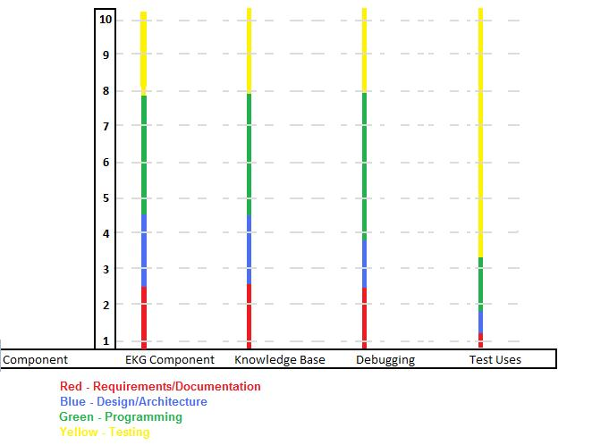

This schedule shows the 4 major steps in each part of group 7’s project: Requirements/Documentation, Design/Architecture, Programming, and Testing/Debugging. This graph gives a general idea the length of each step for the each part of the components group 7 will be working on. This helps predict future time allocation and can also help with rescheduling if a certain part falls behind.

The graph below shows human resource allocation. This depicts the level of involvement of both management and technical staff with the Personal Healthcare Slow Intelligence System.
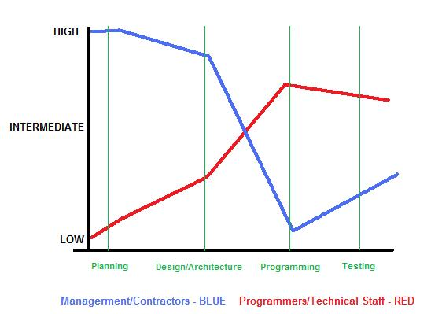

3. XML Message Description

Messages
Messages: References and examples of the XML code located in the Appendix
MsgID:23 Description: Connect to server
Variables:
- Passcode (Passcode of Administrator)
- SecurityLevel (Security Level of Administrator)
- Name (Name of Component to be connected to server)
MsgID:26 Description: Acknowledgement
Variables:
- AckMsgID (This is Ack for MsgID)
- YesNo (Yes/No for positive/negative Ack)
- Name (Name of involved Component)
MsgID:35 Description: EKG Reading
Variables:
- DataStream (EKG data stream)
- DateTime (time stamp)
MsgID:36 Description: EKG Alert
Variables:
- DataStream (EKG data stream)
- Alert Type (EKG alert type)
- DateTime (time stamp)
MsgID:170 Description: EKG KnowledgeBase Query
Variables:
- DateTime (time stamp)
- PulseRate (pulse rate)
- StdDevTimeBetween (standard deviation of time between pulses)
- AggregationInterval (interval time length in seconds)
- AvgQtInterval (average QT value)
- AvgPrInterval (average PR value)
MsgID:171 Description: EKG KnowledgeBase Query Result
Variables:
- DateTime (time stamp)
- EkgStatus (status result)
MsgID:172 Description: EKG Knowledge Base Insert
Variables:
- DateTime (time stamp)
- PatientAge(age of patient)
- PatientRace(race)
- PatientWeight(weight)
- PatientStdDevTimeBetween (standard deviation of time between pulses)
- PatientAggregationInterval (interval time length in seconds)
- PatientAvgQtInterval (average QT value)
- PatientAvgPrInterval (average PR value)

Scenario
SISServer instantiates EKGMonitor. The EKGMonitor runs main().
EKGMonitor sends Msg 23 (connect to server) to SISServer. SISServer rceives message.
SISserver sends Ack message (Msg ID 26) to EKGMonitor component in response to Msg23.
SISServer instantiates EKGKbInterpreter. The EKGKbInterpreter runs and instantiates the EKGKnowledgeBase (which will read a flatfile to build a tree).
EKGKbInterpreter sends Msg 23 (connect to server) to SISServer.
SISserver sends Ack message (Msg ID 26) to EKGKbInterpreter component in response to Msg23.
InputProcessor sends Msg 35 (ekg reading) to EKGMonitor.
EKG Monitor sends Msg 170 (ekg query) to EKGKbInterpreter. The query contains the key values obtained from analysis of the raw ekg data.
EKGKbInterpreter sends Ack message (Msg ID 26) to EKGMonitor component in response to Msg170.
EKGKbInterpreter sends Msg 171 (ekg kb result) to EKGMonitor.
EKGMonitor sends Ack message (Msg ID 26) to EKGKbInterpreter component in response to Msg171.
EKGMonitor sends Msg 32 (ekg alert) to GUI, which displays the vital signals.
EKGMonitor sends Msg 32 (ekg alert) to Uploader, which uploads patients medical condition to remote database.

XML Appendix
XML code of the following Messages at http://www.cs.pitt.edu/~chang/163/interface/MessageSIS.htm :
23:Connect to server
26:Acknowledgement
35:EKG Reading
32:EKG Alert

XML example for MsgID:170 - EKGKbQueryMsg
<XML>
<Msg>
<Head>
<MsgID>170</MsgID>
<Description>EKG KnowledgeBase Query</Description>
</Head>
<Body>
<Item>
<Key>DateTime</Key>
<Value>02112010144033</Value>
</Item>
<Item>
<Key>PulseRate</Key>
<Value>30</Value>
</Item>
<Item>
<Key>StdDevTimeBetween</Key>
<Value>0.2</Value>
</Item>
<Item>
<Key>AggregationInterval</Key>
<Value>60</Value>
</Item>
<Item>
<Key>AvgQtInterval</Key>
<Value>1.0</Value>
</Item>
<Item>
<Key>AvgPrInterval</Key>
<Value>1.5</Value>
</Item>
</Body>
</Msg>
<XML>

XML example for MsgID:171 - EKGKbResultMsg
<XML>
<Msg>
<Head>
<MsgID>171</MsgID>
<Description>EKG KnowledgeBase Query Result</Description>
</Head>
<Body>
<Item>
<Key>DateTime</Key>
<Value>02112010144033</Value>
</Item>
<Item>
<Key>EkgStatus</Key>
<Value>bad</Value>
</Item>
</Body>
</Msg>
<XML>

XML example for MsgID:172 - EKGKbInsertMsg
<XML>
<Msg>
<Head>
<MsgID>172</MsgID>
<Description>EKG KnowledgeBase Insert</Description>
</Head>
<Body>
<Item>
<Key>DateTime</Key>
<Value>02112010144033</Value>
</Item>
<Item>
<Key> PatientAge </Key>
<Value>50</Value>
</Item>
<Item>
<Key> PatientGender </Key>
<Value>M</Value>
</Item>
<Item>
<Item>
<Key> Height </Key>
<Value>72</Value>
</Item>
<Item>
<Key> PatientWeight </Key>
<Value>210</Value>
</Item>
<Item>
<Key> PatientRace</Key>
<Value>Caucasian</Value>
</Item>
<Item>
<Key> PatientStdDevTimeBetween</Key>
<Value>00.0900</Value>
</Item>
<Item>
<Key> PatientAggregationInterval </Key>
<Value>60</Value>
</Item>
<Item>
<Key> PatientAvgQtInterval </Key>
<Value>00.025</Value>
</Item>
<Item>
<Key> PatientAvgPrInterval </Key>
<Value>00.050</Value>
</Item>
</Body>
</Msg>
<XML>

4. UML Diagrams

Use Case Diagram
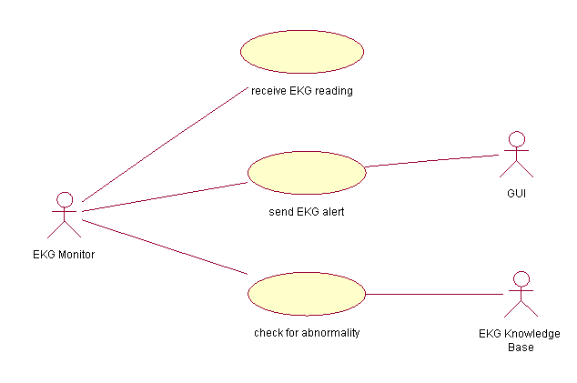

Class Diagram
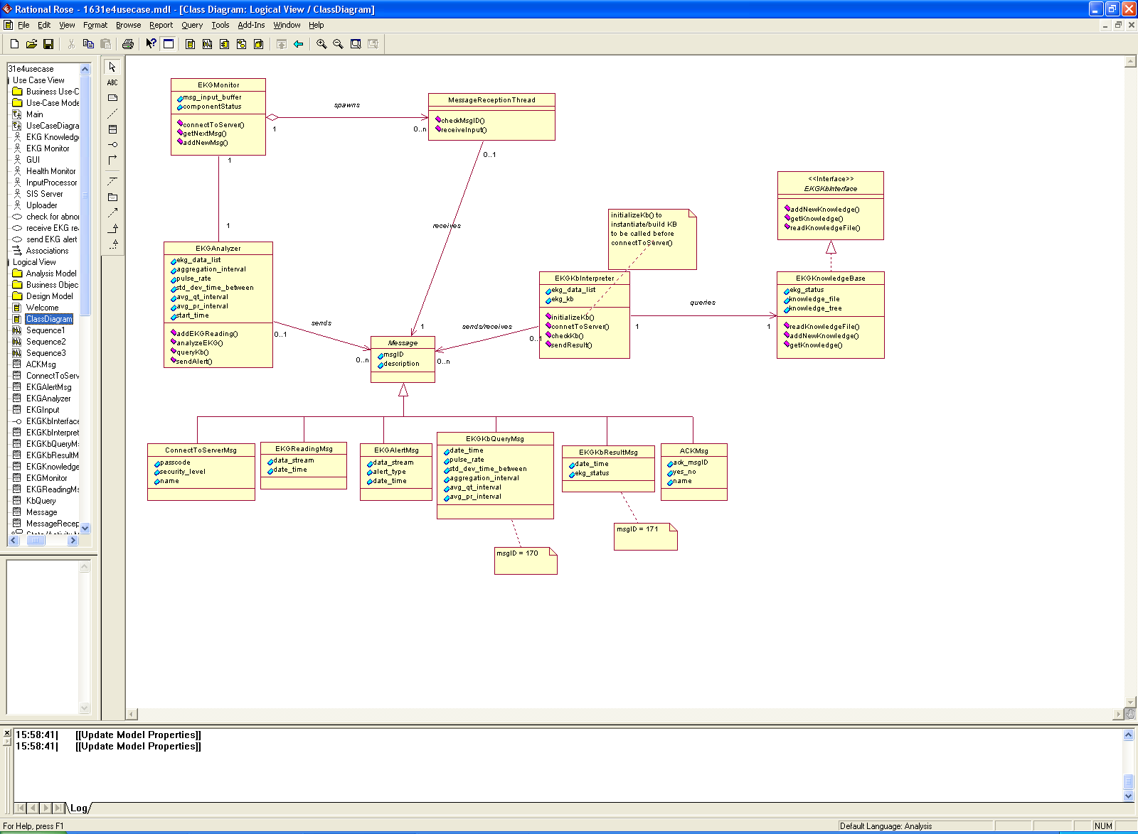

Sequence Diagrams

Receive EKG reading
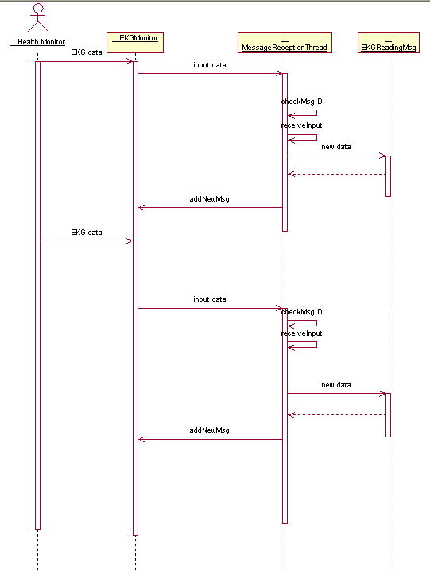

Check for Abnormality
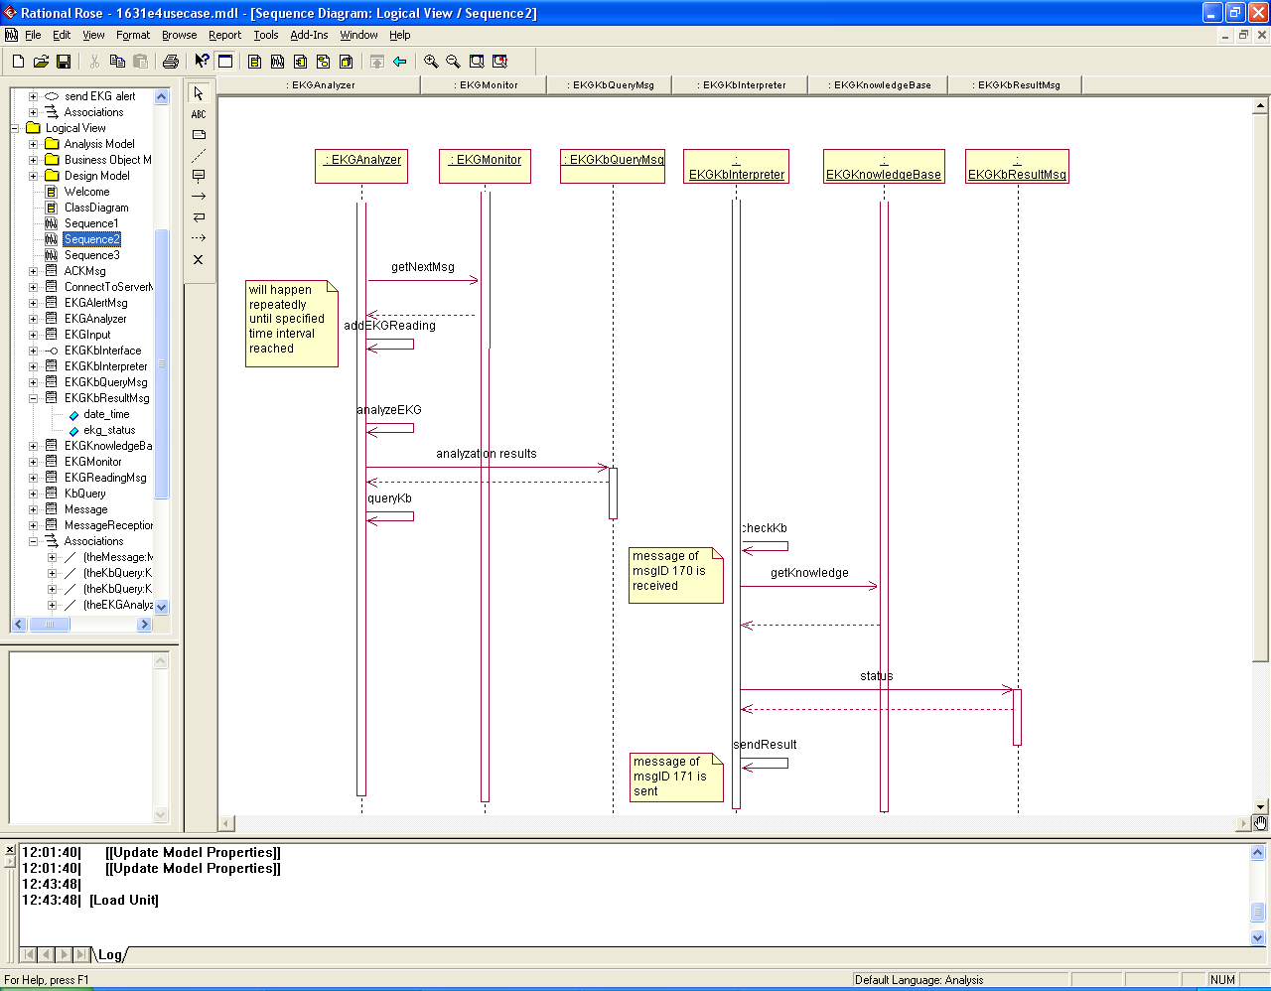

Send EKG Alert
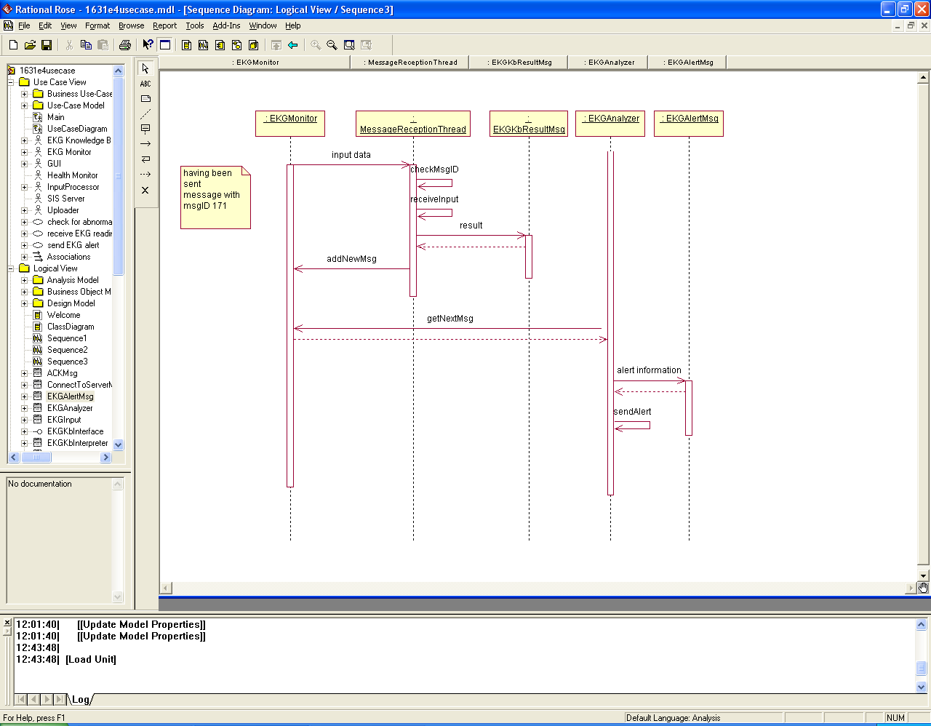

Activity Diagram

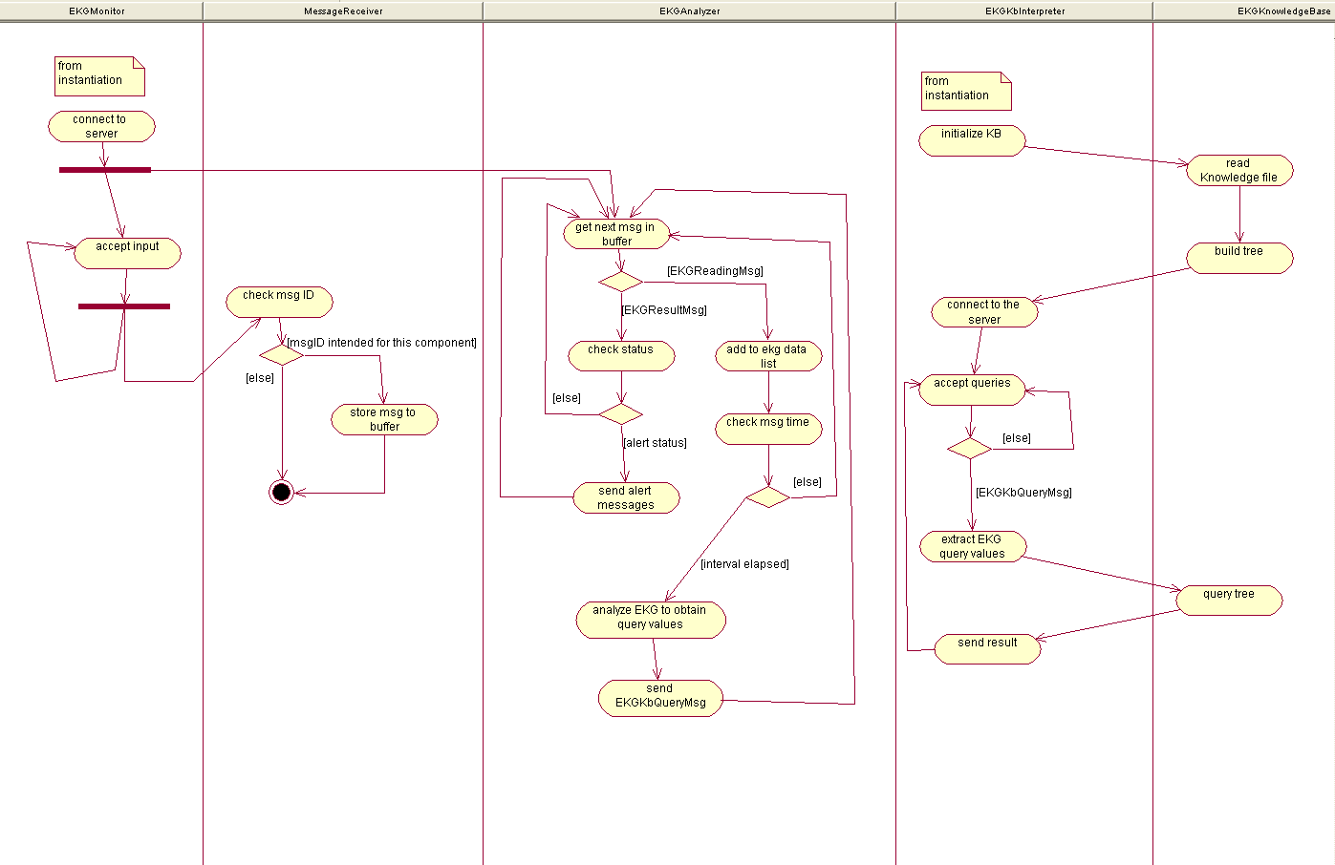

5. EKG Module Source Code Index – Group 7

File Descriptions
g7ekg.java: java program that handles our entire ekg module. This include message transactions, server communication and knowledge base requests
g7kb.java: java program that handles the querying of ekg data to the knowledge base. Returns diagnosis dependant upon reading
g7ekg.XML: creates the ekg monitor
g7kb.XML: creates the ekg knowledge base componenet
g7msg45profileinfo.XML: get user profile information from UI
g7msgKBquery.XML: EKG knowledge base query
g7msgKBqueryResult.XML: message returned based on kb query result
g7testData1.XML: a test file that sends the ekg monitor reads in in order to return diagnosis

XML Files

g7ekg
<?xml version="1.0" encoding="UTF-8" standalone="no"?>
<Msg><Head><MsgID>21</MsgID><Description>Create EKGMonitor Component</Description></Head><Body><Item><Key>Passcode</Key><Value>****</Value></Item><Item><Key>SecurityLevel</Key><Value>3</Value></Item>
<Item><Key>Name</Key><Value>g7ekg</Value></Item><Item><Key>SourceCode</Key><Value>g7ekg.java</Value></Item>
<Item><Key>InputMsgID 1</Key><Value>35</Value></Item>
<Item><Key>OutputMsgID 1</Key><Value>36</Value></Item>
<Item><Key>InputMsgID 2</Key><Value>171</Value></Item>
<Item><Key>OutputMsgID 2</Key><Value>170</Value></Item>
<Item><Key>InputMsgID 3</Key><Value>45</Value></Item>
<Item><Key>Component Description</Key><Value>EKGMonitor checks for abnormality. There could be a knowledge base, but initially we just check if EKG reading is over *** to generate an alert.</Value></Item>
<Item><Key>KnowledgeBase</Key><Value>g7kb</Value></Item>
</Body></Msg>

g7kb
<?xml version="1.0" encoding="UTF-8" standalone="no"?>
<Msg><Head><MsgID>21</MsgID><Description>Create EKGknowledgebase Component</Description></Head><Body><Item><Key>Passcode</Key><Value>****</Value></Item>
<Item><Key>SecurityLevel</Key><Value>3</Value></Item>
<Item><Key>Name</Key><Value>g7kb</Value></Item>
<Item><Key>SourceCode</Key><Value>EKGkb.class</Value></Item>
<Item><Key>InputMsgID 1</Key><Value>170</Value></Item>
<Item><Key>OutputMsgID 1</Key><Value>171</Value></Item>
<Item><Key>InputMsgID 2</Key><Value>45</Value></Item>
<Item><Key>Component Description</Key><Value>EKGknowledgebase checks for abnormality.</Value></Item>
<Item><Key>KnowledgeBase</Key><Value>g7kb</Value></Item>
</Body></Msg>

g7msg45profileinfo
<?xml version="1.0" standalone="yes"?>
<!--Generated by Virtual Remote 1.0-->
<Msg>
<Head><MsgID>45</MsgID><Description>User Profile</Description></Head>
<Body><Item><Key>UserName</Key><Value>user001</Value></Item>
<Item><Key>Sex</Key><Value>male</Value></Item>
<Item><Key>Age</Key><Value>51</Value></Item>
<Item><Key>Weight</Key><Value>167</Value></Item>
<Item><Key>Height</Key><Value>62</Value></Item>
<Item><Key>Diabetes</Key><Value>prediabetic</Value></Item>
<Item><Key>HeartDisease</Key><Value>yes</Value></Item>
<Item><Key>Meal</Key><Value>fasting</Value></Item>
<Item><Key>DateTime</Key><Value>2010-03-16 15:05:10.00000843</Value></Item></Body>
</Msg>

g7msgKBquery
<?xml version="1.0" encoding="UTF-8" standalone="no"?>
<Msg>
<Head>
<MsgID>170</MsgID>
<Description>EKG KnowledgeBase Query</Description>
</Head>
<Body>
<Item>
<Key>DateTime</Key>
<Value>02112010144033</Value>
</Item>
<Item>
<Key>BPM</Key>
<Value>60</Value>
</Item>
<Item>
<Key>AvgQrsInterval</Key>
<Value>1.2</Value>
</Item>
<Item>
<Key>AvgQtInterval</Key>
<Value>1.0</Value>
</Item>
<Item>
<Key>AvgPrInterval</Key>
<Value>1.5</Value>
</Item>
</Body>
</Msg>

g7msgKBqueryResult
<?xml version="1.0" encoding="UTF-8" standalone="no"?>
<Msg>
<Head>
<MsgID>171</MsgID>
<Description>EKG KnowledgeBase Query Result</Description>
</Head>
<Body>
<Item>
<Key>DateTime</Key>
<Value>02112010144033</Value>
</Item>
<Item>
<Key>EkgStatus</Key>
<Value>bad</Value>
</Item>
<Item>
<Key>Diagnosis</Key>
<Value>diagnosis from kb</Value>
</Item>
<Item>
<Key>Suggestions</Key>
<Value>suggestions from kb</Value>
</Item>
</Body>
</Msg>

g7testData1
<?xml version="1.0" standalone="yes"?>
<!--Generated by Virtual Remote 1.0-->
<Msg>
<Head><MsgID>35</MsgID><Description>EKG Reading</Description></Head>
<Body>
<Item>
<Key>LeadI</Key>
<Value>11 640 760 800 776 640 488 280 24 -24 -40 0 0 0 0 0 0 0 0 0 0 0 0 0 0 0 0 0 0 0 0 0 8 16 16 16 16 24 40 40 40 56 56 56 56 56 80 80 80 80 96 80 80 96 96 120 120 120 224 448 584 672 656 520 360 152 40 40 56 56 56 56 56 48 0 -72 480 4840 3008 240 -584 -112 0 0 -24 0 0 0 8 16 24 96 152 200 248 320 376 400 496 576 744 800 776 680 544 360 80 0 -56 -64 -8 0 0 0 0 0 0 0 0 0 0 0 0 0 0 0 0 0 0 0 0 0 16 16 16 16 16 16 24 40 40 40 48 56 56 56 80 80 80 80 80 96 96 96 120 120 160 368 584 656 680 544 448 232 48 16 40 56 56 56 56 56 40 -40 16 2232 4544 4696 1120 -504 -424 0 -24 0 0 0 0 0 0 64 80 128 184 232 288 376 376 480 544 664 768 800 776 632 440 216 0 -16 -64 -40 0 0 0 0 0 0 0 0 0 0 0 0 0 0 0 0 0 0 0 0 0 0 8 16 16 16 16 40 40 40 40 56 56 56 56 56 80 80 96 96 96 96 120 120 96 96 120 264 520 632 680 656 496 288 64 16 16 40 40 40 56 56 56 -16 -80 1160 3872 4800 2280 -176 -584 -56 0 0 -24 0 0 0 16 16 80 112 160 192 248 336 400 416 480 608 760 840 784 672 520 280 32 -16 -40 -24 0 0 0 0 0 0 0 0 0 0 0 0 0 0 0 0 0 0 0 0 0 0 0 0 0 16 16 16 56 56 56 56 56 56 80 80 56 80 96 80 96 96 96 96 120 96 96 200 424 608 680 696 536 392 176 40 16 80 56 56 56 56 80 24 -64 40 2888 4800 3960 512 -560 -224 0 0 0 0 0 0 16 40 40 112 144 176 224 320 376 376 496 584 720 800 800 712 560 392 144 0 -40 -40 0 0 0 0 0 0 0 0 0 0 0 0 0 0 0 0 0 0 0 0 0 0 0 0 16 16 16 24 40 40 40 56 40 40 40 80 80 80 80 96 96 96 96 96 96 96 96 144 320 560 640 680 600 472 248 80 40 40 56 56 56 56 56 40 -32 -104 1792 4344 4696 1560 -360 -424 -16 -24 0 -24 0 0 0 16 40 88 144 168 200 280 360 400 424 528 664 784 840 760 616 448 224 8 -32 -40 -24 0 0 0 0 0 0 0 0 0 0 0 0 0 0 0 0 0 0 0 0 0 0 0 16 16 16 16 16 56 40 40 56 56 56 56 56 56 80 80 96 96 96 96 96 96 120 96 240 496 640 672 656 520 336 120 16 40 48 56 40 40 56 56 0 -96 520 3488 4816 2792 88 -600 -120 0 -24 0 0 0 0 8 16 48 120 152 184 240 328 376 400 496 584 744 800 776 696 544 360 88 -8 -40 -24 0 0 0 0 0 0 0 0 0 0 0 0 0 0 0 0 0 0 0 0 0 0 0 16 16 16 24 40 40 56 40 56 56 56 80 80 96 96 96 96 96 120 120 120 120 120 168 384 600 672 696 560 424 216 40 16 72 56 56 56 80 80 40 -56 56 2424 4616 3936 920 -528 -424 0 -24 0 0 0 0 8 40 40 104 128 184 240 296 376 408 440 528 680 808 816 736 600 424 168 0 -40 -40 -24 0 0 0 0 0 0 0 0 0 0 0 0 0 0 0 0 0 0 0 0 0 0 16 16 16 16 16 40 40 40 40 40 56 56 56 56 64 80 88 96 96 96 96 120 120 128 296 528 648 680 600 504 264 72 16 16 40 40 48 80 56 56 -16 -104 1344 4016 4640 2016 -256 -560 -32 0 0 -24 0 0 0 0 16 64 120 160 216 264 336 376 408 488 616 752 776 776 664 488 288 40 -16 -40 -40 0 0 0 0 0 0 0 0 0 0 0 0 0 0 0 0 0 0 0 0 0 0 0 0 16 16 16 40 40 56 56 40 40 56 56 80 80 96 96 80 96 96 120 96 120 120 208 456 632 664 656 528 400 160 32 16 80 56 56 56 56 80 8 -72 56 3080 4856 3224 368 -536 -200 0 -24 0 0 0 0 0 16 24 152 160 200 208 296 368 384 488 560 728 800 776 720 568 384 128 0 -40 -40 0 0 0 0 0 0 0 0 0 0 0 0 0 0 0 0 0 0 0 0 0 0 0 16 16 16 40 40 40 40 56 56 56 56 56 56 80 56 96 80 96 96 120 120 96 96 120 168 344 568 648 680 568 440 240 72 40 40 56 64 56 56 80 56 -24 -80 1968 4488 4640 1352 -456 -400 -16 0 0 -24 0 0 0 32 40 112 144 176 216 280 360 416 432 544 672 784 800 776 632 480 232 8 -32 -40 -24 0 0 0 0 0 0 0 0 0 0 0 0 0 0 0 0 0 0 0 0 0 0 16 16 16 16 40 40 40 40 40 40 56 56 56 80 56 80 80 96 96 96 96 96 96 96 96 96 240 488 640 680 656 504 304 88 0 16 56 56 56 56 80 56 8 -96 576 3704 4856 2544 -40 -560 -72 0 -24 -24 0 0 0 0 24 72 104 160 208 256 328 376 392 496 592 728 776 776 680 520 320 56 -24 -40 -40 0 0 0 0 0 0 0 0 0 0 0 0 0 0 0 0 0 0 0 0 0 0 16 16 16 16 16 40 40 40 40 40 56 56 56 56 80 80 80 80 96 96 96 96 96 96 112 200 392 600 680 696 512 392 168 40 40 56 40 56 56 56 80 40 -80 80 2656 4728 3856 744 -536 -424 0 0 0 0 0 0 0 16 72 104 160 184 216 304 376 376 496 592 704 800 816 728 600 400 176 0 -40 -40 0 0 0 0 0 0 0 0 0 0 0 0 0 0 0 0 0 0 0 0 0 0 0 0 16 16 24 56 56 56 40 40 56 56 56 80 80 80 80 80 96 96 96 96 120 120 128 312 560 656 680 600 464 272 88 40 56 56 56 80 56 80 56 0 -80 1536 4184 4640 1824 -304 -560 -32 0 0 -24 0 0 0 0 8 80 136 168 200 280 336 360 448 512 640 760 800 760 656 480 272 24 -24 -40 -24 0 0 0 0 0 0 0 0 0 0 0 0 0 0 0 0 0 0 0 0 0 0 16 16 16 16 40 40 40 40 40 56 56 56 56 56 56 80 88 96 96 96 96 120 120 120 208 448 616 664 656 512 344 144 32 16 56 56 56 56 56 56 40 -88 600 3296 4840 3000 240 -576 -224 0 -24 0 0 0 0 0 8 56 120 160 176 224 320 376 384 528 608 736 824 800 712 560 360 96 0 -32 -24 0 0 0 0 0 0 0 0 0 0 0 0 0 0 0 0 0 0 0 0 0 0 0 0 16 16 16 32 40 40 40 56 56 56 56 80 56 80 80 96 96 96 120 120 120 136 168 368 600 664 696 568 408 224 72 40 40 56 64 56 56 48 24 -40 80 2176 4584 4616 1112 -512 -424 -8 -24 0 0 0 0 0 32 40 120 144 176 208 280 368 400 408 552 656 784 816 752 624 464 208 0 -16 -24 0 0 0 0 0 0 0 0 0 0 0 0 0 0 0 0 0 0 0 0 0 0 0 16 16 16 16 32 40 40 40 56 56 56 56 56 56 80 80 96 96 96 96 96 120 120 128 280 520 656 680 656 504 312 88 16 40 56 56 56 56 56 40 -8 -80 1168 3880 4840 2288 -136 -544 -32 0 0 -24 0 0 0 8 16 96 104 160 200 264 344 376 432 488 640 760 800 776 704 512 304 64 -16 -40 -40 0 0 0 0 0 0 0 0 0 0 0 0 0 0 0 0 0 0 0 0 0 0 16 16 16 40 40 40 40 40 56 56 56 56 56 80 56 80 80 80 96 96 96 120 120 120 120 184 424 624 680 696 528 384 160 40 40 56 56 56 56 56 72 40 -80 80 2864 4752 3776 536 -560 -384 0 -24 0 0 0 0 0 0 80 104 160 176 200 304 376 376 512 576 712 800 800 704 568 384 160 0 -24 -40 0 0 0 0 0 0 0 0 0 0 0 0 0 0 0 0 0 0 0 0 0 0 0 16 16 16 16 40 40 40 40 40 56 56 56 56 56 56 80 80 80 96 96 96 96 96 104 120 160 320 544 656 696 576 440 264 40 16 40 40 56 56 56 80 56 -24 -64 1768 4304 4576 1576 -384 -584 -24 -24 0 0 0 0 0 0 40 96 136 176 200 264 344 376 440 520 632 776 816 776 648 464 240 16 -24 -24 0 0 0 0 0 0 0 0 0 0 0 0 0 0 0 0 0 0 0 0 0 0 16 16 16 16 16 40 40 40 56 56 56 56 56 56 80 56 96 96 96 96 96 96 96 120 120 120 240 480 656 680 640 480 320 96 40 40 40 56 56 56 56 80 0 -80 656 3488 4840 2784 88 -560 -184 0 -24 0 0 0 0 24 56 64 96 144 200 248 320 376 392 520 592 744 800 776 688 536 344 88 0 -32 -40 0 0 0 0 0 0 0 0 0 0 0 0 0 0 0 0 0 0 0 0 0 0 0 0 16 16 24 40 40 40 40 40 56 56 56 56 72 56 96 96 96 96 112 120 96 120 160 368 584 656 680 544 424 200 48 16 40 56 56 56 56 56 40 -56 136 2408 4600 4536 920 -552 -400 0 -24 0 -24 0 0 0 40 40 96 128 176 208 288 368 376 456 520 680 784 776 704 600 440 184 0 -16 -40 -24 0 0 0 0 0 0 0 0 0 0 0 0 0 0 0 0 0 0 0 0 0 0 16 16 40 40 16 40 40 40 56 56 56 56 80 56 80 96 96 96 96 96 96 112 120 120 320 528 608 680 656 464 296 88 40 40 56 72 56 56 56 56 -16 -64 1368 4024 2056 -296 -560 -24 0 0 0 0 0 0 16 40 40 144 176 208 264 352 376 416 520 600 760 816 800 656 504 296 40 -16 -40 -24 0 0 0 0 0 0 0 0 0 0 0 0 0 0 0 0 0 0 0 0 0 0 0 16 16 16 16 40 40 40 56 56 56 56 56 88 96 56 80 96 96 104 120 96 96 120 224 472 608 680 696 520 360 144 40 40 40 56 64 80 80 80 16 -80 536 3072 4792 3696 344 -584 -152 0 -24 0 0 0 0 0 16 56 120 160 176 224 312 376 376 488 560 720 800 800 704 560 384 128 0 -24 -40 0 0 0 0 0 0 0 0 0 0 0 0 0 0 0 0 0 0 0 0 0 0 0 0 16 16 16 16 40 40 56 56 40 56 56 56 80 56 80 80 96 80 96 96 96 96 120 160 336 576 664 680 600 440 240 40 16 56 56 56 56 56 56 24 -32 -64 1968 4456 4536 1328 -456 -384 -16 -24 0 -24 0 0 0 24 40 80 136 176 200 272 352 400 424 544 656 784 800 744 624 456 232 8 0 -40 -24 0 0 0 0 0 0 0 0 0 0 0 0 0 0 0 0 0 0 0 0 0 0 16 16 16 16 16 40 40 40 40 56 56 56 56 56 56 80 80 88 96 96 96 96 96 120 96 96 272 488 640 672 656 496 320 112 24 40 80 56 56 80 56 80 0 -80 976 3688 4856 2568 -32 -560 -80 0 -24 -24 0 0 0 16 40 48 120 168 200 248 328 400 408 520 600 744 800 800 680 528 328 80 0 -56 -40 0 0 0 0 0 0 0 0 0 0 0 0 0 0 0 0 0 0 0 0 0 0 0 16 16 16 16 40 40 56 16 56 56 56 56 56 80 96 96 80 96 112 120 120 96 96 120 120 208 432 584 672 680 560 400 184 40 40 40 56 56 80 80 56 16 -80 136 2640 4720 4536 760 -584 -240 0 0 0 -24 0 0 0 0 64 96 152 184 216 288 376 408 464 568 688 792 800 744 608 408 176 0 -40 -64 -8 0 0 0 0 0 0 0 0 0 0 0 0 0 0 0 0 0 0 0 0 0 0 8 16 16 16 40 40 40 48 56 56 56 56 56 56 80 80 80 96 96 96 96 96 96 96 144 320 544 672 696 576 488 264 72 16 16 80 56 56 56 56 40 -32 -80 1560 4192 4880 1840 -320 -544 -24 0 0 0 0 0 0 16 16 80 128 160 192 248 336 400 416 480 632 768 816 760 648 488 280 32 -16 -24 0 0 0 0 0 0 0 0 0 0 0 0 0 0 0 0 0 0 0 0 0 0 0 0 0 16 16 16 40 40 48 56 56 56 56 56 56 56 80 88 96 96 96 96 120 120 120 240 480 608 680 656 496 368 128 16 16 80 56 56 56 56 80 8 -80 680 3280 4824 3656 192 -584 -136 0 0 0 0 0 0 0 16 64 120 160 192 232 320 384 400 464 568 728 800 800 736 552 368 120 0 -32 -40 0 0 0 0 0 0 0 0 0 0 0 0 0 0 0 0 0 0 0 0 0 0 0 16 16 16 40 40 48 56 56 56 56 56 56 80 80 80 80 96 96 96 104 120 96 120 168 360 584 680 680 576 432 224 40 16 40 80 56 56 80 80 32 -40 -64 2208 4496 1144 -456 -384 -8 -24 0 -24 0 0 0 0 64 96 136 168 200 296 368 400 456 584 664 784 800 776 616 464 216 8 -32 -40 0 0 0 0 0 0 0 0 0 0 0 0 0 0 0 0 0 0 0 0 0 0 0 16 16 16 40 40 40 40 40 56 56 56 56 56 80 88 96 96 96 96 96 96 120 120 128 288 528 624 680 656 488 304 104 40 40 40 80 56 56 80 56 -8 -80 1176 3872 4856 -136 -560 -56 0 -24 -24 0 0 0 0 0 88 120 152 200 256 336 416 416 528 648 760 800 776 680 504 320 64 0 -40 -40 0 0 0 0 0 0 0 0 0 0 0 0 0 0 0 0 0 0 0 0 0 0 0 0 16 16 16 40 40 40 40 56 56 56 56 56 80 80 80 80 96 96 96 96 96 112 208 440 584 656 680 536 408 200 24 16 40 56 80 56 56 80 8 -72 176 2864 4728 3600 568 -584 -216 0 0 0 0 0 0 0 0 64 104 152 176 216 304 376 384 496 568 720 792 800 736 568 408 168 0 -16 -24 0 0 0 0 0 0 0 0 0 0 0 0 0 0 0 0 0 0 0 0 0 0 0 0 16 16 16 40 40 40 56 40 40 56 56 80 96 96 80 96 96 96 96 120 120 96 120 152 344 552 680 680 600 464 264 48 16 72 56 56 56 80 96 56 -16 -64 1736 4280 4480 1616 -368 -544 -16 0 0 -24 0 0 0 40 56 80 128 176 216 296 376 376 448 544 672 768 800 776 640 464 248 8 -16 -40 0 0 0 0 0 0 0 0 0 0 0 0 0 0 0 0 0 0 0 0 0 0 0 16 0 16 16 56 56 40 40 56 56 56 56 56 80 80 80 80 80 96 96 96 120 96 96 120 136 248 488 616 664 656 528 376 120 16 16 56 56 56 56 56 56 40 -80 808 3456 4816 2792 64 -600 -120 0 0 -24 0 0 0 0 16 80 112 160 176 224 320 384 400 488 576 728 800 776 672 544 360 88 0 -48 -40 0 0 0 0 0 0 0 0 0 0 0 0 0 0 0 0 0 0 0 0 0 0 8 16 16 16 16 16 16 40 40 40 56 56 56 80 56 56 80 80 96 96 96 96 96 96 96 120 168 376 600 664 680 560 424 216 32 16 56 56 56 56 80 80 24 -40 -40 2416 4648 4440 944 -536 -344 -8 -24 -24 -24 0 0 0 16 24 112 144 176 224 280 360 400 432 528 672 784 800 776 608 440 184 0 -8 -40 -24 0 0 0 0 0 0 0 0 0 0 0 0 0 0 0 0 0 0 0 0 0 0 16 16 16 16 24 40 40 56 40 56 56 56 80 80 56 56 80 96 96 96 104 120 96 120 128 296 536 624 680 640 472 296 96 40 40 56 56 56 56 80 80 -8 -80 1360 4048 4816 2096 -272 -544 -40 0 0 -24 0 0 0 0 8 88 120 176 208 256 328 400 408 504 632 776 800 784 648 488 304 24 0 -40 -40 0 0 0 0 0 0 0 0 0 0 0 0 0 0 0 0 0 0 0 0 0 0 0 16 16 16 16 40 40 56 56 56 56 56 80 80 56 80 96 96 96 96 96 112 120 120 208 456 608 680 656 552 392 160 40 40 40 40</Value>
</Item>
<Item>
<Key>LeadII</Key>
<Value>416 640 800 872 880 664 408 80 -160 -432 -496 -504 -472 -440 -424 -384 -360 -344 -344 -312 -304 -304 -280 -280 -272 -264 -256 -240 -224 -224 -200 -200 -192 -160 -160 -144 -144 -120 -112 -104 -120 -80 -80 -64 -64 -80 -64 -64 -64 -40 -40 -40 -24 -24 0 0 0 0 48 360 600 672 640 440 200 -24 -152 -144 -80 -80 -80 -80 -64 -64 -200 -480 496 6376 3552 -528 -1624 -592 -320 -424 -384 -328 -280 -272 -224 -160 -56 0 0 24 48 88 200 288 424 600 744 872 880 744 528 216 -64 -360 -480 -480 -480 -440 -424 -400 -384 -360 -344 -312 -304 -320 -304 -304 -280 -264 -264 -264 -240 -224 -224 -216 -184 -184 -184 -152 -144 -144 -120 -144 -120 -104 -104 -104 -88 -64 -64 -56 -40 -40 -40 -40 -40 -24 0 0 0 0 0 224 528 632 696 520 304 40 -112 -160 -128 -104 -88 -104 -80 -72 -104 -416 -160 2856 6024 6120 800 -1624 -1304 -304 -416 -400 -392 -320 -280 -232 -200 -88 0 0 0 32 80 200 280 384 536 672 840 880 880 664 368 40 -240 -464 -520 -504 -456 -440 -416 -384 -352 -344 -328 -304 -320 -304 -304 -280 -280 -264 -264 -240 -240 -232 -200 -200 -184 -184 -160 -160 -144 -144 -128 -104 -80 -80 -104 -104 -80 -64 -64 -64 -40 -40 -40 -40 -32 0 0 0 0 0 0 104 448 648 720 656 416 152 -40 -120 -104 -80 -80 -64 -64 -64 -64 -272 -464 1480 5104 6376 2496 -1144 -1624 -424 -320 -400 -384 -320 -288 -264 -160 -112 -40 0 16 16 32 160 208 320 464 568 760 856 856 736 472 120 -120 -400 -520 -504 -480 -440 -424 -400 -376 -360 -328 -304 -304 -320 -280 -280 -280 -264 -264 -248 -240 -224 -224 -200 -184 -184 -160 -144 -144 -144 -120 -120 -120 -104 -104 -80 -80 -80 -64 -64 -64 -40 -40 -40 -24 -24 -24 0 0 0 0 24 288 576 680 696 480 192 -8 -144 -160 -104 -104 -96 -64 -64 -64 -120 -480 408 3784 6328 5000 -80 -1640 -728 -280 -400 -400 -384 -312 -272 -264 -136 -96 -8 0 8 40 80 176 264 416 560 720 864 880 768 576 256 -40 -328 -480 -504 -480 -464 -432 -400 -376 -360 -360 -344 -312 -304 -320 -304 -280 -280 -264 -240 -240 -240 -224 -200 -200 -184 -184 -160 -160 -160 -160 -144 -120 -112 -104 -80 -80 -80 -80 -64 -40 -24 -24 -24 -24 -24 -24 -16 0 -24 0 0 168 496 632 696 600 368 80 -88 -144 -104 -104 -80 -80 -64 -64 -64 -376 -464 2296 5784 6096 1416 -1424 -1240 -320 -384 -400 -384 -312 -280 -264 -216 -136 -32 0 0 40 80 168 240 344 512 680 824 872 856 656 376 48 -192 -456 -496 -480 -464 -440 -424 -392 -360 -360 -320 -320 -304 -320 -304 -304 -272 -264 -240 -240 -232 -224 -224 -224 -160 -184 -160 -160 -160 -144 -144 -120 -104 -104 -80 -80 -80 -80 -64 -40 -40 -40 -40 -40 -40 -24 -24 -24 -24 0 0 64 376 608 688 656 448 200 -16 -120 -104 -88 -80 -80 -64 -40 -40 -160 -440 576 4680 6416 3248 -720 -1600 -520 -304 -400 -400 -352 -296 -264 -200 -144 -56 0 0 24 56 96 216 320 440 544 760 856 880 736 520 176 -80 -392 -480 -504 -480 -456 -424 -400 -384 -344 -344 -328 -304 -304 -304 -280 -280 -264 -264 -240 -240 -240 -240 -192 -200 -184 -160 -160 -160 -152 -144 -120 -120 -104 -104 -104 -80 -80 -80 -64 -64 -40 -40 -64 -40 -24 -24 -40 -40 0 8 240 528 632 680 512 240 8 -152 -160 -104 -104 -80 -80 -80 -72 -120 -456 -160 3168 6120 4936 496 -1664 -912 -304 -416 -424 -392 -312 -280 -240 -144 -96 0 0 16 40 88 176 264 384 536 704 832 856 800 600 304 0 -272 -472 -504 -504 -464 -440 -416 -384 -360 -360 -320 -320 -320 -304 -304 -280 -264 -264 -264 -264 -256 -224 -224 -184 -184 -184 -160 -160 -144 -144 -144 -144 -104 -104 -104 -80 -80 -64 -40 -40 -64 -64 -64 -24 -24 0 -40 -40 0 0 120 440 608 696 576 376 96 -80 -160 -120 -104 -80 -80 -64 -64 -80 -296 -464 1696 5328 6056 2160 -1232 -1584 -408 -320 -424 -384 -336 -280 -280 -176 -128 -56 0 0 16 48 136 224 320 480 616 792 856 840 688 440 96 -136 -408 -504 -504 -464 -440 -424 -384 -360 -360 -344 -344 -304 -304 -304 -280 -280 -280 -264 -264 -240 -224 -224 -184 -184 -176 -160 -160 -128 -144 -144 -120 -104 -80 -104 -80 -80 -64 -80 -64 -64 -40 -40 -40 -24 -24 -24 -24 0 0 24 320 592 664 640 480 240 -32 -128 -144 -104 -104 -80 -80 -80 -64 -104 -480 536 4056 6376 3896 -312 -1624 -656 -280 -408 -424 -360 -304 -256 -224 -168 -72 0 0 16 48 80 184 280 424 520 744 856 856 760 560 232 -48 -344 -480 -504 -464 -464 -424 -424 -392 -360 -344 -344 -304 -304 -320 -280 -280 -280 -280 -248 -240 -200 -184 -184 -200 -184 -184 -160 -144 -144 -120 -104 -120 -104 -96 -80 -80 -80 -80 -64 -64 -40 -40 -40 -32 -24 -24 -24 -24 -16 0 0 192 488 640 680 528 320 40 -80 -144 -120 -80 -64 -80 -80 -80 -64 -400 -464 2584 5952 6016 1112 -1504 -1184 -320 -384 -360 -400 -304 -280 -256 -152 -112 -8 0 0 16 96 144 224 376 536 672 832 880 856 664 376 40 -224 -456 -496 -480 -464 -440 -424 -392 -360 -344 -336 -320 -304 -344 -320 -280 -280 -264 -264 -240 -224 -224 -224 -192 -176 -160 -160 -144 -144 -144 -144 -120 -104 -104 -80 -80 -80 -72 -64 -40 -64 -64 -40 -24 -24 0 0 0 -24 -24 0 0 80 392 616 696 656 400 144 -56 -160 -144 -80 -64 -64 -64 -64 -64 -224 -504 1240 4920 6400 2864 -912 -1584 -480 -320 -424 -384 -320 -296 -264 -176 -120 -48 0 0 40 40 160 216 304 456 592 760 840 856 736 472 128 -104 -392 -480 -504 -464 -456 -440 -424 -384 -368 -344 -344 -312 -304 -320 -280 -280 -280 -272 -264 -240 -224 -224 -192 -184 -160 -144 -160 -160 -144 -144 -104 -120 -120 -104 -104 -80 -80 -80 -64 -40 -40 -64 -40 -24 -24 -24 -24 0 0 0 16 288 560 696 696 488 280 0 -136 -144 -104 -80 -104 -104 -80 -64 -120 -496 -120 3448 6224 4840 216 -1664 -816 -304 -416 -400 -384 -312 -280 -232 -144 -88 0 0 0 40 104 176 264 416 568 712 856 880 800 584 288 0 -312 -496 -520 -480 -464 -424 -424 -400 -368 -360 -344 -344 -320 -312 -304 -280 -280 -280 -256 -240 -240 -240 -224 -184 -168 -160 -160 -160 -144 -120 -104 -104 -104 -80 -80 -80 -72 -64 -64 -64 -40 -40 -40 -40 -24 -24 -24 0 0 0 128 464 616 696 576 360 88 -80 -144 -104 -104 -80 -80 -64 -64 -64 -368 -464 2000 5552 6000 1768 -1360 -1584 -360 -320 -400 -384 -336 -280 -264 -200 -128 -32 0 0 40 104 144 224 336 488 624 800 880 856 664 408 96 -192 -456 -504 -504 -464 -440 -424 -400 -368 -360 -320 -320 -320 -304 -304 -280 -280 -264 -264 -240 -240 -224 -224 -200 -200 -184 -184 -160 -144 -136 -120 -120 -104 -88 -104 -80 -64 -80 -80 -64 -64 -40 -24 -24 -40 -40 -16 0 0 0 32 344 600 664 656 472 224 -16 -152 -144 -104 -80 -80 -64 -64 -64 -120 -480 728 4312 6376 3560 -520 -1664 -600 -304 -440 -400 -336 -280 -272 -216 -144 -48 0 0 16 24 136 184 288 432 592 760 896 880 760 528 216 -72 -376 -472 -480 -464 -440 -424 -400 -384 -360 -344 -320 -304 -304 -304 -288 -280 -272 -264 -264 -232 -224 -200 -224 -200 -160 -184 -160 -144 -144 -144 -120 -104 -88 -104 -104 -104 -80 -64 -64 -64 -40 -32 -24 -24 -24 -24 0 0 0 0 224 560 664 696 528 280 24 -96 -120 -104 -104 -80 -80 -80 -64 -64 -416 -80 2864 6040 5976 824 -1576 -1184 -288 -400 -400 -384 -320 -280 -256 -192 -112 0 0 0 40 64 184 248 392 544 696 840 880 856 640 344 40 -240 -464 -504 -480 -464 -432 -424 -400 -376 -360 -336 -320 -304 -320 -320 -280 -280 -264 -264 -240 -240 -224 -224 -192 -176 -160 -160 -144 -144 -144 -120 -120 -104 -104 -104 -80 -80 -64 -64 -48 -40 -40 -40 -24 -40 -40 -24 0 0 0 88 424 608 696 656 392 128 -56 -160 -144 -104 -64 -64 -80 -80 -80 -272 -424 1472 5120 6400 2512 -1112 -1584 -416 -320 -400 -384 -320 -288 -264 -192 -120 -24 0 0 0 48 136 208 312 440 656 816 856 880 720 480 128 -120 -424 -464 -480 -464 -440 -424 -400 -376 -344 -320 -344 -344 -304 -304 -280 -280 -280 -264 -264 -240 -224 -224 -224 -184 -160 -160 -160 -144 -144 -120 -144 -104 -104 -104 -104 -80 -64 -64 -48 -40 -40 -24 -24 -24 -24 -24 -40 0 0 0 16 288 568 656 680 488 208 -16 -160 -160 -104 -96 -80 -104 -80 -64 -120 -504 416 3768 6288 4760 -64 -1664 -720 -304 -440 -392 -344 -312 -280 -232 -176 -80 0 0 8 16 128 168 272 424 520 720 856 856 800 576 264 -40 -320 -504 -520 -480 -464 -424 -424 -400 -360 -360 -320 -304 -304 -304 -304 -280 -280 -240 -240 -240 -224 -224 -208 -184 -184 -184 -144 -144 -144 -128 -104 -120 -104 -104 -80 -80 -80 -80 -64 -64 -48 -40 -40 -40 -24 -24 -24 -24 -8 0 0 0 144 488 640 688 576 344 80 -104 -160 -104 -104 -104 -80 -64 -64 -64 -360 -440 2264 5744 5960 1448 -1440 -1584 -320 -384 -424 -384 -328 -280 -240 -200 -104 -24 0 8 16 48 200 208 344 496 640 824 856 816 664 400 64 -200 -440 -504 -504 -464 -440 -432 -400 -360 -360 -320 -320 -320 -288 -280 -304 -280 -264 -264 -240 -240 -224 -224 -216 -192 -184 -160 -160 -144 -144 -136 -120 -120 -104 -104 -104 -80 -80 -64 -64 -64 -40 -24 -24 -40 -24 -40 -24 -24 -24 0 40 360 616 672 656 432 160 -24 -152 -144 -104 -80 -80 -80 -64 -64 -224 -480 976 4608 6400 3240 -704 -1664 -536 -320 -424 -360 -328 -280 -272 -232 -144 -40 0 0 0 64 120 192 288 456 600 744 840 856 744 528 184 -72 -368 -504 -504 -480 -440 -440 -416 -384 -360 -360 -336 -320 -320 -304 -280 -280 -264 -264 -264 -240 -216 -184 -200 -184 -184 -160 -160 -144 -144 -136 -120 -104 -104 -104 -104 -96 -80 -64 -64 -64 -40 -40 -40 -40 -24 -8 0 0 0 0 224 544 664 696 504 304 0 -112 -120 -104 -80 -80 -80 -80 -80 -104 -440 -40 3168 6136 5920 520 -1648 -1144 -280 -416 -400 -352 -304 -280 -248 -144 -80 0 0 0 48 88 152 240 400 504 664 840 880 784 584 304 0 -288 -472 -504 -504 -464 -448 -416 -400 -384 -360 -344 -320 -304 -304 -288 -264 -264 -264 -264 -240 -240 -224 -200 -192 -184 -160 -144 -120 -144 -144 -144 -104 -104 -104 -80 -64 -64 -64 -64 -40 -40 -64 -24 -24 -40 -40 0 0 0 0 120 440 624 680 640 400 120 -64 -144 -120 -104 -80 -80 -104 -64 -40 -320 -424 1720 5320 2144 -1264 -1520 -400 -344 -384 -352 -320 -272 -256 -184 -120 -40 0 0 32 40 168 224 336 488 664 816 856 856 688 440 104 -152 -416 -480 -504 -464 -440 -440 -400 -376 -360 -336 -320 -320 -296 -280 -280 -264 -264 -240 -232 -200 -224 -224 -200 -176 -184 -160 -160 -144 -144 -128 -120 -144 -104 -104 -80 -104 -80 -64 -64 -40 -40 -40 -64 -32 -24 -24 -24 0 0 24 304 600 680 696 472 216 -24 -144 -160 -104 -80 -64 -64 -64 -64 -144 -504 568 4032 6328 4616 -304 -1680 -680 -280 -424 -400 -360 -288 -264 -240 -160 -64 0 0 8 56 112 168 280 440 544 728 856 856 776 560 224 -48 -336 -464 -480 -480 -440 -424 -424 -392 -360 -344 -344 -312 -304 -320 -304 -280 -280 -280 -264 -224 -224 -224 -224 -200 -184 -184 -184 -160 -144 -128 -120 -120 -96 -104 -80 -80 -80 -64 -64 -64 -64 -64 -40 -40 -40 -8 0 0 0 0 0 184 512 704 696 544 320 56 -88 -160 -104 -80 -80 -80 -64 -64 -80 -400 -424 2560 5920 5856 1112 -1512 -1080 -312 -400 -400 -384 -328 -280 -264 -160 -120 -16 0 0 24 40 168 240 368 520 656 824 856 816 640 368 48 -208 -472 -520 -504 -480 -456 -424 -400 -384 -360 -320 -320 -320 -304 -320 -280 -280 -264 -240 -240 -232 -216 -200 -200 -184 -184 -160 -160 -144 -144 -120 -120 -104 -104 -104 -80 -64 -64 -64 -56 -40 -40 -40 -40 -24 -8 0 0 0 0 0 0 80 384 608 688 640 440 168 -72 -176 -144 -88 -80 -104 -80 -64 -64 -224 -480 1200 4888 6376 2872 -896 -1520 -496 -320 -424 -384 -328 -280 -264 -200 -120 -56 0 0 16 32 136 200 296 440 648 784 856 856 704 480 184 -104 -392 -480 -480 -480 -456 -440 -424 -384 -352 -344 -344 -320 -320 -304 -280 -264 -264 -264 -256 -240 -240 -240 -200 -200 -184 -184 -160 -160 -152 -144 -120 -120 -104 -120 -104 -88 -64 -64 -64 -64 -64 -64 -40 -24 -8 0 0 0 -24 0 -24 0 264 552 648 680 496 280 8 -128 -144 -88 -64 -80 -64 -64 -64 -160 -456 0 3464 6200 5840 232 -1680 -824 -304 -400 -400 -384 -304 -280 -240 -120 -80 0 0 0 16 80 160 256 400 560 712 848 856 816 600 288 0 -304 -480 -504 -504 -464 -440 -424 -400 -376 -360 -328 -320 -320 -304 -304 -280 -280 -264 -264 -240 -240 -200 -224 -184 -184 -160 -160 -160 -144 -136 -120 -120 -104 -104 -104 -104 -80 -72 -64 -40 -40 -40 -40 -40 -40 -16 0 -24 0 0 0 144 448 688 696 576 360 88 -64 -160 -112 -96 -80 -64 -80 -64 -64 -320 -400 1984 5520 6376 1832 -1368 -1504 -352 -320 -424 -392 -336 -280 -256 -184 -120 -24 0 0 0 72 136 216 344 496 616 808 864 856 656 408 104 -152 -432 -488 -504 -456 -424 -416 -384 -360 -360 -320 -320 -320 -304 -304 -280 -280 -280 -264 -264 -224 -224 -240 -224 -184 -184 -160 -160 -144 -144 -120 -120 -104 -80 -104 -80 -104 -72 -64 -64 -56 -40 -40 -40 -16 0 -24 0 0 0 40 352 584 680 640 464 208 -8 -160 -160 -104 -104 -96 -64 -64 -64 -120 -504 768 4304 6344 4496 -536 -1680 -568 -280 -424 -368 -344 -304 -280 -216 -112 -56 0 0 0 8 136 184 280 416 584 744 856 880 800 528 200 -64 -352 -512 -520 -480 -464 -440 -424 -384 -360 -344 -344 -320 -320 -304 -304 -280 -272 -264 -264 -240 -224 -224 -184 -160 -160 -144 -144 -144 -144 -120 -104 -104 -80 -104 -104 -80 -64 -64 -64 -64 -40 -40 -40 -24 -24 -24 -24 0 0 0 208 504 640 680 528 328 40 -112 -160 -104 -104 -80 -64 -64 -40 -64 -432 -400 2848 5816 808 -1560 -1080 -304 -400 -424 -360 -304 -272 -240 -176 -96 -8 0 8 40 80 160 224 368 528 664 832 856 816 608 360 40 -248 -456 -504 -480 -440 -440 -424 -416 -384 -352 -344 -344 -320 -304 -304 -280 -264 -264 -264 -240 -240 -224 -192 -184 -160 -160 -144 -160 -120 -112 -120 -104 -80 -104 -104 -80 -64 -64 -64 -40 -40 -40 -24 -24 -24 -24 0 0 0 0 88 424 608 696 640 408 136 -56 -160 -144 -112 -80 -80 -80 -80 -64 -240 -504 1448 5120 6376 -1064 -1520 -416 -344 -440 -400 -344 -296 -264 -184 -120 -32 0 0 24 56 144 200 320 488 584 800 880 856 712 480 160 -120 -408 -496 -504 -464 -432 -424 -392 -384 -360 -344 -320 -320 -304 -304 -280 -264 -264 -264 -256 -240 -232 -224 -224 -224 -200 -160 -160 -160 -144 -136 -120 -112 -104 -104 -80 -104 -64 -64 -40 -40 -40 -64 -40 -24 -24 0 0 0 0 8 296 584 696 696 488 248 8 -128 -144 -104 -96 -64 -64 -64 -64 -120 -480 40 3728 6280 4440 -16 -1664 -720 -304 -416 -400 -384 -312 -280 -240 -120 -72 0 0 0 0 136 176 264 416 544 704 848 880 800 568 272 -16 -296 -480 -520 -504 -472 -440 -424 -400 -368 -344 -320 -344 -320 -304 -280 -280 -264 -264 -240 -240 -240 -224 -216 -184 -184 -160 -160 -160 -144 -144 -120 -112 -104 -104 -104 -80 -80 -64 -64 -40 -40 -40 -64 -40 -24 0 -24 -24 0 0 0 160 480 640 680 560 328 80 -88 -160 -120 -96 -80 -80 -64 -64 -64 -376 -400 2240 5704 5760 1488 -1440 -1520 -320 -320 -424 -384 -336 -280 -256 -160 -112 -16 0 0 40 64 160 224 352 528 656 832 864 856 680 392 64 -200 -456 -488 -480 -456 -424 -400 -384 -368 -344 -344 -320 -320 -304 -304 -280 -264 -264 -264 -248 -240 -240 -224 -200 -192 -160 -160 -160 -144 -144 -144 -120 -120 -104 -104 -80 -80 -80 -64 -64 -56 -40 -32 -24 -24 -40 0 -24 0 0 0 0 48 376 616 704 616 448 168 -16 -168 -160 -104 -80 -80 -80 -80 -64 -120 -504 920 4584 6360 3224 -728 -1704 -536 -280 -424 -384 -336 -304 -272 -216 -112 -32 0 0 16 40 144 200 288 448 592 768 880 856 728 520 192 -56 -352 -480 -504 -464 -424 -416 -384 -360 -344 -344 -336 -304 -304 -304 -296 -264 -280 -264 -240 -240 -240 -224 -184 -184 -184 -160 -144 -144 -144 -120 -120 -104 -104 -80 -80 -80 -64 -64 -64 -64 -56 -40 -40 -40 -24 -24 -16 -16 0 0 0 0 240 560 664 696 520 312 16 -112 -144 -104 -80 -80 -80 -64 -64 -64 -440 -384 3160 6184 5720 528 -1592 -1064 -312 -424 -400 -360 -304 -272 -240 -168 -96 -8 0 0 24 64 168 248 400 528 672 848 880 840 600 312 8 -280 -472 -504 -504 -440 -440 -424 -384 -344 -344 -336 -304 -304 -304 -304 -296 -280 -280 -264 -256 -240 -232 -200 -192 -184 -160 -160 -160 -160 -144 -120 -144 -144 -104 -104 -104 -104 -72 -64 -64 -40 -40 -40 -40 -24 -24 -24 -24 -40 0 0 104 456 624 696 640 376 104 -48 -160 -120 -104 -80 -80 -80 -64 -80 -320 -504 1704 5344 6360 2168 -1200 -1480 -376 -344 -400 -384 -320 -280 -264 -208 -152 -32 0 0 24 40 176 224 344 480 632 808 856 856 680 424 104 -152 -432 -480 -504 -464 -432 -424 -392 -360 -344 -344 -320 -320 -304 -304 -280 -264 -264 -264 -256 -224 -200 -200 -184 -184 -184 -160 -144 -144 -120 -112 -104 -104 -80 -104 -80 -80 -80 -64 -64 -56 -40 -40 -24 -24 -24 0 0 0 0 24 320 608 696 592 480 240 -24 -160 -160 -104 -80</Value>
</Item>
<Item>
<Key>LeadIII</Key>
<Value>344 440 440 488 480 384 280 200 24 0 0 0 0 0 0 0 0 0 0 0 0 0 0 0 0 0 0 0 0 0 0 0 0 0 0 0 0 0 0 0 0 0 0 0 0 0 0 0 0 0 0 0 0 0 0 0 0 0 56 264 424 496 496 344 128 0 0 0 0 0 0 0 0 0 0 0 216 1200 -1112 -3600 -3064 -200 456 56 40 40 40 40 96 80 120 160 176 176 200 200 200 248 296 360 440 472 496 400 304 200 104 0 0 0 0 0 0 0 0 0 0 0 0 0 0 0 0 0 0 0 0 0 0 0 0 0 0 0 0 0 0 0 0 0 0 0 0 0 0 0 0 0 0 0 0 0 0 0 0 0 16 176 336 488 496 456 216 16 0 0 0 0 0 0 0 0 0 0 80 736 1296 -32 -2856 -3800 -1160 496 144 40 40 40 40 96 96 96 136 160 160 192 216 200 248 296 368 440 440 496 480 352 240 136 0 0 0 0 0 0 0 0 0 0 0 0 0 0 0 0 0 0 0 0 0 0 0 0 0 0 0 0 0 0 0 0 0 0 0 0 0 0 0 0 0 0 0 0 0 0 0 0 0 0 0 80 320 464 496 480 280 80 0 0 0 0 0 0 0 0 0 0 0 424 1160 1200 -1808 -3880 -2336 192 440 16 40 16 16 80 96 96 120 168 176 176 200 200 208 256 344 416 456 480 480 416 296 200 16 0 0 0 0 0 0 0 0 0 0 0 0 0 0 0 0 0 0 0 0 0 0 0 0 0 0 0 0 0 0 0 0 0 0 0 0 0 0 0 0 0 0 0 0 0 0 0 0 0 0 64 240 408 496 496 416 168 8 0 0 0 0 0 0 0 0 0 0 80 904 1280 -680 -3424 -3760 -496 520 64 40 40 40 80 96 96 120 152 176 176 200 200 208 256 304 360 424 464 480 416 336 224 88 0 0 0 0 0 0 0 0 0 0 0 0 0 0 0 0 0 0 0 0 0 0 0 0 0 0 0 0 0 0 0 0 0 0 0 0 0 0 0 0 0 0 0 0 0 0 0 0 0 0 0 136 360 432 528 480 232 40 0 0 0 0 0 0 0 0 0 0 0 600 1264 696 -2480 -3880 -1632 416 240 16 40 40 48 96 96 96 152 176 176 184 216 216 240 304 360 368 456 472 456 360 256 152 16 0 0 0 0 0 0 0 0 0 0 0 0 0 0 0 0 0 0 0 0 0 0 0 0 0 0 0 0 0 0 0 0 0 0 0 0 0 0 0 0 0 0 0 0 0 0 0 0 0 0 56 280 456 488 496 312 104 0 0 0 0 0 0 0 0 0 0 0 240 1072 1160 -1352 -3688 -2984 -48 456 48 40 40 40 56 120 96 96 160 160 176 216 216 240 280 320 392 456 472 480 400 296 192 72 0 0 0 0 0 0 0 0 0 0 0 0 0 0 0 0 0 0 0 0 0 0 0 0 0 0 0 0 0 0 0 0 0 0 0 0 0 0 0 0 0 0 0 0 0 0 0 0 0 16 200 400 512 520 400 208 32 0 0 0 0 0 0 0 0 0 0 80 768 1296 -224 -3024 -3744 -936 496 104 40 40 40 56 96 96 112 144 176 176 200 216 216 248 296 352 408 456 496 456 344 232 128 0 0 0 0 0 0 0 0 0 0 0 0 0 0 0 0 0 0 0 0 0 0 0 0 0 0 0 0 0 0 0 0 0 0 0 0 0 0 0 0 0 0 0 0 0 0 0 0 0 16 104 328 472 496 456 280 64 0 0 0 0 0 0 0 0 0 0 16 472 1200 680 -2016 -3904 -2120 280 456 16 40 40 40 64 96 96 120 160 160 200 216 200 200 264 344 424 456 480 480 400 272 168 40 0 0 0 0 0 0 0 0 0 0 0 0 0 0 0 0 0 0 0 0 0 0 0 0 0 0 0 0 0 0 0 0 0 0 0 0 0 0 0 0 0 0 0 0 0 0 0 0 0 64 248 408 496 480 344 144 8 0 0 0 0 0 0 0 0 0 0 240 944 1160 -872 -3512 -3744 -384 496 56 40 40 40 48 96 96 104 152 176 200 216 216 224 280 328 400 456 456 480 456 328 232 80 0 0 0 0 0 0 0 0 0 0 0 0 0 0 0 0 0 0 0 0 0 0 0 0 0 0 0 0 0 0 0 0 0 0 0 0 0 0 0 0 0 0 0 0 0 0 0 0 0 0 0 168 368 464 480 440 224 32 0 0 0 0 0 0 0 0 0 0 16 648 1280 120 -2672 -3920 -1400 448 240 16 16 40 48 80 96 104 136 176 176 200 200 200 240 288 344 432 440 496 480 352 248 144 8 0 0 0 0 0 0 0 0 0 0 0 0 0 0 0 0 0 0 0 0 0 0 0 0 0 0 0 0 0 0 0 0 0 0 0 0 0 0 0 0 0 0 0 0 0 0 0 0 0 0 0 56 288 456 496 480 280 80 0 0 0 0 0 0 0 0 0 0 0 240 1120 1160 -1560 -3792 -2920 88 440 24 40 56 56 56 96 80 96 160 176 160 216 200 216 272 320 392 456 480 496 400 312 200 32 0 0 0 0 0 0 0 0 0 0 0 0 0 0 0 0 0 0 0 0 0 0 0 0 0 0 0 0 0 0 0 0 0 0 0 0 0 0 0 0 0 0 0 0 0 0 0 0 0 0 16 208 424 520 520 384 176 8 0 0 0 0 0 0 0 0 0 0 96 864 1296 -416 -3200 -3720 -752 496 88 40 40 40 56 88 96 112 144 176 176 200 200 200 248 304 392 440 456 496 440 352 240 88 0 0 0 0 0 0 0 0 0 0 0 0 0 0 0 0 0 0 0 0 0 0 0 0 0 0 0 0 0 0 0 0 0 0 0 0 0 0 0 0 0 0 0 0 0 0 0 0 0 0 128 336 480 496 456 264 64 0 0 0 0 0 0 0 0 0 0 16 544 1240 616 -2232 -3920 -1896 328 416 16 40 40 40 88 96 96 120 176 176 200 208 216 232 280 352 424 440 488 480 368 264 168 40 0 0 0 0 0 0 0 0 0 0 0 0 0 0 0 0 0 0 0 0 0 0 0 0 0 0 0 0 0 0 0 0 0 0 0 0 0 0 0 0 0 0 0 0 0 0 0 0 0 16 280 416 496 480 336 128 0 0 0 0 0 0 0 0 0 0 0 288 1024 1120 -1088 -3584 -3680 -200 520 40 40 48 56 56 96 96 120 160 176 176 216 216 216 264 312 368 440 456 480 456 304 208 64 0 0 0 0 0 0 0 0 0 0 0 0 0 0 0 0 0 0 0 0 0 0 0 0 0 0 0 0 0 0 0 0 0 0 0 0 0 0 0 0 0 0 0 0 0 0 0 0 0 16 200 400 480 496 400 192 24 0 0 0 0 0 0 0 0 0 0 120 728 1256 -32 -2832 -3880 -1200 504 216 16 40 40 40 96 96 96 160 160 176 184 240 240 264 312 352 456 456 480 456 344 248 120 0 0 0 0 0 0 0 0 0 0 0 0 0 0 0 0 0 0 0 0 0 0 0 0 0 0 0 0 0 0 0 0 0 0 0 0 0 0 0 0 0 0 0 0 0 0 0 0 0 0 40 296 440 496 480 272 64 0 0 0 0 0 0 0 0 0 0 16 432 1152 1120 -1760 -3856 -2840 224 440 16 40 40 40 64 96 96 136 168 176 184 216 216 240 280 320 400 456 480 480 384 288 224 80 0 0 0 0 0 0 0 0 0 0 0 0 0 0 0 0 0 0 0 0 0 0 0 0 0 0 0 0 0 0 0 0 0 0 0 0 0 0 0 0 0 0 0 0 0 0 0 0 0 0 0 240 424 480 496 352 144 8 0 0 0 0 0 0 0 0 0 0 224 936 1296 -632 -3360 -3664 -496 520 80 40 16 16 56 88 96 120 136 160 176 200 216 200 248 304 400 464 456 496 440 344 240 80 0 0 0 0 0 0 0 0 0 0 0 0 0 0 0 0 0 0 0 0 0 0 0 0 0 0 0 0 0 0 0 0 0 0 0 0 0 0 0 0 0 0 0 0 0 0 0 0 0 0 0 0 144 368 496 520 456 248 32 0 0 0 0 0 0 0 0 0 0 16 608 1240 560 -2440 -3904 -1656 416 216 16 16 40 40 56 96 96 144 176 176 200 216 200 216 280 360 440 456 496 480 384 280 144 8 0 0 0 0 0 0 0 0 0 0 0 0 0 0 0 0 0 0 0 0 0 0 0 0 0 0 0 0 0 0 0 0 0 0 0 0 0 0 0 0 0 0 0 0 0 0 0 0 0 0 80 280 464 520 496 304 112 0 0 0 0 0 0 0 0 0 0 0 336 1080 1120 -1312 -3680 -3640 -72 416 40 40 40 40 88 96 96 104 160 176 176 192 216 200 264 320 384 440 464 456 400 320 224 56 0 0 0 0 0 0 0 0 0 0 0 0 0 0 0 0 0 0 0 0 0 0 0 0 0 0 0 0 0 0 0 0 0 0 0 0 0 0 0 0 0 0 0 0 0 0 0 0 0 40 208 408 512 520 408 200 16 0 0 0 0 0 0 0 0 0 0 120 784 1280 -216 -3024 -3904 -976 520 128 40 40 40 48 96 96 96 136 168 176 200 200 208 264 296 336 424 456 480 456 344 240 104 0 0 0 0 0 0 0 0 0 0 0 0 0 0 0 0 0 0 0 0 0 0 0 0 0 0 0 0 0 0 0 0 0 0 0 0 0 0 0 0 0 0 0 0 0 0 0 0 0 0 128 288 464 520 496 280 56 0 0 0 0 0 0 0 0 0 0 16 496 1200 -1984 -3912 -2784 288 400 16 48 56 56 80 120 96 136 176 160 160 200 216 240 280 328 416 456 480 496 376 280 216 40 0 0 0 0 0 0 0 0 0 0 0 0 0 0 0 0 0 0 0 0 0 0 0 0 0 0 0 0 0 0 0 0 0 0 0 0 0 0 0 0 0 0 0 0 0 0 0 0 0 16 248 424 480 496 400 160 0 0 0 0 0 0 0 0 0 0 0 240 968 1296 -856 -3528 -3624 -336 520 48 40 56 40 56 120 96 120 160 176 176 216 216 216 280 320 376 448 464 480 416 344 240 80 0 0 0 0 0 0 0 0 0 0 0 0 0 0 0 0 0 0 0 0 0 0 0 0 0 0 0 0 0 0 0 0 0 0 0 0 0 0 0 0 0 0 0 0 0 0 0 0 0 0 0 168 376 480 496 456 216 40 0 0 0 0 0 0 0 0 0 0 16 664 1256 520 -2656 -3920 -1416 424 200 16 40 56 56 80 96 96 128 176 176 184 200 200 256 288 344 424 480 480 456 344 288 152 0 0 0 0 0 0 0 0 0 0 0 0 0 0 0 0 0 0 0 0 0 0 0 0 0 0 0 0 0 0 0 0 0 0 0 0 0 0 0 0 0 0 0 0 0 0 0 0 0 0 0 0 80 304 464 520 480 320 120 0 0 0 0 0 0 0 0 0 0 0 368 1128 1080 -1536 -3760 -2680 32 400 32 40 40 40 56 96 96 96 160 176 184 200 200 256 288 320 368 440 472 496 400 296 200 40 0 0 0 0 0 0 0 0 0 0 0 0 0 0 0 0 0 0 0 0 0 0 0 0 0 0 0 0 0 0 0 0 0 0 0 0 0 0 0 0 0 0 0 0 0 0 0 0 0 0 0 16 232 408 480 496 400 200 0 0 0 0 0 0 0 0 0 0 0 120 840 1280 -400 -3208 -3600 -768 520 72 16 56 40 56 120 120 96 136 168 176 192 216 216 248 304 384 464 456 496 480 360 256 104 0 0 0 0 0 0 0 0 0 0 0 0 0 0 0 0 0 0 0 0 0 0 0 0 0 0 0 0 0 0 0 0 0 0 0 0 0 0 0 0 0 0 0 0 0 0 0 0 0 0 16 136 368 456 480 456 280 48 0 0 0 0 0 0 0 0 0 0 16 528 1216 1056 -2216 -3920 -1896 360 400 0 48 40 40 64 96 96 136 168 176 192 216 200 216 280 328 400 440 480 496 376 256 160 16 0 0 0 0 0 0 0 0 0 0 0 0 0 0 0 0 0 0 0 0 0 0 0 0 0 0 0 0 0 0 0 0 0 0 0 0 0 0 0 0 0 0 0 0 0 0 0 0 0 40 272 432 480 480 336 128 8 0 0 0 0 0 0 0 0 0 0 264 1008 1280 -1064 -3672 -3600 -216 536 40 16 56 40 56 96 96 120 160 160 176 200 216 224 280 304 384 432 464 496 440 320 232 48 0 0 0 0 0 0 0 0 0 0 0 0 0 0 0 0 0 0 0 0 0 0 0 0 0 0 0 0 0 0 0 0 0 0 0 0 0 0 0 0 0 0 0 0 0 0 0 0 0 0 168 384 512 536 424 208 8 0 0 0 0 0 0 0 0 0 0 16 704 480 -2848 -3920 -1200 472 176 16 40 56 56 96 120 96 152 176 176 200 216 216 256 304 384 448 456 480 456 360 248 128 0 0 0 0 0 0 0 0 0 0 0 0 0 0 0 0 0 0 0 0 0 0 0 0 0 0 0 0 0 0 0 0 0 0 0 0 0 0 0 0 0 0 0 0 0 0 0 0 0 0 96 328 448 496 496 288 88 0 0 0 0 0 0 0 0 0 0 0 424 1184 1040 -3800 -2624 184 376 24 40 40 40 80 96 96 112 160 160 184 240 216 216 264 320 384 440 472 480 400 288 168 24 0 0 0 0 0 0 0 0 0 0 0 0 0 0 0 0 0 0 0 0 0 0 0 0 0 0 0 0 0 0 0 0 0 0 0 0 0 0 0 0 0 0 0 0 0 0 0 0 0 40 248 392 496 496 368 168 0 0 0 0 0 0 0 0 0 0 0 120 904 1280 -616 -3336 -3544 -552 520 48 16 40 56 56 88 96 112 160 176 176 200 216 200 264 320 352 424 472 496 440 328 248 80 0 0 0 0 0 0 0 0 0 0 0 0 0 0 0 0 0 0 0 0 0 0 0 0 0 0 0 0 0 0 0 0 0 0 0 0 0 0 0 0 0 0 0 0 0 0 0 0 0 0 0 144 360 480 496 456 248 32 0 0 0 0 0 0 0 0 0 0 40 600 1240 416 -2400 -3904 -1664 408 376 0 40 40 56 88 96 80 136 168 176 200 216 216 248 288 368 416 432 480 456 368 248 168 24 0 0 0 0 0 0 0 0 0 0 0 0 0 0 0 0 0 0 0 0 0 0 0 0 0 0 0 0 0 0 0 0 0 0 0 0 0 0 0 0 0 0 0 0 0 0 0 0 0 0 0 40 280 440 488 496 344 136 0 0 0 0 0 0 0 0 0 0 0 328 1072 1016 -1280 -3712 -3544 -88 496 24 56 56 40 56 96 96 120 152 160 176 216 216 216 264 312 384 448 464 496 408 312 192 64 0 0 0 0 0 0 0 0 0 0 0 0 0 0 0 0 0 0 0 0 0 0 0 0 0 0 0 0 0 0 0 0 0 0 0 0 0 0 0 0 0 0 0 0 0 0 0 0 0 0 0 16 208 376 456 480 376 184 24 0 0 0 0 0 0 0 0 0 0 40 792 1296 -216 -3024 -3920 -992 480 160 40 40 40 56 80 96 104 152 160 160 208 216 216 264 312 352 408 448 480 456 328 224 120 0 0 0 0 0 0 0 0 0 0 0 0 0 0 0 0 0 0 0 0 0 0 0 0 0 0 0 0 0 0 0 0 0 0 0 0 0 0 0 0 0 0 0 0 0 0 0 0 0 0 0 96 320 464 496 480 304 80 0 0 0 0 0 0 0 0 0 0 0 480 1224 1016 -1960 -3856 -2560 280 336 16 16 56 40 80 96 96 128 160 160 184 200 216 264 288 320 392 456 496 480 400 304 168 24 0 0 0 0 0 0 0 0 0 0 0 0 0 0 0 0 0 0 0 0 0 0 0 0 0 0 0 0 0 0 0 0 0 0 0 0 0 0 0 0 0 0 0 0 0 0 0 0 0 40 256 408 480 496 376 160 0 0 0 0 0 </Value>
</Item>
</Body>
</Msg>

Java Files

g7ekg
/*
* To change this template, choose Tools | Templates
* and open the template in the editor.
*/

import java.io.*;
import java.net.*;
import java.util.*;

public class g7ekg implements ComponentBase
{
//declare intervals
double qrs_interval = 0;
double pr_interval = 0;
double qt_interval = 0;

String time;
String lead1;
String lead2;
String lead3;
int BPM=0;
Socket server;
MsgEncoder mEncoder;
MsgDecoder mDecoder;
boolean activated;//unused
//private Socket client;

g7ekg(String serveraddress){
try {
activated = false;
server = new Socket(serveraddress, 7999);
//System.out.println("Connected to SISServer");
mEncoder = new MsgEncoder();
mDecoder = new MsgDecoder(server.getInputStream());

//send connect to server message
KeyValueList msg = null;
msg = new KeyValueList();
msg.addPair("MsgID","23");
msg.addPair("Description", "Connect to Server");
msg.addPair("SecurityLevel", "3");
msg.addPair("Name", "g7ekg");
mEncoder.sendMsg(msg, server.getOutputStream());

//loop waiting for input
while (true){
KeyValueList kvInput = mDecoder.getMsg();
if (kvInput != null){
//System.out.println("received message "+ kvInput.getValue("MsgID"));
processMsg(kvInput);
}
Thread.sleep(50);
}

} catch (Exception e) {e.printStackTrace();}
}

public static void main(String args[]){
g7ekg app = new g7ekg(args[0]);
}//end main

synchronized public void processMsg(KeyValueList kvList) throws Exception
{
int MsgID = Integer.parseInt(kvList.getValue("MsgID"));
System.out.println("EKGmon processing "+MsgID);
ArrayList<Socket> sendlist;
ArrayList<String> inmsgs, outmsgs;
CompMsgControl tempcmc;
String tempstr;
KeyValueList msg = null;
boolean sendmsg = false; //determines whether we send a message

switch(MsgID)
{
case(45):{//user profile
//receive user profile - not relevant for current ekg kb
//allow component to accept other messages
activated = true;
break;
}
case(24):{//activate component

//System.out.println("activate message");
activated = true;
break;
}
case(25):{//deactivate component
if (activated){
//System.out.println("deactivate message");
activated = false;
}
break;
}
case(35):{//ekg reading message
if (activated){
//send data to method to be analyzed
analyzeReading(kvList.getValue("LeadI"),kvList.getValue("LeadII"),kvList.getValue("LeadIII"));

//get the timestamp
time = Long.valueOf((new Date()).getTime()).toString();

//construct a message for the knowledge base
msg = new KeyValueList();
msg.addPair("MsgID","170");
msg.addPair("Description", "EKG KnowledgeBase Query");
msg.addPair("DateTime", time);
msg.addPair("BPM", String.valueOf(BPM));
msg.addPair("AvgQtInterval", String.valueOf(qt_interval));
msg.addPair("AvgPrInterval", String.valueOf(pr_interval));
msg.addPair("AvgQrsInterval", String.valueOf(qrs_interval));

MsgEncoder mEncoder= new MsgEncoder();
try {
mEncoder.sendMsg(msg, server.getOutputStream());
} catch (IOException e) {e.printStackTrace();}
}//endif activated
break;

}//end case 35
case(171):{//ekg kb result message
if (activated){
//get the result
String result = kvList.getValue("EkgStatus");

//if result is bad, send alerts
if (result.equals("bad")){
msg = new KeyValueList();
msg.addPair("MsgID","36");
msg.addPair("Description", "EKG Alert");
msg.addPair("LeadI", lead1);
msg.addPair("LeadII", lead2);
msg.addPair("LeadIII", lead3);
msg.addPair("DateTime", time);
msg.addPair("AlertType", "EKG Alert");
msg.addPair("Name", "g7 EKG Monitor");
msg.addPair("Diagosis", kvList.getValue("Diagnosis"));
msg.addPair("Suggestions", kvList.getValue("Suggestions"));
}
MsgEncoder mEncoder= new MsgEncoder();
try {
mEncoder.sendMsg(msg, server.getOutputStream());
} catch (IOException e) {e.printStackTrace();}
}//end if activated
break;
}
}
}

private void analyzeReading(String lead1string, String lead2string, String lead3string){
lead1 = new String(lead1string);
lead2 = new String(lead2string);
lead3 = new String(lead3string);
System.out.println("lead3string = "+lead3string);
String lead1array[] = lead1string.split(" ");
String lead2array[] = lead2string.split(" ");
String lead3array[] = lead3string.split(" ");
int num_data_pts = lead1array.length; //gets the amount of data received

int time_index = 0; //marks the the place in the timeline
int pulse_count = 0;

//declare markers for current pulse intervals
int mark1 = 0;
int mark2 = 0;
int mark3 = 0;
int mark4 = 0;

//declare tracking variables
boolean lead1decreasing = false;
boolean lead2decreasing = false;
int count=0;

//reset intervals
qrs_interval = 0;
pr_interval = 0;
qt_interval = 0;

//declare data pts
int datapt1=-1;
int datapt2=-1;
int datapt3=-1;
int datapt4=-1;

//loop while more data to analyze
while((time_index+1) < num_data_pts){
System.out.println("start of new pulse analysis: timeindex = "+time_index);
datapt1=-1;
datapt2=-1;
datapt3=-1;
datapt4=-1;

//watch for lead3 going above zero after ~ 30 consecutive zeros
count = 0;
//wait for ~30 zeros
while (count < 30 && ((time_index+1) < num_data_pts)){
datapt1 = Integer.valueOf(lead3array[time_index]);
time_index++;
datapt2 = Integer.valueOf(lead3array[time_index]);
if (datapt1 == 0 && datapt2 == 0){
count++;
}
}
//wait for lead3 going above zero
while (Integer.valueOf(lead3array[time_index]) < 1 && (time_index+1) < num_data_pts){
time_index++;
}
//set mark1
mark1 = time_index;

//watch for lead3 to be steady at zero and then lead 1 and lead 2 dropping
//wait for lead3 to be steady (at zero)
count = 0;
while (count < 3 && ((time_index+1) < num_data_pts)){
datapt1 = Integer.valueOf(lead3array[time_index]);
time_index++;
datapt2 = Integer.valueOf(lead3array[time_index]);
if (datapt1 == 0 && datapt2 == 0){
count++;
}
}
//wait for both lead1 and lea2 to be decreasing
lead1decreasing = false;
lead2decreasing = false;
while ((lead1decreasing == false && lead2decreasing == false) && ((time_index+1) < num_data_pts)){
datapt1 = Integer.valueOf(lead1array[time_index]);
datapt3 = Integer.valueOf(lead2array[time_index]);
time_index++;
datapt2 = Integer.valueOf(lead1array[time_index]);
datapt4 = Integer.valueOf(lead2array[time_index]);
if (datapt1 > datapt2){
lead1decreasing = true;
}
else{
lead1decreasing = false;
}
if (datapt3 > datapt4){
lead2decreasing = true;
}
else{
lead2decreasing = false;
}
}
//set mark2
mark2 = time_index;
//watch for lead3 to spike low (below -1000)
while (Integer.valueOf(lead3array[time_index]) > -1000 && ((time_index+1) < num_data_pts)){
time_index++;
}
//then watch for lead3 to go above zero
while (Integer.valueOf(lead3array[time_index]) <= 0 && ((time_index+1) < num_data_pts)){
time_index++;
}
//set mark3
mark3 = time_index;

//watch for lead3 to be steady at zero
while((Integer.valueOf(lead3array[time_index]) != 0 && Integer.valueOf(lead3array[time_index++]) != 0) && ((time_index+1) < num_data_pts));
//set mark4
mark4 = time_index;

//calculate and average the intervals
pulse_count++;
System.out.println("new pulse analyzed: "+pulse_count);
pr_interval = (pr_interval*(pulse_count - 1) + (mark2 - mark1)*0.01 )/pulse_count;
qrs_interval = (pr_interval*(pulse_count - 1) + (mark3 - mark2)*0.01)/pulse_count;
qt_interval = (pr_interval*(pulse_count - 1) + (mark4 - mark2)*0.01)/pulse_count;

}//continue and analyze next pulse
System.out.println("calculating BPM");
//calculate the BPM to the nearest 10
BPM = (pulse_count / ( time_index/100)) * 60;
BPM = (int) (Math.round(((double)BPM)/10.0) * 10); //round() returns a long

}//end analyzeReading()
}

g7kb

/*
* To change this template, choose Tools | Templates
* and open the template in the editor.
*/

import java.io.*;
import java.net.*;
import java.util.*;

public class g7kb implements ComponentBase
{
int aggregation_interval;
int pulse_rate;
double std_dev_time_between;
double avg_qt_interval;
double avg_pr_interval;
String time;
String lead1;
String lead2;
String lead3;
Socket server;
MsgEncoder mEncoder;
MsgDecoder mDecoder;
boolean activated;

//private Socket client;

g7kb(String serveraddress)
{
try {
activated = false;
server = new Socket(serveraddress, 7999);
//System.out.println("Connected to SISServer");
mEncoder = new MsgEncoder();
mDecoder = new MsgDecoder(server.getInputStream());

//send connect to server message
KeyValueList msg = null;
msg = new KeyValueList();
msg.addPair("MsgID","23");
msg.addPair("Description", "Connect to Server");
msg.addPair("SecurityLevel", "3");
msg.addPair("Name", "g7kb");
mEncoder.sendMsg(msg, server.getOutputStream());

//loop waiting for input
while (true){
KeyValueList kvInput = mDecoder.getMsg();
if (kvInput != null){
System.out.println("kb received message "+ kvInput.getValue("MsgID"));
processMsg(kvInput);
}

Thread.sleep(50);
}

} catch (Exception e) {e.printStackTrace();}
}

public static void main(String args[]){
g7kb app = new g7kb(args[0]);
}//end main

synchronized public void processMsg(KeyValueList kvList) throws Exception
{
int MsgID = Integer.parseInt(kvList.getValue("MsgID"));
System.out.println("kb processing "+MsgID);
ArrayList<Socket> sendlist;
ArrayList<String> inmsgs, outmsgs;
CompMsgControl tempcmc;
String tempstr;
KeyValueList msg = null;
boolean sendmsg = false; //determines whether we send a message

switch(MsgID)
{

case(45):{//user profile
//receive user profile - not relevant for current ekg kb
//allow component to accept other messages
activated = true;
break;
}
case(24):{//activate component
activated = true;
break;
}

case(170):{//ekg kb query
if (activated){
//get info
Double qrs = Double.valueOf(kvList.getValue("AvgQrsInterval"));
Double pr = Double.valueOf(kvList.getValue("AvgQrsInterval"));
Double qt = Double.valueOf(kvList.getValue("AvgQtInterval"));
int BPM = Integer.valueOf(kvList.getValue("BPM"));
StringBuffer diagnosis = new StringBuffer("");
StringBuffer suggestions = new StringBuffer("");

//determine if bad
boolean badresult = false;

String time = "time";

//look at pr
if (pr < 0.12){
//short pr
diagnosis.append("Hypermagnesemia, Lown-Ganong-Levine, or PW (Wolff-Parkinson-White) Syndrome. ");
suggestions.append("See doctor for shortened PR Interval. ");
badresult = true;
}
else if (pr > 0.20){
//prolonged pr
diagnosis.append("Slowed conduction in AV node. ");
suggestions.append("See doctor for Slowed conduction in bundle branch. ");
badresult = true;
}

//look at qrs
if (qrs > .1 && qrs < .12 ){
//semi-long qrs
diagnosis.append("Incomplete right or left bundle branch block, Nonspecific intraventricular conduction delay, or left anterior or posterior fascicular block. ");
suggestions.append("See doctor for prolonged QRS Interval. ");
badresult = true;
}
else if (qrs > .12){
//prolonged qrs
diagnosis.append("Complete RBBB or LBBB. Nonspecific IVCD, Ectopic rhythms originating in the ventricle. ");
suggestions.append("See doctor for prolonged QRS Interval. ");
badresult = true;
}

//look at qt
//need to calc a reference via bpm
double refpt = .4 + ((70-BPM)*.2);
if (qt > refpt){
//prolonged qt
diagnosis.append("Hypocalcemia. ");
suggestions.append("See doctor for prolonged QT Interval. ");
badresult = true;
}

//send result
msg = new KeyValueList();

if (badresult==true){
msg.addPair("EkgStatus", "bad");
System.out.println("kb sending bad result");
}
else{
msg.addPair("EkgStatus", "ok");
}
msg.addPair("MsgID","171");
msg.addPair("Description", "EKG Query Result");
msg.addPair("DateTime", time);

msg.addPair("Diagnosis", diagnosis.toString());
msg.addPair("Suggestions", suggestions.toString());

MsgEncoder mEncoder= new MsgEncoder();
try {
mEncoder.sendMsg(msg, server.getOutputStream());
} catch (IOException e) {e.printStackTrace();}

}//end if activated
break;
}
}
}
}

6. EKG Module Screen Shots

To start, you must compile g7ekg.java, g7kb.java, SISServer.java, and SISComponentBase.java
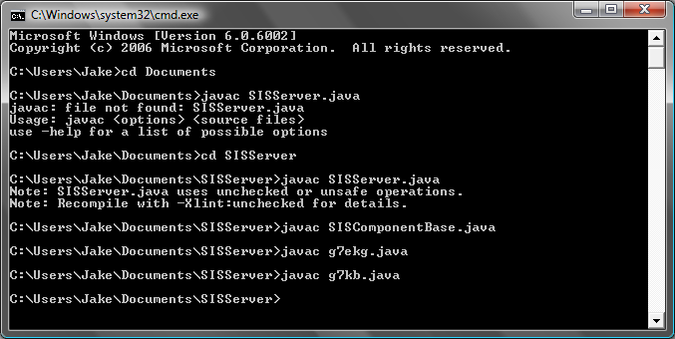
Once these files are compile you will first want to run the SIS Server.
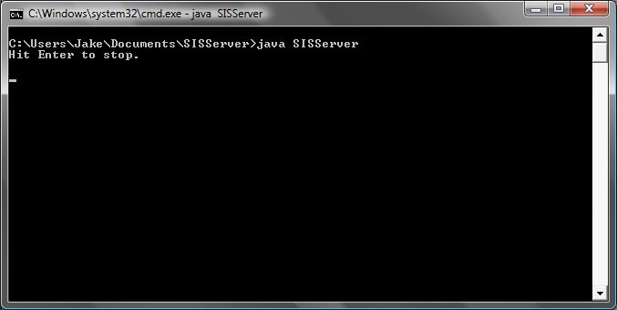
You will then want to open the Virtual Remote
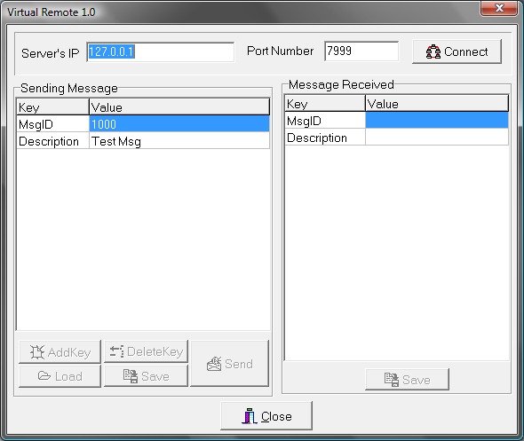
Then connect. You are connected when the Addkey DeleteKey Load and Save become available. Use the server IP 127.0.0.1 and port number 7999.
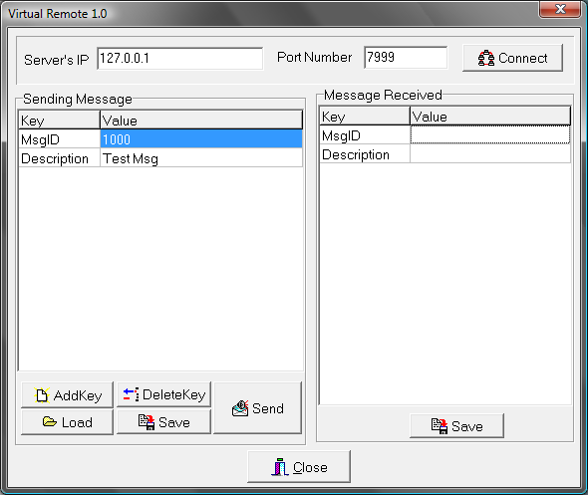

When then want to load messages to initlize our components. For us the two messages we want to load and send to the server are the EKG module intilizer and Knowledge Base Initializer.
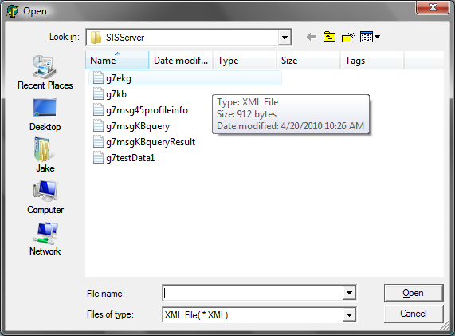
Press send twice on both files so you can make sure the SIS server has a definition of the component. As seen below it says that it has a definition of both because I sent them.
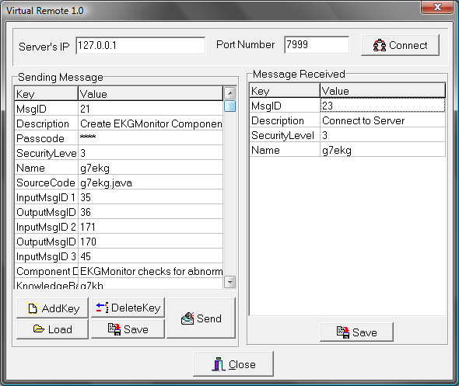
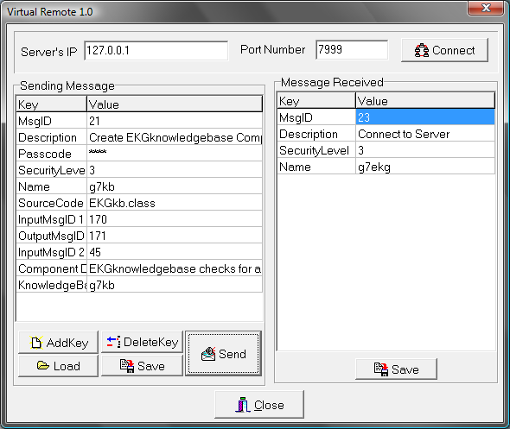
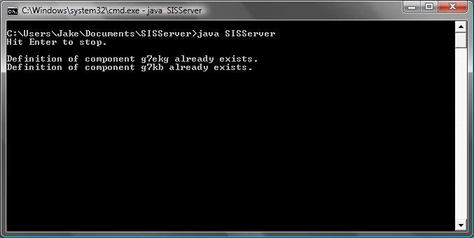
We then want to run/initlize the ekg module using the server IP 127.0.0.1
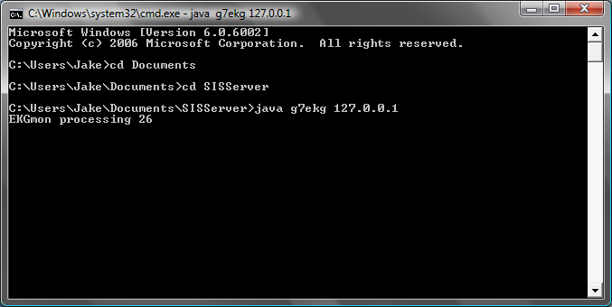
You can see in the remote that the message was received in the message reception pane.

We also do the same with the knowledge base
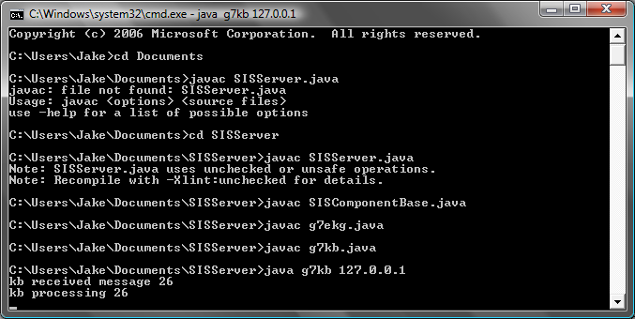
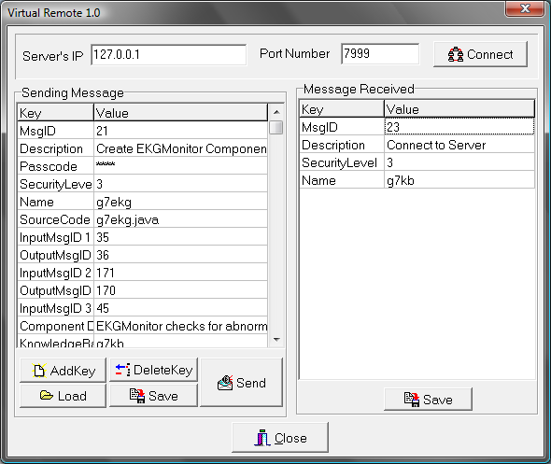

We can then load the a user profile and send that message
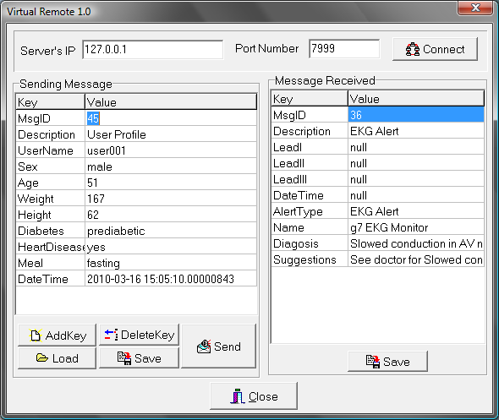
Once a profile is loaded we can load a knowledge base query message to test the knowledge base. When this is sent it will show a return from the knowledge base in the message received.
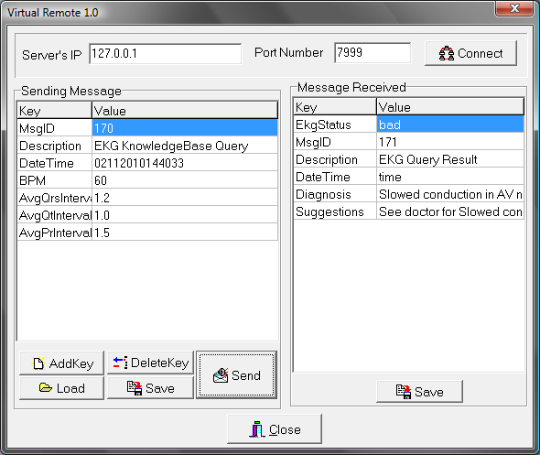

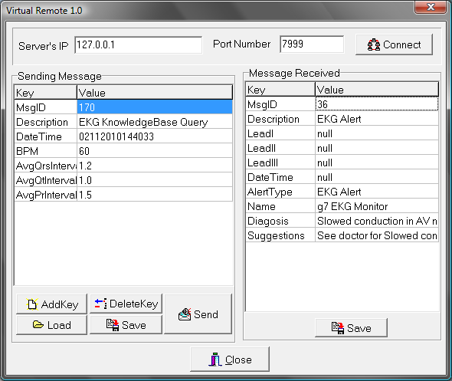
When sending the messages the knowledge base and and ekg module should show they are processing them
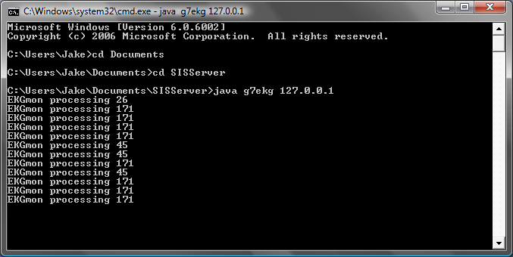

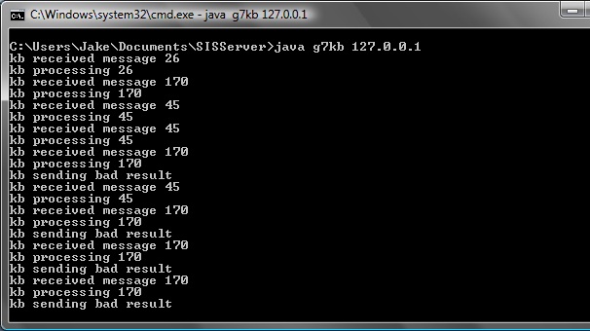

We can then test the functionality of the entire module but loading a test file. The test file holds reading from the three leads. When it is sent, the remote shows the results. First showing the results, then returning a diagnosis.
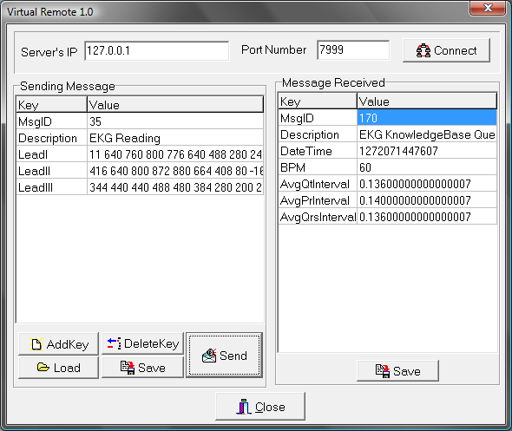
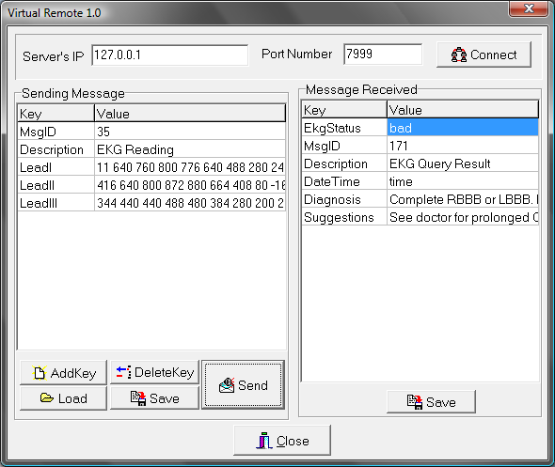abd t

An EKG alert is then received.

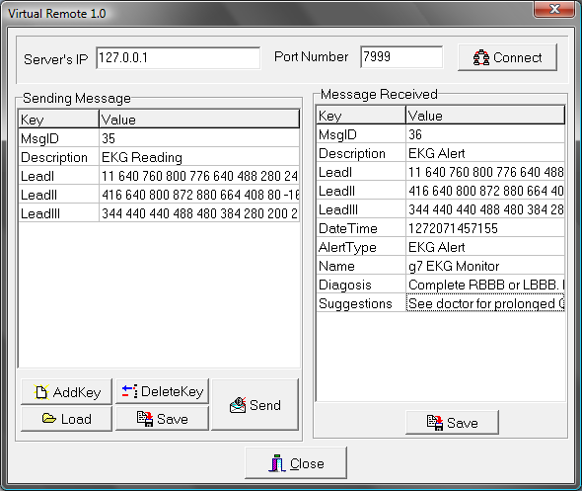
This concludes the functionality of the EKG Module.

7. RESEARCH DOCUMENTATION
The information shown below is a compiled research document summarizing information about electrocardiogram for Group 7’s EKG module.

What is EKG?
- An electrocardiogram (EKG or ECG) is a device which graphically records the electrical activity of the muscles of the heart. It is used to identify normal and abnormal heartbeats.
- The function of the EKG machine depends on the ability of the heart to produce electrical signals. The heart is composed of four chambers which make up two pumps. The right pump receives the blood returning from the body and pumps it to the lungs. The left pump gets blood from the lungs and pumps it out to the rest of the body.
- When an electrical potential is generated in a section of the heart, an electrical current is conducted to the body surface in a specific area. Electrodes attached the body in these areas enable the measurement of these currents.

What waves are produced?
- Each time the heart beats, it produces three distinct EKG waves.
- The first pulse that is seen is called the P wave.
- The second pulse is the largest signal and is called the QRS complex
- The third is the T wave.

What does each Wave mean?
- The T Wave signifies the relaxing, or repolarization of the ventricles.
- The QRS complex the initial downward deflection is termed a Q wave; the initial upward deflection, an R wave; and the downward deflection following the R wave, an S wave. Also known as ventricular depolarization complex.
- The P wave

What do the Values tell us?
- One basic determination that can be made with an EKG is the heart rate, which can be determined by measuring the distance between peaks.
- High blood pressure can be determined: in patients with high blood pressure, the amplitude of the QRS complex is significantly increased.
- Damage in the heart can also be observed by a deformation in the Q wave.
- The most useful characteristic of the EKG is its ability to detect and describe arrhythmias, or abnormal heartbeats
- EKGs can be used to observe obstructions in the arteries. This is typically done by looking for a depressed segment between the S and T waves.
- Heart rate: 50 to 100 beats per minute.
- Rhythm: consistent and even
- What abnormal results mean:
  - Myocardial (cardiac muscle) defect
  - Enlargement of the heart
  - Congenital defects
  - Heart valve disease
  - Arrhythmias (abnormal rhythms)
  - Tachycardia (heart rate too fast) or bradycardia (too slow)
  - Ectopic heartbeat
  - Coronary artery disease
  - Inflammation of the heart (myocarditis)
  - Changes in the amount of electrolytes (chemicals in the blood)
  - Past heart attack
  - Present or impending heart attack

Reading EKG Data…
- http://www.rnceus.com/ekg/ekghowto.html shows how to read an ekg page
- The next website is quite interesting. It is about DIY ecg that people made, yet there readings are all being analyzed by a sound card? Hmm,,, Not sure if this works for our model, but definitely worth taking a look. http://www.neozap.com/ECG3.htm
- Information on a EKG DB interface from MIT, not sure what all the explanations mean though. http://www.physionet.org/physiotools/old/dbpg/dbu_1.htm
- In my opinion this is the best explanation of reading EKG data. http://www.ecglibrary.com/norm.html
- After looking around, it seems that we will need to know the format of the binary data we are receiving and from this we can define the waves.
In electrocardiography, the word lead may refer to either the electrodes attached to the patient, or, properly, (in which case, it is pronounced /lid/) to the voltage between two electrodes.

Placement of electrodes
- Ten electrodes are used for a 12-lead ECG. They are labeled and placed on the patient's body as follows
- Patients who have cardiac, pulmonary, or electrolyte problems or who undergo surgery may need continuous cardiac monitoring to screen for arrhythmias. Unlike a 12-lead electrocardiogram (ECG), which views the heart from 12 angles, a 3- or 5-- lead ECG views it from one to three angles.
- With 3 leads, you get a choice of three views (but no anterior view unless you move the electrodes).
- Choices for leads I,II,III
- Lead I is the voltage between the (positive) left arm (LA) electrode and right arm (RA) electrode. Placement: LA (left arm), just below the left clavicle
- Lead II is the voltage between the (positive) left leg (LL) electrode and the right arm (RA) electrode. Placement: RA (right arm), just below the right clavicle
- Lead III is the voltage between the (positive) left leg (LL) electrode and the left arm (LA) electrode. Placement: LL (left leg), on the lower chest, just above and left of the umbilicus

Duration to capture each type of wave
Feature | Description | Duration
P wave | During normal atrial depolarization, the main electrical vector is directed from the SA node towards the AV node, and spreads from the right atrium to the left atrium. This turns into the P wave on the ECG. | 80ms
PR segment | The PR segment connects the P wave and the QRS complex. This coincides with the electrical conduction from the AV node to the bundle of His to the bundle branches and then to the Purkinje Fibers. This electrical activity does not produce a contraction directly and is merely traveling down towards the ventricles and this shows up flat on the ECG. | 50 to 120ms
QRS complex | The QRS complex is a recording of a single heartbeat on the ECG that corresponds to the depolarization of the right and left ventricles. | 70 to 110ms
ST segment | The ST segment connects the QRS complex and the T wave. The ST segment represents the period when the ventricles are depolarized. It is isoelectric. | 80 to 120ms
T wave | The T wave represents the repolarization (or recovery) of the ventricles. The interval from the beginning of the QRS complex to the apex of the T wave is referred to as the absolute refractory period. The last half of the T wave is referred to as the relative refractory period (or vulnerable period). | 160ms
PR interval | The PR interval is measured from the beginning of the P wave to the beginning of the QRS complex. The PR interval reflects the time the electrical impulse takes to travel from the sinus node through the AV node and entering the ventricles. The PR interval is therefore a good estimate of AV node function. | 120 to 200ms
ST interval | The ST interval is measured from the J point to the end of the T wave. | 320ms
QT interval | The QT interval is measured from the beginning of the QRS complex to the end of the T wave. A prolonged QT interval is a risk factor for ventricular tachyarrhythmias and sudden death. | 300 to 430ms
U wave | The U wave is not always seen. It is typically low amplitude, and, by definition, follows the T wave.

http://library.med.utah.edu/kw/ecg/ecg_outline/Lesson3/index.html.

This is the best I could do to consolidate to something usable. There are so many options out there and configurations. I feel we are going to get a reading in binary, than have some struct that defines what the readings mean specifically.

8. Conclusion

This project has been very interesting. Not only has our knowledge of a specific application of programming expanded, but also on component bases software engineering. The use of multiple modules and integrating them into one full functionally piece of software was very fascinating. The EKG module in specific held many challenges. Learning how to get a reading from each lead took a lot of work. Also the analyzation and diagnosis of readings took a vast range of research in order to capture specifically what we were looking for. The lessons learned from this project gave us the foundation to build upon in our future in devours in software development/management.

