Group 6 Final Project Report
CS1631
Professor S. K. Chang
Spring 2010

Project subject:
Blood Sugar Monitor

Group members:
Luke Weng (luw4@pitt.edu), Bin Gao (big5@pitt.edu)

Contents
UML 3
Revision History 3/16/10 5
Software Plan 6
Knowledge Base Ontology 13
Revision History 3/18/10 16
Scenarios and MsgIDs: 17
XML (original) 19
Revision History 4/8/10 26
XML (updated) 27
Revision History 4/23/10 30
Manual 31
Source Code 38
Revision History 4/30/10 65
XML (updated v2) 66
Source Code v2 67

UML
Use Case Diagram
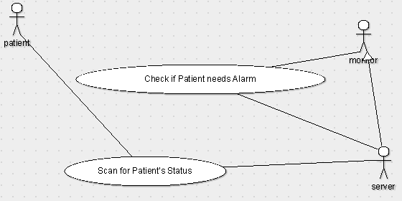
Class Diagram
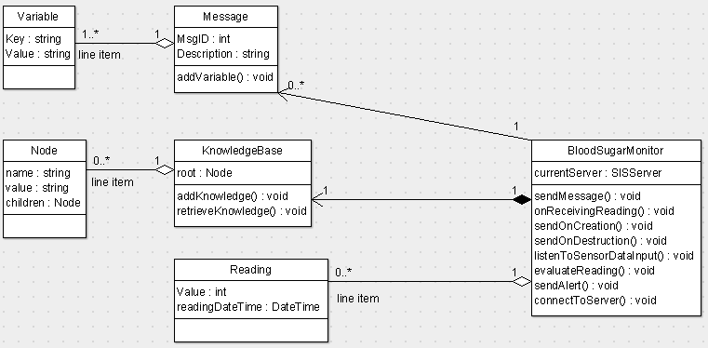

State Diagram
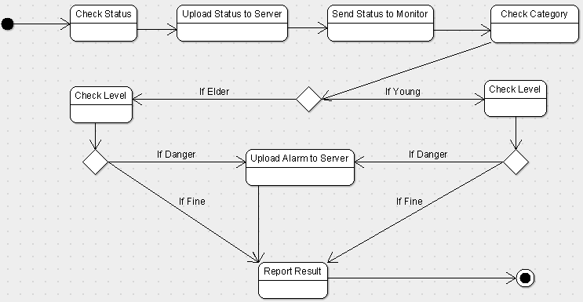
Collaboration Diagram
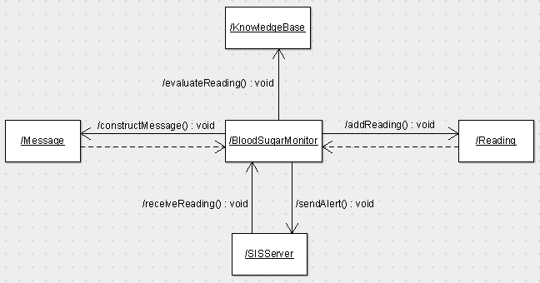

Revision History 3/16/10

Sections Modified: (none)

New Sections Added:
Software Plan 1.0 – 8.0 by Luke Weng
- Scope
- Tasks
- Resources
- Cost
- Schedule
- Implementation Priorities
- Foreseeable Modifications and Enhancements
- Acceptance Criteria
Knowledge Base by Bin Gao
Revision History by Luke Weng

Software Plan
Group 6: Luke Weng, Bin Gao
CS1631 Spring 2009
Document Version 1.0 – Tuesday, March 16, 2010

- Scope

The Software is a component that provides functions that are needed to provide important health information from patients to hospitals. The software module will receive critical information such as blood pressure through the heath monitor. Then the software sends patients’ information to the server and check against the knowledge base for a boundary. If the information exceeds the boundary, the software will send an alert to the hospital regarding to the patient’s critical status.

  - Functions

    - recieveStatus

Retrieve the health status from a patient through the health monitor.

    - sendStatus

Send the new status of the patient to the server to check between appropriate levels.

    - checkStatus

Check patient’s blood pressure level. According to its age, high level will send the critical information alert to the hospital, otherwise return a status update message indicating the patient is in fine state.

    - sendAlarm

Once the boundary value is checked and confirmed that the patient is in critical state, the server will send an alarm indicating patient’s status to the hospital.

    - displayStatus

After checking the blood pressure, the software returns a message to the patient, whether the patient is healthy or in danger.

  - Performance

Performance is not expected to be an issue. The messages are all XML based, which are compact and easily parsed.

  - Limitations

The software will make use of text files in order to store and retrieve status messages. The software yet will not handle anything other than blood pressure level.
- Tasks

  - Review project plan with instructors and obtain design review input.

  - Determine how to access the database in order to save and retrieve information.

  - Specify messages to the module component. Review new messages being created by other groups (if any).

    - Develop preliminary design implementation.

  - Test the interface between the software and the remote control.

  - Finalize the design and implementation and test with the universal interface.

  - Update all design documentation, including UML diagrams to reflect final software implementation.

  - Demonstrate the software and how it works. Combine all documents and source code and create a final report.

- Resources

  - Hardware

The software will be designed and tested on a machine with x86 processor architecture. An internet connection will be required to test in a deployed scenario.

  - Software

The Consultant Agent will be written in java using the latest JDK available. Currently it is JDK 6 Update 12.

  - People

Luke Weng and Bin Gao will be teaming up using extreme programming (XP) techniques to complete the design and implementation.

- Cost

  - Based on the tasks listed in section 2.0 it is estimated that it will take 50 man hours (2 people x 25 hrs) to complete the project.
LOC Cost Table:
Function | Optimistic | Most | Pessimistic | Expected | Deviation
Database | 300 | 400 | 550 | 400 | 40
Interface | 150 | 200 | 350 | 210 | 30
Networking | 250 | 300 | 450 | 310 | 30
Application | 450 | 600 | 900 | 620 | 70
Expected LOC = | 1540
Deviation = | 170
68% range = | 1370 | to | 1710
99% range = | 520 | to | 2560
($/LOC) = | $15
Cost = | $23,100
Labor Cost/Task:
Function | Requirements | Design | Coding | Test | Subtotal
Database | 2.5 | 4.5 | 4.0 | 3.5 | 14.5
Interface | 2.0 | 4.0 | 3.0 | 2.5 | 11.5
Networking | 1.5 | 3.0 | 4.0 | 2.0 | 10.5
Application | 3.0 | 5.5 | 5.0 | 4.5 | 18.0
Total
(man-weeks) | 9.0 | 17.0 | 16.0 | 12.5 | 54.5
Rate
($/man-weeks) | $150 | $400 | $350 | $300
Cost | $1,350 | $6,800 | $5,600 | $3,750 | $17,500
Avg. Cost (Estimated Cost) = |  | $20,300

- Schedule

Task | Effort | Start Date | End Date
Review Project Plan & Obtain Design Input | 2 hrs | Fri March 19 | Fri March 19
Investigate Database Access Mechanisms | 2 hrs | Fri March 19 | Fri March 19
Milestone 1 – Specify Messages | 4 hrs | Thr March 23 | Fri March 19
Preliminary Implementation | 5 hrs | Thr March 23 | Thr March 25
Informal Test with Remote Control | 5 hrs | Fri March 19 | Thr March 25
Milestone 2 (Formal Test with Remote) | 1 hr | Tue March 31 | Tue March 31
Finalize Design & Update Documentation | 5 hrs | Thr Apr 2 | Tue Apr 14
Demo | 1 hr | Tue Apr 14 | Tue Apr 14

6.0 Implementation Priorities
Due to time and personal constraints we will first implement these core functions and features:
- We will implement all the necessary functions with regards to the database including the following:
- checkStatus
- sendAlarm
- displayStatus
We plan for the final project to have all of the functions and features listed on this list implemented. However should we be unable to reach this goal we will at minimum have the first set of functions and features implemented.

7.0 Foreseeable Modifications and Enhancements
All projects general requirements that cannot be implements in the time allotted. Rather than reject good requirement, they are listed here for use in the next generation of the product.
- Other health information besides blood pressure.
- Include more boundaries than just age.
- Add a forum system for technical support.

8.0 Acceptance Criteria
This section describes the conditions under which the final product will be deemed acceptable by the stakeholders. The following will be put into consideration.
- Interface
- Data Transmission
- Information database

Knowledge Base Ontology
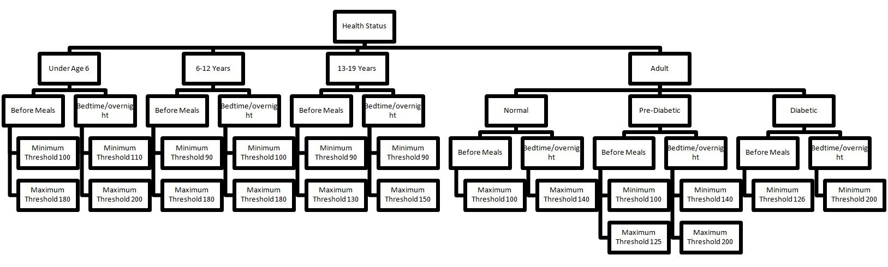
Table 1 Courtesy of UCSF Children's Hospital
Values by age (years) | Before Meals | Bedtime/overnight
Toddlers and preschoolers (under age 6) | 100-180mg/dl | 110-200mg/dl
School age (6-12 years) | 90-180mg/dl | 100-180mg/dl
Adolescents and young adults (13-19 years) | 90-130mg/dl | 90-150mg/dl
Reference: http://www.collectivewizdom.com/NormalFastingBloodSugar.html
Table 2 Courtesy of Susan M. Callahan and the Journal of Clinical Endocrinology and Metabolism
Time of Day | Normal | Pre-Diabetic | Diabetic
Before Meals | Below 100 | 100-125 | 126 and more
Bedtime/overnight | Below 140 | 140-200 | 200 and more
Reference: http://www.ucsfchildrenshospital.org/education/tips_for_checking_blood_sugar/

Use Case Diagram
Class Diagram

State Diagram
Collaboration Diagram

Revision History 3/18/10

Sections Modified: (none)

New Sections Added:
Source code by Bin Gao
Messages by Bin Gao
20, 22, 23, 24, 25, 26, 41, 42, 160, 161, 162

Message XMLs by Luke Weng
20, 22, 23, 24, 25, 26, 41, 42, 160, 161, 162

Scenarios by Bin Gao, edited by Luke Weng
1, 2
Revision History by Luke Weng

Scenarios and MsgIDs:
Scenario 1: Component Handling
- The "Create Component" message (Msg ID 20) brings life to the BloodSugarMonitor.
- BloodSugarMonitor sends a "Connect to Server" message (Msg ID 23) to the SISserver.
- SISserver returns an Ack message (Msg ID 26) to the said component.
- The "Activate Component" message (Msg ID 24) and "Deactivate Component" message (Msg ID 25) activates or deactivates BloodSugarMonitor component.
- The "Kill Component" message (Msg ID 22) destroys the component.
MsgID:20 | Description: Create BloodSugarMonitor Component
Variables:
- Passcode: ****
- SecurityLevel: 3
- Name: BloodSugarMonitor (Name of created Component)
- SourceCode: BSM.jar (Source code file name of created Component)
- InputMsgID 1: 41 (Blood Sugar Reading)
- InputMsgID 2: 160 (Age Group)
- InputMsgID 3: 161 (Precondition)
- InputMsgID 4: 162 (Reading Type)
- OutputMsgID 1: 42 (Blood Sugar Alert)
- Component Description: BloodSugarMonitor checks for abnormality.
MsgID:23 |  | Description: Connect to server (BloodSugarMonitor requests to be connected to Server)
Variables:
- Passcode: **** (Passcode of Administrator)
- SecurityLevel: 3 (Security Level of Administrator)
- Name: BloodSugarMonitor (Name of Component to be connected to server)
MsgID:26 |  | Description: Acknowledgement (Server acknowledges that BloodSugarMonitor is now connected to Server)
Variables:
- AckMsgID: 23 (This is Ack for MsgID)
- YesNo: Yes (Yes/No for positive/negative Ack)
- Name: BloodSugarMonitor (Name of involved Component)
MsgID:24 |  | Description: Activate Component
Variables:
- Passcode: **** (Passcode of Administrator)
- SecurityLevel: 3 (Security Level of Administrator)
- Name: BloodSugarMonitor (Name of activated Component)
- SourceCode: BSM.jar (Source code file name of activated Component)
MsgID:25 |  | Description: DeActivate Component
Variables:
- Passcode: **** (Passcode of Administrator)
- SecurityLevel: 3 (Security Level of Administrator)
- Name: BloodSugarMonitor (Name of deactivated Component)
- SourceCode: BSM.jar (Source code file name of activated Component)
MsgID:22 |  | Description: Kill Component
Variables:
- Passcode: **** (Passcode of Administrator)
- SecurityLevel: 3 (Security Level of Administrator)
- Name: BloodSugarMonitor (Name of killed Component)
- SourceCode: BSM.jar (Source code file name of killed Component)
Scenario 2: Abnormality Handling
- InputProcessor sends a combination of Msg 160 (Age Group), Msg 161 (Precondition), Msg 162 (Reading Type) and Msg 41 (blood sugar reading) to BloodSugarMonitor.
- Checks for abnormality. (BloodSugarMonitor accepts Msg 41, Msg 160, Msg 161, Msg 162 and produces Msg 42, the combination of messages always ends with Msg 41 and is preceded by any of Msg 160, Msg 161 and Msg162)
- If abnormal, BloodSugarMonitor sends Msg 42 (blood sugar alert) to GUI, which displays the vital signals.
- If abnormal, BloodSugarMonitor sends Msg 42 (blood sugar alert) to Uploader, which uploads patients’ medical condition to remote database.
MsgID:41 | Description: Blood Sugar Reading
Variables:
- Blood Sugar: 143 (blood sugar data stream)
- DateTime: Sat Feb 27 18:10:20 EST 2010 (time stamp)
MsgID:42 | Description: Blood Sugar Alert
Variables:
- Blood Sugar: 143 (blood sugar data stream)
- Alert Type: Blood Sugar Alert (blood sugar alert type)
- DateTime: Sat Feb 27 18:10:20 EST 2010 (time stamp)
MsgID:160 | Description: Age Group
Variables:
- Year: 18 (age group data stream)
- DateTime: Sat Feb 27 18:10:20 EST 2010 (time stamp)
MsgID:161 | Description: Precondition
Variables:
- Precondition Type: Normal (precondition data stream)
- DateTime: Sat Feb 27 18:10:20 EST 2010 (time stamp)
MsgID:162 | Description: Reading Type
Variables:
- Reading Type: Before Meals (reading type data stream)
- DateTime: Sat Feb 27 18:10:20 EST 2010 (time stamp)

XML (original)

Msg20.XML
<?xml version="1.0" standalone="yes" ?>
- <Msg>
- <Head>
<MsgID>20</MsgID>
<Description>Create BloodSugarMonitor Component</Description>
</Head>
- <Body>
- <Item>
<Key>Passcode</Key>
<Value>****</Value>
</Item>
- <Item>
<Key>SecurityLevel</Key>
<Value>3</Value>
</Item>
- <Item>
<Key>Name</Key>
<Value>BloodSugarMonitor</Value>
</Item>
- <Item>
<Key>SourceCode</Key>
<Value>BSM.jar</Value>
</Item>
- <Item>
<Key>InputMsgID 1</Key>
<Value>41</Value>
</Item>
<Item>
<Key>InputMsgID 2</Key>
<Value>160</Value>
</Item>
<Item>
<Key>InputMsgID 3</Key>
<Value>161</Value>
</Item>
<Item>
<Key>InputMsgID 4</Key>
<Value>162</Value>
</Item>
- <Item>
<Key>OutputMsgID 1</Key>
<Value>42</Value>
</Item>
- <Item>
<Key>Component Description</Key>
<Value> BloodSugarMonitor checks for abnormality. </Value>
</Item>
</Body>
</Msg>

Msg23.XML
<?xml version="1.0" standalone="yes" ?>
- <Msg>
- <Head>
<MsgID>23</MsgID>
<Description>Connect to Server (BloodSugarMonitor requests to be connected to Server)</Description>
</Head>
- <Body>
- <Item>
<Key>Passcode</Key>
<Value>****</Value>
</Item>
- <Item>
<Key>SecurityLevel</Key>
<Value>3</Value>
</Item>
- <Item>
<Key>Name</Key>
<Value>BloodSugarMonitor</Value>
</Item>
</Body>
</Msg>

Msg26.XML
<?xml version="1.0" standalone="yes" ?>
- <Msg>
- <Head>
<MsgID>26</MsgID>
<Description>Acknowledgement (Server acknowledges that BloodSugarMonitor is now connected to Server)</Description>
</Head>
- <Body>
- <Item>
<Key>AckMsgID</Key>
<Value>23</Value>
</Item>
- <Item>
<Key>YesNo</Key>
<Value>Yes</Value>
</Item>
- <Item>
<Key>Name</Key>
<Value>BloodSugarMonitor</Value>
</Item>
</Body>
</Msg>

Msg24.XML
<?xml version="1.0" standalone="yes" ?>
- <Msg>
- <Head>
<MsgID>24</MsgID>
<Description>Activate Component</Description>
</Head>
- <Body>
- <Item>
<Key>Passcode</Key>
<Value>****</Value>
</Item>
- <Item>
<Key>SecurityLevel</Key>
<Value>3</Value>
</Item>
- <Item>
<Key>Name</Key>
<Value>BloodSugarMonitor</Value>
</Item>
- <Item>
<Key>SourceCode</Key>
<Value>BSM.jar</Value>
</Item>
</Body>
</Msg>

Msg25.XML
<?xml version="1.0" standalone="yes" ?>
- <Msg>
- <Head>
<MsgID>25</MsgID>
<Description>DeActivate Component</Description>
</Head>
- <Body>
- <Item>
<Key>Passcode</Key>
<Value>****</Value>
</Item>
- <Item>
<Key>SecurityLevel</Key>
<Value>3</Value>
</Item>
- <Item>
<Key>Name</Key>
<Value>BloodSugarMonitor</Value>
</Item>
- <Item>
<Key>SourceCode</Key>
<Value>BSM.jar</Value>
</Item>
</Body>
</Msg>

Msg22.XML
<?xml version="1.0" standalone="yes" ?>
- <Msg>
- <Head>
<MsgID>22</MsgID>
<Description>Kill Component</Description>
</Head>
- <Body>
- <Item>
<Key>Passcode</Key>
<Value>****</Value>
</Item>
- <Item>
<Key>SecurityLevel</Key>
<Value>3</Value>
</Item>
- <Item>
<Key>Name</Key>
<Value>BloodSugarMonitor</Value>
</Item>
- <Item>
<Key>SourceCode</Key>
<Value>BSM.jar</Value>
</Item>
</Body>
</Msg>

Msg41.XML
<?xml version="1.0" standalone="yes" ?>
- <Msg>
- <Head>
<MsgID>41</MsgID>
<Description>Blood Sugar Reading</Description>
</Head>
- <Body>
- <Item>
<Key>Blood Sugar</Key>
<Value>143</Value>
</Item>
- <Item>
<Key>DateTime</Key>
<Value>Sat Feb 27 18:10:20 EST 2010</Value>
</Item>
</Body>
</Msg>

Msg42.XML
<?xml version="1.0" standalone="yes" ?>
- <Msg>
- <Head>
<MsgID>42</MsgID>
<Description>Blood Sugar Alert</Description>
</Head>
- <Body>
- <Item>
<Key>Blood Sugar</Key>
<Value>143</Value>
</Item>
- <Item>
<Key>Alert Type</Key>
<Value>Blood Sugar Alert</Value>
</Item>
- <Item>
<Key>DateTime</Key>
<Value>Sat Feb 27 18:10:20 EST 2010</Value>
</Item>
</Body>
</Msg>

Msg160.XML
<?xml version="1.0" standalone="yes" ?>
- <Msg>
- <Head>
<MsgID>160</MsgID>
<Description>Age Group</Description>
</Head>
- <Body>
- <Item>
<Key>Year</Key>
<Value>18</Value>
</Item>
- <Item>
<Key>DateTime</Key>
<Value>Sat Feb 27 18:10:20 EST 2010</Value>
</Item>
</Body>
</Msg>

Msg161.XML
<?xml version="1.0" standalone="yes" ?>
- <Msg>
- <Head>
<MsgID>161</MsgID>
<Description>Precondition</Description>
</Head>
- <Body>
- <Item>
<Key>Type</Key>
<Value>Normal</Value>
</Item>
- <Item>
<Key>DateTime</Key>
<Value>Sat Feb 27 18:10:20 EST 2010</Value>
</Item>
</Body>
</Msg>

Msg162.XML
<?xml version="1.0" standalone="yes" ?>
- <Msg>
- <Head>
<MsgID>162</MsgID>
<Description>Reading Type</Description>
</Head>
- <Body>
- <Item>
<Key>Type</Key>
<Value>Before Meals</Value>
</Item>
- <Item>
<Key>DateTime</Key>
<Value>Sat Feb 27 18:10:20 EST 2010</Value>
</Item>
</Body>
</Msg>

Revision History 4/8/10

Sections Modified:
Source code by Bin Gao
Support new and modified messages and XML files
Refine the coarse grained business component, the monitor component with the associated knowledge base component, to two separate fine grained components. The monitor component talks to the blood sugar reading message, and the knowledge base component talks to the user profile message. The two components communicate with each other with the new thresholds message.
Messages by Bin Gao
g6bloodsugar, g6bloodsugarconnect, g6kbconnect, g6reading, g6alert
Message XMLs by Luke Weng
g6bloodsugar.xml, g6bloodsugarconnect.xml, g6kbconnect.xml, g6reading.xml, g6alert.xml
Switched all xml filenames from message ID to message content

New Sections Added:
Messages by Bin Gao
g6kb, g6userprofile, g6thresholds
Message XMLs by Luke Weng
g6kb.xml, g6userprofile.xml, g6thresholds.xml
Created numerous g6reading.xml and g6userprofile.xml examples

Blood Sugar Monitor ReadMe by Luke Weng

Revision History by Luke Weng edited by Bin Gao

XML (updated)
g6bloodsugar.XML
MsgID:20 | Description: Create g6bloodsugar Component
Variables:
- Passcode: ****
- SecurityLevel: 3
- Name: g6bloodsugar (Name of created Component)
- SourceCode: g6bloodsugar.java (Source code file name of created Component)
- InputMsgID 1: 41 (Blood Sugar Reading)
- InputMsgID 2: 160 (Thresholds)
- InputMsgID 3: 161 (Precondition)
- InputMsgID 4: 162 (Reading Type)
- OutputMsgID 1: 42 (Blood Sugar Alert)
- Component Description: g6bloodsugar checks for abnormality.
g6kb.XML
MsgID:21 | Description: Create g6kb Component
Variables:
- Passcode: ****
- SecurityLevel: 3
- Name: g6kb (Name of created Component)
- SourceCode: g6kb.java (Source code file name of created Component)
- InputMsgID 1: 45 (User Profile)
- OutputMsgID 1: 160 (Blood Sugar Thresholds)
- Component Description: g6kb generates thresholds.
- KnowledgeBase: g6bloodsugarkb.XML
g6bloodsugarconnect.XML

MsgID:23 |  | Description: Connect to server (g6bloodsugar requests to be connected to Server)
Variables:
- Passcode: **** (Passcode of Administrator)
- SecurityLevel: 3 (Security Level of Administrator)
- Name: g6bloodsugar (Name of Component to be connected to server)
g6kbconnect.XML
MsgID:23 |  | Description: Connect to server (g6kb requests to be connected to Server)
Variables:
- Passcode: **** (Passcode of Administrator)
- SecurityLevel: 3 (Security Level of Administrator)
- Name: g6kb (Name of Component to be connected to server)
MsgID:26 |  | Description: Acknowledgement (Server acknowledges that BloodSugarMonitor is now connected to Server)
Variables:
- AckMsgID: 23 (This is Ack for MsgID)
- YesNo: Yes (Yes/No for positive/negative Ack)
- Name: BloodSugarMonitor (Name of involved Component)
MsgID:24 |  | Description: Activate Component
Variables:
- Passcode: **** (Passcode of Administrator)
- SecurityLevel: 3 (Security Level of Administrator)
- Name: BloodSugarMonitor (Name of activated Component)
- SourceCode: BSM.jar (Source code file name of activated Component)
MsgID:25 |  | Description: DeActivate Component
Variables:
- Passcode: **** (Passcode of Administrator)
- SecurityLevel: 3 (Security Level of Administrator)
- Name: BloodSugarMonitor (Name of deactivated Component)
- SourceCode: BSM.jar (Source code file name of activated Component)
MsgID:22 |  | Description: Kill Component
Variables:
- Passcode: **** (Passcode of Administrator)
- SecurityLevel: 3 (Security Level of Administrator)
- Name: BloodSugarMonitor (Name of killed Component)
- SourceCode: BSM.jar (Source code file name of killed Component)
g6reading.XML
MsgID:41 |  |  | Description: Blood Sugar Reading | Example:Msg41.XML
Variables:
- Blood Sugar: 143 (blood sugar data stream)
- DateTime: Sat Feb 27 18:10:20 EST 2010 (time stamp)
g6alert.XML
MsgID:42 |  |  | Description: Blood Sugar Alert | Example:Msg42.XML
Variables:
- Blood Sugar: 143 (blood sugar data stream)
- Alert Type: Blood Sugar Alert (blood sugar alert type)
- Diagnosis: high risk
- Suggestions: see doctor immediately
- Name: g6bloodsugar
- DateTime: Sat Feb 27 18:10:20 EST 2010 (time stamp)
g6userprofile.XML
MsgID:45 | Description: User Profile
Variables:
- UserName: user001 (user's name such as "user001")
- Sex: male ("male" or "female")
- Age: 51 (age in years such as "51")
- Weight: 167 (weight in pounds such as "167")
- Height: 62 (height in inches such as "62")
- Diabetes: prediabetic ("normal", "prediabetic" or "diabetic")
- Heart Disease: yes ("yes" or "no")
- Meal: fasting ("fasting" or "after")
- DateTime: 2010-03-16 15:05:10.00000843 (time stamp)
g6thresholds.XML

 | MsgID:160 | Description: Thresholds
 | Variables:
- Minimum: 0
- Maximum: 140
- hasMinimum: false
- hasMaximum: true

Revision History 4/23/10

Sections Modified:
Source code by Bin Gao
Merged XML files and Java files to a universal directory

New Sections Added:
Blood Sugar Monitor Manual by Luke Weng edited by Bin Gao
Group 6 Final Project Report by Luke Weng

Revision History by Luke Weng

Manual
- Compile every java file under directory g6bloodsugar, if not compiled. Remember to compile g6bloodsugar.java and g6kb.java last.
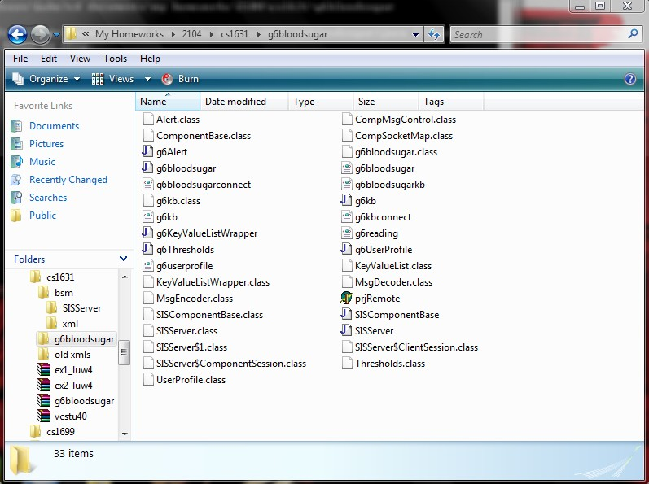
- Run SISServer, allow it to stay on.
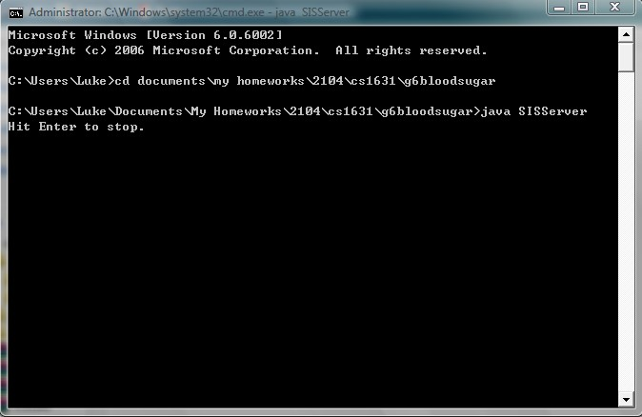
- Run Remote Control, put IP 127.0.0.1, and hit Connect.
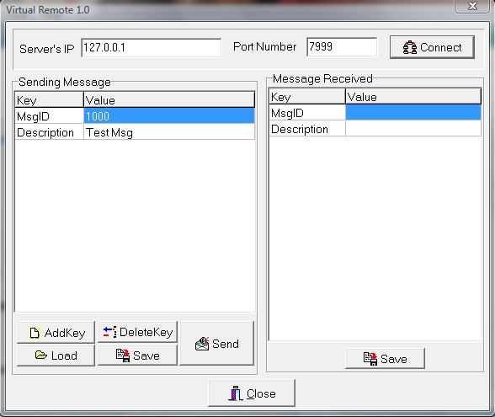

- Load and send each XML file g6bloodsugar.xml and g6kb.xml under directory the same directory.
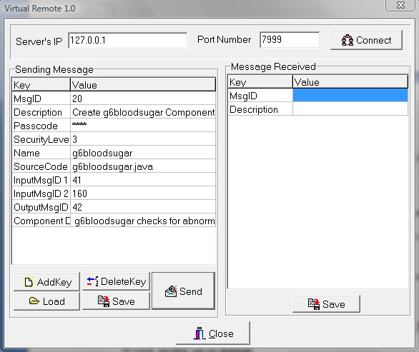
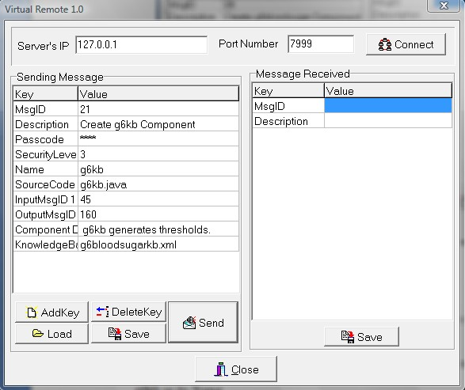
- On a separate console, run: java g6bloodsugar 127.0.0.1. Allow it to stay on.
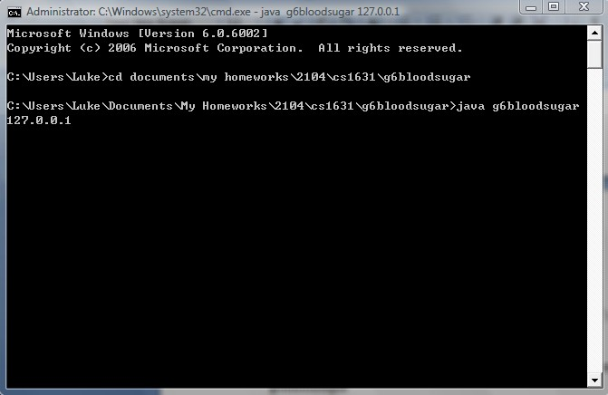
Then the remote should display Msg23 Connect to server, Name should be g6bloodsugar. 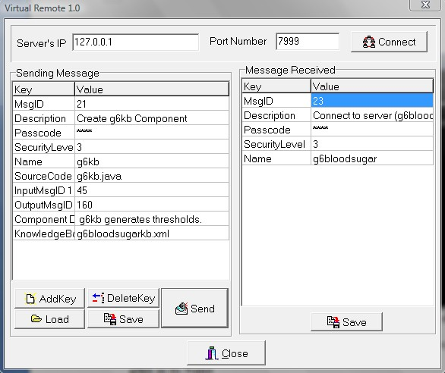
- On another separate console, run g6kb just like above. Then the remote should display g6kb as its Name. 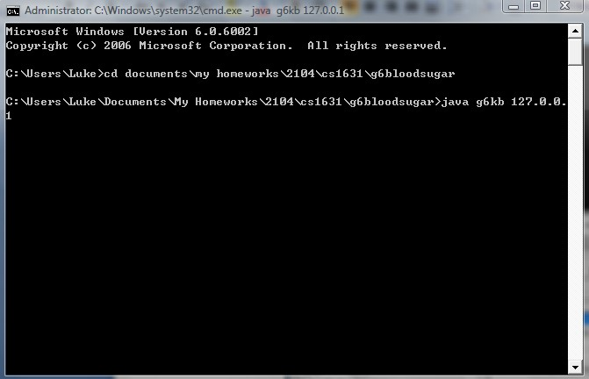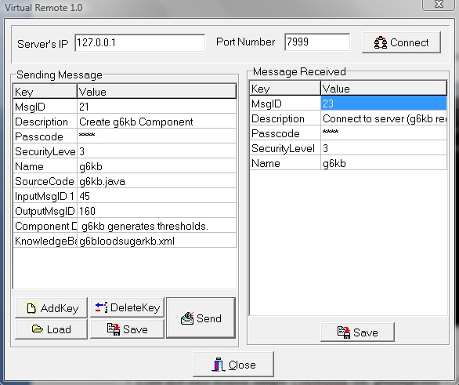

- Load and send desired sample UserProfile (ex. g6userprofile) XML files to the knowledge base component. The knowledge base component will send generated Thresholds message to the monitor component according to its user profile. If void, profile and thresholds set to default.
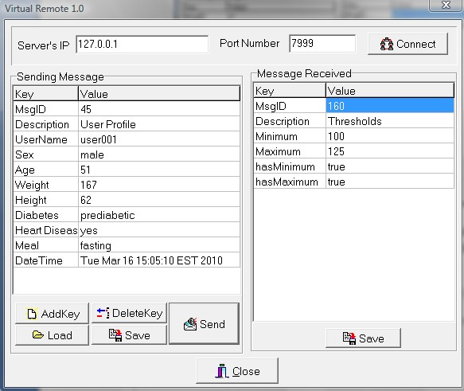
- Load and send desired sample Reading (ex. g6reading) XML files to the monitor component.
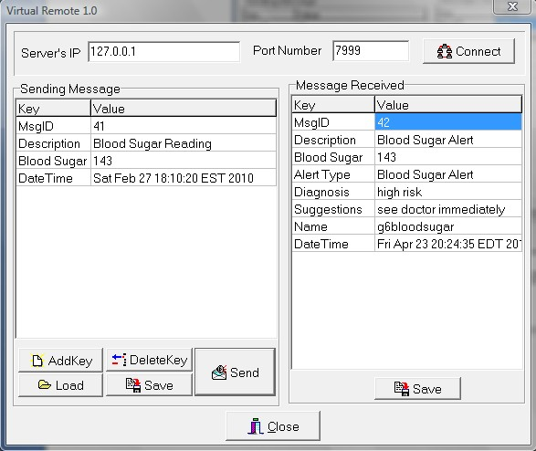
Remote should display whether the subject is at risk, therefore display alert. If not, remote display unchanged. In this case, as example above, the patient’s health is at risk, therefore an alert message appears.

Additional note:
- There could be many different data for user profiles, and so as for different blood sugar readings, the two fine grained components will talks to each other automatically.
- A batch file can also be created for the ease to run g6blooosugar and g6kb with a constant IP address which is 127.0.0.1 as an input argument.

Source Code
g6Alert.java
import java.util.Date;
import java.text.DateFormat;
import java.text.SimpleDateFormat;

class Alert
{
int BloodSugar;
Date DateTime;

public static Alert getFrom(Thresholds theThresholds, int theBloodSugar)
{
if (theThresholds.hasMinimum&&theBloodSugar<theThresholds.Minimum)
{
return new Alert(theBloodSugar);
}

if (theThresholds.hasMaximum&&theBloodSugar>theThresholds.Maximum)
{
return new Alert(theBloodSugar);
}

return null;
}

public Alert(int BloodSugar)
{
this.BloodSugar = BloodSugar;
this.DateTime = new Date();
}

public KeyValueList toKeyValueList()
{
DateFormat aDateFormat = new SimpleDateFormat("EEE MMM dd HH:mm:ss z yyyy");

KeyValueList aKeyValueList = new KeyValueList();

aKeyValueList.addPair("MsgID", "42");
aKeyValueList.addPair("Description", "Blood Sugar Alert");
aKeyValueList.addPair("Blood Sugar", ""+BloodSugar);
aKeyValueList.addPair("Alert Type", "Blood Sugar Alert");
aKeyValueList.addPair("Diagnosis", "high risk");
aKeyValueList.addPair("Suggestions", "see doctor immediately");
aKeyValueList.addPair("Name", "g6bloodsugar");
aKeyValueList.addPair("DateTime", aDateFormat.format(DateTime));

return aKeyValueList;
}
}

g6bloodsugar.java
import java.net.*;
import java.io.*;

public class g6bloodsugar implements ComponentBase, Runnable
{
private Socket universal;
private MsgEncoder mEncoder;
private MsgDecoder mDecoder;
private boolean active;
private Thresholds itsThresholds;
private int BloodSugar;

g6bloodsugar(String IP)
{
try
{
universal = new Socket(IP, 7999);
mEncoder = new MsgEncoder();
mDecoder = new MsgDecoder(universal.getInputStream());
active = false;
itsThresholds = Thresholds.getDefaultThresholds();
}
catch (Exception e)
{
System.out.println("Exception g6bloodsugar(String IP)");
}
}

public void run()
{
KeyValueList kvInput;
try
{
while (true)
{
kvInput = mDecoder.getMsg();
processMsg(kvInput);
}
}
catch (Exception e)
{
System.out.println("Exception run()");
}
}

synchronized public void processMsg(KeyValueList kvList)
{
int MsgID = Integer.parseInt(kvList.getValue("MsgID"));

if (MsgID==24)
{
active = true;
System.out.println("processMsg 24");

return;
}

if (!active)
{
System.out.println("!active");

return;
}

switch (MsgID)
{
case 25:
active = false;
System.out.println("processMsg 25");
break;
case 160:
itsThresholds = new Thresholds(kvList);
break;
case 41:
BloodSugar = Integer.parseInt(kvList.getValue("Blood Sugar"));
Alert anAlert = Alert.getFrom(itsThresholds, BloodSugar);
if (anAlert!=null)
{
sendAlert(anAlert);
}
break;
}
}

public void sendAlert(Alert theAlert)
{
try
{
mEncoder.sendMsg(theAlert.toKeyValueList(), universal.getOutputStream());
}
catch (Exception e)
{
System.out.println("Exception sendAlert(Alert theAlert)");
}
}

public void sendMessage(String xmlpath)
{
try
{
KeyValueListWrapper aKeyValueListWrapper = new KeyValueListWrapper(xmlpath);
mEncoder.sendMsg(aKeyValueListWrapper, universal.getOutputStream());
}
catch (Exception e)
{
System.out.println("Exception sendMessage(String xmlpath)");
}
}

public boolean waitForAck() throws Exception
{
KeyValueList aKeyValueList = mDecoder.getMsg();
String MsgID = aKeyValueList.getValue("MsgID");
if (MsgID.equals("26"))
{
active = true;

return true;
}
else
{
return false;
}
}

public static void main(String []args) throws Exception
{
/*
try
{
BufferedReader br = new BufferedReader(new InputStreamReader(System.in));
String input = br.readLine();
}
catch (Exception e) {}
*/

g6bloodsugar ag6bloodsugar = new g6bloodsugar(args[0]);
ag6bloodsugar.sendMessage("g6bloodsugarconnect.XML");

if (!ag6bloodsugar.waitForAck())
{
throw new Exception("waitForAck");
}

Thread g6bloodsugarThread = new Thread(ag6bloodsugar);
g6bloodsugarThread.setDaemon(false);
g6bloodsugarThread.start();
}
}

g6KeyValueListWrapper.java
import javax.xml.parsers.*;
import org.w3c.dom.*;
import java.io.*;

class KeyValueListWrapper extends KeyValueList
{
public KeyValueListWrapper(String xmlpath)
{
super();
try
{
DocumentBuilderFactory aDocumentBuilderFactory = DocumentBuilderFactory.newInstance();
DocumentBuilder aDocumentBuilder = aDocumentBuilderFactory.newDocumentBuilder();
Document aDocument = aDocumentBuilder.parse(new File(xmlpath));

Element DocElement = aDocument.getDocumentElement();
NodeList aNodeList;
NodeList KeyNodeList;
NodeList ValueNodeList;

aNodeList = DocElement.getElementsByTagName("MsgID");
addPair("MsgID", aNodeList.item(0).getFirstChild().getNodeValue());
aNodeList = DocElement.getElementsByTagName("Description");
addPair("Description", aNodeList.item(0).getFirstChild().getNodeValue());
aNodeList = DocElement.getElementsByTagName("Item");
for (int i=0;i<aNodeList.getLength();i++)
{
KeyNodeList = ((Element)aNodeList.item(i)).getElementsByTagName("Key");
ValueNodeList = ((Element)aNodeList.item(i)).getElementsByTagName("Value");
addPair(KeyNodeList.item(0).getFirstChild().getNodeValue(), ValueNodeList.item(0).getFirstChild().getNodeValue());
}
}
catch (Exception e)
{
System.out.println("Error");
}
}

public static void main(String []args)
{
KeyValueListWrapper aKeyValueListWrapper = new KeyValueListWrapper("22.xml");
}
}

g6Thresholds.java
import java.util.Date;
import java.text.DateFormat;
import java.text.SimpleDateFormat;

class Thresholds
{
public int Minimum;
public int Maximum;
public boolean hasMinimum;
public boolean hasMaximum;

Thresholds()
{
hasMinimum = false;
hasMaximum = false;
}

Thresholds(KeyValueList kvList)
{
Minimum = Integer.parseInt(kvList.getValue("Minimum"));
Maximum = Integer.parseInt(kvList.getValue("Maximum"));
hasMinimum = Boolean.parseBoolean(kvList.getValue("hasMinimum"));
hasMaximum = Boolean.parseBoolean(kvList.getValue("hasMaximum"));
}

public static Thresholds getDefaultThresholds()
{
Thresholds aThresholds = new Thresholds();

aThresholds.setMaximum(140);

return aThresholds;
}

public void setMinimum(int Value)
{
Minimum = Value;
hasMinimum = true;
}

public void setMaximum(int Value)
{
Maximum = Value;
hasMaximum = true;
}

public KeyValueList toKeyValueList()
{
KeyValueList aKeyValueList = new KeyValueList();

aKeyValueList.addPair("MsgID", "160");
aKeyValueList.addPair("Description", "Thresholds");
aKeyValueList.addPair("Minimum", ""+Minimum);
aKeyValueList.addPair("Maximum", ""+Maximum);
aKeyValueList.addPair("hasMinimum", ""+hasMinimum);
aKeyValueList.addPair("hasMaximum", ""+hasMaximum);

return aKeyValueList;
}

public String toString()
{
return ""+hasMinimum+":"+Minimum+"\t"+hasMaximum+":"+Maximum;
}
}
g6kb.java
import javax.xml.parsers.*;
import org.w3c.dom.*;
import java.io.*;
import java.net.*;

public class g6kb implements ComponentBase, Runnable
{
private Socket universal;
private MsgEncoder mEncoder;
private MsgDecoder mDecoder;
private boolean active;
private Element root;

public g6kb(String IP, String xmlpath)
{
try
{
universal = new Socket(IP, 7999);
mEncoder = new MsgEncoder();
mDecoder = new MsgDecoder(universal.getInputStream());
active = false;

DocumentBuilderFactory aDocumentBuilderFactory = DocumentBuilderFactory.newInstance();
DocumentBuilder aDocumentBuilder = aDocumentBuilderFactory.newDocumentBuilder();
Document aDocument = aDocumentBuilder.parse(new File(xmlpath));
root = aDocument.getDocumentElement();
}
catch (Exception e)
{
System.out.println("Exception g6kb(String IP, String xmlpath)");
}
}

public void run()
{
KeyValueList kvInput;
try
{
while (true)
{
kvInput = mDecoder.getMsg();
processMsg(kvInput);
}
}
catch (Exception e)
{
System.out.println("Exception run()");
}
}

synchronized public void processMsg(KeyValueList kvList)
{
int MsgID = Integer.parseInt(kvList.getValue("MsgID"));

if (MsgID==24)
{
active = true;
System.out.println("processMsg 24");

return;
}

if (!active)
{
System.out.println("!active");

return;
}

switch (MsgID)
{
case 25:
active = false;
System.out.println("processMsg 25");
break;
case 45:
UserProfile anUserProfile = new UserProfile(kvList);
Thresholds aThresholds = getThresholds(anUserProfile);
sendThresholds(aThresholds);
break;
}
}

public void sendThresholds(Thresholds theThresholds)
{
try
{
mEncoder.sendMsg(theThresholds.toKeyValueList(), universal.getOutputStream());
}
catch (Exception e)
{
System.out.println("Exception sendAlert(Alert theAlert)");
}
}

private String getDescription(Element theElement)
{
NodeList aNodeList = theElement.getElementsByTagName("Description");

return aNodeList.item(0).getFirstChild().getNodeValue();
}

private Element getElement(NodeList theNodeList, String Description)
{
NodeList aNodeList;
String Value;

for (int i=0;i<theNodeList.getLength();i++)
{
aNodeList = ((Element)theNodeList.item(i)).getElementsByTagName("Description");
Value = aNodeList.item(0).getFirstChild().getNodeValue();
if (Value.equals(Description))
{
return (Element)theNodeList.item(i);
}
}

System.out.println("Error getElement(NodeList theNodeList, String Description): "+Description);

return null;
}

public Thresholds getThresholds(UserProfile theUserProfile)
{
Element currElement = root;
NodeList aNodeList;

aNodeList = currElement.getElementsByTagName("AgeGroup");
if (!theUserProfile.hasYear)
{
currElement = getElement(aNodeList, "Adult");
}
else
{
int Year = theUserProfile.getYear();

if (Year<6)
{
currElement = getElement(aNodeList, "Under Age 6");
}
else if (Year>=6&&Year<=12)
{
currElement = getElement(aNodeList, "Age 6 - 12");
}
else if (Year>=13&&Year<=19)
{
currElement = getElement(aNodeList, "Age 13 - 19");
}
else
{
currElement = getElement(aNodeList, "Adult");
}
}

String AgeGroup = getDescription(currElement);

if (AgeGroup.equals("Adult"))
{
aNodeList = currElement.getElementsByTagName("Precondition");
if (!theUserProfile.hasPrecondition)
{
currElement = getElement(aNodeList, "Normal");
}
else
{
String Precondition = theUserProfile.getPrecondition();

currElement = getElement(aNodeList, Precondition);
}
}

aNodeList = currElement.getElementsByTagName("Type");
if (!theUserProfile.hasReadingType)
{
currElement = getElement(aNodeList, "Bedtime/overnight");
}
else
{
String ReadingType = theUserProfile.getReadingType();

currElement = getElement(aNodeList, ReadingType);
}

Thresholds aThresholds = new Thresholds();

aNodeList = currElement.getElementsByTagName("Min");
if (aNodeList.getLength()==1)
{
int Value = Integer.parseInt(aNodeList.item(0).getFirstChild().getNodeValue());

aThresholds.setMinimum(Value);
}

aNodeList = currElement.getElementsByTagName("Max");
if (aNodeList.getLength()==1)
{
int Value = Integer.parseInt(aNodeList.item(0).getFirstChild().getNodeValue());

aThresholds.setMaximum(Value);
}

return aThresholds;
}

public void sendMessage(String xmlpath)
{
try
{
KeyValueListWrapper aKeyValueListWrapper = new KeyValueListWrapper(xmlpath);
mEncoder.sendMsg(aKeyValueListWrapper, universal.getOutputStream());
}
catch (Exception e)
{
System.out.println("Exception sendMessage(String xmlpath)");
}
}

public boolean waitForAck() throws Exception
{
KeyValueList aKeyValueList = mDecoder.getMsg();
String MsgID = aKeyValueList.getValue("MsgID");
if (MsgID.equals("26"))
{
active = true;

return true;
}
else
{
return false;
}
}

public static void main(String []args) throws Exception
{
/*
try
{
BufferedReader br = new BufferedReader(new InputStreamReader(System.in));
String input = br.readLine();
}
catch (Exception e) {}
*/

g6kb ag6kb = new g6kb(args[0], "g6bloodsugarkb.XML");
ag6kb.sendMessage("g6kbconnect.XML");

if (!ag6kb.waitForAck())
{
throw new Exception("waitForAck");
}

Thread g6kbThread = new Thread(ag6kb);
g6kbThread.setDaemon(false);
g6kbThread.start();
}
}

g6UserProfile.java
class UserProfile
{
public String UserName;
public String Sex;
public int Age;
public int Weight;
public int Height;
public String Diabetes;
public String HeartDisease;
public String Meal;
public boolean hasYear;
public boolean hasPrecondition;
public boolean hasReadingType;

UserProfile()
{
hasYear = false;
hasPrecondition = false;
hasReadingType = false;
}

UserProfile(KeyValueList theKeyValueList)
{
UserName = theKeyValueList.getValue("UserName");
Sex = theKeyValueList.getValue("Sex");
Age = Integer.parseInt(theKeyValueList.getValue("Age"));
Weight = Integer.parseInt(theKeyValueList.getValue("Weight"));
Height = Integer.parseInt(theKeyValueList.getValue("Height"));
Diabetes = theKeyValueList.getValue("Diabetes");
HeartDisease = theKeyValueList.getValue("HeartDisease");
Meal = theKeyValueList.getValue("Meal");

hasYear = true;
hasPrecondition = true;
hasReadingType = true;
}

public int getYear()
{
return Age;
}

public String getPrecondition()
{
if (Diabetes.equals("prediabetic"))
{
return "Pre-Diabetic";
}
else
{
return Diabetes.substring(0, 1).toUpperCase()+Diabetes.substring(1);
}
}

public String getReadingType()
{
if (Meal.equals("after"))
{
return "Bedtime/overnight";
}
else
{
return "Before Meals";
}
}

public String toString()
{
return ""+getYear()+"\t"+getPrecondition()+"\t"+getReadingType();
}
}

Revision History 4/30/10

Sections Modified:
Source code by Bin Gao
g6Alert.java, g6bloodsugar.java
g6bloodsugar.xml
- Blood sugar monitor now can run by accepting User Profile as input and send.
- Blood sugar monitor can return a username in the alert message.
XML by Bin Gao
- MsgID 20 now accepts User Profile (MsgID 45) as InputMsgID 2 in the blood sugar component.
- MsgID 42 now includes variable UserName to return in the alert message.
Group 6 Final Project Report by Luke Weng
Revision History by Luke Weng

XML (updated v2)
g6bloodsugar.XML
MsgID:20 |  | Description: Create g6bloodsugar Component
Variables:
- Passcode: ****
- SecurityLevel: 3
- Name: g6bloodsugar (Name of created Component)
- SourceCode: g6bloodsugar.java (Source code file name of created Component)
- InputMsgID 1: 41 (Blood Sugar Reading)
- InputMsgID 2: 160 (Thresholds)
- InputMsgID 3: 45 (User Profile)
- InputMsgID 3: 161 (Precondition)
- InputMsgID 4: 162 (Reading Type)
- OutputMsgID 1: 42 (Blood Sugar Alert)
- Component Description: g6bloodsugar checks for abnormality.
- Blood Sugar: 143 (blood sugar data stream)
- DateTime: Sat Feb 27 18:10:20 EST 2010 (time stamp)
g6alert.XML
MsgID:42 | Description: Blood Sugar Alert
Variables:
- Blood Sugar: 143 (blood sugar data stream)
- Alert Type: Blood Sugar Alert (blood sugar alert type)
- Diagnosis: high risk
- Suggestions: see doctor immediately
- Name: g6bloodsugar
- UserName: user001
- DateTime: Sat Feb 27 18:10:20 EST 2010 (time stamp)

Source Code v2

g6Alert.java
import java.util.Date;
import java.text.DateFormat;
import java.text.SimpleDateFormat;

class Alert
{
int BloodSugar;
Date DateTime;
static String UserName = "";

public static Alert getFrom(Thresholds theThresholds, int theBloodSugar)
{
if (theThresholds.hasMinimum&&theBloodSugar<theThresholds.Minimum)
{
return new Alert(theBloodSugar);
}

if (theThresholds.hasMaximum&&theBloodSugar>theThresholds.Maximum)
{
return new Alert(theBloodSugar);
}

return null;
}

public Alert(int BloodSugar)
{
this.BloodSugar = BloodSugar;
this.DateTime = new Date();
}

public KeyValueList toKeyValueList()
{
DateFormat aDateFormat = new SimpleDateFormat("EEE MMM dd HH:mm:ss z yyyy");

KeyValueList aKeyValueList = new KeyValueList();

aKeyValueList.addPair("MsgID", "42");
aKeyValueList.addPair("Description", "Blood Sugar Alert");
aKeyValueList.addPair("Blood Sugar", ""+BloodSugar);
aKeyValueList.addPair("Alert Type", "Blood Sugar Alert");
aKeyValueList.addPair("Diagnosis", "high risk");
aKeyValueList.addPair("Suggestions", "see doctor immediately");
aKeyValueList.addPair("Name", "g6bloodsugar");
aKeyValueList.addPair("UserName", UserName);
aKeyValueList.addPair("DateTime", aDateFormat.format(DateTime));

return aKeyValueList;
}
}

g6bloodsugar.java
import java.net.*;
import java.io.*;

public class g6bloodsugar implements ComponentBase, Runnable
{
private Socket universal;
private MsgEncoder mEncoder;
private MsgDecoder mDecoder;
private boolean active;
private Thresholds itsThresholds;
private int BloodSugar;

g6bloodsugar(String IP)
{
try
{
universal = new Socket(IP, 7999);
mEncoder = new MsgEncoder();
mDecoder = new MsgDecoder(universal.getInputStream());
active = false;
itsThresholds = Thresholds.getDefaultThresholds();
}
catch (Exception e)
{
System.out.println("Exception g6bloodsugar(String IP)");
}
}

public void run()
{
KeyValueList kvInput;
try
{
while (true)
{
kvInput = mDecoder.getMsg();
processMsg(kvInput);
}
}
catch (Exception e)
{
System.out.println("Exception run()");
}
}

synchronized public void processMsg(KeyValueList kvList)
{
int MsgID = Integer.parseInt(kvList.getValue("MsgID"));

if (MsgID==24)
{
active = true;
System.out.println("processMsg 24");

return;
}

if (!active)
{
System.out.println("!active");

return;
}

switch (MsgID)
{
case 25:
active = false;
System.out.println("processMsg 25");
break;
case 160:
itsThresholds = new Thresholds(kvList);
break;
case 41:
BloodSugar = Integer.parseInt(kvList.getValue("Blood Sugar"));
Alert anAlert = Alert.getFrom(itsThresholds, BloodSugar);
if (anAlert!=null)
{
sendAlert(anAlert);
}
break;
case 45:
Alert.UserName = kvList.getValue("UserName");
break;
}
}

public void sendAlert(Alert theAlert)
{
try
{
mEncoder.sendMsg(theAlert.toKeyValueList(), universal.getOutputStream());
}
catch (Exception e)
{
System.out.println("Exception sendAlert(Alert theAlert)");
}
}

public void sendMessage(String xmlpath)
{
try
{
KeyValueListWrapper aKeyValueListWrapper = new KeyValueListWrapper(xmlpath);
mEncoder.sendMsg(aKeyValueListWrapper, universal.getOutputStream());
}
catch (Exception e)
{
System.out.println("Exception sendMessage(String xmlpath)");
}
}

public boolean waitForAck() throws Exception
{
KeyValueList aKeyValueList = mDecoder.getMsg();
String MsgID = aKeyValueList.getValue("MsgID");
if (MsgID.equals("26"))
{
active = true;

return true;
}
else
{
return false;
}
}

public static void main(String []args) throws Exception
{
/*
try
{
BufferedReader br = new BufferedReader(new InputStreamReader(System.in));
String input = br.readLine();
}
catch (Exception e) {}
*/

g6bloodsugar ag6bloodsugar = new g6bloodsugar(args[0]);
ag6bloodsugar.sendMessage("g6bloodsugarconnect.XML");

if (!ag6bloodsugar.waitForAck())
{
throw new Exception("waitForAck");
}

Thread g6bloodsugarThread = new Thread(ag6bloodsugar);
g6bloodsugarThread.setDaemon(false);
g6bloodsugarThread.start();
}
}

