CS1631 Personal Healthcare System
Blood Sugar Monitor Component

Group 5
Stephen Paine
Hemant Patel

Table of Contents
1.0 Scope 4
1.1 Functions 4
1.2 Performance 4
1.3 Limitations 4
2.0 Tasks 5
3.0 Resources 5
3.1 Hardware 5
3.2 Software 5
3.3 People 5
4.0 Cost 6
5.0 Schedule 6
Knowledge Base 7
Sources 7
Table 1 8
Knowledge Base Ontological Diagram: 8
UML Diagrams 9
Use-case diagram: 9
Collaboration Diagram: 9
Class Diagram: 10
Activity Diagram: 11
Pre-Defined Messages to be Used 12
New Messages for Blood Sugar Components 13
XML file Examples 13
Msg150.xml 13
Msg151.xml 15
Example Run-thru 16
Revision History 19
Appendix 20
g5common.java 20
g5kb.java 24
g5bloodsugar.java 36

1.0 Scope
The Blood Sugar Monitor component will be one of the eight components that constitute the Personal Healthcare system.

1.1 Functions
The functions that the Blood Sugar Monitor component will perform are: accept blood sugar readings, send blood sugar readings to the Uploader component, send blood sugar readings to the GUI component, compare blood sugar readings to a knowledge base and send alerts if readings are dangerous for the person’s age and gender.

1.2 Performance
Performance of the Blood Sugar Monitor component will be largely determined by the content in the knowledge base. Given a large knowledge base, the component will perform better, i.e. will give more useful warnings with fewer false positives, than if used with a smaller knowledge base. The performance speed-wise of the component should be minimally impacted by the complexity of the knowledge base, and will therefore be limited only by the speed of the message processing capabilities.

1.3 Limitations
The Blood Sugar Monitor component will not be able to account for every individual difference in normal blood sugar levels. It’s knowledge base will be built off of standard blood sugar ranges, and will not be modifiable to accommodate unique cases where a person’s acceptable blood sugar does not fit with the standard ranges, so for these cases, the doctor will need to pay closer attention to the readings, since warnings may not be produced in these cases.

2.0 Tasks
Tasks include performing research on blood sugar and diabetes, so that the knowledge base can be larger and therefore more informative about giving warnings on the incoming blood sugar readings. Other tasks include creating the UML diagrams for the Blood Sugar Monitor component, and also defining any custom messages that the component requires beyond the pre-defined set. The final tasks are creating the component, and then testing it.

3.0 Resources

3.1 Hardware
For the Blood Sugar Monitor component, no extra hardware will be required; it will run on the same hardware as the other components that constitute the Personal Healthcare system.

3.2 Software
To develop the Blood Sugar Monitor component, the Java programming language will be used. Therefore, development can take place on any computer that has the Java compiler and virtual machine. To test the component, the remote control will be used to simulate messages to and from the Personal Healthcare system with the component.

3.3 People
Development and testing of the Blood Sugar Monitor component will be done jointly between Hemant Patel and Stephen Paine. Hemant performed the research for the knowledge base, and the Stephen created the software plan.

4.0 Cost
Using the costs associated with in-house programmers (from exercise 3), the cost per hour per programmer would be $50. Since a team of two is building the Blood Sugar Monitor component, with the work divided equally, then the cost per hour of work will be $100. Until the component has been created, the total number of hours required will not be known, so for now, the following calculations are based off of estimated times.
Research and Documentation 20 Hours
Component Programming 40 Hours
Component Testing 10 Hours
Total Hours 70 Hours
Total Cost $7000.00
Based off the above list of hours, the total cost to develop the Blood Sugar Monitor component will be $7000.

5.0 Schedule
March 4th, 2010: Create UML Documentation, Software Plan, and Knowledge
Base contents.
March 18th, 2010: Milestone 1 – Define all messages to and from component, and
begin building component.
March 30th, 2010: Milestone 2 – Test component with the remote control.
April 13th, 2010: Demo – demonstrate component using remote control.
April 20th, 2010: System Integration Test

Knowledge Base
All measurements of the blood sugar level will be done using the milligrams per deciliter (mg/dL) system. Since as far as we know, we are not measuring the patient's level over a span of three months, the AC1 readings will not be used. Instead reading levels from a normal "self-test" glucose system will be used. This test simply takes a drop of blood and determines the blood sugar level from it.
The values taken are roughly an average from various sources. The numbers were weighted towards more recent values rather than older values.
To make the table a bit clearer, definitions are as follows:
Age - The age range
Normal Range - The range a normal person without diabetes should fall into.
Diabetes Range - This is the range a person with diabetes should fall into.
Anyone who doesn't fall in the range they are supposed will send a warning signal to the system. This is to inform the patient and doctor that there may be a problem with the patient. See Table 1 for exact ranges.

Sources
"How to Lower Your Blood Sugar." <http://www.bloodsugar101.com/flyer.pdf>.
National Diabetes Education Program - Free Information to Prevent and Control Diabetes | NDEP. <http://ndep.nih.gov/publications/OnlineVersion.aspx?NdepId=NDEP-10>.
"What Is a Normal Blood Sugar?" <http://www.phlaunt.com/diabetes/16422495.php>.
"Healthy Blood Sugar Targets." <http://www.phlaunt.com/diabetes/14045621.php>.

Table 1

Age | Normal Range | Diabetes Range
Under 15 | 90 -130 | 95 - 180
Over 15 | 80 - 120 | 90 - 170

Knowledge Base Ontological Diagram:

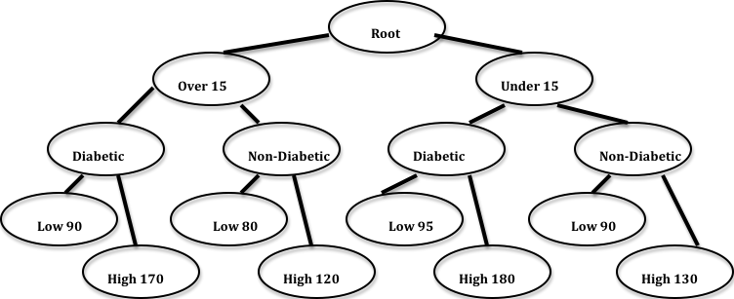

UML Diagrams

Use-case diagram:
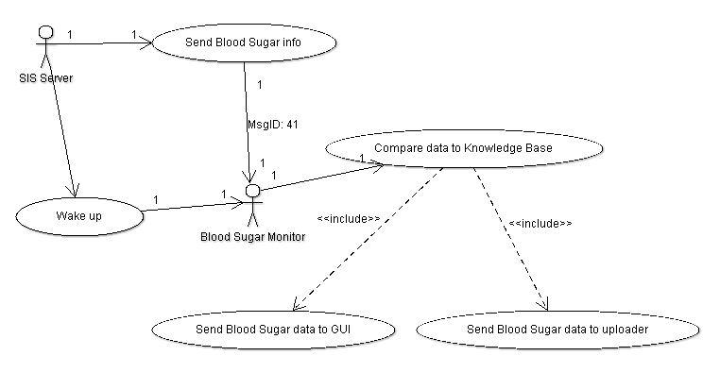

Collaboration Diagram:
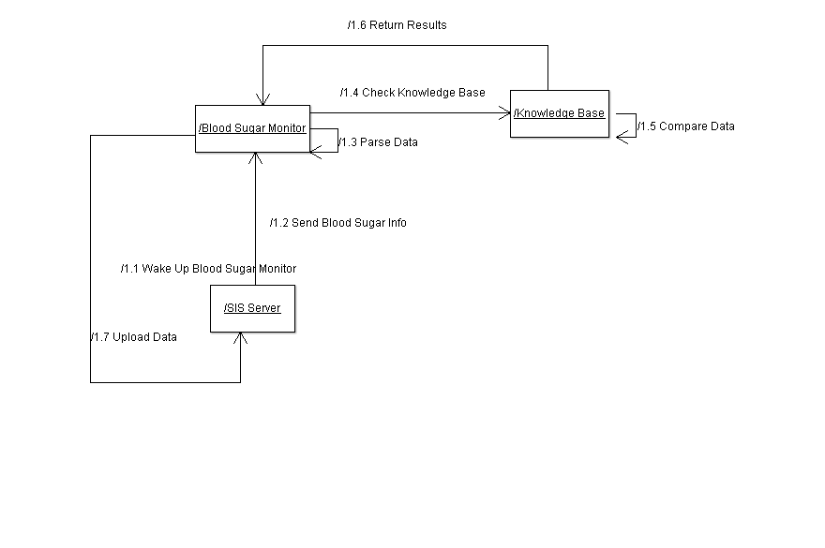

Class Diagram:
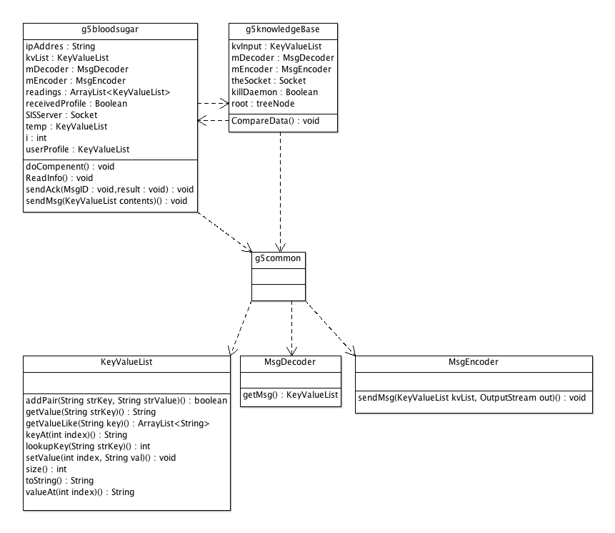

Activity Diagram:
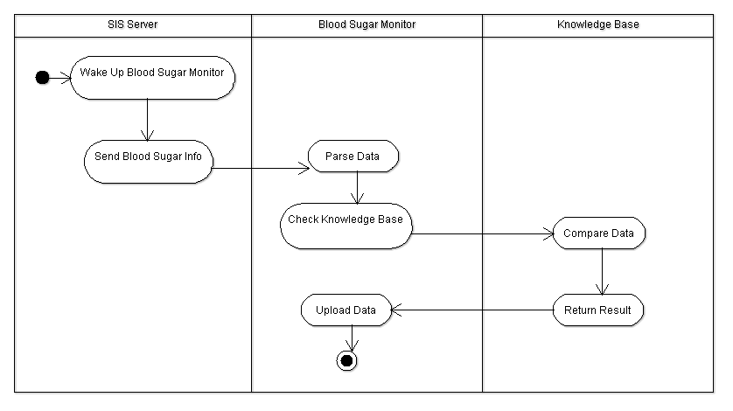

Pre-Defined Messages to be Used

MsgID:23 Description: Connect to server
Variables:
- Passcode (Passcode of Administrator)
- SecurityLevel (Security Level of Administrator)
- Name (Name of Component to be connected to server)

MsgID:26 Description: Acknowledgement
Variables:
- AckMsgID (This is Ack for MsgID)
- YesNo (Yes/No for positive/negative Ack)
- Name (Name of involved Component)

MsgID:41 Description: Blood Sugar Reading
Variables:
- Blood Sugar (blood sugar data stream)
- DateTime (time stamp)

MsgID:42 Description: Blood Sugar Alert
Variables:
- Blood Sugar (blood sugar data stream)
- Alert Type (blood sugar alert type)
- Diagnosis (Normal, Low, or High)
- Suggestions (such as eat more or see doctor etc)
- Name (name of component generating message)
- DateTime (time stamp)

MsgID:45 Description: User Profile
Variables:
- UserName (user's name such as "user001")
- Sex ("male" or "female")
- Age (age in years such as "51")
- Weight (weight in pounds such as "167")
- Height (height in inches such as "62")
- Diabetes ("normal", "prediabetic" or "diabetic")
- Heart Disease ("yes" or "no")
- Meal ("fasting", "before" or "after")
- DateTime (time stamp)

New Messages for Blood Sugar Components

MsgID:150 Description: Lookup Reading
Variables:
- Blood Sugar (blood sugar data)
- UserName (Patients’s username)
- DateTime (time stamp)
- Diabetes (yes/no)
- Age (patient’s age)
- Weight (patient’s weight)

MsgID:151 Description: Return Result
Variables:
- Diagnosis (Low/Normal/High)
- Blood Sugar (blood sugar data stream)
- UserName (Patient’s username)
- Suggestions (suggestion for patient)
- DateTime (time stamp)

XML file Examples

Msg150.xml
<?xml version="1.0" standalone="yes"?>
<!--Generated by Humans-->
<Msg>
<Head><MsgID>150</MsgID><Description>Lookup Reading</Description></Head>
<Body>
<Item>
<Key>Blood Sugar</Key>
<Value>143</Value>
</Item>

<Item>
<Key>DateTime</Key>
<Value>Sat Feb 27 18:10:27 EST 2010</Value>
</Item>

<Item>
<Key>UserName</Key>
<Value>Bob Jenkins</Value>
</Item>

<Item>
<Key>Diabetes</Key>
<Value>Yes</Value>
</Item>

<Item>
<Key>Weight</Key>
<Value>165</Value>
</Item>

<Item>
<Key>Age</Key>
<Value>51</Value>
</Item>

</Body>
</Msg>

Msg151.xml

<?xml version="1.0" standalone="yes"?>
<!--Generated by Humans-->
<Msg>
<Head><MsgID>151</MsgID><Description>Return Result</Description></Head>

<Body>

<Item>
<Key>Diagnosis</Key>
<Value>Normal</Value>
</Item>

<Item>
<Key>Blood Sugar</Key>
<Value>143</Value>
</Item>

<Item>
<Key>UserName</Key>
<Value>Bob Jenkins</Value>
</Item>

<Item>
<Key>Suggestions</Key>
<Value>Keep staying healthy!</Value>
</Item>

<Item>
<Key>DateTime</Key>
<Value>Sat Feb 27 18:10:27 EST 2010</Value>
</Item>

</Body>
</Msg>

Example Run-thru

UniversalInterface, SISserver and HealthMonitor pre-exist or have already been instantiated/activated. GUI, InputProcessor, BloodSugarMonitor and Uploader will be instantiated/activated.

InputProcessor sends Msg 41 (blood sugar reading) to BloodSugarMonitor, which checks for abnormality. BloodSugarMonitor checks for abnormality. There is a knowledge base. We check if blood sugar reading is low, normal or high and send an alert if it is low or high.

BloodSugarMonitor sends Msg 42 (blood sugar alert) to GUI, which displays the vital signals.

BloodSugarMonitor sends Msg 42 (blood sugar alert) to Uploader, which uploads patients medical condition to remote database.

MsgID:21 Description: Create g5 Blood Sugar Monitor Component
Variables:
- Passcode: ****
- SecurityLevel: 3
- Name: g5bloodsugar (Name of created Component)
- SourceCode: g5bloodsugar.class (Source code file name of created Component)
- InputMsgID 1: 26 (Ack)
- InputMsgID 2: 41 (Blood Sugar Reading)
- InputMsgID 3: 45 (User Profile)
- InputMsgID 4: 151 (Return Results from KB)
- OutputMsgID 1: 23 (Connect to Server)
- OutputMsgID 2: 26 (Ack)
- OutputMsgID 3: 42 (Blood Sugar Alert)
- OutputMsgID 4: 150 (Lookup Reading from KB)
- Component Description: BloodSugarMonitor checks for abnormality. There is a knowledge base. We check if blood sugar reading is low, normal or high and send an alert if it is low or high.

MsgID:23 Description: Connect to Server
Variables:
- Passcode: ****
- SecurityLevel: 3
- Name: g5bloodsugar

MsgID:26 Description: Acknowledgement
Variables:
- AckMsgID: 23
- Yes/No: Yes
- Name: g5bloodsugar

MsgID:20 Description: Create g5 Blood Sugar Monitor KB Component
Variables:
- Passcode: ****
- SecurityLevel: 3
- Name: g5kb (Name of created Component)
- SourceCode: g5kb.class (Source code file name of created Component)
- InputMsgID 1: 26 (Ack)
- InputMsgID 2: 150 (Lookup Reading)
- OutputMsgID 1: 23 (Connect to Server)
- OutputMsgID 2: 26 (Ack)
- OutputMsgID 3: 151 (Return Result)
- Component Description: Blood Sugar KB just looks up the result to see if blood sugar reading is low, normal, or high and returns result to BloodSugarMonitor component.

MsgID:23 Description: Connect to Server
Variables:
- Passcode: ****
- SecurityLevel: 3
- Name: g5kb KB

MsgID:26 Description: Acknowledgement
Variables:
- AckMsgID: 23
- Yes/No: Yes
- Name: g5kb

MsgID:41 Description: Blood Sugar Reading
Variables:
- Blood Sugar: 143
- DateTime: Sat Feb 27 18:10:20 EST 2010

MsgID:45 DescriptionUser Profile
Variables:
- UserName: Bob Jenkins
- Age: 51
- Weight: 165
- Height: 70
- Diabetes: prediabetic
- Meal: before
- DateTime: Sat Feb 27 18:10:20 EST 2010

MsgID:150 Description: Lookup Reading
Variables:
- Blood Sugar: 143
- DateTime: Sat Feb 27 18:10:20 EST 2010
- UserName: Bob Jenkins
- Diabetes: Yes
- Weight: 165
- Age: 51

MsgID:151 Description: Return Results
Variables:
- Diagnosis: Normal
- Blood Sugar: 143
- DateTime: Sat Feb 27 18:10:20 EST 2010
- UserName: Bob Jenkins
- Suggestions: Keep staying healthy!

MsgID:42 Description: Blood Sugar Alert
Variables:
- Blood Sugar: 143
- Blood Sugar: 143
- AlertType: Normal
- DateTime: Sat Feb 27 18:10:20 EST 2010

Revision History
March 4th, 2010: Initial creation of UML diagrams
March 16th, 2010: Initial creation of Software Plan and Knowledge Base
April 13th, 2010: Updated XML examples and run thru
April 17th, 2010: Created g5common and modified class names
April 20th, 2010: Updated UML class diagrams, added appendix

Appendix

g5common.java
Taken from SISServer.java

/*
* CS1631 - Personal Health System
* Blood Sugar Monitor Common Classes
* Taken from SISServer.java, and modified to fix errors.
*
* Group 5
* Stephen Paine
* Hemant Patel
*
* Spring 2010
*
*/

import java.io.*;
import java.util.*;

/*
Class KeyValueList:
List of (Key, Value) pair--the basic format of message
keys: MsgID and Description are required for any messages
*/

class KeyValueList {
private Vector<String> keys;
private Vector<String> values;

/* Constructor */
public KeyValueList() {
keys = new Vector<String>();
values = new Vector<String>();
}

/* Look up the value given key, used in getValue() */

public int lookupKey(String strKey) {
for(int i=0; i < keys.size(); i++) {
String k = keys.elementAt(i);
if (strKey.equals(k))
return i;
}
return -1;
}

/* add new (key,value) pair to list */

public boolean addPair(String strKey,String strValue) {
return (keys.add(strKey) && values.add(strValue));
}

/* get the value given key */

public String getValue(String strKey) {
int index=lookupKey(strKey);
if (index==-1)
return null;
return values.elementAt(index);
}

public void setValue(int index, String val) {
if(index >= 0 && index < size())
values.set(index, val);
}

/* Show whole list */
public String toString() {
String result = new String();
for(int i=0; i<keys.size(); i++) {
result+=keys.elementAt(i)+":"+values.elementAt(i)+"\n";
}
return result;
}

public int size() {
return keys.size();
}

/* get Key or Value by index */
public String keyAt(int index) {
return keys.elementAt(index);
}

public String valueAt(int index) {
return values.elementAt(index);
}

public ArrayList<String> getValueLike(String key) {
String temp;
ArrayList<String> results = new ArrayList<String>();
for(int i=0; i < keys.size(); i++) {
temp = keys.elementAt(i);
if (temp.contains(key))
results.add(values.elementAt(i));
}
if(results.size() == 0)
return null;
return results;
}
}

/*
Class MsgEncoder:
Serialize the KeyValue List and Send it out to a Stream.
*/
class MsgEncoder {
//private PrintStream printOut;
/*If you would like to write msg interpreter your self, read below*/
/* Default of delimiter in system is $$$ */
private final String delimiter = "$$$";

public MsgEncoder(){}

/* Encode the Key Value List into a string and Send it out */

public void sendMsg(KeyValueList kvList, OutputStream out) throws IOException {
PrintStream printOut= new PrintStream(out);
if (kvList == null)
return;
String outMsg= new String();
for(int i=0; i<kvList.size(); i++) {
if (outMsg.equals(""))
outMsg = kvList.keyAt(i) + delimiter + kvList.valueAt(i);
else
outMsg += delimiter + kvList.keyAt(i) + delimiter + kvList.valueAt(i);
}
//System.out.println(outMsg);
printOut.println(outMsg);
}
}

/*
Class MsgDecoder:
Get String from input Stream and reconstruct it to
a Key Value List.
*/

class MsgDecoder {
private BufferedReader bufferIn;
private final String delimiter = "$$$";

public MsgDecoder(InputStream in) {
bufferIn = new BufferedReader(new InputStreamReader(in));
}

/*
get String and output KeyValueList
*/

public KeyValueList getMsg() throws IOException {
String strMsg= bufferIn.readLine();

if (strMsg==null)
return null;

KeyValueList kvList = new KeyValueList();
StringTokenizer st = new StringTokenizer(strMsg, delimiter);
while (st.hasMoreTokens()) {
kvList.addPair(st.nextToken(), st.nextToken());
}
return kvList;
}
}

g5kb.java
/*
*CS1631
*
*Personal Health Care System
*Blood Sugar Knowledge Base
*
*Group 5
*Stephen Paine
*Hemant Patel
*/

import java.io.*;
import java.net.*;
import java.util.*;

public class g5kb
{
private static String theIP;
private static String kbFileName="g5bloodsugar.kb";
public Socket theSocket;
public static boolean killDaemon = false;
public KeyValueList kvInput;
public MsgDecoder mDecoder;
public MsgEncoder mEncoder;
//public Date date;
public treeNode root;

public static void main(String [] args)
{
if(args.length != 1)
{
System.out.println("Incorrect number of parameters.");
System.out.println("Use the following instead: java g5kb <SIS Server IP>");
System.exit(0);
}

theIP = args[0];

Thread t = new Thread( new Runnable()
{
public void run()
{
g5kb BSKB=new g5kb();
BSKB.messages(); ///DOOOOOOOOOOOOOOOOOOOOOOOOOOOOO
}
}); //got from the SIS component example thingy

t.setDaemon(true);
t.start();

//while(!killDaemon)
//{
//chill in here
//}
System.out.println( "Hit Enter to stop.\n" );

try
{
System.in.read();
}
catch (Throwable thr) {};

//t.stop();
}

public g5kb()
{
try
{
theSocket = new Socket (theIP, 7999);
mEncoder = new MsgEncoder();
mDecoder = new MsgDecoder(theSocket.getInputStream());
kvInput = new KeyValueList();
// Not being used; we're not changing any dates
//date = new Date(); //java.util.Date()

//DateFormat dateformat = new SimpleDateFormat("yyyy_MM_dd");
//DateFormat dateformat2 = new SimpleDateFormat("HH:mm:ss");
//Format date according to XML style
//DateFormat dateformat = new SimpleDateFormat("EEE MMM dd HH:mm:ss z yyyy");
}
catch (Exception e)
{
System.out.println("An error has occurred. Good thing this isn't a nuclear power plant.");
System.out.println("Error: " +e.getMessage());
e.printStackTrace();
}
}

public void messages()
{
//Need to connect to the server
System.out.println("Attempting to connect to server");

try
{
kvInput.addPair("MsgID","23");
kvInput.addPair("Description","Connect to server");
kvInput.addPair("Passcode","****"); //the hell do i put down for passcode...?
kvInput.addPair("SecurityLevel","3");
kvInput.addPair("Name","g5kb");
sendMsgToServer(kvInput);
}
catch (Exception e)
{
System.out.println("An error has occurred while trying to connect to SISServer.");
//System.out.println("Error: " +e.getMessage());
//e.printStackTrace();
System.exit(0);
}
System.out.println("Connected to SISServer.");

while(true)
{
try
{
kvInput = mDecoder.getMsg();
}
catch(Exception e)
{
System.out.println("An error has occurred while trying to receive a message from SISServer.");
//System.out.println("Error: " +e.getMessage());
//e.printStackTrace();
//System.exit(0);
}

int msgID = Integer.parseInt(kvInput.getValue("MsgID")); //getMessageID

if (msgID == 22)
{
killDaemon = true;
}

else if (msgID == 26)
{
System.out.println("\nReceived an ACK message:\n");
System.out.println(kvInput);
//Don't think im supposed to do anything else here....?

}
else if(msgID == 150)
{
System.out.println("\nReceived a message: ");
System.out.println(kvInput);
//ackMsg(150,"Yes"); //let Monitor know KB got message 150

String diabetes = kvInput.getValue("Diabetes");
String temp2 = kvInput.getValue("Age");
String username = kvInput.getValue("UserName");
String date = kvInput.getValue("DateTime");
String temp = kvInput.getValue("Blood Sugar");
// Not being used
//String Weight = kvInput.getValue("Weight");
String result = null;
treeNode currNode = null;

int BloodSugar = Integer.parseInt(temp);
int age = Integer.parseInt(temp2);
String agetemp;

if(age>15)
agetemp = "OVER 15";
else
agetemp = "UNDER 15";

if(diabetes.equals("prediabetic"))
diabetes = "DIABETIC";
else if (diabetes.equals("diabetic"))
diabetes = "DIABETIC";
else
diabetes = "NONDIABETIC";

System.out.println("Computing result");
//compute results

boolean theKB = createKB();

if(theKB)
{
//traverse tree
if(root.leftNode.name.equals(agetemp))
{
currNode = root.leftNode;
if (currNode.leftNode.name.equals(diabetes))
{
currNode = currNode.leftNode;

int low,high;

low = currNode.leftNode.value;
high = currNode.rightNode.value;

if(BloodSugar < low)
result = "Low";
else if(BloodSugar > high)
result = "High";
else
result = "Normal";
}
else
{
currNode = currNode.rightNode;
int low,high;

low = currNode.leftNode.value;
high = currNode.rightNode.value;

if(BloodSugar < low)
result = "Low";
else if(BloodSugar > high)
result = "High";
else
result = "Normal";
}

}
else
{
currNode = root.rightNode;

if (currNode.leftNode.name.equals(diabetes))
{
currNode = currNode.leftNode;

int low,high;

low = currNode.leftNode.value;
high = currNode.rightNode.value;

if(BloodSugar < low)
result = "Low";
else if(BloodSugar > high)
result = "High";
else
result = "Normal";
}
else
{
currNode = currNode.rightNode;
int low,high;

low = currNode.leftNode.value;
high = currNode.rightNode.value;

if(BloodSugar < low)
result = "Low";
else if(BloodSugar > high)
result = "High";
else
result = "Normal";
}
}
}

else //unable to create knowlegde base so use default values
{
if (!diabetes.toLowerCase().equals("normal")&& (age >15))
{
if(BloodSugar < 90)
result = "Low";
else if(BloodSugar > 170)
result = "High";
else
result = "Normal";
}
else if (!diabetes.toLowerCase().equals("normal") &&(age <=15))
{
if(BloodSugar < 95)
result = "Low";
else if(BloodSugar > 180)
result = "High";
else
result = "Normal";

}
else if (diabetes.toLowerCase().equals("normal") && (age >15))
{
if(BloodSugar < 80)
result = "Low";
else if(BloodSugar > 120)
result = "High";
else
result = "Normal";

}
else //if (diabetes.toLowerCase().equals("normal") && (age <=15))
{
if(BloodSugar < 90)
result = "Low";
else if(BloodSugar > 130)
result = "High";
else
result = "Normal";
}
}

KeyValueList theResults = new KeyValueList();
theResults.addPair("MsgID","151");
theResults.addPair("Description","Return Result");
theResults.addPair("Diagnosis",result);
theResults.addPair("UserName", username);
theResults.addPair("DateTime",date);
theResults.addPair("Blood Sugar",temp);

if(result.equals("Normal"))
{
theResults.addPair("Suggestions","Keep staying healthy!");
}
else if(result.equals("High"))
{
theResults.addPair("Suggestions","Talk to your physician or doctor.");
}
else //if(result.equals("Low"))
{
theResults.addPair("Suggestions","Talk to your physician or doctor.");
}

//end of computing results

sendMsgToServer(theResults);
}
else //receive a message KB is not supposed to receive
{
System.out.println("Received message with ID " +kvInput.getValue("MsgID") + " for some reason...");
}
}
}

public void ackMsg(int msgID, String yesno)
{
KeyValueList ack=new KeyValueList();

ack.addPair("MsgID","26");

String temp = Integer.toString(msgID);

ack.addPair("AckMsgID",temp);
ack.addPair("Yes/No",yesno);

sendMsgToServer(ack);
}

public void sendMsgToServer(KeyValueList temp)
{
try
{
System.out.println("\nSending message: ");
System.out.println(temp);
mEncoder.sendMsg(temp, theSocket.getOutputStream());
}
catch (Exception e)
{
System.out.println("An error has occurred while trying to send a message to SISServer.");
//System.out.println("Error: " +e.getMessage());
//e.printStackTrace();
System.exit(0);

}
}

public boolean createKB() //create kb in tree form
{
ArrayList<String> input = null;
boolean exists = (new File(kbFileName)).exists();
if (exists)
System.out.println("KB File Exists");
else
System.out.println("KB File Doesn't Exist");

if (!exists)
{
return false;
}

try
{
FileInputStream fstream = new FileInputStream(kbFileName);
DataInputStream in = new DataInputStream(fstream);
BufferedReader br = new BufferedReader(new InputStreamReader(in));
String theLine;
input = new ArrayList<String>();

while ((theLine = br.readLine()) != null)
{
input.add(theLine);
}

in.close();
}
catch (Exception e)
{
System.err.println("Error: " + e.getMessage());
return false;
}

String[] temp;
String temp2;
String delimiter = "&&&";

int udl=0,udh=0,unl=0,unh=0,odl=0,odh=0,onl=0,onh =0;

//read in values from file
for (int i = 0; i< input.size();i++)
{
//temp2 =(String) input.get(i);
temp2 = input.get(i);
temp = temp2.split(delimiter);

if (temp[0].equals("under15"))
{
if (temp[1].equals("diabetic"))
{
if (temp[2].equals("low"))
{
udl = Integer.parseInt(temp[3]);
}
else //if temp[2].equals("high")
{
udh = Integer.parseInt(temp[3]);

}
}
else //if (temp[1].equals("nondiabetic")
{
if (temp[2].equals("low"))
{
unl = Integer.parseInt(temp[3]);
}
else //if temp[2].equals("high")
{
unh = Integer.parseInt(temp[3]);
}
}
}
else //(temp[0].equals("over15")
{
if (temp[1].equals("diabetic"))
{
if (temp[2].equals("low"))
{
odl = Integer.parseInt(temp[3]);
}
else //if temp[2].equals("high")
{
odh = Integer.parseInt(temp[3]);
}
}
else //if (temp[1].equals("nondiabetic")
{
if (temp[2].equals("low"))
{
onl = Integer.parseInt(temp[3]);
}
else //if temp[2].equals("high")
{
onh = Integer.parseInt(temp[3]);
}
}
}
}

root = new treeNode("ROOT");
//root.name = "ROOT";
root.leftNode = new treeNode("OVER 15");
root.rightNode = new treeNode("UNDER 15");

treeNode rootLeft = root.leftNode;
treeNode rootRight = root.rightNode;

rootLeft.leftNode = new treeNode("DIABETIC");
rootLeft.rightNode = new treeNode("NONDIABETIC");
treeNode dia = rootLeft.leftNode;
treeNode nonDia = rootLeft.rightNode;

dia.leftNode = new treeNode("LOW",odl);
dia.rightNode = new treeNode("HIGH",odh);
nonDia.leftNode = new treeNode("LOW",onl);
nonDia.rightNode = new treeNode("HIGH",onh);

rootRight.leftNode = new treeNode("DIABETIC");
rootRight.rightNode = new treeNode("NONDIABETIC");
dia = rootRight.leftNode;
nonDia = rootRight.rightNode;

dia.leftNode = new treeNode("LOW",udl);
dia.rightNode = new treeNode("HIGH",udh);
nonDia.leftNode = new treeNode("LOW",unl);
nonDia.rightNode = new treeNode("HIGH",unh);

return true;
}

}

class treeNode
{
int value;
String name;
treeNode leftNode;
treeNode rightNode;

public treeNode()
{
//name = "default";
//treeNode leftNode;
//treeNode rightNode;
//value = 0;
}
public treeNode(String temp)
{
name = temp;
//treeNode leftNode;
//treeNode rightNode;
//value = 0;
}
public treeNode(String temp, int temp2)
{
name = temp;
//treeNode leftNode;
//treeNode rightNode;
value = temp2;
}

public int getValue() //probably dont need this
{
return value;
}

public void setValue(int temp) //probably dont need this
{
value = temp;
}
public void setName(String temp) //probably dont need this
{
name = temp;
}

}

g5bloodsugar.java
/*
* CS1631 - Personal Health System
* Blood Sugar Monitor Component
*
* Group 5
* Stephen Paine
* Hemant Patel
*
* Spring 2010
*
*/

import java.net.*;
import java.util.*;

public class g5bloodsugar {
public static String ipAddress;
public MsgEncoder mEncoder;
public MsgDecoder mDecoder;
//public Date date;
//public DateFormat dateformat;
public KeyValueList kvList,temp,userProfile;
public Socket SISServer;
private Boolean debug;
public ArrayList<KeyValueList> readings;
public Boolean receivedProfile;
public int i;

public g5bloodsugar(String ipAddr) {
try {
SISServer=new Socket(ipAddr, 7999);
mEncoder=new MsgEncoder();
mDecoder=new MsgDecoder(SISServer.getInputStream());
//date=new Date();
//dateformat=new SimpleDateFormat("EEE MMM dd hh:mm:ss zzz yyyy");
kvList=new KeyValueList();
// Set to false to suppress output of messages
debug=true;
readings=new ArrayList<KeyValueList>();
receivedProfile=false;
} catch(Exception ex) {
System.out.println("Error initializing!");
System.exit(0);
}
}

public void sendAck(int MsgID, String result) {
KeyValueList tmp=new KeyValueList();
tmp.addPair("MsgID","26");
tmp.addPair("AckMsgID",""+MsgID);
tmp.addPair("Yes/No",result);
sendMsg(tmp);
}

public void sendMsg(KeyValueList contents) {
try {
if (debug) {
System.out.println("Sending message "+contents.getValue("MsgID"));
System.out.println(contents);
}
mEncoder.sendMsg(contents, SISServer.getOutputStream());
} catch(Exception ex) {
System.out.println("Error sending message!");
System.exit(0);
}
}

public void doComponent() {
//Connect to server
System.out.println("Connecting to SISServer...");
kvList.addPair("MsgID","23");
kvList.addPair("Description","Connect to server");
kvList.addPair("Passcode","****");
kvList.addPair("SecurityLevel","3");
kvList.addPair("Name","g5bloodsugar");
sendMsg(kvList);

// Start recieving
try {
while(true) {
if (mDecoder==null) {
System.out.println("mDecoder null!");
mDecoder = new MsgDecoder(SISServer.getInputStream());
}
kvList = mDecoder.getMsg();
if (kvList==null) {
System.out.println("Error!! kvList null!");
}
System.out.println("Recieved Msg: ");
int MsgID = Integer.parseInt(kvList.getValue("MsgID"));

switch (MsgID) {
case 26:
// Received Acknowledgement Message
System.out.println("26-Acknowledgement");
System.out.println(kvList);
break;
case 41:
// Received Blood Sugar Reading Message
System.out.println("41-Blood Sugar Reading");
System.out.println(kvList);

if (receivedProfile) {
//sendAck(41,"Yes");

temp = new KeyValueList();
temp.addPair("MsgID","150");
temp.addPair("Description","Lookup Reading");

temp.addPair("Blood Sugar",kvList.getValue("Blood Sugar"));
temp.addPair("DateTime",kvList.getValue("DateTime"));
//temp.addPair("DateTime",dateformat.format(date));
temp.addPair("UserName",userProfile.getValue("UserName"));
temp.addPair("Diabetes",userProfile.getValue("Diabetes"));
temp.addPair("Age",userProfile.getValue("Age"));
temp.addPair("Weight",userProfile.getValue("Weight"));

sendMsg(temp);
} else {
// Store reading until we get user profile
readings.add(kvList);
}
break;
case 45:
// Received Profile Message
System.out.println("45-User Profile");
System.out.println(kvList);
userProfile=kvList;
receivedProfile=true;
if (readings.size()>0) {
for (i=0; i<readings.size(); i++) {
temp = new KeyValueList();
temp.addPair("MsgID","150");
temp.addPair("Description","Lookup Reading");
temp.addPair("Blood Sugar",readings.get(i).getValue("Blood Sugar"));
temp.addPair("DateTime",readings.get(i).getValue("DateTime"));
temp.addPair("UserName",userProfile.getValue("UserName"));
temp.addPair("Diabetes",userProfile.getValue("Diabetes"));
temp.addPair("Age",userProfile.getValue("Age"));
temp.addPair("Weight",userProfile.getValue("Weight"));

sendMsg(temp);
}
readings.clear();
}

break;
case 151:
// Received Return Results from KB Message
System.out.println("151-Return Results (from KB)");
System.out.println(kvList);
//sendAck(151,"Yes");
// Always alert, so patient knows when blood sugar is normal
//if (!kvList.getValue("Diagnosis").equals("Normal")) {
temp=new KeyValueList();
temp.addPair("MsgID","42");
temp.addPair("Description","Blood Sugar Alert");
//temp.addPair("Name","g5 Blood Sugar Monitor");
temp.addPair("Name","g5bloodsugar");
//temp.addPair("Alert Type","Blood Sugar Alert -- Blood Sugar is "+kvList.getValue("Diagnosis"));
temp.addPair("Blood Sugar",kvList.getValue("Blood Sugar"));
temp.addPair("Alert Type","Blood Sugar Alert");
temp.addPair("Diagnosis",kvList.getValue("Diagnosis"));
temp.addPair("Suggestions",kvList.getValue("Suggestions"));
temp.addPair("DateTime",kvList.getValue("DateTime"));
//temp.addPair("DateTime",dateformat.format(date));
sendMsg(temp);
//}
break;
default:
//Shouldn't receive any not for me, just default backup case
System.out.printf("%d-Not for me\n",MsgID);
System.out.println(kvList);
}

}
} catch(Exception ex) {
System.out.println("Exception while reading message from SISServer.");
}

}

public static void main(String[] args) {
// Check for correct # of arguments
if (args.length != 1) {
System.out.println("Too few arguments.");
System.out.println("\tTo Run g5bloodsugar Component, use command:\n");
System.out.println("\tjava g5bloodsugar <SISServer IP>\n");
System.exit(0);
}

ipAddress=args[0];

//Run component in thread so we can quit gracefully (sort of)
Thread monitor = new Thread(new Runnable() {
public void run() {
g5bloodsugar BSM=new g5bloodsugar(ipAddress);
BSM.doComponent();
}
});

monitor.setDaemon(true);
monitor.start();

System.out.println( "Hit Enter to stop.\n" );
try {
System.in.read();
} catch (Throwable thr) {};
}
}

