CS 1699 Exercise 4
Jeff Koenig & Josh Hauenschild (G4)
Spring 2010

~The Software (module) Plan~
Blood Pressure Module

1. The scope of this module is to send messages containing blood pressure information and to check this information against a knowledge base of acceptable/critical values. If necessary, this module will send an alert indicating a dangerous blood pressure level. It is important to note that the individuals writing this module are not professionally educated medical personnel and are basing threshold blood pressure values off of widely available numbers. Should any discrepancy require change, or if previously accepted numbers change it will be necessary to update the knowledge base element of this component. Details of how to accomplish this will be provided beginning with the first operational version of this module. Another critical note is that this module will restrict itself solely to blood pressure reports, if other functionalities are desired they should not interfere with the blood pressure module’s ability to perform its tasks.
1a. Functions:
Connect to server: Establish a connection between the blood pressure module and the SIS server.
Check blood pressure information: Check the patient’s blood pressure information against the module’s knowledge base—this involves checking values against threshold numbers.
Send and receive necessary alerts: In the event of abnormal blood pressure levels send necessary alerts to both the patient and medical personnel.
1b. Performance: this must be a real-time system as we are sending and receiving messages that regard a patient’s safety. However, much of the performance will depend on network speed. Upon start up, all new systems should check their performance level and match them against expected/acceptable performance criteria (this criteria should be provided by the system’s administrator).
1c. Limitations: this module will not monitor or handle anything other than information related to blood pressure. As was mentioned above, no functionality non-pertaining to blood pressure reporting/monitoring should be added to this module.
2. Tasks include developing a blood pressure knowledge base containing high and low alert levels as well as an efficient message-passing module capable of sending and receiving messages from and to a main server. The knowledge base will contain threshold numbers for all age categories as well as “alert stages” ranging from “above normal” to “critical.” Building the blood pressure module will require both an initial construction phase as well as a testing and refining stage
3. Resources
3a. Hardware: Medical monitor for testing, computer for programming and testing, second computer for testing messaging across a network.
3b. Software: Virtual classroom (for messaging), java development environment and runtime environment.
3c. People: Jeff and Josh. We will both be programming and testing the module.

4. Cost*
Hardware | $5,000.00
Personnel | $240,000.00
Software | $7,000.00
Expert's Fees | $5,000.00
Testing | $0.00
Total: | $257,000.00

*These estimates are based upon current in-house development costs associated with component construction at our company. Some variations may occur within the actual figures with respect to the estimates should significant hardware/software acquisitions become necessary.

5. Schedule.
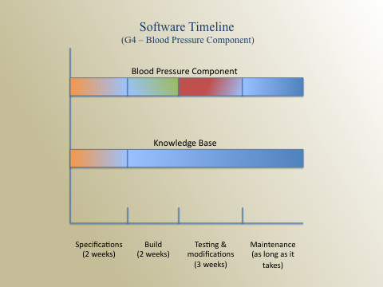

UML Diagrams
Use Case
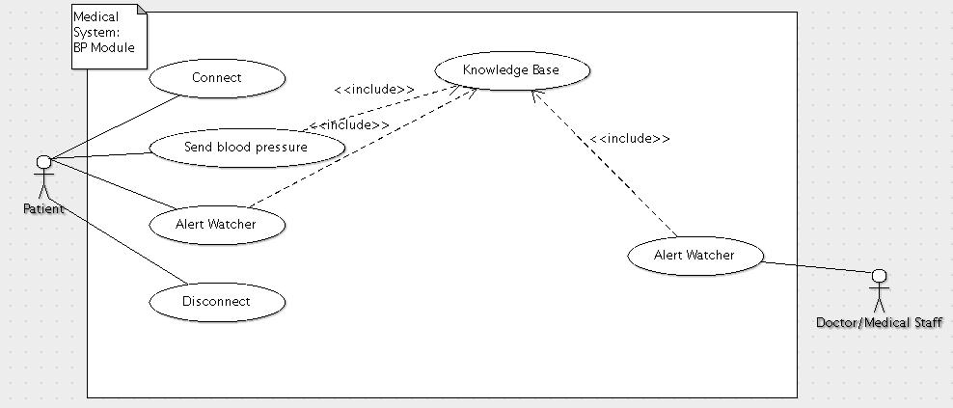
Activity
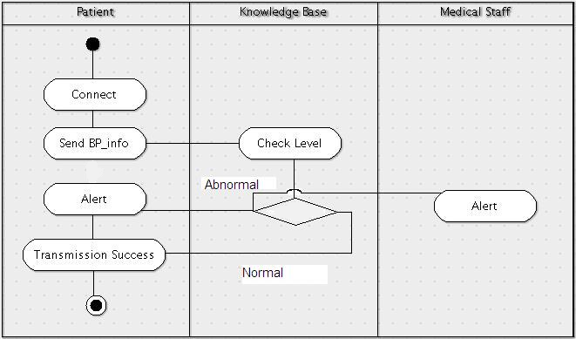

Sequence
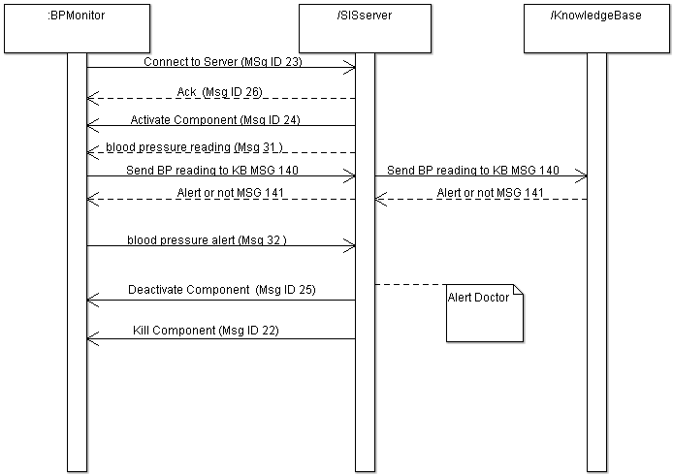

Class
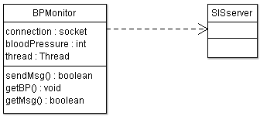

Knowledge Base Version 0.1
References:
http://www.disabled-world.com/artman/publish/bloodpressurechart.shtml
http://www.mayoclinic.com/health/blood-pressure/HI00043
Please note that no cardiovascular specialists were consulted in reference to these numbers. Should this module be used in the future in a real-world scenario it will be necessary to consult with medical professionals before deploying the module.

Milestone 1 Section

Messages
There are 7 total messages necessary for the blood pressure component to function properly. No new messages aside from the predefined Personal HealthCare Slow Intelligence System will be required. The necessary messages are:
- MSG:23 ~ connect to server
- MSG:26 ~ Acknowledgement command
- MSG:24 ~ Activate Component
- MSG:31 ~ request a blood pressure reading
- MSG:32 ~ Blood pressure Alert
- MSG:25 ~ Deactivate Component command
- MSG:22 ~ Kill component command
New Messages:
- MSG:140~ send Bloodpreasure reading to KnowledgeBase
- MSG 141~ returned to BPMonitor from KnowledgeBase returns whether Alert is needed or not

Scenarios

In step-by-step format the message transaction sequence should follow the following format:
- BPMonitor is activated by a user
- Upon activation BPMonitor sends a MSG 23 to connect to the server
- After receiving MSG 23 from the BPMonitor the server returns an Acknowledgement command MSG 26
- The server sends a Activate Component MSG 24
- The server sends a MSG31 to request a blood pressure reading
- The BPMonitor sends MSG140 to the KnowledgeBase
- The KnowledgeBase returns MSG141 (which says whether to alert or not)
- The BPMonitor returns a blood pressure alert MSG 32. If the pressure is critical, the message will indicate the level of alert. If the pressure is normal the alert type will be “no alert.”
- The server sends a Deactivate Component command MSG 25 if no further readings are desired.
- The server sends a Kill component command MSG 22
- The BPMonitor gracefully shuts down

XML
The following is the XML format of the necessary messages.

MSG 23
<Msg>
<Head>
<MsgID>23</MsgID>
<Description>
Connect to Server (GUI requests to be connected to Server)
</Description>
</Head>
<Body>
<Item>
<Key>Passcode</Key>
<Value>****</Value>
</Item>
<Item>
<Key>SecurityLevel</Key>
<Value>3</Value>
</Item>
<Item>
<Key>Name</Key>
<Value>GUI</Value>
</Item>
</Body>
</Msg>

MSG 26
<Msg>
<Head>
<MsgID>26</MsgID>
<Description>
Acknowledgement (Server acknowledges that GUI component is now connected to Server)
</Description>
</Head>
<Body>
<Item>
<Key>AckMsgID</Key>
<Value>23</Value>
</Item>
<Item>
<Key>YesNo</Key>
<Value>Yes</Value>
</Item>
<Item>
<Key>Name</Key>
<Value>GUI</Value>
</Item>
</Body>
</Msg>

MSG 24
<Msg>
<Head>
<MsgID>24</MsgID>
<Description>Activate Component</Description>
</Head>
<Body>
<Item>
<Key>Passcode</Key>
<Value>****</Value>
</Item>
<Item>
<Key>SecurityLevel</Key>
<Value>3</Value>
</Item>
<Item>
<Key>Name</Key>
<Value>GUI</Value>
</Item>
<Item>
<Key>SourceCode</Key>
<Value>GUI.jar</Value>
</Item>
</Body>
</Msg>

MSG 31
<Msg>
<Head>
<MsgID>31</MsgID>
<Description>Blood Pressure Reading</Description>
</Head>
<Body>
<Item>
<Key>Systolic</Key>
<Value>114</Value>
</Item>
<Item>
<Key>Diastolic</Key>
<Value>61</Value>
</Item>
<Item>
<Key>Pulse</Key>
<Value>75</Value>
</Item>
<Item>
<Key>DateTime</Key>
<Value>Sat Feb 27 18:10:20 EST 2010</Value>
</Item>
</Body>
</Msg>

MSG 32
<Msg>
<Head>
<MsgID>32</MsgID>
<Description>Blood Pressure Alert</Description>
</Head>
<Body>
<Item>
<Key>Systolic</Key>
<Value>114</Value>
</Item>
<Item>
<Key>Diastolic</Key>
<Value>61</Value>
</Item>
<Item>
<Key>Pulse</Key>
<Value>75</Value>
</Item>
<Item>
<Key>Alert Type</Key>
<Value>Blood Pressure Alert</Value>
</Item>
<Item>
<Key>DateTime</Key>
<Value>Sat Feb 27 18:10:20 EST 2010</Value>
</Item>
</Body>
</Msg>

MSG 25
<Msg>
<Head>
<MsgID>25</MsgID>
<Description>DeActivate Component</Description>
</Head>
<Body>
<Item>
<Key>Passcode</Key>
<Value>****</Value>
</Item>
<Item>
<Key>SecurityLevel</Key>
<Value>3</Value>
</Item>
<Item>
<Key>Name</Key>
<Value>GUI</Value>
</Item>
<Item>
<Key>SourceCode</Key>
<Value>GUI.jar</Value>
</Item>
</Body>
</Msg>

MSG 22
<Msg>
<Head>
<MsgID>22</MsgID>
<Description>Kill Component</Description>
</Head>
<Body>
<Item>
<Key>Passcode</Key>
<Value>****</Value>
</Item>
<Item>
<Key>SecurityLevel</Key>
<Value>3</Value>
</Item>
<Item>
<Key>Name</Key>
<Value>GUI</Value>
</Item>
<Item>
<Key>SourceCode</Key>
<Value>Gui.jar</Value>
</Item>
</Body>
</Msg>

MSG 140
<Msg>
<Head>
<MsgID>140</MsgID>
<Description>Check Knowledge Base for alert on Blood Preasure</Description>
</Head>
<Body>
<Item>
<Key>Age</Key>
<Value>22</Value>
</Item>
<Item>
<Key>Systolic</Key>
<Value>114</Value>
</Item>
<Item>
<Key>Diastolic</Key>
<Value>61</Value>
</Item>
<Item>
<Key>Pulse</Key>
<Value>75</Value>
</Item>
<Item>
<Key>Alert Type</Key>
<Value>Blood Pressure Alert</Value>
</Item>
<Item>
<Key>DateTime</Key>
<Value>Sat Feb 27 18:10:20 EST 2010</Value>
</Item>
</Body>
</Msg>

MSG 141
<Msg>
<Head>
<MsgID>141</MsgID>
<Description>Says whether to alert or not</Description>
</Head>
<Body>
<Item>
<Key>Systolic</Key>
<Value>114</Value>
</Item>
<Item>
<Key>Diastolic</Key>
<Value>61</Value>
</Item>
<Item>
<Key>Pulse</Key>
<Value>75</Value>
</Item>
<Item>
<Key>Alert</Key>
<Value>Yes/No</Value>
</Item>
<Item>
<Key>Alert Type</Key>
<Value>Blood Pressure Alert</Value>
</Item>
<Item>
<Key>DateTime</Key>
<Value>Sat Feb 27 18:10:20 EST 2010</Value>
</Item>
</Body>
</Msg>

Appendix A (source code)

/***************************************************
* BLOOD PRESSURE MONITOR
***************************************************/
import java.io.*;
import java.net.*;
import java.util.ArrayList;
import java.util.StringTokenizer;
import java.util.Vector;
import java.util.Date;
import java.io.File;
import javax.xml.parsers.DocumentBuilder;
import javax.xml.parsers.DocumentBuilderFactory;
import org.w3c.dom.Document;
import org.w3c.dom.Element;
import org.w3c.dom.Node;
import org.w3c.dom.NodeList;

//import com.sun.jmx.snmp.Timestamp;

public class g4bloodpressure {
static Socket socket;
String delimiter="$$$";
boolean active=false;
boolean hasUserInfo=false;
int systolic,diastolic,pulse,age;
String date,userName;
String diagnosis, suggestions;
String componentName="g4bloodpressure";

public static void main(String args[]){
new g4bloodpressure();
}

public g4bloodpressure(){

socket=null;
try{
socket = new Socket("127.0.0.1", 7999);

} catch (UnknownHostException e) {
System.out.println("Unknown host: kq6py");
System.exit(1);
} catch (IOException e) {
System.out.println("No I/O");
System.exit(1);
}
System.out.println("Server accepted connection");

buildMsg(23);//builds initial msg23

getMsg(socket);
}
class MsgDecoder
{
private BufferedReader bufferIn;
private final String delimiter = "$$$";

public MsgDecoder(InputStream in)
{
bufferIn = new BufferedReader(new InputStreamReader(in));
}

/*
get String and output KeyValueList
*/

public KeyValueList getMsg() throws IOException
{
String strMsg= bufferIn.readLine();
System.out.println("In Msg: "+strMsg);
if (strMsg==null)
return null;

KeyValueList kvList = new KeyValueList();
StringTokenizer st = new StringTokenizer(strMsg, delimiter);
while (st.hasMoreTokens())
{
kvList.addPair(st.nextToken(), st.nextToken());
}
return kvList;
}

}

public void getMsg(Socket socket){
try
{
InputStream in;
String line;
BufferedReader bufferIn;
in=socket.getInputStream();
bufferIn = new BufferedReader(new InputStreamReader(in));
int pos;

//while not kill msg
while(true){
//Receive msg from server
line=bufferIn.readLine();
if(line!=null)
{//print the msg
System.out.println("BP received: "+line); //raw message
//read in the key value pairs $$$ delimited
StringTokenizer strTok = new StringTokenizer(line, "$");

ArrayList<String> items = new ArrayList<String>();

while(strTok.hasMoreTokens())
{
items.add(strTok.nextToken());
}

//we handle msg 24,31,45,141,25,22
pos = items.indexOf("MsgID");

if(pos != -1 && items.get(pos+1).equals("26"))
{
System.out.println("Connection to the server has been acknowledged and accepted");

}
else if(pos != -1 && items.get(pos+1).equals("24"))
{
pos=items.indexOf("Name");
if(items.get(pos+1).equals(componentName)){
active=true;
System.out.println("Monitor activated");
}
}
else if(pos != -1 && items.get(pos+1).equals("31"))
{
if(hasUserInfo){
pos=items.indexOf("Systolic");
systolic=Integer.parseInt(items.get(pos+1));
pos=items.indexOf("Diastolic");
diastolic=Integer.parseInt(items.get(pos+1));
pos=items.indexOf("Pulse");
pulse=Integer.parseInt(items.get(pos+1));
pos=items.indexOf("DateTime");
date=items.get(pos+1);
buildMsg(140);
}
else
System.out.println("User information not yet received");
}
else if(pos != -1 && items.get(pos+1).equals("141"))
{
System.out.println("Knowledge Base accepted msg 140");
pos=items.indexOf("Diagnosis");
diagnosis=items.get(pos+1);
pos=items.indexOf("Suggestions");
suggestions=items.get(pos+1);

pos=items.indexOf("Alert");
if(pos != -1 && items.get(pos+1).equals("Yes"))
buildMsg(32);

}
else if(pos != -1 && items.get(pos+1).equals("45"))
{
pos=items.indexOf("UserName");
userName=items.get(pos+1);
pos=items.indexOf("Age");
age=Integer.parseInt(items.get(pos+1));
hasUserInfo=true;
}
else if(pos != -1 && items.get(pos+1).equals("25"))
{
pos=items.indexOf("Name");
if(items.get(pos+1).equals(componentName)){
active=false;
System.out.println("Monitor deactivated");
}
}
else if(pos != -1 && items.get(pos+1).equals("22"))
{
pos=items.indexOf("Name");
if(items.get(pos+1).equals(componentName)){
System.out.println("Kill Msg recieved. Shutting down...");
System.exit(1);
}
}
else{
//ignore message
}

}
line=null;
}
}catch(Exception e){
System.out.println("Error in getMsg()");
System.out.println(e);
}
}
/*
* only build msg 23, 32, 140
*/
public void buildMsg(int msgNum){
KeyValueList list=new KeyValueList();

if(msgNum!=23 && msgNum!=32 && msgNum!=140)
System.out.println("msg number: "+msgNum+ "is not applicable message");
else{
/*try {//reads XML file
File file = new File(".\\xml\\"+msgNum+".xml");
DocumentBuilderFactory dbf = DocumentBuilderFactory.newInstance();
DocumentBuilder db = dbf.newDocumentBuilder();
Document doc = db.parse(file);
doc.getDocumentElement().normalize();
//System.out.println("Root element " + doc.getDocumentElement().getNodeName());
list.addPair("MsgID", ""+msgNum);
NodeList nodeLst=doc.getElementsByTagName("Item");

for (int s = 0; s < nodeLst.getLength(); s++) {

Node fstNode = nodeLst.item(s);

if (fstNode.getNodeType() == Node.ELEMENT_NODE) {

Element fstElmnt = (Element) fstNode;
NodeList fstNmElmntLst = fstElmnt.getElementsByTagName("Key");
Element fstNmElmnt = (Element) fstNmElmntLst.item(0);
NodeList keyNameNodeList = fstNmElmnt.getChildNodes();
// System.out.println("Key : " + ((Node) keyNameNodeList.item(0)).getNodeValue());
NodeList lstNmElmntLst = fstElmnt.getElementsByTagName("Value");
Element lstNmElmnt = (Element) lstNmElmntLst.item(0);
NodeList valueNodeList = lstNmElmnt.getChildNodes();
// System.out.println("Value : " + ((Node) valueNodeList.item(0)).getNodeValue());

list.addPair(keyNameNodeList.item(0).getNodeValue(), valueNodeList.item(0).getNodeValue());

}

} catch (Exception e) {
e.printStackTrace();
}*/

list.addPair("MsgID", ""+msgNum);

if(msgNum==32){

list.addPair("Systolic", ""+systolic);
list.addPair("Diastolic", ""+diastolic);
list.addPair("Pulse", ""+pulse);
list.addPair("Name", componentName);
list.addPair("Diagnosis", diagnosis);
list.addPair("Suggestions", suggestions);
list.addPair("DateTime", date);

}
else if(msgNum==140){
list.addPair("Age", ""+age);
list.addPair("Systolic", ""+systolic);
list.addPair("Diastolic", ""+ diastolic);
list.addPair("Pulse", ""+pulse);
list.addPair("DateTime", date);

}
else if(msgNum==23){
list.addPair("Name", componentName);
list.addPair("SecurityLevel", "3");
list.addPair("Passcode", "****");
}

try {
sendMsg(list);
} catch (IOException e) {

e.printStackTrace();
}
}
}

public void sendMsg(KeyValueList kvList) throws IOException
{

PrintStream printOut= new PrintStream(socket.getOutputStream());
if (kvList == null)
return;
String outMsg= new String();
for(int i=0; i<kvList.size(); i++)
{
if (outMsg.equals(""))
outMsg = kvList.keyAt(i) + delimiter + kvList.valueAt(i);
else
outMsg += delimiter + kvList.keyAt(i) + delimiter + kvList.valueAt(i);
}
System.out.println("Sending: "+outMsg);
printOut.println(outMsg);
}
}
/*
Class KeyValueList:
List of (Key, Value) pair--the basic format of message
keys: MsgID and Description are required for any messages
*/

class KeyValueList
{
private Vector keys;
private Vector values;

/* Constructor */
public KeyValueList()
{
keys = new Vector();
values = new Vector();
}

/* Look up the value given key, used in getValue() */

public int lookupKey(String strKey)
{
for(int i=0; i < keys.size(); i++)
{
String k = (String) keys.elementAt(i);
if (strKey.equals(k))
return i;
}
return -1;
}

/* add new (key,value) pair to list */

public boolean addPair(String strKey,String strValue)
{
return (keys.add(strKey) && values.add(strValue));
}

/* get the value given key */

public String getValue(String strKey)
{
int index=lookupKey(strKey);
if (index==-1)
return null;
return (String) values.elementAt(index);
}

public void setValue(int index, String val)
{
if(index >= 0 && index < size())
values.set(index, val);
}

/* Show whole list */
public String toString()
{
String result = new String();
for(int i=0; i<keys.size(); i++)
{
result+=(String) keys.elementAt(i)+":"+(String) values.elementAt(i)+"\n";
}
return result;
}

public int size()
{
return keys.size();
}

/* get Key or Value by index */
public String keyAt(int index){ return (String) keys.elementAt(index);}
public String valueAt(int index){ return (String) values.elementAt(index);}

public ArrayList<String> getValueLike(String key)
{
String temp;
ArrayList<String> results = new ArrayList<String>();
for(int i=0; i < keys.size(); i++)
{
temp = (String) keys.elementAt(i);
if (temp.contains(key))
results.add((String) values.elementAt(i));
}
if(results.size() == 0)
return null;
return results;
}
}

/***************************************************
* BLOOD PRESSURE KNOWLEDGE BASE
***************************************************/

import java.io.*;
import java.net.*;
import java.util.ArrayList;
import java.util.Vector;
import java.util.StringTokenizer;
import java.io.File;
import javax.xml.parsers.DocumentBuilder;
import javax.xml.parsers.DocumentBuilderFactory;
import org.w3c.dom.Document;
import org.w3c.dom.Element;
import org.w3c.dom.Node;
import org.w3c.dom.NodeList;

public class g4kb
{
static Socket socket;
String delimiter="$$$";

public static void main(String args[])
{
g4kb mon= new g4kb();
}

public g4kb()
{

socket=null;
try
{
//the KB will have its own connection to the monitor or server?
socket = new Socket("127.0.0.1", 7999);

}
catch (UnknownHostException e)
{
System.out.println("Unknown host: kq6py");
System.exit(1);
}
catch (IOException e)
{
System.out.println("No I/O");
System.exit(1);
}
System.out.println("Server accepted connection");

buildMsg(23);//builds and sends initial msg23

while(true)
{
getMsg(socket); //get a 140
}
}

public boolean buildMsg(int num)
{
try{

PrintStream printOut= new PrintStream(socket.getOutputStream());

if(num != 23 && num != 141)
{
System.out.println("Message type: "+num+" not recognized");
return false;
}

//send first message
if(num == 23)
{
String str = "MsgID$$$23$$$Passcode$$$****$$$SecurityLevel$$$3$$$Name$$$g4kb";
System.out.println("KB sending: "+str);
printOut.println(str);
return true;
}

//send status
if(num == 141)
{

return true;
}

}
catch(IOException e)
{
System.out.println("***Error*** >> "+ e);
}
return false;
}

public void getMsg(Socket socket)
{
try
{
//MsgDecoder mDecoder= new MsgDecoder(socket.getInputStream());
//MsgEncoder mEncoder= new MsgEncoder();
KeyValueList kvInput;
InputStream in;
String line;
BufferedReader bufferIn;
in=socket.getInputStream();
bufferIn = new BufferedReader(new InputStreamReader(in));
//while not kill msg

while(true)
{
//Receive msg from server
line=bufferIn.readLine();
if(line!=null)
{//print the msg
System.out.println("KB received: "+line); //raw message
//read in the key value pairs $$$ delimited
StringTokenizer strTok = new StringTokenizer(line, "$");

ArrayList<String> items = new ArrayList<String>();

while(strTok.hasMoreTokens())
{
items.add(strTok.nextToken());
}

int pos = items.indexOf("MsgID");

//if it is a 140 we need to do some work
if(pos != -1 && items.get(pos+1).equals("140"))
{
//fields to set and send
int s = 0, d = 0, age = 0, p=0;

//age
pos = items.indexOf("Age");
age = Integer.parseInt(items.get(pos+1));

//diastolic
pos = items.indexOf("Diastolic");
d = Integer.parseInt(items.get(pos+1));

//Systolic
pos = items.indexOf("Systolic");
s = Integer.parseInt(items.get(pos+1)); //returns the Systolic value

//get the pulse and return -- not used by this component but apperantly we must have it...
pos = items.indexOf("Pulse");
p = Integer.parseInt(items.get(pos+1));

//initial part of message 141
String dia = "Normal";
String sug = "Have a great day";
String str;
str = "MsgID$$$141$$$Systolic$$$"+s+"$$$Diastolic$$$"+d+"$$$"+"Pulse$$$"+p+"$$$Alert$$$No$$$Alert Type$$$Blood Pressure Alert";

//if it is high check how high
//set Diagnosis, Suggestions
boolean alert = checkPressure(s, d, age);
if ( alert )
{
str = "MsgID$$$141$$$Systolic$$$"+s+"$$$Diastolic$$$"+d+"$$$"+"Pulse$$$"+p+"$$$Alert$$$Yes$$$Alert Type$$$Blood Pressure Alert";
if(s < 90 || d < 60)
{
dia = "hypotension (low blood pressure alert)";
sug = "Consult your doctor";
}
//stage 1
if(s < 160)
{
dia = "Stage 1";
sug = "Consult your doctor";
}
//stage 2
if(s > 159 && s < 180)
{
dia = "Stage 2";
sug = "Consult your doctor";
}
//stage 3
if(s > 179 && s < 210)
{
dia = "Stage 3";
sug = "Consult your doctor";
}
//stage 4
if(s > 209)
{
dia = "Stage 4";
sug = "Consult your doctor";
}

}

//build
str = str+"$$$Diagnosis$$$"+dia+"$$$Suggestions$$$"+sug+"$$$DateTime$$$Sat Feb 27 18:10:20 EST 2010";

//send
try
{
PrintStream printOut= new PrintStream(socket.getOutputStream());
System.out.println("KB sending: "+str);
printOut.println(str);
}
catch(IOException e)
{
System.out.println("***Error*** >> "+ e);
}

}
//if it is a 26 we are acknowledged
if(pos != -1 && items.get(pos+1).equals("26"))
{
String name;
//make sure name is correct
pos = items.indexOf("Name");
name = (String)items.get(pos+1);
System.out.println("Acknowledgement [26] recieved.");
}

}
line=null;
}

}catch(Exception e){
System.out.println("Error in getMsg()");
System.out.println(e);
}
}//end getMsg

/*
Class KeyValueList:
List of (Key, Value) pair--the basic format of message
keys: MsgID and Description are required for any messages
*/

class KeyValueList
{
private Vector keys;
private Vector values;

/* Constructor */
public KeyValueList()
{
keys = new Vector();
values = new Vector();
}

/* Look up the value given key, used in getValue() */

public int lookupKey(String strKey)
{
for(int i=0; i < keys.size(); i++)
{
String k = (String) keys.elementAt(i);
if (strKey.equals(k))
return i;
}
return -1;
}

/* add new (key,value) pair to list */

public boolean addPair(String strKey,String strValue)
{
return (keys.add(strKey) && values.add(strValue));
}

/* get the value given key */

public String getValue(String strKey)
{
int index=lookupKey(strKey);
if (index==-1)
return null;
return (String) values.elementAt(index);
}

public void setValue(int index, String val)
{
if(index >= 0 && index < size())
values.set(index, val);
}

/* Show whole list */
public String toString()
{
String result = new String();
for(int i=0; i<keys.size(); i++)
{
result+=(String) keys.elementAt(i)+":"+(String) values.elementAt(i)+"\n";
}
return result;
}

public int size()
{
return keys.size();
}

/* get Key or Value by index */
public String keyAt(int index){ return (String) keys.elementAt(index);}
public String valueAt(int index){ return (String) values.elementAt(index);}

public ArrayList<String> getValueLike(String key)
{
String temp;
ArrayList<String> results = new ArrayList<String>();
for(int i=0; i < keys.size(); i++)
{
temp = (String) keys.elementAt(i);
if (temp.contains(key))
results.add((String) values.elementAt(i));
}
if(results.size() == 0)
return null;
return results;
}
}
/*
* Knoledge Base values section
*/
public boolean checkPressure(int s, int d, int age)
{
//patch for hypotension detection
if(s < 90 || d < 60)
{
return true;
}

if(age > 0 && age < 20)
{
if(s > 120)
{
return true;
}
if(d > 81)
{
return true;
}
}
else if(age > 19 && age < 25)
{
if(s > 132)
{
return true;
}
if(d > 83)
{
return true;
}
}
else if(age > 24 && age < 30)
{
if(s > 133)
{
return true;
}
if(d > 84)
{
return true;
}
}
else if(age > 29 && age < 35)
{
if(s > 134)
{
return true;
}
if(d > 85)
{
return true;
}
}
else if(age > 34 && age < 40)
{
if(s > 135)
{
return true;
}
if(d > 86)
{
return true;
}
}
else if(age > 39 && age < 45)
{
if(s > 137)
{
return true;
}
if(d > 87)
{
return true;
}
}
else if(age > 44 && age < 50)
{
if(s > 139)
{
return true;
}
if(d > 88)
{
return true;
}
}
else if(age > 49 && age < 55)
{
if(s > 142)
{
return true;
}
if(d > 89)
{
return true;
}
}
else if(age > 54 && age < 60)
{
if(s > 144)
{
return true;
}
if(d > 90)
{
return true;
}
}

else if(age > 59)
{
if(s > 147)
{
return true;
}
if(d > 91)
{
return true;
}
}
return false;
}
}

Appendix B (initialization message and test messages)

MSG 21

<?xml version="1.0" standalone="yes"?>
<!--Generated by Virtual Remote 1.0-->
<Msg>
<Head><MsgID>21</MsgID><Description>Create BloodPressureMonitor Component</Description></Head>
<Body><Item><Key>Passcode</Key><Value>****</Value></Item><Item><Key>SecurityLevel</Key><Value>3</Value></Item><Item><Key>Name</Key><Value>g4bloodpressure</Value></Item><Item><Key>SourceCode</Key><Value>g4bloodpressure.java</Value></Item><Item><Key>InputMsgID 1</Key><Value>31</Value></Item><Item><Key>InputMsgID 2</Key><Value>26</Value></Item><Item><Key>OutputMsgID 1</Key><Value>23</Value></Item><Item><Key>OutputMsgID 2</Key><Value>32</Value></Item><Item><Key>Component Description</Key><Value>BloodPressureMonitor checks for abnormality. There could be a knowledge base, but initially we just check if high blood pressure reading is over 130 to generate an alert.</Value></Item><Item><Key>KnowledgeBase</Key><Value>BPM.owl</Value></Item><Item><Key>OutputMsgID 3</Key><Value>140</Value></Item><Item><Key>InputMsgID 3</Key><Value>141</Value></Item><Item><Key>InputMsgID 4</Key><Value>25</Value></Item><Item><Key>InputMsgID 5</Key><Value>22</Value></Item><Item><Key>InputMsgID 6</Key><Value>24</Value></Item><Item><Key>InputMsgID 7</Key><Value>45</Value></Item></Body>
</Msg>

MSG 31 -- ALERT

<?xml version="1.0" standalone="yes"?>
<!--Generated by Virtual Remote 1.0-->
<Msg>
<Head><MsgID>31</MsgID><Description>Blood Pressure Reading</Description></Head>
<Body><Item><Key>Systolic</Key><Value>200</Value></Item><Item><Key>Diastolic</Key><Value>61</Value></Item><Item><Key>Pulse</Key><Value>75</Value></Item><Item><Key>DateTime</Key><Value>2010-03-16 15:05:10.00000843</Value></Item></Body>
</Msg>

MSG 31 – No ALERT

<?xml version="1.0" standalone="yes"?>
<!--Generated by Virtual Remote 1.0-->
<Msg>
<Head><MsgID>31</MsgID><Description>Blood Pressure Reading</Description></Head>
<Body><Item><Key>Systolic</Key><Value>114</Value></Item><Item><Key>Diastolic</Key><Value>61</Value></Item><Item><Key>Pulse</Key><Value>75</Value></Item><Item><Key>DateTime</Key><Value>2010-03-16 15:05:10.00000843</Value></Item></Body>
</Msg>

MSG 45

<?xml version="1.0" standalone="yes"?>
<!--Generated by Virtual Remote 1.0-->
<Msg>
<Head><MsgID>45</MsgID><Description>User Profile</Description></Head>
<Body><Item><Key>UserName</Key><Value>user001</Value></Item><Item><Key>Sex</Key><Value>male</Value></Item><Item><Key>Age</Key><Value>51</Value></Item><Item><Key>Weight</Key><Value>167</Value></Item><Item><Key>Height</Key><Value>62</Value></Item><Item><Key>Diabetes</Key><Value>prediabetic</Value></Item><Item><Key>HeartDisease</Key><Value>yes</Value></Item><Item><Key>Meal</Key><Value>fasting</Value></Item><Item><Key>DateTime</Key><Value>2010-03-16 15:05:10.00000843</Value></Item></Body>
</Msg>

Revision History:
- Addition of a cost table (added 3/15/10).
- Addition of a timeline (added 3/16/10).
- Addition of detail/clarification to the software plan in general (last change 3/16/10).
- Addition of BPMonitor message types, scenarios, and XML (added 3/18/10)
- Addition of 2 new messages for communication between BPMonitor and KnowledgeBase(3/23/2010)
- Addition of final source code and test messages (4/23/10)
- Source code updated to reflect changes made to solve bugs (4/29/10)
  - Corrected missing hypotension (low pressure) alert (g4kb)
  - Corrected missing pulse value (g4kb)
  - Corrected double systolic listing (g4bloodpressure)

