Maciej Zukowski maz29@pitt.edu

John Wilt jaw84@pitt.edu

GROUP 2
The Software Plan
1.0 Scope What we will be doing is developing the GUI and also the SPO2 monitor components for the Personal Healthcare system. The GUI will display all the critical and useful information to the end user. It will be displayed in a way that is very eye pleasing and intuitive. It will have text boxes with labels for certain criteria and it will also have graphs for EKG readings. The SPO2 Monitor will handle all the data that will deal with SPO2 readings

  - Functions The GUI will have to decipher messages that are sent to it so that it can display the proper information from each. Depending on the data it will have to choose how and where to display it. The SPO2 Monitor will have to use the knowledge base and use the message it gets to see how the patient is doing on the SPO2 side.

  - Performance The GUI will be the most important of the whole program on the user’s standpoint. The user assumes that all the components work but it also depends how the use the information and display it. This component must be quick and intuitive. The SPO2 monitor on the other hand is pretty simple but should be very reliable and robust. It has to do its job 100% every time without error. It should be almost instantaneous when it retrieves a message to send one back.

1.3 Limitations There is nothing that these components will not be able to do that they have been assigned to do. Everything is very do able with also the ability to be error proof.

2.0 Tasks The first thing our group will do will develop the SPO2 Monitor after we get a very good sense of how the whole system works then will build the GUI so that it will be very intuitive.

3.0 Resources
3.1 Hardware We will just need a couple of Windows XP computers to build and develop and deploy this.
3.2 Software We will need the Java SDK to build the programs and also a windows machine to test the components.
3.3 People We will split up the work equally depending on the partner’s skills and abilities. Each partner should get same amount of work comparatively.

How it works
The GUI works by it is a jframe with jlabels inside. Once the GUI is ran it starts a new thread which waits for the messages in the run method a message will not be processed until the user has successfully submitted his information. When the user submits his info message 45 is sent to the server and the GUI is now allowed to receive and display messages. If the message is 36 or 38 then the GUI will call the explode function on the values of leadI, leadII, and leadIII. This function puts all the values into an array to be displayed. After expode function is called then drawekg is called and uses those arrays of values to figure out how much to shrink and squeeze the graph it then draws the points. If message 32,34,38 are received then it also displays a message showing the alert and also updates the values on the monitor.
The SPO2Monitor is also similarly implemented and has a thread running that receives message 33 checks if the value is too low and if it is then sends back a new message.

GUI
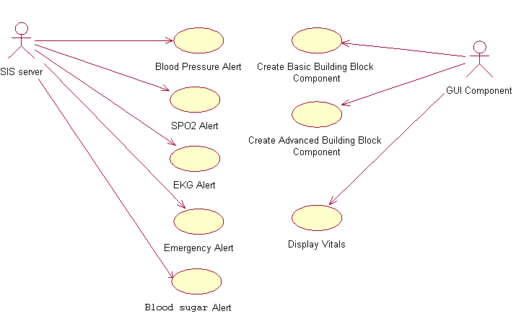GUI Use case Diagram

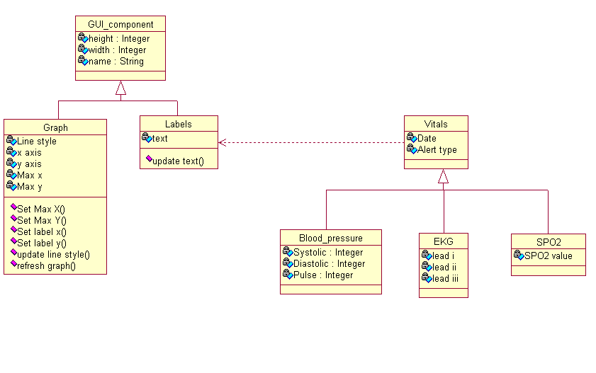GUI Class Diagram
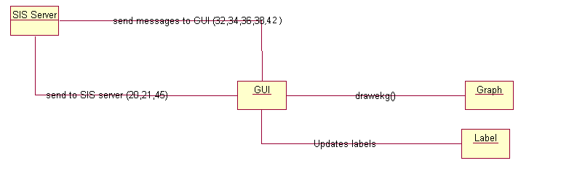GUI Collaboration Diagram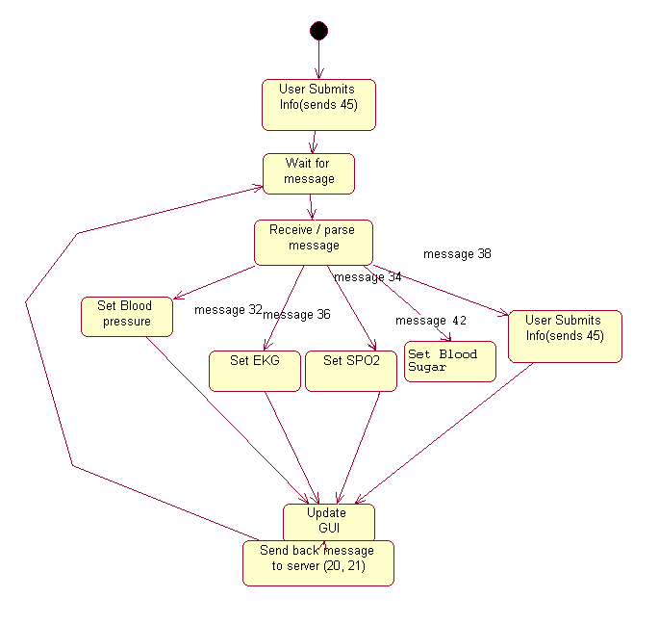GUI State chart diagram

SPO2
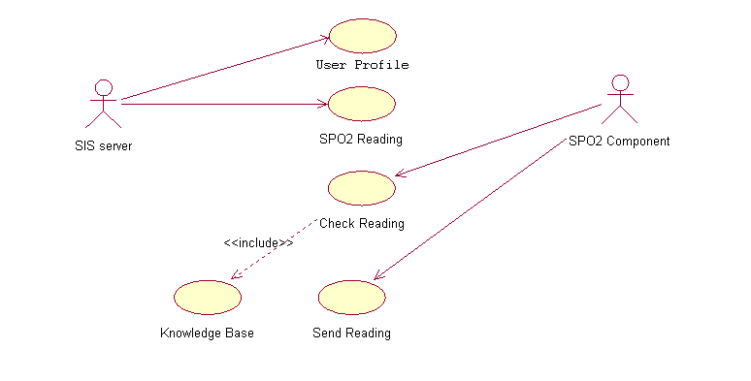
SPO2 Use Case Diagram
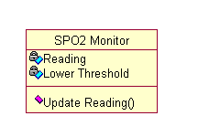
SPO2 Class Diagram
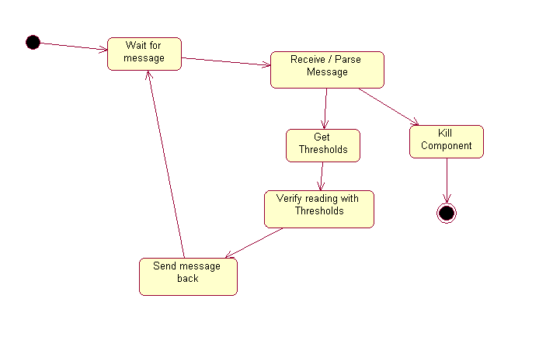
SPO2 State Chart Diagram
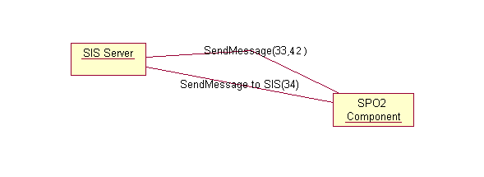 SPO2 Collaboration Diagram

SpO₂ Knowledge Base
Brief medical Background
SpO₂ (Saturation of peripheral oxygen) – estimates the oxygen saturation level. This measures the amount of oxygen attached to the hemoglobin cells in the circulatory system. A simpler explanation is the amount of oxygen being carried by red blood cells. The result shown will be a percentage. A normal percentage is 98, and this means that 98% of the air you are breathing gets to your body tissues. A table is shown below which further breaks down SpO₂ levels.
The equation used to calculate SpO₂ is as follows:
SpO₂ = HbO₂ / (HbO₂ + Hb)
This level is typically measured by using a device known as a pulse oximeter. This device works by indirectly measuring the oxygen saturation of a patient’s blood.
The SpO₂ levels tend to drop (up to or around 5%) while sleeping, but this is a normal occurrence. Patients with asthma tend to have lower SpO₂ readings, and typically have a harder time maintaining them.
 | Healthy | Pulmonary, cardiovascular chronic disease or common cold, or pneumonia | High altitude
Good | 96%-99% | Normal Drops by 4% | Drops by 2-4%
Warning | Drop by 3-4% then something wrong | Warning Drops by 4% | Drops by 2-4%
Deadly | <90% | There is no exact number but if you test 4% below your average or less than 90% then seek immediate attention | Drops by 2-4%

Appendix
Source code g2GUI.java
import java.io.*;
import java.net.*;
import java.util.*;
import java.awt.*;
import java.sql.Timestamp;
import javax.swing.*;

public class g2GUI extends javax.swing.JFrame implements Runnable {
boolean didUserLogin;
String address;
int port;
Socket s;
MsgEncoder en;
MsgDecoder de;
int[] l1,l2,l3;
ArrayList<Point> pointsl1,pointsl2,pointsl3;

int min,max, numData;

public g2GUI(String addr, int prt) {
address = addr;
port = prt;

initComponents();
getContentPane().setBackground(new Color(102,102,102));

new Thread(this).start();
didUserLogin=false;
jPanel2.setVisible(false);
loginMessage.setVisible(true);

}

public void run() {
KeyValueList inkvl;
int sys, dia,pul,spo2In,bloodSugar;
try{
s = new Socket(address,port);
en = new MsgEncoder();
de = new MsgDecoder(s.getInputStream());
KeyValueList l = new KeyValueList();
l.addPair("MsgID", "23");
l.addPair("Name", "g2GUI");
en.sendMsg(l, s.getOutputStream());
int msgID;
while(true){
System.out.println("Waiting for server to send message...");
inkvl = de.getMsg();
msgID = Integer.parseInt(inkvl.getValue("MsgID"));
// look for a message ID in the KeyValueList
if((inkvl.lookupKey("MsgID")!=-1 && didUserLogin) || msgID==26 ){
// parse to an int, then do what is needed

switch(msgID){
case 22:
System.exit(0);break;

case 26: System.out.println("Initialized");break;

case 32:
// take in Blood Pressure Alert
System.out.println("Got message 32 Blood Pressure Alert");
sys = Integer.parseInt(inkvl.getValue("Systolic"));
dia = Integer.parseInt(inkvl.getValue("Diastolic"));
pul = Integer.parseInt(inkvl.getValue("Pulse"));
this.systolic.setText(""+sys);
this.diastolic.setText(""+dia);
this.pulse.setText(""+pul);
JOptionPane.showMessageDialog(this, inkvl.getValue("Alert Type"));
break;

case 34:
// SPO2 Alert
System.out.println("Got message 34 SPO2 Alert");
spo2In = Integer.parseInt(inkvl.getValue("SPO2"));
this.spo2.setText(""+spo2In);
JOptionPane.showMessageDialog(this, inkvl.getValue("Alert Type"));
break;

case 36:
try {
this.explode(inkvl.getValue("LeadI"),inkvl.getValue("LeadII"),inkvl.getValue("LeadIII"));
this.drawEkg();
}
catch(Exception e) {
System.out.println("Error graphing "+e);
}
JOptionPane.showMessageDialog(this, inkvl.getValue("Alert Type"));
break;
case 38:

System.out.println("Got 38");
///////////////
sys = Integer.parseInt(inkvl.getValue("Systolic"));
dia = Integer.parseInt(inkvl.getValue("Diastolic"));
pul = Integer.parseInt(inkvl.getValue("Pulse"));
spo2In = Integer.parseInt(inkvl.getValue("SPO2"));

this.spo2.setText(""+spo2In);
this.systolic.setText(""+sys);
this.diastolic.setText(""+dia);
this.pulse.setText(""+pul);

//comment this out if the graph doesnt work//////////////////
try {
this.explode(inkvl.getValue("LeadI"),inkvl.getValue("LeadII"),inkvl.getValue("LeadIII"));
this.drawEkg();
}
catch(Exception e) {
System.out.println("Error graphing");
}

JOptionPane.showMessageDialog(this, inkvl.getValue("Alert Type"));
break;
case 42:
System.out.println("Got 42");
bloodSugar = Integer.parseInt(inkvl.getValue("Blood Sugar"));
//update bloodSugar on gui here with the value bloodSugar
this.bloodSugarLabel.setText(""+bloodSugar);
JOptionPane.showMessageDialog(this, inkvl.getValue("Alert Type"));
break;

default: System.out.println("GUI does not take MsgID: "+msgID);break;
}
}
else{
System.out.println("No MsgID or Not logged in");
}
}
}
catch (Exception e) {
System.out.println(e);
}
}

public void drawEkg() {
max = min = l1[0];

numData = Math.max(l3.length,Math.max(l1.length,l2.length));
for (int i = 1; i<l1.length;i++) {
if (l1[i] > max)
max = l1[i];
if (l1[i] < min)
min = l1[i];
}
for (int i = 0; i<l2.length;i++) {
if (l2[i] > max)
max = l1[i];
if (l2[i] < min)
min = l2[i];
}
for (int i = 0; i<l3.length;i++) {
if (l3[i] > max)
max = l3[i];
if (l3[i] < min)
min = l3[i];
}
//graph.setSize(new Dimension(numData,max-min));

int squeeze = (int)Math.ceil(numData/graph.getWidth());
int shrink = (int)(Math.ceil((Math.abs(min)+max)/graph.getHeight()));
int zoom = 1;
pointsl1 = new ArrayList<Point>();
pointsl2 = new ArrayList<Point>();
pointsl3 = new ArrayList<Point>();
for (int i = 0; i<l1.length-squeeze;i+=squeeze) {
int av=0;
for (int j = 0;j<squeeze;j++) {
av+= l1[i+j];
}
av=(av/squeeze)/(shrink/zoom);
pointsl1.add(new Point(i,-av+(max/shrink)));
}
for (int i = 0; i<l2.length-squeeze;i+=squeeze) {
int av=0;
for (int j = 0;j<squeeze;j++) {
av+= l2[i+j];
}
av=(av/squeeze)/(shrink/zoom);
pointsl2.add(new Point(i,-av+(max/shrink)));
}
for (int i = 0; i<l3.length-squeeze;i+=squeeze) {
int av=0;
for (int j = 0;j<squeeze;j++) {
av += l3[i+j];
}
av=(av/squeeze)/(shrink/zoom);
pointsl3.add(new Point(i,-av+(max/shrink)));
}
((Graph)graph).paintIt(pointsl1, pointsl2, pointsl3,(max/shrink));

}

public void explode (String l1, String l2, String l3) {
String[] one = l1.split(" ");
String[] two = l2.split(" ");
String[] three = l3.split(" ");
this.l1 = new int[one.length];
this.l2 = new int[two.length];
this.l3 = new int[three.length];

for(int i =0; i<one.length;i++) {

this.l1[i] = (int)Integer.parseInt(one[i]);
this.l2[i] = (int)Integer.parseInt(two[i]);
this.l3[i] = (int)Integer.parseInt(three[i]);
}
}

@SuppressWarnings("unchecked")
// <editor-fold defaultstate="collapsed" desc="Generated Code">//GEN-BEGIN:initComponents
private void initComponents() {

Meal = new javax.swing.ButtonGroup();
Sex = new javax.swing.ButtonGroup();
diabetesGroup = new javax.swing.ButtonGroup();
graph = new Graph();
jLabel2 = new javax.swing.JLabel();
jLabel1 = new javax.swing.JLabel();
jPanel2 = new javax.swing.JPanel();
jSeparator1 = new javax.swing.JSeparator();
pulse = new javax.swing.JLabel();
jLabel6 = new javax.swing.JLabel();
spo2 = new javax.swing.JLabel();
systolic = new javax.swing.JLabel();
diastolic = new javax.swing.JLabel();
jLabel4 = new javax.swing.JLabel();
jLabel5 = new javax.swing.JLabel();
jLabel7 = new javax.swing.JLabel();
jSeparator2 = new javax.swing.JSeparator();
jLabel3 = new javax.swing.JLabel();
jSeparator3 = new javax.swing.JSeparator();
jLabel10 = new javax.swing.JLabel();
bloodSugarLabel = new javax.swing.JLabel();
jPanel3 = new javax.swing.JPanel();
label1 = new java.awt.Label();
label2 = new java.awt.Label();
label3 = new java.awt.Label();
label4 = new java.awt.Label();
label5 = new java.awt.Label();
HeartDisease = new javax.swing.JCheckBox();
MealFast = new javax.swing.JRadioButton();
MealBefore = new javax.swing.JRadioButton();
MealAfter = new javax.swing.JRadioButton();
UserName = new javax.swing.JTextField();
jLabel8 = new javax.swing.JLabel();
SexMale = new javax.swing.JRadioButton();
SexFemale = new javax.swing.JRadioButton();
Weight = new javax.swing.JTextField();
Age = new javax.swing.JTextField();
Height = new javax.swing.JTextField();
submitB = new javax.swing.JButton();
jLabel9 = new javax.swing.JLabel();
Dnormal = new javax.swing.JRadioButton();
Dprediabetic = new javax.swing.JRadioButton();
Ddiabetic = new javax.swing.JRadioButton();
loginMessage = new javax.swing.JLabel();

setDefaultCloseOperation(javax.swing.WindowConstants.EXIT_ON_CLOSE);
setBackground(new java.awt.Color(102, 102, 102));
setResizable(false);

graph.setBackground(new java.awt.Color(204, 204, 255));
graph.setBorder(javax.swing.BorderFactory.createBevelBorder(javax.swing.border.BevelBorder.RAISED));

jLabel2.setText("EKG Graph");

javax.swing.GroupLayout graphLayout = new javax.swing.GroupLayout(graph);
graph.setLayout(graphLayout);
graphLayout.setHorizontalGroup(
graphLayout.createParallelGroup(javax.swing.GroupLayout.Alignment.LEADING)
.addGroup(javax.swing.GroupLayout.Alignment.TRAILING, graphLayout.createSequentialGroup()
.addContainerGap(866, Short.MAX_VALUE)
.addComponent(jLabel2)
.addContainerGap())
);
graphLayout.setVerticalGroup(
graphLayout.createParallelGroup(javax.swing.GroupLayout.Alignment.LEADING)
.addGroup(graphLayout.createSequentialGroup()
.addContainerGap()
.addComponent(jLabel2)
.addContainerGap(145, Short.MAX_VALUE))
);

jLabel1.setBackground(new java.awt.Color(228, 224, 224));
jLabel1.setFont(new java.awt.Font("Monospaced", 1, 18));
jLabel1.setForeground(new java.awt.Color(255, 255, 102));
jLabel1.setText("Health Care Monitor");

jPanel2.setBackground(new java.awt.Color(153, 153, 153));
jPanel2.setBorder(javax.swing.BorderFactory.createTitledBorder(""));
jPanel2.setForeground(new java.awt.Color(28, 28, 28));

jSeparator1.setOrientation(javax.swing.SwingConstants.VERTICAL);

pulse.setFont(new java.awt.Font("Lucida Grande", 0, 36));
pulse.setText("-");

jLabel6.setFont(new java.awt.Font("Lucida Grande", 0, 15));
jLabel6.setForeground(new java.awt.Color(255, 255, 102));
jLabel6.setText("Pulse");
jLabel6.setVerticalAlignment(javax.swing.SwingConstants.TOP);

spo2.setFont(new java.awt.Font("Lucida Grande", 0, 36));
spo2.setText("-");

systolic.setText("-");

diastolic.setText("-");

jLabel4.setFont(new java.awt.Font("Lucida Grande", 0, 14));
jLabel4.setText("Systolic:");

jLabel5.setFont(new java.awt.Font("Lucida Grande", 0, 14));
jLabel5.setText("Diastolic:");

jLabel7.setFont(new java.awt.Font("Lucida Grande", 0, 15));
jLabel7.setForeground(new java.awt.Color(255, 255, 102));
jLabel7.setText("SPO2");
jLabel7.setVerticalAlignment(javax.swing.SwingConstants.TOP);

jSeparator2.setOrientation(javax.swing.SwingConstants.VERTICAL);

jLabel3.setFont(new java.awt.Font("Lucida Grande", 0, 15));
jLabel3.setForeground(new java.awt.Color(255, 255, 102));
jLabel3.setText("Blood Pressure");
jLabel3.setVerticalAlignment(javax.swing.SwingConstants.TOP);

jSeparator3.setOrientation(javax.swing.SwingConstants.VERTICAL);

jLabel10.setFont(new java.awt.Font("Lucida Grande", 0, 15));
jLabel10.setForeground(new java.awt.Color(255, 255, 102));
jLabel10.setText("Blood Sugar");
jLabel10.setVerticalAlignment(javax.swing.SwingConstants.TOP);

bloodSugarLabel.setFont(new java.awt.Font("Lucida Grande", 0, 36)); // NOI18N
bloodSugarLabel.setText("-");

javax.swing.GroupLayout jPanel2Layout = new javax.swing.GroupLayout(jPanel2);
jPanel2.setLayout(jPanel2Layout);
jPanel2Layout.setHorizontalGroup(
jPanel2Layout.createParallelGroup(javax.swing.GroupLayout.Alignment.LEADING)
.addGroup(javax.swing.GroupLayout.Alignment.TRAILING, jPanel2Layout.createSequentialGroup()
.addContainerGap()
.addGroup(jPanel2Layout.createParallelGroup(javax.swing.GroupLayout.Alignment.TRAILING)
.addGroup(jPanel2Layout.createSequentialGroup()
.addGroup(jPanel2Layout.createParallelGroup(javax.swing.GroupLayout.Alignment.TRAILING)
.addComponent(jLabel5)
.addComponent(jLabel4))
.addGap(18, 18, 18)
.addGroup(jPanel2Layout.createParallelGroup(javax.swing.GroupLayout.Alignment.LEADING)
.addComponent(systolic)
.addComponent(diastolic))
.addGap(27, 27, 27))
.addGroup(jPanel2Layout.createSequentialGroup()
.addComponent(jLabel3)
.addPreferredGap(javax.swing.LayoutStyle.ComponentPlacement.UNRELATED)))
.addComponent(jSeparator3, javax.swing.GroupLayout.PREFERRED_SIZE, javax.swing.GroupLayout.DEFAULT_SIZE, javax.swing.GroupLayout.PREFERRED_SIZE)
.addGroup(jPanel2Layout.createParallelGroup(javax.swing.GroupLayout.Alignment.LEADING)
.addGroup(jPanel2Layout.createSequentialGroup()
.addPreferredGap(javax.swing.LayoutStyle.ComponentPlacement.RELATED)
.addComponent(jLabel10))
.addGroup(jPanel2Layout.createSequentialGroup()
.addGap(23, 23, 23)
.addComponent(bloodSugarLabel, javax.swing.GroupLayout.PREFERRED_SIZE, 64, javax.swing.GroupLayout.PREFERRED_SIZE)))
.addPreferredGap(javax.swing.LayoutStyle.ComponentPlacement.RELATED, 33, Short.MAX_VALUE)
.addComponent(jSeparator1, javax.swing.GroupLayout.PREFERRED_SIZE, javax.swing.GroupLayout.DEFAULT_SIZE, javax.swing.GroupLayout.PREFERRED_SIZE)
.addGroup(jPanel2Layout.createParallelGroup(javax.swing.GroupLayout.Alignment.LEADING)
.addGroup(jPanel2Layout.createSequentialGroup()
.addGap(14, 14, 14)
.addComponent(jLabel6))
.addGroup(jPanel2Layout.createSequentialGroup()
.addPreferredGap(javax.swing.LayoutStyle.ComponentPlacement.UNRELATED)
.addComponent(pulse, javax.swing.GroupLayout.PREFERRED_SIZE, 64, javax.swing.GroupLayout.PREFERRED_SIZE)))
.addPreferredGap(javax.swing.LayoutStyle.ComponentPlacement.RELATED)
.addComponent(jSeparator2, javax.swing.GroupLayout.PREFERRED_SIZE, javax.swing.GroupLayout.DEFAULT_SIZE, javax.swing.GroupLayout.PREFERRED_SIZE)
.addGap(18, 18, 18)
.addGroup(jPanel2Layout.createParallelGroup(javax.swing.GroupLayout.Alignment.LEADING)
.addComponent(spo2)
.addComponent(jLabel7))
.addGap(54, 54, 54))
);
jPanel2Layout.setVerticalGroup(
jPanel2Layout.createParallelGroup(javax.swing.GroupLayout.Alignment.LEADING)
.addGroup(javax.swing.GroupLayout.Alignment.TRAILING, jPanel2Layout.createSequentialGroup()
.addContainerGap(20, Short.MAX_VALUE)
.addGroup(jPanel2Layout.createParallelGroup(javax.swing.GroupLayout.Alignment.LEADING)
.addGroup(jPanel2Layout.createSequentialGroup()
.addComponent(jLabel10, javax.swing.GroupLayout.PREFERRED_SIZE, 19, javax.swing.GroupLayout.PREFERRED_SIZE)
.addPreferredGap(javax.swing.LayoutStyle.ComponentPlacement.RELATED)
.addComponent(bloodSugarLabel, javax.swing.GroupLayout.PREFERRED_SIZE, 45, javax.swing.GroupLayout.PREFERRED_SIZE))
.addComponent(jSeparator1, javax.swing.GroupLayout.PREFERRED_SIZE, 83, javax.swing.GroupLayout.PREFERRED_SIZE)
.addGroup(jPanel2Layout.createSequentialGroup()
.addComponent(jLabel6)
.addPreferredGap(javax.swing.LayoutStyle.ComponentPlacement.RELATED)
.addComponent(pulse, javax.swing.GroupLayout.PREFERRED_SIZE, 45, javax.swing.GroupLayout.PREFERRED_SIZE))
.addComponent(jSeparator2, javax.swing.GroupLayout.PREFERRED_SIZE, 83, javax.swing.GroupLayout.PREFERRED_SIZE)
.addGroup(jPanel2Layout.createSequentialGroup()
.addComponent(jLabel7)
.addPreferredGap(javax.swing.LayoutStyle.ComponentPlacement.RELATED)
.addComponent(spo2))
.addGroup(jPanel2Layout.createParallelGroup(javax.swing.GroupLayout.Alignment.TRAILING, false)
.addGroup(jPanel2Layout.createSequentialGroup()
.addComponent(jLabel3, javax.swing.GroupLayout.PREFERRED_SIZE, 19, javax.swing.GroupLayout.PREFERRED_SIZE)
.addPreferredGap(javax.swing.LayoutStyle.ComponentPlacement.RELATED, javax.swing.GroupLayout.DEFAULT_SIZE, Short.MAX_VALUE)
.addGroup(jPanel2Layout.createParallelGroup(javax.swing.GroupLayout.Alignment.BASELINE)
.addComponent(jLabel4)
.addComponent(systolic))
.addPreferredGap(javax.swing.LayoutStyle.ComponentPlacement.UNRELATED)
.addGroup(jPanel2Layout.createParallelGroup(javax.swing.GroupLayout.Alignment.BASELINE)
.addComponent(jLabel5)
.addComponent(diastolic)))
.addComponent(jSeparator3, javax.swing.GroupLayout.PREFERRED_SIZE, 83, javax.swing.GroupLayout.PREFERRED_SIZE)))
.addGap(44, 44, 44))
);

jPanel3.setBackground(new java.awt.Color(153, 153, 153));
jPanel3.setBorder(javax.swing.BorderFactory.createTitledBorder(""));
jPanel3.setForeground(new java.awt.Color(28, 28, 28));

label1.setBackground(new java.awt.Color(153, 153, 153));
label1.setText("User Name");

label2.setBackground(new java.awt.Color(153, 153, 153));
label2.setText("Sex");

label3.setText("Age");

label4.setBackground(new java.awt.Color(153, 153, 153));
label4.setText("Weight(lb)");

label5.setBackground(new java.awt.Color(153, 153, 153));
label5.setText("Height(in)");

HeartDisease.setBackground(new java.awt.Color(153, 153, 153));
HeartDisease.setText("Heart Disease?");

MealFast.setBackground(new java.awt.Color(153, 153, 153));
Meal.add(MealFast);
MealFast.setText("Fasting");
MealFast.addActionListener(new java.awt.event.ActionListener() {
public void actionPerformed(java.awt.event.ActionEvent evt) {
MealFastActionPerformed(evt);
}
});

MealBefore.setBackground(new java.awt.Color(153, 153, 153));
Meal.add(MealBefore);
MealBefore.setText("Before");

MealAfter.setBackground(new java.awt.Color(153, 153, 153));
Meal.add(MealAfter);
MealAfter.setText("After");

jLabel8.setText("Meal:");

SexMale.setBackground(new java.awt.Color(153, 153, 153));
Sex.add(SexMale);
SexMale.setText("Male");

SexFemale.setBackground(new java.awt.Color(153, 153, 153));
Sex.add(SexFemale);
SexFemale.setText("Female");

submitB.setText("Submit");
submitB.addActionListener(new java.awt.event.ActionListener() {
public void actionPerformed(java.awt.event.ActionEvent evt) {
submitBActionPerformed(evt);
}
});

jLabel9.setText("Diabetes:");

Dnormal.setBackground(new java.awt.Color(153, 153, 153));
diabetesGroup.add(Dnormal);
Dnormal.setText("Normal");

Dprediabetic.setBackground(new java.awt.Color(153, 153, 153));
diabetesGroup.add(Dprediabetic);
Dprediabetic.setText("Prediabetic");

Ddiabetic.setBackground(new java.awt.Color(153, 153, 153));
diabetesGroup.add(Ddiabetic);
Ddiabetic.setText("diabetic");

javax.swing.GroupLayout jPanel3Layout = new javax.swing.GroupLayout(jPanel3);
jPanel3.setLayout(jPanel3Layout);
jPanel3Layout.setHorizontalGroup(
jPanel3Layout.createParallelGroup(javax.swing.GroupLayout.Alignment.LEADING)
.addGroup(jPanel3Layout.createSequentialGroup()
.addGroup(jPanel3Layout.createParallelGroup(javax.swing.GroupLayout.Alignment.LEADING)
.addGroup(jPanel3Layout.createSequentialGroup()
.addContainerGap()
.addComponent(label1, javax.swing.GroupLayout.PREFERRED_SIZE, javax.swing.GroupLayout.DEFAULT_SIZE, javax.swing.GroupLayout.PREFERRED_SIZE)
.addGap(4, 4, 4)
.addComponent(UserName, javax.swing.GroupLayout.PREFERRED_SIZE, 90, javax.swing.GroupLayout.PREFERRED_SIZE)
.addGap(18, 18, 18)
.addComponent(HeartDisease))
.addGroup(jPanel3Layout.createSequentialGroup()
.addContainerGap(8, javax.swing.GroupLayout.PREFERRED_SIZE)
.addGroup(jPanel3Layout.createParallelGroup(javax.swing.GroupLayout.Alignment.LEADING)
.addGroup(jPanel3Layout.createSequentialGroup()
.addGap(2, 2, 2)
.addGroup(jPanel3Layout.createParallelGroup(javax.swing.GroupLayout.Alignment.LEADING)
.addGroup(jPanel3Layout.createSequentialGroup()
.addGap(10, 10, 10)
.addGroup(jPanel3Layout.createParallelGroup(javax.swing.GroupLayout.Alignment.LEADING)
.addGroup(jPanel3Layout.createSequentialGroup()
.addGap(40, 40, 40)
.addComponent(MealFast))
.addComponent(jLabel8, javax.swing.GroupLayout.PREFERRED_SIZE, 60, javax.swing.GroupLayout.PREFERRED_SIZE))
.addPreferredGap(javax.swing.LayoutStyle.ComponentPlacement.UNRELATED)
.addComponent(MealBefore)
.addPreferredGap(javax.swing.LayoutStyle.ComponentPlacement.UNRELATED)
.addComponent(MealAfter))
.addGroup(jPanel3Layout.createSequentialGroup()
.addComponent(label3, javax.swing.GroupLayout.PREFERRED_SIZE, javax.swing.GroupLayout.DEFAULT_SIZE, javax.swing.GroupLayout.PREFERRED_SIZE)
.addGap(5, 5, 5)
.addComponent(Age, javax.swing.GroupLayout.PREFERRED_SIZE, 40, javax.swing.GroupLayout.PREFERRED_SIZE)
.addPreferredGap(javax.swing.LayoutStyle.ComponentPlacement.RELATED)
.addComponent(label5, javax.swing.GroupLayout.PREFERRED_SIZE, javax.swing.GroupLayout.DEFAULT_SIZE, javax.swing.GroupLayout.PREFERRED_SIZE)
.addPreferredGap(javax.swing.LayoutStyle.ComponentPlacement.RELATED)
.addComponent(Height, javax.swing.GroupLayout.PREFERRED_SIZE, 40, javax.swing.GroupLayout.PREFERRED_SIZE)
.addPreferredGap(javax.swing.LayoutStyle.ComponentPlacement.RELATED)
.addComponent(label4, javax.swing.GroupLayout.PREFERRED_SIZE, javax.swing.GroupLayout.DEFAULT_SIZE, javax.swing.GroupLayout.PREFERRED_SIZE)
.addGap(8, 8, 8)
.addComponent(Weight, javax.swing.GroupLayout.PREFERRED_SIZE, 40, javax.swing.GroupLayout.PREFERRED_SIZE))))
.addGroup(jPanel3Layout.createSequentialGroup()
.addGap(42, 42, 42)
.addComponent(label2, javax.swing.GroupLayout.PREFERRED_SIZE, javax.swing.GroupLayout.DEFAULT_SIZE, javax.swing.GroupLayout.PREFERRED_SIZE)
.addGap(4, 4, 4)
.addComponent(SexMale)
.addGap(23, 23, 23)
.addComponent(SexFemale))))
.addGroup(jPanel3Layout.createSequentialGroup()
.addComponent(jLabel9)
.addPreferredGap(javax.swing.LayoutStyle.ComponentPlacement.UNRELATED)
.addComponent(Dnormal)
.addPreferredGap(javax.swing.LayoutStyle.ComponentPlacement.UNRELATED)
.addComponent(Dprediabetic)
.addPreferredGap(javax.swing.LayoutStyle.ComponentPlacement.UNRELATED)
.addComponent(Ddiabetic)))
.addContainerGap(64, Short.MAX_VALUE))
.addGroup(javax.swing.GroupLayout.Alignment.TRAILING, jPanel3Layout.createSequentialGroup()
.addContainerGap(303, Short.MAX_VALUE)
.addComponent(submitB)
.addContainerGap())
);
jPanel3Layout.setVerticalGroup(
jPanel3Layout.createParallelGroup(javax.swing.GroupLayout.Alignment.LEADING)
.addGroup(jPanel3Layout.createSequentialGroup()
.addContainerGap()
.addGroup(jPanel3Layout.createParallelGroup(javax.swing.GroupLayout.Alignment.LEADING)
.addGroup(jPanel3Layout.createParallelGroup(javax.swing.GroupLayout.Alignment.BASELINE)
.addComponent(UserName, javax.swing.GroupLayout.PREFERRED_SIZE, javax.swing.GroupLayout.DEFAULT_SIZE, javax.swing.GroupLayout.PREFERRED_SIZE)
.addComponent(HeartDisease))
.addComponent(label1, javax.swing.GroupLayout.PREFERRED_SIZE, javax.swing.GroupLayout.DEFAULT_SIZE, javax.swing.GroupLayout.PREFERRED_SIZE))
.addGap(3, 3, 3)
.addGroup(jPanel3Layout.createParallelGroup(javax.swing.GroupLayout.Alignment.LEADING, false)
.addComponent(SexMale, javax.swing.GroupLayout.DEFAULT_SIZE, javax.swing.GroupLayout.DEFAULT_SIZE, Short.MAX_VALUE)
.addComponent(SexFemale, javax.swing.GroupLayout.DEFAULT_SIZE, javax.swing.GroupLayout.DEFAULT_SIZE, Short.MAX_VALUE)
.addComponent(label2, javax.swing.GroupLayout.PREFERRED_SIZE, javax.swing.GroupLayout.DEFAULT_SIZE, javax.swing.GroupLayout.PREFERRED_SIZE))
.addGap(7, 7, 7)
.addGroup(jPanel3Layout.createParallelGroup(javax.swing.GroupLayout.Alignment.LEADING, false)
.addComponent(Age)
.addComponent(Weight)
.addComponent(label4, javax.swing.GroupLayout.DEFAULT_SIZE, javax.swing.GroupLayout.DEFAULT_SIZE, Short.MAX_VALUE)
.addComponent(label5, javax.swing.GroupLayout.DEFAULT_SIZE, javax.swing.GroupLayout.DEFAULT_SIZE, Short.MAX_VALUE)
.addComponent(Height)
.addComponent(label3, javax.swing.GroupLayout.PREFERRED_SIZE, javax.swing.GroupLayout.DEFAULT_SIZE, javax.swing.GroupLayout.PREFERRED_SIZE))
.addGroup(jPanel3Layout.createParallelGroup(javax.swing.GroupLayout.Alignment.LEADING)
.addGroup(jPanel3Layout.createSequentialGroup()
.addPreferredGap(javax.swing.LayoutStyle.ComponentPlacement.RELATED)
.addGroup(jPanel3Layout.createParallelGroup(javax.swing.GroupLayout.Alignment.LEADING)
.addGroup(jPanel3Layout.createParallelGroup(javax.swing.GroupLayout.Alignment.BASELINE)
.addComponent(MealFast)
.addComponent(MealBefore)
.addComponent(MealAfter))
.addComponent(jLabel8, javax.swing.GroupLayout.PREFERRED_SIZE, 20, javax.swing.GroupLayout.PREFERRED_SIZE))
.addPreferredGap(javax.swing.LayoutStyle.ComponentPlacement.UNRELATED)
.addGroup(jPanel3Layout.createParallelGroup(javax.swing.GroupLayout.Alignment.TRAILING, false)
.addComponent(jLabel9, javax.swing.GroupLayout.Alignment.LEADING, javax.swing.GroupLayout.DEFAULT_SIZE, javax.swing.GroupLayout.DEFAULT_SIZE, Short.MAX_VALUE)
.addComponent(Dnormal, javax.swing.GroupLayout.Alignment.LEADING, javax.swing.GroupLayout.DEFAULT_SIZE, javax.swing.GroupLayout.DEFAULT_SIZE, Short.MAX_VALUE)
.addComponent(Dprediabetic, javax.swing.GroupLayout.Alignment.LEADING, javax.swing.GroupLayout.DEFAULT_SIZE, javax.swing.GroupLayout.DEFAULT_SIZE, Short.MAX_VALUE)
.addComponent(Ddiabetic, javax.swing.GroupLayout.Alignment.LEADING)))
.addGroup(jPanel3Layout.createSequentialGroup()
.addGap(25, 25, 25)
.addComponent(submitB)))
.addGap(4, 4, 4))
);

loginMessage.setBackground(new java.awt.Color(153, 153, 153));
loginMessage.setFont(new java.awt.Font("Tahoma", 0, 18));
loginMessage.setForeground(new java.awt.Color(255, 255, 51));
loginMessage.setText("Please Login");

javax.swing.GroupLayout layout = new javax.swing.GroupLayout(getContentPane());
getContentPane().setLayout(layout);
layout.setHorizontalGroup(
layout.createParallelGroup(javax.swing.GroupLayout.Alignment.LEADING)
.addGroup(layout.createSequentialGroup()
.addContainerGap()
.addGroup(layout.createParallelGroup(javax.swing.GroupLayout.Alignment.LEADING)
.addComponent(jLabel1)
.addGroup(layout.createSequentialGroup()
.addGroup(layout.createParallelGroup(javax.swing.GroupLayout.Alignment.LEADING)
.addComponent(loginMessage, javax.swing.GroupLayout.PREFERRED_SIZE, 290, javax.swing.GroupLayout.PREFERRED_SIZE)
.addComponent(jPanel2, javax.swing.GroupLayout.PREFERRED_SIZE, javax.swing.GroupLayout.DEFAULT_SIZE, javax.swing.GroupLayout.PREFERRED_SIZE))
.addGap(18, 18, 18)
.addComponent(jPanel3, javax.swing.GroupLayout.DEFAULT_SIZE, javax.swing.GroupLayout.DEFAULT_SIZE, Short.MAX_VALUE))
.addComponent(graph, javax.swing.GroupLayout.DEFAULT_SIZE, javax.swing.GroupLayout.DEFAULT_SIZE, Short.MAX_VALUE))
.addContainerGap(javax.swing.GroupLayout.DEFAULT_SIZE, Short.MAX_VALUE))
);
layout.setVerticalGroup(
layout.createParallelGroup(javax.swing.GroupLayout.Alignment.LEADING)
.addGroup(layout.createSequentialGroup()
.addContainerGap()
.addComponent(jLabel1)
.addPreferredGap(javax.swing.LayoutStyle.ComponentPlacement.RELATED)
.addComponent(graph, javax.swing.GroupLayout.PREFERRED_SIZE, javax.swing.GroupLayout.DEFAULT_SIZE, javax.swing.GroupLayout.PREFERRED_SIZE)
.addPreferredGap(javax.swing.LayoutStyle.ComponentPlacement.RELATED)
.addGroup(layout.createParallelGroup(javax.swing.GroupLayout.Alignment.TRAILING)
.addComponent(jPanel3, javax.swing.GroupLayout.PREFERRED_SIZE, 170, javax.swing.GroupLayout.PREFERRED_SIZE)
.addGroup(layout.createSequentialGroup()
.addComponent(loginMessage, javax.swing.GroupLayout.DEFAULT_SIZE, javax.swing.GroupLayout.DEFAULT_SIZE, Short.MAX_VALUE)
.addPreferredGap(javax.swing.LayoutStyle.ComponentPlacement.RELATED)
.addComponent(jPanel2, javax.swing.GroupLayout.PREFERRED_SIZE, javax.swing.GroupLayout.DEFAULT_SIZE, javax.swing.GroupLayout.PREFERRED_SIZE)))
.addContainerGap(javax.swing.GroupLayout.DEFAULT_SIZE, Short.MAX_VALUE))
);

pack();
}// </editor-fold>//GEN-END:initComponents

private void MealFastActionPerformed(java.awt.event.ActionEvent evt) {//GEN-FIRST:event_MealFastActionPerformed
// TODO add your handling code here:
}//GEN-LAST:event_MealFastActionPerformed

private void submitBActionPerformed(java.awt.event.ActionEvent evt) {//GEN-FIRST:event_submitBActionPerformed
// this button is pressed when the user wants to send message 45
KeyValueList l = new KeyValueList();
String errorStr ="Please provide the following information:";
boolean validMSG = true;
l.addPair("MsgID", "45");

// Username
if(UserName.getText().equals("")){
errorStr+="\nusername";
validMSG = false;
}else{
l.addPair("UserName",UserName.getText());
}

// Age
if(Age.getText().equals("")){
errorStr+="\nage";
validMSG = false;
}else{
l.addPair("Age",Age.getText());
}

// Height
if(Height.getText().equals("")){
errorStr+="\nheight";
validMSG = false;
}else{
l.addPair("Height",Height.getText());
}

// Weight
if(Weight.getText().equals("")){
errorStr+="\nweight";
validMSG = false;
}else{
l.addPair("Weight",Weight.getText());
}

// check sex:
if(!SexMale.isSelected() && !SexFemale.isSelected()){
errorStr+="\ngender";
validMSG = false;
} else {
// determine m / f
if(SexMale.isSelected()){
l.addPair("Sex","male");
}else{
l.addPair("Sex","female");
}
}

// check meal
if(!MealFast.isSelected() && !MealBefore.isSelected() && !MealAfter.isSelected()){
errorStr+="\ndiet";
validMSG = false;
} else {
// fast / before / afer
if(MealFast.isSelected()){
l.addPair("Meal","fasting");
}else if(MealBefore.isSelected()) {
l.addPair("Meal","before");
}else{
l.addPair("Meal","after");
}
}

// check diabetes
if(!Dnormal.isSelected() && !Dprediabetic.isSelected() && !Ddiabetic.isSelected()){
errorStr+="\ndiabetes category";
validMSG = false;
} else {
// fast / before / afer
if(Dnormal.isSelected()){
l.addPair("Diabetes","normal");
}else if(Dprediabetic.isSelected()) {
l.addPair("Diabetes","prediabetic");
}else{
l.addPair("Diabetes","diabetic");
}
}

// heart disease - No check either yes or no
if(HeartDisease.isSelected()){
l.addPair("HeartDisease", "yes");
} else {
l.addPair("HeartDisease", "no");
}

if(validMSG){
// timestamp it and send
Date d = new Date();
d.getTime();
Timestamp ts = new Timestamp(d.getTime());
l.addPair("DateTime",ts.toString());

try{
// send it *as of 4/13/10 this will not show up in remote

System.out.println(l);

en.sendMsg(l, s.getOutputStream());
didUserLogin=true;
jPanel2.setVisible(true);
loginMessage.setVisible(false);
}
catch(Exception e){
System.out.println("Cannot send message 45");
}
}
else{
JOptionPane.showMessageDialog(this, errorStr);
}
}//GEN-LAST:event_submitBActionPerformed

/**
* @param args the command line arguments
*/
public static void main(String args[]) {
final String address1;
final int port1 = 7999;
// get params (address / port)
if(args.length>=1){
address1 = args[0];
}
else{
System.out.println("No address given, assuming 127.0.0.1");
address1 = "127.0.0.1";
}

java.awt.EventQueue.invokeLater(new Runnable() {
public void run() {
new g2GUI(address1,port1).setVisible(true);
}
});
}

// Variables declaration - do not modify//GEN-BEGIN:variables
private javax.swing.JTextField Age;
private javax.swing.JRadioButton Ddiabetic;
private javax.swing.JRadioButton Dnormal;
private javax.swing.JRadioButton Dprediabetic;
private javax.swing.JCheckBox HeartDisease;
private javax.swing.JTextField Height;
private javax.swing.ButtonGroup Meal;
private javax.swing.JRadioButton MealAfter;
private javax.swing.JRadioButton MealBefore;
private javax.swing.JRadioButton MealFast;
private javax.swing.ButtonGroup Sex;
private javax.swing.JRadioButton SexFemale;
private javax.swing.JRadioButton SexMale;
private javax.swing.JTextField UserName;
private javax.swing.JTextField Weight;
private javax.swing.JLabel bloodSugarLabel;
private javax.swing.ButtonGroup diabetesGroup;
private javax.swing.JLabel diastolic;
public javax.swing.JPanel graph;
private javax.swing.JLabel jLabel1;
private javax.swing.JLabel jLabel10;
private javax.swing.JLabel jLabel2;
private javax.swing.JLabel jLabel3;
private javax.swing.JLabel jLabel4;
private javax.swing.JLabel jLabel5;
private javax.swing.JLabel jLabel6;
private javax.swing.JLabel jLabel7;
private javax.swing.JLabel jLabel8;
private javax.swing.JLabel jLabel9;
private javax.swing.JPanel jPanel2;
private javax.swing.JPanel jPanel3;
private javax.swing.JSeparator jSeparator1;
private javax.swing.JSeparator jSeparator2;
private javax.swing.JSeparator jSeparator3;
private java.awt.Label label1;
private java.awt.Label label2;
private java.awt.Label label3;
private java.awt.Label label4;
private java.awt.Label label5;
private javax.swing.JLabel loginMessage;
private javax.swing.JLabel pulse;
private javax.swing.JLabel spo2;
private javax.swing.JButton submitB;
private javax.swing.JLabel systolic;
// End of variables declaration//GEN-END:variables

class Graph extends JPanel {
private ArrayList<Point> l1,l2,l3;
private int max;
public void paintIt(ArrayList<Point> l1, ArrayList<Point> l2, ArrayList<Point> l3, int max) {
this.l1 = l1;
this.l2 = l2;
this.l3 = l3;
this.max = max;
//System.out.println("got to printIt");
this.repaint();
}
public void paintComponent(Graphics g2) {
Graphics2D g = (Graphics2D)g2.create();
super.paintComponent(g);
//System.out.println("got to paint c");
if(l1 == null)
return;
//System.out.println("got to paint c");
g.setColor(Color.DARK_GRAY);
//g.drawString("Hello", 50, 50);
g.drawLine(0,max,this.getWidth(),max);
try {
for(int i = 0;i<l1.size()-1;i++) {
//System.out.println(this.l1.get(i).x + "," +this.l1.get(i).y+ "," + this.l1.get(i+1).x+ "," + this.l1.get(i+1).y);
g.drawLine(i, this.l1.get(i).y, i+1, this.l1.get(i+1).y);
g.drawLine(i, this.l2.get(i).y, i+1, this.l2.get(i+1).y);
g.drawLine(i, this.l3.get(i).y, i+1, this.l3.get(i+1).y);
}
}
catch (Exception e) {System.out.println(e);}
System.out.println("finished");

}
}
class Point {
public int x,y;
public Point(int x, int y) {
this.x=x;
this.y=y;
}
}
class KeyValueList
{
private Vector keys;
private Vector values;

/* Constructor */
public KeyValueList()
{
keys = new Vector();
values = new Vector();
}

/* Look up the value given key, used in getValue() */

public int lookupKey(String strKey)
{
for(int i=0; i < keys.size(); i++)
{
String k = (String) keys.elementAt(i);
if (strKey.equals(k))
return i;
}
return -1;
}

/* add new (key,value) pair to list */

public boolean addPair(String strKey,String strValue)
{
return (keys.add(strKey) && values.add(strValue));
}

/* get the value given key */

public String getValue(String strKey)
{
int index=lookupKey(strKey);
if (index==-1)
return null;
return (String) values.elementAt(index);
}

public void setValue(int index, String val)
{
if(index >= 0 && index < size())
values.set(index, val);
}

/* Show whole list */
public String toString()
{
String result = new String();
for(int i=0; i<keys.size(); i++)
{
result+=(String) keys.elementAt(i)+":"+(String) values.elementAt(i)+"\n";
}
return result;
}

public int size()
{
return keys.size();
}

/* get Key or Value by index */
public String keyAt(int index){ return (String) keys.elementAt(index);}
public String valueAt(int index){ return (String) values.elementAt(index);}

public ArrayList<String> getValueLike(String key)
{
String temp;
ArrayList<String> results = new ArrayList<String>();
for(int i=0; i < keys.size(); i++)
{
temp = (String) keys.elementAt(i);
if (temp.contains(key))
results.add((String) values.elementAt(i));
}
if(results.size() == 0)
return null;
return results;
}
}

/*
Class MsgEncoder:
Serialize the KeyValue List and Send it out to a Stream.
*/
class MsgEncoder
{
private PrintStream printOut;
/*If you would like to write msg interpreter your self, read below*/
/* Default of delimiter in system is $$$ */
private final String delimiter = "$$$";

public MsgEncoder(){}

/* Encode the Key Value List into a string and Send it out */

public void sendMsg(KeyValueList kvList, OutputStream out) throws IOException
{
PrintStream printOut= new PrintStream(out);
if (kvList == null)
return;
String outMsg= new String();
for(int i=0; i<kvList.size(); i++)
{
if (outMsg.equals(""))
outMsg = kvList.keyAt(i) + delimiter + kvList.valueAt(i);
else
outMsg += delimiter + kvList.keyAt(i) + delimiter + kvList.valueAt(i);
}
//System.out.println(outMsg);
printOut.println(outMsg);
}
}

/*
Class MsgDecoder:
Get String from input Stream and reconstruct it to
a Key Value List.
*/

class MsgDecoder
{
private BufferedReader bufferIn;
private final String delimiter = "$$$";

public MsgDecoder(InputStream in)
{
bufferIn = new BufferedReader(new InputStreamReader(in));
}

/*
get String and output KeyValueList
*/

public KeyValueList getMsg() throws IOException
{
String strMsg= bufferIn.readLine();

if (strMsg==null)
return null;

KeyValueList kvList = new KeyValueList();
StringTokenizer st = new StringTokenizer(strMsg, delimiter);
while (st.hasMoreTokens())
{
kvList.addPair(st.nextToken(), st.nextToken());
}
return kvList;
}

}

}
g2SPO2Monitor.java
import java.net.*;
/*
* To change this template, choose Tools | Templates
* and open the template in the editor.
*/

/**
*
* @author jaw84, maz29
*/
public class g2SPO2Monitor {
Socket s;
boolean didReceive45=false;
KeyValueList userProfile;
MsgEncoder en;
MsgDecoder de;

public g2SPO2Monitor (Socket s) {
this.s = s;
KeyValueList inkvl;

try{
en = new MsgEncoder();
de = new MsgDecoder(s.getInputStream());
KeyValueList l = new KeyValueList();
l.addPair("MsgID", "23");
l.addPair("Name", "g2SPO2Monitor");
en.sendMsg(l, s.getOutputStream());

while(true){
System.out.println("Waiting for server to send message...");
inkvl = de.getMsg();
int msgID = Integer.parseInt(inkvl.getValue("MsgID"));

//check if its message 45
if(msgID==45) {
didReceive45=true;
userProfile=inkvl;
System.out.println("Got user profile");
}
// look for a message ID in the KeyValueList
else if(msgID!=-1 && didReceive45){
// parse to an int, then do what is needed

switch(msgID){
case 22: System.exit(0);break;

case 26: System.out.println("Initialized");break;

case 33:
// take in SPO2 reading, return msg 34 to server
int spo2 = Integer.parseInt(inkvl.getValue("SPO2"));

KeyValueList skvl = new KeyValueList();
skvl.addPair("MsgID", "34");
skvl.addPair("Name", "g2SPO2Monitor");

if(spo2<92){
skvl.addPair("Alert Type","SP02 Alert");
}
else{
skvl.addPair("Alert Type","Normal SPO2");
}
skvl.addPair("DateTime",inkvl.getValue("DateTime"));
skvl.addPair("SPO2",""+spo2);
en.sendMsg(skvl,s.getOutputStream());
System.out.println("To server:\n"+skvl);
break;

default: System.out.println("SPO2 monitor does not take MsgID: "+msgID);break;
}
}
else{
System.out.println("No MsgID or User Profile not sent");
}
}
}
catch (Exception e) {
System.out.println("ERROR: "+e);
}
}

public static void main(String[] args) {
String address;
int port;

// get params (address / port)
if(args.length>=1){
address = args[0];
}
else{
System.out.println("No address given, assuming 127.0.0.1");
address = "127.0.0.1";
}

if(args.length>1){
try{
port = Integer.parseInt(args[1]);
}
catch(Exception e){
System.out.println("Error with given port, assuming 7999");
port = 7999;
}
}
else{
System.out.println("No port given, assuming 7999");
port = 7999;
}

try {
System.out.println("Address: "+address);
System.out.println("Port: "+port);

Socket s = new Socket(address,port);
g2SPO2Monitor m = new g2SPO2Monitor(s);
System.out.println("should not get here!");
}

catch (Exception e) {
System.out.println(e);
}
}
}
XML FILES
Createg2GUI.xml
<?xml version="1.0" standalone="yes" ?>
- <!--
Generated by Virtual Remote 1.0
-->
- <Msg>
- <Head>
<MsgID>20</MsgID>
<Description>Create g2GUI Component</Description>
</Head>
- <Body>
- <Item>
<Key>Passcode</Key>
<Value>****</Value>
</Item>
- <Item>
<Key>SecurityLevel</Key>
<Value>3</Value>
</Item>
- <Item>
<Key>Name</Key>
<Value>g2GUI</Value>
</Item>
- <Item>
<Key>SourceCode</Key>
<Value>g2Gui.class</Value>
</Item>
- <Item>
<Key>InputMsgID 1</Key>
<Value>32</Value>
</Item>
- <Item>
<Key>InputMsgID 2</Key>
<Value>34</Value>
</Item>
- <Item>
<Key>InputMsgID 3</Key>
<Value>36</Value>
</Item>
- <Item>
<Key>InputMsgID 4</Key>
<Value>38</Value>
</Item>
- <Item>
<Key>InputMsgID 5</Key>
<Value>42</Value>
</Item>
- <Item>
<Key>OutputMsgID 1</Key>
<Value>20</Value>
</Item>
- <Item>
<Key>OutputMsgID 2</Key>
<Value>21</Value>
</Item>
- <Item>
<Key>OutputMsgID 3</Key>
<Value>22</Value>
</Item>
- <Item>
<Key>OutputMsgID 4</Key>
<Value>45</Value>
</Item>
- <Item>
<Key>Component Description</Key>
<Value>GUI displays the vital signals and manage SIS</Value>
</Item>
</Body>
</Msg>

CreateSPO2Monitor.xml
<?xml version="1.0" standalone="yes" ?>
- <!--
Generated by Virtual Remote 1.0
-->
- <Msg>
- <Head>
<MsgID>21</MsgID>
<Description>Create SPO2Monitor Component</Description>
</Head>
- <Body>
- <Item>
<Key>Passcode</Key>
<Value>****</Value>
</Item>
- <Item>
<Key>SecurityLevel</Key>
<Value>3</Value>
</Item>
- <Item>
<Key>Name</Key>
<Value>g2SPO2Monitor</Value>
</Item>
- <Item>
<Key>SourceCode</Key>
<Value>g2SPO2Monitor.java</Value>
</Item>
- <Item>
<Key>InputMsgID 1</Key>
<Value>33</Value>
</Item>
- <Item>
<Key>InputMsgID 2</Key>
<Value>45</Value>
</Item>
- <Item>
<Key>OutputMsgID 1</Key>
<Value>34</Value>
</Item>
- <Item>
<Key>Component Description</Key>
<Value>SPO2Monitor checks for abnormality. There could be a knowledge base, but initially we just check if SPO2 reading is over *** to generate an alert.</Value>
</Item>
</Body>
</Msg>

SCREENSHOTS
Prelogin
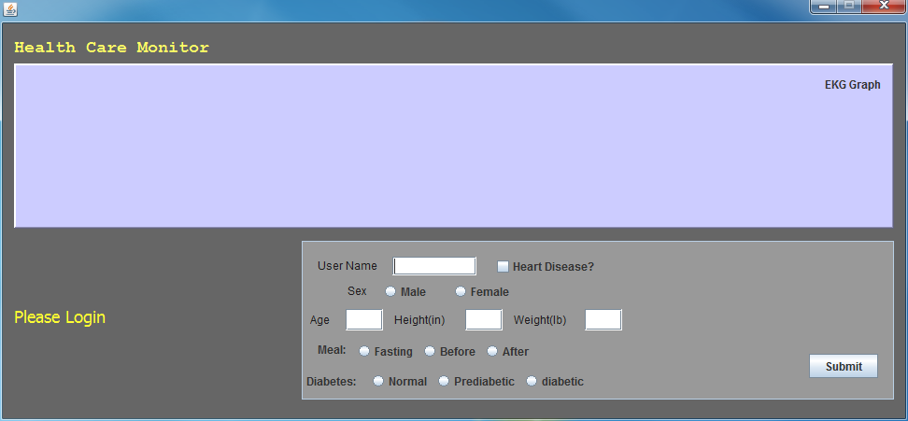
Post login
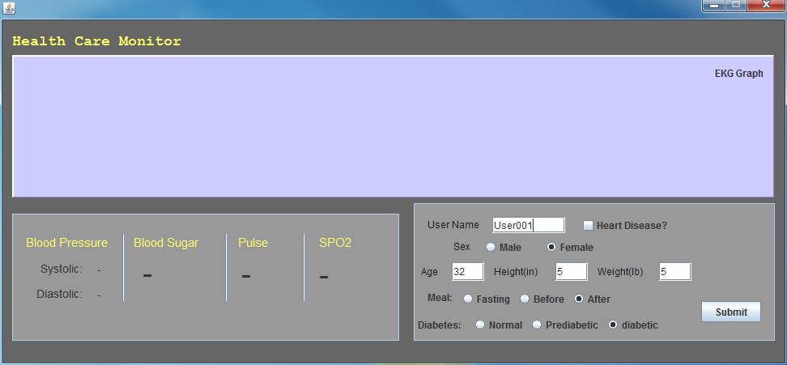
SPO2 Initialization
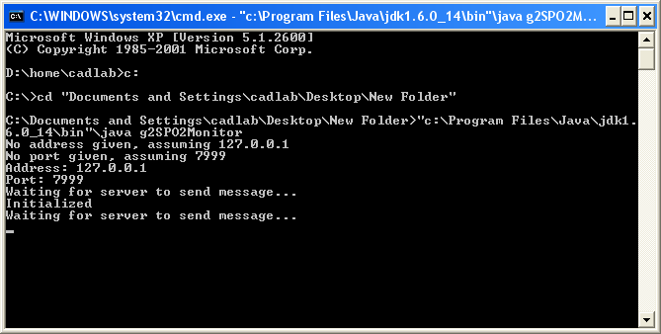
SPO2 Receives 45
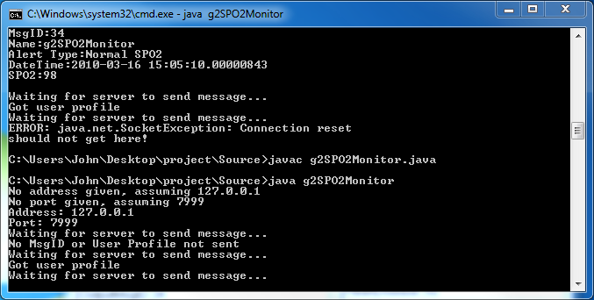
SPO2 Receives 33
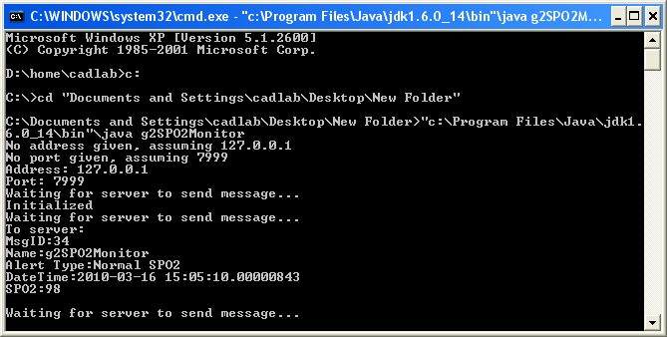
GUI receives 34
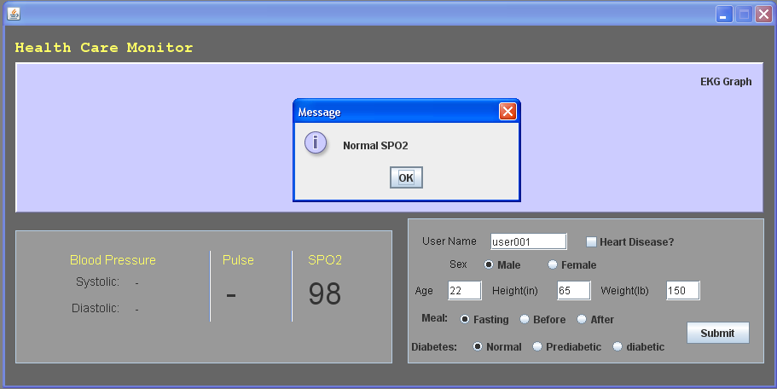
GUI receives message 38
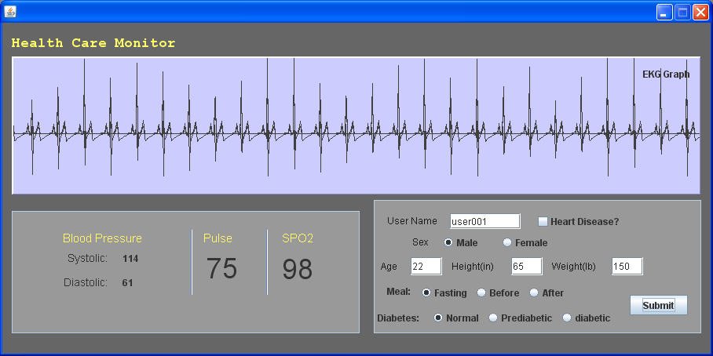
GUI receives message 42
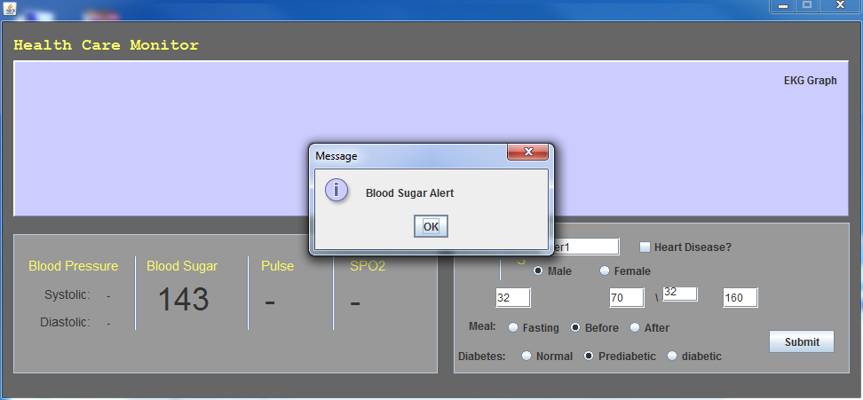
Console for GUI
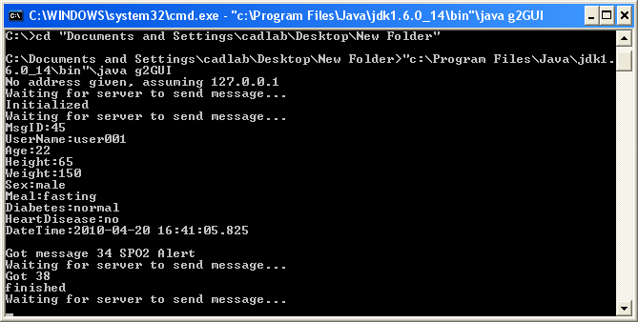

Revision History
V1: UML and Documentation March 4th 2010
V2: Update UML and Documentation March 10th 2010
V3: Add XML messages March 18th 2010
V4: April 20, 2010 Updates UML and documentation
V5: Add revision History
v6: April 29, 2010 SPO2 now accepts message 45 and runs after receiving it. GUI addition includes the blood sugar reading alert. This document including UML, XML, and source code were updated to include these changes.

