Ryan Brashear
John Harley

Revision History
3-11-10 We added our knowledge base information to our exercise four assignment
3-22-10 We updated our UML Diagrams
3-22-10 We updated some XML messages
4-7-10 We re-numbered the XML messages according to the new messaging scheme that is being used for the Health Monitor
4-10-10 We added message number 45 to our SPO2 monitor
4-12-10 We now take in more messages when we run the GUI because we need SPO2 levels, etc.
4-12-10 We changed our GUI to stay running and become and agent application
4-12-10 We now allow users to switch, and take in multiple values while running
4-12-10 We re-wrote the code for the GUI component to be more comprehensive
4-13-10 Added pop up dialogs for warning messages for general health monitors
4-17-10 Added graphic for systolic and diastolic readings
4-19-10 Finalized working versions of G1GUI and G1SPO2 files

The Software Plan
1.0 Scope
The software that is to be designed is a Personal HealthCare Slow Intelligence System (PHSIS). This PHSIS will be a multi-functional GUI based application. The monitor will contain a variety of components which will perform different tasks. UniversalInterface, SISserver and HealthMonitor pre-exist or have already been instantiated/activated, so we our class will be implementing the other components. GUI, InputProcessor, BloodPressure Monitor and Uploader will be instantiated/activated. Our group will be working on the GUI and Pulse Oximeter Oxygen Saturation (SPO2) Monitor alongside Group 2. We can use the UniversalInterface to simulate messages from these components in case some of the components are not available to us. Messages to these components will be ignored by the SIS Server, but still displayed on the right panel of the UniversalInterface. We don't need to have access to the HealthMonitor to develop and test our plug-in components. Our group is responsible for the GUI component and a simple SPO2 monitor. A component is brought to life by the "Create Component" message (Msg ID 20, or 21 if there is a knowledge base). When a component first comes to life, it should send a "Connect to Server" message (Msg ID 23) to the SISserver. SISserver will return an Ack message (Msg ID 26) to the component in which we are using. The "Activate Component" message (Msg ID 24) and "Deactivate Component" message (Msg ID 25) will activate/deactivate the said component. Finally, the "Kill Component" message (Msg ID 22) will destroy it. This will be a part of our SPO2 Monitor design.
1.1 Functions
Our PHSIS will have an interactive window that allows the user to enter their username and password to verify that they are an authorized user. An authorized user includes patients, physicians and other authorized personnel. If they are a new patient they will have to create a user profile. The BloodPressure Monitor (done by another group) sends Msg 32 (blood pressure alert) to GUI, which displays the vital signals. The GUI accepts Msg 32, 34, 36, 38 and produces Msg 20, 21. There are other messages and other components for heart rate, such as the SPO2 level. The GUI will also display the combined vitals, which will include EKG, SPO2, etc.

1.2 Performance
The performance of the PHSIS will be directly related to the size of the database, and the quality of the server. The performance of our GUI will be based on how many messages will be sent and received. If our server is running at low speeds then everything will be running slow, since every message is passed through the server. We will just have to work with what we have for now, and try to make everything so that it is as fast as possible.
1.3 Limitations
We plan on making our GUI and SPO2 monitor to be modular so that we can add features in the future. With growth of the software we will also need better and bigger servers as well as more room in the database. If everyone in the world uses this server, then we will have to increase its size. For right now, we will be implementing our product to have a low number of users, then in the future we will make it so that anyone can use it and will perform at a fast pace.

2.0 Tasks
For the PHSIS development there will be a manager, who oversees the development. John Harley will be the manager and Ryan Brashear will be the document specialist. The document specialist is in charge of keeping all of the documentation. Thirdly there will be a SPO2 designer and a GUI manager, who is in charge of the logic and graphics of the programming of the GUI. My partner and I will be both be testing and coding our system. We will try to test each other’s implementations so that we are not biased about our code. The functions we will implement are a GUI program and SPO2 monitor.
The GUI will provide a simple user interface to represent a nice graphical interface to show all of the messages received in an organized fashion. These messages will be used to show the health of the user or patient. The interface will have several buttons with functionality to model the actions that would take place. The GUI will display warnings if the patient’s health is at risk or abnormal.
Saturation of peripheral oxygen (Sp_{O2}) is an estimation of the oxygen saturation level usually measured with a pulse oximeter device. It can be calculated with the pulse oximetry which will have already been implemented in our system. We will pass on the messages to the universal interface through the server. Since the universal interface and server have already been implemented we will need to know how to send the messages and when.

3.0 Resources
3.1 Hardware
The hardware that will be used in the design of our Personal HealthCare monitor will be a DELL laptop and also an Apple Laptop. We intend for our program to be used on the PHSIS (Personal HealthCare Slow Intelligence System) monitor device. The monitor will be self-sufficient and will be able to run independently on the device. The device has the ability to upload the information to the internet for use by physicians to be able to quickly identity problems to help treat the patient effectively.

3.2 Software
The software we will be using to develop the SPO2 monitor will be a mixture of Java programming along with XML code. This is how we will implement the messages that are used to communicate between the different monitors and share information through the SIS server which gets input readings from the blood pressure, blood sugar, EKG, general health, and SPO2 monitors. The Java programming will be done with NotePad, NetBeans, or Eclipse depending on which environment we like the best. The GUI design will be implemented with Netbeans.

3.3 People
The project manager will be John Harley. This job includes organizing and scheduling the project and how the developers will make arrangements to meet. The document specialist will be Ryan Brasher. The document specialists will work on completing the various documents and presentations we will need for the upcoming milestones. The SPO2 and GUI programmers will be both Ryan Brashear and John Harley. We will focus on creating a seamless, user friendly graphical user interface environment to be the interface between the different health monitors and display them in an attractive manner for the health care provider’s use for the users to interact with for the product. Both of the developers will be testers of the various programs. We will make sure that if one person creates a component, they are not allowed to test that component, and they will have to test a different one.

4.0 Cost
Function Optimistic Most Pessimistic Expected Deviation $/Line Line/Month Cost Months
a m b Le Ld

GUI 100 120 250 622 25

SPO2 Monitor 80 100 180 510 17

LABOR COST

Tasks Requirements Design Coding Test Subtotal
Function

interface .5 1.0 1.5 3.5 6.5
SPO2 .5 1.0 1.5 2.5 5.5
Total 1.0 2.0 3.0 6.0 12.0
(man-days)

Rate $60 $80 $100 $150
($/man-days)

Cost $60 $160 $300 $900 $1,420

5.0 Schedule
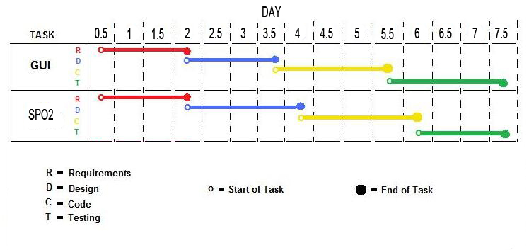

This schedule shows the different tasks our group must accomplish in order to finish our product on time. Each task has 4 steps: requirements, design, coding, and testing. This schedule will allow us to see whether we need to speed up different aspects of the project if we start falling behind. At the end of the project, we were able to keep to our outlined schedule for the most part. Certain aspects took longer others, but the phases ended up evening out and we completed the project on time and it is all working as expected.

XML Message Descriptions

MsgID:31 Description: Blood Pressure Reading
Variables:
- Systolic
- Diastolic
- Pulse
- DateTime
MsgID:32 Description: Blood Pressure Alert
Variables:
- Systolic
- Diastolic
- Pulse
- Alert Type
- Name
- DateTime
MsgID:33 Description: SPO2 Reading
Variables:
- SPO2
- DateTime
MsgID:34 Description: SPO2 Alert
Variables:
- SPO2
- Alert Type
- Name
- DateTime
MsgID:36 Description: EKG Alert
Variables:
- LeadI
- LeadII
- LeadIII
- Alert Type
- Name
- Date Time
MsgID:38 Description: Emergency Alert
Variables:
- Systolic
- Diastolic
- Pulse
- DateTime
- LeadI
- LeadII
- LeadIII
- DateTimeEKG
- Alert Type
- protocol
- Name
- DateTime
MsgID:41 Description: Blood Sugar Reading
Variables:
- Blood Sugar
- DateTime
MsgID:42 Description: Blood Sugar Alert
Variables:
- Blood Sugar
- Alert Type
- Diagnosis
- Suggestions
- Name
- DateTime
MsgID:20 Description: Create GUI Component
Variables:
- Passcode
- Security Level
- Name
- SourceCode
- InputMsgID 1
- InputMsgID 2
- InputMsgID 3
- InputMsgID 4
- InputMsgID 5
- InputMsgID 6
- InputMsgID 7
- InputMsgID 8
- OutputMsgID 1
- OutputMsgID 2
- OutputMsgID 3
- OutputMsgID 4
- Component Description
MsgID:21 Description: Create SPO2 Component
Variables:
- Passcode
- Security Level
- Name
- SourceCode
- InputMsgID 1
- InputMsgID 2
- OutputMsgID 1
- Component Description
- KnowledgeBase

XML Messages

<Msg>
−
<Head>
<MsgID>31</MsgID>
<Description>Blood Pressure Reading</Description>
</Head>
−
<Body>
−
<Item>
<Key>Systolic</Key>
<Value>114</Value>
</Item>
−
<Item>
<Key>Diastolic</Key>
<Value>61</Value>
</Item>
−
<Item>
<Key>Pulse</Key>
<Value>75</Value>
</Item>
−
<Item>
<Key>DateTime</Key>
<Value>2010-03-16 15:05:10.00000843</Value>
</Item>
</Body>
</Msg>

<Msg>
−
<Head>
<MsgID>32</MsgID>
<Description>Blood Pressure Alert</Description>
</Head>
−
<Body>
−
<Item>
<Key>Systolic</Key>
<Value>114</Value>
</Item>
−
<Item>
<Key>Diastolic</Key>
<Value>61</Value>
</Item>
−
<Item>
<Key>Pulse</Key>
<Value>75</Value>
</Item>
−
<Item>
<Key>Alert Type</Key>
<Value>Blood Pressure Alert</Value>
</Item>
−
<Item>
<Key>Name</Key>
<Value>g3 Blood Pressure Monitor</Value>
</Item>
−
<Item>
<Key>DateTime</Key>
<Value>2010-03-16 15:05:10.00000843</Value>
</Item>
</Body>
</Msg>

<Msg>
−
<Head>
<MsgID>33</MsgID>
<Description>SPO2 Reading</Description>
</Head>
−
<Body>
−
<Item>
<Key>SPO2</Key>
<Value>98</Value>
</Item>
−
<Item>
<Key>DateTime</Key>
<Value>2010-03-16 15:05:10.00000843</Value>
</Item>
</Body>
</Msg>

<Msg>
−
<Head>
<MsgID>34</MsgID>
<Description>SPO2 Alert</Description>
</Head>
−
<Body>
−
<Item>
<Key>SPO2</Key>
<Value>98</Value>
</Item>
−
<Item>
<Key>Alert Type</Key>
<Value>SPO2 Alert</Value>
</Item>
−
<Item>
<Key>Name</Key>
<Value>g1SPO2Monitor</Value>
</Item>
−
<Item>
<Key>DateTime</Key>
<Value>2010-03-16 15:05:10.00000843</Value>
</Item>
</Body>
</Msg>

<Msg>
−
<Head>
<MsgID>36</MsgID>
<Description>EKG Alert</Description>
</Head>
−
<Body>
−
<Item>
<Key>LeadI</Key>
−
<Value>
11 640 760 800 776 640 488 280 24 -24 -40 0 0 0 0 0 0 0 0 0 0 0 0 0 0 0 0 0 0 0 0 0 8 16 16 16 16 24 40 40 40 56 56 56 56 56 80 80 80 80 96 80 80 96 96 120 120 120 224 448 584 672 656 520 360 152 40 40 56 56 56 56 56 48 0 -72 480 4840 3008 240 -584 -112 0 0 -24 0 0 0 8 16 24 96 152 200 248 320 376 400 496 576 744 800 776 680 544 360 80 0 -56 -64 -8 0 0 0 0 0 0 0 0 0 0 0 0 0 0 0 0 0 0 0 0 0 16 16 16 16 16 16 24 40 40 40 48 56 56 56 80 80 80 80 80 96 96 96 120 120 160 368 584 656 680 544 448 232 48 16 40 56 56 56 56 56 40 -40 16 2232 4544 4696 1120 -504 -424 0 -24 0 0 0 0 0 0 64 80 128 184 232 288 376 376 480 544 664 768 800 776 632 440 216 0 -16 -64 -40 0 0 0 0 0 0 0 0 0 0 0 0 0 0 0 0 0 0 0 0 0 0 8 16 16 16 16 40 40 40 40 56 56 56 56 56 80 80 96 96 96 96 120 120 96 96 120 264 520 632 680 656 496 288 64 16 16 40 40 40 56 56 56 -16 -80 1160 3872 4800 2280 -176 -584 -56 0 0 -24 0 0 0 16 16 80 112 160 192 248 336 400 416 480 608 760 840 784 672 520 280 32 -16 -40 -24 0 0 0 0 0 0 0 0 0 0 0 0 0 0 0 0 0 0 0 0 0 0 0 0 0 16 16 16 56 56 56 56 56 56 80 80 56 80 96 80 96 96 96 96 120 96 96 200 424 608 680 696 536 392 176 40 16 80 56 56 56 56 80 24 -64 40 2888 4800 3960 512 -560 -224 0 0 0 0 0 0 16 40 40 112 144 176 224 320 376 376 496 584 720 800 800 712 560 392 144 0 -40 -40 0 0 0 0 0 0 0 0 0 0 0 0 0 0 0 0 0 0 0 0 0 0 0 0 16 16 16 24 40 40 40 56 40 40 40 80 80 80 80 96 96 96 96 96 96 96 96 144 320 560 640 680 600 472 248 80 40 40 56 56 56 56 56 40 -32 -104 1792 4344 4696 1560 -360 -424 -16 -24 0 -24 0 0 0 16 40 88 144 168 200 280 360 400 424 528 664 784 840 760 616 448 224 8 -32 -40 -24 0 0 0 0 0 0 0 0 0 0 0 0 0 0 0 0 0 0 0 0 0 0 0 16 16 16 16 16 56 40 40 56 56 56 56 56 56 80 80 96 96 96 96 96 96 120 96 240 496 640 672 656 520 336 120 16 40 48 56 40 40 56 56 0 -96 520 3488 4816 2792 88 -600 -120 0 -24 0 0 0 0 8 16 48 120 152 184 240 328 376 400 496 584 744 800 776 696 544 360 88 -8 -40 -24 0 0 0 0 0 0 0 0 0 0 0 0 0 0 0 0 0 0 0 0 0 0 0 16 16 16 24 40 40 56 40 56 56 56 80 80 96 96 96 96 96 120 120 120 120 120 168 384 600 672 696 560 424 216 40 16 72 56 56 56 80 80 40 -56 56 2424 4616 3936 920 -528 -424 0 -24 0 0 0 0 8 40 40 104 128 184 240 296 376 408 440 528 680 808 816 736 600 424 168 0 -40 -40 -24 0 0 0 0 0 0 0 0 0 0 0 0 0 0 0 0 0 0 0 0 0 0 16 16 16 16 16 40 40 40 40 40 56 56 56 56 64 80 88 96 96 96 96 120 120 128 296 528 648 680 600 504 264 72 16 16 40 40 48 80 56 56 -16 -104 1344 4016 4640 2016 -256 -560 -32 0 0 -24 0 0 0 0 16 64 120 160 216 264 336 376 408 488 616 752 776 776 664 488 288 40 -16 -40 -40 0 0 0 0 0 0 0 0 0 0 0 0 0 0 0 0 0 0 0 0 0 0 0 0 16 16 16 40 40 56 56 40 40 56 56 80 80 96 96 80 96 96 120 96 120 120 208 456 632 664 656 528 400 160 32 16 80 56 56 56 56 80 8 -72 56 3080 4856 3224 368 -536 -200 0 -24 0 0 0 0 0 16 24 152 160 200 208 296 368 384 488 560 728 800 776 720 568 384 128 0 -40 -40 0 0 0 0 0 0 0 0 0 0 0 0 0 0 0 0 0 0 0 0 0 0 0 16 16 16 40 40 40 40 56 56 56 56 56 56 80 56 96 80 96 96 120 120 96 96 120 168 344 568 648 680 568 440 240 72 40 40 56 64 56 56 80 56 -24 -80 1968 4488 4640 1352 -456 -400 -16 0 0 -24 0 0 0 32 40 112 144 176 216 280 360 416 432 544 672 784 800 776 632 480 232 8 -32 -40 -24 0 0 0 0 0 0 0 0 0 0 0 0 0 0 0 0 0 0 0 0 0 0 16 16 16 16 40 40 40 40 40 40 56 56 56 80 56 80 80 96 96 96 96 96 96 96 96 96 240 488 640 680 656 504 304 88 0 16 56 56 56 56 80 56 8 -96 576 3704 4856 2544 -40 -560 -72 0 -24 -24 0 0 0 0 24 72 104 160 208 256 328 376 392 496 592 728 776 776 680 520 320 56 -24 -40 -40 0 0 0 0 0 0 0 0 0 0 0 0 0 0 0 0 0 0 0 0 0 0 16 16 16 16 16 40 40 40 40 40 56 56 56 56 80 80 80 80 96 96 96 96 96 96 112 200 392 600 680 696 512 392 168 40 40 56 40 56 56 56 80 40 -80 80 2656 4728 3856 744 -536 -424 0 0 0 0 0 0 0 16 72 104 160 184 216 304 376 376 496 592 704 800 816 728 600 400 176 0 -40 -40 0 0 0 0 0 0 0 0 0 0 0 0 0 0 0 0 0 0 0 0 0 0 0 0 16 16 24 56 56 56 40 40 56 56 56 80 80 80 80 80 96 96 96 96 120 120 128 312 560 656 680 600 464 272 88 40 56 56 56 80 56 80 56 0 -80 1536 4184 4640 1824 -304 -560 -32 0 0 -24 0 0 0 0 8 80 136 168 200 280 336 360 448 512 640 760 800 760 656 480 272 24 -24 -40 -24 0 0 0 0 0 0 0 0 0 0 0 0 0 0 0 0 0 0 0 0 0 0 16 16 16 16 40 40 40 40 40 56 56 56 56 56 56 80 88 96 96 96 96 120 120 120 208 448 616 664 656 512 344 144 32 16 56 56 56 56 56 56 40 -88 600 3296 4840 3000 240 -576 -224 0 -24 0 0 0 0 0 8 56 120 160 176 224 320 376 384 528 608 736 824 800 712 560 360 96 0 -32 -24 0 0 0 0 0 0 0 0 0 0 0 0 0 0 0 0 0 0 0 0 0 0 0 0 16 16 16 32 40 40 40 56 56 56 56 80 56 80 80 96 96 96 120 120 120 136 168 368 600 664 696 568 408 224 72 40 40 56 64 56 56 48 24 -40 80 2176 4584 4616 1112 -512 -424 -8 -24 0 0 0 0 0 32 40 120 144 176 208 280 368 400 408 552 656 784 816 752 624 464 208 0 -16 -24 0 0 0 0 0 0 0 0 0 0 0 0 0 0 0 0 0 0 0 0 0 0 0 16 16 16 16 32 40 40 40 56 56 56 56 56 56 80 80 96 96 96 96 96 120 120 128 280 520 656 680 656 504 312 88 16 40 56 56 56 56 56 40 -8 -80 1168 3880 4840 2288 -136 -544 -32 0 0 -24 0 0 0 8 16 96 104 160 200 264 344 376 432 488 640 760 800 776 704 512 304 64 -16 -40 -40 0 0 0 0 0 0 0 0 0 0 0 0 0 0 0 0 0 0 0 0 0 0 16 16 16 40 40 40 40 40 56 56 56 56 56 80 56 80 80 80 96 96 96 120 120 120 120 184 424 624 680 696 528 384 160 40 40 56 56 56 56 56 72 40 -80 80 2864 4752 3776 536 -560 -384 0 -24 0 0 0 0 0 0 80 104 160 176 200 304 376 376 512 576 712 800 800 704 568 384 160 0 -24 -40 0 0 0 0 0 0 0 0 0 0 0 0 0 0 0 0 0 0 0 0 0 0 0 16 16 16 16 40 40 40 40 40 56 56 56 56 56 56 80 80 80 96 96 96 96 96 104 120 160 320 544 656 696 576 440 264 40 16 40 40 56 56 56 80 56 -24 -64 1768 4304 4576 1576 -384 -584 -24 -24 0 0 0 0 0 0 40 96 136 176 200 264 344 376 440 520 632 776 816 776 648 464 240 16 -24 -24 0 0 0 0 0 0 0 0 0 0 0 0 0 0 0 0 0 0 0 0 0 0 16 16 16 16 16 40 40 40 56 56 56 56 56 56 80 56 96 96 96 96 96 96 96 120 120 120 240 480 656 680 640 480 320 96 40 40 40 56 56 56 56 80 0 -80 656 3488 4840 2784 88 -560 -184 0 -24 0 0 0 0 24 56 64 96 144 200 248 320 376 392 520 592 744 800 776 688 536 344 88 0 -32 -40 0 0 0 0 0 0 0 0 0 0 0 0 0 0 0 0 0 0 0 0 0 0 0 0 16 16 24 40 40 40 40 40 56 56 56 56 72 56 96 96 96 96 112 120 96 120 160 368 584 656 680 544 424 200 48 16 40 56 56 56 56 56 40 -56 136 2408 4600 4536 920 -552 -400 0 -24 0 -24 0 0 0 40 40 96 128 176 208 288 368 376 456 520 680 784 776 704 600 440 184 0 -16 -40 -24 0 0 0 0 0 0 0 0 0 0 0 0 0 0 0 0 0 0 0 0 0 0 16 16 40 40 16 40 40 40 56 56 56 56 80 56 80 96 96 96 96 96 96 112 120 120 320 528 608 680 656 464 296 88 40 40 56 72 56 56 56 56 -16 -64 1368 4024 2056 -296 -560 -24 0 0 0 0 0 0 16 40 40 144 176 208 264 352 376 416 520 600 760 816 800 656 504 296 40 -16 -40 -24 0 0 0 0 0 0 0 0 0 0 0 0 0 0 0 0 0 0 0 0 0 0 0 16 16 16 16 40 40 40 56 56 56 56 56 88 96 56 80 96 96 104 120 96 96 120 224 472 608 680 696 520 360 144 40 40 40 56 64 80 80 80 16 -80 536 3072 4792 3696 344 -584 -152 0 -24 0 0 0 0 0 16 56 120 160 176 224 312 376 376 488 560 720 800 800 704 560 384 128 0 -24 -40 0 0 0 0 0 0 0 0 0 0 0 0 0 0 0 0 0 0 0 0 0 0 0 0 16 16 16 16 40 40 56 56 40 56 56 56 80 56 80 80 96 80 96 96 96 96 120 160 336 576 664 680 600 440 240 40 16 56 56 56 56 56 56 24 -32 -64 1968 4456 4536 1328 -456 -384 -16 -24 0 -24 0 0 0 24 40 80 136 176 200 272 352 400 424 544 656 784 800 744 624 456 232 8 0 -40 -24 0 0 0 0 0 0 0 0 0 0 0 0 0 0 0 0 0 0 0 0 0 0 16 16 16 16 16 40 40 40 40 56 56 56 56 56 56 80 80 88 96 96 96 96 96 120 96 96 272 488 640 672 656 496 320 112 24 40 80 56 56 80 56 80 0 -80 976 3688 4856 2568 -32 -560 -80 0 -24 -24 0 0 0 16 40 48 120 168 200 248 328 400 408 520 600 744 800 800 680 528 328 80 0 -56 -40 0 0 0 0 0 0 0 0 0 0 0 0 0 0 0 0 0 0 0 0 0 0 0 16 16 16 16 40 40 56 16 56 56 56 56 56 80 96 96 80 96 112 120 120 96 96 120 120 208 432 584 672 680 560 400 184 40 40 40 56 56 80 80 56 16 -80 136 2640 4720 4536 760 -584 -240 0 0 0 -24 0 0 0 0 64 96 152 184 216 288 376 408 464 568 688 792 800 744 608 408 176 0 -40 -64 -8 0 0 0 0 0 0 0 0 0 0 0 0 0 0 0 0 0 0 0 0 0 0 8 16 16 16 40 40 40 48 56 56 56 56 56 56 80 80 80 96 96 96 96 96 96 96 144 320 544 672 696 576 488 264 72 16 16 80 56 56 56 56 40 -32 -80 1560 4192 4880 1840 -320 -544 -24 0 0 0 0 0 0 16 16 80 128 160 192 248 336 400 416 480 632 768 816 760 648 488 280 32 -16 -24 0 0 0 0 0 0 0 0 0 0 0 0 0 0 0 0 0 0 0 0 0 0 0 0 0 16 16 16 40 40 48 56 56 56 56 56 56 56 80 88 96 96 96 96 120 120 120 240 480 608 680 656 496 368 128 16 16 80 56 56 56 56 80 8 -80 680 3280 4824 3656 192 -584 -136 0 0 0 0 0 0 0 16 64 120 160 192 232 320 384 400 464 568 728 800 800 736 552 368 120 0 -32 -40 0 0 0 0 0 0 0 0 0 0 0 0 0 0 0 0 0 0 0 0 0 0 0 16 16 16 40 40 48 56 56 56 56 56 56 80 80 80 80 96 96 96 104 120 96 120 168 360 584 680 680 576 432 224 40 16 40 80 56 56 80 80 32 -40 -64 2208 4496 1144 -456 -384 -8 -24 0 -24 0 0 0 0 64 96 136 168 200 296 368 400 456 584 664 784 800 776 616 464 216 8 -32 -40 0 0 0 0 0 0 0 0 0 0 0 0 0 0 0 0 0 0 0 0 0 0 0 16 16 16 40 40 40 40 40 56 56 56 56 56 80 88 96 96 96 96 96 96 120 120 128 288 528 624 680 656 488 304 104 40 40 40 80 56 56 80 56 -8 -80 1176 3872 4856 -136 -560 -56 0 -24 -24 0 0 0 0 0 88 120 152 200 256 336 416 416 528 648 760 800 776 680 504 320 64 0 -40 -40 0 0 0 0 0 0 0 0 0 0 0 0 0 0 0 0 0 0 0 0 0 0 0 0 16 16 16 40 40 40 40 56 56 56 56 56 80 80 80 80 96 96 96 96 96 112 208 440 584 656 680 536 408 200 24 16 40 56 80 56 56 80 8 -72 176 2864 4728 3600 568 -584 -216 0 0 0 0 0 0 0 0 64 104 152 176 216 304 376 384 496 568 720 792 800 736 568 408 168 0 -16 -24 0 0 0 0 0 0 0 0 0 0 0 0 0 0 0 0 0 0 0 0 0 0 0 0 16 16 16 40 40 40 56 40 40 56 56 80 96 96 80 96 96 96 96 120 120 96 120 152 344 552 680 680 600 464 264 48 16 72 56 56 56 80 96 56 -16 -64 1736 4280 4480 1616 -368 -544 -16 0 0 -24 0 0 0 40 56 80 128 176 216 296 376 376 448 544 672 768 800 776 640 464 248 8 -16 -40 0 0 0 0 0 0 0 0 0 0 0 0 0 0 0 0 0 0 0 0 0 0 0 16 0 16 16 56 56 40 40 56 56 56 56 56 80 80 80 80 80 96 96 96 120 96 96 120 136 248 488 616 664 656 528 376 120 16 16 56 56 56 56 56 56 40 -80 808 3456 4816 2792 64 -600 -120 0 0 -24 0 0 0 0 16 80 112 160 176 224 320 384 400 488 576 728 800 776 672 544 360 88 0 -48 -40 0 0 0 0 0 0 0 0 0 0 0 0 0 0 0 0 0 0 0 0 0 0 8 16 16 16 16 16 16 40 40 40 56 56 56 80 56 56 80 80 96 96 96 96 96 96 96 120 168 376 600 664 680 560 424 216 32 16 56 56 56 56 80 80 24 -40 -40 2416 4648 4440 944 -536 -344 -8 -24 -24 -24 0 0 0 16 24 112 144 176 224 280 360 400 432 528 672 784 800 776 608 440 184 0 -8 -40 -24 0 0 0 0 0 0 0 0 0 0 0 0 0 0 0 0 0 0 0 0 0 0 16 16 16 16 24 40 40 56 40 56 56 56 80 80 56 56 80 96 96 96 104 120 96 120 128 296 536 624 680 640 472 296 96 40 40 56 56 56 56 80 80 -8 -80 1360 4048 4816 2096 -272 -544 -40 0 0 -24 0 0 0 0 8 88 120 176 208 256 328 400 408 504 632 776 800 784 648 488 304 24 0 -40 -40 0 0 0 0 0 0 0 0 0 0 0 0 0 0 0 0 0 0 0 0 0 0 0 16 16 16 16 40 40 56 56 56 56 56 80 80 56 80 96 96 96 96 96 112 120 120 208 456 608 680 656 552 392 160 40 40 40 40
</Value>
</Item>
−
<Item>
<Key>LeadII</Key>
−
<Value>
416 640 800 872 880 664 408 80 -160 -432 -496 -504 -472 -440 -424 -384 -360 -344 -344 -312 -304 -304 -280 -280 -272 -264 -256 -240 -224 -224 -200 -200 -192 -160 -160 -144 -144 -120 -112 -104 -120 -80 -80 -64 -64 -80 -64 -64 -64 -40 -40 -40 -24 -24 0 0 0 0 48 360 600 672 640 440 200 -24 -152 -144 -80 -80 -80 -80 -64 -64 -200 -480 496 6376 3552 -528 -1624 -592 -320 -424 -384 -328 -280 -272 -224 -160 -56 0 0 24 48 88 200 288 424 600 744 872 880 744 528 216 -64 -360 -480 -480 -480 -440 -424 -400 -384 -360 -344 -312 -304 -320 -304 -304 -280 -264 -264 -264 -240 -224 -224 -216 -184 -184 -184 -152 -144 -144 -120 -144 -120 -104 -104 -104 -88 -64 -64 -56 -40 -40 -40 -40 -40 -24 0 0 0 0 0 224 528 632 696 520 304 40 -112 -160 -128 -104 -88 -104 -80 -72 -104 -416 -160 2856 6024 6120 800 -1624 -1304 -304 -416 -400 -392 -320 -280 -232 -200 -88 0 0 0 32 80 200 280 384 536 672 840 880 880 664 368 40 -240 -464 -520 -504 -456 -440 -416 -384 -352 -344 -328 -304 -320 -304 -304 -280 -280 -264 -264 -240 -240 -232 -200 -200 -184 -184 -160 -160 -144 -144 -128 -104 -80 -80 -104 -104 -80 -64 -64 -64 -40 -40 -40 -40 -32 0 0 0 0 0 0 104 448 648 720 656 416 152 -40 -120 -104 -80 -80 -64 -64 -64 -64 -272 -464 1480 5104 6376 2496 -1144 -1624 -424 -320 -400 -384 -320 -288 -264 -160 -112 -40 0 16 16 32 160 208 320 464 568 760 856 856 736 472 120 -120 -400 -520 -504 -480 -440 -424 -400 -376 -360 -328 -304 -304 -320 -280 -280 -280 -264 -264 -248 -240 -224 -224 -200 -184 -184 -160 -144 -144 -144 -120 -120 -120 -104 -104 -80 -80 -80 -64 -64 -64 -40 -40 -40 -24 -24 -24 0 0 0 0 24 288 576 680 696 480 192 -8 -144 -160 -104 -104 -96 -64 -64 -64 -120 -480 408 3784 6328 5000 -80 -1640 -728 -280 -400 -400 -384 -312 -272 -264 -136 -96 -8 0 8 40 80 176 264 416 560 720 864 880 768 576 256 -40 -328 -480 -504 -480 -464 -432 -400 -376 -360 -360 -344 -312 -304 -320 -304 -280 -280 -264 -240 -240 -240 -224 -200 -200 -184 -184 -160 -160 -160 -160 -144 -120 -112 -104 -80 -80 -80 -80 -64 -40 -24 -24 -24 -24 -24 -24 -16 0 -24 0 0 168 496 632 696 600 368 80 -88 -144 -104 -104 -80 -80 -64 -64 -64 -376 -464 2296 5784 6096 1416 -1424 -1240 -320 -384 -400 -384 -312 -280 -264 -216 -136 -32 0 0 40 80 168 240 344 512 680 824 872 856 656 376 48 -192 -456 -496 -480 -464 -440 -424 -392 -360 -360 -320 -320 -304 -320 -304 -304 -272 -264 -240 -240 -232 -224 -224 -224 -160 -184 -160 -160 -160 -144 -144 -120 -104 -104 -80 -80 -80 -80 -64 -40 -40 -40 -40 -40 -40 -24 -24 -24 -24 0 0 64 376 608 688 656 448 200 -16 -120 -104 -88 -80 -80 -64 -40 -40 -160 -440 576 4680 6416 3248 -720 -1600 -520 -304 -400 -400 -352 -296 -264 -200 -144 -56 0 0 24 56 96 216 320 440 544 760 856 880 736 520 176 -80 -392 -480 -504 -480 -456 -424 -400 -384 -344 -344 -328 -304 -304 -304 -280 -280 -264 -264 -240 -240 -240 -240 -192 -200 -184 -160 -160 -160 -152 -144 -120 -120 -104 -104 -104 -80 -80 -80 -64 -64 -40 -40 -64 -40 -24 -24 -40 -40 0 8 240 528 632 680 512 240 8 -152 -160 -104 -104 -80 -80 -80 -72 -120 -456 -160 3168 6120 4936 496 -1664 -912 -304 -416 -424 -392 -312 -280 -240 -144 -96 0 0 16 40 88 176 264 384 536 704 832 856 800 600 304 0 -272 -472 -504 -504 -464 -440 -416 -384 -360 -360 -320 -320 -320 -304 -304 -280 -264 -264 -264 -264 -256 -224 -224 -184 -184 -184 -160 -160 -144 -144 -144 -144 -104 -104 -104 -80 -80 -64 -40 -40 -64 -64 -64 -24 -24 0 -40 -40 0 0 120 440 608 696 576 376 96 -80 -160 -120 -104 -80 -80 -64 -64 -80 -296 -464 1696 5328 6056 2160 -1232 -1584 -408 -320 -424 -384 -336 -280 -280 -176 -128 -56 0 0 16 48 136 224 320 480 616 792 856 840 688 440 96 -136 -408 -504 -504 -464 -440 -424 -384 -360 -360 -344 -344 -304 -304 -304 -280 -280 -280 -264 -264 -240 -224 -224 -184 -184 -176 -160 -160 -128 -144 -144 -120 -104 -80 -104 -80 -80 -64 -80 -64 -64 -40 -40 -40 -24 -24 -24 -24 0 0 24 320 592 664 640 480 240 -32 -128 -144 -104 -104 -80 -80 -80 -64 -104 -480 536 4056 6376 3896 -312 -1624 -656 -280 -408 -424 -360 -304 -256 -224 -168 -72 0 0 16 48 80 184 280 424 520 744 856 856 760 560 232 -48 -344 -480 -504 -464 -464 -424 -424 -392 -360 -344 -344 -304 -304 -320 -280 -280 -280 -280 -248 -240 -200 -184 -184 -200 -184 -184 -160 -144 -144 -120 -104 -120 -104 -96 -80 -80 -80 -80 -64 -64 -40 -40 -40 -32 -24 -24 -24 -24 -16 0 0 192 488 640 680 528 320 40 -80 -144 -120 -80 -64 -80 -80 -80 -64 -400 -464 2584 5952 6016 1112 -1504 -1184 -320 -384 -360 -400 -304 -280 -256 -152 -112 -8 0 0 16 96 144 224 376 536 672 832 880 856 664 376 40 -224 -456 -496 -480 -464 -440 -424 -392 -360 -344 -336 -320 -304 -344 -320 -280 -280 -264 -264 -240 -224 -224 -224 -192 -176 -160 -160 -144 -144 -144 -144 -120 -104 -104 -80 -80 -80 -72 -64 -40 -64 -64 -40 -24 -24 0 0 0 -24 -24 0 0 80 392 616 696 656 400 144 -56 -160 -144 -80 -64 -64 -64 -64 -64 -224 -504 1240 4920 6400 2864 -912 -1584 -480 -320 -424 -384 -320 -296 -264 -176 -120 -48 0 0 40 40 160 216 304 456 592 760 840 856 736 472 128 -104 -392 -480 -504 -464 -456 -440 -424 -384 -368 -344 -344 -312 -304 -320 -280 -280 -280 -272 -264 -240 -224 -224 -192 -184 -160 -144 -160 -160 -144 -144 -104 -120 -120 -104 -104 -80 -80 -80 -64 -40 -40 -64 -40 -24 -24 -24 -24 0 0 0 16 288 560 696 696 488 280 0 -136 -144 -104 -80 -104 -104 -80 -64 -120 -496 -120 3448 6224 4840 216 -1664 -816 -304 -416 -400 -384 -312 -280 -232 -144 -88 0 0 0 40 104 176 264 416 568 712 856 880 800 584 288 0 -312 -496 -520 -480 -464 -424 -424 -400 -368 -360 -344 -344 -320 -312 -304 -280 -280 -280 -256 -240 -240 -240 -224 -184 -168 -160 -160 -160 -144 -120 -104 -104 -104 -80 -80 -80 -72 -64 -64 -64 -40 -40 -40 -40 -24 -24 -24 0 0 0 128 464 616 696 576 360 88 -80 -144 -104 -104 -80 -80 -64 -64 -64 -368 -464 2000 5552 6000 1768 -1360 -1584 -360 -320 -400 -384 -336 -280 -264 -200 -128 -32 0 0 40 104 144 224 336 488 624 800 880 856 664 408 96 -192 -456 -504 -504 -464 -440 -424 -400 -368 -360 -320 -320 -320 -304 -304 -280 -280 -264 -264 -240 -240 -224 -224 -200 -200 -184 -184 -160 -144 -136 -120 -120 -104 -88 -104 -80 -64 -80 -80 -64 -64 -40 -24 -24 -40 -40 -16 0 0 0 32 344 600 664 656 472 224 -16 -152 -144 -104 -80 -80 -64 -64 -64 -120 -480 728 4312 6376 3560 -520 -1664 -600 -304 -440 -400 -336 -280 -272 -216 -144 -48 0 0 16 24 136 184 288 432 592 760 896 880 760 528 216 -72 -376 -472 -480 -464 -440 -424 -400 -384 -360 -344 -320 -304 -304 -304 -288 -280 -272 -264 -264 -232 -224 -200 -224 -200 -160 -184 -160 -144 -144 -144 -120 -104 -88 -104 -104 -104 -80 -64 -64 -64 -40 -32 -24 -24 -24 -24 0 0 0 0 224 560 664 696 528 280 24 -96 -120 -104 -104 -80 -80 -80 -64 -64 -416 -80 2864 6040 5976 824 -1576 -1184 -288 -400 -400 -384 -320 -280 -256 -192 -112 0 0 0 40 64 184 248 392 544 696 840 880 856 640 344 40 -240 -464 -504 -480 -464 -432 -424 -400 -376 -360 -336 -320 -304 -320 -320 -280 -280 -264 -264 -240 -240 -224 -224 -192 -176 -160 -160 -144 -144 -144 -120 -120 -104 -104 -104 -80 -80 -64 -64 -48 -40 -40 -40 -24 -40 -40 -24 0 0 0 88 424 608 696 656 392 128 -56 -160 -144 -104 -64 -64 -80 -80 -80 -272 -424 1472 5120 6400 2512 -1112 -1584 -416 -320 -400 -384 -320 -288 -264 -192 -120 -24 0 0 0 48 136 208 312 440 656 816 856 880 720 480 128 -120 -424 -464 -480 -464 -440 -424 -400 -376 -344 -320 -344 -344 -304 -304 -280 -280 -280 -264 -264 -240 -224 -224 -224 -184 -160 -160 -160 -144 -144 -120 -144 -104 -104 -104 -104 -80 -64 -64 -48 -40 -40 -24 -24 -24 -24 -24 -40 0 0 0 16 288 568 656 680 488 208 -16 -160 -160 -104 -96 -80 -104 -80 -64 -120 -504 416 3768 6288 4760 -64 -1664 -720 -304 -440 -392 -344 -312 -280 -232 -176 -80 0 0 8 16 128 168 272 424 520 720 856 856 800 576 264 -40 -320 -504 -520 -480 -464 -424 -424 -400 -360 -360 -320 -304 -304 -304 -304 -280 -280 -240 -240 -240 -224 -224 -208 -184 -184 -184 -144 -144 -144 -128 -104 -120 -104 -104 -80 -80 -80 -80 -64 -64 -48 -40 -40 -40 -24 -24 -24 -24 -8 0 0 0 144 488 640 688 576 344 80 -104 -160 -104 -104 -104 -80 -64 -64 -64 -360 -440 2264 5744 5960 1448 -1440 -1584 -320 -384 -424 -384 -328 -280 -240 -200 -104 -24 0 8 16 48 200 208 344 496 640 824 856 816 664 400 64 -200 -440 -504 -504 -464 -440 -432 -400 -360 -360 -320 -320 -320 -288 -280 -304 -280 -264 -264 -240 -240 -224 -224 -216 -192 -184 -160 -160 -144 -144 -136 -120 -120 -104 -104 -104 -80 -80 -64 -64 -64 -40 -24 -24 -40 -24 -40 -24 -24 -24 0 40 360 616 672 656 432 160 -24 -152 -144 -104 -80 -80 -80 -64 -64 -224 -480 976 4608 6400 3240 -704 -1664 -536 -320 -424 -360 -328 -280 -272 -232 -144 -40 0 0 0 64 120 192 288 456 600 744 840 856 744 528 184 -72 -368 -504 -504 -480 -440 -440 -416 -384 -360 -360 -336 -320 -320 -304 -280 -280 -264 -264 -264 -240 -216 -184 -200 -184 -184 -160 -160 -144 -144 -136 -120 -104 -104 -104 -104 -96 -80 -64 -64 -64 -40 -40 -40 -40 -24 -8 0 0 0 0 224 544 664 696 504 304 0 -112 -120 -104 -80 -80 -80 -80 -80 -104 -440 -40 3168 6136 5920 520 -1648 -1144 -280 -416 -400 -352 -304 -280 -248 -144 -80 0 0 0 48 88 152 240 400 504 664 840 880 784 584 304 0 -288 -472 -504 -504 -464 -448 -416 -400 -384 -360 -344 -320 -304 -304 -288 -264 -264 -264 -264 -240 -240 -224 -200 -192 -184 -160 -144 -120 -144 -144 -144 -104 -104 -104 -80 -64 -64 -64 -64 -40 -40 -64 -24 -24 -40 -40 0 0 0 0 120 440 624 680 640 400 120 -64 -144 -120 -104 -80 -80 -104 -64 -40 -320 -424 1720 5320 2144 -1264 -1520 -400 -344 -384 -352 -320 -272 -256 -184 -120 -40 0 0 32 40 168 224 336 488 664 816 856 856 688 440 104 -152 -416 -480 -504 -464 -440 -440 -400 -376 -360 -336 -320 -320 -296 -280 -280 -264 -264 -240 -232 -200 -224 -224 -200 -176 -184 -160 -160 -144 -144 -128 -120 -144 -104 -104 -80 -104 -80 -64 -64 -40 -40 -40 -64 -32 -24 -24 -24 0 0 24 304 600 680 696 472 216 -24 -144 -160 -104 -80 -64 -64 -64 -64 -144 -504 568 4032 6328 4616 -304 -1680 -680 -280 -424 -400 -360 -288 -264 -240 -160 -64 0 0 8 56 112 168 280 440 544 728 856 856 776 560 224 -48 -336 -464 -480 -480 -440 -424 -424 -392 -360 -344 -344 -312 -304 -320 -304 -280 -280 -280 -264 -224 -224 -224 -224 -200 -184 -184 -184 -160 -144 -128 -120 -120 -96 -104 -80 -80 -80 -64 -64 -64 -64 -64 -40 -40 -40 -8 0 0 0 0 0 184 512 704 696 544 320 56 -88 -160 -104 -80 -80 -80 -64 -64 -80 -400 -424 2560 5920 5856 1112 -1512 -1080 -312 -400 -400 -384 -328 -280 -264 -160 -120 -16 0 0 24 40 168 240 368 520 656 824 856 816 640 368 48 -208 -472 -520 -504 -480 -456 -424 -400 -384 -360 -320 -320 -320 -304 -320 -280 -280 -264 -240 -240 -232 -216 -200 -200 -184 -184 -160 -160 -144 -144 -120 -120 -104 -104 -104 -80 -64 -64 -64 -56 -40 -40 -40 -40 -24 -8 0 0 0 0 0 0 80 384 608 688 640 440 168 -72 -176 -144 -88 -80 -104 -80 -64 -64 -224 -480 1200 4888 6376 2872 -896 -1520 -496 -320 -424 -384 -328 -280 -264 -200 -120 -56 0 0 16 32 136 200 296 440 648 784 856 856 704 480 184 -104 -392 -480 -480 -480 -456 -440 -424 -384 -352 -344 -344 -320 -320 -304 -280 -264 -264 -264 -256 -240 -240 -240 -200 -200 -184 -184 -160 -160 -152 -144 -120 -120 -104 -120 -104 -88 -64 -64 -64 -64 -64 -64 -40 -24 -8 0 0 0 -24 0 -24 0 264 552 648 680 496 280 8 -128 -144 -88 -64 -80 -64 -64 -64 -160 -456 0 3464 6200 5840 232 -1680 -824 -304 -400 -400 -384 -304 -280 -240 -120 -80 0 0 0 16 80 160 256 400 560 712 848 856 816 600 288 0 -304 -480 -504 -504 -464 -440 -424 -400 -376 -360 -328 -320 -320 -304 -304 -280 -280 -264 -264 -240 -240 -200 -224 -184 -184 -160 -160 -160 -144 -136 -120 -120 -104 -104 -104 -104 -80 -72 -64 -40 -40 -40 -40 -40 -40 -16 0 -24 0 0 0 144 448 688 696 576 360 88 -64 -160 -112 -96 -80 -64 -80 -64 -64 -320 -400 1984 5520 6376 1832 -1368 -1504 -352 -320 -424 -392 -336 -280 -256 -184 -120 -24 0 0 0 72 136 216 344 496 616 808 864 856 656 408 104 -152 -432 -488 -504 -456 -424 -416 -384 -360 -360 -320 -320 -320 -304 -304 -280 -280 -280 -264 -264 -224 -224 -240 -224 -184 -184 -160 -160 -144 -144 -120 -120 -104 -80 -104 -80 -104 -72 -64 -64 -56 -40 -40 -40 -16 0 -24 0 0 0 40 352 584 680 640 464 208 -8 -160 -160 -104 -104 -96 -64 -64 -64 -120 -504 768 4304 6344 4496 -536 -1680 -568 -280 -424 -368 -344 -304 -280 -216 -112 -56 0 0 0 8 136 184 280 416 584 744 856 880 800 528 200 -64 -352 -512 -520 -480 -464 -440 -424 -384 -360 -344 -344 -320 -320 -304 -304 -280 -272 -264 -264 -240 -224 -224 -184 -160 -160 -144 -144 -144 -144 -120 -104 -104 -80 -104 -104 -80 -64 -64 -64 -64 -40 -40 -40 -24 -24 -24 -24 0 0 0 208 504 640 680 528 328 40 -112 -160 -104 -104 -80 -64 -64 -40 -64 -432 -400 2848 5816 808 -1560 -1080 -304 -400 -424 -360 -304 -272 -240 -176 -96 -8 0 8 40 80 160 224 368 528 664 832 856 816 608 360 40 -248 -456 -504 -480 -440 -440 -424 -416 -384 -352 -344 -344 -320 -304 -304 -280 -264 -264 -264 -240 -240 -224 -192 -184 -160 -160 -144 -160 -120 -112 -120 -104 -80 -104 -104 -80 -64 -64 -64 -40 -40 -40 -24 -24 -24 -24 0 0 0 0 88 424 608 696 640 408 136 -56 -160 -144 -112 -80 -80 -80 -80 -64 -240 -504 1448 5120 6376 -1064 -1520 -416 -344 -440 -400 -344 -296 -264 -184 -120 -32 0 0 24 56 144 200 320 488 584 800 880 856 712 480 160 -120 -408 -496 -504 -464 -432 -424 -392 -384 -360 -344 -320 -320 -304 -304 -280 -264 -264 -264 -256 -240 -232 -224 -224 -224 -200 -160 -160 -160 -144 -136 -120 -112 -104 -104 -80 -104 -64 -64 -40 -40 -40 -64 -40 -24 -24 0 0 0 0 8 296 584 696 696 488 248 8 -128 -144 -104 -96 -64 -64 -64 -64 -120 -480 40 3728 6280 4440 -16 -1664 -720 -304 -416 -400 -384 -312 -280 -240 -120 -72 0 0 0 0 136 176 264 416 544 704 848 880 800 568 272 -16 -296 -480 -520 -504 -472 -440 -424 -400 -368 -344 -320 -344 -320 -304 -280 -280 -264 -264 -240 -240 -240 -224 -216 -184 -184 -160 -160 -160 -144 -144 -120 -112 -104 -104 -104 -80 -80 -64 -64 -40 -40 -40 -64 -40 -24 0 -24 -24 0 0 0 160 480 640 680 560 328 80 -88 -160 -120 -96 -80 -80 -64 -64 -64 -376 -400 2240 5704 5760 1488 -1440 -1520 -320 -320 -424 -384 -336 -280 -256 -160 -112 -16 0 0 40 64 160 224 352 528 656 832 864 856 680 392 64 -200 -456 -488 -480 -456 -424 -400 -384 -368 -344 -344 -320 -320 -304 -304 -280 -264 -264 -264 -248 -240 -240 -224 -200 -192 -160 -160 -160 -144 -144 -144 -120 -120 -104 -104 -80 -80 -80 -64 -64 -56 -40 -32 -24 -24 -40 0 -24 0 0 0 0 48 376 616 704 616 448 168 -16 -168 -160 -104 -80 -80 -80 -80 -64 -120 -504 920 4584 6360 3224 -728 -1704 -536 -280 -424 -384 -336 -304 -272 -216 -112 -32 0 0 16 40 144 200 288 448 592 768 880 856 728 520 192 -56 -352 -480 -504 -464 -424 -416 -384 -360 -344 -344 -336 -304 -304 -304 -296 -264 -280 -264 -240 -240 -240 -224 -184 -184 -184 -160 -144 -144 -144 -120 -120 -104 -104 -80 -80 -80 -64 -64 -64 -64 -56 -40 -40 -40 -24 -24 -16 -16 0 0 0 0 240 560 664 696 520 312 16 -112 -144 -104 -80 -80 -80 -64 -64 -64 -440 -384 3160 6184 5720 528 -1592 -1064 -312 -424 -400 -360 -304 -272 -240 -168 -96 -8 0 0 24 64 168 248 400 528 672 848 880 840 600 312 8 -280 -472 -504 -504 -440 -440 -424 -384 -344 -344 -336 -304 -304 -304 -304 -296 -280 -280 -264 -256 -240 -232 -200 -192 -184 -160 -160 -160 -160 -144 -120 -144 -144 -104 -104 -104 -104 -72 -64 -64 -40 -40 -40 -40 -24 -24 -24 -24 -40 0 0 104 456 624 696 640 376 104 -48 -160 -120 -104 -80 -80 -80 -64 -80 -320 -504 1704 5344 6360 2168 -1200 -1480 -376 -344 -400 -384 -320 -280 -264 -208 -152 -32 0 0 24 40 176 224 344 480 632 808 856 856 680 424 104 -152 -432 -480 -504 -464 -432 -424 -392 -360 -344 -344 -320 -320 -304 -304 -280 -264 -264 -264 -256 -224 -200 -200 -184 -184 -184 -160 -144 -144 -120 -112 -104 -104 -80 -104 -80 -80 -80 -64 -64 -56 -40 -40 -24 -24 -24 0 0 0 0 24 320 608 696 592 480 240 -24 -160 -160 -104 -80
</Value>
</Item>
−
<Item>
<Key>LeadIII</Key>
−
<Value>
344 440 440 488 480 384 280 200 24 0 0 0 0 0 0 0 0 0 0 0 0 0 0 0 0 0 0 0 0 0 0 0 0 0 0 0 0 0 0 0 0 0 0 0 0 0 0 0 0 0 0 0 0 0 0 0 0 0 56 264 424 496 496 344 128 0 0 0 0 0 0 0 0 0 0 0 216 1200 -1112 -3600 -3064 -200 456 56 40 40 40 40 96 80 120 160 176 176 200 200 200 248 296 360 440 472 496 400 304 200 104 0 0 0 0 0 0 0 0 0 0 0 0 0 0 0 0 0 0 0 0 0 0 0 0 0 0 0 0 0 0 0 0 0 0 0 0 0 0 0 0 0 0 0 0 0 0 0 0 0 16 176 336 488 496 456 216 16 0 0 0 0 0 0 0 0 0 0 80 736 1296 -32 -2856 -3800 -1160 496 144 40 40 40 40 96 96 96 136 160 160 192 216 200 248 296 368 440 440 496 480 352 240 136 0 0 0 0 0 0 0 0 0 0 0 0 0 0 0 0 0 0 0 0 0 0 0 0 0 0 0 0 0 0 0 0 0 0 0 0 0 0 0 0 0 0 0 0 0 0 0 0 0 0 0 80 320 464 496 480 280 80 0 0 0 0 0 0 0 0 0 0 0 424 1160 1200 -1808 -3880 -2336 192 440 16 40 16 16 80 96 96 120 168 176 176 200 200 208 256 344 416 456 480 480 416 296 200 16 0 0 0 0 0 0 0 0 0 0 0 0 0 0 0 0 0 0 0 0 0 0 0 0 0 0 0 0 0 0 0 0 0 0 0 0 0 0 0 0 0 0 0 0 0 0 0 0 0 0 64 240 408 496 496 416 168 8 0 0 0 0 0 0 0 0 0 0 80 904 1280 -680 -3424 -3760 -496 520 64 40 40 40 80 96 96 120 152 176 176 200 200 208 256 304 360 424 464 480 416 336 224 88 0 0 0 0 0 0 0 0 0 0 0 0 0 0 0 0 0 0 0 0 0 0 0 0 0 0 0 0 0 0 0 0 0 0 0 0 0 0 0 0 0 0 0 0 0 0 0 0 0 0 0 136 360 432 528 480 232 40 0 0 0 0 0 0 0 0 0 0 0 600 1264 696 -2480 -3880 -1632 416 240 16 40 40 48 96 96 96 152 176 176 184 216 216 240 304 360 368 456 472 456 360 256 152 16 0 0 0 0 0 0 0 0 0 0 0 0 0 0 0 0 0 0 0 0 0 0 0 0 0 0 0 0 0 0 0 0 0 0 0 0 0 0 0 0 0 0 0 0 0 0 0 0 0 0 56 280 456 488 496 312 104 0 0 0 0 0 0 0 0 0 0 0 240 1072 1160 -1352 -3688 -2984 -48 456 48 40 40 40 56 120 96 96 160 160 176 216 216 240 280 320 392 456 472 480 400 296 192 72 0 0 0 0 0 0 0 0 0 0 0 0 0 0 0 0 0 0 0 0 0 0 0 0 0 0 0 0 0 0 0 0 0 0 0 0 0 0 0 0 0 0 0 0 0 0 0 0 0 16 200 400 512 520 400 208 32 0 0 0 0 0 0 0 0 0 0 80 768 1296 -224 -3024 -3744 -936 496 104 40 40 40 56 96 96 112 144 176 176 200 216 216 248 296 352 408 456 496 456 344 232 128 0 0 0 0 0 0 0 0 0 0 0 0 0 0 0 0 0 0 0 0 0 0 0 0 0 0 0 0 0 0 0 0 0 0 0 0 0 0 0 0 0 0 0 0 0 0 0 0 0 16 104 328 472 496 456 280 64 0 0 0 0 0 0 0 0 0 0 16 472 1200 680 -2016 -3904 -2120 280 456 16 40 40 40 64 96 96 120 160 160 200 216 200 200 264 344 424 456 480 480 400 272 168 40 0 0 0 0 0 0 0 0 0 0 0 0 0 0 0 0 0 0 0 0 0 0 0 0 0 0 0 0 0 0 0 0 0 0 0 0 0 0 0 0 0 0 0 0 0 0 0 0 0 64 248 408 496 480 344 144 8 0 0 0 0 0 0 0 0 0 0 240 944 1160 -872 -3512 -3744 -384 496 56 40 40 40 48 96 96 104 152 176 200 216 216 224 280 328 400 456 456 480 456 328 232 80 0 0 0 0 0 0 0 0 0 0 0 0 0 0 0 0 0 0 0 0 0 0 0 0 0 0 0 0 0 0 0 0 0 0 0 0 0 0 0 0 0 0 0 0 0 0 0 0 0 0 0 168 368 464 480 440 224 32 0 0 0 0 0 0 0 0 0 0 16 648 1280 120 -2672 -3920 -1400 448 240 16 16 40 48 80 96 104 136 176 176 200 200 200 240 288 344 432 440 496 480 352 248 144 8 0 0 0 0 0 0 0 0 0 0 0 0 0 0 0 0 0 0 0 0 0 0 0 0 0 0 0 0 0 0 0 0 0 0 0 0 0 0 0 0 0 0 0 0 0 0 0 0 0 0 0 56 288 456 496 480 280 80 0 0 0 0 0 0 0 0 0 0 0 240 1120 1160 -1560 -3792 -2920 88 440 24 40 56 56 56 96 80 96 160 176 160 216 200 216 272 320 392 456 480 496 400 312 200 32 0 0 0 0 0 0 0 0 0 0 0 0 0 0 0 0 0 0 0 0 0 0 0 0 0 0 0 0 0 0 0 0 0 0 0 0 0 0 0 0 0 0 0 0 0 0 0 0 0 0 16 208 424 520 520 384 176 8 0 0 0 0 0 0 0 0 0 0 96 864 1296 -416 -3200 -3720 -752 496 88 40 40 40 56 88 96 112 144 176 176 200 200 200 248 304 392 440 456 496 440 352 240 88 0 0 0 0 0 0 0 0 0 0 0 0 0 0 0 0 0 0 0 0 0 0 0 0 0 0 0 0 0 0 0 0 0 0 0 0 0 0 0 0 0 0 0 0 0 0 0 0 0 0 128 336 480 496 456 264 64 0 0 0 0 0 0 0 0 0 0 16 544 1240 616 -2232 -3920 -1896 328 416 16 40 40 40 88 96 96 120 176 176 200 208 216 232 280 352 424 440 488 480 368 264 168 40 0 0 0 0 0 0 0 0 0 0 0 0 0 0 0 0 0 0 0 0 0 0 0 0 0 0 0 0 0 0 0 0 0 0 0 0 0 0 0 0 0 0 0 0 0 0 0 0 0 16 280 416 496 480 336 128 0 0 0 0 0 0 0 0 0 0 0 288 1024 1120 -1088 -3584 -3680 -200 520 40 40 48 56 56 96 96 120 160 176 176 216 216 216 264 312 368 440 456 480 456 304 208 64 0 0 0 0 0 0 0 0 0 0 0 0 0 0 0 0 0 0 0 0 0 0 0 0 0 0 0 0 0 0 0 0 0 0 0 0 0 0 0 0 0 0 0 0 0 0 0 0 0 16 200 400 480 496 400 192 24 0 0 0 0 0 0 0 0 0 0 120 728 1256 -32 -2832 -3880 -1200 504 216 16 40 40 40 96 96 96 160 160 176 184 240 240 264 312 352 456 456 480 456 344 248 120 0 0 0 0 0 0 0 0 0 0 0 0 0 0 0 0 0 0 0 0 0 0 0 0 0 0 0 0 0 0 0 0 0 0 0 0 0 0 0 0 0 0 0 0 0 0 0 0 0 0 40 296 440 496 480 272 64 0 0 0 0 0 0 0 0 0 0 16 432 1152 1120 -1760 -3856 -2840 224 440 16 40 40 40 64 96 96 136 168 176 184 216 216 240 280 320 400 456 480 480 384 288 224 80 0 0 0 0 0 0 0 0 0 0 0 0 0 0 0 0 0 0 0 0 0 0 0 0 0 0 0 0 0 0 0 0 0 0 0 0 0 0 0 0 0 0 0 0 0 0 0 0 0 0 0 240 424 480 496 352 144 8 0 0 0 0 0 0 0 0 0 0 224 936 1296 -632 -3360 -3664 -496 520 80 40 16 16 56 88 96 120 136 160 176 200 216 200 248 304 400 464 456 496 440 344 240 80 0 0 0 0 0 0 0 0 0 0 0 0 0 0 0 0 0 0 0 0 0 0 0 0 0 0 0 0 0 0 0 0 0 0 0 0 0 0 0 0 0 0 0 0 0 0 0 0 0 0 0 0 144 368 496 520 456 248 32 0 0 0 0 0 0 0 0 0 0 16 608 1240 560 -2440 -3904 -1656 416 216 16 16 40 40 56 96 96 144 176 176 200 216 200 216 280 360 440 456 496 480 384 280 144 8 0 0 0 0 0 0 0 0 0 0 0 0 0 0 0 0 0 0 0 0 0 0 0 0 0 0 0 0 0 0 0 0 0 0 0 0 0 0 0 0 0 0 0 0 0 0 0 0 0 0 80 280 464 520 496 304 112 0 0 0 0 0 0 0 0 0 0 0 336 1080 1120 -1312 -3680 -3640 -72 416 40 40 40 40 88 96 96 104 160 176 176 192 216 200 264 320 384 440 464 456 400 320 224 56 0 0 0 0 0 0 0 0 0 0 0 0 0 0 0 0 0 0 0 0 0 0 0 0 0 0 0 0 0 0 0 0 0 0 0 0 0 0 0 0 0 0 0 0 0 0 0 0 0 40 208 408 512 520 408 200 16 0 0 0 0 0 0 0 0 0 0 120 784 1280 -216 -3024 -3904 -976 520 128 40 40 40 48 96 96 96 136 168 176 200 200 208 264 296 336 424 456 480 456 344 240 104 0 0 0 0 0 0 0 0 0 0 0 0 0 0 0 0 0 0 0 0 0 0 0 0 0 0 0 0 0 0 0 0 0 0 0 0 0 0 0 0 0 0 0 0 0 0 0 0 0 0 128 288 464 520 496 280 56 0 0 0 0 0 0 0 0 0 0 16 496 1200 -1984 -3912 -2784 288 400 16 48 56 56 80 120 96 136 176 160 160 200 216 240 280 328 416 456 480 496 376 280 216 40 0 0 0 0 0 0 0 0 0 0 0 0 0 0 0 0 0 0 0 0 0 0 0 0 0 0 0 0 0 0 0 0 0 0 0 0 0 0 0 0 0 0 0 0 0 0 0 0 0 16 248 424 480 496 400 160 0 0 0 0 0 0 0 0 0 0 0 240 968 1296 -856 -3528 -3624 -336 520 48 40 56 40 56 120 96 120 160 176 176 216 216 216 280 320 376 448 464 480 416 344 240 80 0 0 0 0 0 0 0 0 0 0 0 0 0 0 0 0 0 0 0 0 0 0 0 0 0 0 0 0 0 0 0 0 0 0 0 0 0 0 0 0 0 0 0 0 0 0 0 0 0 0 0 168 376 480 496 456 216 40 0 0 0 0 0 0 0 0 0 0 16 664 1256 520 -2656 -3920 -1416 424 200 16 40 56 56 80 96 96 128 176 176 184 200 200 256 288 344 424 480 480 456 344 288 152 0 0 0 0 0 0 0 0 0 0 0 0 0 0 0 0 0 0 0 0 0 0 0 0 0 0 0 0 0 0 0 0 0 0 0 0 0 0 0 0 0 0 0 0 0 0 0 0 0 0 0 0 80 304 464 520 480 320 120 0 0 0 0 0 0 0 0 0 0 0 368 1128 1080 -1536 -3760 -2680 32 400 32 40 40 40 56 96 96 96 160 176 184 200 200 256 288 320 368 440 472 496 400 296 200 40 0 0 0 0 0 0 0 0 0 0 0 0 0 0 0 0 0 0 0 0 0 0 0 0 0 0 0 0 0 0 0 0 0 0 0 0 0 0 0 0 0 0 0 0 0 0 0 0 0 0 0 16 232 408 480 496 400 200 0 0 0 0 0 0 0 0 0 0 0 120 840 1280 -400 -3208 -3600 -768 520 72 16 56 40 56 120 120 96 136 168 176 192 216 216 248 304 384 464 456 496 480 360 256 104 0 0 0 0 0 0 0 0 0 0 0 0 0 0 0 0 0 0 0 0 0 0 0 0 0 0 0 0 0 0 0 0 0 0 0 0 0 0 0 0 0 0 0 0 0 0 0 0 0 0 16 136 368 456 480 456 280 48 0 0 0 0 0 0 0 0 0 0 16 528 1216 1056 -2216 -3920 -1896 360 400 0 48 40 40 64 96 96 136 168 176 192 216 200 216 280 328 400 440 480 496 376 256 160 16 0 0 0 0 0 0 0 0 0 0 0 0 0 0 0 0 0 0 0 0 0 0 0 0 0 0 0 0 0 0 0 0 0 0 0 0 0 0 0 0 0 0 0 0 0 0 0 0 0 40 272 432 480 480 336 128 8 0 0 0 0 0 0 0 0 0 0 264 1008 1280 -1064 -3672 -3600 -216 536 40 16 56 40 56 96 96 120 160 160 176 200 216 224 280 304 384 432 464 496 440 320 232 48 0 0 0 0 0 0 0 0 0 0 0 0 0 0 0 0 0 0 0 0 0 0 0 0 0 0 0 0 0 0 0 0 0 0 0 0 0 0 0 0 0 0 0 0 0 0 0 0 0 0 168 384 512 536 424 208 8 0 0 0 0 0 0 0 0 0 0 16 704 480 -2848 -3920 -1200 472 176 16 40 56 56 96 120 96 152 176 176 200 216 216 256 304 384 448 456 480 456 360 248 128 0 0 0 0 0 0 0 0 0 0 0 0 0 0 0 0 0 0 0 0 0 0 0 0 0 0 0 0 0 0 0 0 0 0 0 0 0 0 0 0 0 0 0 0 0 0 0 0 0 0 96 328 448 496 496 288 88 0 0 0 0 0 0 0 0 0 0 0 424 1184 1040 -3800 -2624 184 376 24 40 40 40 80 96 96 112 160 160 184 240 216 216 264 320 384 440 472 480 400 288 168 24 0 0 0 0 0 0 0 0 0 0 0 0 0 0 0 0 0 0 0 0 0 0 0 0 0 0 0 0 0 0 0 0 0 0 0 0 0 0 0 0 0 0 0 0 0 0 0 0 0 40 248 392 496 496 368 168 0 0 0 0 0 0 0 0 0 0 0 120 904 1280 -616 -3336 -3544 -552 520 48 16 40 56 56 88 96 112 160 176 176 200 216 200 264 320 352 424 472 496 440 328 248 80 0 0 0 0 0 0 0 0 0 0 0 0 0 0 0 0 0 0 0 0 0 0 0 0 0 0 0 0 0 0 0 0 0 0 0 0 0 0 0 0 0 0 0 0 0 0 0 0 0 0 0 144 360 480 496 456 248 32 0 0 0 0 0 0 0 0 0 0 40 600 1240 416 -2400 -3904 -1664 408 376 0 40 40 56 88 96 80 136 168 176 200 216 216 248 288 368 416 432 480 456 368 248 168 24 0 0 0 0 0 0 0 0 0 0 0 0 0 0 0 0 0 0 0 0 0 0 0 0 0 0 0 0 0 0 0 0 0 0 0 0 0 0 0 0 0 0 0 0 0 0 0 0 0 0 0 40 280 440 488 496 344 136 0 0 0 0 0 0 0 0 0 0 0 328 1072 1016 -1280 -3712 -3544 -88 496 24 56 56 40 56 96 96 120 152 160 176 216 216 216 264 312 384 448 464 496 408 312 192 64 0 0 0 0 0 0 0 0 0 0 0 0 0 0 0 0 0 0 0 0 0 0 0 0 0 0 0 0 0 0 0 0 0 0 0 0 0 0 0 0 0 0 0 0 0 0 0 0 0 0 0 16 208 376 456 480 376 184 24 0 0 0 0 0 0 0 0 0 0 40 792 1296 -216 -3024 -3920 -992 480 160 40 40 40 56 80 96 104 152 160 160 208 216 216 264 312 352 408 448 480 456 328 224 120 0 0 0 0 0 0 0 0 0 0 0 0 0 0 0 0 0 0 0 0 0 0 0 0 0 0 0 0 0 0 0 0 0 0 0 0 0 0 0 0 0 0 0 0 0 0 0 0 0 0 0 96 320 464 496 480 304 80 0 0 0 0 0 0 0 0 0 0 0 480 1224 1016 -1960 -3856 -2560 280 336 16 16 56 40 80 96 96 128 160 160 184 200 216 264 288 320 392 456 496 480 400 304 168 24 0 0 0 0 0 0 0 0 0 0 0 0 0 0 0 0 0 0 0 0 0 0 0 0 0 0 0 0 0 0 0 0 0 0 0 0 0 0 0 0 0 0 0 0 0 0 0 0 0 40 256 408 480 496 376 160 0 0 0 0 0
</Value>
</Item>
−
<Item>
<Key>Alert Type</Key>
<Value>EKG Alert</Value>
</Item>
−
<Item>
<Key>Name</Key>
<Value>g7 EKG Monitor</Value>
</Item>
−
<Item>
<Key>DateTime</Key>
<Value>2010-03-16 15:05:10.00000843</Value>
</Item>
</Body>
</Msg>

<Msg>
−
<Head>
<MsgID>38</MsgID>
<Description>Emergency Alert</Description>
</Head>
−
<Body>
−
<Item>
<Key>Systolic</Key>
<Value>114</Value>
</Item>
−
<Item>
<Key>Diastolic</Key>
<Value>61</Value>
</Item>
−
<Item>
<Key>Pulse</Key>
<Value>75</Value>
</Item>
−
<Item>
<Key>DateTimeBP</Key>
<Value>2010-03-16 15:05:10.00000843</Value>
</Item>
−
<Item>
<Key>SPO2</Key>
<Value>98</Value>
</Item>
−
<Item>
<Key>DateTimeSPO2</Key>
<Value>2010-03-16 15:05:10.00000843</Value>
</Item>
−
<Item>
<Key>LeadI</Key>
−
<Value>
11 640 760 800 776 640 488 280 24 -24 -40 0 0 0 0 0 0 0 0 0 0 0 0 0 0 0 0 0 0 0 0 0 8 16 16 16 16 24 40 40 40 56 56 56 56 56 80 80 80 80 96 80 80 96 96 120 120 120 224 448 584 672 656 520 360 152 40 40 56 56 56 56 56 48 0 -72 480 4840 3008 240 -584 -112 0 0 -24 0 0 0 8 16 24 96 152 200 248 320 376 400 496 576 744 800 776 680 544 360 80 0 -56 -64 -8 0 0 0 0 0 0 0 0 0 0 0 0 0 0 0 0 0 0 0 0 0 16 16 16 16 16 16 24 40 40 40 48 56 56 56 80 80 80 80 80 96 96 96 120 120 160 368 584 656 680 544 448 232 48 16 40 56 56 56 56 56 40 -40 16 2232 4544 4696 1120 -504 -424 0 -24 0 0 0 0 0 0 64 80 128 184 232 288 376 376 480 544 664 768 800 776 632 440 216 0 -16 -64 -40 0 0 0 0 0 0 0 0 0 0 0 0 0 0 0 0 0 0 0 0 0 0 8 16 16 16 16 40 40 40 40 56 56 56 56 56 80 80 96 96 96 96 120 120 96 96 120 264 520 632 680 656 496 288 64 16 16 40 40 40 56 56 56 -16 -80 1160 3872 4800 2280 -176 -584 -56 0 0 -24 0 0 0 16 16 80 112 160 192 248 336 400 416 480 608 760 840 784 672 520 280 32 -16 -40 -24 0 0 0 0 0 0 0 0 0 0 0 0 0 0 0 0 0 0 0 0 0 0 0 0 0 16 16 16 56 56 56 56 56 56 80 80 56 80 96 80 96 96 96 96 120 96 96 200 424 608 680 696 536 392 176 40 16 80 56 56 56 56 80 24 -64 40 2888 4800 3960 512 -560 -224 0 0 0 0 0 0 16 40 40 112 144 176 224 320 376 376 496 584 720 800 800 712 560 392 144 0 -40 -40 0 0 0 0 0 0 0 0 0 0 0 0 0 0 0 0 0 0 0 0 0 0 0 0 16 16 16 24 40 40 40 56 40 40 40 80 80 80 80 96 96 96 96 96 96 96 96 144 320 560 640 680 600 472 248 80 40 40 56 56 56 56 56 40 -32 -104 1792 4344 4696 1560 -360 -424 -16 -24 0 -24 0 0 0 16 40 88 144 168 200 280 360 400 424 528 664 784 840 760 616 448 224 8 -32 -40 -24 0 0 0 0 0 0 0 0 0 0 0 0 0 0 0 0 0 0 0 0 0 0 0 16 16 16 16 16 56 40 40 56 56 56 56 56 56 80 80 96 96 96 96 96 96 120 96 240 496 640 672 656 520 336 120 16 40 48 56 40 40 56 56 0 -96 520 3488 4816 2792 88 -600 -120 0 -24 0 0 0 0 8 16 48 120 152 184 240 328 376 400 496 584 744 800 776 696 544 360 88 -8 -40 -24 0 0 0 0 0 0 0 0 0 0 0 0 0 0 0 0 0 0 0 0 0 0 0 16 16 16 24 40 40 56 40 56 56 56 80 80 96 96 96 96 96 120 120 120 120 120 168 384 600 672 696 560 424 216 40 16 72 56 56 56 80 80 40 -56 56 2424 4616 3936 920 -528 -424 0 -24 0 0 0 0 8 40 40 104 128 184 240 296 376 408 440 528 680 808 816 736 600 424 168 0 -40 -40 -24 0 0 0 0 0 0 0 0 0 0 0 0 0 0 0 0 0 0 0 0 0 0 16 16 16 16 16 40 40 40 40 40 56 56 56 56 64 80 88 96 96 96 96 120 120 128 296 528 648 680 600 504 264 72 16 16 40 40 48 80 56 56 -16 -104 1344 4016 4640 2016 -256 -560 -32 0 0 -24 0 0 0 0 16 64 120 160 216 264 336 376 408 488 616 752 776 776 664 488 288 40 -16 -40 -40 0 0 0 0 0 0 0 0 0 0 0 0 0 0 0 0 0 0 0 0 0 0 0 0 16 16 16 40 40 56 56 40 40 56 56 80 80 96 96 80 96 96 120 96 120 120 208 456 632 664 656 528 400 160 32 16 80 56 56 56 56 80 8 -72 56 3080 4856 3224 368 -536 -200 0 -24 0 0 0 0 0 16 24 152 160 200 208 296 368 384 488 560 728 800 776 720 568 384 128 0 -40 -40 0 0 0 0 0 0 0 0 0 0 0 0 0 0 0 0 0 0 0 0 0 0 0 16 16 16 40 40 40 40 56 56 56 56 56 56 80 56 96 80 96 96 120 120 96 96 120 168 344 568 648 680 568 440 240 72 40 40 56 64 56 56 80 56 -24 -80 1968 4488 4640 1352 -456 -400 -16 0 0 -24 0 0 0 32 40 112 144 176 216 280 360 416 432 544 672 784 800 776 632 480 232 8 -32 -40 -24 0 0 0 0 0 0 0 0 0 0 0 0 0 0 0 0 0 0 0 0 0 0 16 16 16 16 40 40 40 40 40 40 56 56 56 80 56 80 80 96 96 96 96 96 96 96 96 96 240 488 640 680 656 504 304 88 0 16 56 56 56 56 80 56 8 -96 576 3704 4856 2544 -40 -560 -72 0 -24 -24 0 0 0 0 24 72 104 160 208 256 328 376 392 496 592 728 776 776 680 520 320 56 -24 -40 -40 0 0 0 0 0 0 0 0 0 0 0 0 0 0 0 0 0 0 0 0 0 0 16 16 16 16 16 40 40 40 40 40 56 56 56 56 80 80 80 80 96 96 96 96 96 96 112 200 392 600 680 696 512 392 168 40 40 56 40 56 56 56 80 40 -80 80 2656 4728 3856 744 -536 -424 0 0 0 0 0 0 0 16 72 104 160 184 216 304 376 376 496 592 704 800 816 728 600 400 176 0 -40 -40 0 0 0 0 0 0 0 0 0 0 0 0 0 0 0 0 0 0 0 0 0 0 0 0 16 16 24 56 56 56 40 40 56 56 56 80 80 80 80 80 96 96 96 96 120 120 128 312 560 656 680 600 464 272 88 40 56 56 56 80 56 80 56 0 -80 1536 4184 4640 1824 -304 -560 -32 0 0 -24 0 0 0 0 8 80 136 168 200 280 336 360 448 512 640 760 800 760 656 480 272 24 -24 -40 -24 0 0 0 0 0 0 0 0 0 0 0 0 0 0 0 0 0 0 0 0 0 0 16 16 16 16 40 40 40 40 40 56 56 56 56 56 56 80 88 96 96 96 96 120 120 120 208 448 616 664 656 512 344 144 32 16 56 56 56 56 56 56 40 -88 600 3296 4840 3000 240 -576 -224 0 -24 0 0 0 0 0 8 56 120 160 176 224 320 376 384 528 608 736 824 800 712 560 360 96 0 -32 -24 0 0 0 0 0 0 0 0 0 0 0 0 0 0 0 0 0 0 0 0 0 0 0 0 16 16 16 32 40 40 40 56 56 56 56 80 56 80 80 96 96 96 120 120 120 136 168 368 600 664 696 568 408 224 72 40 40 56 64 56 56 48 24 -40 80 2176 4584 4616 1112 -512 -424 -8 -24 0 0 0 0 0 32 40 120 144 176 208 280 368 400 408 552 656 784 816 752 624 464 208 0 -16 -24 0 0 0 0 0 0 0 0 0 0 0 0 0 0 0 0 0 0 0 0 0 0 0 16 16 16 16 32 40 40 40 56 56 56 56 56 56 80 80 96 96 96 96 96 120 120 128 280 520 656 680 656 504 312 88 16 40 56 56 56 56 56 40 -8 -80 1168 3880 4840 2288 -136 -544 -32 0 0 -24 0 0 0 8 16 96 104 160 200 264 344 376 432 488 640 760 800 776 704 512 304 64 -16 -40 -40 0 0 0 0 0 0 0 0 0 0 0 0 0 0 0 0 0 0 0 0 0 0 16 16 16 40 40 40 40 40 56 56 56 56 56 80 56 80 80 80 96 96 96 120 120 120 120 184 424 624 680 696 528 384 160 40 40 56 56 56 56 56 72 40 -80 80 2864 4752 3776 536 -560 -384 0 -24 0 0 0 0 0 0 80 104 160 176 200 304 376 376 512 576 712 800 800 704 568 384 160 0 -24 -40 0 0 0 0 0 0 0 0 0 0 0 0 0 0 0 0 0 0 0 0 0 0 0 16 16 16 16 40 40 40 40 40 56 56 56 56 56 56 80 80 80 96 96 96 96 96 104 120 160 320 544 656 696 576 440 264 40 16 40 40 56 56 56 80 56 -24 -64 1768 4304 4576 1576 -384 -584 -24 -24 0 0 0 0 0 0 40 96 136 176 200 264 344 376 440 520 632 776 816 776 648 464 240 16 -24 -24 0 0 0 0 0 0 0 0 0 0 0 0 0 0 0 0 0 0 0 0 0 0 16 16 16 16 16 40 40 40 56 56 56 56 56 56 80 56 96 96 96 96 96 96 96 120 120 120 240 480 656 680 640 480 320 96 40 40 40 56 56 56 56 80 0 -80 656 3488 4840 2784 88 -560 -184 0 -24 0 0 0 0 24 56 64 96 144 200 248 320 376 392 520 592 744 800 776 688 536 344 88 0 -32 -40 0 0 0 0 0 0 0 0 0 0 0 0 0 0 0 0 0 0 0 0 0 0 0 0 16 16 24 40 40 40 40 40 56 56 56 56 72 56 96 96 96 96 112 120 96 120 160 368 584 656 680 544 424 200 48 16 40 56 56 56 56 56 40 -56 136 2408 4600 4536 920 -552 -400 0 -24 0 -24 0 0 0 40 40 96 128 176 208 288 368 376 456 520 680 784 776 704 600 440 184 0 -16 -40 -24 0 0 0 0 0 0 0 0 0 0 0 0 0 0 0 0 0 0 0 0 0 0 16 16 40 40 16 40 40 40 56 56 56 56 80 56 80 96 96 96 96 96 96 112 120 120 320 528 608 680 656 464 296 88 40 40 56 72 56 56 56 56 -16 -64 1368 4024 2056 -296 -560 -24 0 0 0 0 0 0 16 40 40 144 176 208 264 352 376 416 520 600 760 816 800 656 504 296 40 -16 -40 -24 0 0 0 0 0 0 0 0 0 0 0 0 0 0 0 0 0 0 0 0 0 0 0 16 16 16 16 40 40 40 56 56 56 56 56 88 96 56 80 96 96 104 120 96 96 120 224 472 608 680 696 520 360 144 40 40 40 56 64 80 80 80 16 -80 536 3072 4792 3696 344 -584 -152 0 -24 0 0 0 0 0 16 56 120 160 176 224 312 376 376 488 560 720 800 800 704 560 384 128 0 -24 -40 0 0 0 0 0 0 0 0 0 0 0 0 0 0 0 0 0 0 0 0 0 0 0 0 16 16 16 16 40 40 56 56 40 56 56 56 80 56 80 80 96 80 96 96 96 96 120 160 336 576 664 680 600 440 240 40 16 56 56 56 56 56 56 24 -32 -64 1968 4456 4536 1328 -456 -384 -16 -24 0 -24 0 0 0 24 40 80 136 176 200 272 352 400 424 544 656 784 800 744 624 456 232 8 0 -40 -24 0 0 0 0 0 0 0 0 0 0 0 0 0 0 0 0 0 0 0 0 0 0 16 16 16 16 16 40 40 40 40 56 56 56 56 56 56 80 80 88 96 96 96 96 96 120 96 96 272 488 640 672 656 496 320 112 24 40 80 56 56 80 56 80 0 -80 976 3688 4856 2568 -32 -560 -80 0 -24 -24 0 0 0 16 40 48 120 168 200 248 328 400 408 520 600 744 800 800 680 528 328 80 0 -56 -40 0 0 0 0 0 0 0 0 0 0 0 0 0 0 0 0 0 0 0 0 0 0 0 16 16 16 16 40 40 56 16 56 56 56 56 56 80 96 96 80 96 112 120 120 96 96 120 120 208 432 584 672 680 560 400 184 40 40 40 56 56 80 80 56 16 -80 136 2640 4720 4536 760 -584 -240 0 0 0 -24 0 0 0 0 64 96 152 184 216 288 376 408 464 568 688 792 800 744 608 408 176 0 -40 -64 -8 0 0 0 0 0 0 0 0 0 0 0 0 0 0 0 0 0 0 0 0 0 0 8 16 16 16 40 40 40 48 56 56 56 56 56 56 80 80 80 96 96 96 96 96 96 96 144 320 544 672 696 576 488 264 72 16 16 80 56 56 56 56 40 -32 -80 1560 4192 4880 1840 -320 -544 -24 0 0 0 0 0 0 16 16 80 128 160 192 248 336 400 416 480 632 768 816 760 648 488 280 32 -16 -24 0 0 0 0 0 0 0 0 0 0 0 0 0 0 0 0 0 0 0 0 0 0 0 0 0 16 16 16 40 40 48 56 56 56 56 56 56 56 80 88 96 96 96 96 120 120 120 240 480 608 680 656 496 368 128 16 16 80 56 56 56 56 80 8 -80 680 3280 4824 3656 192 -584 -136 0 0 0 0 0 0 0 16 64 120 160 192 232 320 384 400 464 568 728 800 800 736 552 368 120 0 -32 -40 0 0 0 0 0 0 0 0 0 0 0 0 0 0 0 0 0 0 0 0 0 0 0 16 16 16 40 40 48 56 56 56 56 56 56 80 80 80 80 96 96 96 104 120 96 120 168 360 584 680 680 576 432 224 40 16 40 80 56 56 80 80 32 -40 -64 2208 4496 1144 -456 -384 -8 -24 0 -24 0 0 0 0 64 96 136 168 200 296 368 400 456 584 664 784 800 776 616 464 216 8 -32 -40 0 0 0 0 0 0 0 0 0 0 0 0 0 0 0 0 0 0 0 0 0 0 0 16 16 16 40 40 40 40 40 56 56 56 56 56 80 88 96 96 96 96 96 96 120 120 128 288 528 624 680 656 488 304 104 40 40 40 80 56 56 80 56 -8 -80 1176 3872 4856 -136 -560 -56 0 -24 -24 0 0 0 0 0 88 120 152 200 256 336 416 416 528 648 760 800 776 680 504 320 64 0 -40 -40 0 0 0 0 0 0 0 0 0 0 0 0 0 0 0 0 0 0 0 0 0 0 0 0 16 16 16 40 40 40 40 56 56 56 56 56 80 80 80 80 96 96 96 96 96 112 208 440 584 656 680 536 408 200 24 16 40 56 80 56 56 80 8 -72 176 2864 4728 3600 568 -584 -216 0 0 0 0 0 0 0 0 64 104 152 176 216 304 376 384 496 568 720 792 800 736 568 408 168 0 -16 -24 0 0 0 0 0 0 0 0 0 0 0 0 0 0 0 0 0 0 0 0 0 0 0 0 16 16 16 40 40 40 56 40 40 56 56 80 96 96 80 96 96 96 96 120 120 96 120 152 344 552 680 680 600 464 264 48 16 72 56 56 56 80 96 56 -16 -64 1736 4280 4480 1616 -368 -544 -16 0 0 -24 0 0 0 40 56 80 128 176 216 296 376 376 448 544 672 768 800 776 640 464 248 8 -16 -40 0 0 0 0 0 0 0 0 0 0 0 0 0 0 0 0 0 0 0 0 0 0 0 16 0 16 16 56 56 40 40 56 56 56 56 56 80 80 80 80 80 96 96 96 120 96 96 120 136 248 488 616 664 656 528 376 120 16 16 56 56 56 56 56 56 40 -80 808 3456 4816 2792 64 -600 -120 0 0 -24 0 0 0 0 16 80 112 160 176 224 320 384 400 488 576 728 800 776 672 544 360 88 0 -48 -40 0 0 0 0 0 0 0 0 0 0 0 0 0 0 0 0 0 0 0 0 0 0 8 16 16 16 16 16 16 40 40 40 56 56 56 80 56 56 80 80 96 96 96 96 96 96 96 120 168 376 600 664 680 560 424 216 32 16 56 56 56 56 80 80 24 -40 -40 2416 4648 4440 944 -536 -344 -8 -24 -24 -24 0 0 0 16 24 112 144 176 224 280 360 400 432 528 672 784 800 776 608 440 184 0 -8 -40 -24 0 0 0 0 0 0 0 0 0 0 0 0 0 0 0 0 0 0 0 0 0 0 16 16 16 16 24 40 40 56 40 56 56 56 80 80 56 56 80 96 96 96 104 120 96 120 128 296 536 624 680 640 472 296 96 40 40 56 56 56 56 80 80 -8 -80 1360 4048 4816 2096 -272 -544 -40 0 0 -24 0 0 0 0 8 88 120 176 208 256 328 400 408 504 632 776 800 784 648 488 304 24 0 -40 -40 0 0 0 0 0 0 0 0 0 0 0 0 0 0 0 0 0 0 0 0 0 0 0 16 16 16 16 40 40 56 56 56 56 56 80 80 56 80 96 96 96 96 96 112 120 120 208 456 608 680 656 552 392 160 40 40 40 40
</Value>
</Item>
−
<Item>
<Key>LeadII</Key>
−
<Value>
416 640 800 872 880 664 408 80 -160 -432 -496 -504 -472 -440 -424 -384 -360 -344 -344 -312 -304 -304 -280 -280 -272 -264 -256 -240 -224 -224 -200 -200 -192 -160 -160 -144 -144 -120 -112 -104 -120 -80 -80 -64 -64 -80 -64 -64 -64 -40 -40 -40 -24 -24 0 0 0 0 48 360 600 672 640 440 200 -24 -152 -144 -80 -80 -80 -80 -64 -64 -200 -480 496 6376 3552 -528 -1624 -592 -320 -424 -384 -328 -280 -272 -224 -160 -56 0 0 24 48 88 200 288 424 600 744 872 880 744 528 216 -64 -360 -480 -480 -480 -440 -424 -400 -384 -360 -344 -312 -304 -320 -304 -304 -280 -264 -264 -264 -240 -224 -224 -216 -184 -184 -184 -152 -144 -144 -120 -144 -120 -104 -104 -104 -88 -64 -64 -56 -40 -40 -40 -40 -40 -24 0 0 0 0 0 224 528 632 696 520 304 40 -112 -160 -128 -104 -88 -104 -80 -72 -104 -416 -160 2856 6024 6120 800 -1624 -1304 -304 -416 -400 -392 -320 -280 -232 -200 -88 0 0 0 32 80 200 280 384 536 672 840 880 880 664 368 40 -240 -464 -520 -504 -456 -440 -416 -384 -352 -344 -328 -304 -320 -304 -304 -280 -280 -264 -264 -240 -240 -232 -200 -200 -184 -184 -160 -160 -144 -144 -128 -104 -80 -80 -104 -104 -80 -64 -64 -64 -40 -40 -40 -40 -32 0 0 0 0 0 0 104 448 648 720 656 416 152 -40 -120 -104 -80 -80 -64 -64 -64 -64 -272 -464 1480 5104 6376 2496 -1144 -1624 -424 -320 -400 -384 -320 -288 -264 -160 -112 -40 0 16 16 32 160 208 320 464 568 760 856 856 736 472 120 -120 -400 -520 -504 -480 -440 -424 -400 -376 -360 -328 -304 -304 -320 -280 -280 -280 -264 -264 -248 -240 -224 -224 -200 -184 -184 -160 -144 -144 -144 -120 -120 -120 -104 -104 -80 -80 -80 -64 -64 -64 -40 -40 -40 -24 -24 -24 0 0 0 0 24 288 576 680 696 480 192 -8 -144 -160 -104 -104 -96 -64 -64 -64 -120 -480 408 3784 6328 5000 -80 -1640 -728 -280 -400 -400 -384 -312 -272 -264 -136 -96 -8 0 8 40 80 176 264 416 560 720 864 880 768 576 256 -40 -328 -480 -504 -480 -464 -432 -400 -376 -360 -360 -344 -312 -304 -320 -304 -280 -280 -264 -240 -240 -240 -224 -200 -200 -184 -184 -160 -160 -160 -160 -144 -120 -112 -104 -80 -80 -80 -80 -64 -40 -24 -24 -24 -24 -24 -24 -16 0 -24 0 0 168 496 632 696 600 368 80 -88 -144 -104 -104 -80 -80 -64 -64 -64 -376 -464 2296 5784 6096 1416 -1424 -1240 -320 -384 -400 -384 -312 -280 -264 -216 -136 -32 0 0 40 80 168 240 344 512 680 824 872 856 656 376 48 -192 -456 -496 -480 -464 -440 -424 -392 -360 -360 -320 -320 -304 -320 -304 -304 -272 -264 -240 -240 -232 -224 -224 -224 -160 -184 -160 -160 -160 -144 -144 -120 -104 -104 -80 -80 -80 -80 -64 -40 -40 -40 -40 -40 -40 -24 -24 -24 -24 0 0 64 376 608 688 656 448 200 -16 -120 -104 -88 -80 -80 -64 -40 -40 -160 -440 576 4680 6416 3248 -720 -1600 -520 -304 -400 -400 -352 -296 -264 -200 -144 -56 0 0 24 56 96 216 320 440 544 760 856 880 736 520 176 -80 -392 -480 -504 -480 -456 -424 -400 -384 -344 -344 -328 -304 -304 -304 -280 -280 -264 -264 -240 -240 -240 -240 -192 -200 -184 -160 -160 -160 -152 -144 -120 -120 -104 -104 -104 -80 -80 -80 -64 -64 -40 -40 -64 -40 -24 -24 -40 -40 0 8 240 528 632 680 512 240 8 -152 -160 -104 -104 -80 -80 -80 -72 -120 -456 -160 3168 6120 4936 496 -1664 -912 -304 -416 -424 -392 -312 -280 -240 -144 -96 0 0 16 40 88 176 264 384 536 704 832 856 800 600 304 0 -272 -472 -504 -504 -464 -440 -416 -384 -360 -360 -320 -320 -320 -304 -304 -280 -264 -264 -264 -264 -256 -224 -224 -184 -184 -184 -160 -160 -144 -144 -144 -144 -104 -104 -104 -80 -80 -64 -40 -40 -64 -64 -64 -24 -24 0 -40 -40 0 0 120 440 608 696 576 376 96 -80 -160 -120 -104 -80 -80 -64 -64 -80 -296 -464 1696 5328 6056 2160 -1232 -1584 -408 -320 -424 -384 -336 -280 -280 -176 -128 -56 0 0 16 48 136 224 320 480 616 792 856 840 688 440 96 -136 -408 -504 -504 -464 -440 -424 -384 -360 -360 -344 -344 -304 -304 -304 -280 -280 -280 -264 -264 -240 -224 -224 -184 -184 -176 -160 -160 -128 -144 -144 -120 -104 -80 -104 -80 -80 -64 -80 -64 -64 -40 -40 -40 -24 -24 -24 -24 0 0 24 320 592 664 640 480 240 -32 -128 -144 -104 -104 -80 -80 -80 -64 -104 -480 536 4056 6376 3896 -312 -1624 -656 -280 -408 -424 -360 -304 -256 -224 -168 -72 0 0 16 48 80 184 280 424 520 744 856 856 760 560 232 -48 -344 -480 -504 -464 -464 -424 -424 -392 -360 -344 -344 -304 -304 -320 -280 -280 -280 -280 -248 -240 -200 -184 -184 -200 -184 -184 -160 -144 -144 -120 -104 -120 -104 -96 -80 -80 -80 -80 -64 -64 -40 -40 -40 -32 -24 -24 -24 -24 -16 0 0 192 488 640 680 528 320 40 -80 -144 -120 -80 -64 -80 -80 -80 -64 -400 -464 2584 5952 6016 1112 -1504 -1184 -320 -384 -360 -400 -304 -280 -256 -152 -112 -8 0 0 16 96 144 224 376 536 672 832 880 856 664 376 40 -224 -456 -496 -480 -464 -440 -424 -392 -360 -344 -336 -320 -304 -344 -320 -280 -280 -264 -264 -240 -224 -224 -224 -192 -176 -160 -160 -144 -144 -144 -144 -120 -104 -104 -80 -80 -80 -72 -64 -40 -64 -64 -40 -24 -24 0 0 0 -24 -24 0 0 80 392 616 696 656 400 144 -56 -160 -144 -80 -64 -64 -64 -64 -64 -224 -504 1240 4920 6400 2864 -912 -1584 -480 -320 -424 -384 -320 -296 -264 -176 -120 -48 0 0 40 40 160 216 304 456 592 760 840 856 736 472 128 -104 -392 -480 -504 -464 -456 -440 -424 -384 -368 -344 -344 -312 -304 -320 -280 -280 -280 -272 -264 -240 -224 -224 -192 -184 -160 -144 -160 -160 -144 -144 -104 -120 -120 -104 -104 -80 -80 -80 -64 -40 -40 -64 -40 -24 -24 -24 -24 0 0 0 16 288 560 696 696 488 280 0 -136 -144 -104 -80 -104 -104 -80 -64 -120 -496 -120 3448 6224 4840 216 -1664 -816 -304 -416 -400 -384 -312 -280 -232 -144 -88 0 0 0 40 104 176 264 416 568 712 856 880 800 584 288 0 -312 -496 -520 -480 -464 -424 -424 -400 -368 -360 -344 -344 -320 -312 -304 -280 -280 -280 -256 -240 -240 -240 -224 -184 -168 -160 -160 -160 -144 -120 -104 -104 -104 -80 -80 -80 -72 -64 -64 -64 -40 -40 -40 -40 -24 -24 -24 0 0 0 128 464 616 696 576 360 88 -80 -144 -104 -104 -80 -80 -64 -64 -64 -368 -464 2000 5552 6000 1768 -1360 -1584 -360 -320 -400 -384 -336 -280 -264 -200 -128 -32 0 0 40 104 144 224 336 488 624 800 880 856 664 408 96 -192 -456 -504 -504 -464 -440 -424 -400 -368 -360 -320 -320 -320 -304 -304 -280 -280 -264 -264 -240 -240 -224 -224 -200 -200 -184 -184 -160 -144 -136 -120 -120 -104 -88 -104 -80 -64 -80 -80 -64 -64 -40 -24 -24 -40 -40 -16 0 0 0 32 344 600 664 656 472 224 -16 -152 -144 -104 -80 -80 -64 -64 -64 -120 -480 728 4312 6376 3560 -520 -1664 -600 -304 -440 -400 -336 -280 -272 -216 -144 -48 0 0 16 24 136 184 288 432 592 760 896 880 760 528 216 -72 -376 -472 -480 -464 -440 -424 -400 -384 -360 -344 -320 -304 -304 -304 -288 -280 -272 -264 -264 -232 -224 -200 -224 -200 -160 -184 -160 -144 -144 -144 -120 -104 -88 -104 -104 -104 -80 -64 -64 -64 -40 -32 -24 -24 -24 -24 0 0 0 0 224 560 664 696 528 280 24 -96 -120 -104 -104 -80 -80 -80 -64 -64 -416 -80 2864 6040 5976 824 -1576 -1184 -288 -400 -400 -384 -320 -280 -256 -192 -112 0 0 0 40 64 184 248 392 544 696 840 880 856 640 344 40 -240 -464 -504 -480 -464 -432 -424 -400 -376 -360 -336 -320 -304 -320 -320 -280 -280 -264 -264 -240 -240 -224 -224 -192 -176 -160 -160 -144 -144 -144 -120 -120 -104 -104 -104 -80 -80 -64 -64 -48 -40 -40 -40 -24 -40 -40 -24 0 0 0 88 424 608 696 656 392 128 -56 -160 -144 -104 -64 -64 -80 -80 -80 -272 -424 1472 5120 6400 2512 -1112 -1584 -416 -320 -400 -384 -320 -288 -264 -192 -120 -24 0 0 0 48 136 208 312 440 656 816 856 880 720 480 128 -120 -424 -464 -480 -464 -440 -424 -400 -376 -344 -320 -344 -344 -304 -304 -280 -280 -280 -264 -264 -240 -224 -224 -224 -184 -160 -160 -160 -144 -144 -120 -144 -104 -104 -104 -104 -80 -64 -64 -48 -40 -40 -24 -24 -24 -24 -24 -40 0 0 0 16 288 568 656 680 488 208 -16 -160 -160 -104 -96 -80 -104 -80 -64 -120 -504 416 3768 6288 4760 -64 -1664 -720 -304 -440 -392 -344 -312 -280 -232 -176 -80 0 0 8 16 128 168 272 424 520 720 856 856 800 576 264 -40 -320 -504 -520 -480 -464 -424 -424 -400 -360 -360 -320 -304 -304 -304 -304 -280 -280 -240 -240 -240 -224 -224 -208 -184 -184 -184 -144 -144 -144 -128 -104 -120 -104 -104 -80 -80 -80 -80 -64 -64 -48 -40 -40 -40 -24 -24 -24 -24 -8 0 0 0 144 488 640 688 576 344 80 -104 -160 -104 -104 -104 -80 -64 -64 -64 -360 -440 2264 5744 5960 1448 -1440 -1584 -320 -384 -424 -384 -328 -280 -240 -200 -104 -24 0 8 16 48 200 208 344 496 640 824 856 816 664 400 64 -200 -440 -504 -504 -464 -440 -432 -400 -360 -360 -320 -320 -320 -288 -280 -304 -280 -264 -264 -240 -240 -224 -224 -216 -192 -184 -160 -160 -144 -144 -136 -120 -120 -104 -104 -104 -80 -80 -64 -64 -64 -40 -24 -24 -40 -24 -40 -24 -24 -24 0 40 360 616 672 656 432 160 -24 -152 -144 -104 -80 -80 -80 -64 -64 -224 -480 976 4608 6400 3240 -704 -1664 -536 -320 -424 -360 -328 -280 -272 -232 -144 -40 0 0 0 64 120 192 288 456 600 744 840 856 744 528 184 -72 -368 -504 -504 -480 -440 -440 -416 -384 -360 -360 -336 -320 -320 -304 -280 -280 -264 -264 -264 -240 -216 -184 -200 -184 -184 -160 -160 -144 -144 -136 -120 -104 -104 -104 -104 -96 -80 -64 -64 -64 -40 -40 -40 -40 -24 -8 0 0 0 0 224 544 664 696 504 304 0 -112 -120 -104 -80 -80 -80 -80 -80 -104 -440 -40 3168 6136 5920 520 -1648 -1144 -280 -416 -400 -352 -304 -280 -248 -144 -80 0 0 0 48 88 152 240 400 504 664 840 880 784 584 304 0 -288 -472 -504 -504 -464 -448 -416 -400 -384 -360 -344 -320 -304 -304 -288 -264 -264 -264 -264 -240 -240 -224 -200 -192 -184 -160 -144 -120 -144 -144 -144 -104 -104 -104 -80 -64 -64 -64 -64 -40 -40 -64 -24 -24 -40 -40 0 0 0 0 120 440 624 680 640 400 120 -64 -144 -120 -104 -80 -80 -104 -64 -40 -320 -424 1720 5320 2144 -1264 -1520 -400 -344 -384 -352 -320 -272 -256 -184 -120 -40 0 0 32 40 168 224 336 488 664 816 856 856 688 440 104 -152 -416 -480 -504 -464 -440 -440 -400 -376 -360 -336 -320 -320 -296 -280 -280 -264 -264 -240 -232 -200 -224 -224 -200 -176 -184 -160 -160 -144 -144 -128 -120 -144 -104 -104 -80 -104 -80 -64 -64 -40 -40 -40 -64 -32 -24 -24 -24 0 0 24 304 600 680 696 472 216 -24 -144 -160 -104 -80 -64 -64 -64 -64 -144 -504 568 4032 6328 4616 -304 -1680 -680 -280 -424 -400 -360 -288 -264 -240 -160 -64 0 0 8 56 112 168 280 440 544 728 856 856 776 560 224 -48 -336 -464 -480 -480 -440 -424 -424 -392 -360 -344 -344 -312 -304 -320 -304 -280 -280 -280 -264 -224 -224 -224 -224 -200 -184 -184 -184 -160 -144 -128 -120 -120 -96 -104 -80 -80 -80 -64 -64 -64 -64 -64 -40 -40 -40 -8 0 0 0 0 0 184 512 704 696 544 320 56 -88 -160 -104 -80 -80 -80 -64 -64 -80 -400 -424 2560 5920 5856 1112 -1512 -1080 -312 -400 -400 -384 -328 -280 -264 -160 -120 -16 0 0 24 40 168 240 368 520 656 824 856 816 640 368 48 -208 -472 -520 -504 -480 -456 -424 -400 -384 -360 -320 -320 -320 -304 -320 -280 -280 -264 -240 -240 -232 -216 -200 -200 -184 -184 -160 -160 -144 -144 -120 -120 -104 -104 -104 -80 -64 -64 -64 -56 -40 -40 -40 -40 -24 -8 0 0 0 0 0 0 80 384 608 688 640 440 168 -72 -176 -144 -88 -80 -104 -80 -64 -64 -224 -480 1200 4888 6376 2872 -896 -1520 -496 -320 -424 -384 -328 -280 -264 -200 -120 -56 0 0 16 32 136 200 296 440 648 784 856 856 704 480 184 -104 -392 -480 -480 -480 -456 -440 -424 -384 -352 -344 -344 -320 -320 -304 -280 -264 -264 -264 -256 -240 -240 -240 -200 -200 -184 -184 -160 -160 -152 -144 -120 -120 -104 -120 -104 -88 -64 -64 -64 -64 -64 -64 -40 -24 -8 0 0 0 -24 0 -24 0 264 552 648 680 496 280 8 -128 -144 -88 -64 -80 -64 -64 -64 -160 -456 0 3464 6200 5840 232 -1680 -824 -304 -400 -400 -384 -304 -280 -240 -120 -80 0 0 0 16 80 160 256 400 560 712 848 856 816 600 288 0 -304 -480 -504 -504 -464 -440 -424 -400 -376 -360 -328 -320 -320 -304 -304 -280 -280 -264 -264 -240 -240 -200 -224 -184 -184 -160 -160 -160 -144 -136 -120 -120 -104 -104 -104 -104 -80 -72 -64 -40 -40 -40 -40 -40 -40 -16 0 -24 0 0 0 144 448 688 696 576 360 88 -64 -160 -112 -96 -80 -64 -80 -64 -64 -320 -400 1984 5520 6376 1832 -1368 -1504 -352 -320 -424 -392 -336 -280 -256 -184 -120 -24 0 0 0 72 136 216 344 496 616 808 864 856 656 408 104 -152 -432 -488 -504 -456 -424 -416 -384 -360 -360 -320 -320 -320 -304 -304 -280 -280 -280 -264 -264 -224 -224 -240 -224 -184 -184 -160 -160 -144 -144 -120 -120 -104 -80 -104 -80 -104 -72 -64 -64 -56 -40 -40 -40 -16 0 -24 0 0 0 40 352 584 680 640 464 208 -8 -160 -160 -104 -104 -96 -64 -64 -64 -120 -504 768 4304 6344 4496 -536 -1680 -568 -280 -424 -368 -344 -304 -280 -216 -112 -56 0 0 0 8 136 184 280 416 584 744 856 880 800 528 200 -64 -352 -512 -520 -480 -464 -440 -424 -384 -360 -344 -344 -320 -320 -304 -304 -280 -272 -264 -264 -240 -224 -224 -184 -160 -160 -144 -144 -144 -144 -120 -104 -104 -80 -104 -104 -80 -64 -64 -64 -64 -40 -40 -40 -24 -24 -24 -24 0 0 0 208 504 640 680 528 328 40 -112 -160 -104 -104 -80 -64 -64 -40 -64 -432 -400 2848 5816 808 -1560 -1080 -304 -400 -424 -360 -304 -272 -240 -176 -96 -8 0 8 40 80 160 224 368 528 664 832 856 816 608 360 40 -248 -456 -504 -480 -440 -440 -424 -416 -384 -352 -344 -344 -320 -304 -304 -280 -264 -264 -264 -240 -240 -224 -192 -184 -160 -160 -144 -160 -120 -112 -120 -104 -80 -104 -104 -80 -64 -64 -64 -40 -40 -40 -24 -24 -24 -24 0 0 0 0 88 424 608 696 640 408 136 -56 -160 -144 -112 -80 -80 -80 -80 -64 -240 -504 1448 5120 6376 -1064 -1520 -416 -344 -440 -400 -344 -296 -264 -184 -120 -32 0 0 24 56 144 200 320 488 584 800 880 856 712 480 160 -120 -408 -496 -504 -464 -432 -424 -392 -384 -360 -344 -320 -320 -304 -304 -280 -264 -264 -264 -256 -240 -232 -224 -224 -224 -200 -160 -160 -160 -144 -136 -120 -112 -104 -104 -80 -104 -64 -64 -40 -40 -40 -64 -40 -24 -24 0 0 0 0 8 296 584 696 696 488 248 8 -128 -144 -104 -96 -64 -64 -64 -64 -120 -480 40 3728 6280 4440 -16 -1664 -720 -304 -416 -400 -384 -312 -280 -240 -120 -72 0 0 0 0 136 176 264 416 544 704 848 880 800 568 272 -16 -296 -480 -520 -504 -472 -440 -424 -400 -368 -344 -320 -344 -320 -304 -280 -280 -264 -264 -240 -240 -240 -224 -216 -184 -184 -160 -160 -160 -144 -144 -120 -112 -104 -104 -104 -80 -80 -64 -64 -40 -40 -40 -64 -40 -24 0 -24 -24 0 0 0 160 480 640 680 560 328 80 -88 -160 -120 -96 -80 -80 -64 -64 -64 -376 -400 2240 5704 5760 1488 -1440 -1520 -320 -320 -424 -384 -336 -280 -256 -160 -112 -16 0 0 40 64 160 224 352 528 656 832 864 856 680 392 64 -200 -456 -488 -480 -456 -424 -400 -384 -368 -344 -344 -320 -320 -304 -304 -280 -264 -264 -264 -248 -240 -240 -224 -200 -192 -160 -160 -160 -144 -144 -144 -120 -120 -104 -104 -80 -80 -80 -64 -64 -56 -40 -32 -24 -24 -40 0 -24 0 0 0 0 48 376 616 704 616 448 168 -16 -168 -160 -104 -80 -80 -80 -80 -64 -120 -504 920 4584 6360 3224 -728 -1704 -536 -280 -424 -384 -336 -304 -272 -216 -112 -32 0 0 16 40 144 200 288 448 592 768 880 856 728 520 192 -56 -352 -480 -504 -464 -424 -416 -384 -360 -344 -344 -336 -304 -304 -304 -296 -264 -280 -264 -240 -240 -240 -224 -184 -184 -184 -160 -144 -144 -144 -120 -120 -104 -104 -80 -80 -80 -64 -64 -64 -64 -56 -40 -40 -40 -24 -24 -16 -16 0 0 0 0 240 560 664 696 520 312 16 -112 -144 -104 -80 -80 -80 -64 -64 -64 -440 -384 3160 6184 5720 528 -1592 -1064 -312 -424 -400 -360 -304 -272 -240 -168 -96 -8 0 0 24 64 168 248 400 528 672 848 880 840 600 312 8 -280 -472 -504 -504 -440 -440 -424 -384 -344 -344 -336 -304 -304 -304 -304 -296 -280 -280 -264 -256 -240 -232 -200 -192 -184 -160 -160 -160 -160 -144 -120 -144 -144 -104 -104 -104 -104 -72 -64 -64 -40 -40 -40 -40 -24 -24 -24 -24 -40 0 0 104 456 624 696 640 376 104 -48 -160 -120 -104 -80 -80 -80 -64 -80 -320 -504 1704 5344 6360 2168 -1200 -1480 -376 -344 -400 -384 -320 -280 -264 -208 -152 -32 0 0 24 40 176 224 344 480 632 808 856 856 680 424 104 -152 -432 -480 -504 -464 -432 -424 -392 -360 -344 -344 -320 -320 -304 -304 -280 -264 -264 -264 -256 -224 -200 -200 -184 -184 -184 -160 -144 -144 -120 -112 -104 -104 -80 -104 -80 -80 -80 -64 -64 -56 -40 -40 -24 -24 -24 0 0 0 0 24 320 608 696 592 480 240 -24 -160 -160 -104 -80
</Value>
</Item>
−
<Item>
<Key>LeadIII</Key>
−
<Value>
344 440 440 488 480 384 280 200 24 0 0 0 0 0 0 0 0 0 0 0 0 0 0 0 0 0 0 0 0 0 0 0 0 0 0 0 0 0 0 0 0 0 0 0 0 0 0 0 0 0 0 0 0 0 0 0 0 0 56 264 424 496 496 344 128 0 0 0 0 0 0 0 0 0 0 0 216 1200 -1112 -3600 -3064 -200 456 56 40 40 40 40 96 80 120 160 176 176 200 200 200 248 296 360 440 472 496 400 304 200 104 0 0 0 0 0 0 0 0 0 0 0 0 0 0 0 0 0 0 0 0 0 0 0 0 0 0 0 0 0 0 0 0 0 0 0 0 0 0 0 0 0 0 0 0 0 0 0 0 0 16 176 336 488 496 456 216 16 0 0 0 0 0 0 0 0 0 0 80 736 1296 -32 -2856 -3800 -1160 496 144 40 40 40 40 96 96 96 136 160 160 192 216 200 248 296 368 440 440 496 480 352 240 136 0 0 0 0 0 0 0 0 0 0 0 0 0 0 0 0 0 0 0 0 0 0 0 0 0 0 0 0 0 0 0 0 0 0 0 0 0 0 0 0 0 0 0 0 0 0 0 0 0 0 0 80 320 464 496 480 280 80 0 0 0 0 0 0 0 0 0 0 0 424 1160 1200 -1808 -3880 -2336 192 440 16 40 16 16 80 96 96 120 168 176 176 200 200 208 256 344 416 456 480 480 416 296 200 16 0 0 0 0 0 0 0 0 0 0 0 0 0 0 0 0 0 0 0 0 0 0 0 0 0 0 0 0 0 0 0 0 0 0 0 0 0 0 0 0 0 0 0 0 0 0 0 0 0 0 64 240 408 496 496 416 168 8 0 0 0 0 0 0 0 0 0 0 80 904 1280 -680 -3424 -3760 -496 520 64 40 40 40 80 96 96 120 152 176 176 200 200 208 256 304 360 424 464 480 416 336 224 88 0 0 0 0 0 0 0 0 0 0 0 0 0 0 0 0 0 0 0 0 0 0 0 0 0 0 0 0 0 0 0 0 0 0 0 0 0 0 0 0 0 0 0 0 0 0 0 0 0 0 0 136 360 432 528 480 232 40 0 0 0 0 0 0 0 0 0 0 0 600 1264 696 -2480 -3880 -1632 416 240 16 40 40 48 96 96 96 152 176 176 184 216 216 240 304 360 368 456 472 456 360 256 152 16 0 0 0 0 0 0 0 0 0 0 0 0 0 0 0 0 0 0 0 0 0 0 0 0 0 0 0 0 0 0 0 0 0 0 0 0 0 0 0 0 0 0 0 0 0 0 0 0 0 0 56 280 456 488 496 312 104 0 0 0 0 0 0 0 0 0 0 0 240 1072 1160 -1352 -3688 -2984 -48 456 48 40 40 40 56 120 96 96 160 160 176 216 216 240 280 320 392 456 472 480 400 296 192 72 0 0 0 0 0 0 0 0 0 0 0 0 0 0 0 0 0 0 0 0 0 0 0 0 0 0 0 0 0 0 0 0 0 0 0 0 0 0 0 0 0 0 0 0 0 0 0 0 0 16 200 400 512 520 400 208 32 0 0 0 0 0 0 0 0 0 0 80 768 1296 -224 -3024 -3744 -936 496 104 40 40 40 56 96 96 112 144 176 176 200 216 216 248 296 352 408 456 496 456 344 232 128 0 0 0 0 0 0 0 0 0 0 0 0 0 0 0 0 0 0 0 0 0 0 0 0 0 0 0 0 0 0 0 0 0 0 0 0 0 0 0 0 0 0 0 0 0 0 0 0 0 16 104 328 472 496 456 280 64 0 0 0 0 0 0 0 0 0 0 16 472 1200 680 -2016 -3904 -2120 280 456 16 40 40 40 64 96 96 120 160 160 200 216 200 200 264 344 424 456 480 480 400 272 168 40 0 0 0 0 0 0 0 0 0 0 0 0 0 0 0 0 0 0 0 0 0 0 0 0 0 0 0 0 0 0 0 0 0 0 0 0 0 0 0 0 0 0 0 0 0 0 0 0 0 64 248 408 496 480 344 144 8 0 0 0 0 0 0 0 0 0 0 240 944 1160 -872 -3512 -3744 -384 496 56 40 40 40 48 96 96 104 152 176 200 216 216 224 280 328 400 456 456 480 456 328 232 80 0 0 0 0 0 0 0 0 0 0 0 0 0 0 0 0 0 0 0 0 0 0 0 0 0 0 0 0 0 0 0 0 0 0 0 0 0 0 0 0 0 0 0 0 0 0 0 0 0 0 0 168 368 464 480 440 224 32 0 0 0 0 0 0 0 0 0 0 16 648 1280 120 -2672 -3920 -1400 448 240 16 16 40 48 80 96 104 136 176 176 200 200 200 240 288 344 432 440 496 480 352 248 144 8 0 0 0 0 0 0 0 0 0 0 0 0 0 0 0 0 0 0 0 0 0 0 0 0 0 0 0 0 0 0 0 0 0 0 0 0 0 0 0 0 0 0 0 0 0 0 0 0 0 0 0 56 288 456 496 480 280 80 0 0 0 0 0 0 0 0 0 0 0 240 1120 1160 -1560 -3792 -2920 88 440 24 40 56 56 56 96 80 96 160 176 160 216 200 216 272 320 392 456 480 496 400 312 200 32 0 0 0 0 0 0 0 0 0 0 0 0 0 0 0 0 0 0 0 0 0 0 0 0 0 0 0 0 0 0 0 0 0 0 0 0 0 0 0 0 0 0 0 0 0 0 0 0 0 0 16 208 424 520 520 384 176 8 0 0 0 0 0 0 0 0 0 0 96 864 1296 -416 -3200 -3720 -752 496 88 40 40 40 56 88 96 112 144 176 176 200 200 200 248 304 392 440 456 496 440 352 240 88 0 0 0 0 0 0 0 0 0 0 0 0 0 0 0 0 0 0 0 0 0 0 0 0 0 0 0 0 0 0 0 0 0 0 0 0 0 0 0 0 0 0 0 0 0 0 0 0 0 0 128 336 480 496 456 264 64 0 0 0 0 0 0 0 0 0 0 16 544 1240 616 -2232 -3920 -1896 328 416 16 40 40 40 88 96 96 120 176 176 200 208 216 232 280 352 424 440 488 480 368 264 168 40 0 0 0 0 0 0 0 0 0 0 0 0 0 0 0 0 0 0 0 0 0 0 0 0 0 0 0 0 0 0 0 0 0 0 0 0 0 0 0 0 0 0 0 0 0 0 0 0 0 16 280 416 496 480 336 128 0 0 0 0 0 0 0 0 0 0 0 288 1024 1120 -1088 -3584 -3680 -200 520 40 40 48 56 56 96 96 120 160 176 176 216 216 216 264 312 368 440 456 480 456 304 208 64 0 0 0 0 0 0 0 0 0 0 0 0 0 0 0 0 0 0 0 0 0 0 0 0 0 0 0 0 0 0 0 0 0 0 0 0 0 0 0 0 0 0 0 0 0 0 0 0 0 16 200 400 480 496 400 192 24 0 0 0 0 0 0 0 0 0 0 120 728 1256 -32 -2832 -3880 -1200 504 216 16 40 40 40 96 96 96 160 160 176 184 240 240 264 312 352 456 456 480 456 344 248 120 0 0 0 0 0 0 0 0 0 0 0 0 0 0 0 0 0 0 0 0 0 0 0 0 0 0 0 0 0 0 0 0 0 0 0 0 0 0 0 0 0 0 0 0 0 0 0 0 0 0 40 296 440 496 480 272 64 0 0 0 0 0 0 0 0 0 0 16 432 1152 1120 -1760 -3856 -2840 224 440 16 40 40 40 64 96 96 136 168 176 184 216 216 240 280 320 400 456 480 480 384 288 224 80 0 0 0 0 0 0 0 0 0 0 0 0 0 0 0 0 0 0 0 0 0 0 0 0 0 0 0 0 0 0 0 0 0 0 0 0 0 0 0 0 0 0 0 0 0 0 0 0 0 0 0 240 424 480 496 352 144 8 0 0 0 0 0 0 0 0 0 0 224 936 1296 -632 -3360 -3664 -496 520 80 40 16 16 56 88 96 120 136 160 176 200 216 200 248 304 400 464 456 496 440 344 240 80 0 0 0 0 0 0 0 0 0 0 0 0 0 0 0 0 0 0 0 0 0 0 0 0 0 0 0 0 0 0 0 0 0 0 0 0 0 0 0 0 0 0 0 0 0 0 0 0 0 0 0 0 144 368 496 520 456 248 32 0 0 0 0 0 0 0 0 0 0 16 608 1240 560 -2440 -3904 -1656 416 216 16 16 40 40 56 96 96 144 176 176 200 216 200 216 280 360 440 456 496 480 384 280 144 8 0 0 0 0 0 0 0 0 0 0 0 0 0 0 0 0 0 0 0 0 0 0 0 0 0 0 0 0 0 0 0 0 0 0 0 0 0 0 0 0 0 0 0 0 0 0 0 0 0 0 80 280 464 520 496 304 112 0 0 0 0 0 0 0 0 0 0 0 336 1080 1120 -1312 -3680 -3640 -72 416 40 40 40 40 88 96 96 104 160 176 176 192 216 200 264 320 384 440 464 456 400 320 224 56 0 0 0 0 0 0 0 0 0 0 0 0 0 0 0 0 0 0 0 0 0 0 0 0 0 0 0 0 0 0 0 0 0 0 0 0 0 0 0 0 0 0 0 0 0 0 0 0 0 40 208 408 512 520 408 200 16 0 0 0 0 0 0 0 0 0 0 120 784 1280 -216 -3024 -3904 -976 520 128 40 40 40 48 96 96 96 136 168 176 200 200 208 264 296 336 424 456 480 456 344 240 104 0 0 0 0 0 0 0 0 0 0 0 0 0 0 0 0 0 0 0 0 0 0 0 0 0 0 0 0 0 0 0 0 0 0 0 0 0 0 0 0 0 0 0 0 0 0 0 0 0 0 128 288 464 520 496 280 56 0 0 0 0 0 0 0 0 0 0 16 496 1200 -1984 -3912 -2784 288 400 16 48 56 56 80 120 96 136 176 160 160 200 216 240 280 328 416 456 480 496 376 280 216 40 0 0 0 0 0 0 0 0 0 0 0 0 0 0 0 0 0 0 0 0 0 0 0 0 0 0 0 0 0 0 0 0 0 0 0 0 0 0 0 0 0 0 0 0 0 0 0 0 0 16 248 424 480 496 400 160 0 0 0 0 0 0 0 0 0 0 0 240 968 1296 -856 -3528 -3624 -336 520 48 40 56 40 56 120 96 120 160 176 176 216 216 216 280 320 376 448 464 480 416 344 240 80 0 0 0 0 0 0 0 0 0 0 0 0 0 0 0 0 0 0 0 0 0 0 0 0 0 0 0 0 0 0 0 0 0 0 0 0 0 0 0 0 0 0 0 0 0 0 0 0 0 0 0 168 376 480 496 456 216 40 0 0 0 0 0 0 0 0 0 0 16 664 1256 520 -2656 -3920 -1416 424 200 16 40 56 56 80 96 96 128 176 176 184 200 200 256 288 344 424 480 480 456 344 288 152 0 0 0 0 0 0 0 0 0 0 0 0 0 0 0 0 0 0 0 0 0 0 0 0 0 0 0 0 0 0 0 0 0 0 0 0 0 0 0 0 0 0 0 0 0 0 0 0 0 0 0 0 80 304 464 520 480 320 120 0 0 0 0 0 0 0 0 0 0 0 368 1128 1080 -1536 -3760 -2680 32 400 32 40 40 40 56 96 96 96 160 176 184 200 200 256 288 320 368 440 472 496 400 296 200 40 0 0 0 0 0 0 0 0 0 0 0 0 0 0 0 0 0 0 0 0 0 0 0 0 0 0 0 0 0 0 0 0 0 0 0 0 0 0 0 0 0 0 0 0 0 0 0 0 0 0 0 16 232 408 480 496 400 200 0 0 0 0 0 0 0 0 0 0 0 120 840 1280 -400 -3208 -3600 -768 520 72 16 56 40 56 120 120 96 136 168 176 192 216 216 248 304 384 464 456 496 480 360 256 104 0 0 0 0 0 0 0 0 0 0 0 0 0 0 0 0 0 0 0 0 0 0 0 0 0 0 0 0 0 0 0 0 0 0 0 0 0 0 0 0 0 0 0 0 0 0 0 0 0 0 16 136 368 456 480 456 280 48 0 0 0 0 0 0 0 0 0 0 16 528 1216 1056 -2216 -3920 -1896 360 400 0 48 40 40 64 96 96 136 168 176 192 216 200 216 280 328 400 440 480 496 376 256 160 16 0 0 0 0 0 0 0 0 0 0 0 0 0 0 0 0 0 0 0 0 0 0 0 0 0 0 0 0 0 0 0 0 0 0 0 0 0 0 0 0 0 0 0 0 0 0 0 0 0 40 272 432 480 480 336 128 8 0 0 0 0 0 0 0 0 0 0 264 1008 1280 -1064 -3672 -3600 -216 536 40 16 56 40 56 96 96 120 160 160 176 200 216 224 280 304 384 432 464 496 440 320 232 48 0 0 0 0 0 0 0 0 0 0 0 0 0 0 0 0 0 0 0 0 0 0 0 0 0 0 0 0 0 0 0 0 0 0 0 0 0 0 0 0 0 0 0 0 0 0 0 0 0 0 168 384 512 536 424 208 8 0 0 0 0 0 0 0 0 0 0 16 704 480 -2848 -3920 -1200 472 176 16 40 56 56 96 120 96 152 176 176 200 216 216 256 304 384 448 456 480 456 360 248 128 0 0 0 0 0 0 0 0 0 0 0 0 0 0 0 0 0 0 0 0 0 0 0 0 0 0 0 0 0 0 0 0 0 0 0 0 0 0 0 0 0 0 0 0 0 0 0 0 0 0 96 328 448 496 496 288 88 0 0 0 0 0 0 0 0 0 0 0 424 1184 1040 -3800 -2624 184 376 24 40 40 40 80 96 96 112 160 160 184 240 216 216 264 320 384 440 472 480 400 288 168 24 0 0 0 0 0 0 0 0 0 0 0 0 0 0 0 0 0 0 0 0 0 0 0 0 0 0 0 0 0 0 0 0 0 0 0 0 0 0 0 0 0 0 0 0 0 0 0 0 0 40 248 392 496 496 368 168 0 0 0 0 0 0 0 0 0 0 0 120 904 1280 -616 -3336 -3544 -552 520 48 16 40 56 56 88 96 112 160 176 176 200 216 200 264 320 352 424 472 496 440 328 248 80 0 0 0 0 0 0 0 0 0 0 0 0 0 0 0 0 0 0 0 0 0 0 0 0 0 0 0 0 0 0 0 0 0 0 0 0 0 0 0 0 0 0 0 0 0 0 0 0 0 0 0 144 360 480 496 456 248 32 0 0 0 0 0 0 0 0 0 0 40 600 1240 416 -2400 -3904 -1664 408 376 0 40 40 56 88 96 80 136 168 176 200 216 216 248 288 368 416 432 480 456 368 248 168 24 0 0 0 0 0 0 0 0 0 0 0 0 0 0 0 0 0 0 0 0 0 0 0 0 0 0 0 0 0 0 0 0 0 0 0 0 0 0 0 0 0 0 0 0 0 0 0 0 0 0 0 40 280 440 488 496 344 136 0 0 0 0 0 0 0 0 0 0 0 328 1072 1016 -1280 -3712 -3544 -88 496 24 56 56 40 56 96 96 120 152 160 176 216 216 216 264 312 384 448 464 496 408 312 192 64 0 0 0 0 0 0 0 0 0 0 0 0 0 0 0 0 0 0 0 0 0 0 0 0 0 0 0 0 0 0 0 0 0 0 0 0 0 0 0 0 0 0 0 0 0 0 0 0 0 0 0 16 208 376 456 480 376 184 24 0 0 0 0 0 0 0 0 0 0 40 792 1296 -216 -3024 -3920 -992 480 160 40 40 40 56 80 96 104 152 160 160 208 216 216 264 312 352 408 448 480 456 328 224 120 0 0 0 0 0 0 0 0 0 0 0 0 0 0 0 0 0 0 0 0 0 0 0 0 0 0 0 0 0 0 0 0 0 0 0 0 0 0 0 0 0 0 0 0 0 0 0 0 0 0 0 96 320 464 496 480 304 80 0 0 0 0 0 0 0 0 0 0 0 480 1224 1016 -1960 -3856 -2560 280 336 16 16 56 40 80 96 96 128 160 160 184 200 216 264 288 320 392 456 496 480 400 304 168 24 0 0 0 0 0 0 0 0 0 0 0 0 0 0 0 0 0 0 0 0 0 0 0 0 0 0 0 0 0 0 0 0 0 0 0 0 0 0 0 0 0 0 0 0 0 0 0 0 0 40 256 408 480 496 376 160 0 0 0 0 0
</Value>
</Item>
−
<Item>
<Key>DateTimeEKG</Key>
<Value>2010-03-16 15:05:10.00000843</Value>
</Item>
−
<Item>
<Key>Alert Type</Key>
<Value>General Alert</Value>
</Item>
−
<Item>
<Key>protocol</Key>
<Value>Cardiac</Value>
</Item>
−
<Item>
<Key>Name</Key>
<Value>g9 General Monitor</Value>
</Item>
−
<Item>
<Key>DateTime</Key>
<Value>2010-03-16 15:05:10.00000843</Value>
</Item>
</Body>
</Msg>

<Msg>
−
<Head>
<MsgID>41</MsgID>
<Description>Blood Sugar Reading</Description>
</Head>
−
<Body>
−
<Item>
<Key>Blood Sugar</Key>
<Value>143</Value>
</Item>
−
<Item>
<Key>DateTime</Key>
<Value>2010-03-16 15:05:10.00000843</Value>
</Item>
</Body>
</Msg>

<Msg>
−
<Head>
<MsgID>42</MsgID>
<Description>Blood Sugar Alert</Description>
</Head>
−
<Body>
−
<Item>
<Key>Blood Sugar</Key>
<Value>143</Value>
</Item>
−
<Item>
<Key>Alert Type</Key>
<Value>Blood Sugar Alert</Value>
</Item>
−
<Item>
<Key>Diagnosis</Key>
<Value>high risk</Value>
</Item>
−
<Item>
<Key>Suggestions</Key>
<Value>see doctor immediately</Value>
</Item>
−
<Item>
<Key>Name</Key>
<Value>g5 Blood Sugar Monitor</Value>
</Item>
−
<Item>
<Key>DateTime</Key>
<Value>2010-03-16 15:05:10.00000843</Value>
</Item>
</Body>
</Msg>

<Msg>
−
<Head>
<MsgID>20</MsgID>
<Description>Create GUI Component</Description>
</Head>
−
<Body>
−
<Item>
<Key>Passcode</Key>
<Value>****</Value>
</Item>
−
<Item>
<Key>SecurityLevel</Key>
<Value>3</Value>
</Item>
−
<Item>
<Key>Name</Key>
<Value>g1GUI</Value>
</Item>
−
<Item>
<Key>SourceCode</Key>
<Value>Gui.jar</Value>
</Item>
−
<Item>
<Key>InputMsgID 1</Key>
<Value>32</Value>
</Item>
−
<Item>
<Key>InputMsgID 2</Key>
<Value>34</Value>
</Item>
−
<Item>
<Key>InputMsgID 3</Key>
<Value>36</Value>
</Item>
−
<Item>
<Key>InputMsgID 4</Key>
<Value>38</Value>
</Item>
−
<Item>
<Key>InputMsgID 5</Key>
<Value>33</Value>
</Item>
−
<Item>
<Key>InputMsgID 6</Key>
<Value>41</Value>
</Item>
−
<Item>
<Key>InputMsgID 7</Key>
<Value>31</Value>
</Item>
−
<Item>
<Key>InputMsgID 8</Key>
<Value>42</Value>
</Item>
−
<Item>
<Key>OutputMsgID 1</Key>
<Value>20</Value>
</Item>
−
<Item>
<Key>OutputMsgID 2</Key>
<Value>21</Value>
</Item>
−
<Item>
<Key>OutputMsgID 3</Key>
<Value>22</Value>
</Item>
−
<Item>
<Key>OutputMsgID 4</Key>
<Value>45</Value>
</Item>
−
<Item>
<Key>Component Description</Key>
<Value>GUI displays the vital signals and manage SIS</Value>
</Item>
</Body>
</Msg>

<Msg>
−
<Head>
<MsgID>21</MsgID>
<Description>Create SPO2Monitor Component</Description>
</Head>
−
<Body>
−
<Item>
<Key>Passcode</Key>
<Value>****</Value>
</Item>
−
<Item>
<Key>SecurityLevel</Key>
<Value>3</Value>
</Item>
−
<Item>
<Key>Name</Key>
<Value>g1SPO2Monitor</Value>
</Item>
−
<Item>
<Key>SourceCode</Key>
<Value>SPO2.jar</Value>
</Item>
−
<Item>
<Key>InputMsgID 1</Key>
<Value>33</Value>
</Item>
−
<Item>
<Key>InputMsgID 2</Key>
<Value>45</Value>
</Item>
−
<Item>
<Key>OutputMsgID 1</Key>
<Value>34</Value>
</Item>
−
<Item>
<Key>Component Description</Key>
−
<Value>
SPO2Monitor checks for abnormality. There could be a knowledge base, but initially we just check if SPO2 reading is over *** to generate an alert.
</Value>
</Item>
−
<Item>
<Key>KnowledgeBase</Key>
<Value>SPO2.owl</Value>
</Item>
</Body>
</Msg>

UML Diagrams
Activty Diagram
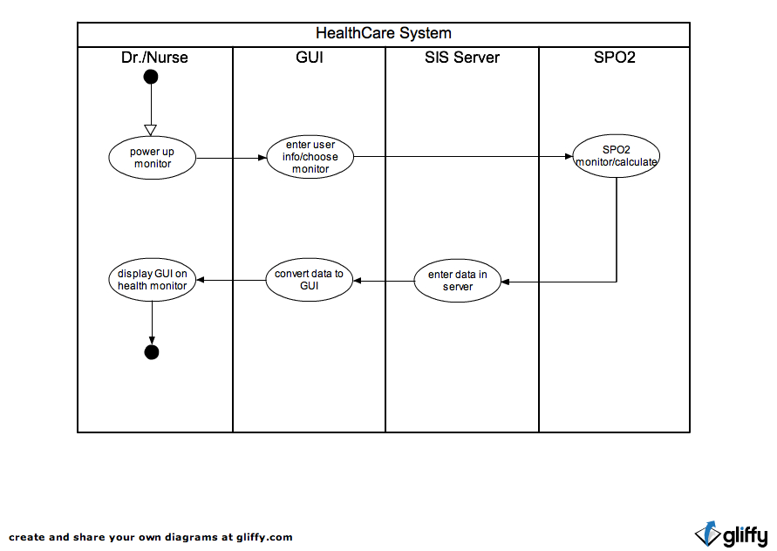

Class Diagram
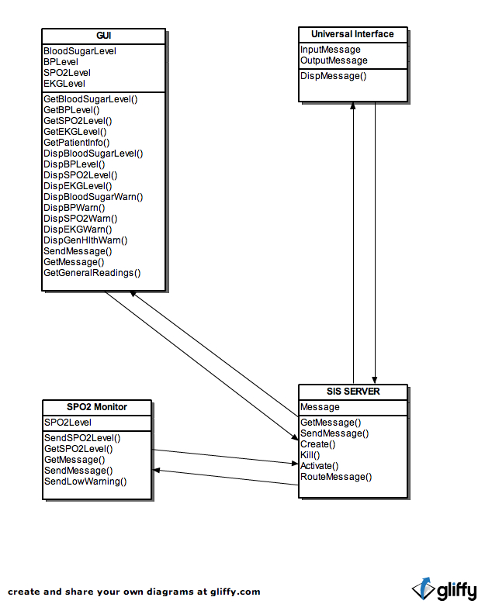

Use Case Diagram
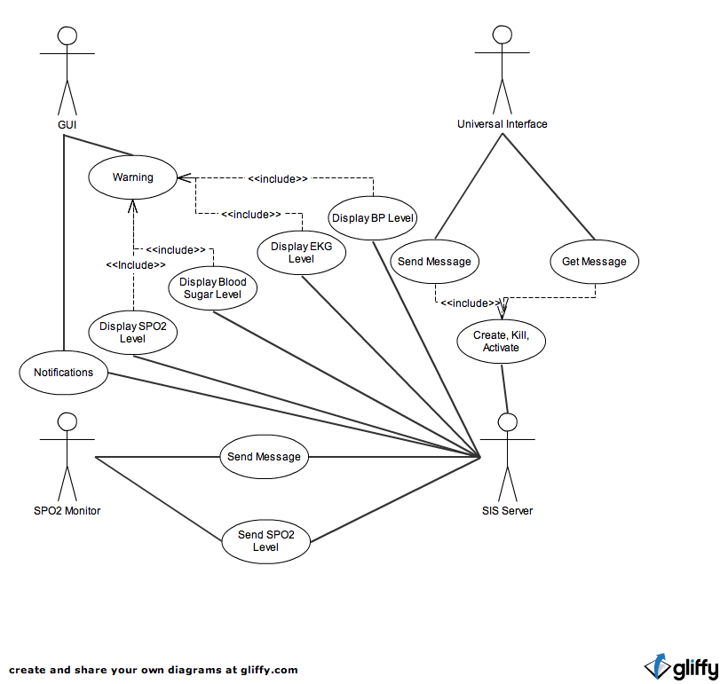

Sequence Diagram
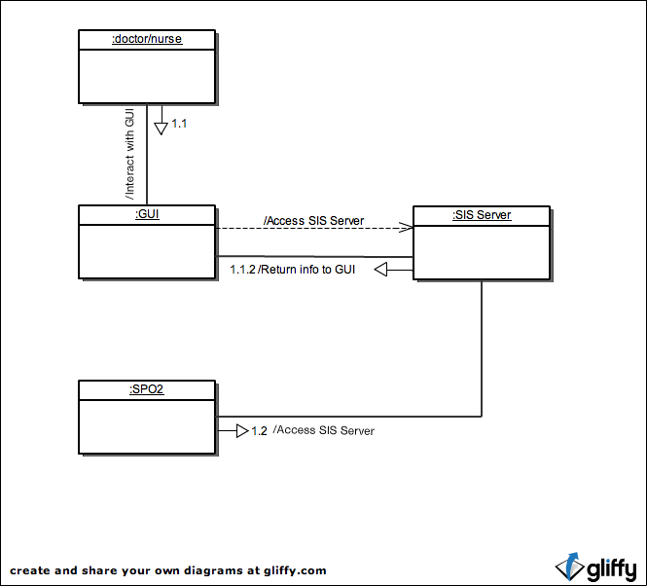

Screenshots

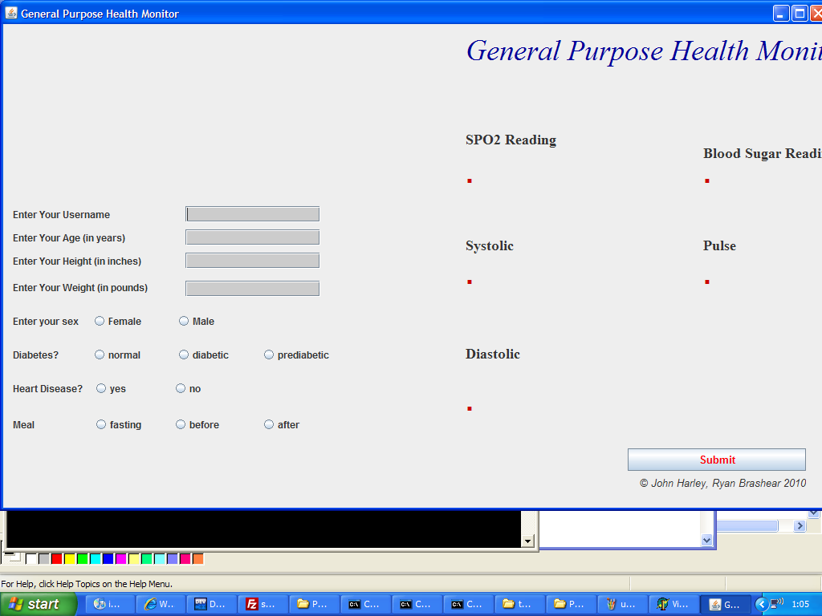

Here is an initial screenshot of our GUI program when it is first launched before any input is entered by the user

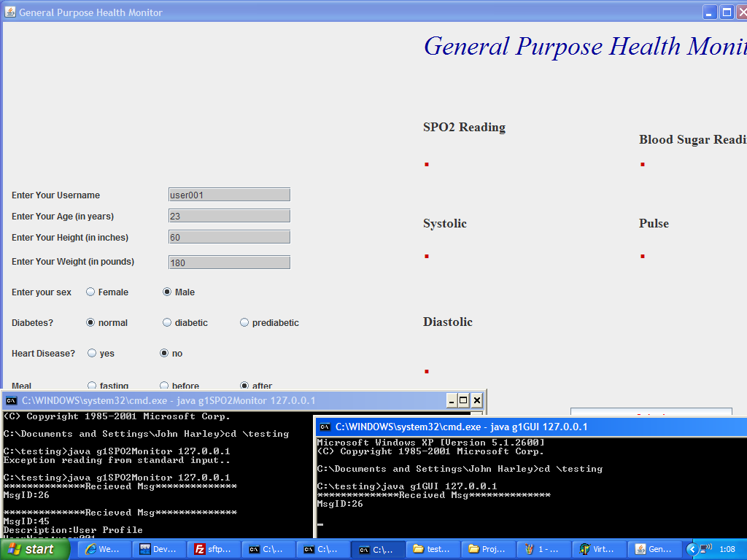

Here the results are seen after the user enters their information, and message 45 is sent to the server

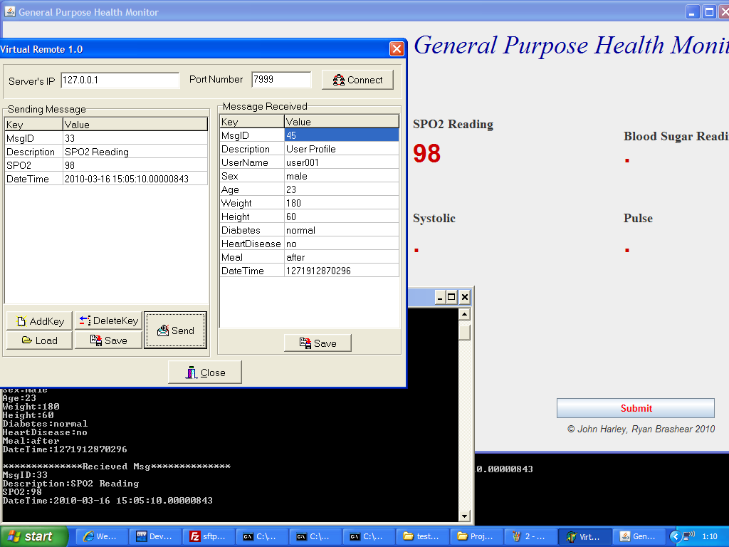

After message 45 has been sent to the server, our component recieves message 33 with the SPO2 reading value.

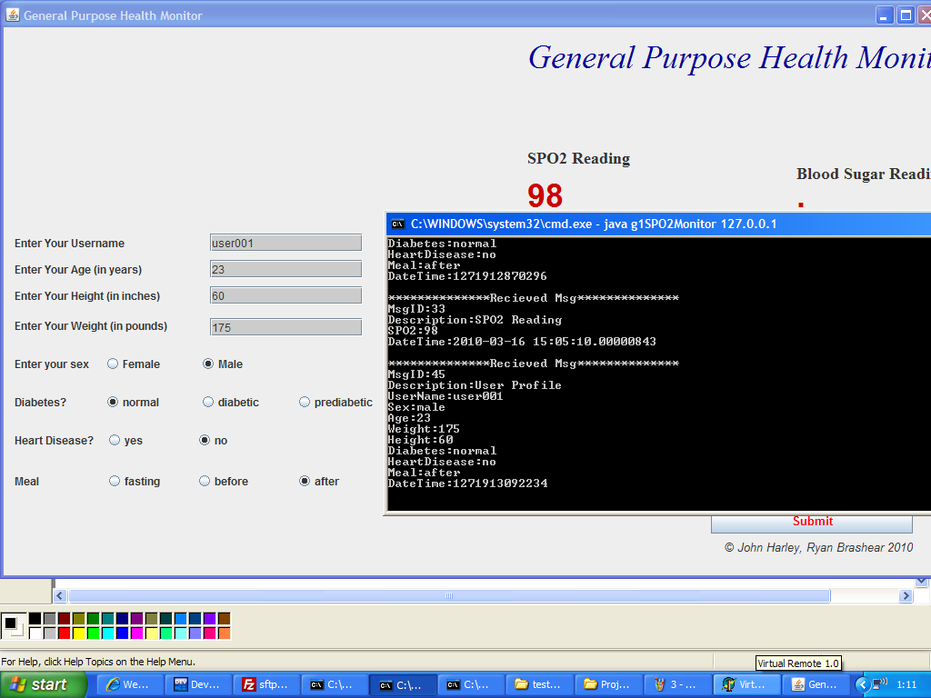
Messages 33 and 45 are received by the GUI component and the result of the SPO2 reading is displayed to the user in red.

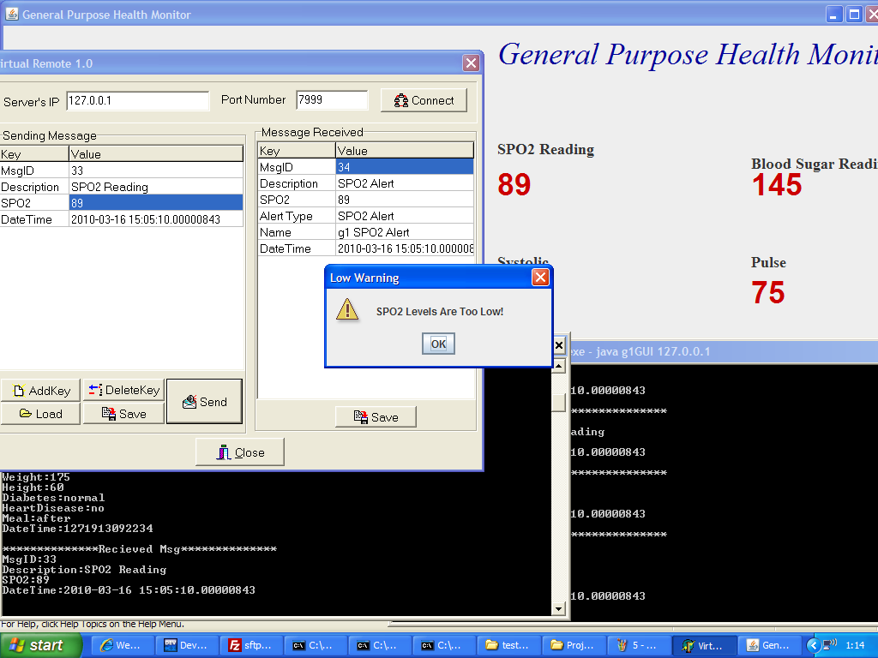

If the SPO2 reading value is too low, our component will receive message 34 stating that there is an SPO2 alert. This message is sent by our SPO2 component. A dialog box alerts the user that their SPO2 level is low. Notice Blood Sugar, Pulse, Systolic, and Diastolic values are displayed in red.

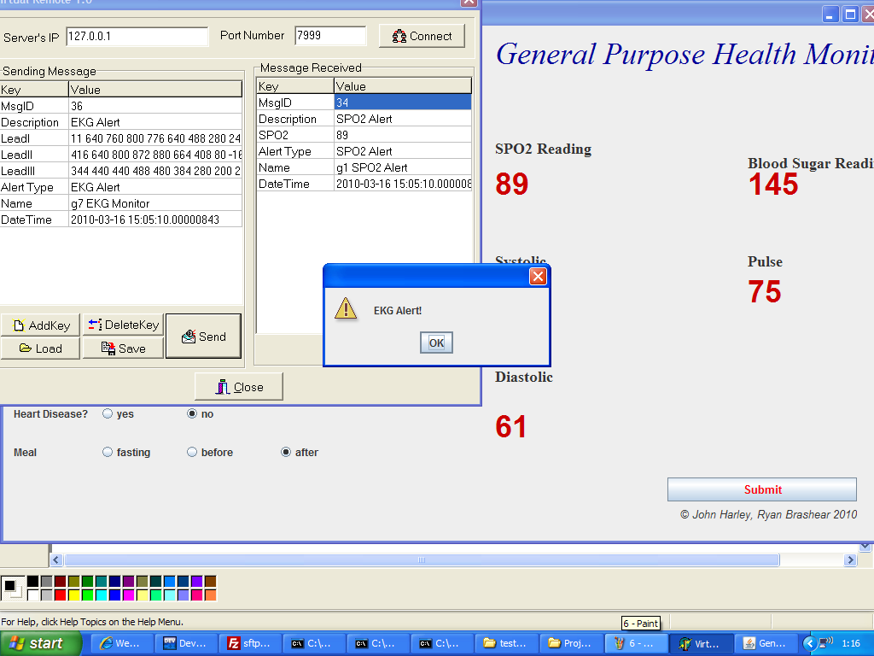

When message 36 is sent, we receive message 34 and display a dialog box with an EKG Alert for the user.

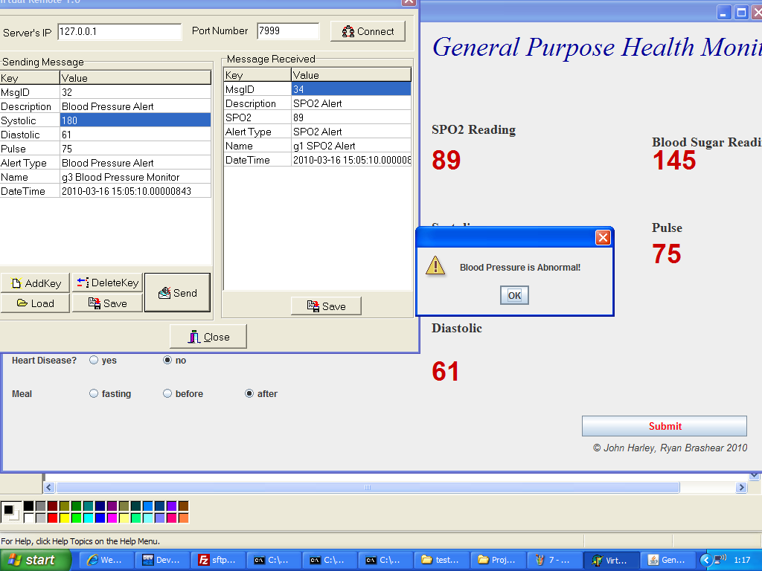
When message 32 is sent, this triggers a dialog box to signal Blood Pressure is Abnormal for the given user.

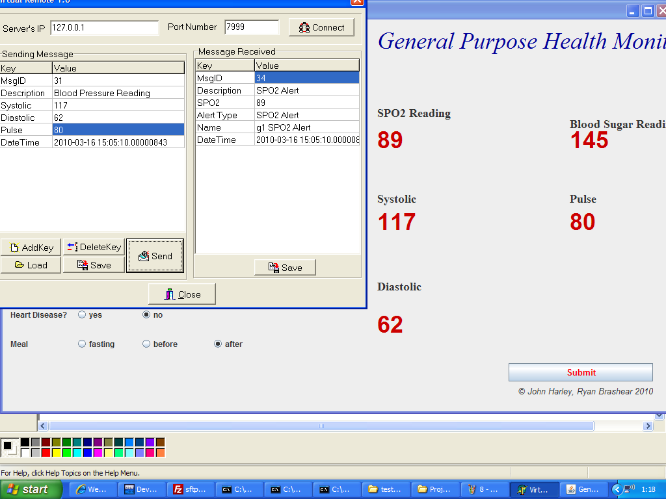
When message 31 is sent, the GUI displays the Systolic, Diastolic, and Pulse values that are received.

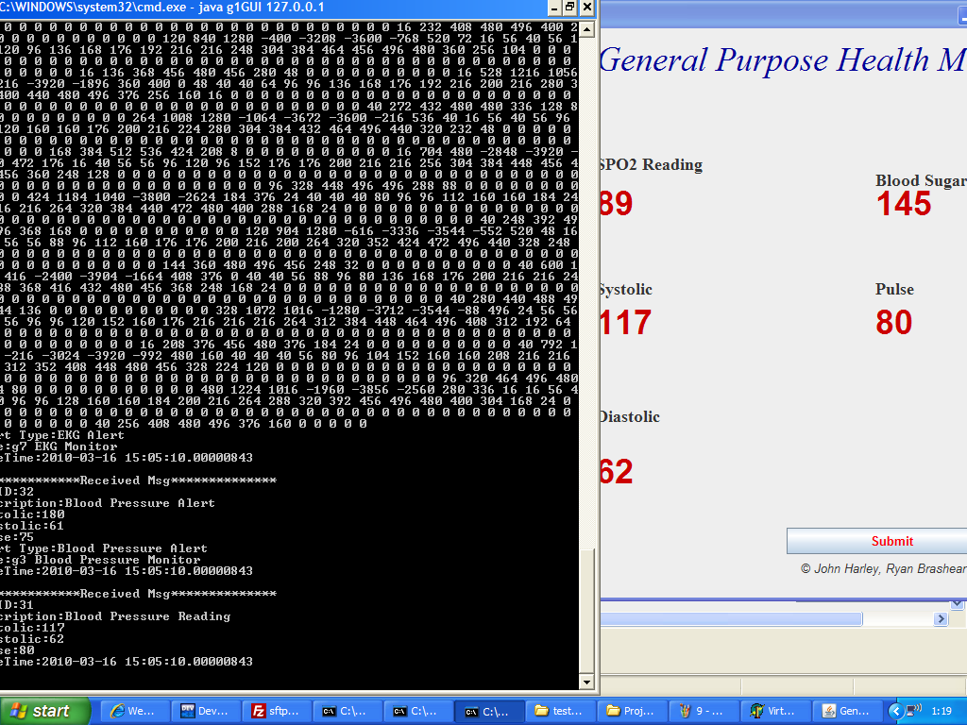

Our component recieves a Blood Pressure reading, and if the reading is outside of a specified range, a Blood Pressure Alert is triggered and displayed to the user.

Appendix A
G1GUI.java

/********************************************************
**Authors: John Harley, Ryan Brashear **
**Project: g1GUI.java **
**Modified: 4-7-10 **
**Class: CS1631 **
**Due: 4-13-10 **
********************************************************/
import java.io.*;
import java.net.*;
import java.util.*;
import java.util.regex.*;
import java.awt.*;
import java.awt.event.*;
import javax.swing.*;

public class g1GUI extends NewJFrame
{
Socket universal;
JFrame frame;
JFrame frame1;
JOptionPane pane;
int n = 0;
public static String userName;
public static String Age;
public static String Height;
public static String Weight;
public static String Diabetes;
public static String heartDisease;
public static String Meal;
public static String Sex;
String userName2;
String Age2;
String Height2;
String Weight2;
String Diabetes2;
String heartDisease2;
String Meal2;
String Sex2;
String time;

g1GUI(String servaddr)
{

try{
universal = new Socket(servaddr, 7999);

MsgEncoder mEncoder = new MsgEncoder();
final MsgDecoder mDecoder = new MsgDecoder(universal.getInputStream());

KeyValueList kvlResult = new KeyValueList();
kvlResult.addPair("MsgID","23");
kvlResult.addPair("Description", "Connect to Server");
kvlResult.addPair("SecurityLevel", "3");
kvlResult.addPair("Name", "g1GUI");
mEncoder.sendMsg(kvlResult, universal.getOutputStream());

MsgEncoder mgEncoder = new MsgEncoder();
KeyValueList kvgResult = new KeyValueList();

NewJFrame frame = new NewJFrame();
frame.setVisible(true);
while(NewJFrame.userName.equals("") || NewJFrame.Age.equals("") || NewJFrame.Sex.equals("") || NewJFrame.heartDisease.equals("") || NewJFrame.Meal.equals("") || NewJFrame.Diabetes.equals("") || NewJFrame.Weight.equals("") || NewJFrame.Height.equals(""))
{

}
time = Long.valueOf((new Date()).getTime()).toString();

kvgResult.addPair("MsgID","45");
kvgResult.addPair("Description", "User Profile");
kvgResult.addPair("UserName", NewJFrame.userName);
kvgResult.addPair("Sex", NewJFrame.Sex);
kvgResult.addPair("Age", NewJFrame.Age);
kvgResult.addPair("Weight", NewJFrame.Weight);
kvgResult.addPair("Height", NewJFrame.Height);
kvgResult.addPair("Diabetes", NewJFrame.Diabetes);
kvgResult.addPair("HeartDisease", NewJFrame.heartDisease);
kvgResult.addPair("Meal", NewJFrame.Meal);
kvgResult.addPair("DateTime", time);
mgEncoder.sendMsg(kvgResult, universal.getOutputStream());
userName2 = NewJFrame.userName;
Age2 = NewJFrame.Age;
Height2 = NewJFrame.Height;
Weight2 = NewJFrame.Weight;
Diabetes2 = NewJFrame.Diabetes;
heartDisease2 = NewJFrame.heartDisease;
Meal2 = NewJFrame.Meal;
Sex2 = NewJFrame.Sex;

/* receiving thread*/
Thread t = new Thread (new Runnable()
{
public void run()
{

KeyValueList kvInput;
try
{

while(true)
{
kvInput = mDecoder.getMsg();
System.out.println("**************Received Msg**************");
System.out.println(kvInput);
processMsg(kvInput);
}
}
catch(Exception ex)
{ System.out.println("Exception while sending to universal interface..");}
}
});
t.setDaemon(true);
t.start();
}catch(Exception ex)
{System.out.println("Exception reading from standard input..");}

try{
while (true)
{
if (!NewJFrame.userName.equals(userName2) || !NewJFrame.Age.equals(Age2) || !NewJFrame.Sex.equals(Sex2)|| !NewJFrame.Weight.equals(Weight2)|| !NewJFrame.Height.equals(Height2)|| !NewJFrame.heartDisease.equals(heartDisease2)|| !NewJFrame.Diabetes.equals(Diabetes2)|| !NewJFrame.Meal.equals(Meal2) )
{
MsgEncoder mgEncoder = new MsgEncoder();
KeyValueList kResult = new KeyValueList();
time = Long.valueOf((new Date()).getTime()).toString();
kResult.addPair("MsgID","45");
kResult.addPair("Description", "User Profile");
kResult.addPair("UserName", NewJFrame.userName);
kResult.addPair("Sex", NewJFrame.Sex);
kResult.addPair("Age", NewJFrame.Age);
kResult.addPair("Weight", NewJFrame.Weight);
kResult.addPair("Height", NewJFrame.Height);
kResult.addPair("Diabetes", NewJFrame.Diabetes);
kResult.addPair("HeartDisease", NewJFrame.heartDisease);
kResult.addPair("Meal", NewJFrame.Meal);
kResult.addPair("DateTime", time);
mgEncoder.sendMsg(kResult, universal.getOutputStream());
userName2 = NewJFrame.userName;
Age2 = NewJFrame.Age;
Height2 = NewJFrame.Height;
Weight2 = NewJFrame.Weight;
Diabetes2 = NewJFrame.Diabetes;
heartDisease2 = NewJFrame.heartDisease;
Meal2 = NewJFrame.Meal;
Sex2 = NewJFrame.Sex;
}
}

}catch(Exception ex)
{ System.out.println("Exception reading from standard input..");}
}

public static void main(String args[])
{
g1GUI app = new g1GUI(args[0]);
}

public void processMsg(KeyValueList kvList) throws Exception
{
int MsgID = Integer.parseInt(kvList.getValue("MsgID"));
ArrayList<Socket> sendlist;
ArrayList<String> inmsgs, outmsgs;
CompMsgControl tempcmc;
String tempstr;
String result1;
String result2;
String result3;
String result4;
String result5;
String result6;
String result7;
String result8;
String result9;
String result10;

switch(MsgID)
{
case 31:

result1 = kvList.getValue("Systolic");
result2 = kvList.getValue("Diastolic");
result3 = kvList.getValue("Pulse");
try{
NewJFrame.systolic.setText(result1);
NewJFrame.diastolic.setText(result2);
NewJFrame.pulse.setText(result3);
}
catch(Exception ex)
{ System.out.println("Exception reading BloodPressure..");}
break;
case 32:
/*
result1 = kvList.getValue("Systolic");
result2 = kvList.getValue("Diastolic");
result3 = kvList.getValue("Pulse");
result4 = kvList.getValue("Alert Type");
result5 = kvList.getValue("Name");
result6 = kvList.getValue("DateTime");
*/
JFrame frame6 = new JFrame();
JOptionPane.showMessageDialog(frame6,"Blood Pressure is Abnormal!",null,JOptionPane.WARNING_MESSAGE);

break;
case 33:
result1 = kvList.getValue("SPO2");
NewJFrame.spo2.setText(result1);
break;
case 34:
/*
result1 = kvList.getValue("SPO2");
result2 = kvList.getValue("Alert Type");
result3 = kvList.getValue("Name");
result4 = kvList.getValue("DateTime");
*/
JFrame frame3 = new JFrame();
JOptionPane.showMessageDialog(frame3,"SPO2 Levels Are Too Low!","Low Warning",JOptionPane.WARNING_MESSAGE);
break;
case 36:
//result1 = kvList.getValue("Alert Type");
//result2 = kvList.getValue("Name");
//result3 = kvList.getValue("DateTime");
JFrame frame4 = new JFrame();
JOptionPane.showMessageDialog(frame4,"EKG Alert!",null,JOptionPane.WARNING_MESSAGE);

break;
case 38:
/*
result1 = kvList.getValue("Systolic");
result2 = kvList.getValue("Diastolic");
result3 = kvList.getValue("Pulse");
result4 = kvList.getValue("DateTimeBP");
result5 = kvList.getValue("SPO2");
result6 = kvList.getValue("DateTimeSPO2");
result7 = kvList.getValue("DateTimeEKG");
result8 = kvList.getValue("Alert Type");
result9 = kvList.getValue("Name");
result10 = kvList.getValue("DateTime");
*/
JFrame frame5 = new JFrame();
JOptionPane.showMessageDialog(frame5,"Emergency!",null,JOptionPane.WARNING_MESSAGE);
break;
case 41:
result1 = kvList.getValue("Blood Sugar");
try{
NewJFrame.bloodSugar.setText(result1);
}
catch(Exception ex)
{ System.out.println("Exception reading blood sugar..");}
break;
case 42:
JFrame frame7 = new JFrame();
JOptionPane.showMessageDialog(frame7,"Blood Sugar Alert!",null,JOptionPane.WARNING_MESSAGE);
break;
}
}

}

G1SPO2Monitor.java
/********************************************************
**Authors: John Harley, Ryan Brashear **
**Project: g1SPO2Monitor.java **
**Modified: 4-7-10 **
**Class: CS1631 **
**Due: 4-13-10 **
********************************************************/
import java.io.*;
import java.net.*;
import java.util.*;

public class g1SPO2Monitor
{
Socket universal;

g1SPO2Monitor(String servaddr)
{
try{
universal = new Socket(servaddr, 7999);

MsgEncoder mEncoder = new MsgEncoder();
final MsgDecoder mDecoder = new MsgDecoder(universal.getInputStream());

KeyValueList kvlResult = new KeyValueList();
kvlResult.addPair("MsgID","23");
kvlResult.addPair("Description", "Connect to Server");
kvlResult.addPair("SecurityLevel", "3");
kvlResult.addPair("Name", "g1SPO2Monitor");
mEncoder.sendMsg(kvlResult, universal.getOutputStream());
/* receiving thread*/
Thread t = new Thread (new Runnable()
{
public void run()
{
KeyValueList kvInput;
try
{
while(true)
{
kvInput = mDecoder.getMsg();
System.out.println("**************Recieved Msg**************");
System.out.println(kvInput);
processMsg(kvInput);
}
}
catch(Exception ex)
{ System.out.println("Exception while sending to universal interface..");}
}
});
t.setDaemon(true);
t.start();
}
catch(Exception ex)
{
System.out.println("Exception reading from standard input..");
}
try
{
MsgEncoder mEncoder = new MsgEncoder();
BufferedReader br = new BufferedReader(new InputStreamReader(System.in));
while (true)
{
String input = br.readLine();
KeyValueList kvList = new KeyValueList();
StringTokenizer st = new StringTokenizer(input, "$$$");
while (st.hasMoreTokens())
{
kvList.addPair(st.nextToken(), st.nextToken());
}

mEncoder.sendMsg(kvList, universal.getOutputStream());
}
}
catch(Exception ex)
{
System.out.println("Exception reading from standard input..");
}
}
public static void main(String args[])
{
g1SPO2Monitor app = new g1SPO2Monitor(args[0]);
}
public void processMsg(KeyValueList kvList) throws Exception
{
int MsgID = Integer.parseInt(kvList.getValue("MsgID"));
ArrayList<Socket> sendlist;
ArrayList<String> inmsgs, outmsgs;
CompMsgControl tempcmc;
String tempstr;

switch(MsgID)
{
case 33:
String result1 = kvList.getValue("SPO2");
String result2 = kvList.getValue("DateTime");
int aInt = Integer.parseInt(result1);
if (aInt < 91)
{
MsgEncoder mEncoder = new MsgEncoder();
KeyValueList kvResult = new KeyValueList();
kvResult.addPair("MsgID","34");
kvResult.addPair("Description", "SPO2 Alert");
kvResult.addPair("SPO2", result1);
kvResult.addPair("Alert Type", "SPO2 Alert");
kvResult.addPair("Name", "g1 SPO2 Alert");
kvResult.addPair("DateTime", result2);
try
{
mEncoder.sendMsg(kvResult, universal.getOutputStream());
}
catch(Exception ex)
{ System.out.println("Exception sending SPO2 Alert..");}
}
break;
}
}
}

NewJFrame.java
import javax.swing.JOptionPane;

/*
* To change this template, choose Tools | Templates
* and open the template in the editor.
*/

/*
* NewJFrame.java
*
* Created on Apr 14, 2010, 8:00:15 PM
*/

/**
*
* @author John Harley
*/
public class NewJFrame extends javax.swing.JFrame {
public static String userName = "";
public static String Height = "";
public static String Age = "";
public static String heartDisease = "";
public static String Meal = "";
public static String Weight = "";
public static String Sex = "";
public static String Diabetes = "";

/** Creates new form NewJFrame */
public NewJFrame() {
initComponents();
}

/** This method is called from within the constructor to
* initialize the form.
* WARNING: Do NOT modify this code. The content of this method is
* always regenerated by the Form Editor.
*/
@SuppressWarnings("unchecked")
// <editor-fold defaultstate="collapsed" desc="Generated Code">
private void initComponents() {

buttonGroup1 = new javax.swing.ButtonGroup();
buttonGroup2 = new javax.swing.ButtonGroup();
buttonGroup3 = new javax.swing.ButtonGroup();
buttonGroup4 = new javax.swing.ButtonGroup();
submitButton = new javax.swing.JButton();
jLabel1 = new javax.swing.JLabel();
jLabel2 = new javax.swing.JLabel();
jLabel4 = new javax.swing.JLabel();
jLabel3 = new javax.swing.JLabel();
HeightText = new javax.swing.JTextField();
AgeText = new javax.swing.JTextField();
userNameText = new javax.swing.JTextField();
WeightText = new javax.swing.JTextField();
jLabel5 = new javax.swing.JLabel();
jLabel6 = new javax.swing.JLabel();
jLabel7 = new javax.swing.JLabel();
jLabel8 = new javax.swing.JLabel();
jLabel9 = new javax.swing.JLabel();
jLabel10 = new javax.swing.JLabel();
bloodSug = new javax.swing.JLabel();
jLabel11 = new javax.swing.JLabel();
jLabel12 = new javax.swing.JLabel();
jLabel13 = new javax.swing.JLabel();
systolic = new javax.swing.JLabel();
diastolic = new javax.swing.JLabel();
pulse = new javax.swing.JLabel();
spo2 = new javax.swing.JLabel();
bloodSugar = new javax.swing.JLabel();
jRadioButton1 = new javax.swing.JRadioButton();
jRadioButton2 = new javax.swing.JRadioButton();
jRadioButton3 = new javax.swing.JRadioButton();
jRadioButton4 = new javax.swing.JRadioButton();
jRadioButton5 = new javax.swing.JRadioButton();
jRadioButton6 = new javax.swing.JRadioButton();
jRadioButton7 = new javax.swing.JRadioButton();
jRadioButton8 = new javax.swing.JRadioButton();
jRadioButton9 = new javax.swing.JRadioButton();
jRadioButton10 = new javax.swing.JRadioButton();
jLabel14 = new javax.swing.JLabel();
jLabel16 = new javax.swing.JLabel();

setDefaultCloseOperation(javax.swing.WindowConstants.EXIT_ON_CLOSE);
setTitle("General Purpose Health Monitor");
setBackground(new java.awt.Color(153, 153, 153));
setForeground(java.awt.Color.white);

submitButton.setFont(new java.awt.Font("Lucida Grande", 1, 13));
submitButton.setForeground(new java.awt.Color(255, 0, 0));
submitButton.setText("Submit");
submitButton.setToolTipText("Submit Information");
submitButton.addActionListener(new java.awt.event.ActionListener() {
public void actionPerformed(java.awt.event.ActionEvent evt) {
submitButtonActionPerformed(evt);
}
});

jLabel1.setText("Enter Your Username");

jLabel2.setText("Enter Your Age (in years)");

jLabel3.setText("Enter Your Height (in inches)");

HeightText.setBackground(new java.awt.Color(204, 204, 204));

AgeText.setBackground(new java.awt.Color(204, 204, 204));

userNameText.setBackground(new java.awt.Color(204, 204, 204));

WeightText.setBackground(new java.awt.Color(204, 204, 204));
WeightText.setToolTipText("Enter a weight");

jLabel5.setText("Enter Your Weight (in pounds)");
jLabel5.setToolTipText("Enter your weight");

jLabel6.setText("Enter your sex");
jLabel6.setToolTipText("Enter sex");

jLabel7.setText("Diabetes?");
jLabel7.setToolTipText("High Blood Pressure?");

jLabel8.setText("Heart Disease?");
jLabel8.setToolTipText("Heart Disease?");

jLabel9.setText("Meal");
jLabel9.setToolTipText("Meal?");

jLabel10.setFont(new java.awt.Font("Times New Roman", 1, 18));
jLabel10.setText("SPO2 Reading");

bloodSug.setFont(new java.awt.Font("Times New Roman", 1, 18));
bloodSug.setText("Blood Sugar Reading");

jLabel11.setFont(new java.awt.Font("Times New Roman", 1, 18));
jLabel11.setText("Systolic");

jLabel12.setFont(new java.awt.Font("Times New Roman", 1, 18));
jLabel12.setText("Diastolic");

jLabel13.setFont(new java.awt.Font("Times New Roman", 1, 18));
jLabel13.setText("Pulse");

systolic.setFont(new java.awt.Font("Synchro LET", 1, 36));
systolic.setForeground(new java.awt.Color(204, 0, 0));
systolic.setText(".");

diastolic.setFont(new java.awt.Font("Synchro LET", 1, 36));
diastolic.setForeground(new java.awt.Color(204, 0, 0));
diastolic.setText(".");

pulse.setFont(new java.awt.Font("Synchro LET", 1, 36));
pulse.setForeground(new java.awt.Color(204, 0, 0));
pulse.setText(".");

spo2.setFont(new java.awt.Font("Synchro LET", 1, 36));
spo2.setForeground(new java.awt.Color(204, 0, 0));
spo2.setText(".");

bloodSugar.setFont(new java.awt.Font("Synchro LET", 1, 36));
bloodSugar.setForeground(new java.awt.Color(204, 0, 0));
bloodSugar.setText(".");

buttonGroup1.add(jRadioButton1);
jRadioButton1.setText("Male");
jRadioButton1.addActionListener(new java.awt.event.ActionListener() {
public void actionPerformed(java.awt.event.ActionEvent evt) {
jRadioButton1ActionPerformed(evt);
}
});

buttonGroup1.add(jRadioButton2);
jRadioButton2.setText("Female");
jRadioButton2.addActionListener(new java.awt.event.ActionListener() {
public void actionPerformed(java.awt.event.ActionEvent evt) {
jRadioButton2ActionPerformed(evt);
}
});

buttonGroup2.add(jRadioButton3);
jRadioButton3.setText("normal");
jRadioButton3.addActionListener(new java.awt.event.ActionListener() {
public void actionPerformed(java.awt.event.ActionEvent evt) {
jRadioButton3ActionPerformed(evt);
}
});

buttonGroup2.add(jRadioButton4);
jRadioButton4.setText("prediabetic");
jRadioButton4.addActionListener(new java.awt.event.ActionListener() {
public void actionPerformed(java.awt.event.ActionEvent evt) {
jRadioButton4ActionPerformed(evt);
}
});

buttonGroup2.add(jRadioButton5);
jRadioButton5.setText("diabetic");
jRadioButton5.addActionListener(new java.awt.event.ActionListener() {
public void actionPerformed(java.awt.event.ActionEvent evt) {
jRadioButton5ActionPerformed(evt);
}
});

buttonGroup3.add(jRadioButton6);
jRadioButton6.setText("yes");
jRadioButton6.addActionListener(new java.awt.event.ActionListener() {
public void actionPerformed(java.awt.event.ActionEvent evt) {
jRadioButton6ActionPerformed(evt);
}
});

buttonGroup3.add(jRadioButton7);
jRadioButton7.setText("no");
jRadioButton7.addActionListener(new java.awt.event.ActionListener() {
public void actionPerformed(java.awt.event.ActionEvent evt) {
jRadioButton7ActionPerformed(evt);
}
});

buttonGroup4.add(jRadioButton8);
jRadioButton8.setText("fasting");
jRadioButton8.addActionListener(new java.awt.event.ActionListener() {
public void actionPerformed(java.awt.event.ActionEvent evt) {
jRadioButton8ActionPerformed(evt);
}
});

buttonGroup4.add(jRadioButton9);
jRadioButton9.setText("before");
jRadioButton9.addActionListener(new java.awt.event.ActionListener() {
public void actionPerformed(java.awt.event.ActionEvent evt) {
jRadioButton9ActionPerformed(evt);
}
});

buttonGroup4.add(jRadioButton10);
jRadioButton10.setText("after");
jRadioButton10.addActionListener(new java.awt.event.ActionListener() {
public void actionPerformed(java.awt.event.ActionEvent evt) {
jRadioButton10ActionPerformed(evt);
}
});

jLabel14.setFont(new java.awt.Font("Times New Roman", 2, 36));
jLabel14.setForeground(new java.awt.Color(0, 0, 153));
jLabel14.setText("General Purpose Health Monitor");

jLabel16.setFont(new java.awt.Font("Lucida Grande", 2, 13));
jLabel16.setText("� John Harley, Ryan Brashear 2010");

javax.swing.GroupLayout layout = new javax.swing.GroupLayout(getContentPane());
getContentPane().setLayout(layout);
layout.setHorizontalGroup(
layout.createParallelGroup(javax.swing.GroupLayout.Alignment.LEADING)
.addGroup(layout.createSequentialGroup()
.addContainerGap()
.addGroup(layout.createParallelGroup(javax.swing.GroupLayout.Alignment.LEADING)
.addGroup(layout.createSequentialGroup()
.addGroup(layout.createParallelGroup(javax.swing.GroupLayout.Alignment.LEADING)
.addGroup(layout.createSequentialGroup()
.addGroup(layout.createParallelGroup(javax.swing.GroupLayout.Alignment.LEADING)
.addGroup(layout.createParallelGroup(javax.swing.GroupLayout.Alignment.LEADING)
.addGroup(layout.createParallelGroup(javax.swing.GroupLayout.Alignment.LEADING)
.addComponent(jLabel1, javax.swing.GroupLayout.DEFAULT_SIZE, 196, Short.MAX_VALUE)
.addComponent(jLabel2))
.addComponent(jLabel3))
.addComponent(jLabel5))
.addGroup(layout.createParallelGroup(javax.swing.GroupLayout.Alignment.LEADING)
.addGroup(layout.createSequentialGroup()
.addGap(102, 102, 102)
.addComponent(jLabel4))
.addGroup(layout.createSequentialGroup()
.addGap(29, 29, 29)
.addGroup(layout.createParallelGroup(javax.swing.GroupLayout.Alignment.LEADING, false)
.addComponent(WeightText, javax.swing.GroupLayout.DEFAULT_SIZE, 168, Short.MAX_VALUE)
.addComponent(AgeText)
.addComponent(userNameText, javax.swing.GroupLayout.DEFAULT_SIZE, 165, Short.MAX_VALUE)
.addComponent(HeightText))))
.addPreferredGap(javax.swing.LayoutStyle.ComponentPlacement.RELATED, 191, Short.MAX_VALUE))
.addGroup(layout.createSequentialGroup()
.addGroup(layout.createParallelGroup(javax.swing.GroupLayout.Alignment.LEADING)
.addGroup(layout.createSequentialGroup()
.addGroup(layout.createParallelGroup(javax.swing.GroupLayout.Alignment.LEADING)
.addComponent(jLabel6, javax.swing.GroupLayout.PREFERRED_SIZE, 90, javax.swing.GroupLayout.PREFERRED_SIZE)
.addComponent(jLabel7))
.addPreferredGap(javax.swing.LayoutStyle.ComponentPlacement.RELATED)
.addGroup(layout.createParallelGroup(javax.swing.GroupLayout.Alignment.LEADING, false)
.addComponent(jRadioButton3, javax.swing.GroupLayout.DEFAULT_SIZE, javax.swing.GroupLayout.DEFAULT_SIZE, Short.MAX_VALUE)
.addComponent(jRadioButton2, javax.swing.GroupLayout.DEFAULT_SIZE, 76, Short.MAX_VALUE))
.addGap(29, 29, 29)
.addGroup(layout.createParallelGroup(javax.swing.GroupLayout.Alignment.LEADING)
.addComponent(jRadioButton1, javax.swing.GroupLayout.PREFERRED_SIZE, 78, javax.swing.GroupLayout.PREFERRED_SIZE)
.addComponent(jRadioButton5)))
.addGroup(layout.createSequentialGroup()
.addComponent(jLabel8, javax.swing.GroupLayout.PREFERRED_SIZE, 92, javax.swing.GroupLayout.PREFERRED_SIZE)
.addPreferredGap(javax.swing.LayoutStyle.ComponentPlacement.RELATED)
.addGroup(layout.createParallelGroup(javax.swing.GroupLayout.Alignment.LEADING)
.addComponent(jRadioButton8, javax.swing.GroupLayout.PREFERRED_SIZE, 85, javax.swing.GroupLayout.PREFERRED_SIZE)
.addComponent(jRadioButton6)))
.addGroup(layout.createSequentialGroup()
.addComponent(jLabel9, javax.swing.GroupLayout.PREFERRED_SIZE, 37, javax.swing.GroupLayout.PREFERRED_SIZE)
.addGap(162, 162, 162)
.addGroup(layout.createParallelGroup(javax.swing.GroupLayout.Alignment.LEADING)
.addComponent(jRadioButton7, javax.swing.GroupLayout.PREFERRED_SIZE, 60, javax.swing.GroupLayout.PREFERRED_SIZE)
.addComponent(jRadioButton9))))
.addGap(28, 28, 28)
.addGroup(layout.createParallelGroup(javax.swing.GroupLayout.Alignment.LEADING)
.addComponent(jRadioButton4)
.addComponent(jRadioButton10))
.addGap(166, 166, 166)))
.addGroup(layout.createParallelGroup(javax.swing.GroupLayout.Alignment.LEADING)
.addGroup(layout.createSequentialGroup()
.addGroup(layout.createParallelGroup(javax.swing.GroupLayout.Alignment.TRAILING)
.addGroup(javax.swing.GroupLayout.Alignment.LEADING, layout.createSequentialGroup()
.addGroup(layout.createParallelGroup(javax.swing.GroupLayout.Alignment.LEADING)
.addComponent(jLabel10, javax.swing.GroupLayout.PREFERRED_SIZE, 137, javax.swing.GroupLayout.PREFERRED_SIZE)
.addComponent(jLabel11))
.addGap(103, 103, 103))
.addGroup(javax.swing.GroupLayout.Alignment.LEADING, layout.createSequentialGroup()
.addComponent(spo2, javax.swing.GroupLayout.PREFERRED_SIZE, 151, javax.swing.GroupLayout.PREFERRED_SIZE)
.addPreferredGap(javax.swing.LayoutStyle.ComponentPlacement.RELATED))
.addGroup(javax.swing.GroupLayout.Alignment.LEADING, layout.createSequentialGroup()
.addPreferredGap(javax.swing.LayoutStyle.ComponentPlacement.RELATED)
.addGroup(layout.createParallelGroup(javax.swing.GroupLayout.Alignment.LEADING)
.addComponent(jLabel12)
.addComponent(systolic, javax.swing.GroupLayout.DEFAULT_SIZE, 296, Short.MAX_VALUE)
.addComponent(diastolic, javax.swing.GroupLayout.PREFERRED_SIZE, 125, javax.swing.GroupLayout.PREFERRED_SIZE))
.addPreferredGap(javax.swing.LayoutStyle.ComponentPlacement.RELATED)))
.addGroup(layout.createParallelGroup(javax.swing.GroupLayout.Alignment.LEADING)
.addGroup(layout.createParallelGroup(javax.swing.GroupLayout.Alignment.LEADING, false)
.addComponent(bloodSugar, javax.swing.GroupLayout.DEFAULT_SIZE, javax.swing.GroupLayout.DEFAULT_SIZE, Short.MAX_VALUE)
.addComponent(jLabel13, javax.swing.GroupLayout.PREFERRED_SIZE, 88, javax.swing.GroupLayout.PREFERRED_SIZE)
.addComponent(pulse, javax.swing.GroupLayout.DEFAULT_SIZE, javax.swing.GroupLayout.DEFAULT_SIZE, Short.MAX_VALUE))
.addComponent(bloodSug, javax.swing.GroupLayout.PREFERRED_SIZE, 181, javax.swing.GroupLayout.PREFERRED_SIZE))
.addGap(34, 34, 34))
.addGroup(layout.createSequentialGroup()
.addPreferredGap(javax.swing.LayoutStyle.ComponentPlacement.RELATED)
.addComponent(jLabel14, javax.swing.GroupLayout.PREFERRED_SIZE, 499, javax.swing.GroupLayout.PREFERRED_SIZE)
.addContainerGap())))
.addGroup(javax.swing.GroupLayout.Alignment.TRAILING, layout.createSequentialGroup()
.addGroup(layout.createParallelGroup(javax.swing.GroupLayout.Alignment.TRAILING)
.addComponent(jLabel16)
.addComponent(submitButton, javax.swing.GroupLayout.PREFERRED_SIZE, 222, javax.swing.GroupLayout.PREFERRED_SIZE))
.addGap(87, 87, 87))))
);
layout.setVerticalGroup(
layout.createParallelGroup(javax.swing.GroupLayout.Alignment.LEADING)
.addGroup(layout.createSequentialGroup()
.addGroup(layout.createParallelGroup(javax.swing.GroupLayout.Alignment.LEADING)
.addGroup(layout.createSequentialGroup()
.addContainerGap()
.addComponent(jLabel14, javax.swing.GroupLayout.PREFERRED_SIZE, 43, javax.swing.GroupLayout.PREFERRED_SIZE)
.addPreferredGap(javax.swing.LayoutStyle.ComponentPlacement.RELATED)
.addGroup(layout.createParallelGroup(javax.swing.GroupLayout.Alignment.LEADING)
.addGroup(layout.createSequentialGroup()
.addGap(58, 58, 58)
.addComponent(jLabel10, javax.swing.GroupLayout.DEFAULT_SIZE, 62, Short.MAX_VALUE))
.addGroup(javax.swing.GroupLayout.Alignment.TRAILING, layout.createSequentialGroup()
.addComponent(bloodSug)
.addGap(3, 3, 3)))
.addGap(52, 52, 52)
.addGroup(layout.createParallelGroup(javax.swing.GroupLayout.Alignment.BASELINE)
.addComponent(jLabel1)
.addComponent(userNameText, javax.swing.GroupLayout.PREFERRED_SIZE, javax.swing.GroupLayout.DEFAULT_SIZE, javax.swing.GroupLayout.PREFERRED_SIZE))
.addGroup(layout.createParallelGroup(javax.swing.GroupLayout.Alignment.LEADING)
.addGroup(layout.createSequentialGroup()
.addGap(9, 9, 9)
.addGroup(layout.createParallelGroup(javax.swing.GroupLayout.Alignment.BASELINE)
.addComponent(jLabel2)
.addComponent(AgeText, javax.swing.GroupLayout.PREFERRED_SIZE, javax.swing.GroupLayout.DEFAULT_SIZE, javax.swing.GroupLayout.PREFERRED_SIZE))
.addPreferredGap(javax.swing.LayoutStyle.ComponentPlacement.RELATED)
.addGroup(layout.createParallelGroup(javax.swing.GroupLayout.Alignment.BASELINE)
.addComponent(jLabel3, javax.swing.GroupLayout.PREFERRED_SIZE, 26, javax.swing.GroupLayout.PREFERRED_SIZE)
.addComponent(HeightText, javax.swing.GroupLayout.PREFERRED_SIZE, javax.swing.GroupLayout.DEFAULT_SIZE, javax.swing.GroupLayout.PREFERRED_SIZE)))
.addGroup(layout.createSequentialGroup()
.addGap(18, 18, 18)
.addGroup(layout.createParallelGroup(javax.swing.GroupLayout.Alignment.BASELINE)
.addComponent(jLabel11)
.addComponent(jLabel13))))
.addGap(12, 12, 12)
.addGroup(layout.createParallelGroup(javax.swing.GroupLayout.Alignment.LEADING)
.addComponent(jLabel5)
.addComponent(WeightText, javax.swing.GroupLayout.PREFERRED_SIZE, javax.swing.GroupLayout.DEFAULT_SIZE, javax.swing.GroupLayout.PREFERRED_SIZE))
.addGap(18, 18, 18)
.addGroup(layout.createParallelGroup(javax.swing.GroupLayout.Alignment.BASELINE)
.addComponent(jLabel6)
.addComponent(jRadioButton2)
.addComponent(jRadioButton1, javax.swing.GroupLayout.PREFERRED_SIZE, 23, javax.swing.GroupLayout.PREFERRED_SIZE))
.addGap(18, 18, 18)
.addGroup(layout.createParallelGroup(javax.swing.GroupLayout.Alignment.BASELINE)
.addComponent(jLabel7)
.addComponent(jRadioButton3)
.addComponent(jLabel12)
.addComponent(jRadioButton5)
.addComponent(jRadioButton4)))
.addGroup(layout.createSequentialGroup()
.addGap(161, 161, 161)
.addGroup(layout.createParallelGroup(javax.swing.GroupLayout.Alignment.BASELINE)
.addComponent(spo2)
.addComponent(bloodSugar))
.addGap(79, 79, 79)
.addGroup(layout.createParallelGroup(javax.swing.GroupLayout.Alignment.BASELINE)
.addComponent(systolic)
.addComponent(pulse, javax.swing.GroupLayout.PREFERRED_SIZE, 47, javax.swing.GroupLayout.PREFERRED_SIZE))
.addPreferredGap(javax.swing.LayoutStyle.ComponentPlacement.RELATED, 89, Short.MAX_VALUE)))
.addGroup(layout.createParallelGroup(javax.swing.GroupLayout.Alignment.LEADING)
.addGroup(layout.createSequentialGroup()
.addGap(18, 18, 18)
.addGroup(layout.createParallelGroup(javax.swing.GroupLayout.Alignment.BASELINE)
.addComponent(jLabel8)
.addComponent(jRadioButton6)
.addComponent(jRadioButton7))
.addGap(18, 18, 18)
.addGroup(layout.createParallelGroup(javax.swing.GroupLayout.Alignment.BASELINE)
.addComponent(jLabel9, javax.swing.GroupLayout.PREFERRED_SIZE, 30, javax.swing.GroupLayout.PREFERRED_SIZE)
.addComponent(jRadioButton8)
.addComponent(jRadioButton9)
.addComponent(jRadioButton10)))
.addGroup(layout.createSequentialGroup()
.addGap(28, 28, 28)
.addComponent(diastolic, javax.swing.GroupLayout.PREFERRED_SIZE, 32, javax.swing.GroupLayout.PREFERRED_SIZE)
.addGap(37, 37, 37)
.addComponent(jLabel4)))
.addGap(8, 8, 8)
.addComponent(submitButton)
.addPreferredGap(javax.swing.LayoutStyle.ComponentPlacement.RELATED)
.addComponent(jLabel16)
.addGap(22, 22, 22))
);

pack();
}// </editor-fold>

private void submitButtonActionPerformed(java.awt.event.ActionEvent evt) {

//username
try
{
userName = this.userNameText.getText();
}
catch (Exception e)
{
JOptionPane.showMessageDialog(this,"Incorrect user name","Error", JOptionPane.ERROR_MESSAGE);

return;
}
//ask for height
try
{
Height = this.HeightText.getText();
}
catch (Exception e)
{
JOptionPane.showMessageDialog(this,"Incorrect height","Error", JOptionPane.ERROR_MESSAGE);

return;
//ask for age
}
try
{
Age = this.AgeText.getText();
}
catch (Exception e)
{
JOptionPane.showMessageDialog(this,"Incorrect age","Error", JOptionPane.ERROR_MESSAGE);

return;
}

//Weight;
try
{
Weight = this.WeightText.getText();
}
catch (Exception e)
{
JOptionPane.showMessageDialog(this,"Incorrect Weight","Error", JOptionPane.ERROR_MESSAGE);

return;
}
/*
//String Sex;
try
{
Sex = this.SexText.getText();
}
catch (Exception e)
{
JOptionPane.showMessageDialog(this,"Incorrect Sex","Error", JOptionPane.ERROR_MESSAGE);

return;
}

//String Diabetes;
try
{
Diabetes = this.DiabetesText.getText();
}
catch (Exception e)
{
JOptionPane.showMessageDialog(this,"Incorrect diabetes","Error", JOptionPane.ERROR_MESSAGE);

return;
}

//Meal;
try
{
Meal = this.MealText.getText();
}
catch (Exception e)
{
JOptionPane.showMessageDialog(this,"Incorrect Meal","Error", JOptionPane.ERROR_MESSAGE);

return;
}

//heartDisease;
try
{
heartDisease = this.heartDiseaseText.getText();
}
catch (Exception e)
{
JOptionPane.showMessageDialog(this,"Incorrect heartDisease","Error", JOptionPane.ERROR_MESSAGE);

return;
}

*/

}

private void jRadioButton1ActionPerformed(java.awt.event.ActionEvent evt) {
Sex = "male";
}

private void jRadioButton2ActionPerformed(java.awt.event.ActionEvent evt) {
Sex = "female";
}

private void jRadioButton3ActionPerformed(java.awt.event.ActionEvent evt) {
Diabetes = "normal";
}

private void jRadioButton4ActionPerformed(java.awt.event.ActionEvent evt) {
Diabetes = "prediabetic";
}

private void jRadioButton5ActionPerformed(java.awt.event.ActionEvent evt) {
Diabetes = "diabetic";
}

private void jRadioButton6ActionPerformed(java.awt.event.ActionEvent evt) {
heartDisease = "yes";
}

private void jRadioButton7ActionPerformed(java.awt.event.ActionEvent evt) {
heartDisease = "no";
}

private void jRadioButton8ActionPerformed(java.awt.event.ActionEvent evt) {
Meal = "fasting";
}

private void jRadioButton9ActionPerformed(java.awt.event.ActionEvent evt) {
Meal = "before";
}

private void jRadioButton10ActionPerformed(java.awt.event.ActionEvent evt) {
Meal = "after";
}

/**
* @param args the command line arguments
*/
public static void main(String args[]) {
java.awt.EventQueue.invokeLater(new Runnable() {
public void run() {
new NewJFrame().setVisible(true);
}
});
}

// Variables declaration - do not modify
private javax.swing.JTextField AgeText;
private javax.swing.JTextField HeightText;
private javax.swing.JTextField WeightText;
private javax.swing.JLabel bloodSug;
public static javax.swing.JLabel bloodSugar;
private javax.swing.ButtonGroup buttonGroup1;
private javax.swing.ButtonGroup buttonGroup2;
private javax.swing.ButtonGroup buttonGroup3;
private javax.swing.ButtonGroup buttonGroup4;
public static javax.swing.JLabel diastolic;
private javax.swing.JLabel jLabel1;
private javax.swing.JLabel jLabel10;
private javax.swing.JLabel jLabel11;
private javax.swing.JLabel jLabel12;
private javax.swing.JLabel jLabel13;
private javax.swing.JLabel jLabel14;
private javax.swing.JLabel jLabel16;
private javax.swing.JLabel jLabel2;
private javax.swing.JLabel jLabel3;
private javax.swing.JLabel jLabel4;
private javax.swing.JLabel jLabel5;
private javax.swing.JLabel jLabel6;
private javax.swing.JLabel jLabel7;
private javax.swing.JLabel jLabel8;
private javax.swing.JLabel jLabel9;
private javax.swing.JRadioButton jRadioButton1;
private javax.swing.JRadioButton jRadioButton10;
private javax.swing.JRadioButton jRadioButton2;
private javax.swing.JRadioButton jRadioButton3;
private javax.swing.JRadioButton jRadioButton4;
private javax.swing.JRadioButton jRadioButton5;
private javax.swing.JRadioButton jRadioButton6;
private javax.swing.JRadioButton jRadioButton7;
private javax.swing.JRadioButton jRadioButton8;
private javax.swing.JRadioButton jRadioButton9;
public static javax.swing.JLabel pulse;
public static javax.swing.JLabel spo2;
private javax.swing.JButton submitButton;
public static javax.swing.JLabel systolic;
private javax.swing.JTextField userNameText;
// End of variables declaration

}

