PatAlex Solutions Component Message Manual

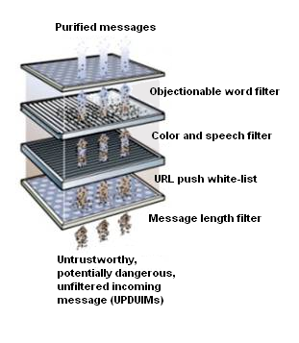

MsgID:7 | Description: URLs Pushed | Built-in Message
Variables:
- MainURL
- AudioURL
- VideoURL
- ForTeacherOnly( True or False)[ note: student is allowed to push page only to teacher]
- FilterUsed (a new string that contains the title and version of the filtering program used, if the message has been filtered)
Example XML:
<?xml version="1.0" standalone="yes" ?>
<!-- Generated by Virtual Remote 1.0 -->
- <Msg>
- <Head>
<MsgID>7</MsgID>
<Description>URLs Pushed</Description>
</Head>
- <Body>
- <Item>
<Key>MainURL</Key>
<Value>http://www.pitt.edu</Value>
</Item>
- <Item>
<Key>AudioURL</Key>
<Value>http://www.pitt.edu</Value>
</Item>
- <Item>
<Key>VideoURL</Key>
<Value>http://www.pitt.edu</Value>
</Item>
- <Item>
<Key>ForTeacherOnly</Key>
<Value>False</Value>
</Item>
- <Item>
<Key>FilterUsed</Key>
<Value>PatAlex Filter v0.9b</Value>
</Item>
</Body>
</Msg>

Use in Component:
Message is used in URL push white-listing (and filtering).
Message Pathway through Component:
Component is a filter and thus passes messages through while modifying them. Therefore, component will receive this message and, depending on settings, modify the message contents and, if the message is passed through (to the client – like a proxy), add the FilterUsed property.

MsgID:8 | Description: Instant Message | Built-in Message
Variables:
- FromFirstName [note: sender's first name]
- FromLastName [note: sender's last name ]
- ToFirstName [note: receiver's first name ]
- ToLastName [note: receiver's last name ]
- MsgColor
- IsAudio ( True or False)
- IsBroadcase( True of False) [note: when true, ToFirstName and ToLastName will be null)
- FilterUsed (a new string that contains the title and version of the filtering program used, if the message has been filtered)
Example XML:
<?xml version="1.0" standalone="yes" ?>
<!-- Generated by Virtual Remote 1.0 -->
- <Msg>
- <Head>
<MsgID>8</MsgID>
<Description>Instant Message</Description>
</Head>
- <Body>
- <Item>
<Key>FromFistName</Key>
<Value>Pat</Value>
</Item>
- <Item>
<Key>FromLastName</Key>
<Value>Alex</Value>
</Item>
- <Item>
<Key>ToFirstName</Key>
<Value />
</Item>
- <Item>
<Key>ToLastName</Key>
<Value />
</Item>
- <Item>
<Key>MsgColor</Key>
<Value>234</Value>
</Item>
- <Item>
<Key>IsAudio</Key>
<Value>True</Value>
</Item>
- <Item>
<Key>IsBroadCast</Key>
<Value>True</Value>
</Item>
- <Item>
<Key>FilterUsed</Key>
<Value>PatAlex Filter v0.9b</Value>
</Item>
</Body>
</Msg>

Use in Component:
Message is used in:
    - Message-boundary rejection (i.e. determining length of messages and rejecting those that are too long).
    - Dictionary-based objectionable word filtering (i.e. filtering distasteful words from messages).
    - Text color removal filter.
    - Speech setting removal filter (to prevent talking messages).
Message Pathway through Component:
Component is a filter and thus passes messages through while modifying them. Therefore, component will receive this message and, depending on settings, modify the message contents and, if the message is passed through (to the client – like a proxy), add the FilterUsed property.

