**Readme**

2017/02/18 by Zinan Zhang

We will use the Android Studio as the platform, which is strongly recommended by Google.

**Before installing, you need to aware:**

1. PC requirement:
   1. You will need at least 10G space for installing.
   2. You will need at least a 4G memory PC.

**Download Android studio**

Open your browser and go to the address below and *download* the software by clicking the green button.

<https://developer.android.com/studio/index.html>

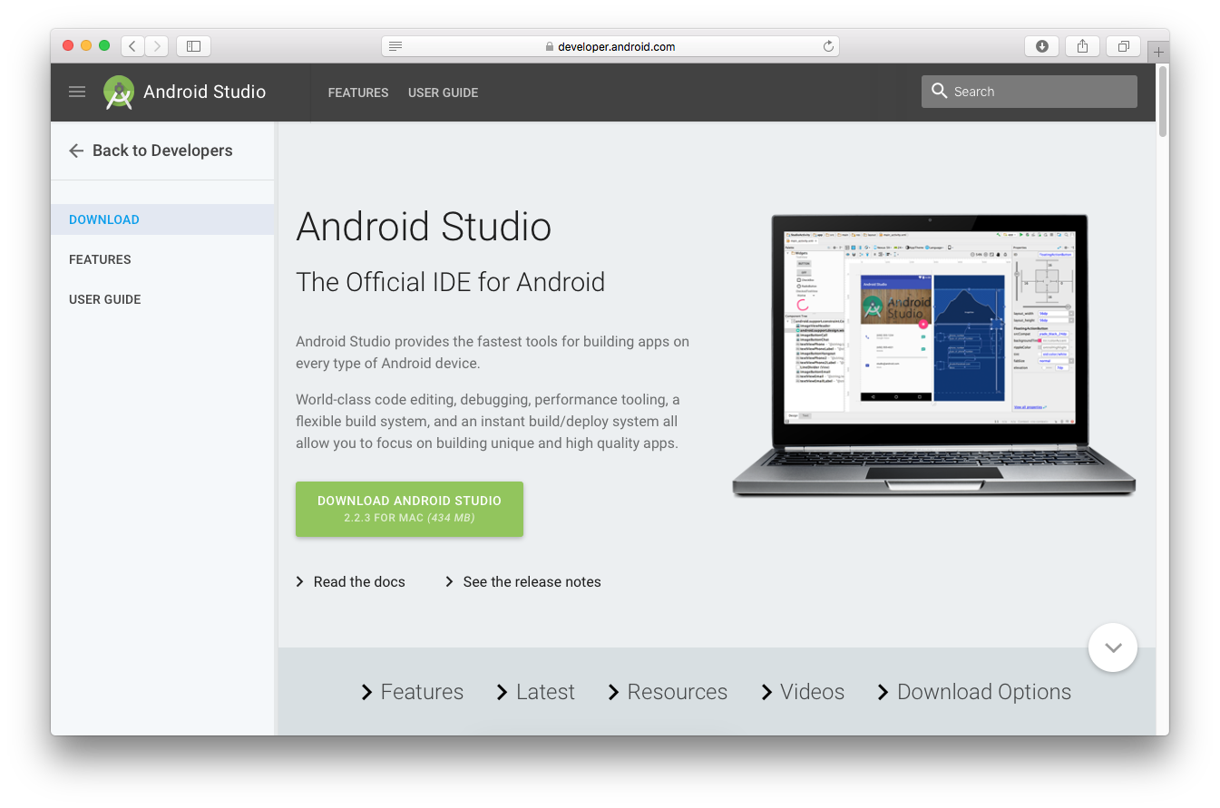

**Install Android studio**

We use Mac OS as an example.

Step 1: Double click the package you just downloaded. Then you will see:

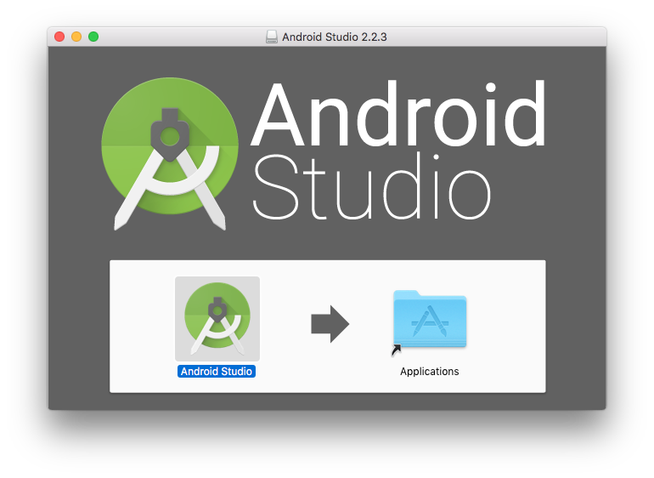

Step 2: Drag the Android Studio image into to Application documents.

Step 3: Open the software. Then you can just click the red circled items as shown below,

without any other changes:

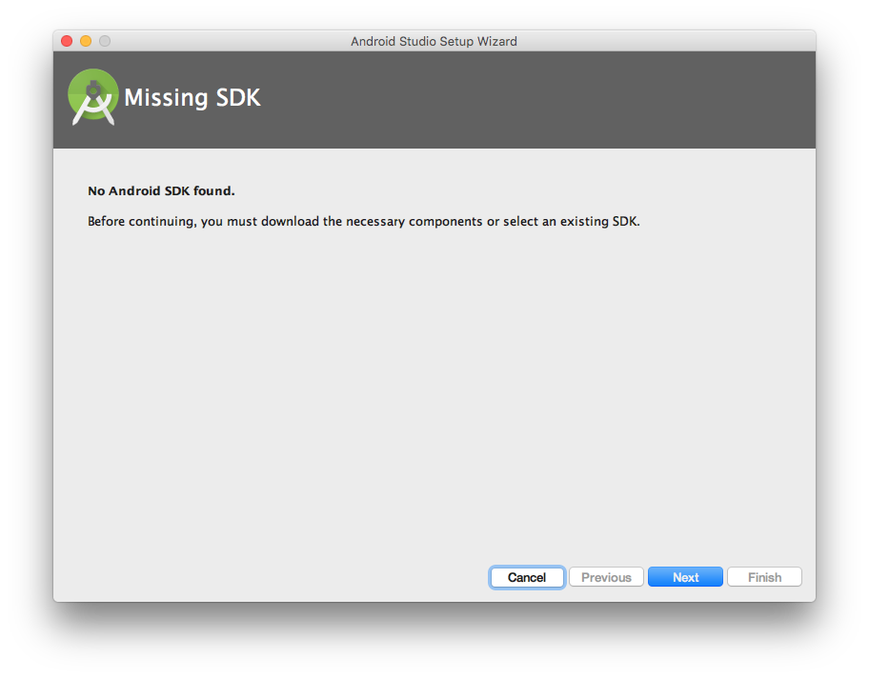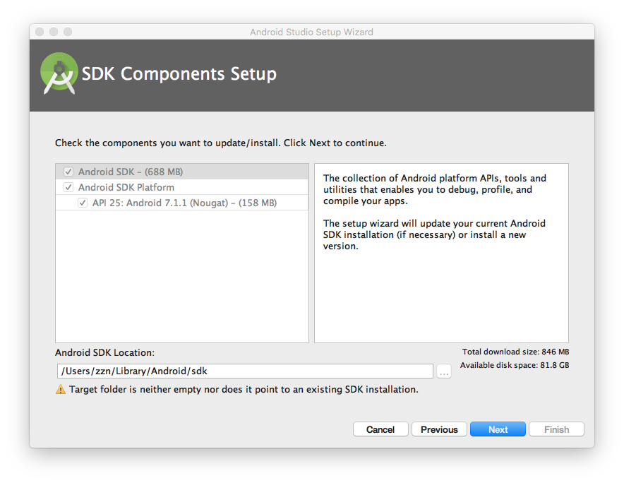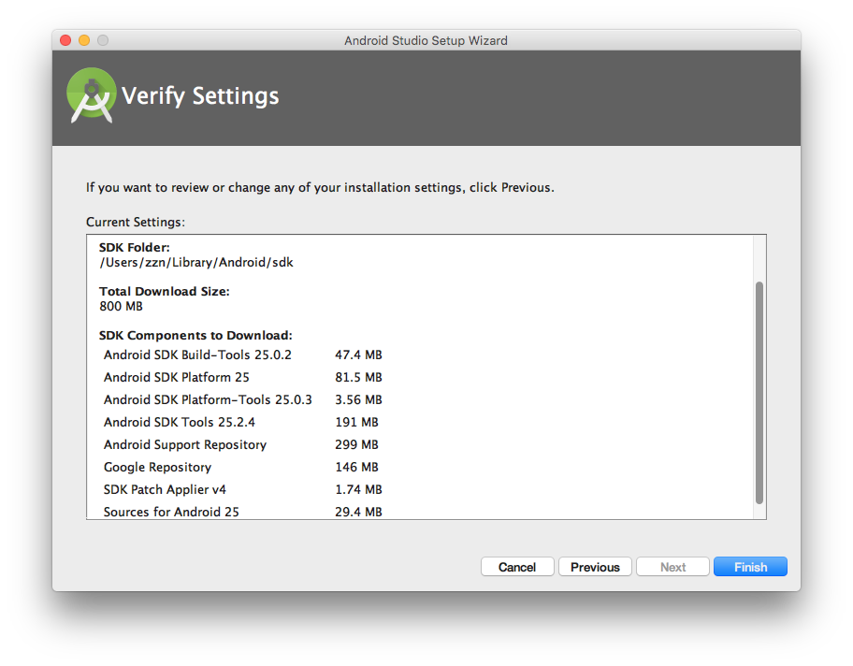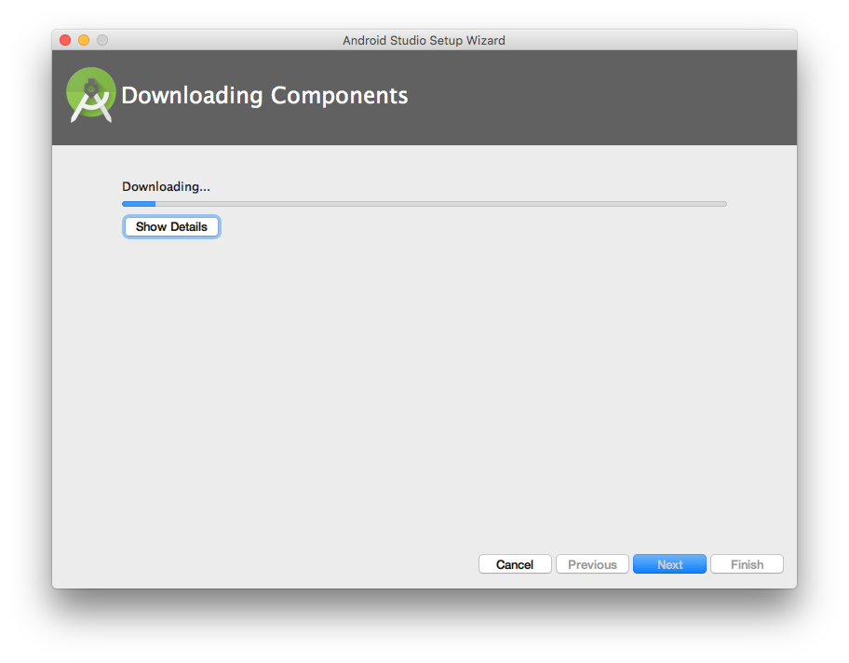

It will take you some time to download the basic SDK in this process. I strongly recommend you finish the installing on campus’ Internet, greatly saving your

time.

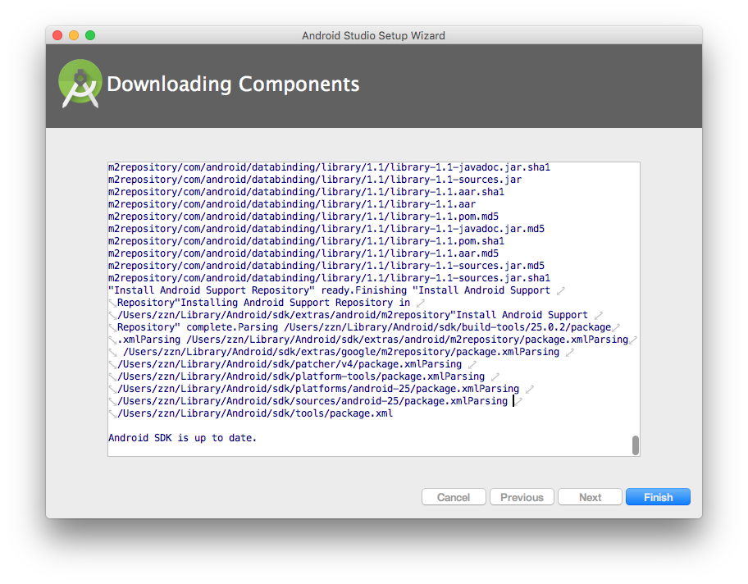

**Reminder:**

* You can install any SDK you want in SDK Manager.
* To open the SDK Manager from Android Studio, click **Tools > Android > SDK Manager** or click **SDK Manager**

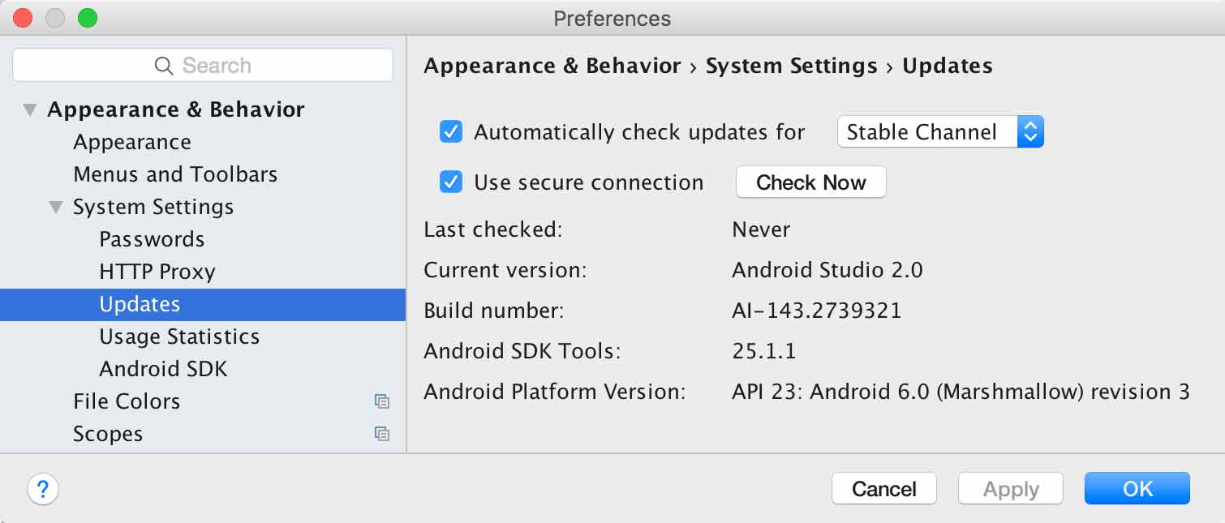

**Import the project framework**

By now, you have installed the platform completely. You can download the basic framework package (SISv5android.zip) from course web :

<http://people.cs.pitt.edu/~chang/163/interface/SequenceSIS.htm>.

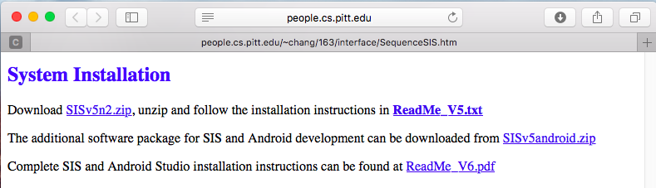

Then, you can Import a component by clicking the item circled below.

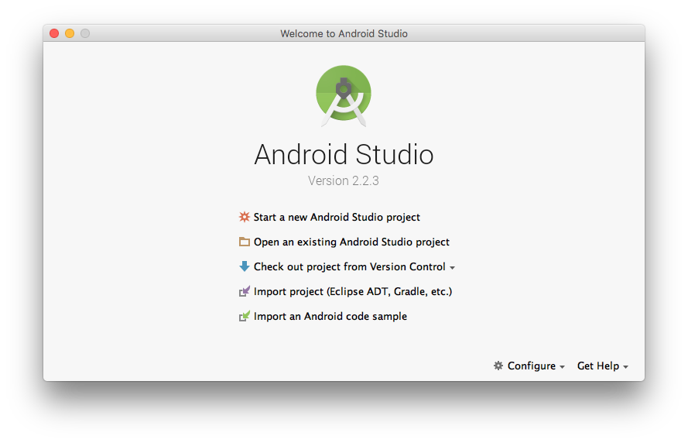

You will set the input path first and then click OK. Then, you can start working on your project.

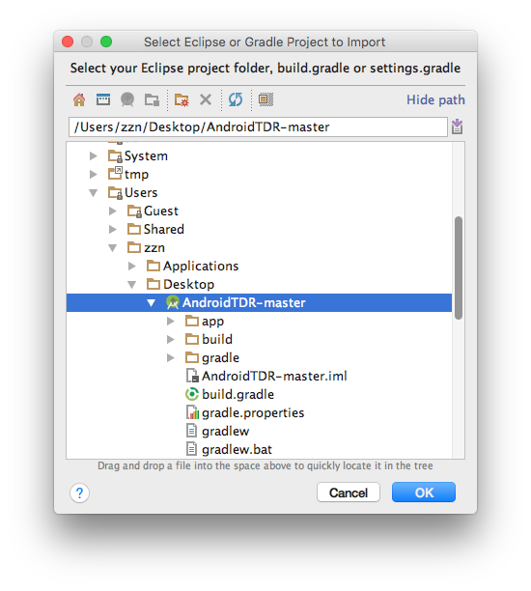

**How the component-based system works**

Let’s use a simple example to illustrate how the component based system works. Assume that we want to use Input processor to send a message to the uploader, which is illustrated below:

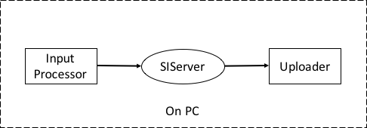

Step 1: Connect the Arduino device to PC via USB.

Step 2: Open Arduino IDE on PC and import the **PC version program** to the Arduino device by clicking the button in the red circle. (The PC version’s file name is “TDR_PC_Basic”)

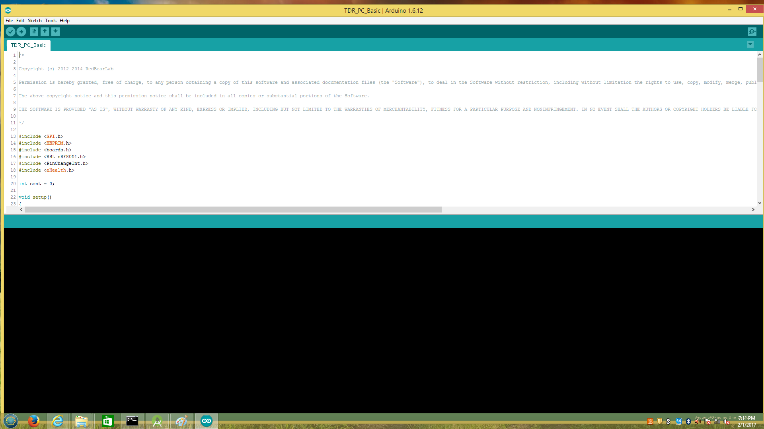

Step 3: Run SIS server --> run initializer --> run input processor --> run uploader (Or you may use the scripts in the document “Scripts”)

**Reminder**:

1. You must run server first, and then run the initializer, in that sequence.
2. If you are using the lab computer in Dr. Chang’s Visual Computer Laboratory, you must disconnect the sphygmomanometer first, before importing the program into the

Arduino device. A photo of the sphygmomanometer is shown below:

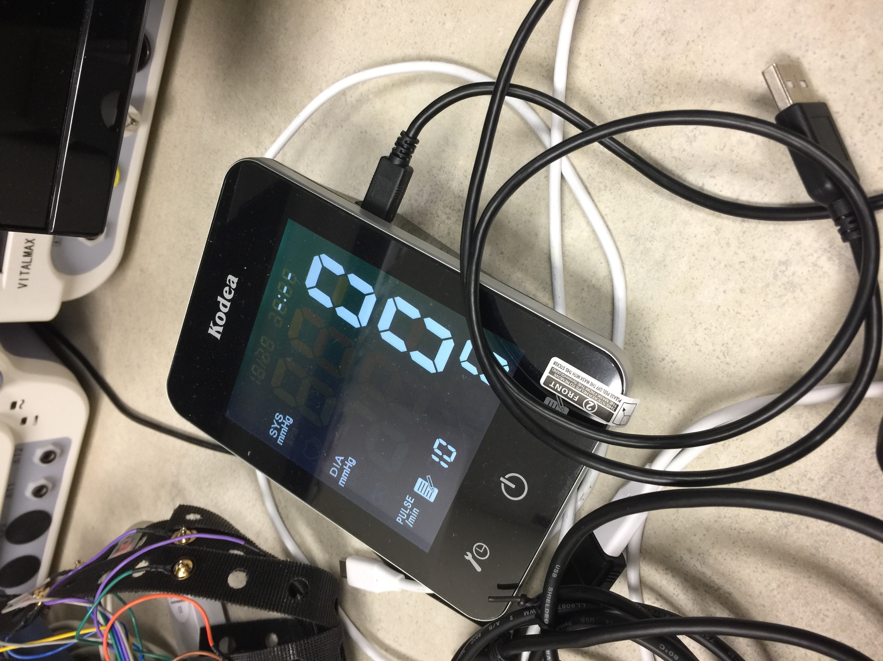

**How to make Android Application communicate with SIServer on PC**

Let’s use a simple example to illustrate how it works. Assume that we want to use the Input processor to send a message to the uploader as illustrated below:

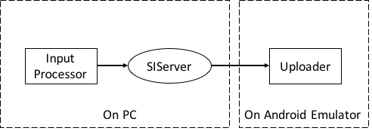

Step 1: Run the SIS server --> run initializer --> run input processor

Step 2: Check your PC’s IP address.

Step 3: Open the android studio and import the android version of the Uploader. (You can find the SISv5_Android in document “SISv5_Android”)

Step 4: Build and run your Android Emulator.



Step 5: Select an emulator version. For the first time, you may need to create a new virtual device. Click the button in the red circle as below:

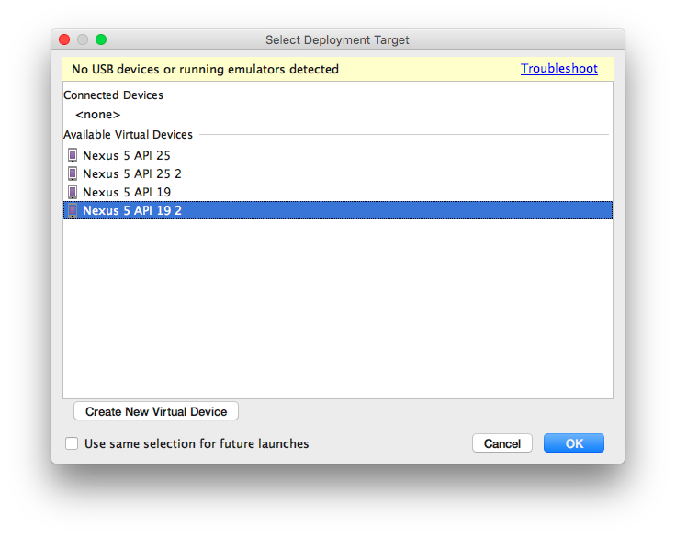

Step 6: Input your PC’s IP address and server’s port number. (Port number normally is 53217. You can find it in server’s source code.) Then click “REGISTER” first, and then click “CONNECT”. Now you have made them to communicate with each other successfully.

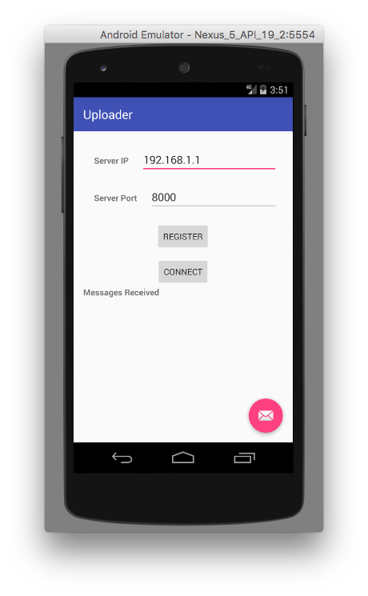

**Reminder:**

1. If you are using the lab computer, you must disconnect the sphygmomanometer when importing the sphygmomanometer software component.
2. If you want to change the IP address, please do not delete the “.” between the numbers.
3. If you want to change the PC version of the SIS System component into Android version by yourself, perhaps you need to be aware of the following:
4. After you imported the framework, you need to change the IP address to your PC’s IP address.

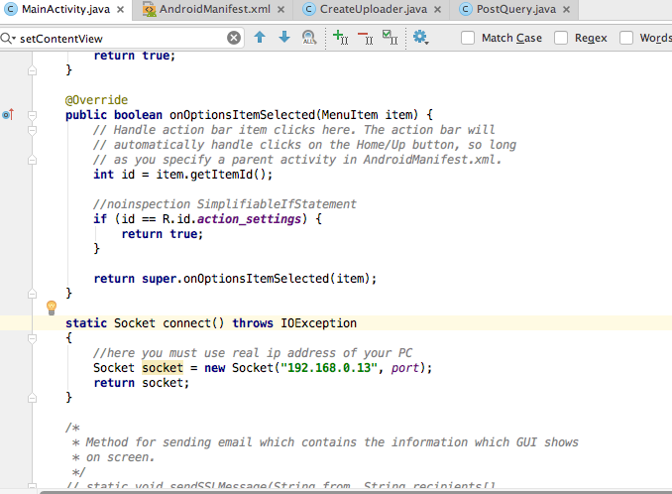

1. In order to obtain the permission to access the internet, you need to add three lines of code to your android project as shown below:

<**uses-permission android:name="android.permission.INTERNET"** />  
<**uses-permission android:name="android.permission.ACCESS_NETWORK_STATE"** />  
<**uses-permission android:name="android.permission.ACCESS_WIFI_STATE"** />

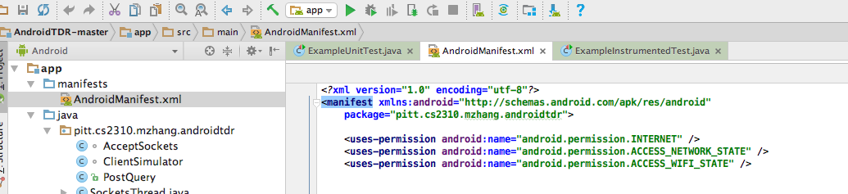

1. You should create a new thread whenever you use socket connection, such as:



1. To add the email function, Android platform uses another packet for email. So you need to make some modification of your Android project. For further explanation read <https://java.net/projects/javamail/pages/Android>.
2. If your Android SDK version is higher than Android 21, then you may always need to acquire the permission before any operation on your smart phone. For example, the following piece of code is asking for Bluetooth permission. Without those code, you cannot use the Bluetooth in your application.

if (android.os.Build.VERSION.SDK_INT >= android.os.Build.VERSION_CODES.M) {

if (checkSelfPermission(Manifest.permission.ACCESS_FINE_LOCATION) == PackageManager.PERMISSION_DENIED) {

Log.d("permission", "permission denied to ACCESS_FINE_LOCATION - requesting it");

String[] permissions = {Manifest.permission.BLUETOOTH};

requestPermissions(permissions, PERMISSION_REQUEST_CODE);

}

}

**How to deploy the whole SIS System with multiple components on Android**

Let’s use a simple example to illustrate how it works. Assume that we want to use Input processor to send a message to the uploader as shown below:

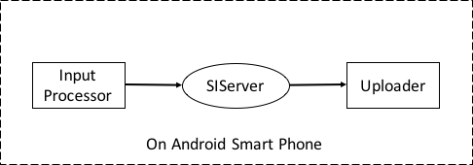

Step 1: Connect the Arduino device to PC via USB.

Step 2: Open Arduino IDE on PC and import the **Android version program** to the Arduino device (The Android version’s file name is “TDR_ Basic”).

Step 3: Connect your smart phone to your PC and open the Android studio.

Step 4: Import the Android version SIS server into the android studio and run it. Then you will see a menu asking you to select a device to run your program. **You should select your android smart phone** (rather than other emulators) as the device to run program. Now the program will be installed on your phone automatically. Then click the button “START SERVER”, the server will be started and its IP address and port number will be shown on the screen.

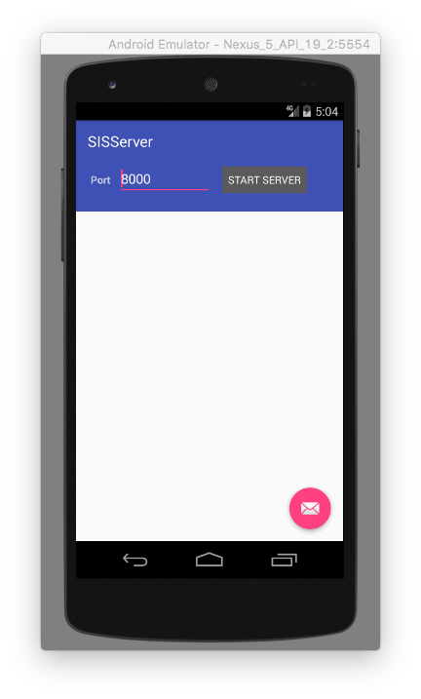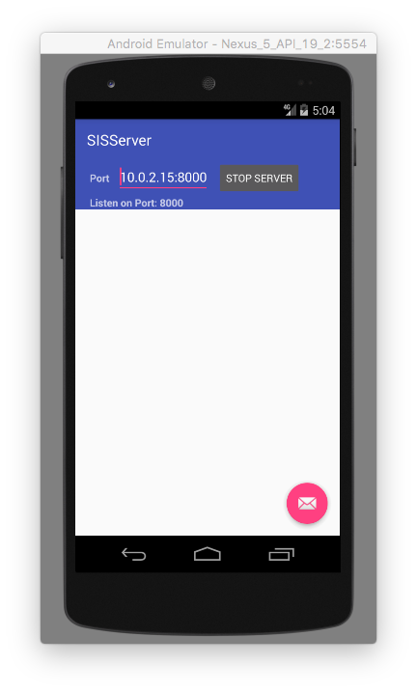

Step 5: Import the Android version of Uploader into the android studio and run it with your smart phone. Now the program will be installed on your phone automatically. Set the IP address and port number consistent with the server’s IP address and port number. Then click “REGISTER” and “CONNECT”.



Step 6: Import the Android version of Input processor into the android studio (document name is **“InputProcessor”**), and run it with your smart phone. Now the program will be installed on your phone automatically. Click the item on the upper right and search the Bluetooth signal from Arduino device (whose name is “TDR BLE”). Then input alphabet “d” to request data from the Arduino device. Now click the button “Register” --> “Connect” --> “Collect Data” --> “Send Message”. The data will be gathered by the Arduino device and sent to uploader.

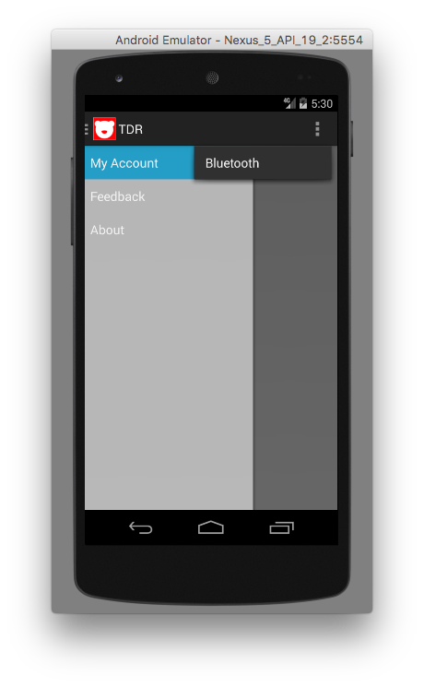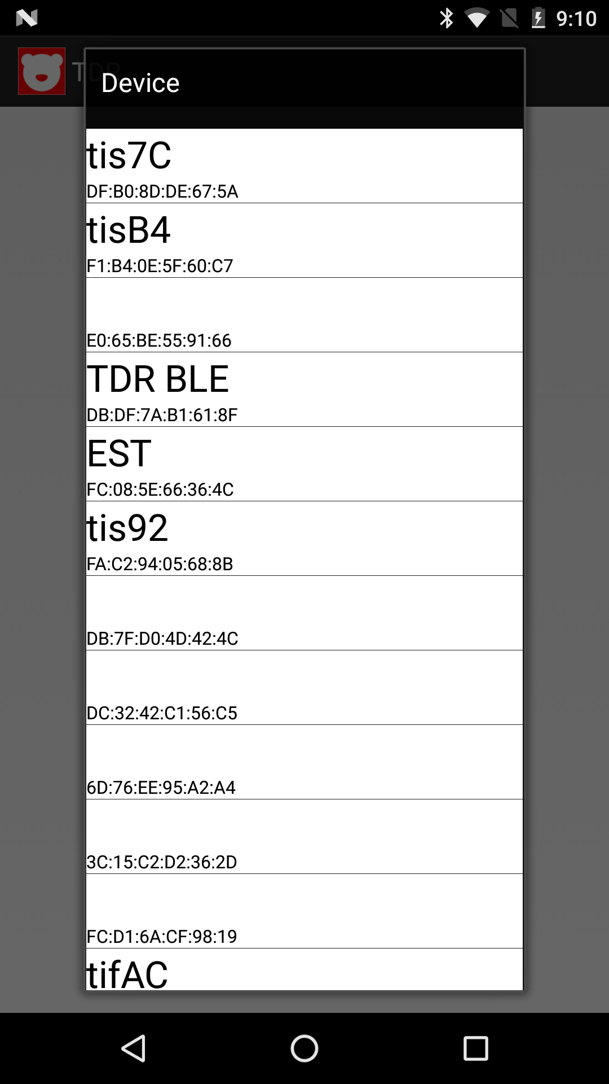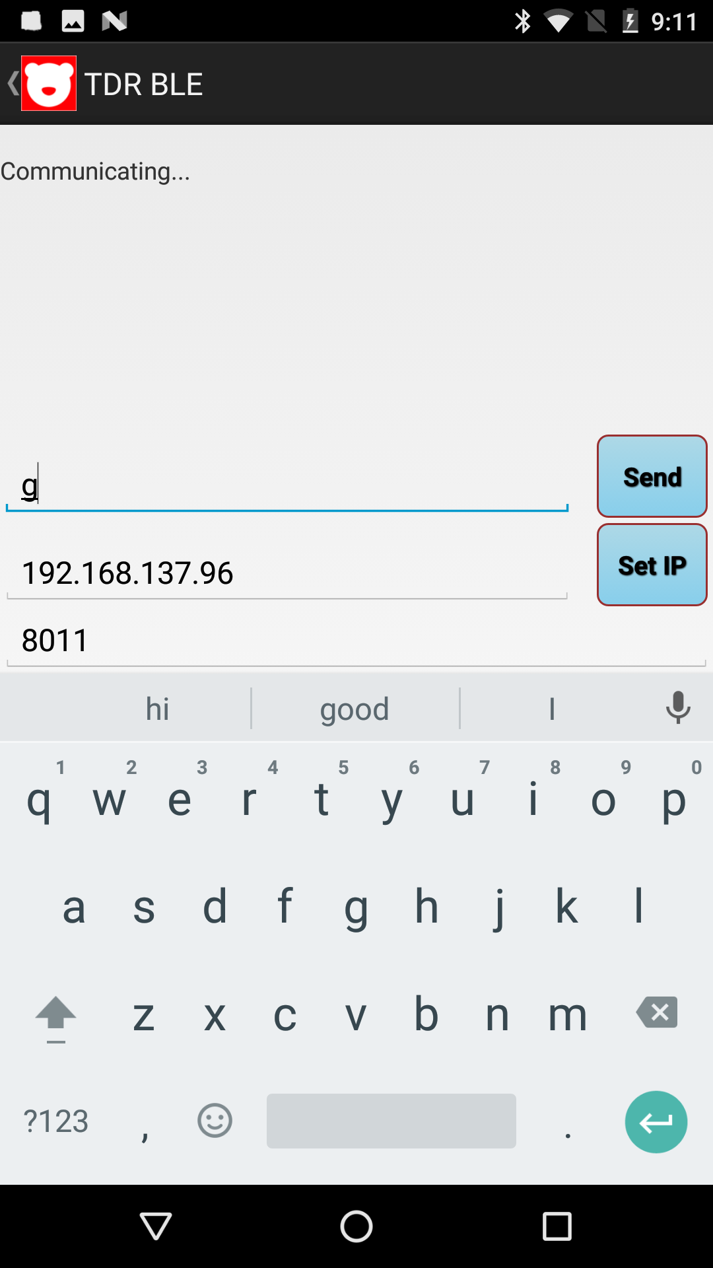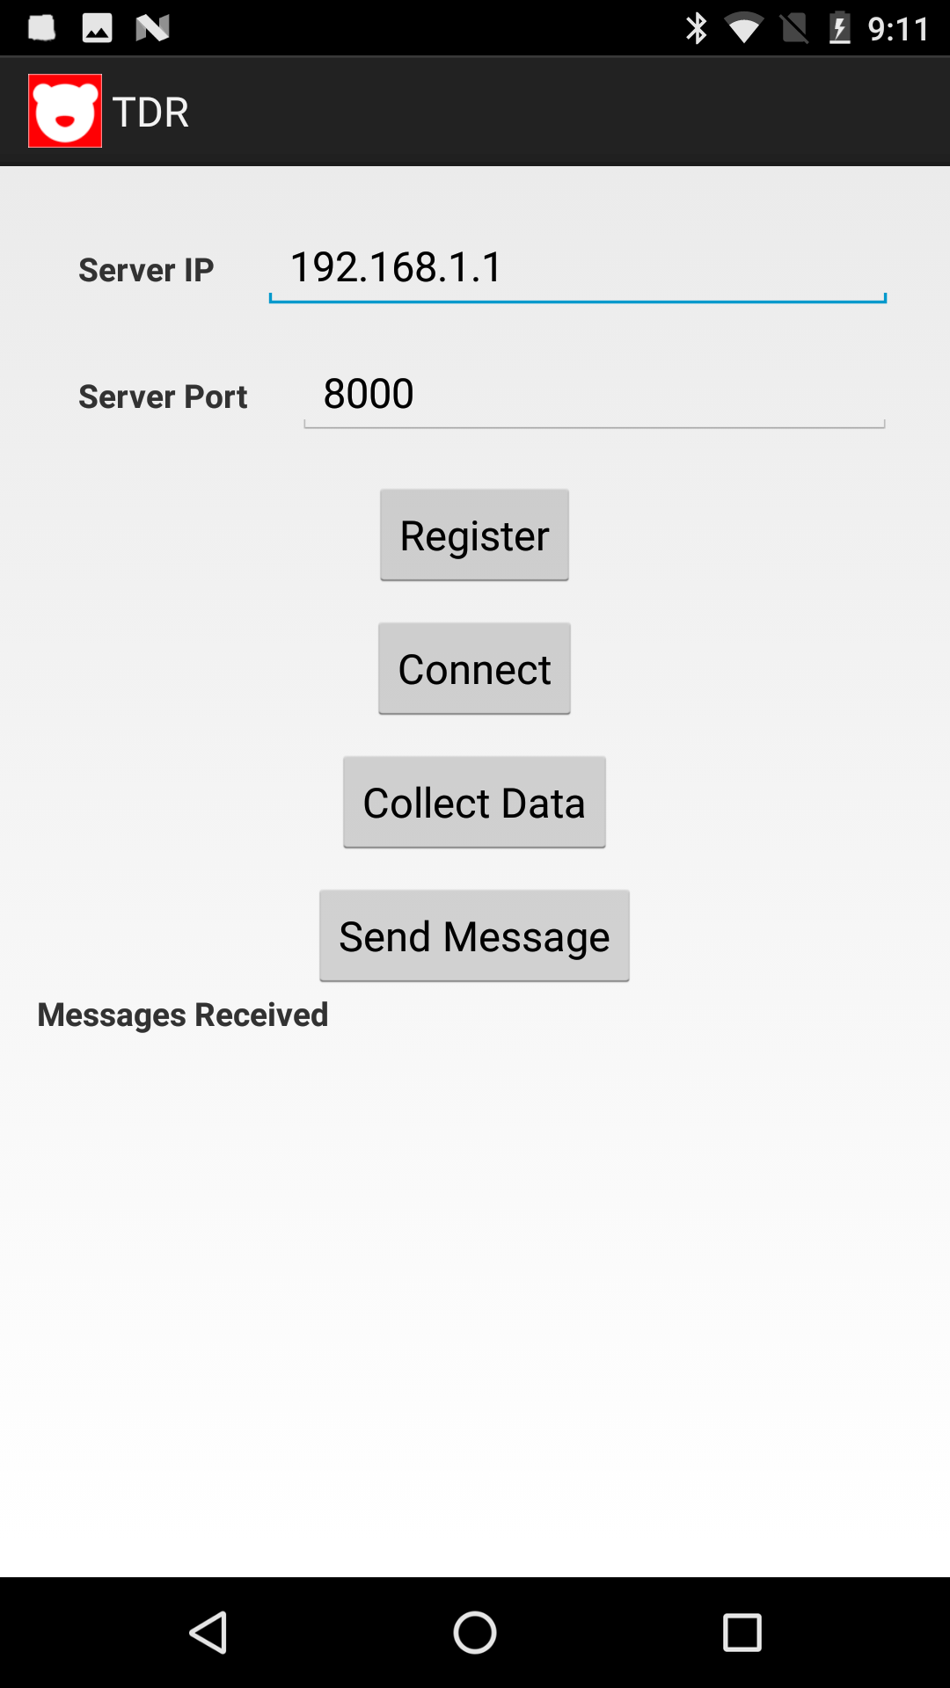

**How to use Android version of PrjRemote**

Step1: Run your PrjRemote on your Android phone or emulator.

Step2: Then you will see the picture as shown below. Fill in the blank (you can leave the “Fresh Rate” as default, and the default content for “Scope” is “SIS.Scope1”), and click “CONNECT”:

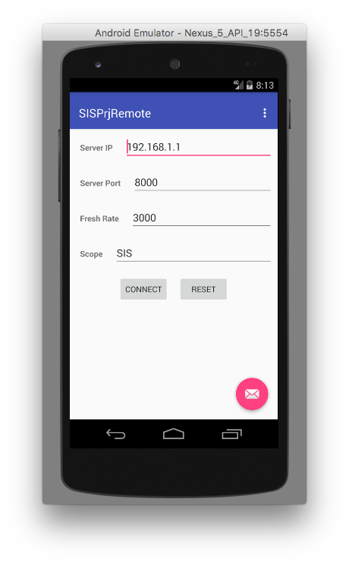

You can get your Sever IP and Server Port on the sever picture as shown below:

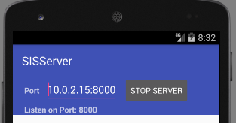

Step3: Send a register message to server as shown below:

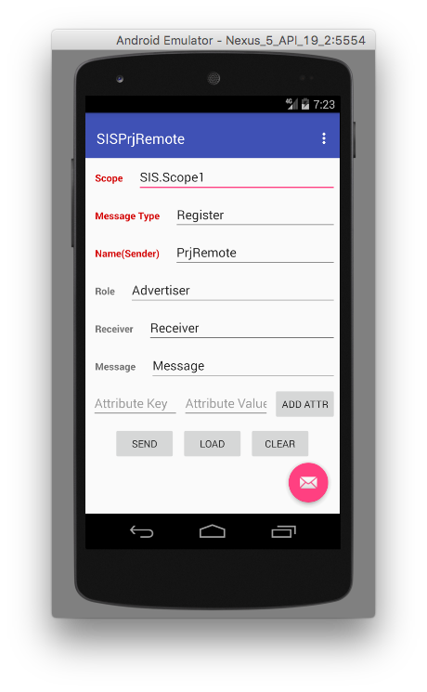

Step4: Send a connect message to server as shown below:

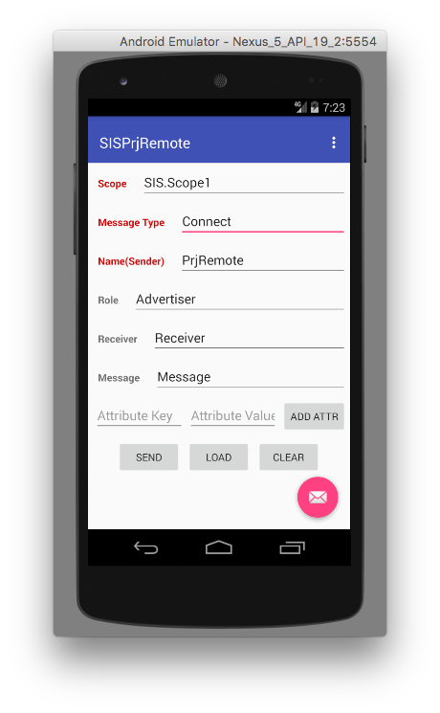

Step5: Now you can use this Android version of PrjRemote just like the PC version.

**How to set up a hot spot on Windows 8**

For lab’s PC, see the link:

<https://www.wiknix.com/how-to-create-wifi-hotspot-in-windows-8-187/>