**Software Plan – Mobile Phone Voting System**

**Ishvaraus Davis, Gregg Karanovich**

**CS 1631**

**Spring 2017**

**Scope**

The mobile phone voting system is a software solution that will allow participants to vote in a contest from an android device. The android phone will be able to send an email to software running on a pc that will keep track of the voting tallies and be able to display results at the end. The software will have the ability to stop the voting process from the android phones and the results table will be deleted after the voting round is complete. The software will allow for a quick way for users to vote from a smart phone as well as provide a way to display the results so the winner can be determined.

*Functions*

1. Voter can send an email to a pc running the voting software
2. PC software can receive an email from an android device
3. Ensure the user only selects one poster
4. Save candidateID, count into a TallyTable
5. Save VoterPhoneNo, CandidateID into a VoterTable
6. Issue a special command that stops the voting
7. Display the TallyTable in decreasing order based on number of votes
8. Eliminate the VoterTable at the end

*Performance*

1. The System shall be able to handle 50 concurrent users
2. The system shall be able to stop voting within 50 ms
3. The TallyTable should be able to hold at least 1000 ID rows
4. The VoterTable should be able to hold at least 1000 PhoneNo rows

*Limitations*

1. System will only be able to handle input from android devices
2. System doesn’t provide a way to change a vote

**Tasks**

1. Create an android application
   1. Allow user to send email
   2. Allow user to input phone #
   3. Allow user to input poster ID number
   4. Only allow user to input 1 poster ID number
   5. Post requests to the desktop server
   6. Receive message that stops all voting from the PC
   7. Create usable user interface
2. Create a desktop application
   1. Make a server that parses through the email sent from the android application
   2. Add data to the appropriate table
   3. Send a quit message to participating android devices
   4. Create a database with two tables (VoterTable & TallyTable)
   5. VoterTable will have 2 columns (VoterPhoneNo & CandidateID)
   6. TallyTable will have 2 columns(CandidateID & Count)

**Resources**

*Hardware*

1. PC
2. Android device

*Software*

1. Android Studio
2. Web development environment (Netbeans/PHP)
3. Java environment

*People*

1. Gregg Karanovich – Software developer (Desktop)
2. Ishvaraus Davis – Software developer (Android)

**UML Diagrams**

*Use Case Diagram*

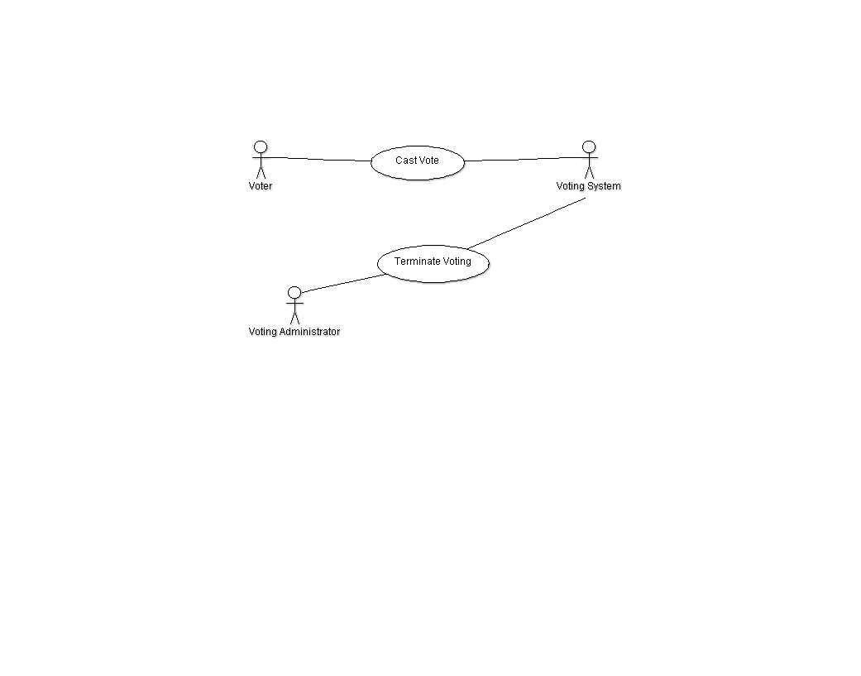

*Class Diagram*

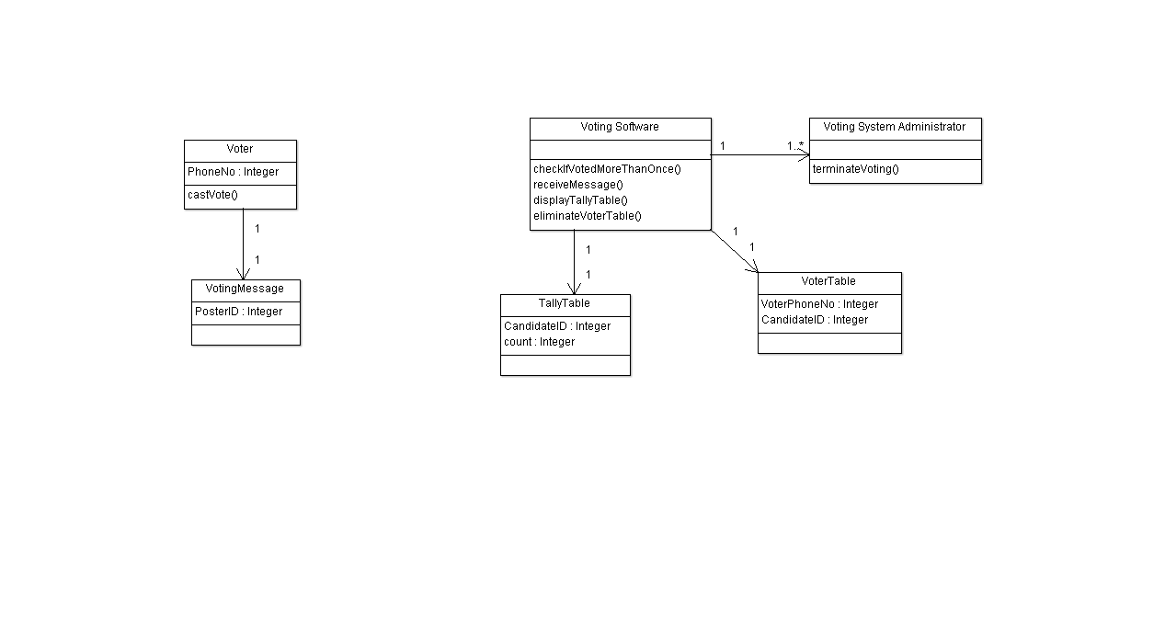

*Activity Diagram*

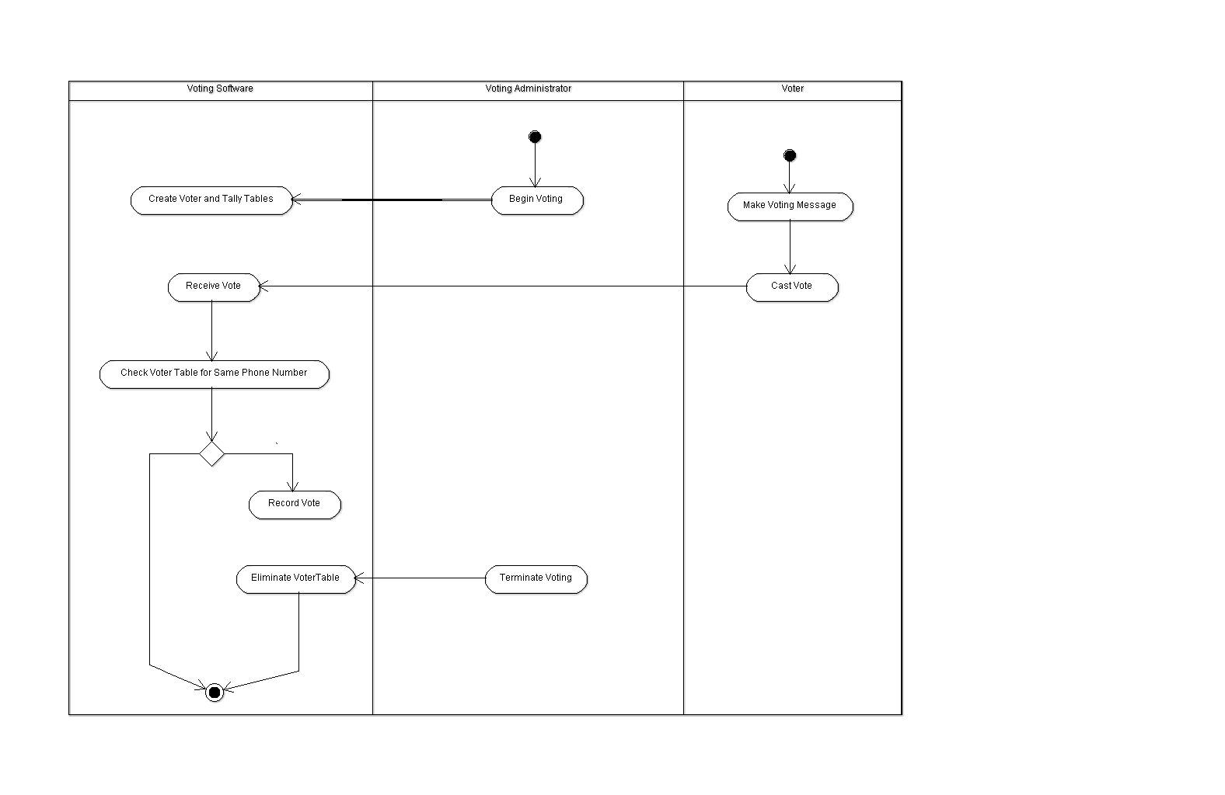

*Deployment Diagram*

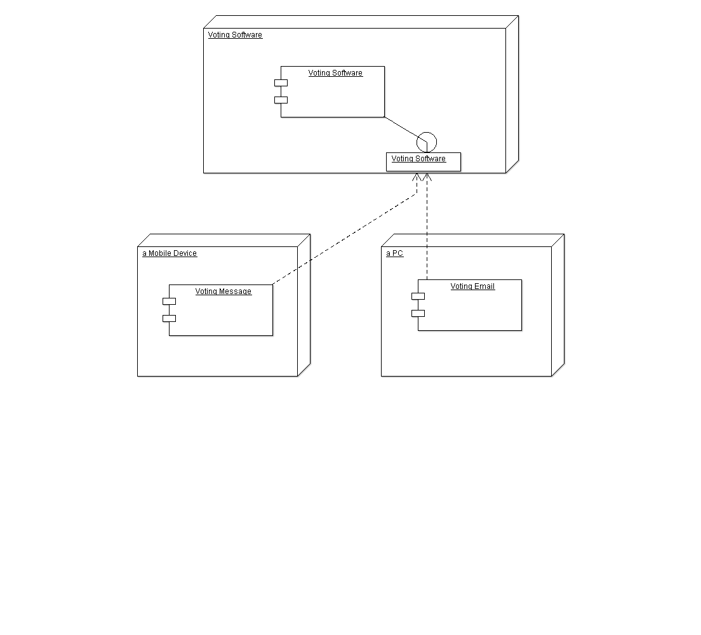

*Collaboration Diagram*

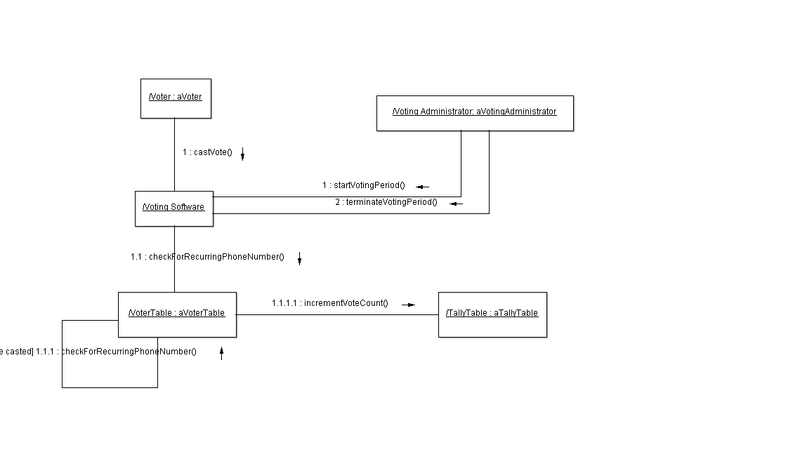

**Questionnaire**

Date: 2/14/17

Group ID: 8

Member #1 (last name): Davis

Member #2 (last name): Karanovich

1. Input mode. Please select one:

1.1 (!) Voter will send a short text message from their

mobile phone to my smart phone (Note: don't select

this option if your phone is not a smart phone, or

there is no way to access the incoming short

text message by a phone-resident input processor,

or your phone is not 100% available on CS-Day.)

1.2 ( ) Voter will send a e-mail from their mobile phone

to my smart phone (Note: don't select this option

if your phone is not a smart phone, or there is

no way to access the incoming e-mail by a

phone-resident input processor, or your phone is

not 100% available on CS-Day.)

1.3 ( ) Voter will send a e-mail from their mobile phone

or computer account to my computer account.

(Note: Do not select this option

if you cannot access your e-mail from your

notebook or PC, or there is no way to access

the incoming e-mail by an input processor

running on your notebook or PC, or your notebook

or PC is not 100% available on CS-Day.)

1.4 ( ) My group does not have any of the above. (In

which case I will give you special permission

to withdraw.)

2. If you select 1.1 or 1.2, answer the following questions:

2.1 My smart phone's phone number: 912-550-6413

(Voters will send text message/e-mail to this number

which will be printed on the poster on CS-Day)

2.2 My smart phone manufacturer, model number and

other hardware details:

Manufacturer - ZTE

Model: N9518

2.3 (!) My smart phone runs Android and I know how

to develop an Android app as the input processor

and another Android app as the VotingSoftware component

2.4 ( ) My smart phone does not run Android but I know

how to develop an app as the input processor

and another app as the VotingSoftware component in

the following language:__________________

2.5 ( ) My development platform is my smart phone

(Note: This is not highly recommended)

2.6 (!) My development platform is my notebook or PC

running under: Windows 10.1 and I will be

able to port the app to my smart phone.

3. If you select 1.3, answer the following questions:

(Note: I expect most groups will select this option,

however bonus points will be awarded for groups

selecting either option 1.1 or option 1.2.)

3.1 My computer account to be used to receive incoming

e-mail votes: ___________________________

3.2 Hardware details about my notebook or PC:

___________________________________________

3.3 Software details about my notebook or PC:

___________________________________________

4. Development Diagram:

4.1 (!) With the above information I think I know how to

draw a development diagram

4.2 ( ) With the above information I still have no clue

how to draw a development diagram. My question is:

______________________________________