Introduction to e-Commerce

We can include additional features such as requesting payments, soliciting donations and so on to a website so that it can handle e-commerce.

To do that we need to sign up with an e-commerce provider such as PayPal.

Once you are in PayPal, look for **apps center**, and then **payment**, then **buttons**, and then **saved buttons**. These saved buttons are previously created by you or your web designer to allow customers to make payments.

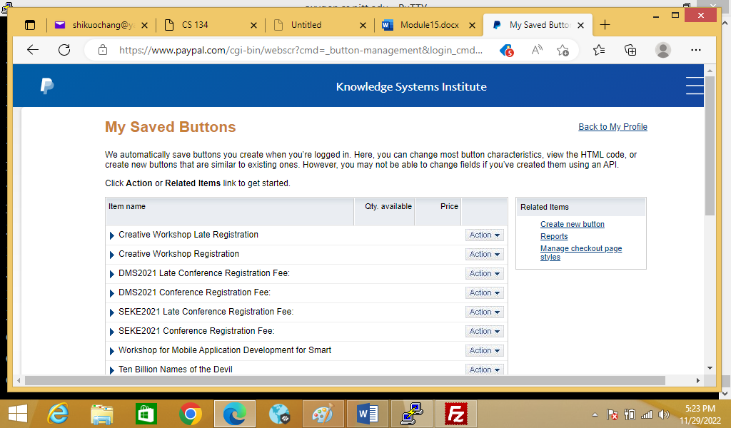

You can now edit a saved button to create a new customized button.

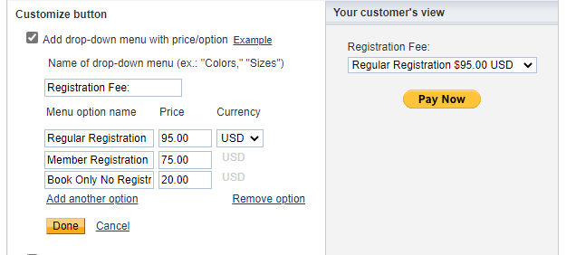

Then you can add your button codes to your webpage.

Top of Form

You just created customized HTML code for your button. The final step is to copy the code from this page and paste it into your website editor.

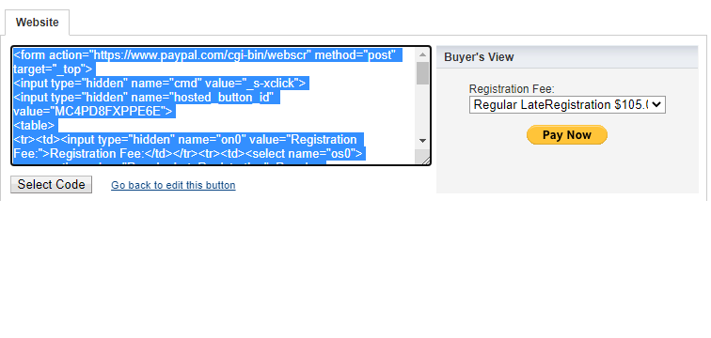

**How to copy the button code:**

1. Click **Select Code**.
2. Right-click and copy the selected code.

**How to paste the button code in your website editor:**

The code must be pasted in the "code" view, where you can view and edit HTML.

1. In your website editor or admin page, open the page where you want to add your button.
2. Look for an option to view or edit HTML.
3. Find the section of the page where you want your button to appear.
4. Right-click and paste your button code into the HTML.
5. Save and publish the page. (The preview function in your editor may not display the button code correctly.)
6. Test the button to make sure it links to a PayPal payment page.

Bottom of Form