IC Card: Visual Specification for Rapid Prototyping of Time-Critical Applications

Shi-Kuo Chang, Perry Rajnovic and Mark Zalar
Department of Computer Science
University of Pittsburgh, Pittsburgh, PA 15260 USA
chang@cs.pitt.edu

Abstract: We describe IC card, which is a visual specification scheme for the rapid prototyping of time-critical applications. The software developer can use IC cards to describe the entities of an application and their interaction patterns to capture user’s requirements. The IC card management system, which is a visual specification tool, supports the creation and editing of IC cards and the transformation of IC cards into an XML specification. The XML specification can be transformed into an IC system and compiled into codes, thus creating a working prototype. Application examples are described.

1. Introduction

Recent advances in communications technology, web-based applications and service oriented architecture have stimulated application software development with shorter turn-around time to produce software possessing the following desirable characteristics: (a) it integrates web services, software components and legacy software into a functioning system; (b) it is operational before deadline and remains operational until expiration time; and (c) it satisfies user-specified timing constraints.

To address these issues, we describe an approach for the rapid prototyping of time-critical applications with the following major features:

- visual specification using IC cards
- detailed design by means of an IC system
- automatic transformation into codes

The IC card is used for the visual specification of an application. It captures the interaction patterns among entities and also allows the specification of timing constraints. The interaction patterns lead to the specification of interaction protocols, the transformation into an IC system, and finally the compilation into codes.

This approach can be used to integrate web services, software components and legacy software into a functioning system. It also allows the software developer to specify timing constraints in the initial specification (the IC card) and carry them over to the detailed design (the IC system). Because of the automatic code generation capability, it is suitable for the rapid prototyping of time-critical applications.

This paper is organized as follows. In Section 2 we introduce the concept of the IC card as a means of visual specification of an application from the viewpoint of the user. An example of the visual specification of a small part of a health care delivery system is presented in Section 3. The IC card management system is described in Section 4. The detailed design of the IC system for health care delivery is described in Section 5. The rapid prototyping environment and tools, and further research topics are discussed in Section 6.

2. IC Card

An IC card is the user’s specification of an active object or an agent. An active object usually interacts with other active objects according to certain interaction patterns. These interacting active objects are similar to brain cells in a brain. Therefore in our approach an active object is called an index cell (IC), and the scheme to specify an active object is called an IC card. The system of interacting index cells is called an IC system, or an active index system, or an active index [2]. IC system or active index system has been applied to the design of active information systems [3] and smart image systems [4].

When we consider the interaction among active objects or agents, there are a number of factors to be considered or questions to be asked: a) who has control? b) who performs the work? and c) what are the timing constraints?

To answer the first two questions we introduce the concept of the state of an active object. The four basic states of an active object can be illustrated by emoticons as shown in Figure 1. The presence of eyes indicates “in control”, while the absence of eyes indicates “no control”; a smile means “no work”, while tight lips means “work”.



Figure 1. Emoticons indicating the four basic states of an active object.

Based upon the pairing of the states of an active object and an interacting active object, sixteen dyadic interaction patterns can be formed as shown in Figure 2.


Figure 2. Sixteen dyadic interaction patterns.

In Figure 2 the patterns are communicating pairs engaged in dyadic communication. The active object representing oneself, shown as the larger emoticon, is the self agent and the interacting active object representing the other, shown as the smaller emoticon, is the alien agent. If one agent is in control and the other not in control, the agent in control is the master and the other the slave. If both agents are in control, this pattern is considered a pattern with interaction. (This does not mean a master and a slave have no interaction, but their interaction is less complex.) Finally a mirror pattern is the reverse of a pattern, i.e., the mirror pattern of pattern (A, B) is pattern (B, A), where A and B are communicating agents.

In order to systematically categorize the patterns we will eliminate some useless patterns. We first eliminate those patterns where neither the self agent nor the alien agent is in control. We next eliminate those patterns where both the self agent and the alien agent are in control but neither is doing any work. These are the patterns that will never occur in practice and therefore eliminated. In Figure 2 they are colored white (or colorless). After these useless patterns are eliminated, the rest can be categorized as follows.

The quiet pattern is one where the self agent is in control and the alien agent its slave, neither doing any work. The quiet pattern is colored grey and its mirror pattern light grey.

The by_myself_no_interaction pattern is one where the self agent is in control and doing the work, and the alien agent its slave but not doing any work. This pattern is colored green and its mirror pattern light green.

The next pattern, the by_myself_with_interaction pattern, is one where the self agent is in control and doing the work, and the alien agent also in control but not doing any work. The pattern is colored yellow.

The mirror pattern of the previous pattern, the by_others_with_interaction pattern, is one where the self agent is in control not doing any work, and the alien agent also in control but doing the work. This pattern is colored red.

The by_others_no_interaction pattern is one where the self agent is in control and either not doing any work or doing some work, and the alien agent its slave doing the work. This pattern is colored golden, and its mirror pattern light golden. (There are two golden patterns and two light golden patterns in Figure 2.)

Finally the mixed pattern is one where both the self agent and the alien agent are in control and doing the work. This pattern indicates a complex situation and is colored purple. The mirror pattern of a mixed pattern is itself.

Therefore from the sixteen interaction patterns shown in Figure 2 we found six basic interaction patterns – quiet, by_myself_no_interaction, by_myself_with_interaction, by_others_no_interaction, by_others_with_interaction, and mixed. These six basic patterns are included in the IC card as shown in Figure 3.

Since an IC card in general represents an active object in control, we do not include the light-colored mirror patterns in the IC card because these are patterns where the self agent is not in control.

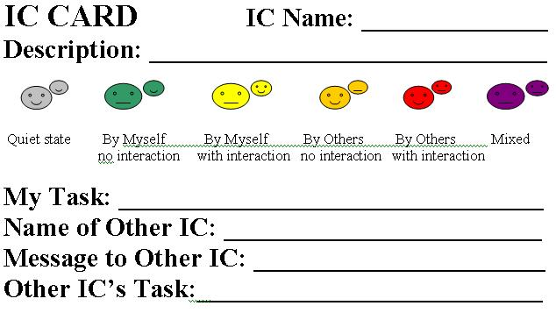

Figure 3. An IC card with interaction patterns.

A pattern is good if its interaction protocol is simple. For example a green pattern is good because the self agent is doing the work by itself so there is no problem of interaction. The yellow pattern is nearly as good as the green pattern because the self agent is doing the work but there is more interaction. A golden pattern is perhaps the best because the self agent is the master and the slave is doing or at least sharing the work.

On the other hand a red pattern is not so good because the control is shared between the self agent and the alien agent but the alien agent is doing the work. Therefore if the alien agent gets out of control it may be difficult to recover from the situation. In fact the red color reminds the user there may be trouble. Finally the mixed pattern is a complex situation. Usually if an IC card has a purple pattern, further decomposition of this IC card into simpler IC cards may be necessary.

An IC card is therefore a visual representation of an active object. It is comparable to the traditional hand-held index card or a brain storming flash card. The IC card is also related to the CRC (class, responsibility, collaboration) card in object-oriented design [1], but places more emphasis on interaction patterns.

3. Visual Specification using IC Cards

In this section we present an example to illustrate visual specification of requirements using IC cards. The application is a health care delivery system, and the example is based upon a small part of the health care delivery system, i.e., a disabled patient raising an alarm. This scenario is described as follows.

The sensing device takes videos/pictures and sends it to the current condition agent. This agent will periodically send updates to the patient record, especially if an unusual event occurs. Eventually in the scenario, an alarm is detected from the sensor equipment. This alarm is propagated to the primary hospital of the patient. This will then get propagated to the primary medical expert and the medical assistant. The expert will then request a query to the patient condition to gather more information about patient’s other physical conditions that could help diagnosis the problem. The results are returned to the expert. The expert analyzes them and then determines there is a need to send a dispatcher (nurse) the patient. The expert then sends an action item for the nurse to perform on the patient. The nurse acknowledges it, and the same nurse will eventually send an update message to the expert. The expert then queries the patient’s current condition and sends a message to the nurse that the patient is OK. The nurse acknowledges the message. This concludes, at least for the purpose of this example, the disabled patient scenario.

3.1. The IC Cards

From the above described disabled patient scenario we can create at least six IC cards, namely Sensor, Camera, Sensor Emergency Alert，Hospital Response, Expert and Nurse. Their IC cards are shown below in Figure 4:

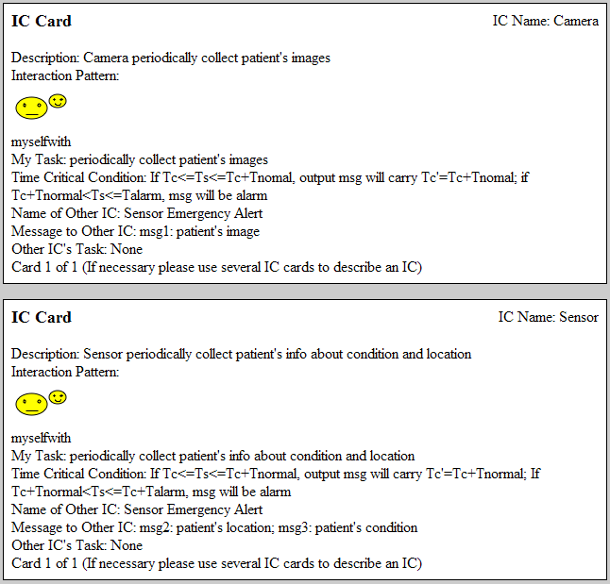
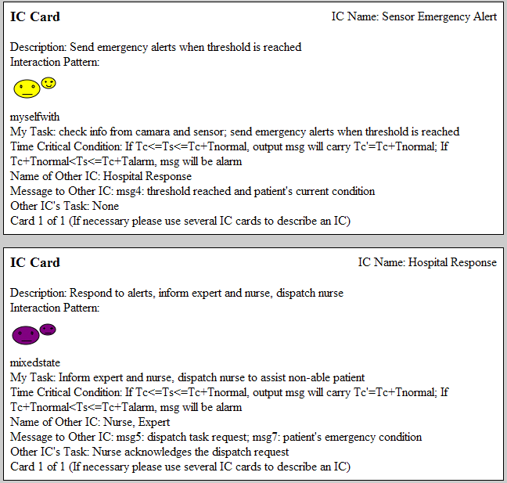
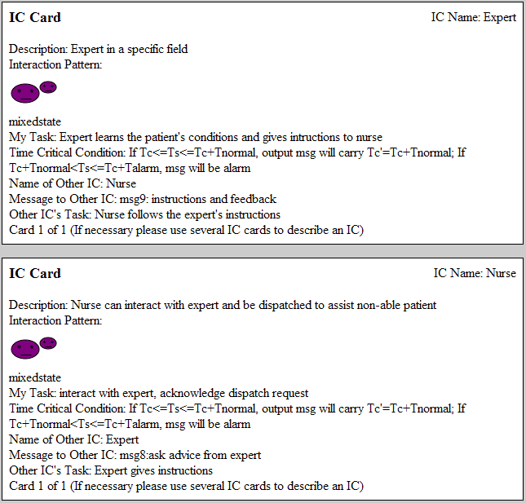

Figure 4. The IC cards.

In Figure 4, some IC cards are colored in purple, indicating mixed patterns. Therefore further decomposition into simpler IC cards is possible. Since the IC card is an abstraction, we can go into as detailed a level as we deem it necessary.

3.2. Timing constraints

Included with the alarm message is a time parameter, Tc. This time parameter is important in prioritizing the messages as they are propagated throughout the network, i.e., the IC system. The time parameter will inform the participants of the network the critically of the message so that the higher time-critical messages can be handled with more urgency than lower time-critical messages.

In this scenario, when the alarm is detected by the sensors, the alarm is propagated to the recipients with a time parameter of Tc. The Tc is then analyzed. If Tc + Tnormal > Ts > Tc (the time parameter is still within the time allowed for time critical messages to be acted on), a new Tc, Tc’, is calculated Tc + Tnormal. If Tc + Talarm > Ts > Tc + Tnormal, the message is now of a higher priority than that of a normal critical message. Message of this type are acted upon immediately.

4. IC Card Management System

The IC card Management System ICMS allows the user to create a new IC card, edit it and view it along with all available IC cards from the IC card database. In addition the user can specify the interactions among IC cards and the contents of all cards in the database. Each IC card can be linked to other IC cards and supported by a knowledge-base. Along with each application, the application knowledge can be developed and integrated within the IC Cards, regardless of the number of cards. A collection of IC cards is therefore an object-oriented knowledge structure, which itself facilitates transformation into an implementation, i.e., a prototype.

4.1. IC Card Adder

The IC Card Adder is used to add IC Cards to the IC Card XML Database. To access this tool, click the “Add IC Card to Database” link on the management system’s main menu. Figure 5 shows the user interface for this tool. This tool allows users to enter all data specific to an IC card into this form and then submit it to be added to the database. If the user fails to fill out any of the IC card’s fields, the card will not be added to the database until all information is provided. The user will be notified of any missing data.
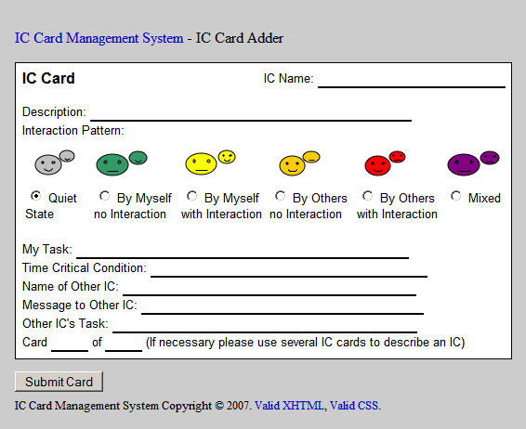
Figure 5. The IC Card.

If the user indicates that a card is part of a group (i.e. Card “x” of “y,” where y > 1), he/she will be presented with an interface similar to Figure 6 for specifying the group to which the card belongs. The user is presented with a list of all groups that currently exist in the XML database. If the current card is a member of a pre-existing group, the user may select that group from the list. Otherwise, the user should choose the “Create a New Group” option to form a new group and add the current IC card to that group. After group selection is complete, press the “Submit Group” button.

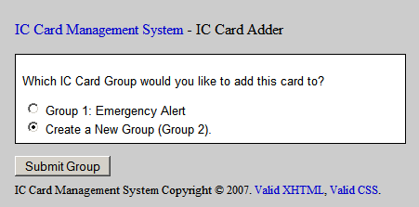
Figure 6. IC Card Adder.

After all information has been entered for the IC card and, if necessary, the card’s group is specified, the current IC card XML database will be updated with the new IC card. This database is then available by selecting the “Current IC Card XML Database” link on the management system’s main menu.

4.2. IC Card Editor

The IC Card Editor is used to edit IC Cards currently in the IC Card XML Database. To access this tool, click the “Edit an IC Card in the Database” link on the management system’s main menu. The user will first be asked to select a card to edit. Figure 7 shows the interface for selecting a card to edit. After selecting an IC card to edit, press the “Edit Card” button. Next, the user will be presented with an interface nearly identical to Figure 1 displaying all the information currently stored in the selected IC card. All information on the card is editable. Once all desired changes have been made to the IC card’s contents, press the “Submit Card” button under the form. This will cause the IC card XML database to be updated to reflect all changes. The database is then available by selecting the “Current IC Card XML Database” link on the management system’s main menu.
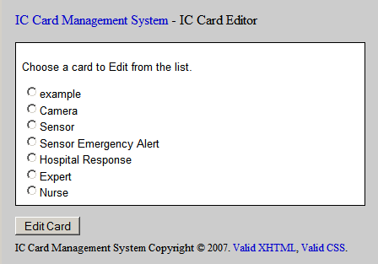
Figure 7. IC Card Editor.

4.3. IC Card Viewer

The IC Card Viewer is used to view IC Cards currently in the IC Card XML Database. To access this tool, click the “View an IC Card in the Database” link on the management system’s main menu. The user will first be asked to select a card to view using an interface nearly identical to Figure 7. After selecting an IC card to view, press the “View Card” button. Next, the user will be presented with the selected IC card for viewing similar to Figure 8.
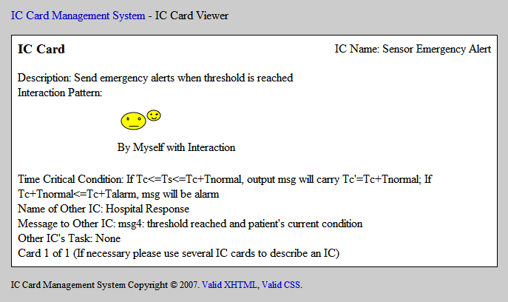
Figure 8. IC Card Viewer.

4.4. IC Card Interaction Tool

The IC Card Interaction Tool is used to specify the interactions of IC Cards currently in the IC Card XML Database. To access this tool, click the “Specify IC Card Interactions” link on the management system’s main menu. Figure 9 shows the user interface for this tool. All of the IC cards currently in the IC Card XML Database will be listed. This tool allows users to specify parent patterns for each IC Card in the database by selecting a parent pattern from the dropdown list next to each IC card’s name. Users may also (optionally) specify URLs for a scenario and/or IC system for each IC Card in the database by entering the corresponding URL(s) in the blanks to the right of the corresponding IC card name. Finally, users may specify URLs for a scenario and IC system for the entire IC card list. These global URLs may be entered in the blanks at the bottom of the form. As indicated in the text above the blanks, if the user does not specify URLs, default URLs will be used.
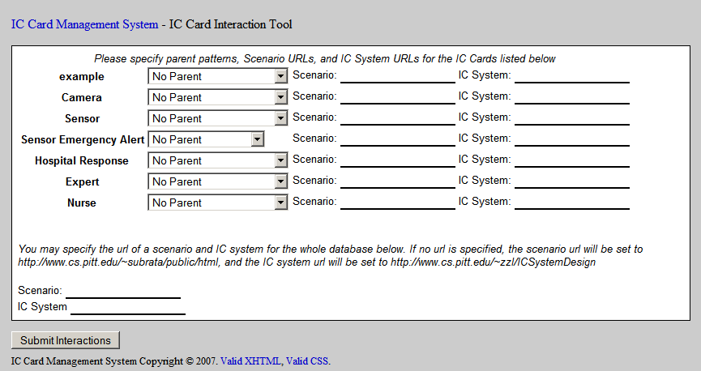
Figure 9. IC Card Interaction Tool.

After all desired information has been entered into the form; press the “Submit Interactions” button under the form to generate an XML database from the specified information. This database is then available by selecting the “Current IC Card Interactions XML Database” link on the management system’s main menu.

4.5. Clear the Database

The “Clear the Database” option is used to clear the current IC Card XML Database. To access this option, click the “Clear the Database” link on the management system’s main menu.

4.6. IC Card XML Database

The IC Card XML Database is an XML file containing the IC card information entered since the last time the “Clear the Database” option was chosen. To view this database, click the “Current IC Card XML Database” link on the management system’s main menu. Note: if you view this database using a browser that supports XSLT, the XML will be rendered in a viewable, stylized fashion.

4.7. IC Card Interactions XML Database

The IC Card Interactions XML Database is an XML file containing the IC card interaction information specified the last time the IC Card Interaction Tool was used. To view this database, click the “Current IC Card Interactions XML Database” link on the management system’s main menu. If this database is viewed using a browser that supports XSLT, the XML will be rendered in a viewable, stylized fashion.

5. The IC System

Based upon the IC cards for requirements specification, the IC system for health care delivery can be designed. First we describe the IC sub-systems for initialization. Then we describe the IC sub-system for able patient, and finally the IC sub-system for disabled patient. The complete health care delivery system is the integration of these IC sub-systems.

5.1. New Patient Initialization

A new patient will provide data about himself/herself. This data will be stored in the network’s database. The hospital that the patient has selected as his/her primary hospital will be notified of its new patient. The new patient’s data will indicate that the user is either capable of taking care of himself or not. If the patient cannot take care of himself, a new unable patient index cell is created by the system. Otherwise, a new able patient index cell is created by the system. This is shown in Figure 10.

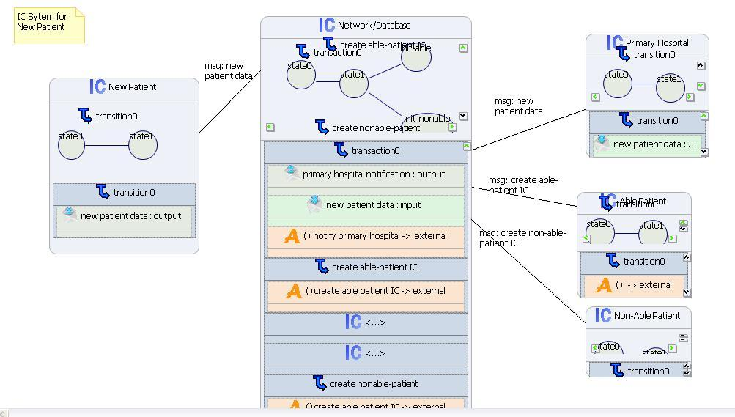

Figure 10. New patient initialization.

5.2. New Hospital Initialization

A new hospital will provide information about itself to be stored on the network. A new Hospital index cell is created. Based on the location of the hospital, nearby patients will be notified in order to provide them the opportunity to change their primary hospital (this would be a separate scenario for changing primary hospital).

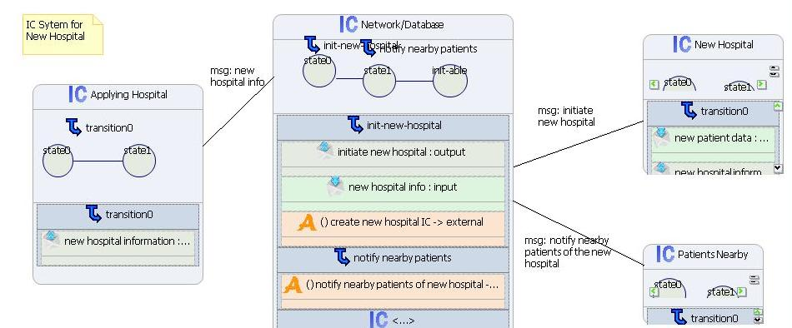

Figure 11. New hospital initialization.

5.3. New Expert Initialization

A new expert will provide his/her credentials to the network, as well as the hospital at which he/she works. A new Expert index cell is created. Patients who may be interested in such a specialist will be notified so that they may switch their primary hospital.
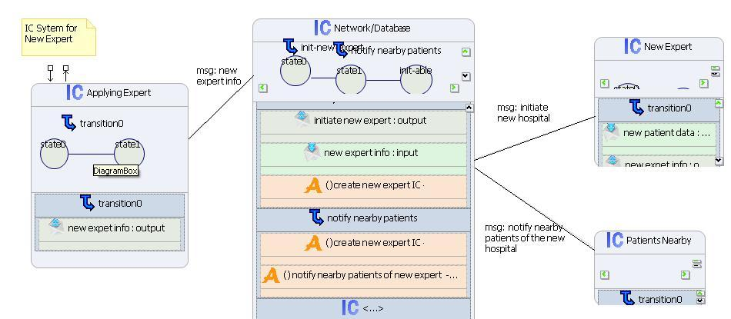
Figure 12. New expert initialization.

5.4. IC Sub-System for Able Patient

In this able-patient scenario, an able patient can make alert request by himself/herself. Sensor Emergency Alert cell receives messages from both the patient (Patient Emergency Alert) and the Sensor and/or Camera, and it forwards the information to Hospital Response cell. Then Nurse is informed and the nurse can interact with the Able Patient, making queries and instructing the patient. The patient follows the nurse’s instructions, answers questions and makes queries. If the nurse is not sure about what to do, she can ask for advice from the Doctor (the same as “Expert”).

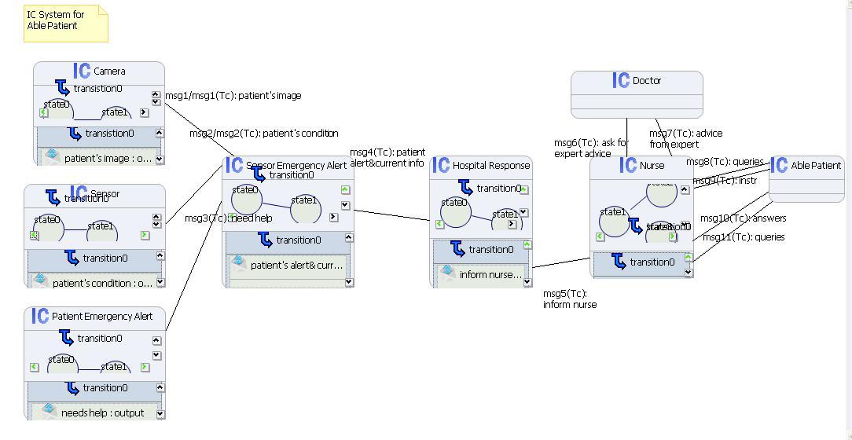
Figure 13. IC sub-system for able patient.

5.5. IC Sub-System for Disabled Patient

In this disabled patient scenario, a disabled patient cannot make alert request by himself/herself, so alert is initiated by Sensor and/or Camera. Sensor Emergency Alert cell forwards the alert information to Hospital Response cell when some parameter threshold is reached. Both the Doctor and Nurse will be informed. Nurse will be dispatched to assist the unable patient if necessary. When a nurse receives the dispatch task request, he/she should make acknowledgement. Nurse and doctor will be informed of the current conditions of the unable patient sent by sensor and camera, and nurse can communicate with doctor.
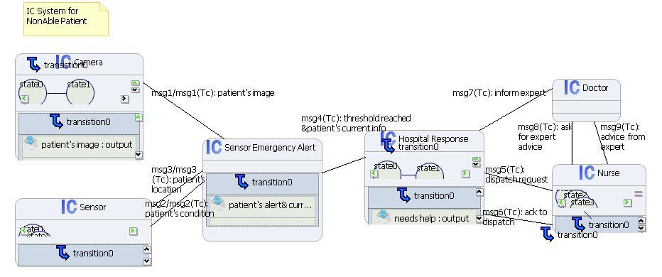
Figure 14. IC Sub-System for Disabled Patient.

5.6. Timing Constraints on Messages

In all of the time-critical messages, Tc is the time parameter. Once such a message arrives at the target IC, a checking for the time will be done. Let current system clock be Ts. If Ts < Tc then the IC is not triggered. If Tc+Tnormal >= Ts >= Tc then the output message will carry a new time parameter Tc'(Tc’ = Tc+Tnormal.). If Tc+Talarm >= Ts > Tc+Tnormal, i.e., Tc is within an alarm threshold Talarm, then an alarm message is sent to request immediate response. For different ICs, the Tnormal and Talarm can be different, so that we can flexibly set reasonable thresholds to best meet our application.

Specifically, the timing constraints in the messages for the above three IC Systems: For the initializations, messages are not time-critical, so they do not carry any time parameters. For the able patient IC system, almost all messages are time-critical, because this is a just-in-time application meaning requests should be resolved within limited timing budget. A special case is msg1 and msg2 as depicted in the figure: Before alert is detected, the sensor and/or camera just periodically send messages which have no time parameters (here I just simply put down msg1: patient’s image and msg2: patient’s condition). However, once it’s known that an alert exists in the network, the messages msg1 and msg2 are time-critical, because they have to be delivered in time to ensure effective interactions between nurse& patient(or between doctor& nurse). Thus msg1 and msg2 should carry time parameters, in the form of msg1 (Tc): patient’s image and msg2 (Tc): patient’s condition. For the disabled patient IC system, the timing constraints work in the same way as the able-patient scenario.

6. Discussion

The rapid prototyping environment and tools are shown in Figure 15. The details of this rapid prototyping environment and tools are discussed in [5]. The user/developer first creates and edits the IC cards using the IC Card Management System, which generates an XML specification XML_{icc}. Next the user/developer can design an IC system based upon the user requirements specified by XML_{icc} using the Multimedia Knowledge Eclipse Environment [6], which in turn produces another XML specification XML_{icx}. The IC Software Engineering Environment accepts the XML specification of the IC system XML_{icx}, compiles it into executable code, runs the code and produces runtime snapshots for tracing the execution.

In software engineering terms, the links to scenarios and links to IC system could be used for cross references and tracking an application from scenarios to IC cards to IC system to implementation. This offers traceability and a unified structure in object-oriented design. Since traceability is maintained by the rapid prototyping environment, the user/developer can go back to change the requirements by modifying the IC cards, redesign the IC system, and tests it again.

IC Card Management System
Multimedia Knowledge Eclipse Environment
IC Software Engineering Environment
IC Card
XML_{jcc}
XML_{jcx}
Code
User
Knowledge-Base
Figure 15. Tools for the rapid prototyping environment.

A software design laboratory with the IC cards has been incorporated into the two undergraduate software engineering courses at the University of Pittsburgh. During the past several years the first author has used it as a learning tool, with substantial informal positive feedback from the students. We plan to further study the effects on the students’ learning results, by dividing the students into two groups, one using the tools and the other group not using the tool. After requirements gathering and software design, the students will be asked to respond to a questionnaire regarding their learning experiences. Other surveys will be conducted and objective measures recorded, such as time of completion of the requirements gathering phase and the design phase and so on, to analyze the effectiveness of the software design laboratory.

Acknowledgements:

Perry Rajnovic and Mark Zalar implemented the initial single-user version of the IC Card Management System, and Emilio Zegarra implemented the multi-user version of the IC Card Management System. Subrata Acharya and Aimee Brown provided the UML diagrams for disabled patient care. Zhoulan Zhang and Colin Ehrig provided the detailed example of IC system for disabled patient care using MKEE, the IC System Visual Editor, which was implemented by Giuseppe Marco Scarfogliero and Lorenzo Sorrentino. Their contributions are hereby acknowledged.

References:

[1] Kent Beck and Ward Cunningham, "A Laboratory For Teaching Object-Oriented Thinking", Proceedings of 1989 ACM OOPSLA Conference on Object-Oriented Programming, 1989, 1-6.

[2] Shi-Kuo Chang, "Towards a Theory of Active Index", Journal of Visual Languages and Computing, Vol. 6, No. 1, March 1995, 101-118.

[3] Shi-Kuo Chang, D. Graupe, K. Hasegawa and H. Kordylewski, “An Active Medical Information System using Active Index and Artificial Neural Network", in Advances in Medical Image Databases, (S. Wong, ed.), Kluwer, 1998, 225-249.

[4] S. K. Chang, T. Y. Hou and A. Hsu, "Smart Image Design for Large Image Databases", Journal of Visual Languages and Computing, Vol. 3, No. 4, December 1992, 323-342.

[5] Shi-Kuo Chang, Zhoulan Zhang, Colin J. Ihrig, Valentina Ternelli and Paolo Maresca, “Transformations for Rapid Prototyping of Time-Critical Applications”, Technical Report, University of Pittsburgh, September 2007.

[6] P. Maresca, S.K. Chang, M. Pesce, "Application of Active Index to the Management of E-Learning", Rivista della societ` italiana di e-learning Rivista Si-el, Vol. 3, No. 2, 2006, November 2006, 331-341.

