Health Speak Scenario Demo
Scenario 1: Startup of the application
When the application begins, you are greeted with a screen that displays the title and the buttons you can interact with. If a user wants to type in their messages, they can enter it in the text field. If a user wants to speak their messages into their microphone, they can press the record voice button. Then, the user can press send message once it’s inputted.
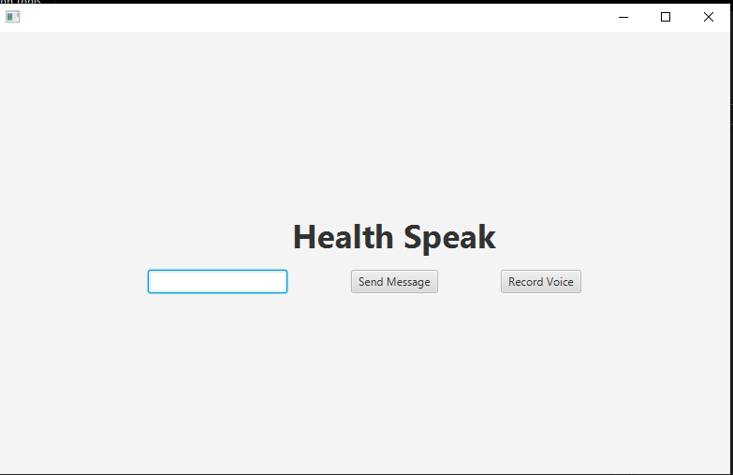
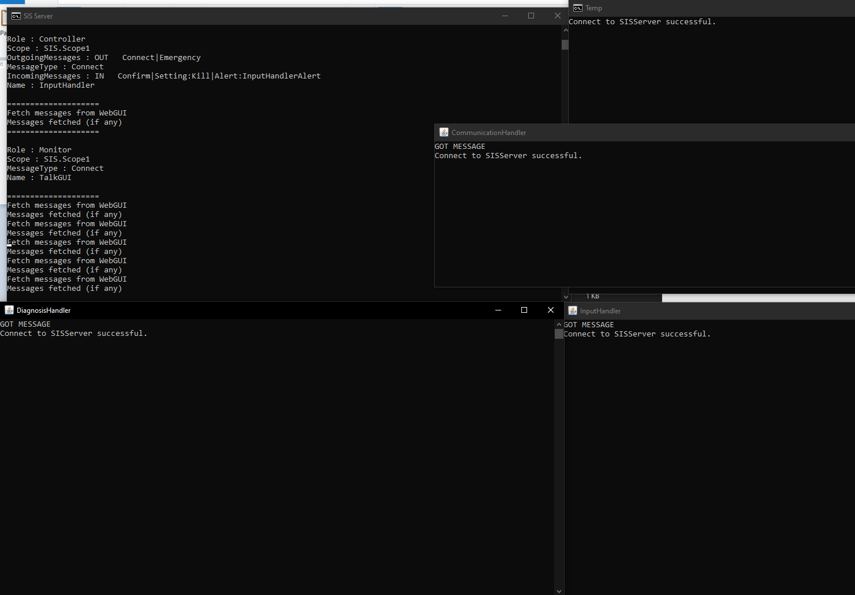
Scenario 2: Speaking a message
When you press record voice, you need to wait a second for the voice input component to startup. Once it’s started up, you can speak your message into your default microphone. If the message is successfully inputted, it will appear in the text box.
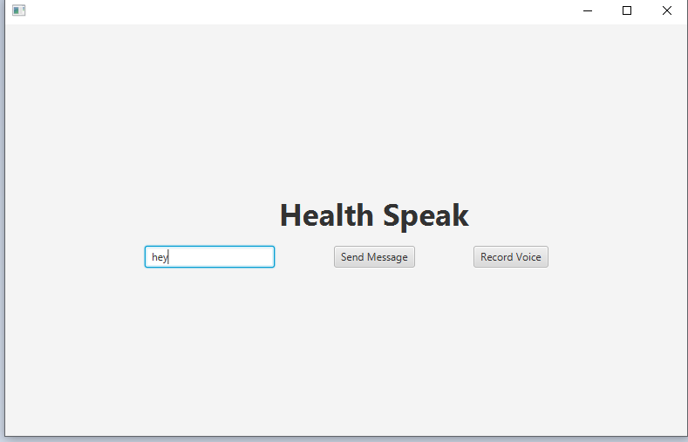
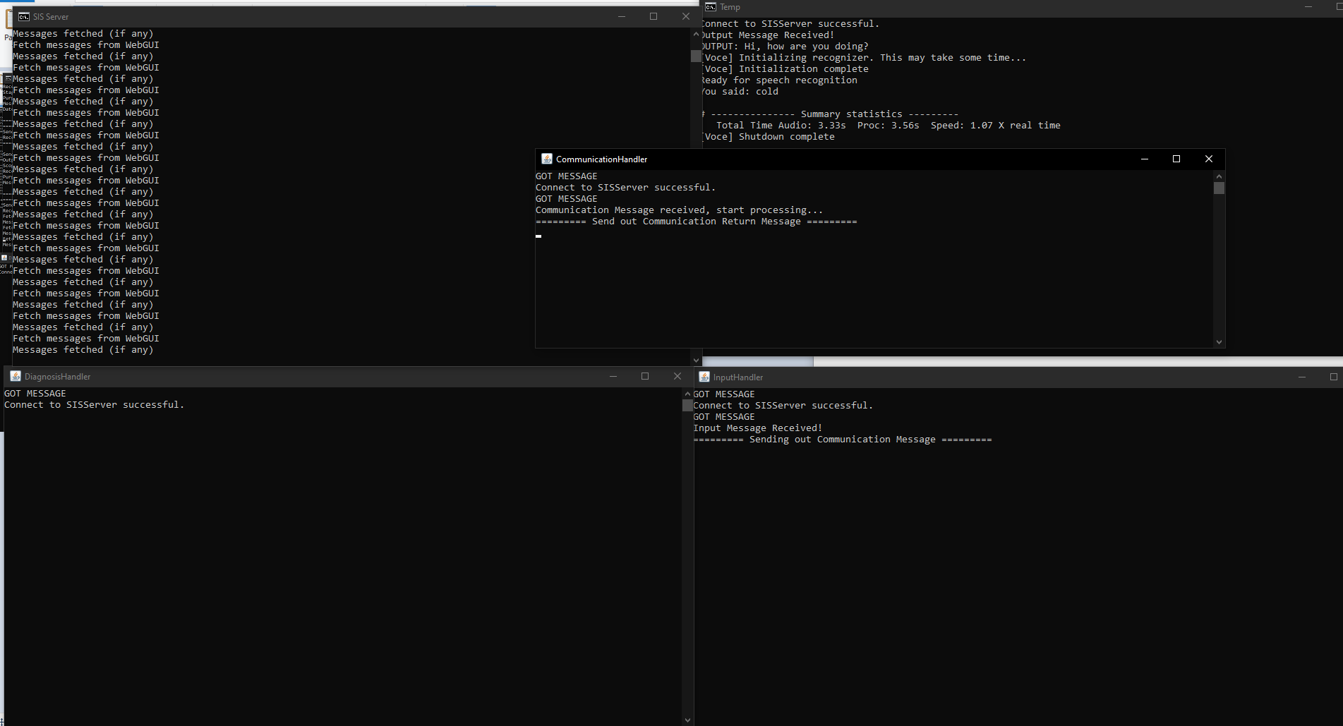
Scenario 3: Sending a message
Once your message is sent, the SISServer will process your message. Once it’s processed, the server will respond with a message for the user to communicate with them. The server will usually ask questions for the user to answer, in order to attempt to diagnose them. Once the server has received answers to enough questions, it will try to diagnose the patient.
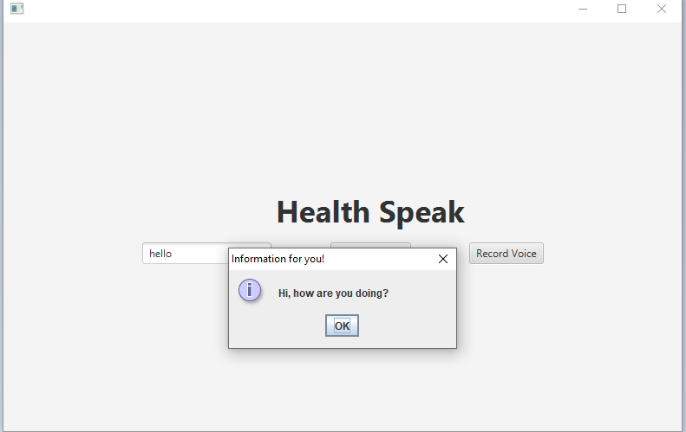
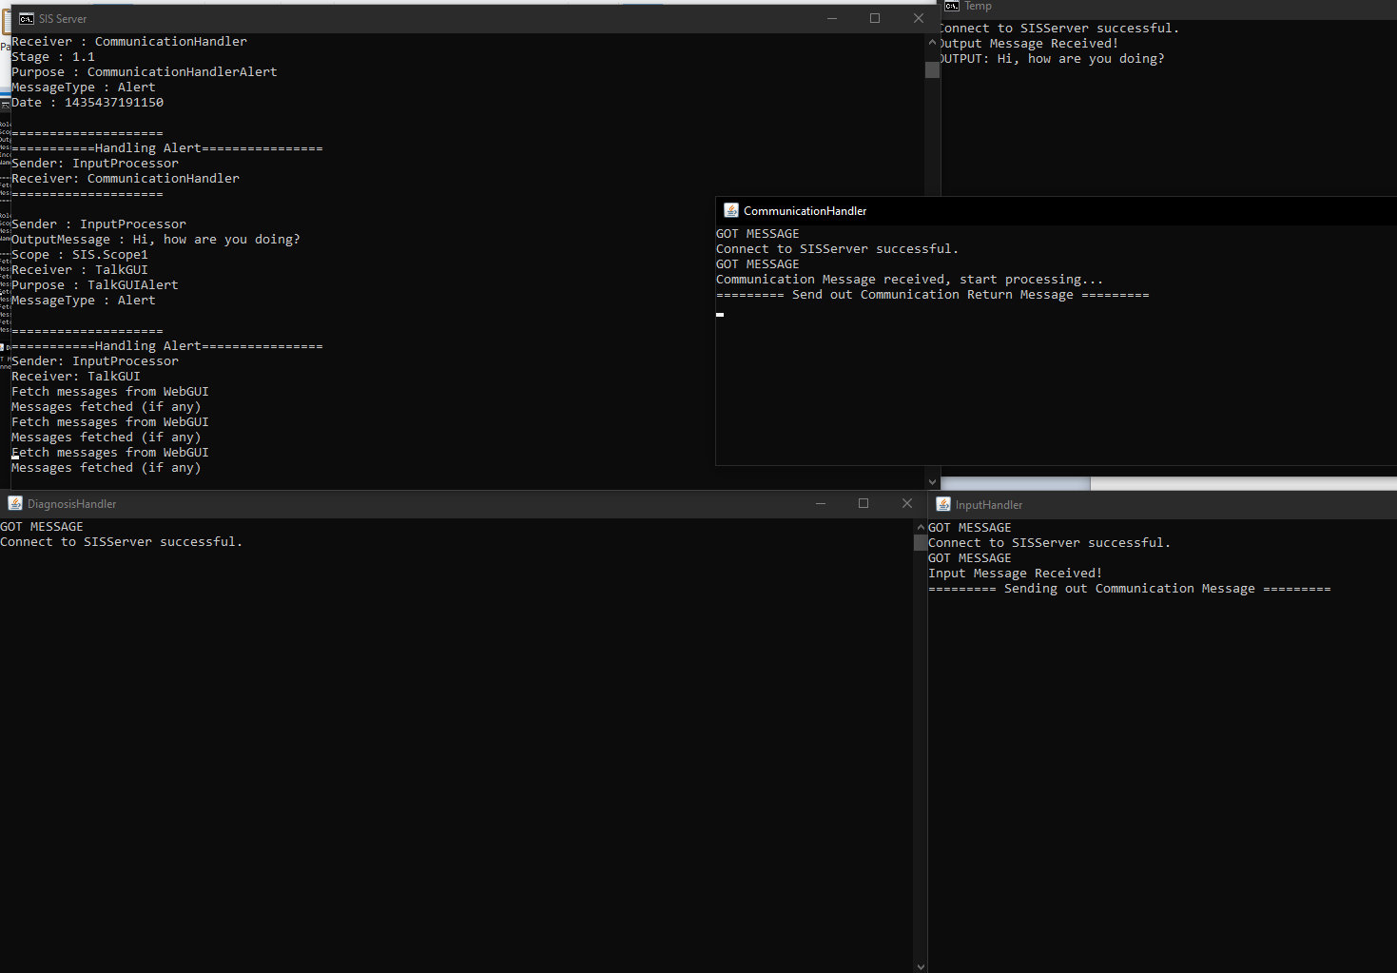
Scenario 4: Receiving a diagnosis
Once the server has spoken with the patient for long enough, it will output a possible treatment for what it has diagnosed the patient with. The system is not meant to guarantee any diagnosis, it is just to help patients speak with their medical professionals about the disease they may have. Thus, the system provides information, rather than instructions for the patient.
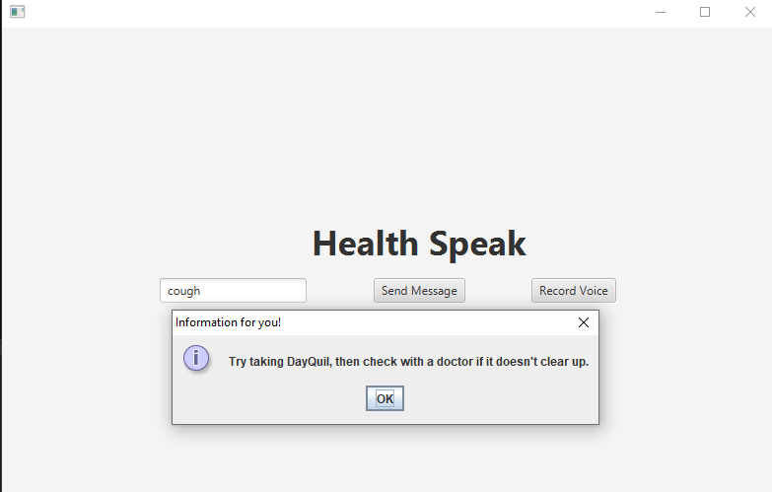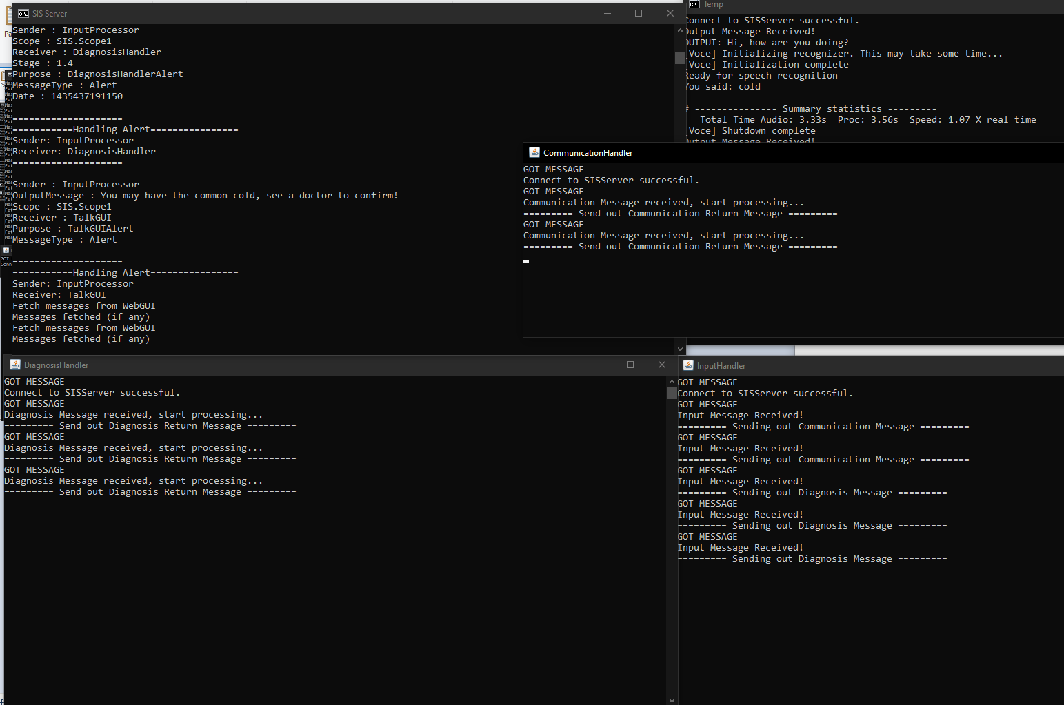
Code Sample:
