- TalkGUI
  - Handles the interaction with the patient. The patient will send messages to the hospital system, which will process the messages and return a communication or diagnosis message. The patient will input messages through this and receives messages through this component.
- InputHandler
  - A supercomponent that handles all incoming messages from patients. This processor will detect if a message is for communication or for diagnosis. Depending on the context on the input message, this handler will disperse further processing to either the communication handler or the diagnosis handler.
- CommunicationHandler
  - Handles inputs that contain communication messages. The communication handler ensures that the patient feels like they are talking to a person, rather than a machine. It makes sure that the patient receives welcoming and goodbye messages, as well as conversational messages.
- DiagnosisHandler
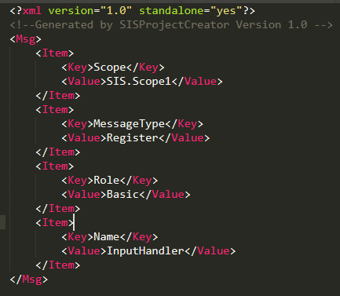
  - Handles inputs that contain diagnosis information. When a patient informs the input handler about their current health status, the diagnosis handler compares this input to data to see what the patient may possibly be suffering from. The diagnosis handler then works forward from its current information, asking questions about the state of the patient.
First scenario, a patient starts up the Chat GUI to communicate with the server.
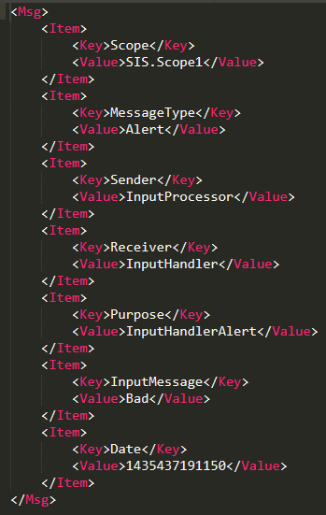
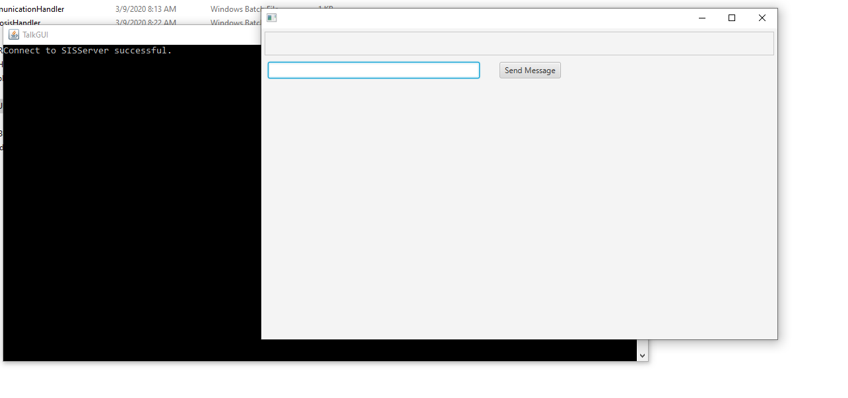
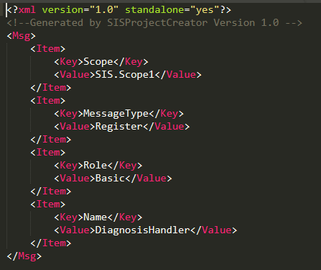
Second scenario, the patient sends a hello message to the server and receives a message back:
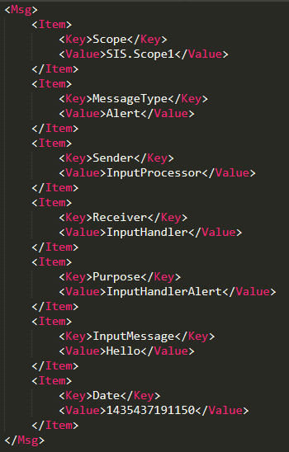
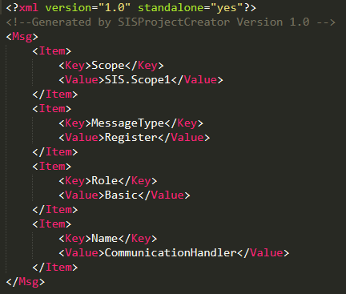
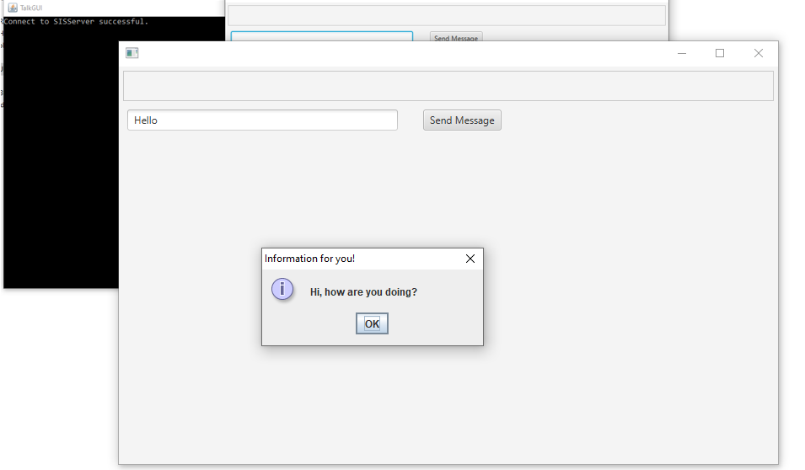
Third scenario, the patient answers the server when asked if they have been coughing:
